IHR Online Research Seminar Delivery Survey

Report Summary

Dr Matt Phillpott

28 July 2010

00 Introduction 01
01 Awareness 04
02 Post-paper Discussion 05
03 Interactive Features 06
04 Participation 10
05 Live streamed events 11
06 Conclusions 14
07 Survey Summary (statistics) 17

The IHR produced its first podcast of a research seminar on 28 September 2009 for the Voluntary Action History seminar group. Lynsey Cullen’s paper on ‘The First Lady Almoner’ was viewed 44 times in its first month online and has since maintained interest (with 93 viewings recorded between October 2009 and March 2010). Since then the publications team have helped to produce over 50 further podcasts for six seminar groups, selected papers from the last two Anglo-American conferences and a further two events (Miles Taylor’s inaugural lecture and the 2010 Fellows lecture). In total 5,621 visits were made to these pages during the same period (October 2009 to March 2010) with some seminars fairing better than others but all receiving interest. This is borne out by the results of our survey, which suggests that a respectable 37.4% of the participants were aware of the existence of these podcasts.

The survey asked historians across the country about their views, knowledge and current use of podcasts and asked them how they would feel about using podcasts in their research and in a more interactive way in the future. The survey also questioned historians about the potential of online live seminar events. The survey went live on 18 May 2010 and was run for 23 days (16 working days) ending on 9 June 2010. To help uptake of the survey a competition was offered. All replies to the survey (where an email address was offered) would be automatically entered into a prize draw to win a one year subscription to the IHR’s journal, Historical Research.

The survey received a huge and overwhelmingly positive response. By the end of its first day nearly 80 people had taken part; and by the closing date we had collected 301 responses, 116 of which were anonymous. Many of the questions asked took the form of multiple choice options but with the additional option of adding comments in a free-text box. Roughly half of those who took part in the survey gave additional comments, exceeding our expectations and providing a detailed glimpse into the academic community’s views and opinions.

As with most surveys, we cannot claim to represent the entire community of historians but the high number of responses combined with answers to specific questions allows us to be confident that we have gathered from the views of a wide variety of researchers. In answer to the first survey question – have you used podcasts for research and learning purposes? – 57.5% replied that they had not. The additional comments ranged from those who were unsure what podcasts are to those that regularly used them in learning and research. The 242 participants who left details of their area of research revealed a good range of chronological, geographical and methodological interests. There were few areas of historical interest that were not represented. Data that were not collected in this survey, such as the location of the participants and their status (academic, postgraduate, other interested parties), can be inferred from some of the responses, again suggesting that there was a good range contained in the survey.

By far the most important result from the survey is the overwhelming support for the IHR’s provision of podcasts from its research seminar programme. In response to the question ‘Do you think it is a good idea for the IHR to podcast its research seminars?’, only 9.7% responded negatively.

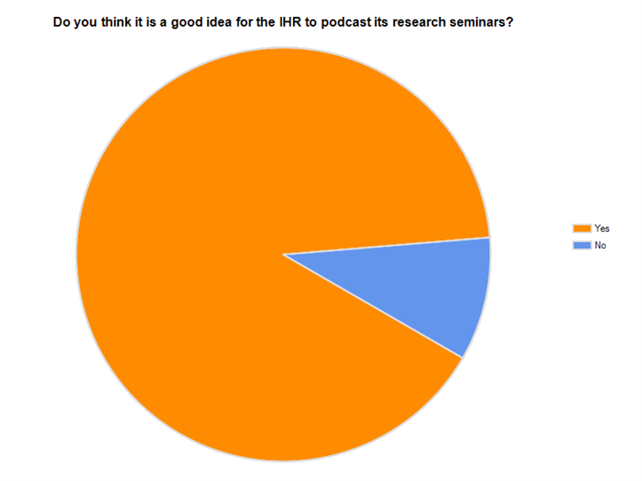

This result confirms that there is indeed interest in research seminar podcasts and, from additional comments made by those who responded ‘yes’, a great desire to gain access to the IHR seminars in particular. Many respondents reflected that it was generally impossible for researchers outside London to attend more than a few (if any) of the IHR seminars, but that there was considerable desire to gain access of some kind. A significant number also referred to the London-centric nature of the IHR’s activities and were gratified by the possibility that podcasting offered an opportunity to change that perception.

The following analysis is derived from the survey results and will help both to assess the value of the IHR podcasts already online and the potential for long-term success of the current IHR Digital project. Each question or set of questions will be analysed separately before final conclusions are made.

01 Awareness

The first set of questions was asked specifically to assess current awareness, interest in and opinions about podcasting and to gauge general levels of enthusiasm within the History profession. The questions assessed general knowledge of podcasts first, asking ‘Have you used podcasts for research and learning purposes?’, and then adding ‘If you have, did you find the experience useful?’ The responses to these two questions brought out some interesting preconceptions in the profession and highlighted some serious issues.

- 57.5% of participants have not used podcasts for research and learning purposes.
  - A small minority of participants were hostile to the idea of podcasts as a viable mechanism for historical enquiry and sceptical of their use as profitable teaching and learning tools.
  - There is still a proportion of researchers who have a lack of knowledge about what a podcast is and how to access them.
  - Lack of time to use resources that are not significantly tied to traditional methods of teaching and research.
  - A distinct lack of relevant and findable podcasts to draw upon.
- 42.5% of participants have used podcasts for research and learning purposes.
  - Popular resources are Melvyn Bragg’s Radio 4 show ‘In our Time’ and the British Museum’s recent ‘History of the World in 100 Objects’.
  - Podcasts currently used mainly to further basic knowledge about a subject, to gain insights into different fields of study, and to keep up to date with current research.
  - A few participants noted that podcasts offered an alternative means to see what other institutions were doing.
  - Podcasts seen as a way to bring variety to research and to fit learning into other areas of life (i.e., when travelling, doing household chores etc.).
  - Convenience was argued to be the most important reason for using podcasts, especially when it would be difficult to get to the seminar itself (largely for those outside London).
  - The use of podcasts for teaching purposes was highlighted as most participants’ main area of interaction. These responses point towards a vision of podcasts as only appropriate or thought about as tools for undergraduate tuition.
- 85.9% of those that answered ‘yes’ to the first question also answered ‘yes’ to having found the experience useful.
- Few participants commented on bad experiences with podcasts – although poor quality audio was listed as a problem.

In general the responses to these questions highlight that podcasts are generally seen as an alternative teaching tool for training undergraduate students rather than as a useful tool for research; although there is a curiosity about the idea that they could be used in this way. Occasional references to ‘In our Time’ and institutional podcasts suggest that there are some in the profession who do see podcasts as having significant research potential, but it seems clear that this is still a minority view and very much dependent upon the area of study that the participant is engaged in. At present there simply are not enough podcasts on specific subjects to support most research practice. The majority of those who said that they had not used podcasts for research and learning purposes did so because they had not yet found anything relevant to their field of study.

02 Post-paper discussion

There are tangible benefits from having access to the post-paper discussion where ideas and debates are floated and impressions made. However, there are also significant issues to be recognised in making this material available; not least the potential effect that broadcasting of the discussion could have on the seminar atmosphere. We therefore asked those who responded to the survey whether, as a member of the audience, they would be happy to have the discussion put online as well. 73.4% answered that they had no problem with this, 17.4% were uncertain and only 9.2% felt that the discussion should remain open only to those in attendance. We also asked if those who answered the survey thought that they would find a recording of the discussion a useful addition. The responses were largely the same with a slight increase in the uncertain category (21.1%). 71.3% believed they would find the inclusion of the discussion useful and 7.5% felt that they would not. The arguments given for and against are diametrically opposed, highly incompatible and seemingly capable of provoking strong opinions.

- Against the inclusion of the post-paper discussion.
  - Concern that it would hinder the audience from asking questions, especially when a question might be from a position of little knowledge.
  - Broadcasting of the discussion would be detrimental to the quality and openness of the audience’s questions and perhaps to the speakers’ responses.
  - In the ‘safe’ environment of the seminar room potential for ‘embarrassment’ can be minimised, but if it is recorded and uploaded online then anyone could have access.
  - A few participants highlighted that those recordings could be potentially harmful to future employment and acceptance in the profession.
  - There was a concern that the microphone would not be able to pick up the audience very well, thereby distorting the audio quality.
  - Concern about how the IHR would gain permission from the audience to include the discussion.

- For the inclusion of the post-paper discussion.
  - Potential benefits for the listener to stimulate further discussion and improve knowledge, raise new ideas and thoughts, or clear up vague or undeveloped elements of the paper.
  - To gain multiple perspectives on the topic.
  - Discussion is the most likely part of a seminar to provoke ideas for further research.
  - The discussion is the only part of a seminar that is unlikely ever to be published in any form, therefore making it all the more valuable.
  - Some responses hinted at an existing dissatisfaction with post-paper discussions and noted that if the audience knew that their comments would be recorded it might actually promote more constructive discussion and criticism.

Those participants against including the discussion, although only representing at most 26.6% of the vote (if we include the uncertain responses which also highlight the same issues), reveal that some scholars might feel pressured and uncomfortable if they knew that their questions and comments were being recorded. We are therefore faced with a challenge. On the one hand there are excellent reasons to include post-paper discussions for pedagogical reasons. In essence the discussion is often the more interesting part of a seminar as it realises the full potential of the paper. However, on the other hand we are faced with a very real concern that the audience might feel constrained and uncomfortable at the prospect of being recorded. It is clear from the responses that most people who took part in the survey felt that the positives of broadcasting the discussion outweighed the potential negatives. However, the points raised against the inclusion of the discussion are of concern.

03 Interactive features

As the idea behind the IHR Digital project is to do more than simply broadcast the research seminars but also to provide an online space for further discussion, debate and analysis, it seemed appropriate to ask participants what features they would be interested in and how they might use them. The first of these questions sought to determine interest in the use of forums or similar applications that would allow for a continuation of the post-paper discussion online. The idea would be that historians who had listened to the podcast could ask questions or add to a discussion about the paper to which the speaker and original audience members might also contribute. This feature would (in theory) add value to the podcast and remove the limitations of a largely one-way dialogue that podcasts generally encourage. Increased communication would benefit the research interests of all interested parties. When asked if they would find this feature useful 82.2% responded that they would; however many of those answers came with a caveat that participants were not sure it would work in practice, or whether they would have enough time to take part.

- For the use of forums.
  - This form of interaction will make history more accessible and dynamic, whilst also ‘retaining its academic stature’ and provide an opportunity for scholars who cannot generally reach the seminars in London to take part in the discussions.
  - One solution to opening the ‘closed doors’ of academia and giving access to those who are not already established academics (including postgraduate and early career academics).
  - Forums should deepen analysis and understanding, allowing for a less London-centric, English-centric or Euro-centric discourse.
  - Potential for engaging with and making new contacts on particular topics that might not otherwise occur.
  - The provision of an archived discussion for learning and reference.
- Against the use of forums.
  - Forum discussions cannot replace discussion in person (and might even take away from that discussion).
  - The nuance of a paper is difficult to follow unless you are there in person (i.e., an audio recording does not portray the visual and atmospheric elements of a seminar).
  - The best scholarly interaction has to involve a face-to-face meeting if it is to provide anything beyond a shallow discussion.
  - Enthusiasm for research papers tends to die down relatively quickly limiting the usefulness of any debate to only a short period of time at best.
  - A concern that the forum discussion would analyse the talk to a degree that could end up working against the speaker, especially when they were presenting half-formed ideas.
  - Concern that ideas expressed in the forum might be plagiarised.
  - Issue of moderation and the tendency for forums to fall into derogatory comment or useless bickering (which also brings up the issue of who should moderate and what constitutes an unnecessary comment).

The next question proposed the idea of enabling online ‘collaborative research’ through the use of discussion forums, wikis and making links between seminar podcasts. The question asked whether historians would be interested in this type of facility. 84.8% of participants said that they would. Many responses focused on the same issues as for the previous question, but a few other elements did come out in the answers.

- For online ‘collaborative research’.
  - Hope for increased interdisciplinary collaboration, and collaboration between scholars across the world.
  - These forms of virtual collaborative relationships might help to save cost and time involved in research projects and provide the platform for expanding the scope of the project.
  - Potential learning outcomes for undergraduates.
  - Increase in knowledge about available resources, evidence and debates amongst scholars.
- Against online ‘collaborative research’.
  - Not enough time to spend on these activities.
  - Would produce inferior research results.
  - The conversation will inevitably end up being about fairly basic stuff between those that had less knowledge of the subject rather than about detailed historical enquiry.

The third question in this section of the survey took a different approach to the others and asked scholars to select from a list which additional tools and features they would like to enable them to make more from a podcasted seminar. There was some confusion as to the meaning of some of the items (particularly e-portfolio) which may have skewed the results slightly but for the most part this question generally confirmed our expectations but also brought up a few surprises.

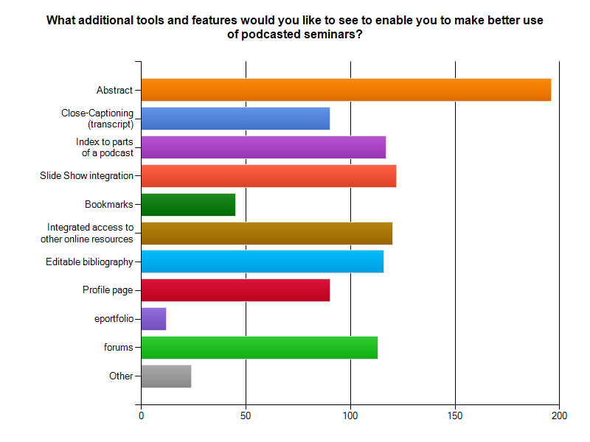

By far the most popular feature desired by those who took part in the survey was an abstract (83.4%). The most undesired features were the e-portfolio (5.1%) and the chat messenger system (10.2%) although it is difficult to be certain whether these low counts were not partly induced by a lack of clarity on the part of the survey. Bookmarks were also unpopular with only 19.1% of votes but again this might in part be due to a lack of explanation as to its use in the website. Most features were popular with about half of those surveyed.

- Transcript
  - Several participants argued that provision of transcripts would work against the nature of seminar papers, particularly but not exclusively when they were works in progress. The concern raised is largely entangled in the perception that transcripts might be used by scholars as if they were publications in their own right.
- Slide show presentations
  - Slide show presentations would be an essential addition in some cases.
  - A concern that there would be copyright issues involved in providing slide shows.
- Podcasts
  - Recommendation to allow for downloads of a podcast rather than just streaming online (this feature is already available on the IHR podcasts)
  - Vodcast (video recordings) as a means of projecting a more relatable experience of the seminar itself.
- Search facilities
  - Keywords for browsing archived podcasts requested.
  - Increased search facilities including chronological and thematic databases
  - Zotero (bibliographical organiser) integration.
- Publications
  - Featuring resultant publications from the paper (or at the least a reference to those publications).

The primary concern raised (albeit amongst a minority of responses) related to the amount of time and effort involved in these pursuits. Integrating slide shows with audio recordings can be a time-consuming task. Some participants also wondered if these additional features would require more time and effort on the part of the speakers. Others voiced their concern that podcasting would become a requirement of giving a paper at the IHR rather than a voluntary activity.

- Participation

Question 9 of the survey attempted to assess the interest in the previous set of interactive features in a slightly different way. It simply asked whether participants would be more or less likely to give a paper at the IHR knowing that it was going to be used in this way. This is an important question as it offers further insight into the potential acceptance and popularity of these features, whilst at the same time assessing the likely impact it might have on speaker recruitment by seminar groups. Almost half of those who took part in the survey answered that it would make no difference to them at all (47.7%). 7.2% were unsure what affect this would have on them and 14% would judge it upon the type of paper that they were thinking of presenting. Only 9.8% felt that they were less likely to give a paper under these conditions while 21.2% claimed that they would be more likely to give a paper knowing that they would have these resources as an additional benefit.

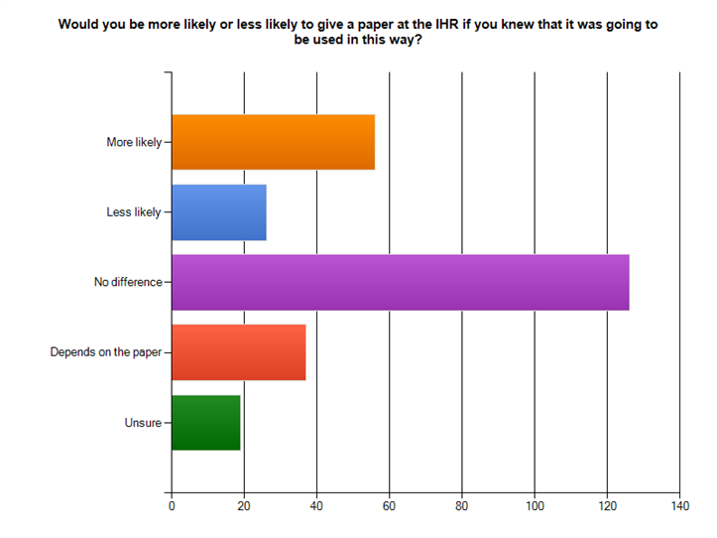

- Less likely.
  - Wide hesitation from postgraduate and early career academics who are highly concerned about the reception of their papers in academic circles and the potential negative effect this might have for eventual publication.
  - Fear of embarrassment and of presenting unpolished ideas in the public domain.
  - Loss of control of the paper after it has been presented.
  - Claim or belief that the ‘safe’ environment of the seminar room is incompatible with the purposes and intentions of podcasting.

It is worth noting that these concerns were also particularly raised for ‘work in progress’ papers; there were a few calls that only ‘polished’ papers be podcasted. 21.2% of participants on the other hand believed that they would be more likely to present at the IHR if they knew that it would be made available as a podcast with interactive participation. This is good news. Almost without fail those that made additional comments emphasised the greater benefits that these features would give them access to.

- More likely.
  - Wider feedback and diffusion of ideas (and recognition) is seen as a prominent bonus.
  - The potential for worldwide engagement and the possibilities of receiving a critique from a wider audience, thus making more out of the paper than would previously have been possible.
  - Hope for more collaborative research and prospects of making new contacts related to the subject matter.

In all 76.1% of the participants to this survey would still present at the IHR if their paper was podcasted. A further 14% might do so depending on the type of paper that they were presenting. Even if we take into account the 9.8% who would be deterred from presenting, in terms of speaker recruitment 271 out of 301 participants would still present which may even be an increase over current numbers, considering the 21.2% who answered that they would be more likely to present. If advertised correctly the additional benefit to the speaker might actually increase interest and at the very least would put few people off. As podcasting is a voluntary addition anyway the survey strongly suggests that speaker recruitment will be increased.

- Live streamed events

Questions 10 through to 12 asked the participants of the survey whether they thought live streaming of selected seminars was a good idea, whether they preferred audio or video streams for live events, and finally if they would be more interested if they were able to take part in the post-paper discussion. Although 51.5% answered that they would be interested in live online seminars there was an almost equal divide between those who were not interested (20.2%) and those who were uncertain (28.2%). When asked if they would be more interested if a feature was provided that would allow them to communicate in real time with the seminar, 56.3% voted yes and 43.7% voted no. This second question, however, does not account for the answer to the earlier question and therefore makes no distinction between those who were initially interested, those who were unsure and those who were uninterested. Through cross-examination between these questions we can see that there is a great deal of uncertainty about these ideas and that there is a more-or-less even divide between those who are cautiously interested and those who are not. Comparison between the two questions shows that:

- 10 who responded to the first question did not answer the second question.
- Of those who only answered the first question only two replied yes, the rest answered no.
- 92 answered yes to both questions.
- 34 answered no to both questions.
- 11 answered no to the first question and yes to the second question.
- 41 answered yes to the first question and no to the second question.
- 74 answered uncertain to the first question.
- 35 of those who answered uncertain to the first question answered no to the second question but 39 answered yes.

At least 42 participants did not like the idea of live events at all. That is 16% of the total. A total of 92 participants were interested with or without the addition of interaction (that is 35%). Interestingly only 11 participants (4%) might be more convinced of the idea of live streaming if they were given the opportunity to interact but 41 participants (15%) would prefer to not interact. Of those who were uncertain about the idea of live streaming 39 seemed more interested by the idea of interaction. This means that about 19% of those who answered these questions might be more interested in live streaming if they were able to take part in the seminar.

In total about 54% are either interested or curious about the idea of live streaming, however the other half of the participants would be more difficult to convince. Of all the responses to the survey the issue of live streaming is the most divisive and has been met with some curiosity but also much doubt about its usefulness and potential for success.

- Against live streamed events.
  - Preference for the flexibility of pre-recorded podcasts over the limitations of a pre-arranged time slot even if the option to interact live was offered.
  - Issue of time-zone differences between countries and potential that other commitments might make it impossible for audience members to take part at a specified time.
  - Increased risk of audience non-attendance.
  - Technology limitations – problems of bandwidth and unreliable connections.
  - Inclusion of real-time input from those listening online could be disruptive to the seminar itself and boring for those actually there in person.
- For live streamed events.
  - An ‘enhanced experience’ where viewers can ‘enter the spirit of a discussion’ has invaluable benefits.
  - Live streaming would be useful for big names, key-note speakers or debates relevant to national or international contemporary issues.
  - A useful teaching tool for postgraduate and undergraduate learning.
  - Useful for scholars distant from London to take part in the seminars.
  - Colleagues could ‘make an event of it’ by watching the live stream together in their own institution and using that as the basis for their own discussions.
  - Live events will need to be well-organised and advertised.

One participant ventured a comparison to WUN virtual seminars as a successful example of live streaming. The Worldwide Universities Network (WUN) comprises 15 ‘research-intensive’ institutions spanning five continents (including the UK) and uses virtual seminars as one method of linking this network together.

The survey also asked participants whether they would prefer audio or video streams for the live events. Out of the 233 participants who answered this question 137 (58.8%) voted for video and 96 (41.2%) for audio as their preference. From other answers in this survey it would seem that most participants would prefer audio only for pre-recorded podcasts as they are only interested in the words spoken and would find a video of someone talking dull. However, some participants did highlight that they would prefer video because it allowed them to make a better appraisal of the paper as a whole. There were various comments that suggested that integrated slide shows would generally be better than video. For live events video is narrowly preferred as one method of enhancing the experience in these instances.

6. Conclusions

In all, the results of this survey were highly positive. 90.3% of participants believe that the IHR is right to produce podcasts of the research seminars and that these would be useful resources. Over 70% of the participants would find post-paper discussions useful even if there are serious questions about privacy and seminar atmosphere. Over 80% would like to interact on some level with the podcasts and over 75% would not be put off giving a paper at the IHR if they knew that they would be recorded; in fact podcasting might even increase speaker interest. Participants were less certain about live streaming but there was enough cautious interest to suggest that there would be an audience for a trial run. Although some serious issues have been raised in this survey none of them precludes the ideas that the IHR wishes to test through this project. Indeed the results clearly demonstrate the potential for success as long as we treat participation as voluntary and remain open to the needs and desires of the profession.

From the 90.3% who felt that it is a good idea for the IHR to produce podcasts from its research seminars the main reasons highlighted were the opening up of the seminars for those unable to reach London and the relieving of the perceived London-centric nature of the seminars. The outreach potential (both within academia and external to it) and the encouragement of wider participation and exposure worldwide provided by podcasting is seen amongst this group as a generally beneficial development.

As also stressed in answers to the survey, those already using podcasts do so at a time and place of their own choosing, often whilst performing other tasks and often whilst on the move. Those already onboard therefore see podcasts as an addition to their own learning that fits into their lifestyle. Obviously, not everyone will want to or will be able to fit podcasts into their lifestyle, especially at times when they are away from their research, but these responses suggest that there are a growing number who find it helpful to make use of podcasts on a regular basis.

Those few who disagreed with the idea entirely highlighted issues that can be divided roughly into three categories. First, the potential for researchers to be put off from presenting original ideas or works in progress for fear of plagiarism and misinterpretation. Amongst this group there was a definitive discomfort with the idea of having their and other papers broadcasted and a very real concern that the public viewing of seminars would have a detrimental and transformative effect on the seminars themselves. Second, the issue of use of resources was highlighted in a few responses, suggesting that some participants feel that resources should be put into more 'traditional' ventures or that podcasting should be restricted only to high-profile speakers and/or subjects. The final issue brought up by those participants who were against the IHR podcasting the seminars raised the often-cited concern that audience size would diminish as the paper would be available online soon enough.

In general, however, the ideas put forward in the survey by the IHR are viewed by the majority of participants as helping the profession direct itself towards new twenty-first-century methods of enquiry and endeavour. What is needed is an easily accessible and searchable platform with a diverse range of period and topic specific papers as well as a broad spectrum of approaches and methodologies. The present lack of highly visible podcasts on specific topics means that most researchers have yet to find more than one or two (at best) recordings that are useful to their research. The IHR is well placed to provide that content. The research seminar groups represent the diversity that exists in the historical profession and each provides a regular series of papers that can form the basis for an in-depth archive of specific content.

The main concern voiced through the answers to this survey is that podcasting of the IHR seminars would be a requirement of giving a paper and that no opt-out option would be provided. It is clear that even those who are highly positive about the idea of podcasts would like to see this as a voluntary option that can be taken up by individuals or groups as or if they require. There needs to be enough flexibility to allow researchers ranging from established academics to postgraduate students and beyond the option to select if they would like to have the paper podcasted and if they do, to what extent other additional resources (such as a recording of the post-paper discussion, slide shows etc.) should be provided.

The IHR platform is a high-concept idea with features that are experimental and untried (as evidenced by the answers to this survey). It was therefore decided at an early stage that the more experimental features will be removable or editable depending on their reception. It was also decided at an early stage that the success of the project rested on providing as much flexibility as possible. The IHR is aware that interactive features and functions could be used by historians in a variety of different ways, some of which will be unpredictable.

The results of this survey also highlighted that there is an opinion amongst some scholars that podcasts are only fit for undergraduate and postgraduate tuition and are not useful as research tools for professionals. I am not so sure that this is true. The problem I see here is not in the content provided by podcasts but in the perception of it. The survey showed that there is a fair degree of concern that podcasts will be used as ‘published’ alternatives to traditional publications and that historians will cite and plagiarise them before the original author has had a chance properly to express his or her arguments. Also intertwined in this concern is a belief that seminar papers are not generally proper material for scholarly publications but rather have a different use in the academic profession. As discussed in the answers to the survey, seminars are often about testing out theories and ideas or gaining feedback in an informal atmosphere. They are not generally about finalised and polished pieces of research. However, I see no reason why historians should view podcasted versions of those seminars as anything different than they do when attending them in person. They are after all offering the same content but to a wider audience. A seminar paper might further my thinking on a subject or send my thoughts in a new direction. It might also identify for me research or evidence of which I was previously unaware. I would not, however, treat that information in the same way as I would material in a scholarly article or book. It makes little difference if I witnessed the paper in person or later online, other than I might feel more inclined to cite a reference to the podcast in any subsequent work on that topic. That citation would not, however, replace a published work but would be a reflection of the process of research that already occurs in traditional face-to-face seminars. That reference would address the plagiarism issue by properly identifying its source and emphasising at the same time the ‘work in progress’ nature of the evidence.

I believe that the scholarly community is very good at dividing its research materials between those items of polished scholarly repute and those items that should be judged more circumspectly. Podcasts will therefore be used appropriately – and where they are not the author in question will be brought up over the issue. To further emphasise this point (which I feel is crucial to the success of the project) I suggest that we produce some guidelines on how to cite and make use of podcasts in scholarly works, and to dissuade researchers from viewing them as polished ‘published’ materials.

07 Survey Summary

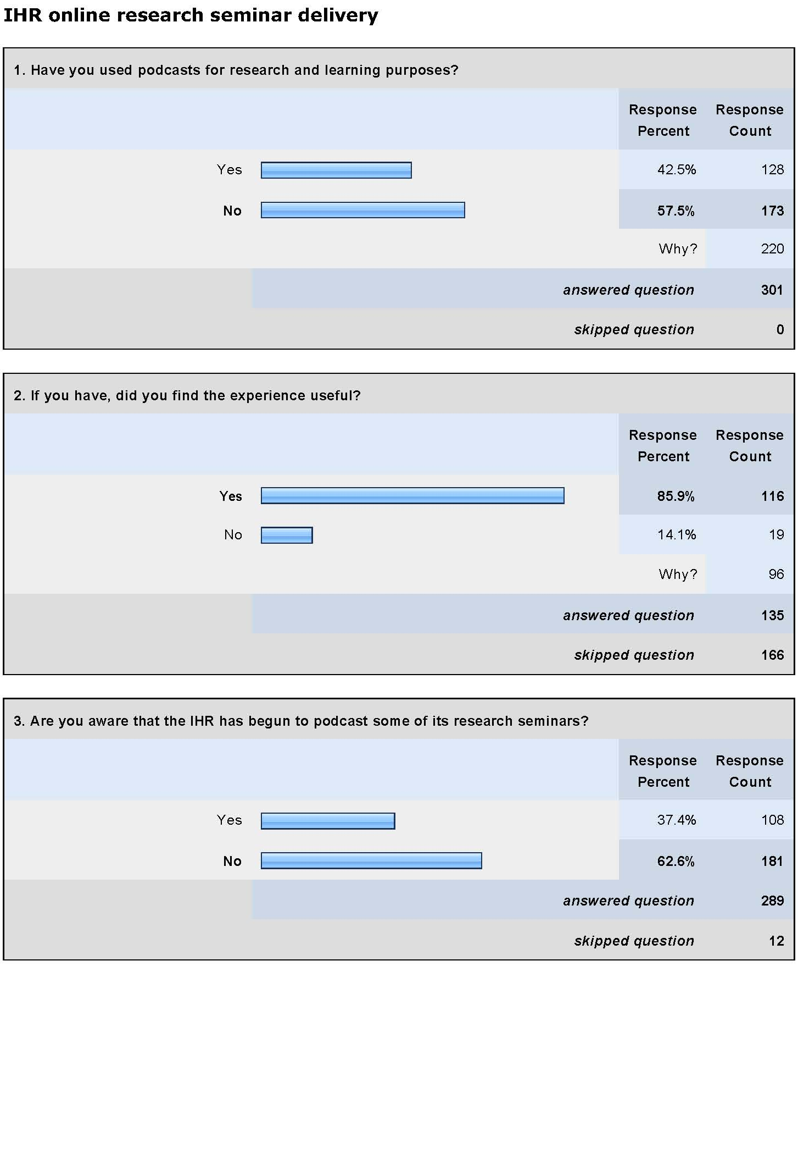
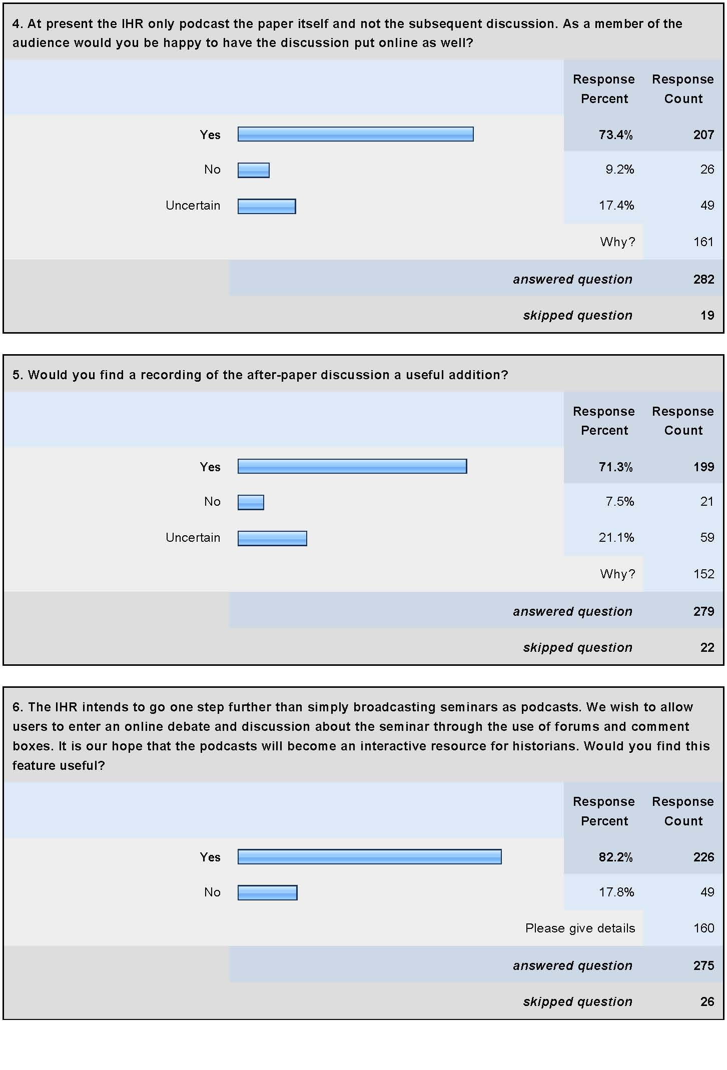
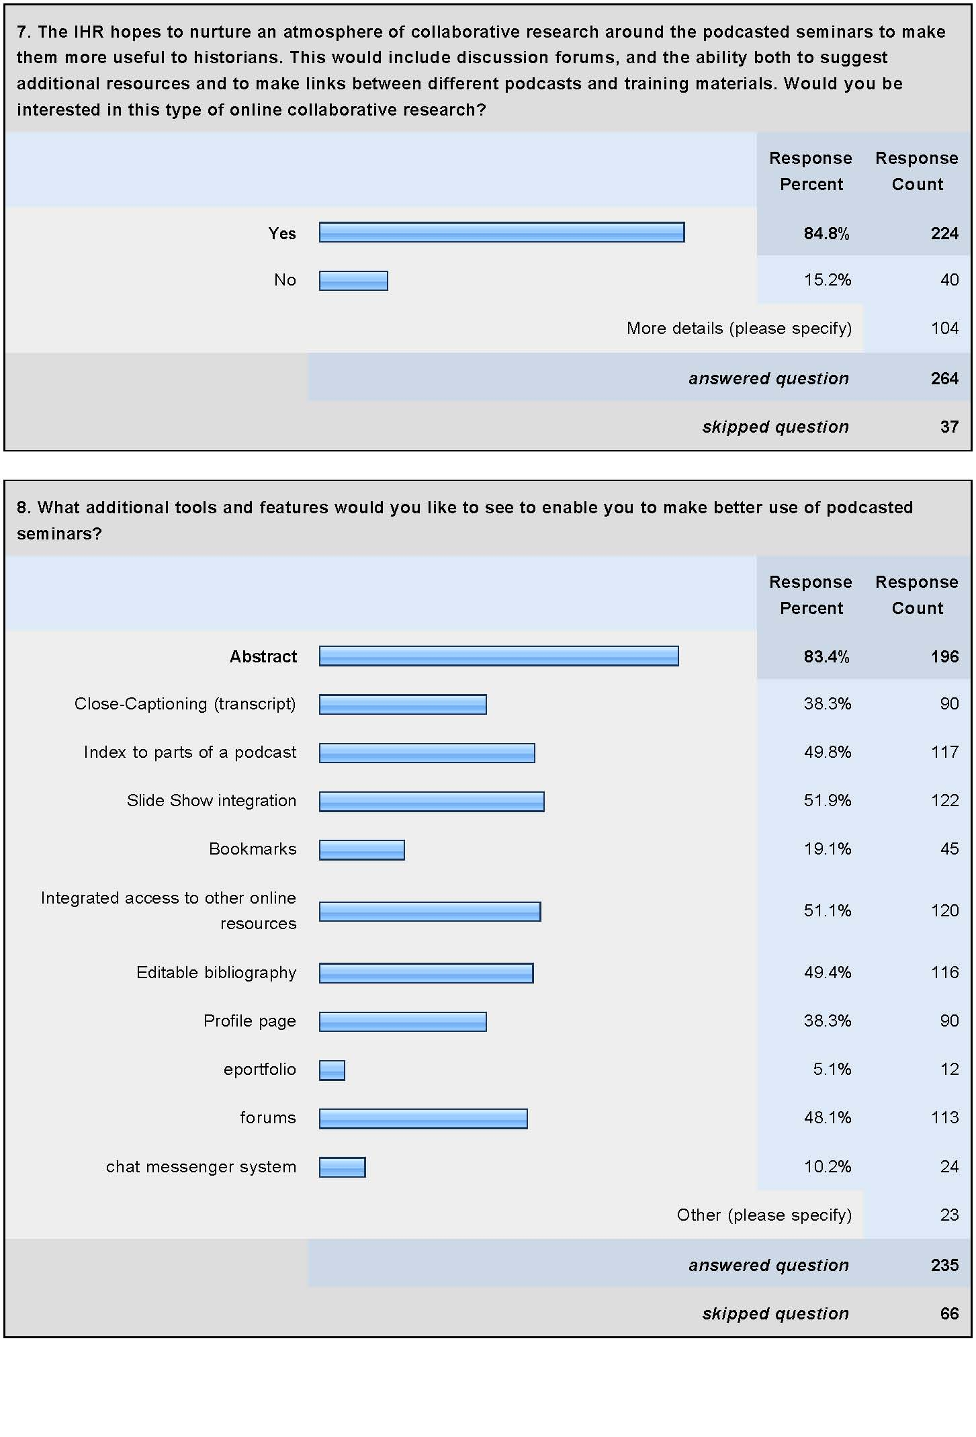
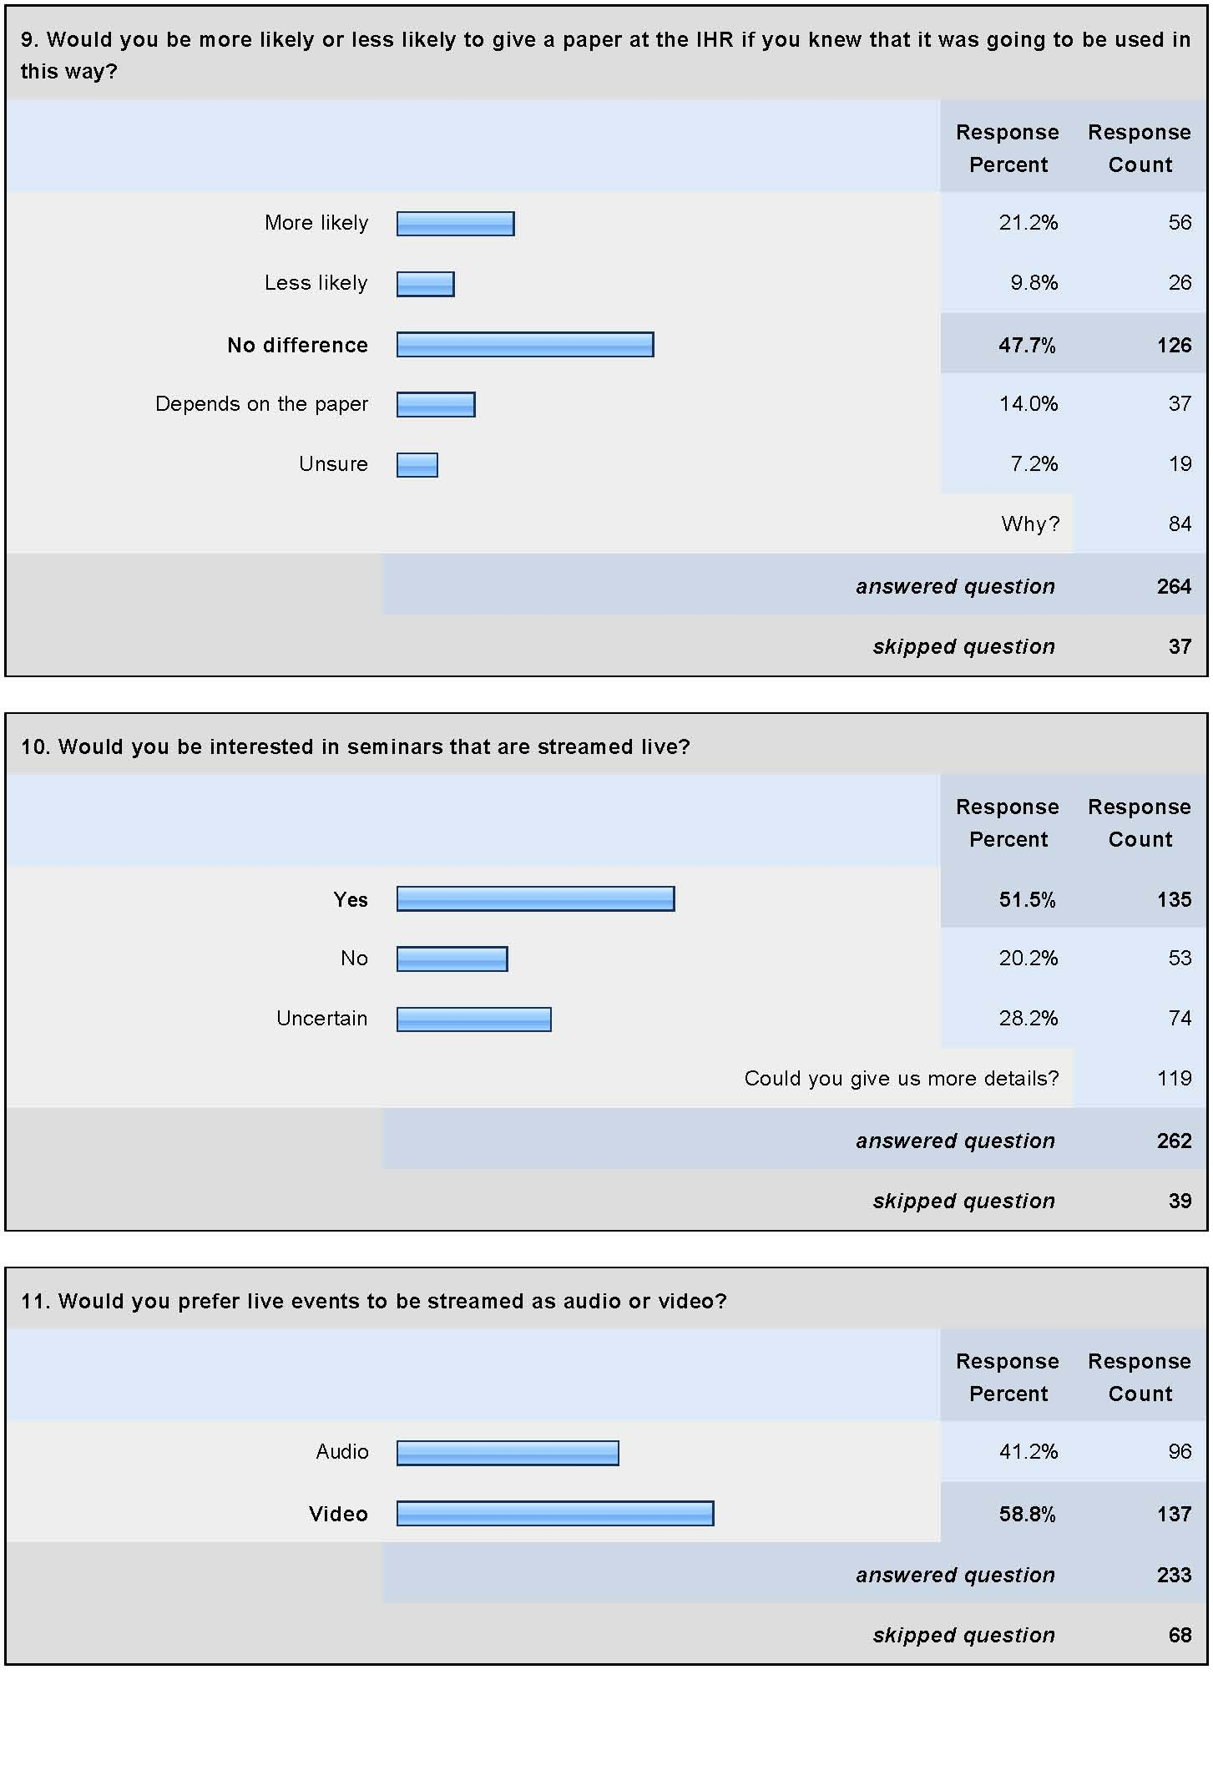
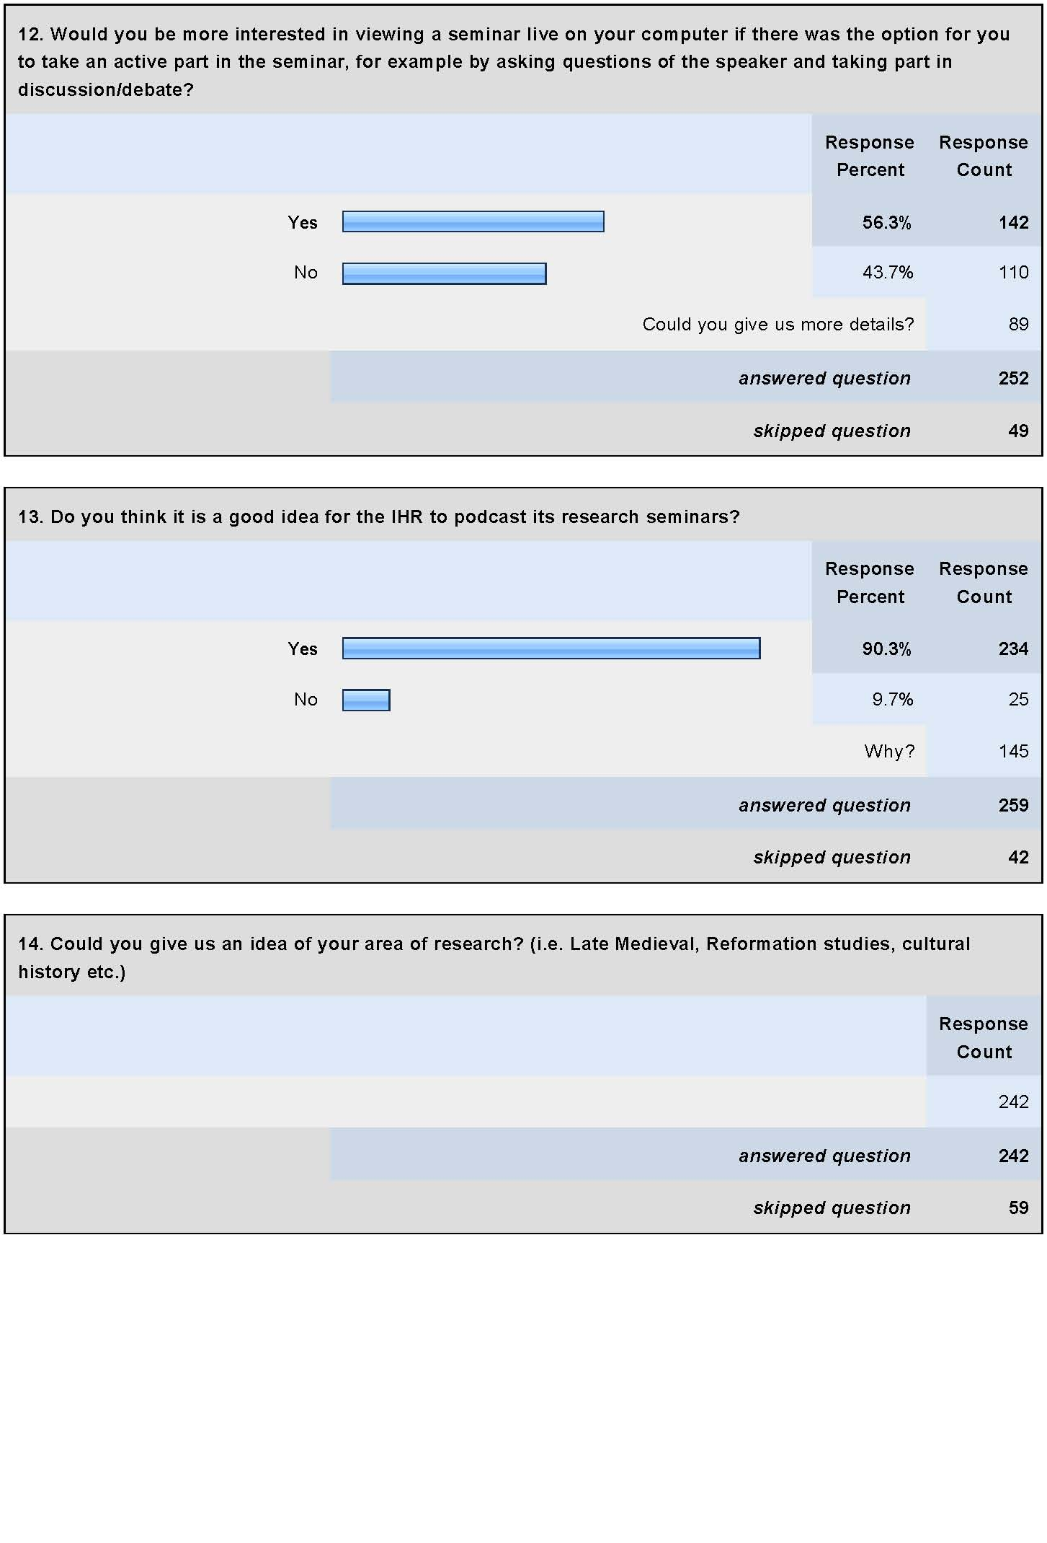
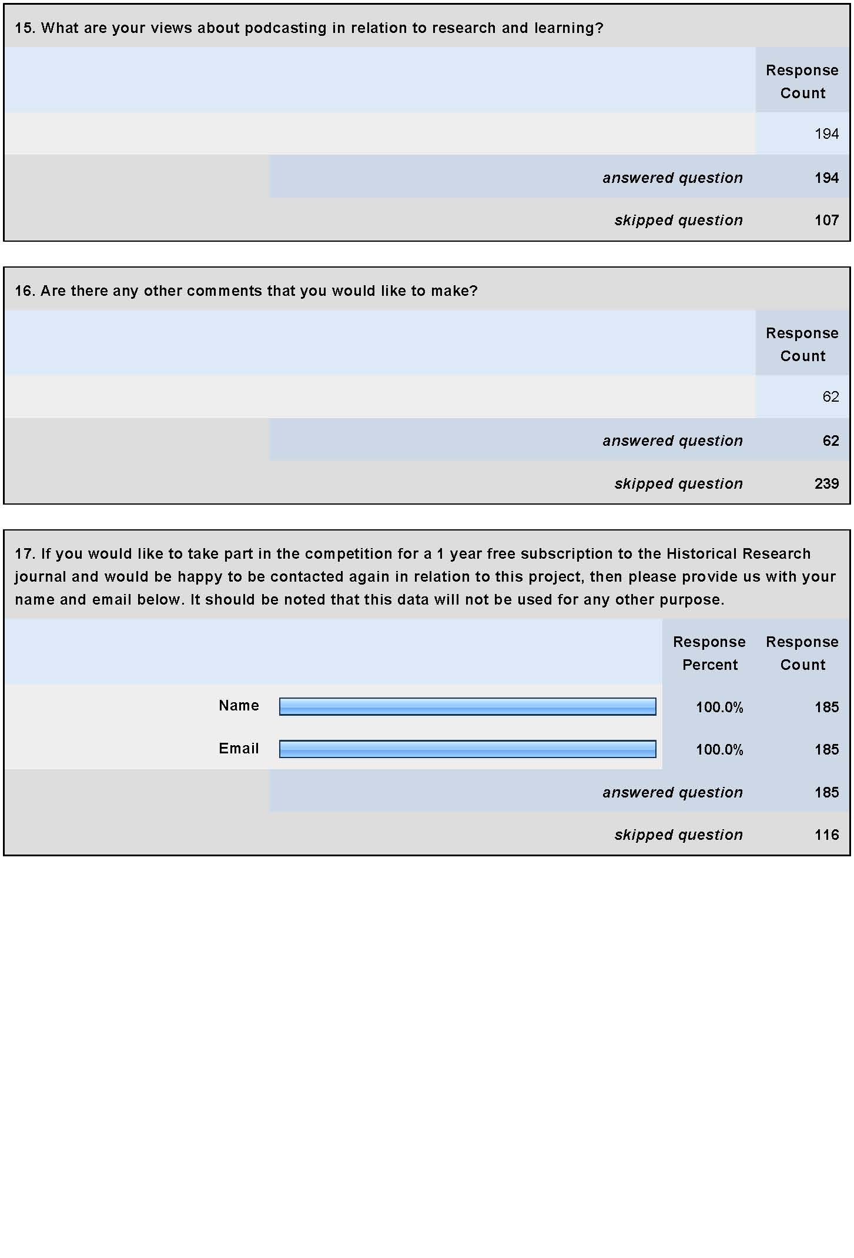

Statistics correct as of Friday 16 July 2010. See http://www.history.ac.uk/digital/podcasts for the podcasts. The Anglo-American Conference 2009 (Cities) and 2010 (Environment) have been edited but not yet placed online. These are, however, forthcoming.
The survey was largely advertised to academic institutions and it is therefore expected that there are relatively few external responses contained in the survey for that reason. Several comments clearly showed that postgraduates, early career academics and established academics are represented in the survey.
We have investigated this issue. It should be sufficient to inform the audience at the beginning of the seminar that the discussion will be recorded. In this scenario there still has to be room for objection after the event in case of embarrassment or error.
This is particularly likely in the case of the e-portfolio. There were several comments stating that they were unclear what this is.
This is an issue that was of concern in the early stages of the HumBox project (an online repository of humanities teaching materials). Slide shows had to be checked for potential copyright infringements and such offending items removed. This could, on occasion, make a presentation bland as most of the images were removed. However, a cursory glance at the HumBox repository (www.humbox.ac.uk) shows that there are a multitude of presentations uploaded there, many of which retain their original integrity. HumBox has taken a very straightforward approach to this issue. Every attempt will be made to avoid copyrighted materials but if any are found they will be removed (or edited) immediately.
Zotero is a FireFox add-on although plans appear to be underway to produce a version compatible with Internet Explorer as well. Inclusion for a website is relatively easy simply requiring a ‘Zotero button’ (a short piece of html code).
The number 42 is derived from the 34 who answered no to both questions with the 8 participants who only answered the first question in the negative.
This sum is calculated by adding up those who answered yes to both questions; those who answered no to the first question but answered yes to the second; and those who answered uncertain to the first question and yes to the second question.
WUN (Worldwide Universities Network), www.wun.ac.uk/.
This question was not asked for podcasts in general which does mean we are lacking some more general information about audio/visual preferences.

