The Archaeology of the Manuscript: Towards Modern Palaeography
Wim Van Mierlo

As students of poetry, we have conceptions of what a poem is; we have notions of what poetic creation is; but do we actually know how a poem comes into being? There certainly is a poetic tradition going back to the Romantics that sees creation as something mysterious, elevated, ungraspable, issuing almost out of nothing. Shelley’s likening of inspiration to a ‘fading coal’ is probably the most famous expression of this. ‘[T]he mind in creation’, he said, is fuelled to ‘transitory brightness’ by an ‘inconstant wind’, the moment of inspiration powering the brain to perceive a sublime glimpse of the uncreated poem. But inspiration is a fickle, uncontrollable power. To capture that potent but momentary glimpse in language is like chasing the wind. And so ‘when composition begins, inspiration is already on the decline’ (Shelley 1977: 503-504). Composition, for Shelley, is inspiration’s poorer cousin.
During composition, a poet is (I imagine) not always fully conscious of the mental, creative and cognitive processes that allow writing to happen. Yet he cannot be fully unconscious of these processes either. Shelley’s idealized notion of inspiration may strike one as rather remote from the actual experience of writing. A modern poet who refined Shelley’s theory is Robert Graves, who divided the creation of poetry into two distinct phases. In the first phase, the poem flickers into being almost subconsciously, as it is ‘rhythmically formed in the poet’s mind, during a trance-like suspension of his normal habits of thought, by the supra-logical reconciliation of conflicting emotional ideas’. The second phase begins when the poet has emotionally ‘dissociated himself from the poem’ and begins ‘testing and correcting’ it ‘on common-sense principles’, transforming the poem-in-the-rough into something that will ‘satisfy public scrutiny’, all the while making sure that ‘nothing of poetic value is lost or impaired’ (Graves 1995: 3-4). Graves thus significantly broadens Shelley’s understanding of inspiration and spreads it across different levels of emotion and experience. What is significant, however, is that inspiration no longer excludes pen and paper, for even in the first stage invention manifests itself directly in writing.
Literary archives allow us to study that writing not only in its finished, but also in its inchoate, embryonic state. The work-in-progress, contained in drafts and manuscripts, offers fruitful insights in the physical processes that underpin its construction. Critique génétique, a theory and practice devoted to studying drafts, analyzes these processes. It emphasizes not the after-life of the work, when the finished text is released to the public, but what comes before: the avant-texte, the text before it is ‘the text’. As a rich, dynamic network of emergent textual components whose development we can study, the avant-texte encompasses all the stages of literary creation (invention, conceptualization, planning and organization, drafting and revision) and the different modes of writing (notetaking, sketching, drafting, revising and correcting) that take place on a variety documents (notebooks, loose leaves, typescripts, page proofs).
As the manuscripts I will discuss in this essay show, the work of the poet involves not only a struggle with language, but also a struggle with paper and ink. Studying the growth of a poem through manuscripts may seem to demystify romantic notions of inspiration. But it cannot completely pass over these notions either. Revision is not only about mechanistic change, or about selecting the right word or expression; it is also about invention. Inspiration does not simply precede, but also happens during composition. Manuscripts are, as Daniel Ferrer observes, the ‘dépôts sédimentaires’ of invention (2011: 53).
Even so, I shall not contend that by looking into the poet’s workshop one gains privileged access to the poet’s mind. The archive does not offer a way to reclaim a process that remains unfathomable perhaps even to the poet himself. Yet if we accept that manuscripts can say something about creativity, we need to learn how to read their signs. Louis Hay’s classic adage - manuscripts have something to tell; it is time we made them speak – is still pertinent (Hay 1996: 207). The question that deserves our attention, therefore, is how do we distil the poet’s vision from his revisions? What the archaeology of the manuscript must investigate is the meaning behind the cancellations, insertions, substitutions and overwritings that are layered across the page.
While coming to terms with the creative origins of poetry (using as case studies manuscripts by Wordsworth, Keats and Wilfred Owen), my purpose with this archaeology is to expand the analysis of literary drafts to incorporate a more detailed palaeographical investigation. One of the main goals of critique génétique is to disentangle the temporal aspects of writing from the ‘undifferentiated’ manuscripts in the archive and via a number of preparatory operations such as ordering, classifying and deciphering distil from them the avant-text (de Biasi 2004: 38). This process, however, depreciates the manuscript’s spatial attributes, its look and appearance. Once the avant-texte is established, and the writing is ‘lifted off’ the page, the physical dimensions of the document are reduced to a one-dimensional text. Some recent work has moved from mere deciphering of the words to analyzing the graphic signs that are indicative of the processes that produced them. Even more so than the actual words and revisions, this palaeographical evidence provides information about the dynamics of composition. The way the hand moves across the page and the variations this produces (quick or slow, straight or slanted, spontaneous or contrived) is indicative of the creative intensity that drives the writing. The flow of the writing, the vigour of the pen, the boldness of the cancellations, the positioning of the writing on the page all inform us about the circumstances in which the writing took place as well as about the characteristic habits (or usus scribendi) of the individual writer (Ferrer 1998: 256). As well as elucidating how the manuscript functions in its own right, this palaeographical information also highlights broader contexts of the biography of the text and the scribal culture that is at work at the time. While critique génétique sees manuscripts as largely private and wholly idiosyncratic productions, writing nonetheless is a cultural phenomenon where specific practices are shared at certain periods in time (Ferrer 1998: 259-60, 265).
What I mean by the archaeology of the manuscript is not something purely metaphorical, but offers a relevant conceptual and methodological perspective on what is essentially a book-historical matter. The challenges that archaeologists face when they interpret the past are similar to those encountered in the palaeographical analysis of modern manuscripts. The fragmentary writing found in drafts, notebooks, fair copies, typescripts and page proofs is similar to the shards of pottery or other remains of human activity uncovered in an archaeological dig. They are our only means of reclaiming the processes of creation from the past. Archaeology and manuscript studies essentially share the same basic hermeneutic problem: how does one begin to understand the evidence without already knowing what it means? Archaeology, therefore, as a discipline cannot function without the support of other specialisms like history, art history, anthropology, geography, geo-physics, and archaeobotany. Likewise, the study of literary drafts is not possible without the context of literary history, biography, genre studies, poetics, literary criticism, publishing history, reception history, paper history and so on. More to the point is that archaeological research and manuscript studies involve a ‘multistranded and multiscalar process’; in other words, it is not enough to create just one interpretation, but to make ‘sense of the data at different spatial and temporal scales’, particularly as the data is complexly diverse, illusive and frequently conflicting (Hodder 1999: 43, 78, 99). What defines archaeological research are the ‘dynamic, dialectical, unstable relations between objects, contexts and interpretations’ (Hodder 1999: 84); with manuscripts, too, we need to recognize the variable relations between the physical documents, the contexts of their production and the interpretations of the textual and graphic signs. Only by connecting and comparing the evidence can we begin to make sense of what is in front of us.
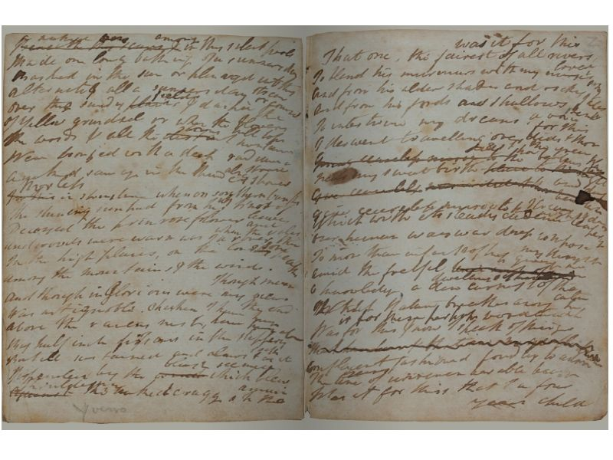
Figure 1: William Wordsworth, The Prelude, MS JJ, ff. Y^{v}-Z^{r} [ff. 90^{v}-91^{r} in DC MS 19]. Reproduction by kind permission of The Wordsworth Trust.

Beginning The Prelude
I want to begin elucidating these ideas by looking at the beginnings of William Wordsworth’s The Prelude in MS JJ (Figure 1), which is itself a part of Dove Cottage MS 19 (one of four notebooks that William and his sister Dorothy purchased at 1s each in preparation for their extended stay in Germany in 1798), and which contains the now-famous opening lines: ‘was it for this | That one, the fairest of all rivers loved | To blend his murmurs with my nurse’s song’ (f.Z^{r}) (1977: 115). These lines, however, pose a particular problem. They occur towards the back of the notebook from which the writing seems to proceed backwards, from the recto onto the corresponding verso and continuing from there onto the preceding pages. Most scholars consider ‘was it for this’ to be the ‘origin’ of Wordsworth’s great poem on the growth of the poet’s mind, even though when he wrote these lines in late autumn 1789 it cannot have been clear even to him what would come from them fifty years hence.
But are they really the beginning? The evidence is not entirely conclusive. DC MS19 already contained many other bits of writing composed after Wordsworth had arrived in Goslar. To start a new poem he not only needed unused space, but also a place that he could easily return to without having to leaf through the whole notebook. The final 11 leaves of the notebook offered that space. Apart from that the precise sequence remains elusive. Scholars have established that the order of inscription generally moves inwards away from the back in five different stages; within these stages the direction of writing moves mostly forwards, ‘in a zigzag fashion’. Sometimes Wordsworth turned the notebook sideways because the width of the page better accommodated the length of his lines; sometimes, too, he wrote down short sections out of sequence with the rest (1977: 3).
Why did Wordsworth make work so difficult for himself? Why didn’t he turn his notebook upside down and proceed forwards? This would have made the process simpler and more intuitive – moreover, he had done it elsewhere already. Could it not be that there is no order at all?
While emphasis in recent scholarship has certainly shifted away from a ‘retrospective perspective’ on the ‘two-part’ Prelude towards a view that the poem grew from ‘a loosely connected sequence of fragmentary blocks of writing’, the assumption remains that ‘was it for this’ was the beginning. The reasoning for this, however, was derived not from evidence in MS JJ, but from the order of the poem in two later fair copies: MS V, a copy which Dorothy produced with the assistance of her brother, and MS U, a duplicate copy by Mary Hutchinson, both of which open with ‘Was it for this’. The order of poem in these manuscripts is used to ‘reconstruct’ the five-stage sequence in the earlier draft. The sequence in the fair copies, however, was the result of a further creative act by Wordsworth that intervened between MS JJ and the later manuscripts.

Linearity and Revision
Writing is inevitably a linear activity; it purposely moves forward towards the completion of the text. But the operative words forward, purpose, and completion are not as self-evident as they appear. Just as origins are difficult to recover, the end the writer strives towards does not predetermine the course by which that end is reached. The composition process, and the trajectory it follows, is marked as much by deviation and indeterminacy as by straight, progressive development.
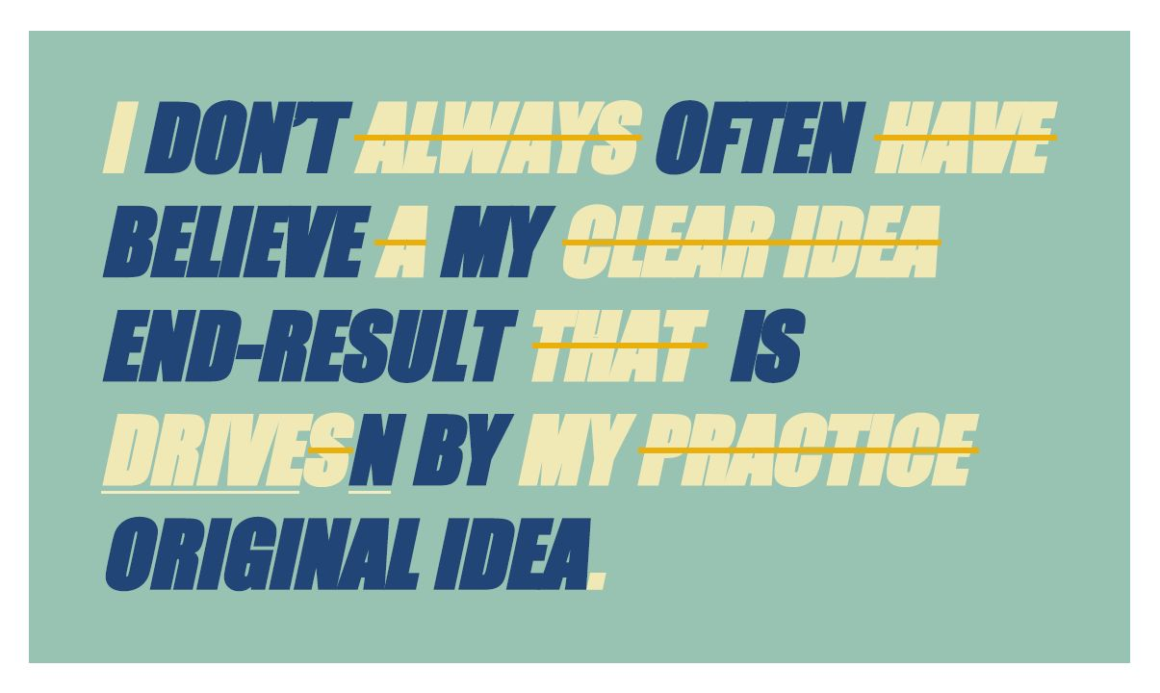
Figure 2: Anne Charnock, ‘Uncertainty Series No.1’. Reproduction by kind permission of the artist.
To take these ideas forward – of beginnings, linearity and process, and purpose – I want to look at the Certainty Suspended project of the Manchester artist Anne Charnock, a series of ‘work art’ canvases inspired by the ‘track changes’ function in Microsoft Word (Figure 2). These works visualize the processes of revision that operate in artistic creation, showing writing as something that is layered and tentative, rather than settled and definite. For Charnock, the intertwining of contradictory sentences gives ‘solidity to her own meandering thoughts and uncertainties’ (2006: n.p.). The example I have chosen, ‘Uncertainty Series No. 1’, specifically presents the idea of prevarication that underlies the process of revision. Between the first statement – ‘I always have a clear idea that drives my practice’ – and the revised statement – ‘I don’t often believe my end-result is driven by my original idea’ – lies a movement that captures the transition from confidence to equivocalness through seemingly unpremeditated discovery. The truth about creation as a process is expressed as much by the revised statement as by the act of revision. And thus, perhaps paradoxically, the original statement, though placed sous rature, remains legible and does not entirely lose its value. This is the double existence of the cancellation, its ‘loss and gain’, ‘emptiness and fullness’, ‘forgetfulness and recollection’ (Grésillon 2008: 88). While the original statement has been negated, it has not lost meaning. Hence it remains (or becomes) possible to read the revised statement in relation to the original from whence it came. It is that connection between the two – that present absence – that gives ‘solidity’ to the uncertainty.
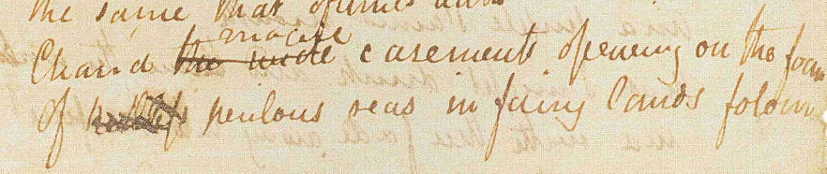
Figure 3: Detail of John Keats, autograph manuscript, ‘Ode to the Nightingale’, Fitzwilliam Museum, MS 1-1933, reproduced by permission of the Syndics of The Fitzwilliam Museum, Cambridge
Charnock thus consciously emulates what for any writer is an ordinary experience. Her aesthetics of revision evokes schematically what happens more intricately in a draft. Take, for example, the revisions that Keats made in the autograph manuscript of ‘Ode to a Nightingale’ (Figure 3, see also Hebron 2009, 138). The changes that Keats introduced are minor, but they add subtle depth to the poem, such as for example the change in the seventh stanza from ‘the wide windows opening on the foam’ to ‘the magic casements’. The windows, after all, are not real but imagined windows, recollected from an auditory vision of the nightingale’s song in ‘fairy lands forlorn’ (Keats 1978: 371). The change is clearly a reasoned change, but not all revisions are like this. Keats’s rapid, almost desultory change of ‘keelless’ into ‘perilous’ in the final line of the penultimate stanza is undoubtedly of a different order. This currente calamo revision happened almost without interruption, for ‘keelless’ seems hardly a fitting adjective for the sea. ‘Perilous’ is very much le mot juste.
What is interesting in Keats’s dynamic of revision is not the choice of words, but the process of choosing, and the fact that we can practically observe Keats’s mind tripping up. Apart from revealing the history of the text’s composition, manuscripts also tell us a good deal about method and craft, about aims, intentions and poetics, about the history and sociology of the text. Keats changing ‘keelless’ to ‘perilous’ may still be a rather unrevealing example, but if we turn to the revisions effected in the opening of the poem a more intricate process emerges (see Hebron 2009, 138).
While Keats’s changes are not substantial, their sequence is not immediately apparent. What is fairly certain is that the change from ‘painful’ to ‘drowsy’, although doubtless an improvement, comes as a result of altering ‘falls’ to ‘pains’. But how did this come to pass? Are we to imagine that Keats held a poem in his mind that began with an irregular abcb rhyme scheme – an irregularity that he removed by adding ‘pains’ so that it pairs with ‘drains’? Somehow this seems unlikely. So is it that he revised the first line currente calamo before composing the next? In this case, ‘pains’ existed before ‘drains’, which implies that the third line was an invention on the fly. Whatever line the poet first had in mind it must have rhymed with ‘falls’. Or is it rather that he invented the third line on the fly, discarding whatever originally he had in mind, which then necessitated correcting the opening rhyme word? The second scenario seems the more likely one, because the syntax joining up lines 1 and 2 works properly with ‘pains | My sense’, but not with ‘falls | My sense’ and because the placement of the final word, ‘drunk’, dips slightly below the base of the line, indicating that it was written after ‘pains’ above. Even if Keats largely composed in his head, invention and revision are not completely separate activities. Made almost without premeditation, his revisions are certainly not those of a poet merely tinkering with his text.

Protocols
We tend to see poets mainly as Kopfarbeiter who think their poems into existence before committing them to paper. But, as Keats’s example shows, poems do not always spring whole from the mind of the poet. It may be that the Papierarbeiter – poets for whom invention happens mostly in the course of writing – are a much more dominant category. Simon Armitage, in his opening address of the 2011 T.S. Eliot International Summer School in London, neatly expressed the idea of working over the poem as ‘pushing words around on a piece of paper’. A kind of poetic jamming, one might say. In the popular imagination, the poet ‘slogging away’ at his desk may not be a common image, and yet enough accounts exist to indicate that this is what happens. Keats lamented that he sometimes wrote for eight hours a day without producing as much as a single poem (1970: 12). Sylvia Plath similarly reported that she and her husband Ted Hughes forced themselves into a routine of ‘several hours work of solid writing a day’, but submitted that their output was always going to be small, often no more than one ‘good poem apiece’ (1975: 259).
Ted Hughes is indeed a very good case in point. His poetics ascribe an almost shamanistic role to the poet, but this role is contravened by his practice. Anyone who has looked at his archive, the sheer volume of extant manuscripts apart, knows from the way in which he completes draft after endless draft that he is a poet who needs the page for his poems to come into being.
With this in mind, we need to look more fundamentally at the issue of temporality and the issue of finality. With Charnock’s text art, as with Keats’s revisions, there clearly is a before and an after. Composition is not (just) about creating a perfect form, not even about executing a plan. It is rather about developing a plan, trying to execute it and adjusting it along the way as better ideas present themselves. All the while, the final poem remains a vague and elusive ambition, accomplished only through trial and error.
The process of writing, however, as Charnock illuminates, is also procedural, which leads Ferrer to state that a draft, rather than being a text, is ‘a protocol for making a text’ (1998: 261). Defining manuscripts in this way, is useful theoretically: it reflects the psychological and cognitive dimensions of the act of creation as well as its constructivist aspects. But it also puts a limit on the phenomenology of the manuscript, as it emphasizes the ‘now’ of writing, rather than the ‘then’ of the archival dossier; it is in danger too, perhaps, of privileging mechanics over invention. In its most essential form, writing indeed follows a protocol that can be parsed as ‘write “keelless”; strike out and replace with “perilous”’.
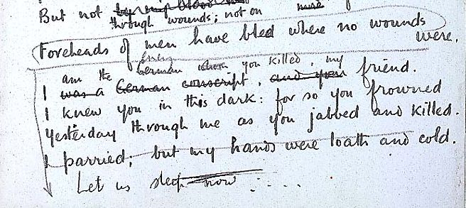Figure 4: Detail of Wilfred Owen, autograph manuscript, ‘Strange Meeting’, British Library Add. MS 43,720, f.4, reproduced from The Great War Archive, University of Oxford, <http://www.oucs.ox.ac.uk/ww1lit/collections/document/5202/4588 >.
Protocols like this are commonly found in composition. The final draft of Wilfred Owen’s ‘Strange Meeting’, a fairly tidy draft that looks close to finished, is a good example (Figure 4). After Owen brought the poem to near-completion, the idea for a structural improvement, which would increase the emotional tension in the poem, presented itself to him. Using a downward-pointing arrow, he indicated that ‘Foreheads of men have bled where no wounds were’ ought to be moved to the end, making the poem now less complete. The penultimate stanza is one line short and the rhyme scheme, even if the initial plan had been simply to shuffle all verses up by one line, has become irregular requiring further work to restore the balance. Besides the need for further revision, Owen’s instruction is not without ambiguity either: did he intend to move the line to below the half line ‘Let us sleep now’ (which itself may not have been final), or did he mean to replace ‘I parried; but my hands were loath and cold’ with ‘Foreheads of men’? Since Owen never carried out his instruction, it is not clear how he wanted to finish the poem.
Creation, in other words, does not happen according to a few binary operations, but through a series of simultaneous, multi-relational switches, some of which are visible in the archival dossier and some invisible. The mind in creation does not always strictly adhere to protocols. This pluriformity obviously creates practical difficulties for reconstructing the sequence of inscription, but it also highlights the spatial dimension of the manuscript through which the temporality of composition must be approached. Here again the analogy with archaeology is useful: just as individual artefacts found in a dig must be linked to other finds and contexts, the relations between the elements on the manuscript page, and the relation of that page to other pages and documents, must be established and understood. Those relationships can – and must be – sequential, but they can and will also be radial; writing often radiates out at different levels and in different directions simultaneously.
A true archaeology of the manuscript requires, therefore, something of a holistic approach. It is an examination not just of writing or the moments of inscription on the page, but also of the psychical aspects of the document on which the writing happens (is it a notebook or piece of scrap paper? is it large and spacious or small and compact?) and of the writing tools used: a quill, steel pen, pencil, fountain pen, ball-point pen or typewriter. These material objects form very much part of the ‘textual experience’ and the circumstances in which the poet composes his work. Pen and paper are not neutral in the writing; they can stimulate or inhibit, and thus determine the rhythm of composition, and the shape of what is being written. The clues for this are mostly subtle, but they are there, in the flow of the handwriting, the way the writing fills the page, the manner in which the page is turned, the appearance of the cancellations, and the way sections of the text are integrated or separated, and so on.

A Modern Palaeography
With this idea of a holistic approach in mind, I want to return to the so-called beginning of Wordsworth’s Prelude and put my archaeological analysis into practice. I want to claim that ‘was it for this’ were not the first words that Wordsworth wrote of his poem. On the basis of palaeographical evidence and an awareness of manuscript culture at the turn of the eighteenth century, there are at least three reasons to consider.
1. The primacy of sequentiality. If for whatever reason the normal sequential progression of writing is compromised, because for example the writer begins to re-order what he has written or because he uses open spaces in an otherwise already well-used manuscript, one expects there to be some system with numbers or diacritics that allow the writer afterwards to reconstruct the sequence he has created. Given that this is absent in Wordsworth’s copybook, and given that we have no evidence of an unambiguous textual or syntactical sequence either, it is likely that the writing did not proceed linearly, but segmentally – a mode of writing in batches which A.C. Swinburne called writing in ‘parcels’ (1918: 171).
2. The principle of economy. Comfort and efficiency dictate how the writer uses his paper, regardless of whether the support is a set of tiny scraps of paper or a large copybook. The choice of support or writing base depends on the writer’s preferences and the circumstances under which he works. Keats’s manuscript of ‘Ode to a Nightingale’, written at Hampstead on two half leaves of reasonably small size (20.5 x 12 cm), presupposes in-door use, which contrasts with Wordsworth using a compact notebook for the earliest draft of The Prelude; since he was travelling, portability was essential. The size (15 x 9.5 cm) put constraints on the need for expansion (an innate characteristic of the creative impulse). To alleviate this restriction somewhat Wordsworth frequently turns his notebook sideways and, most importantly, knowing it was going to be an extended work, began his new poem using the empty pages at the back. It would surely have been easier if had turned the notebook upside and inscribed the poem forwards. That he did not do this is another indication that the poem was written in batches.
3. The logic of space works at the micro-level too. One can clearly observe that ‘was it for this’ was written first (in other words, it is not an insertion crammed above the top line); one also sees that Wordsworth deliberately left a blank half-line and that he did not capitalize ‘was’. This suggests that ‘was it for this’ is a continuation of something, though it has no discernible antecedent. It can be inferred, therefore, that the clause was intended to continue a section not yet written.
Further examination of the spatial distribution of the draft indicates, too, that the embryo of the Prelude is fragmentary rather than a single sequence inscribed in an unusual order. The handwriting is not always of equal quality: some sections are clearly rough draft, in pencil or ink; others are fair copied in ink. Just half of the sections in the draft run across a page break, while the others are discrete units contained on a single page. On three pages Wordsworth drew a horizontal line that divides the text above from that below; in two instances (W^{v} and X^{v}), the writing was already separated by a blank space; in the other instance (S^{v}), the line runs through the writing and separates what was initially one unit, all of this showing that Wordsworth treated his text flexibly. Other pages end with space left unused at the bottom (R^{r}, T^{v} ) or end with an unfinished verse line (f. T^{r}). Finally, f. Z^{v} contains five fragments – each beginning mid-way down the line with a non-capitalized word – with additional verses in ink and pencil on the inside back cover alongside it. These fragments are routinely ignored by scholars or cast aside as ‘preamble drafts’ (Parrish in Wordsworth 1977: 8). While they are connected associatively (the first fragment, ‘a gentle [?], a mild creative breeze | a vital breeze that passes gently on | O[’]er things it has made’, connects with the next, ‘A tempest[,] a redundant energy […] disturbing things created’, and so on), they are discrete entries.
Adding up the evidence, one can only conclude that the composition of MS JJ was discontinuous, that it was done in ‘parcels’. Which section of the poem might have preceded which is now practically impossible to determine. What we have, though, is an origin for The Prelude that has no stable beginning. Out of this origin Wordsworth distils a more complete version (in manuscripts V and U) by shoring together the fragments from the notebook. Recognizing the disjointed nature of the manuscript gives us a better sense of the mind in creation. The handful of fragments that Wordsworth compiled is particularly significant because they nearly express his poetics at the time. The imagery, too, is disjointed, conflicting, not yet fully articulated; the ‘creative breeze’ is simultaneously ‘mild’ and ‘vital’, tempestuous and ‘redundant’, creative but not yet creating. The idea that the creative force is passive, but not without influence - as expressed by ‘Creating not but as it may | disturbing things created’ - is an echo of the famous core of Tintern Abbey, written just six months before: the ‘gleams of half-extinguished thought’ that stimulate the senses into ‘what they half create | and what perceive’ (Wordsworth 1965: 109-10). At the same time, this creative force connects with the frequent occurrence of the ‘spirit’ in MS JJ, in particular the lines ‘the eternal spirit, he that has | His life in unimaginable things’ and he that paints ‘The visible imagery of all the worlds’ (U^{r}). The spirit’s ‘bounteous power’ is what permits Wordsworth’s vision.
Whether these fragments are afterthoughts or forethoughts is impossible to say. What is certain is that they resonate with the themes of his poem on the growth of the poetic mind. Their inarticulated state approximates the moment of invention, even though for the poet himself they would not be of practical use until 1804, when Wordsworth integrated them into the ‘glad preamble’ of The Prelude. All of this puts ‘was it for this’ in a different perspective, which rather than being a point of departure was a fortuitous discovery that produced a segment felicitous enough to be promoted – at least temporally – to an incipit at the next level.

Conclusion
More is to be said about this manuscript, and all the others I have discussed. By way of conclusion, I want to reiterate that manuscripts, just like archaeological artifacts, serve as windows into the past and into the dark room of the poet’s creativity and invention. Manuscripts, however, are more than texts in creation; they are material objects whose physical features and what they mean for the creative process need to be understood as well. The blots and blemishes, the undulating lines and variable scripts, the manner in which the writing occupies the page tell as much a story about invention and revision as the transitory words themselves. Understanding these features might well lead to an essential question for the archaeology of the manuscript. Why does a manuscript look the way it does? The manuscript’s graphic signs, the dynamic layering of the writing, are at the same time an obstacle and a clue to the interpretation of its genesis. With time itself absent, the spatial dimensions of the draft require translating into the temporal sequence of writing. But the two dimensions of the textual palimpsest alone are not sufficient. Manuscripts are organic wholes. Their components are relational that need to be treated holistically. To do so is to come to terms with the manuscripts’ inner logic, how they function within the creative process, and how they reflect and contribute to the manuscript culture of their time.
The archaeology of the manuscript belongs, therefore, to what D.F. McKenzie called the ‘sociology of texts’ (1999: 13). Where McKenzie considered the processes of textual production to be the history of the text’s ‘after-life’ and the way the text was controlled by agencies other than the author - from typesetter to book designer, from publisher to bookseller - I see the ‘pre-history’ of the text moving in the other direction, away from the finished text to the processes that created it. A palaeography of modern manuscripts must occupy itself with the graphic minutiae of handwriting and composition in order to give meaning to the genesis of the work and the creative energies that inspired it. But it must also embed that meaning in as broad and varied a context as possible, from the very individual and idiosyncratic writing processes to the cultural determinants that shaped it. Just as archaeology must reclaim the past from the stratified layers of a dig, modern palaeography has to come to terms with the habits and customs that lie behind the scrawls on the page and the culture that produced them in the first place.

List of References
2006. Anne Charnock and Chris Clark. Cornerhouse Projects. [Online]. Available at:
http://www.cornerhouse.org/art/art-exhibitions/anne-charnock-and-chris-clarke
[accessed 4 February 2012].
Cowton, J. and Bushel, S. (eds) n.d. From Goslar to Grasmere – William Wordsworth:
Electronic Manuscripts. Grasmere: The Wordsworth Trust; Lancaster:
Department of English and Creative Writing, University of Lancaster. [Online]
Available at:
http://collections.wordsworth.org.uk/GtoG/home.asp?page=FrontPage [accessed
4 February 2010].
De Biasi, P.-M. 2004. Toward a science of literature: Manuscript analysis and the genesis of the work, in Genetic Criticism: Texts and Avant-textes, edited by J.
Deppman et al. Philadelphia: University of Pennsylvania Press, 36-68.
Derrida, J. 1997. Of Grammatology, translated by Gayatri Chakravorty Spivak.
Baltimore: Johns Hopkins University Press.
Ferrer, D. 1998. The open space of the draft page: James Joyce and modern
manuscripts, in The Iconic Page in Manuscript, Print, and Digital Culture,
edited by G. Bornstein and T. Tinkle. Ann Arbor: University of Michigan Press,
249-68.
Ferrer, D. 2011. Logiques de brouillon: Modèles pour une critique génétique. Paris:
Éditions du Seuil.
Ford, N.F. 1952. Keats’s romantic seas: ‘Ruthless’ or ‘Keelless’? Keats-Shelley
Journal, 1, 11-22.
Graves, R. 1995. Collected Writings on Poetry, edited by P. O’Prey. Manchester:
Carcanet Press; Paris: Alyscamp Press.
Grésillon, A. 2008. La mise en œuvre: Itinéraires génétiques. Paris: CNRS Éditions.
Hay, L. 1996. History or genesis? Yale French Studies, 89, 191–207.
Hay, L. 2009. Réflexions sur la discipline, in Critique génétique: Concepts, méthodes,
outils, edited by O. Anokhina and S. Pétillon. n.p.: Imec éditeur, 21-31.
Hebron, S. 2009. John Keats: A Poet and His Manuscripts. London: British Library.
Hodder, I. 1999. The Archaeological Process: An Introduction. Oxford: Blackwell.
Keats, J. 1970. Letters of John Keats, edited by R. Gittings. Oxford: Oxford University
Press.
Keats, J. 1978. The Poems of John Keats, edited by J. Stillinger. Cambridge, Mass.: The
Belknapp Press of Harvard University Press.
McKenzie, D.F. 1999. Bibliography and the Sociology of Texts. Cambridge: Cambridge
University Press.
Plachta, B. 1997. Editionswissenschaft: Eine Einführung in Methode und Praxis der
Edition neuerer Texte. Stuttgart: Reclam.
Plath, S. 1975. Letters Home: Correspondence 1950-1963, edited by A. Plath. London:
Faber and Faber.
Ridley, M.R. 1933. Keats’ Craftsmanship: A Study in Poetic Development. Oxford:
Clarendon Press.
Shelley, P.B. 1977. Shelley’s Poetry and Prose: Authoritative Texts, Criticism, edited
by D.H. Reiman and S.B. Powers. New York: Norton.
Sidney, C. 1903. A morning’s work in Hampstead Heath. Monthly Review, 10, 130-41.
Swinburne, A.C. 1918. The Letters of Algernon Charles Swinburne, edited by E. Gosse
and T.J. Wise. London: William Heinemann.
Wellek, R. and Warren, A. 1973. Theory of Literature. Harmondsworth: Penguin
Books.
Wordsworth, W. 1965. Selected Poems and Prefaces, edited by J. Stillinger. Boston:
Houghton Mifflin.
Wordsworth, W. 1977. The Prelude, 1798-1799, edited by S.M. Parrish. Ithaca: Cornell
University Press; Hassocks, Suss.: Harvester Press.
Wu, D. 2002. Wordsworth: An Inner Life. Oxford: Blackwell.

I allude here to the misguided case that René Wellek and Austin Warren build using Keats’s ‘Ode to a Nightingale’ to dismiss ‘genetic’ study (1973: 90-91).
‘sedimenterary deposits’.
The ‘avant-texte’ is therefore not an archival source, but a construct.
These ‘signes graphiques’ include not only ‘lettres et mots’, but also ‘ratures, marques de positions (renvois, insertions, déplacements), symbols, sigles, dessins’ and other genetic operations (Hay 2009: 23).
Hodder’s discussion of how archaeologists interpret contains important insights for students of manuscripts. See in particular his treatment of ‘pre-understanding’ and the hermeneutic circle (1999: 49-51) and passim.
The five stages correspond to (1) ff. X^{v} to Z^{r}; (2) V^{r} to X^{r}; (3) U^{r} to V^{r}; (4) R^{r} to T^{v}; (5) P^{r} to Q^{v}. See ‘Prelude MS JJ: Spatial and Physical Order of Entry’, From Goslar to Grasmere, http://collections.wordsworth.org.uk/GtoG/home.asp?page=MSJJ1bOrderofEntry.
For the precise sequence, see ‘Stephen Parrish Transcription on MS JJ’ in Cowton and Bushell (n.d.).
The notebook had already been turned upside down once, beginning on f. 71, which contains an essay on moral philosophy and notes on German grammar.
‘Understanding MS JJ in Context’, From Goslar to Grasmere, http://collections.wordsworth.org.uk/GtoG/home.asp?page=MSJJInContext1.
‘[T]he reading text of JJ presents a plausible order, and one that may for a number of reasons seem the likeliest’ (Parrish in Wordsworth 1977: 5). Duncan Wu acknowledges that the vignettes in MS JJ ‘were still not thought of as part of the same work’, and for this reason believes it is a mistake to call MS JJ ‘an early version of The Prelude’ (2002: 122-3).
See also 90-91. The Derridean notion of placing text (or sign) ‘under erasure’ to which I allude appears pertinent for Charnock’s revisionist art. Playing on the absent presence of the erasure, she undermines any sense of absolutist meaning by insisting on the inherent, inescapable doubleness of her statement. Grésillon obviously refers to the same tension. For Derrida, the erasure is as much a non-metaphysics as a technique to criticize metaphysics. His generally anti-historicist philosophy, however, which denies the possibility of origins and originarity, is at odds with archival and indeed archaeological investigations which are preoccupied with the before/after of origins and original materials rather than their presence/absence. See Of Grammatology (1997: 61) as well Gayatra Spivak’s introduction (1997: xvii-xviii, lxxx and passim).
First suggested in 1903 when the manuscript came to light, ‘keelless’ has been the accepted reading. See Colvin Sidney (1903: 140). Later scholars thought they recognized a third adjective written on top of ‘keelless’, of which ‘ruthless’, derived from Woodhouse’s shorthand transcription, is the most widely accepted (Ridley 1933: 230). There is, however, no third adjective; the shape of Keats’s cancellations merely creates an appearance of additional letter forms.
For ‘keelless’, Newell F. Ford also offers ships that do not show their keel because of calm seas – in which case the negative meaning of the later ‘perilous’ reverses the originally positive connotation (1952: 13-14). The term ‘currente calamo’ literally means with a running pen, and signifies a revision made on the fly without much premeditation.
On this distinction, see Plachta (1997: 46-58).
‘I Have written some fresh parcels of my “Tristram and Iseult” and hope to grapple with it steadily before long’ (Swinburne 1918: 171).
Several critics have pointed to the parallels between Tintern Abbey and the ‘two-part’ Prelude; see, among others, Duncan Wu (2002: 108).
See Wu (2002: 193-4).
McKenzie’s ‘after life’ and my ‘pre-history’ sit at opposite sides of the spectrum, the one concerned with transmission and reception, the other with composition and production of the text. See Bibliography and the Sociology of Texts (1999).

