‘Gratie ende Bevalligheydt: The Concept of Grace in Dutch Art Literature’
Student No. 1442449
_
MA Art History, Curatorship & Renaissance Culture
Master’s Dissertation
_
25 September 2015
Warburg Institute

Contents
Introduction 3
Chapter I Graceful terms 5
Chapter II Attempts at definition 10
Chapter III Graceful behaviour 14
Chapter IV The body and the soul 18
Chapter V Graceful genre(s) 24
Chapter VI Graceful manner 30
Chapter VII Graceful colour 34
Conclusion 37
Bibliography 39
Appendix – Images 42

Gratie ende Bevalligheydt:
The Concept of Grace in Dutch Art Literature
The rich body of art theory and art criticism from the Low Countries has long been neglected by art historical scholarship. In comparison to other European writings, it was not only thought to be negligible in terms of quantitative output, but also found wanting in terms of originality of ideas - and thus insignificant to the history of art. In the past few decades this unfounded underestimation of a vast tradition of Dutch art literature was finally recognised and slowly reversed, paying due attention to the ample amount of works that exist in both the native Dutch as well as in the humanist Latin. As such, a simultaneous initiative inspired art historical scholarship to study the vernacular vocabulary of these texts in order to pinpoint terms and concepts shrouded in a veil of mystery. This trend has been crucial to the understanding of Dutch art; by resurrecting the meanings of the artistic jargon of a period - particularly if one pays close attention to the specific contexts in which words were employed and to which specific artists, works of art, or qualities of works of art, they were applied - one can gain some unusual insights into both the aesthetic priorities of the artists and the appreciations of the audience of the time. Thus far, words such as houding, vlak, fraey, aerdigh and schilderachtig have already been subjected to close scrutiny. Yet it has been expressed multiple times that there is no doubt that much work still needs to be done on the vocabulary of art in the Netherlands, more specifically on (subjective) terms used to describe works of art which are not specific to artistic contexts. One such term is grace, which was originally used by classical rhetors such as Cicero and Quintilian and reintroduced in the Italian Renaissance, where it assumed a place that it had not enjoyed previously. The most significant development was initiated by Baldassare Castiglione, who embedded the term in the world of courtly etiquette with his famous work Il Cortegiano – an act which greatly popularised the idea of grace as elegant speech, movement and conduct, connotations which are still associated with it in present times. It was Giorgio Vasari who derived directly from Castiglione’s ideas on grace and applied them explicitly to the visual arts, borrowing the term for lack of a proper artistic vocabulary. In the hands of these two historical figures, among many other Renaissance writers, the classical term fared well in Italy’s rather theoretic and philosophical aesthetic climate, which equalled grace to divine perfection. Yet art historical scholarship has hardly ever considered how the term functioned in the somewhat more down-to-earth, practical Dutch artistic tradition that was only ever partially influenced by classicist ideas. In one of the often neglected works of Dutch art criticism, Het Gulden Cabinet of 1662, Cornelis de Bie refers to a Franciscus du Chatel from Brussels who painted ‘Boere-kerremissen, wacht-huysen en soo danighe op de manier van Adriaen Brouwer, en andere hier voor verhaelt, allen het welck met een goedt oordeel ende manier…midts dien de selve is overloopende van gratie ende lieffelijcke ghedachten.’ In this fragment the artist is compared to Adriaen Brouwer, a similarity which resulted in his works to be overflowing with grace and lovely thoughts. This is quite a remarkable statement as Brouwer has a notorious reputation for the depictions of drunks, fools, licentiousness and other vulgar themes. As such, he is probably the last artist to ever be associated with grace by any Renaissance standards of elegant conduct. This begs the question what it is exactly that the Dutch defined as graceful in the seventeenth century and whether their notions of grace differed significantly from both their Italian predecessors and the modern viewer. The pages below take on this task and explore the Dutch treatment of a concept that has been crucial to the history of aesthetics ever since Antiquity and all throughout the Early Modern period. Despite its constant presence all over Europe and the influential mark that grazia left on the pages of Italian art theory (and grâce on those of the French), its significance in the Dutch artistic tradition has been largely left unnoticed. The term has been previously addressed in passing remarks for the most well-known Dutch artistic texts by Karel van Mander, Gerard de Lairesse, Samuel van Hoogstraten and Franciscus Junius, yet a more elaborate survey on the role of grace in the Dutch artistic tradition from the end of the sixteenth till the beginning of the eighteenth century has thus far not been written. This study aims to create a more comprehensive understanding of the concept; while incorporating salient observations from previous research it simultaneously seeks to explore the use of grace by other authors, including Latin sources of Dutch provenance and generally neglected texts, such as De Lairesse’s more unfamiliar Grondleggginge ter Teekenkonst. By venturing beyond isolated remarks on individual authors and analysing the term in a wider historical framework, we allow ourselves to pinpoint both the continuity and the anomalies of Dutch art literature– and to ultimately shed some light on such a peculiar statement as De Bie’s.
Graceful terms
As a starting point, it is imperative to investigate the etymology of the Dutch terminology for grace in order to discover any significant linguistic peculiarities. The most straightforward term for grace, gratie, like the Italian grazia, is ultimately derived from the Latin gratia. In the Ancient world this was used by the rhetor Quintilian to describe Pliny the Elder’s famous passage about the first graceful artist Apelles in the Natural History. Pliny himself employs the Latin venustas in this passage and indicates that this was in its turn a translation from the Greek charis, generally translated as charm. The theorists from the Low Countries were quite aware of these Ancient roots as is evident from their own descriptions of Apelles in which this passage is often paraphrased. Van Mander, the author of what is considered to be the very first work of Dutch art history, for example recapitulates Pliny’s statement in his Schilder-boeck of 1604 by relating that Apelles’s fellow artists shared a certain grace ‘die de Griecken heeten Charis, in welcke hyse alle overtrof, of te boven gingh’.
As many before them, the Dutch had been greatly inspired by the legacy of the classical world, which resulted in a lively humanist tradition including Latin correspondence. As such, the art world of the Low Countries had produced a vast array of Neo-Latin works of art theory, largely in order to disseminate these written texts to an international audience. In this way, fragments of Netherlandish texts turned up in Britain, France, Germany, Italy and the Iberian world - the work De Pictura Veterum (1637) by Junius being particularly popular throughout Europe. However, most artists for and by whom these works were written did not enjoy an equally solid philological base and as a consequence a large share of art theory was written and read in the vernacular. In fact, many of these authors - like Junius, who produced an elaborate Dutch translation of his Latin work in 1641- were aiming to transform the vernacular into an adequate schilderspraeke, or language of art, in order to write a Dutch theory of painting on par with the best classical Latin or Greek. These treatises express an explicit wish to emancipate the Dutch artistic language; that is to purify it from any Latinised influences of modern Romance languages and to find Germanic root artistic terms or konstwoorden to translate the humanist vocabulary. Willem Goeree relates in his drawing manual of 1670 that he has often had the intention to write ‘in onse Nederduytsche spraeck’ (in our German language), while Van Hoogstraten informs the reader in his introduction to the art of painting that he will discuss the topic of composition ‘met Duitsche woorden’ (with German words). In this way, many specific terms derived from Latin received both Latin root and Germanic root synonyms in Dutch, as the language of international humanism was fused with studio knowledge in the vernacular. As such, acties (actions) became doeningen and anatomie (anatomy) became menschkunde, while grace was not only translated as gratie but also as bevallichheyt, bevalligheyd or any other variant spelling of the modern word bevalligheid. In this sense, Junius describes grace as ‘een sekere soort van aengenaemheyd ofte welstandigheyd (die ghemeynlick de Gratie ende Bevalligheydt der Schilderyen ghenaemt wordt)’. Goeree in a similar fashion speaks of ‘de gracie, of liever de bevalligheyd (het regte ciersel van de Schoonheyd)’, the word ‘liever’ or ‘rather’ indicating that the latter was apparently preferred or more commonly used. Van Hoogstraten titled one of the chapters of his work ‘Van de dansleyding, dat is, de welstandige en bevallijke beweging der Beelden, of anders de Graselijkheyt in allerley doeningen’, in which he mentions that ‘is dan deze gratie zoo aengenaem in de levende beweegingen, hoe nootzakelijk moet ze dan in onze konst geacht worden, daer de bevallijkheyt zoo vorderlijk is.’ Again the words ‘of anders’ (‘or else’) indicate that both terms are synonymous, while in the second phrase gratie and bevallijkheyt are two sides to the same coin, one used for reality and the other for the world of art. Just as the Italians had multiple synonyms for grace (such as leggiadria and venustà), with this statement he similarly marks the two as equals.
Both Roman and German root terms are used in the plural; people and pictures can have multiple gracelijkheden or bevalligheden. De Lairesse, who wrote at the beginning of the eighteenth century, even calls the mythological Graces ‘de drie bevalligheden’, which appears to have been common usage (unlike today) as the phrase shows up in the work of Van Hoogstraten as well. Both men often referred to the mythological graces in connection to pictorial concepts: De Lairesse has three requirements for the beauty of a nude figure – proportion, easy movement and a healthy colour – which he dubs the three Graces, while Van Hoogstraten assigns Aglaje to choice of subject matter, Eufrosine to the movement and actions of figures and Thaleyde to the harmony of colours. Arnold Houbraken and Jacob Campo Weyerman – who wrote some of the latest compilations of Dutch artists after the early example of Van Mander - apply the same phrase in 1721 and 1729, while it also appears in a 1636 work by the poet Joost van den Vondel, indicating that it was a more widespread phenomenon outside of art theory and across the time span of over a century.
Van Mander and Junius are both known to have invented a range of neologisms in order to translate distinct Antique concepts. Yet the notion of the vernacular bevalligheyd already circulated outside of the artistic sphere as part of a wider linguistic context. The word stems from the verb bevallen, which generally means ‘to be pleasing’ or ‘to be to someone’s liking’, which is still used in this sense in the modern Dutch. As such, it is perhaps most comparable to the Italian piacevole. As is evident from the examples in the Woordenboek der Nederlandsche Taal the word can be used in connection to any type of affairs - such as in a poem on the Exodus by Vondel, in which Moses asks God ‘Zal u den wierooc van ons heylighe offerhanden Bevallen?’ However, as well as its Latinised equivalents, it is most commonly used in application to people, their appearance, movement, actions and attitude, as in the book of Judges of the Statenbijbel where ‘De vrouwe … beviel in Simsons oogen’. This manner of expression also occurs very often in the art treatises; Van Mander sees a work by Cornelis Ketel with his ‘wel bevallen’ (with great pleasure), and in a similar fashion pictures are often gracelijck or bevallijck ‘om te sien’ (to look at), indicating that grace is something that is perceived mostly with the visual sense. In this sense, it does not differ significantly from the Italian use of the term as ‘pleasing to the eye’. Yet bevallig also appears to be used with a rather different connotation. According to the WNT, a rare use of the word also equals bevallig to geschikt, suitable or adequate. This form appears to have been used occasionally in the art treatises as well, for example by Van Mander, who in his Life of Penni writes about ‘bevallijckheyt, oft inclinatie tot eenighe goede Const’. The Ancient artist Pausias, according to the same author, ‘had een goede gratie, eenen Osse te maken van vooren in ‘t vercorten’. In a similar fashion, De Lairesse writes that he has noticed through experience that young people who are inclined to the art of painting and have an able mind are generally more proficient and thus have ‘meer bevalligheid tot vordering dezer oeffening’. All these lines appear to refer to grace as a certain aptitude, ability or disposition, a rare form that hardly occurs in modern Dutch nor in the Italian. Grace hence also denotes whether or not the artist is competent for the profession which is the noble art of painting, which should be marked as a significant peculiarity.
Bevallig appears to be a relatively modern word (though currently old-fashioned), as no examples (neither of its older spelling bevallijck) are mentioned in the WNT before the seventeenth century. The term gracelijck (graceful) on the other hand is somewhat older - examples in the Middelnederlands Woordenboek stem mostly from the fourteenth century in Flanders. The treatises on art use both words interchangeably and often simultaneously, as can be deducted from the abovementioned examples. Both forms were certainly not used sporadically - authors such as Junius and Van Hoogstraten even dedicated entire chapters to the topic, illustrating the importance of the concept to Dutch art literature. Yet, as De Vries has stated previously, between 1604 and 1671 the Dutch language changed just as dramatically as the way in which the visual arts were perceived. Indeed, a trend appears to occur over time in which one can distinctly detect an increase in preference for the vernacular term. Approaching the matter from the point of statistics, Van Mander – as one may remember one of the earliest art historians in the vernacular- used words such as gracy and gracelijck significantly more often than he used derivatives of bevallijckheyt. De Lairesse, writing over a century later on the other hand, nearly lost the Latinised version in his vocabulary, using it only eight times as opposed to the over a hundred instances of the Germanised term. More significantly, halfway through the eighteenth century, Weyerman and Johan van Gool appear to have eliminated it completely from their lexicon, merely making use of the vernacular. This development clearly illustrates that the last stage of the emancipation of the Dutch schilderspraeke was finally a fact.
Attempts at definition
Art historical scholarship has notoriously coined grace as an indefinable and evasive term. Likewise, the authors of these treatises themselves often struggled in their endeavours to unravel its meaning. From the authors’ attempts at definition one gets the impression of an incomprehensible essence coated in a thick layer of secrecy. Goeree notes that it is a ‘heimelijke’ (secret) force which ‘we wel in ons gevoelen, maar niet geheel net noch ten klaarsten en verstaan’. Junius claims that graceful works are those inexplicable pieces ‘die ’s menschen begrijp en Konst te boven gaen, tafereelen, die gheseyt worden door een onuytspreckelicke, onnaedoenelicke, boven naturelicke, goddelicke Konst-grepe suyverlick ghedaen te sijn’ and that ‘daer in dese voordvaerende bevalligheyd sulcke verborghene schatten van een onbegrijpelick verghenoeghen sijn te vinden’. As these statements illustrate and as Weststeijn already noted, this enigmatic element often resulted in grace being defined in terms of negatives. Grace is ‘onkennelijk’, inconceivable and incomprehensible, while it led Van Mander to dub bevallicheyt as ‘ick en weet niet wat’ or ‘I don’t know what’ - a Dutch rendition of the often quoted Italian ‘non so che’ of Vasari and other Renaissance writers. In a similar fashion, Domenicus Lampsonius, who wrote art historical works in Latin at the end of the sixteenth century, employed the Latin equivalent when he attributed a certain ‘nescio quid’ in the Life of Lambert Lombard.
Miedema believes that these phrases are derived from the ‘nescio quid’ in the Augustinian doctrine on the grace of God. He indicates that the artistic concept of grace is directly borrowed from the Medieval theological one, thus charging the references to grace by the art theorists as derived from a religious principle. However, even though this particular phrase may have been taken up by artistic writers –perhaps because they were fond of the poetics of it - this does not necessarily imply that they consciously adopted any theological element. Admittedly, the New Testament used the same Greek charis to refer to divine grace and as Junius’s abovementioned words allude to, many of the theorists believed that grace was something bordering on the divine that had to be bestowed on the artist by the heavens. Nevertheless, it is most plausible that the Dutch authors copied the line directly from Italian writers without an awareness of its origins over a thousand years earlier. There is a distinct difference between theological and pictorial grace and any references to it in these texts must be distinguished from Augustine’s intentions in the context of religious faith. Just how much the Dutch art theorists thought of this term as a practical aspect of the art of painting is illustrated by their own definitions. While Vasari was the first to extend the concept of grace explicitly to the visual arts, he nevertheless was not a theoretician and as such managed to avoid an attempt at a working definition. Junius however, first thoroughly embedded grace in a foundation of visual categories. In the introductory paragraph of his chapter on grace he shares that there are five principal elements which the ancients observed in a picture. These were all discussed in the previous five chapters, namely invention, proportion, colour (including light and shadow), motion (including action and passion) and disposition or the general placement of the figures in the composition. According to Junius, a work can only emanate grace if this grace proceeds out of every element by itself, but most importantly out of a mutual accord of all five. This was supported by Van Hoogstraten, who phrased it such that ‘Gratie bestaet in de ontmoeting van al de deelen der Konst.’ With this conception they hark back on Quintilian, who maintained that one cannot attain perfection even if each individual part of a speech is pleasing enough. In this theory, grace almost becomes one of these pictorial categories in itself, but it is De Bie who ultimately fully realises this idea. He holds gratie as one of eight aspects in a composition leading to the perfection of painting. Thus grace is defined as an actual pictorial category besides things such as colour, invention or placement of figures. From the union of these elements, more abstract, subjective qualities are formed, leading to virtue, grandeur, nobility and beauty. In this sense, De Bie ventures one step further beyond the view of Junius; grace is not an abstract result of a perfect combination of the painter’s tools, it is actually one of them. This reveals the large extent to which grace was viewed as a vital addition to the technical aspects of painting.
One of the most fundamental discussions in Italian art theory regarding the definition of grace is the relationship between grace and beauty. Does grace equal beauty or are they two distinct phenomena? Is beauty a sign of grace or grace a condition for beauty? Alberti, for instance, seems to have believed grace to be vaguely interchangeable with beauty: ‘quella gratia ne’ corpi quale dicono belezza’. An important development occurred when Vasari, again through the intercessor of Castiglione, gave grace a new quality in both corporal beauty and the arts by clearly separating and even contrasting one and the other. While beauty was based on rules and correct proportions, grace was solely reliant on good judgement (see upcoming chapter). This comparing and contrasting of grace and beauty was a widespread philosophical phenomenon in the Cinquecento, albeit with fluctuating outcomes. At first sight it might appear as if the Dutch theorists agreed with Vasari, but a closer look reveals that it is not entirely straightforward how consciously they distinguished one from the other. Van Mander, naturally under the influence of his Italian example, appears to share his opinion in the Life of Bandinelli, when he claims that the artist’s figures are beautiful but lacked grace. Yet when reading in between the lines of his words it is very plausible that he could have just as easily believed the opposite, as for example at the very end of his work where he writes about the Greek Helen who was ‘soo uytnemende schoon, dat haer bevallijckheyt tot haer trock de liefde van alle de Princen van geheel Griecklandt’. The same applies to Weyerman, who, in an anecdote about a certain artist called Mile, maintained that the man was so ‘bevallig van aangezigt, dat de Bredaasche Juffers hem tytelden den mooien Schilder’. These types of passing remarks tend to suggest that beauty and grace were viewed as one and the same thing. Junius at a first glance also appears to make grace independent from beauty: ‘Beauty doth not always beget liking; it is onely Grace which maketh the faire ones fairer than faire’. In the same passage however, he specifies that ‘in beautifull bodies grace is the life of beauty’, which would make grace an essential condition of beauty in which the two cannot be separated. The confusion reaches its absolute peak with Goeree, who includes all possibilities in one single treatise. He often phrases his ideas in a way which could indicate that he saw grace and beauty as identical, for example: ‘want gelijk ons de geschape dingen best behagen, welke schoon en volkomen zijn, soo blijft er geen reden over, waarom de nageboodste dingen niet deselve bevalligheyd aan het oogh van den Beschouwer souden voortbrengen’. On the other hand, there is evidence for a view which presents grace as an inherent aspect of beauty, as when he speaks of a type of ‘Schoonheyd welke daar en boven in een lieffelijcke Bevalligheyd gelegen is’. However, in another passage entitled ‘bevalligheyd is het uyterste optoysel der Schoonheyd’ he mentions emperor Nero who was said to be beautiful but not graceful, which provides for an inherent contradiction. One cannot help but get the impression that these treatises were not explicitly concerned about such a dissection, as none of the authors present a coherent opinion on the matter. These conflicting statements seem to illustrate that perhaps the Dutch theorists were not contemplating these ontological matters to the same degree as the their more philosophical Italian counterparts.
Graceful behaviour
As was stated above, the term grace was used primarily in the field of rhetoric in classical times. A lot of this legacy was retained in the Dutch tradition, both in the artistic treatises as well as in the wider array of prose and poetry in the Dutch language. As such, according to the WNT ,Vondel’s phrase ‘Indien ‘t mijn lippen aen bevalligheit moght faelen’ from the play Joseph in Dotan is used in the sense of the power and persuasiveness of his words. Another example from the poet Jacob Cats emphasises the link to speech as well. In his ‘Christelijk huis-wijf’, a poetical list of the duties of a wife to her husband, he instructs the ideal spouse: ‘Gy, set u voor het bed om sijn verdriet te breken, Of door een soet onthaal, of met een bevalligh spreken’. In the treatises on art its meaning similarly extended beyond the visual realm to designate ‘pleasing to the ear’. In the Schilderboeck of Van Mander, grace is often described as a personality trait of the artist which reveals itself in his attractive eloquence and oral skill. Thus Apelles, the so-called Prince of Grace, ‘hadde oock een seker bequame gratie van een soete ghemeensaemheyt en gespraecklijckheyt, die den machtighen grooten Coningh Alexander soo sonderlinghe heeft bevallen’, while his Renaissance reincarnation Raphael similarly had ‘een seker statelijck wesen, met een bevallijcke ghesprakelijcheyt verselt’. Hence grace is also a quality that makes artists likeable to their patrons, such as the painter Francesco Francia who was loved by all princes and lords of Italy because he could cheer up even the saddest people with his speech. This connection between patron and artist reminds one of Castiglione’s ideal courtier who must have ‘una certa grazia e, come se dice, un sangue, che lo faccia al primo aspetto a chiunque lo vede grato ed amabile, e sia questo un ornamento che componga e compagni tutte le operazione sue, e prometta nella fronte quel tale esser degno del commercio e grazia d’ogni gran signore.’ This likeability did not only stem from the literal words that were spoken, but relied more generally on the manner in which the speaker carried himself: ‘Bevalligheyd [is] voortkomende uyt een zoet en aanminnig gebaar of bestuur der Oogen, Mont en Handen’ accompanying ‘de streelende toonen der tong’. Hence it is certainly not a coincidence that charisma comes from the same Greek root as grace.
While it was established above that a direct theological subtext is rather far-fetched in treatises on art, a more nuanced tendency in art historical scholarship has suggested that grace sometimes crosses the border of aesthetics to the realm of ethics. In Dutch art literature, this was oriented towards modesty and decency. In the work of De Lairesse, graceful figures are compared specifically to Venus Urania, the heavenly, virtuous Venus – as opposed to the worldly, ‘onkuische’ (unchaste) goddess. This might also be the reason why Lampsonius, in an Italian letter to Vasari, specifically mentions that holy images have more potential for grace than any profane history or fable. The author most concerned with this aspect of grace was Van Mander, who appeared to be particularly attentive to virtue. In the Life of Alberti he discusses a Jan van Fiesole in whose ‘geestlijcke Beelden was te sien een seker uytnemende gratie van devotie’. Moreover, he locates grace mostly in the countenance of the Virgin Mary. An illustrative passage appears in the Life of Raphael, who would bestow on his images of the Virgin ‘wat tot een maeghdelijck wesen voeghlijck mach betamen: de oogen zijn vergeselschapt met zedicheyt, t'voorhooft met eere, de neuse met gratie’. Considering this affiliation with virtue, it comes as no surprise that grace is mostly presented as a feminine quality, which is explicitly underlined by De Lairesse’s statement that ‘het vrouwelyk geslacht gewoonlyk meerder tederheid en bevalligheid bezit’. Nevertheless, even men are assigned the characteristic of grace. While Van Mander mainly locates grace in female faces, in the Life of Barocci he considers some ‘bevallijcke oude mans’ (graceful old men), who are deemed graceful due to their honourable (‘eersaame’) features. He also mentions the young Hymenaeus, who was so graceful that he was taken for a Virgin by many. Moreover, he describes a work by Francesco Mazzoli, more commonly known as Parmigianino, who painted a Saint Roch in the Monsignori chapel of the San Petronio in Bologna (see figure 1), which Van Mander attributes a ‘schoon gracelijcke tronie, om hoogh ten hemelwaert siende, als Gode danckende’. This face has distinctly sweet, feminine features for a male saint, with round, blushing cheeks, large eyes and full soft lips. All of this might suggest that men are similarly able to receive the qualification of grace precisely for their feminine features as expressions of virtue or devotion.
As was mentioned above, Castiglione firmly established grace as both the main objective and source of elegant courtesy, taking the concept outside of art and into reality. In what appears to be the wake of Castiglione’s courtly etiquette, De Lairesse - more than any of the other Dutch theorists- similarly dedicates large sections of his text to the behavioural mannerisms of ideal figures, as according to him proper manners are the sole cause for grace. He carried this through to such an extent that he even included sections, including drawings, on how figures ought to hold their glassware and cutlery (see figure 2). Karel Emanuel Biset´s Tric-Trac Players is a good example of a painting which De Lairesse would thus hold in high esteem: a high-life genre piece depicting the upper classes of society, in which the girl on the right holds the glass delicately between her thumb and index finger, while the boy pouring a drink on the left holds his cup lightly at the base, barely touching it (see figure 3). De Vries noted that grace, according to De Lairesse, could solely be found in these highest circles, but one cannot wholly agree with the scholar. When one reads between the lines of De Lairesse’s work, members of the lower classes could indeed possess a certain type of grace, though in their own peculiar way. Thus farmers can also be graceful, yet he indicates that one ought to make sure that if these peasants shall contain any grace in a picture ‘dat het zelve meede op zyn boers zy’. To him, it is a quality which one may possess partially ‘maar ten deele’ (only partly), a grey concept rather than black and white which one either has or does not have. Yet people of higher rank such as kings and queens do as a rule posses more of it, and any artisan wishing to call himself an artist must ensure that he acts according to this hierarchy: ‘de personen, die de deftigheid en bevalligheid meest eigen zyn, ook meest daar in moeten uitmunten’. Most importantly, he locates ungraceful countenances mostly in ill-mannered people, while a model that lacks a good upbringing and fine manners would make a picture ungraceful, deformed and stiff. As Claus Kemmer already noted, this emphasis on proper education and etiquette indicate that grace is first and foremost an acquired social characteristic for De Lairesse, not necessarily bestowed by noble birth –though as we saw it certainly helps. This conception also allowed for De Lairesse’s view that clothes could create grace for a person who lacked this grace himself – or remove it from someone who already had it. This emphasis on education makes for a remarkable contradiction with Castiglione’s notions of grace. Despite the rather contradictory function of Il Cortegiano as an instructional manual, Castiglione believed that grace was bestowed by birth and repeatedly emphasised the commonplace that it was not to be learned. In a similar fashion, many art critics, like Vasari, attached great value to the innate gifts of those who were destined to be artists. Being a gift of nature and the heavens, it is an essential element of this philosophy that grace cannot be otherwise acquired. This notion was generally accepted by most of the Dutch authors. Van Hoogstraten in Calliope, his chapter on grace, mentions the three graces Agalje, Eufrosine, and Thaleye, or ‘schoonheyt, gracelijkheyt en bevallijkheyt’, which are ‘Goodengaeven, die niet dan door een Hemelval te leeren zijn’. In the same camp, Weyerman relates that Apelles had ‘dat Talent, dat niet te verkrijgen is door dag en nacht te studeeren’, while Junius analogously adds that it is questionless that grace cannot be taught by any rules of art. De Lairesse, on the other hand, unusually claimed that practice outweighed nature, which could change people over time, such as Maarten van Heemskerck and Andrea Mantegna who were born and raised as farmer and shepherd. More specifically, the artist can gain knowledge of what grace is and how to incorporate it in his work simply by being inquisitive and by observing and accompanying oneself with ‘elevated’ graceful people whenever they may appear. Thus grace was also seen as a skill for the artist to pick up, not only in his own behaviour but also in his paintings.
The body and the soul
In Italian (art) theory grace is witnessed mostly in the bodies of figures, which manifests itself in their mobilisation. A Dutch word that is often used in relation to grace is zwier, as in Weyerman’s description of Apelles where it is used for the graceful artist’s brushwork: ‘Dat deel van de Schilderkonst dat de Kenners de Bevalligheyt of een aardigen Zwier noemen, was eygen aan zijn penseel’. The word translates roughly as flourish, yet it carries stronger connotations of movement. The WNT indicates that the verb zwieren covers any movement that is not in a straight line, such as whirling, swerving, sweeping, turning, waving, twirling, twisting, curling or winding. Van Hoogstraten illustrates this connection to motion in a little verse:
’t gebeurt wel zelf in beelden schoon van stal
dat hen ontbreekt de rechte Hemelval
Bevallijkheyt, door heymlijke gebreeken
die in de zwier van haer beweeging steeken.
Oddly enough, despite its clear association with grace, zwier does not always carry positive connotations: on the same page, Van Hoogstraten subsequently complains about its role in the erroneous practices of artists at the beginning of the century. These artists mistakenly tried to excel nature ‘met hunne beelden zeer weyts en zwierich te doen draeyen en zwaeyen, en handen en voeten met Sprangerse greepen gansch verkrampt, en uit het lit te doen buigen’, an excess of movement that is clearly not always appreciated. Goeree agrees that ‘voorts moeten de ermen zedig en gantsch niet wild in het doen of ver van den anderen afgedwaald zijn, ’t en zy in noodzakelijk voorval van een geweldige daad’. Hoogstraten’s allusion to Bartholomeus Spranger, a Flemish painter active mostly at the end of the sixteenth century, indicates that this remark is directed at the Mannerists with whom he was associated. Spranger’s Venus and Mars Warned by Mercury and his Allegory of Justice and Prudence illustrate this convulsive action, in which the arms of the women reach back unnaturally in a movement that nearly dislocates them (see figures 4 and 5). About a century before Van Hoogstraten’s treatise was published this was a quality which was fervently admired, as is evident from Van Mander’s laudatory Life of Sprangher in which these movements or actien are considered particularly graceful. Van Mander stresses this admiration in his assessment of Spranger’s Nuptials of Cupid and Psyche. As Melion noted, the determining factor for the graceful quality of the figures in this work is their adherence to the Italian figura serpentina: the figures interact with rotating movements creating fluent, spiralling lines (see figures 6 to 8). In Van Mander’s case, their actions are thus appreciated precisely because of their zwier - the Dutch equivalent of serpentine movement - yet towards the second half of the seventeenth century the term became used for bodily positions with less extravagance and exaggeration. This makes one wonder what it was exactly that Van Hoogstraten and his contemporary critics were aiming for, as the opposite extreme of exaggerated movement, stijvichheyt or stiffness, was to be avoided at all times as well. De Lairesse is more specific about the type of movement Van Hoogstraten prefers: ‘door de gemakkelyke beweeging, verstaan wy, dat alle leeden tot de minste toe…zonder moeyten, met een bevallige zwier haar beweeging doen’. As such it is no coincidence that Van Hoogstraten denominated his chapter on graceful movement the Dansleyding, the art of dancing: the key to graceful movement is effortlessness. This is ultimately derived from Castiglione’s Cortegiano again, which coined this ‘nonchalance of movement and action’ with the newly invented word sprezzatura. Due to the repeated emphasis on modesty in movement halfway through the seventeenth century, this type of gracefulness was not necessarily located in the limbs with the widest reach, such as the arms or legs. Instead, they tended to locate it particularly often in the depiction of figures’ hands, and Van Dyck was said to be the master of painting them. In George Gage with Two Men or his self portrait of 1620 the relaxed pose of the sitters -leaning casually against a wall - allows them to place their arms in such a position that the hand is able to dangle free with a flick of the wrist that demonstrates elegant ease (figures 9 and 10). Even in his religious work, such as in his Ecce Homo, the hands of the figure are similarly depicted in a manner that leaves them utterly relaxed (see figure 11). Many of his works thus illustrate that grace is awarded to his figures precisely due to such facility.
Despite grace being closely related to movement, one other place in the body where it was located most often is the face or tronie, which was considered the most important part of the body. This focus is particularly present in Van Mander. As was already hinted at above, he often employs the term grace in connection with modest, female faces such as are on a number of occasions admired in the Flemish primitives. Naturally a lot of Italian works also contain grace in the faces of their figures, yet Van Mander points this out unusually often even when Vasari, whom he used as an important source, does not. This fixation on the face might pertain to its capability of expression of human emotion. Graceful faces are also mournful faces, as when Van Mander points to the ‘weemoedigen ghelaet’ (wistful countenance) of farmers painted by Giotto and the crying saints in a fresco by Raphael. Similarly, he explicitly admires a Nativity by Correggio in which an on-looking woman is clearly in a state of discomfort due to the heavy light radiating from the Christ child (see figure 12). Nevertheless, her whole countenance is deemed graceful. Goeree supported this reverence with his own conviction that the face is the mirror of the soul and the preeminent mark of expression of the inner self: ‘de Tronye de spiegel, of liever het levendig uytdruksel van de Ziel is, daar in, neffens veel bevalligheyd, meest alle de pogingen van ’t gemoed konnen gesien werden; tot welk de rest der Leden buyten aanmerking van de Tronie net met allen konnen doen.’ This is probably the main motivation for Goeree to particularly emphasise the eyes throughout his treatise, the so-called windows to the soul, which according to him would be the ‘voorname woonplaats der bevalligheyd’ (illustrious dwelling of grace). This introspective element of grace also manifests itself in its regular application to the rather ambiguous wesen, which roughly translates as essence or nature. This suggests that it refers to an internal quality that manifests itself in the entire being of the figure, which as a consequence simultaneously applies to grace. This ‘spiritual’ element of grace is not a new phenomenon, the Italian humanist Benedetto Varchi, like many of his contemporaries, had previously claimed in one of his lectures titled Discorso della belezza e della grazia that ‘dell’ anima viene all’uomo tutta quella bellezza che noi chiamamo grazia’.
By extension of this, grace is also described as an invisible force of immense appeal, capable of drawing in the unsuspecting viewer and rousing their inner passions. Weyerman alludes to this when, in his own version of the story of Apelles, he relates that the most graceful artist ‘had een zeker iets...dat het Hart raakte en de Ziel verheugde’. De Lairesse speaks of a painting’s power ‘de zinnen der aanschouwers met bevalligheid te streelen’, while according to Van Hoogstraten ‘bevalligheydt spoort aen om te beminne’. It is a phenomenon ‘die macht over d’aenschouwers heeft’, while Goeree adds that this seduction occurs ‘ons en yder buyten alle toedoen’, approaching grace as an involuntary compulsion that cannot be reckoned with, forcing anyone who encounters it to instantly comply. As one can probably glean from the abovementioned examples, Weststeijn remarked that it is ultimately the public that bestow grace on the artist and his work. Indeed, as was mentioned above, the vernacular bevallig stems from a verb that quite literally means to please someone, indicating that the use of it applies more to the audience than to any intrinsic aspects of the object. This is even more explicit when one investigates the vocabulary of for example Goeree, who phrases what an ancient artist had done to his painting as ‘met een bysondere aardigheyd, bevallig aan de beschouwers gemaakt’, implying the act of transmitting it, gracefully, to the viewer. Moreover, grace is a quality that can literally be in the eye of the beholder. Goeree mentions ‘t bevallig oog’ (the graceful eye) of a famous art lover, hinting at a quality of judgement that could be graceful in its own right. This judgement is an element that was already crucial in the minds of the Italians: Federico Zuccaro made this very explicit when he wrote that ‘la gratia...alletta la vista et apaga il gusto...è assolutamente nell’buon’gusto, e nell’buon giuditio’. This also applied to the artists themselves. According to Vasari, although measurement may make the work well proportioned and beautiful, the eye nevertheless must decide. As grace cannot be quantified, and it is not provable or measurable, the artist’s eye, along with that of the spectator, determined the quality of a work. Thus, as several scholars have already expressed before, grace is mostly an irrational quality affecting the human emotions rather than the faculty of reason. This is underlined by a particular section in Goeree’s work in which he mentions three different types of proportion, ‘natuurlijke’ (natural), ‘maatredige’ (proportional) and the proportion ‘der bevalligheyd’, one of which the artist must choose to follow in his depictions of figures. One surmises that the first two are fixed and based on measure while the third is based on intuitive judgement. This last type of proportion may only be used in cases of emergency and appears to be linked to a lack of ‘verstand’ (reason) and a large amount of ‘Schilderkundige vryheyd’ (artistic freedom).
According to the Italians, this type of judgement was a universally valid ability. It appeared to be inherent in every human being somewhat like our modern notions of Jungian archetypes or collective memory: everybody recognises grace when they see it. This immediate intuitive reaction often came in the form of an intense physical or emotional response. Junius describes the impact of grace on an attentive audience who ‘sich aen de selvighe stucken met sulcken diepen verwonderinghe vergaepen, datse als door een verruckte verslaeghenheyd en heymelicke beduchtheyd stock-stille blijven staen’. However, this differs significantly from the perspective of most of the Dutch authors, according to whom this judgement was more personal. In their view, some were more capable of judgement than others, depending on the learnedness of both artist and audience. According to Jan de Bisschop’s commentary to his book of classical drawings, the amount of grace that is bestowed on an artwork is dependent on the experienced knowledge of the viewer: ‘Het geen nu schoon, of om beter te seggen bevallijck is en aengenaem met weinich konst en ware deught sal veel of weinich in achtingh sijn na dat de kennis en ’t begrip der liefhebbers klein of groot is.’ De Lairesse indicates that not all eyes are equally ‘kundig’ (adept) to understand the reason of someone’s grace. Moreover, in his eyes any artist needs to have a ‘grondige kennis van de bevalligheid’, as if it’s a skill for which one requires a certain type of knowledge. Van Hoogstraten pursues this even further when he maintains that a good artist must have studied several subjects outside of art, such as history and physics, in order to obtain grace. This stands in direct opposition to the mindset of Renaissance art theorists such as Dolce, who quotes Cicero in writing ‘essendo così gran differenza dai dotti agl’ignoranti, era pochissima nel giudicare’. Thus the Dutch treatises did not fully abandon all aspects of reason when it comes to grace.
Finally, one cannot wholly agree with Weststeijn that grace is essentially not a quality of the artist. Not only have we seen that the conduct of the artist himself was assessed for grace, and that good judgement also applied to his own working methods, but Junius and Weyerman both speak of grace as an ‘air’ of the picture, which is ‘breathed forth’ from the image, and which most importantly proceeds directly ‘out of the Artificers spirit’. As such it only appears in the image at the agency of the artist, which is emphasised by an important passage in the work of Philips Angel. In his paragone between painting and poetry he describes the weakness of the latter to be its assessment of grace being dependent on the reader:
…welke gracelijckheyt aen ’t ghebruyck van den ghebruycker hangt, het welcke met de Schildery alsoo niet toe en gaet: want het onderscheyt van de beweeginghe worts ons ghesichte, soo haest wy ’t op de Schilderye lesen, voor geworpen, in soodanighe ghestalte als de Schilder dat gewilt heeft dat het hem verthonnen soude; sonder aen de wille van den gebruycker gehouden te sijn.
He thus rules for the superiority of painting as it is the less subjective of the two, its effects being completely at the mercy of the intentions of the artist.
Graceful genre(s)
In the seventeenth century Rubens and Van Dyck were some of the most appreciated artists in the Low Countries as upholders of the classical ideal. When Junius had finished his compilation of classical anecdotes he sent copies of the newly published work to both men in order to receive their comments. Even seventeenth century Italian critics like Giovanni Pietro Bellori dedicated chapters of their Lives to them – and certainly not with any depreciating content. Not surprisingly, these two artists were also believed to contain an abundance of artistic grace, as was already illustrated above for Van Dyck. However, the Dutch critics did not hesitate to apply the label of gracefulness to other artists as well, some of which come as more of a revelation. One of the Dutch artists that Bellori does condemn in his Idea is Pieter van Laer, nick named Il Bamboccio, a reputation earned for his preference for low life genre scenes such as markets, robbers and peasants with cattle. In a comparison to Caravaggio, he is not only scolded for copying nature without improving on it, but for deliberately celebrating the worst in nature: ‘...furono condannati maggiormente, per havere imitato li peggiori, e li più vili, come in questi nostri tempi, Michel Angelo da Caravaggio fù troppo naturale, dipinse i simili, e’l Bamboccio i peggiori’. As for the Dutch treatises, De Vries noted that it was common for all Dutch late seventeenth century texts to rule for a higher status of Dutch art; an art that was to be dissociated from its tolerance of the lowly and the vulgar. Both Junius and De Lairesse - generally classified as classicist theorists - most certainly agreed with the notion that one ought to select the best parts from nature. In fact, it was Junius who was the inspiration for the majority of Bellori’s ideas. De Lairesse openly shows his disgust for artists who depict beggars, brothels, taverns, smokers, gamblers, filthy children on the potty, ‘en wat noch vuilder en erger is’. In a true classicist spirit, he contends that one ought to conceal nature’s defects which take away all grace in a work of art, and condemns the artists who deliberately emphasise them: ‘Waar bleef dan het waarneemen van de bevalligheid, welke ons leert, dat alles, wat een Schilder onderneemt, op zyn schoonst moet verkoozen worden: en zy in tegendeel helpen de gebreken op den troon, verbergende het aangenaame der natuur.’ On the other hand, he also points out that an artist should not hesitate to include such imperfections in his work for the sake of probability and variety. This seems to be supported by Van Hoogstraten, as in a passage about the making of portraits he relates that ‘indien daer eenige onvolmaektheyt, of iets leelijks in bevonden wort, zoo en willen we niet, dat men dezelve geheelijk achterweege late’, the main objection being that it would harm the likeness of the painting. On this note, De Vries’s claim that all seventeenth century texts openly despise ‘the vulgar’ should also be reconsidered, as an array of such low life genre painters are no less associated with grace. We have now finally reached the introductory statement by De Bie, who refers to a Franciscus du Chatel from Brussels in comparison to Adriaen Brouwer. Unfortunately, the identity of Du Chatel is unknown, but as was stated above Adriaen Brouwer had attained a notorious reputation for his representations of drunks, fools, licentiousness and other themes which neither De Lairesse nor Bellori could hardly ever have deemed graceful. With this statement, De Bie puts this genre painter on a par with the grace of the classicists which he mentioned earlier on in his work, such as Abraham Janssens. More importantly, as this statement proves, the choice of lowly subject matter does not bereave the artist of his good judgement. The works of the famous genre painter Jan Steen are generally considered to be graceful as well, such as in a catalogus by Gerard Hoet, where he is said to have made a graceful work ‘zynde een boere buitenhuis, gestoffeerd met zeer veele beelden, zich vermaakende met eten, drinken, zingen en speelen’. Moreover, Melion pointed to an important passage in the Album Amicorum of Abraham Ortelius, a cartographer and humanist well acquainted with contemporary artistic circles. Even though this source does not originate from a professional art theorist or critic per se, it clearly praises the artist Pieter Brueghel, declaring him free of a fault increasingly evident among his contemporaries: they distort nature by imposing artificial standards of grace through their powers of invention, preferring adventitious ornament to nature’s true forms. In the artist’s adherence to natural grace, he is even compared to the famous Apelles as being able to paint things that no one else could paint. This is quite significant as Brueghel - like Adriaan Brouwer - is infamous for his depictions of boerekermissen (farmers fairs), and more importantly, his cripples. Thus his graceful works actually stress the imperfections that the classicists so fervently strove to hide.
It is a well known fact that artists from the Low Countries were often depreciated for a general disrespect towards the hierarchy of genres as established by the Academic tradition; a hierarchy in which genre dangled at the very bottom. So called high-life genre, on the other hand, was appreciated by all Dutch theorists, even by De Lairesse. These scenes tend less towards the vilest scenes in human existence, but rather to the general bustle of everyday activity, usually in the higher circles of society. Houbraken clearly admires these types of scenes in his Life of Mathys Neveu, a student of Gerard Dou: ‘de voorwerpen zyner konst zyn doorgaans bevallig voor ’t oog, aangezien hy het meest vrolyke gezelschapjes, Juffertjes en Heertjes die Teedrinken, met de kaart spelen, of anderszins elkander onthalen, ook wel kraamkamertjes, en dergelyke vertoonselen doet zien.’ He also makes mention of Pieter Wouwerman, who ‘verbeelde veeltyds, Stalletjes, Pleisterplaatsen, inzonderheid Valkejachten te Paerd met Juffertjes, dat aangenaam en voor elk bevallig is.’ Important to note in these passages is the repeated use of diminutives which turn bevallig into something closer to cute and adorable rather than sophisticated and elegant. This attitude is particularly evident in the work of Weyerman, whose work closely imitated Houbraken’s in a lot of respects. According to him, the Ancient artist Pausias made his pictures very small ‘en om ze zo veelts te bevalliger te doen schynen, verkoos hy meestentijds tot zijn voorwerpen, jonge Kindertjes of Kupidootjes’, while he similarly praises an unknown Dutch artist called Joan Glaudius de Cocq, who was famous for his ‘bevallige gebytelde kleine naakte kaboutertjes’. This association between grace and endearment would also provide an explanation as to why it is so often located in the presence of children. A case in point are two works that Van Mander discusses in detail in which it are the little putti or children to which he attributes grace, while the women in the pictures are hardly noticed (see figure 13 and 14). One also gets the impression that more often than not this association was literally about size. In the Life of Bandinelli, Van Mander indicates that it is significantly more challenging to conceive grace in a larger object - in Bandinelli’s case an exceptionally large marble statue of Hercules and Cacus. Moreover, Weyerman also notes how the Ancient painter Leonticus depicted both a scene of the victory of Aratus and an image of a singing woman, which would be proof that he could depict both ‘bevallige’ as well as ‘verhevene voorwerpen’ (lofty objects). This reminds strongly of Vasari’s distinction between grandeur and grace, in which he had already created opposite fronts of the severe and sublime works of Leonardo versus the qualities of ease, sweetness and simplicity to be found in Raphael. It appears that the Dutch theorists acknowledged Vasari’s premise and subsequently elaborated on it. Bevalligheid became a term that was not even remotely applicable to grand or elevated pictures, but rather to something small and delicate. This may occasionally carry a slightly pejorative undertone, but it should still be read as a conviction that ‘small’ subject matter could be particularly graceful. This conviction developed not the least because they simultaneously associated grace with an upbeat mood of cheer and gaiety contrasting directly with serious melancholy. Junius claimed that ‘een verdrietighlick swaermoedighe maniere van wercken d’aenghenaeme Gratie des wercks door een onlieffelicke hardigheyd gantsch en gaer verdooft’. De Lairesse writes in a similar fashion that melancholic artists are less capable of adding grace to a picture than artists of a light and cheerful nature. In the same sense, the Dutch often mentioned the word vrolyk (gay) in combination with grace. Weyerman, in his Life of Polygnotus of Thasos, writes that this man was the first to give grace to his statues only by making them smile ‘door welke vrolijke en geestrijke gelaatstrekken die gewoone strengheden wierden verzacht’. In a similar fashion, De Lairesse claimed that the three Graces should always be depicted smiling, otherwise they will lack the utmost grace. Barasch already noted that Vasari had the tendency to describe grace in terms of sensory metaphors, such as sweetness and softness. The Dutch, on the other hand, thus personally added another dimension of mood.
From all of the above one can discern that one of the main concerns in the Dutch history of art was choice of subject matter, or verkiezinge. This aspect of the painter’s profession was in fact often praised for its grace, while Vasari hardly mentions it at all in this respect. A particularly intriguing passage about verkiezinge is to be found in De Lairesse’s work. In a section on the making of portraits he includes a comparison between Titian and Van Dyck, in which the Dutch artist comes out rather more favourably than the Italian in terms of grace:
Laat mij toe, dat ik eens een vergelyking maake van die twee groote Meesters, Titiaan en van Dyk, ten opzichte der oordelen die ik wel van hunne Konstwerken heb hooren vellen. Van den laatsten word gezegt, dat hy in tekening, bevalligheid, en verkiezing, ten aanzien van de Conterfeitsels, de allerkonstigste was. Niettemin heb ik ér veele van Titiaan, welke by de meesten noch hooger geacht word, gezien, die my voorkwamen onverbeterlyk te zyn, hoewel minder bevallig. Maar hier komt weder myne stelling, dat het gebrek in bevalligheid ’t geen zyne landaard eigen is, zyne verkiezing bepaalt, en dierhalven hem minder te wyten is…
According to De Lairesse, Titian outstrips Van Dyck in all respects except for grace, the reason for which being not only Titian’s individual skills, but a more general lack of grace in the nature of all his Italian countrymen. Moreover, the cause of Titian’s failure resides in the selection of his subject matter, suggesting that the Dutch verkiezing generally exceeds that of the Italians. This is a rather peculiar statement coming from a culture in which Italians and Dutch alike repeatedly emphasise the superiority of the former, particularly when it comes to the rendering of figures. While writers such as Gian Paulo Lomazzo do list Dutch artists in the context of grace, such as Marcus Geeraerts, Joachim Beuckelaer, Maarten van Heemskerck , Lucas van Leyden and Cornelis Visscher, these are negligible occasions in their larger histories of art. Similarly, Vasari only once mentions a Willem Key, and this is presumably merely due to the fact that his works try to imitate the Italian manner (see figures 15 and 16). Even in Van Mander’s Schilderboeck - which first attempted to put Dutch artists on the forefront of art history besides their Italian counterparts - it are still the Italians who are most often mentioned in connection to grace, more than twice as often as his Dutch examples. Some contradictory evidence comes from very early on in the history of Dutch art literature, when national artists were tentatively put on a par with the Italians in Lampsonius’s letters, as in an example to Titian from the year 1567. In this correspondence he specifically recommends Cornelis Cort as an engraver of the Italian master’s works, as he fervently believes that Cort’s hand will give the upmost grace to his paintings. As Melion phrased it aptly, Lampsonius sets painter and engraver in conversation, calling for dialogue between their characteristic hands. Yet while Lampsonius’s letters illustrate a persistent effort to convince the Italian art world that the Dutch would not stay behind in terms of grace, De Lairesse’s comment is truly unique. Over a century later he appears to believe that the tables have actually turned.
Graceful manner
Montijano García noted in his analysis of Vasari’s artistic vocabulary that when the context of grace switches from the artistic object to the creator, the artist, the term becomes a synonym for maniera or manner. Throughout the Dutch treatises one can discern an analogous trend. First of all, grace is also used as one of multiple categories of style; De Lairesse, for example, mentions four different manners of drawing. The first is strong, bold and robust, as in the manner of Michelangelo and the school of Bologna; the second is weak and feminine as employed by a Jan de Boulogne; the third manner is ‘vol van Teeder en Bevalligheid’ (full of tenderness and grace), which is attributed to Apelles, Phidias and Praxtiteles, while the fourth manner is of great line, natural, modest and correct, as by Raphael and Poussin. Moreover, grace is paired with the adjective sonderlingh throughout the treatises, meaning singular or personal, which indicates that it is something unique to each artist that varies from individual to individual. This is particularly evident in the words of Junius, who believed that:
...every Artificer hath a peculiar Grace in his works, agreeing with the constitution of his nature; so...we are not instantly to condemne every Artificer that seemeth to follow another way then such a one we doe delight in; for it may very well be, that severall Masters in the severall wayes their owne nature leadeth them to, should not misse for all that the Grace they doe aime at.
Because every artist’s grace is unique to him or her, Junius also indicates that it cannot be copied; one can only find true grace in the originals. In order to attain grace an artist should thus always do what he is best at, not something that he loathes, and seeing that grace comes in different natures, ‘we should study to attain to the skill of discerning every one his manner of Art’. He even adds that ‘in some Artificers virtues are not pleasing; in some on the contrary vices themselves are graceful.’ With this in mind it perhaps is somewhat less surprising that artists such as Jan Steen and Adriaan Brouwer were ever deemed graceful in the minds of these authors. This singularity also appears to be the reason why Weyerman, in his introduction of the Life of Adriaan Brouwer, declares the following passage which deserves to be quoted at length:
Zo wel als de Muziek een deftige toon voor de Courant, en een vrolyke toon heeft voor de Bouree; en dat de Dichtkunde zo wel het boertig als het ernstig verhandelt; zo wel verbeelt ons de Schilderkunst zo nu en dan gemeene en belagchelijke, als verhevene en statelijke voorwerpen. Het is altoos in de Schilderkonst een konst de voorwerpen, van wat soort die ook mogen zyn, wel te verbeelden, zijnde het oogmerk van die konst, de natuur na te volgen en uyt te drukken. De verdienste van een tafereel bestaat min in het uytgedrukte voorwerp, als in de waarheyt van de uytdrukking; en het is een vastgestelde waarheyt dat een gemeen bedrijf, volmaaktelijk by het penseel verbeelt, altoos meerder Goedkeurders zal hebben, als een prachtig en luydruchtig voorwerp dat onbevalliglijk is behandelt.
This passage illustrates an important point: some authors did not depreciate certain types of subject matter an sich because to them most value was to be found in the graceful or veracious execution of the artist. Thus Adriaan Brouwer is called the ‘Ape of Humanity’ elsewhere in Weyerman’s work, but certainly not in a pejorative sense. In fact, lowly genre subjects could be appreciated precisely because of their truth to nature. What type of execution might accompany this graceful naturalism? In the Life of Adriaan Brouwer, it is written that his manner is ‘naarstiglijk’ (assiduous) and ‘uytvoeriglijk’ (detailed), while he is said to be ‘traag in het schilderen’ (slow in execution). This is in direct opposition to the Italian theorists, to whom facility in grace did not only pertain to the movement of figures, but also to the working methods of the artist. As Blunt phrased it, the Italians of the Cinquecento prided themselves that they could establish records in covering wall space. Vasari, for example, boasts about himself that he executes his works ‘non dico con grandissima prestezza, ma sì bene con incredibile facilità e senza stento’. Any trace of laboriousness, any evidence that the artist has sweated over his work, will utterly destroy the grace of a painting in Vasari’s judgement. Certainly, this predilection for effortlessness was taken up by the Northern theorists as well, as it stemmed from authoritative Ancient examples. Van Mander copied this classical commonplace in his Life of Callimachus, which stated that the Ancient artist spent too much time on his works, trying to improve on them continuously, which took away all their initial grace. Moreover, in the well-known Life of Apelles, he – like many other Dutch authors- makes a reference to the vital flaw of Protegenes, Apelles’s only rival: ‘te groote neersticheyt, en sorghvuldicheyt, somtijden schadelijck is: want men sal bevinden, dat een dingen dat met moeyten oft moeylijck ghedaen is, dickwils moeylijck om te sien sal wesen, en ghebreck hebben van eenen gheest oft gratie, als noch in't leven der moderne Meesters hier en daer ghespeurt sal worden.’ Weyerman - in significant contradiction to his statements about Brouwer -sheds more light on who these modern masters might have been who executed their work ‘mogelijk met al te veel yver’ , namely ‘van Slingelant, van der Werf, en andere stipte Schilders’. It is obvious that such a remark is intended to be to the detriment of two artists who are generally considered to belong to the group of Leidse fijnschilders. This is somewhat remarkable as many of the artists that were lauded for their grace in these texts were known exactly for this type of painstaking, meticulous execution. A point in case is Frans van Mieris, an important Leidse fijnschilder, whose detailed handeling is deemed particularly graceful by many of the writers, even by Weyerman himself, who calls it ‘natuurlyk en bevalliglyk’ (natural and graceful). Van Hoogstraten similarly expresses an admiration for this ‘lifelike’ element of diligent labour and attention: ‘de deugt van ’t werk bestaet in bevallijke natuerlijkheyt, en als men die met haest onmachtich is, zoo behoort men ‘er tijdt toe te nemen.’ Support for this attitude even comes from classicist author De Lairesse, who in a description of consecutive ways of handling the brush emphasises the last manner, in which one ‘met een groot geduld en langmoedigheid, de uiterste lieffelykheid en bevalligheid daar aan geefd.’ According to him, two out of three virtues which any painter must possess in the handling of his paint are patience and carefulness or voorzichtigheid, with the explicit aim to finish the work properly. He emphasises that ‘de handeling, alleen, in het voltoojen eens Konst stukwerks, d’uiterste bevalligheid en volmaaktheid toebrengt, waar van zyn meeste voordeel afhankelyk is’. This consistent insistence on finish and handling suggest that he appears to give priority to execution over design. This is quite significant, as one of the qualities that was most admired in Renaissance thought was disegno, which might be the reason why Vasari saw a graceful boldness in the initial phase of the sketch – a grace which is in fact lost after finishing the work. This appreciation of ‘boldness’ and the capture of the first impulses of invention appear to have been taken up by Junius, who spoke of the ‘werkelicke hitte haerer eerster invallen’ when he claimed that ‘soo word dan de bevalligheyd der Schilderijen bevalligher gemaeckt wanneer men in de selvighe een gemackelicke vaerdigheyd verneemt, ontstaende uyt d’opwellende kracht der inventie die uyt de volle borst des moedighen Konstenaers...overvloedighlick uytborrelt.’ De Lairesse seems to lean towards the other camp: while an artist can design the most elegant and pleasing concept, this is of no use to him if he cannot execute it properly, providing a significant contrast in thought. All in all, while the Italians may have had the tendency to prefer lofty subject matter over form, the Dutch instead preferred form over lofty subject matter.
Graceful colour
As the chapters above should have revealed by now, grace is a concept that spans a vast range of paradigms: it can be for example found in the artist’s personality and painterly skill, but also extends to the pictorial elements of the painting itself. As was mentioned above, grace was supposed to be detected in the ‘whole’ of the painting, yet its adjectival form is used repeatedly in conjunction with a single pictorial aspect, namely colour. An important argument in the history of art that occurred in the second half of the seventeenth century was the debate of colour versus drawing. While this debate was mainly set in France and Italy, it inevitably affected the Low Countries as well. The supporters of the classical ideal maintained that line was essential while colour was mere decoration. In line with this assumption, colour was occasionally approached with a slightly pejorative undertone in some of the Dutch treatises as well. A point in case is an entertaining anecdote by Houbraken on how his master Van Hoogstraten once visited the court of the emperor, where he met a man who made small portraits in watercolour ‘die hy zoo bevallig voor de Hofdames, met schoone koleurtjes wist op te pronken, dat zy er op verzot waren’. Van Hoogstraten responded to his works in an outrage, claiming that what this man painted should not receive the name of art. Junius similarly contends that a strong reliance on colour merely reveals a superficial strategy to please the viewer. He states that he would not wish artists to busy themselves merely with colours ‘seeing it may not be expected that all things should always be done to the good liking of capricious and ignorantly supercilious spectators’. Colour is delightful and pleasing only to an audience which neglects lines - the literal ‘sinewes of art’ - for the ‘idle study of colours’. Indeed, as the chapter on movement – that is the Italian figura serpentina and the Dutch zwier- may have illustrated, grace is commonly defined as a quality of line. As such it is remarkable how often the concept of grace occurs in the theorists’ discussions of colour. For Van Mander, for example, Venice is the ultimate city, described as the ‘graceful residence’ of the arts for its proficiency in colouring. Moreover, in his Life of Bandinelli, he commends the artist’s proficiency in drawing, but adds that the grace of his works was lost due to a lack of skill in colouring. This general appreciation of colour also extended to the complexion of figures, as Goeree demonstrates with his comments about a ‘Bevalligheyd van een aangename roodigheyd’, a reddish flush of the cheeks. As was stated above, de Lairesse similarly presented one of his three graces as healthy skin colour, while Van Hoogstraten dedicated one of his own to the harmony of colours, indicating that the opinion of Junius was not at all shared by the majority of authors. For De Lairesse, in fact, the proper placement of colours as well as their variety gave ‘eene der grootste bevalligheden in een stuk’, as there is nothing that satisfies and bewitches the senses more than their multiplicity and concord. He also openly preferred the addition of colour to prints, which was supposed to be the ultimate art of lines. In fact, in his eyes, paintings were more deserving of praise than the draughtsmanship of prints, precisely due to their advantage of artful colouring. Moreover, as Junius indicated above, light and shadow were considered a key element of the wider category of colour. For De Lairesse, they are crucial as well in order to attain any measure of grace. In his own words: ‘schoone actie en ommetrek door een kwalyk genomen licht kan werkeloos gemaakt, en de gracelykheid te niet gedaan worden’ while ‘door de bevalligheid verstaa ik de schikking in ’t algemeen, wanneer een tronie met voordeel is gedraaid, min of meer na het licht, om welstandige schaduwen te doen voortkomen’. It is essential to him that the choice of lighting is in accordance with the subject matter and mood of the depicted scene. Thus a soft and sweet subject lighted with a ‘wreede, vlakke daaging en scherpe schaduw’ will lose all its grace, and the other way around. As examples he mentions the murder of Julius Caesar and the wedding of Antiochus and Stratonice, the former inappropriately embedded in soft lighting, the other too severely lit. All of this appears to be negating the classical assumption that line is essential while colour is trivial - which adds to the curiosity that many of these words emerged from the pen of De Lairesse, who in the debate of colour versus drawing is expected to be on the side of the latter. Likewise, it is perhaps rather surprising that several classicist painters are also regularly deemed graceful for their colour, such as Abraham Janssens in the work of De Bie. On the other hand, a connection between grace and colour might have been expected. An essential issue in the colour versus line debate was the notion that line appealed to the mind, while the domain of colour ‘merely’ satisfied the eye. Considering that grace was supposed to ‘please the eye’ (and the viewer) without touching the realm of the rational, as was established above, an emphasis on the graceful quality of colour would be perfectly within lines of expectation. This association also brings us back to the appraisal of natural likeness, which is precisely the reason why De Lairesse, in a chapter called ‘On graceful and beautiful colouring’, dismisses the ‘raauwe bontigheid’ (raw multi-colour) of certain masters. These artists, such as Rembrandt’s master Lievens, ‘willende het leeven al te schoon hebben’, which seems to suggest that their colours create an artificial effect. A small but significant addition to Junius’s abovementioned statement perfectly encapsulates this thought: ‘While colours can commend a picture very much, this is only in the specific case when they are decent, or following nature’ and not when ‘drawne in by an importunately odious affectation’. Once again, the bottom line appears to be that grace is expected to be in accordance with modest but unrelenting naturalism.
Conclusion
As was stated at the very beginning of this thesis, the Dutch art critics and theorists of the seventeenth century had a direct aim to emancipate their vernacular vocabulary into an independent language of art. An analysis of the concept of grace reveals a similar development: the authors of Dutch art history appear to have created parallel versions of the term in both the classical and in the vernacular- and not only in linguistic terms. On the one hand, in an attempt to follow classical traditions, the concept maintained quite some characteristic features of Renaissance origins. As such, grace was still considered a vital aspect of both inner and outer movement, ethics and etiquette. Nevertheless, grace also acquired a distinct local flavour: an alternative paradigm of grace embedded it firmly in facial expression as well as in mobile posture, in colour as well as in line, in elaborate execution as well as in sketchy design, in artificial perfection as well as in the veracity of nature. These new additions neither improved nor replaced the former form of grace -as they might have done linguistically- but rather acted as a compliment to it. As this analysis has illustrated, a history of grace is inevitably a history of taste, with an interpretation that is highly susceptible to cultural fashion and the changing of time. In the Dutch tradition, grace obtained a set of new connotations, such as ‘gay’, ‘cute’ and ‘adequate’. Overall, its rather generic meaning still revolved around a figure or object that was simply pleasant to look at, yet this did not necessarily always conform to Renaissance standards. Genre pictures also moved the Dutch and meticulous detail could be pleasing to their eyes. Lowly subject matter could be graceful precisely due to its veracity and truth to nature which was so very much appreciated. This unique point of view enabled the work of an artist like Adriaan Brouwer to have ever been labelled as graceful. In fact, a high regard for choice of subject matter even led to the belief that the Dutch outdid the Italians in terms of grace. While the heritage of Castiglione and other Renaissance humanists dealt with grace mainly as an aspect of the actions and appearance of ‘real’ people, it appears that the Dutch discussed grace in a very pictorial sense. While they similarly experienced great difficulty in finding an accurate definition of the term, nevertheless we can establish that grace bordered more on the technical than the philosophical. By some, grace was thought to be part of a trade that could be learned, while it required a skilled eye to apply and discern. Not only were they less concerned with the precise distinctions between grace and beauty, but in the hands of the Dutch grace became its own theoretical category as part of the division of the principal elements of painting. Even the mythological graces literally transformed into colour and subject matter, while the agency of the artist rose to the same level as that of the viewer and the heavens. Thus they applied it, perhaps even more so than Vasari, to art. These generalised statements might seem to produce an image of seventeenth century Dutch art theory as a harmoniously unified whole. On the contrary, the adherence to classical commonplaces combined with the input of original ideas often led to significant contradictions, showing how much the notion of grace could vary from person to person. In fact, there are many occasions to point out when the critics and theorists even contradicted themselves. Thus it for example appears that Gerard De Lairesse does not always live up to his reputation as the epitome of Dutch classicist writing. However, all in all, the Dutch borrowed a term of distinctly classical origins and adapted it to fit their own aesthetic preferences and skills. As such it is about time that Dutch art literature is appreciated for its individuality and divergence and is viewed as more than purely derivative from the ‘grand’ Renaissance.

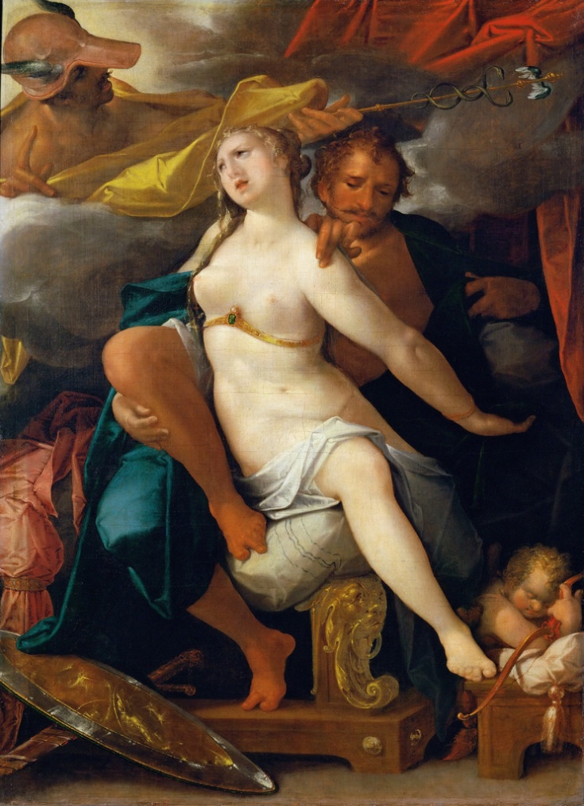
Bibliography
Primary sources
Angel, P. Lof der Schilder-Konst, Leiden 1642.
Castiglione, B. Il Libro del Cortegiano, Venice 1528, ed. V. Cian, Florence 1947.
De Bie, C. Het Gulden Cabinet van de Edel Vry Schilder-Const, Antwerpen 1662.
De Bisschop, J. Paradigmata Graphices Variorum Artificum, The Hague 1671.
De Lairesse, G. Grondlegginge ter Teekenkonst, Amsterdam 1701.
De Lairesse, G. Groot Schilderboek, Amsterdam 1712.
Buchelius, A. Res Pictoriae (1583-1639), eds G. J. Hoogewerff and J. Q. van Regteren Altena, The Hague 1928.
Goeree, W. Inleydinge tot de Al-ghemeene Teycken-konst, Middelburg 1670.
Goeree, W. Natuurlyk en Schilderkonstig Ontwerp der Menschkunde, Amsterdam1682.
Hoet, G. Catalogus of Naamlyst van Schilderyen, The Hague 1752.
Houbraken, A. De Groote Schouburgh der Nederlantsche Konstschilders en Schilderessen, Amsterdam 1721.
Junius, F. De Schilder-Konst der Oude Begrepen in Drie Boeken, Middelburg 1641.
Junius, F. The Painting of the Ancients, in Three Bookes, London 1638.
Lampsonius, D. Lamberti Lombardi Apud Eburones Pictoris Celeberrimi Vita, Bruges 1565.
Lomazzo, G. P. Scritti sulle Arti, ed. P. Ciardi, Florence 1973.
Ortelius, A. Album Amicorum, ed. J. Puraye, Amsterdam 1969.
Van Gool, J. De Nieuwe Schouburg der Nederlantsche Kunstschilders en Schilderessen, The Hague 1750.
Van Hoogstraten, S. Inleyding tot de Hooge Schoole der Schilderkonst, Rotterdam 1678.
Van Mander, K. Het Schilder-Boeck, Haarlem 1604.
Vasari, G. Le Vite de' Più Eccellenti Pittori, Scultori, e Architettori, Florence 1568, ed. Giuntina.
Weyerman, J. C. De Levens-Beschryvingen der Nederlandsche Konst-schilders, met een Uytbreyding over de Schilder-Konst der Ouden, The Hague 1729.
Secondary Literature
Barasch, M. Theories of Art: From Plato to Winckelmann, New York 1985.
Blunt, A. Artistic Theory in Italy 1450-1600, Oxford 1940.
Broos, T. Tussen Zwart en Ultramarijn: de Levens van Schilders Beschreven door Jacob Campo Weyerman (1677-1747), Amsterdam 1990.
De Mambro Santos, R. La Civil Conversazione Pittorica: Riflessione Estetica e Produzione Artistica nel Trattato di Karel van Mander, Sant'Oreste 1998.
De Vries, L. Gerard de Lairesse: an Artist between Stage and Studio, Amsterdam 1998.
De Vries, L. How To Create Beauty: De Lairesse on the Theory and Practice of Making Art, Leiden 2011.
De Vries, L. ‘Gerard de Lairesse: The Critical Vocabulary of an Art Theorist’, Oud Holland, CXVII, 2004, p. 79-98.
Engass, R. and J. Brown. Eds. Italian and Spanish Art, 1600-1750: Sources and Documents, Evanston 1992.
Kemmer, C. ‘In Search of Classical Form: De Lairesse’s Groot Schilderboek and Seventeenth Century Dutch Genre Painting’, Simiolus, XXVI, 1998, p. 87-115.
Melion, W. S. Shaping the Netherlandish Canon: Karel van Mander’s Schilder-Boeck, Chicago 1991.
Middelnederlands Woordenboek online (gtb.int.nl, last edited in 2010).
Miedema, H. Karel van Mander, the Lives of the Illustrious Netherlandish and German Painters, Doornspijk 1999.
Miedema, H. Kunst, Kunstenaar en Kunstwerk bij Van Mander: een Analyse van zijn Levensbeschrijvingen, Alphen aan den Rijn 1981.
Monk, S. H. ‘A Grace Beyond the Reach of Art’, Journal of the History of Ideas, V, 1944, p. 131-150.
Montijano García, J. M. Giorgio Vasari y la Formulación de un Vocabulario Artístico, Malaga 2002.
Nativel, C. ‘A Plea for Franciscus Junius as an Art Theorician’, in: Franciscus Junius F. F. and his Circle, ed. R. H. Bremmer Jr. Amsterdam 1998.
Sciolla, G.C. and Volpi, C. Da Van Eyck a Brueghel, Scritti sulle Arti di Domenico Lampsonio, Turin 2001.
Tatarkiewicz, W. History of Aesthetics, vol. III, Warsaw 1974.
Taylor, P. ‘The Practice of Painting in Dutch Art Theory’, in Begrifflichkeit, Konzepte, Definitionen: Schreiben über Kunst und ihre Medien in Giovan Pietro Belloris Viten und der Kunstliteratur der Frühen Neuzeit, eds. E. Oy-Marra, M. von Bernstorff and H. Keazor, Wiesbaden 2014.
Weststeijn, T. The Visible World: Samuel van Hoogstraten’s Art Theory and the Legitimation of Painting in the Dutch Golden Age, Amsterdam 2008.
Weststeijn, T. Art and Antiquity in the Netherlands and Britain: The Vernacular Arcadia of Franciscus Junius, Leiden 2015.
Wohl, H. The Aesthetics of Italian Renaissance Art: a Reconsideration of Style, New York 1999.
Woordenboek der Nederlandsche Taal online (gtb.int.nl, last edited in 2010).

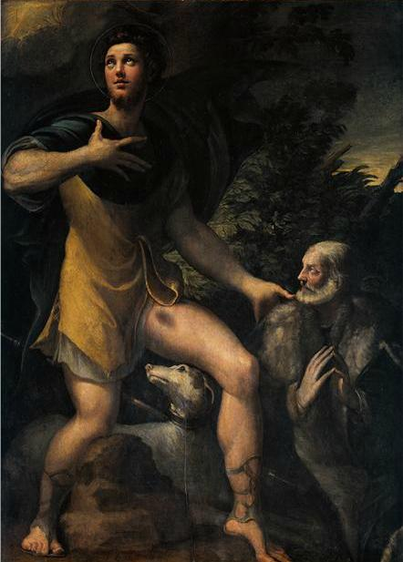
Appendix – Images

Fig. 1. Parmigianino, St. Roch and Donor, 1527. Retrieved from Artstor.org.

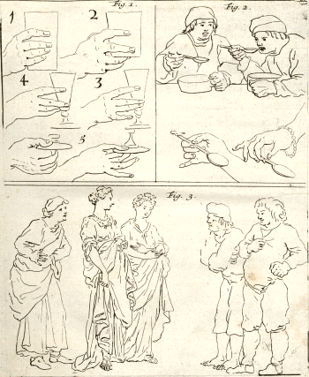

Fig. 2. De Lairese, Groot Schilderboeck, I, 54. Retrieved from dbnl.org.

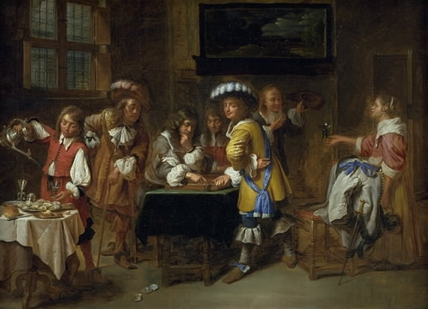

Fig. 3. Charles Emanuel Biset, Trictrac players. Retrieved from Statens Museum for Kunst website.

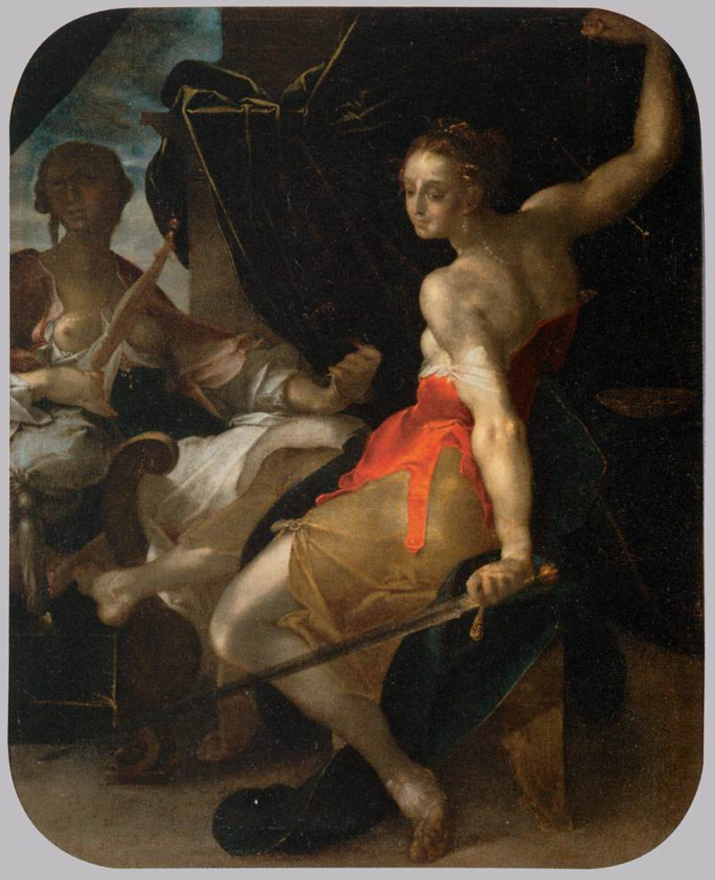

Fig. 4. Bartolomeus Spranger, Allegory of Justice and Prudence, 1600. Retrieved from Wikimedia.org.

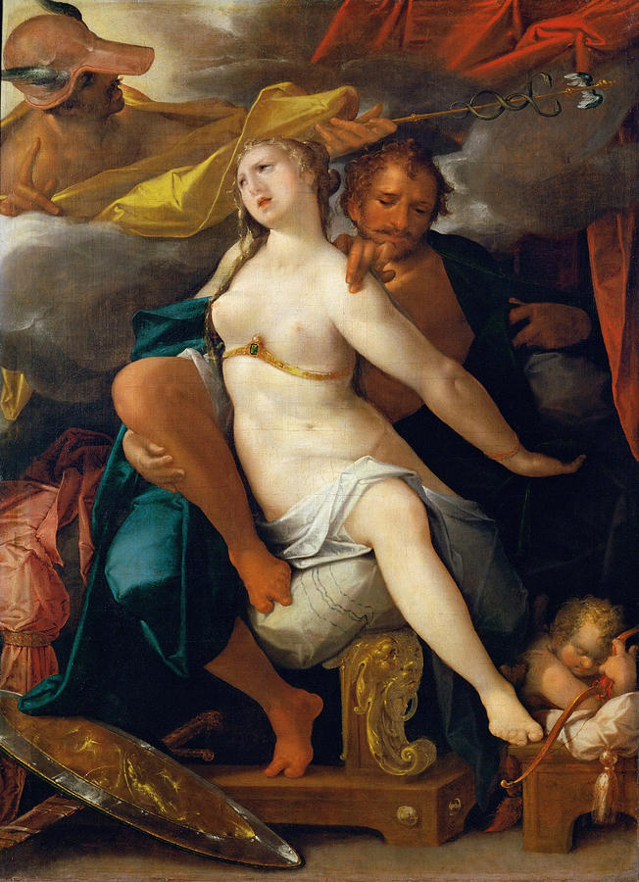
Fig. 5. Bartolomeus Spranger, Venus and Mars warned by Mercury, 1586. Retrieved from Artstor.org.

Figs 6-8. Details of The Feast of the Gods at the Wedding of Cupid and Psyche, Hendrik Goltzius after Bartholomeus Spranger, 1587. Retrieved from Metmuseum.org.

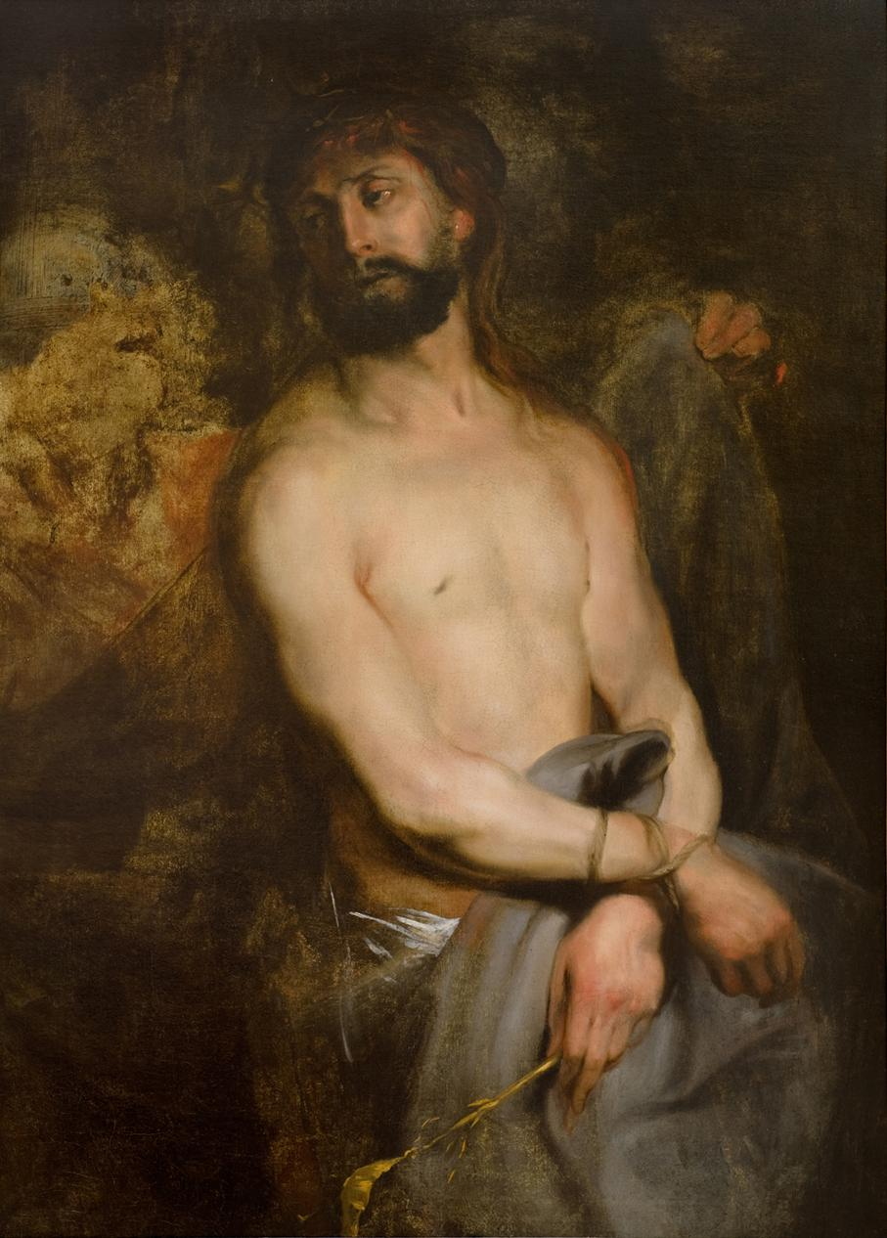
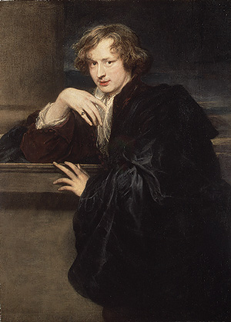

Fig. 11. Anthony van Dyck, Ecce Homo, 1625. Retrieved from Artstor.org.
Fig. 10. Anthony van Dyck, Self Portrait, 1620. Retrieved from Metmuseum.org.

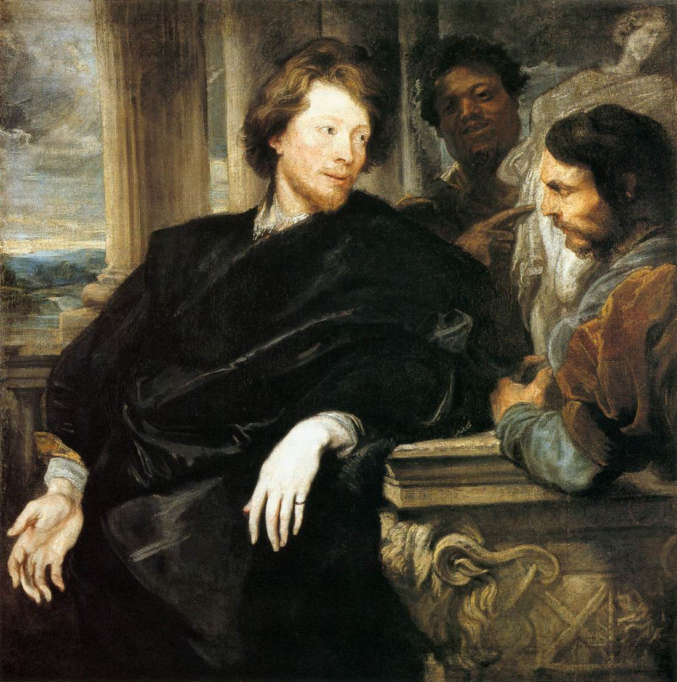

Fig. 9. Anthony van Dyck, George Gage with Two Men, 1623. Retrieved from nationalgallery.org.uk.

Fig. 13. Detail of Andrea Mantegna, Triumphs of Caesar, Gonzaga Palace, Mantua, 1492. Retrieved from Wikimedia.org.

Fig. 12. Detail of Correggio, Nativity, 1530. Retrieved from Google Art Project.

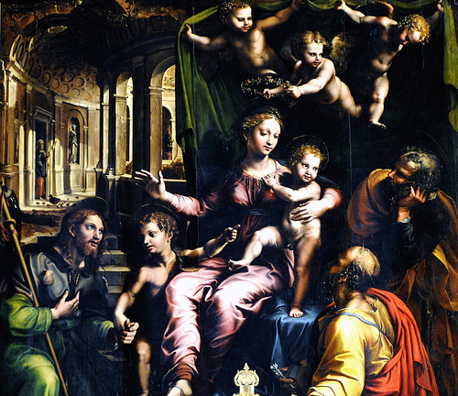
Fig. 14. Detail of Giulio Romano, Madonna and Saints, S. Maria dell’Anima, Rome, 1524. Retrieved from Gettyimages.com

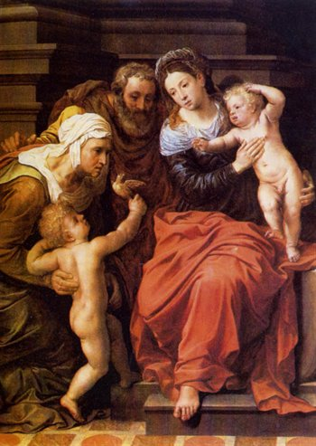
Fig. 15. Willem Key, Holy Family with Elisabeth and John, 1552. Retrieved from Thuisinbrabant.nl.
Fig. 16. Willem Key, Last Supper, 1560. Retrieved from Wikimedia.org.
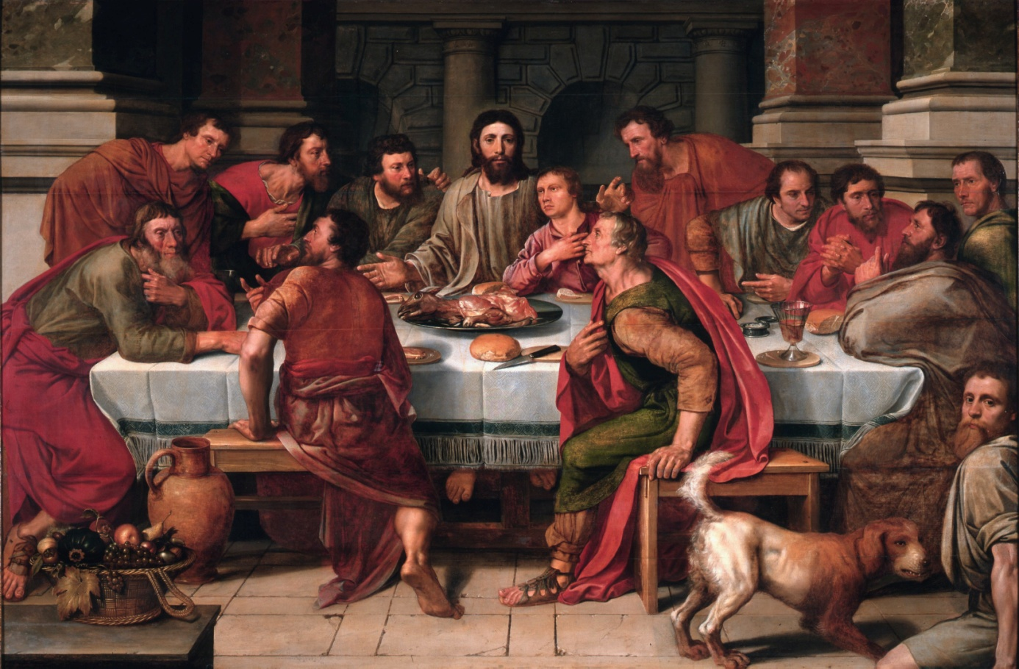

Taylor, ‘The Practice of Painting in Dutch Art Theory’, Wiesbaden 2014, p. 301.
For an extensive list of books published between 1600 and 1725 on art in the Low Countries see De Pauw-de Veen, De Begrippen “Schilder”, “Schilderij” en “Schilderen” in de Zeventiende Eeuw, Brussels 1969, p. 17-22. This list counts over 30 works, excluding correspondence of artists such as Rubens or annotated drawing books. Other excluded works are Latin writings by Arnoldus Buchelius (Res Pictoriae, 1583-1639), Johannes Molanus (De Picturis et Imaginibus Sacris Liber, 1570), Dominicus Lampsonius (Pictorum Aliquot Celebrium Germaniae Inferioris Effigies, 1572) (Lamberti Lombardi Apud Eburones Pictoris Celeberrimi Vita, 1565) and Gerardus Vossius (De Quatuor Artibus Popularibus, 1650).
Taylor, 2014, p. 296; Wohl, The Aesthetics of Italian Renaissance Art, New York 1999, p. 1.
See for example Taylor, ‘The Concept of Houding in Dutch Art Theory’, Journal of the Warburg and Courtauld Institutes, LV, 1992, p. 210-32; Taylor, ‘Flatness in Dutch Art: Theory and Practice’, Oud Holland, CXXI, 2008, p. 153-84; Miedema, Fraey en Aerdigh, Schoon en Moy in Karel van Manders Schilder-Boeck, Amsterdam 1984; De Pauw-De Veen, 1969. For an elaborate analysis of the vocabulary of De Lairesse see De Vries, ‘Gerard de Lairesse: The Critical Vocabulary of an Art Theorist’, Oud Holland, CXVII, 2004, p. 78-98.
Taylor, 2014, p. 298; De Vries, 2004, p. 80.
Monk, ‘A Grace Beyond the Reach of Art’, Journal of the History of Ideas, V, 1944, p. 133; Wohl, 1999, p. 1; Tatarkiewicz, History of Aesthetics, Warsaw 1974, vol. III, p. 119.
Tatarkiewicz, 1974, p. 119.
Blunt, Artistic Theory in Italy 1450-1600, Oxford 1940, p. 97; Wohl, 1999, p. 1.
Practical in the sense that these treatises were written by artists themselves, as opposed to the Italian texts, and as such closer to professional instruction manuals rather than elite, humanist, philosophical pastimes (E.g. Taylor, 2014, p. 283, 298; Weststeijn, Art and Antiquity in the Netherlands and Britain, Leiden 2015, p. 124; De Vries, Gerard de Lairesse: an Artist between Stage and Studio, Amsterdam 1998, p. 71-2).
‘Farmers’ fairs, guardhouses and other such things in the manner of Adriaen Brouwer, and others mentioned before, all of which is with a good judgement and manner…as this is overflowing of grace and lovely thoughts’. De Bie, Het Gulden Cabinet van de Edel Vry Schilderconst, Antwerpen 1662, p. 399. Emphasis mine hereafter.
The most significant contributions came from H. Miedema (Commentaries to Van Mander’s Den Grondt der Edel Vry Schilder-Const, Utrecht 1973 and The Lives of the Illustrious and Netherlandish Painters, Doornspijk 1994-99; Een Vergelijking Tussen Van Mander en Vasari, Alphen aan den Rijn 1984; Kunst, Kunstenaar en Kunstwerk bij Karel van Mander, Alphen aan den Rijn, 1981), W. S. Melion (Shaping the Netherlandish Canon, Chicago 1991), L. de Vries (2004 and 1998; How To Create Beauty, Leiden 2011), T. Weststeijn (The Visible World, Amsterdam 2008) and S. H. Monk (1944, p. 131-50).
See note 2. Besides the four abovementioned authors, useful material was obtained predominantly from Willem Goeree, Cornelis De Bie, Philips Angel, Arnold Houbraken, Jacob Weyerman, Johan van Gool and Jan de Bisschop.
Woordenboek der Nederlandsche Taal online (hereafter WNT) ‘Gratie’.
Monk, 1944, p. 133.
Pliny, Natural History (XXXV.79-80) in Monk, 1944, p. 133.
‘Which the Greeks called Charis, in which he outdid or exceeded them all’. Van Mander, Het Schilder-boeck, Haarlem 1604, 77r.
Weststeijn, 2015, p. 24.
Ibid.
Taylor, 2014, p. 287.
Weststeijn, 2015, p. 19-22, 145-46. Junius also produced an English version (Painting of the Ancients, London 1638).
Weststeijn, 2015, p. 21.
Goeree, Inleydinge tot de Al-ghemeene Teycken-konst, Middelburg 1670, p. 15. Van Hoogstraten, Inleyding tot de Hooge Schoole der Schilderkonst, Rotterdam 1678, p. 176.
Weststeijn, 2015, p. 240, 127.
‘A certain kind of pleasantness or good appearance (which is generally called the grace and bevalligheydt of paintings)’, Junius, De Schilder-Konst der Oude Begrepen in Drie Boeken, Middelburg 1641, p. 315.
‘The grace, or rather, the bevalligheid (the true ornament of beauty)’. Goeree, Natuurlyk en Schilderkonstig Ontwerp der Menschkunde, Amsterdam 1682, p. 24.
‘On the art of dancing, that is, the charming and bevallijke movement of figures, or else, the gracefulness in all sorts of actions’, ‘as this grace is so pleasant in the motions of reality, how vital shouldn’t it be reckoned in our art, in which bevallijkheyt is so advantageous’.Van Hoogstraten, 1678, p. 292.
The noun gracelijkheyt (gracefulness) or any of its variant spellings only occur in an art historical context according to the WNT (‘Gracelijkheid’).
De Lairesse, Groot Schilderboek, Amsterdam 1712, vol. I, p. 8, 398; Van Hoogstraten, 1678, p. 278.
De Lairesse, 1712, I, 21; Van Hoogstraten, 1678, p. 278.
Houbraken, De Groote Schouburgh der Nederlantsche Konstschilders en Schilderessen, Amsterdam 1721, vol. III, p. 407. Weyerman, De levens-beschryvingen der Nederlandsche konst-schilders, The Hague 1729, vol. I, p. 282; Vondel, Werken, III.273 (1636) mentions ‘t Hof der drie bevalligheden’ (WNT online ‘Bevalligheid’).
Weststeijn, 2015, p. 22, 123.
‘Will the incense of our holy sacrifice please you?’, Vondel, Werken, I.51 (1612); ‘The woman...was pleasing to Simon’s eyes’, Statenbijbel, Richteren 14.7 (1688) (both from WNT online ‘Bevallen II’).
Van Mander, 1604, 276r, 292v.
E.g. Zuccaro, L'Idea de' Pittori, Scultori ed Architetti, 1607 (II.4) in Blunt, 1940, p. 145.
WNT online ‘Bevallig’.
‘Grace, or the inclination to any good art’, Van Mander, 1604, 122v.
‘Had a good grace in making an ox foreshortened from the front’, Ibid, 73r.
‘More grace in the progress of this exercise’, De Lairesse, Grondlegginge ter Teekenkonst, Amsterdam 1701, p. 19.
MNW online ‘Gracelijc I’.
The terms gratie and bevalligheid are synonymous according to the WNT as well (‘Gratie’).
Junius Book 3, chapter 6; Van Hoogstraten chapter 8, Calliope. However, the occasional treatise hardly makes use of the term at all, e.g. Philips Angel’s Lof der Schilder-konst (Leiden, 1642) Goeree’s Inleydingh tot de Pracktijck der Al-gemeene Schilder-Konst (Middelburg, 1670) nor his 1670 Inleydinge; most Latin sources of the sixteenth century did not even mention the term (e.g. Lampsonius, 1572) or mainly used the word venustas (e.g. Buchelius, Res Pictoriae) making it hard to establish whether they were speaking of grace or beauty.
De Vries, 2004, p. 80.
He uses the Latinised terms over a 100 times versus the approximately 50 occurrences in the German-oriented forms.
He uses the Latinised form solely in the context of the mythological Graces.
Van Gool, De Nieuwe Schouburg der Nederlantsche Kunstschilders en Schilderessen, The Hague 1750. Weyerman, 1729.
Weststeijn, 2008, p. 132, 157; Montijano García, Georgio Vasari y la formulación de un vocabulario artístico, Malaga 2002, p. 163; Barasch, Theories of Art, New York 1985, p. 220; Monk, 1944, p. 134; see the last two titles for a summarised history of the term from Antiquity onwards.
‘Do feel inside of us, but don’t completely and clearly understand’, Goeree, 1682, p. 20.
‘Which surpass both human comprehension and art, pictures, that are said to be fashioned purely by an unutterable, inimitable, supernatural, divine art’, ‘in this expeditious grace are to be found such hidden treasures of an inconceivable satisfaction’. Junius, 1641, p. 323.
Weststeijn, 2008, p. 132.
Van Mander, 1604, 212v; Miedema, 1981, p. 169-70.
Lampsonius, 1565, p. 5.
Miedema, 1999, vol. IV, p. 87; Miedema, 1981, p. 169-70.
Tatarkiewicz also noted that grace was a new concept in the art theory of the Renaissance, harking back on the ancient meaning (charm), but different from the Medieval divine favour of before (p. 119, 202).
E.g. in Luke 2.56 (WNT online ‘Gracelijkheid’).
Tatarkiewicz even believes that the Italian art theorists themselves derived the expression from Petrarch, who used the phrase regularly (p. 201).
Unless they consciously refer to the ‘gratie Gods’ such as in De Bie, 1662, p. 436-339.
Barasch, 1985, p. 224.
Junius, 1638, p. 195.
‘Grace exists in the meeting of all the aspects of art’. Van Hoogstraten, 1678, p. 278.
Junius, 1638, p. 283.
De Bie, 1662, p. 399.
‘That bodily grace which we call beauty’. Leon Battista Alberti, Della Pittura (1435) in Blunt, 1940, p. 93.
Blunt, 1940, p. 93.
Tatarkiewicz, 1974, p. 119-20, 131, 202-3.
Van Mander, 1604, 155r.
‘So incredibly beautiful, that her grace gained her the love of all the princes in the whole of Greece’, Van Mander, 1604, 92v.
‘Graceful in countenance, that the damsels of Breda called him the beautiful painter’, Weyerman, 1729, IV, 27.
Junius, 1638, p. 284.
Ibid. As was stated previously, De Bie defined grace as a pictorial category that led to the production of beauty, which seems to follow the same line of thought.
‘Just as natural things please us most, which are beautiful and perfect, so there is no reason why artificial things would not bring the same grace to the eye of the viewer’, Goeree, 1682, p. 17.
‘Beauty which most of all lies in a lovely grace’, Ibid, p. 23.
‘Grace is the utmost adornment of beauty’, Ibid, p. 24.
It is repeatedly emphasised that the connection between rhetoric and the arts must not be underestimated (e.g. Monk, 1944, p. 132, Weststeijn, 2008, p. 19); Junius for example based his entire written work on classical rhetorical commonplaces which he applied to an artistic framework.
‘In case my lips may lack in bevalligheid’, Vondel, Werken, III.739 (1640), WNT ‘Bevalligheid’.
‘You, go to his bed to end his sorrow, either through a sweet gesture or with a graceful manner of speech’, Cats, Alle de wercken, I.376a (1625), WNT ‘Bevallig’.
‘Had as well a certain competent grace of a sweet familiarity and speech, which so exceptionally pleased the mighty king Alexander’, ‘a certain noble essence, accompanied with a graceful manner of speech’. Van Mander, 1604, 78v, 117r.
Van Mander, 1604, 109v.
‘A certain grace, as one says, a temperament that makes him welcome and likeable at first sight to whoever sees him, and this should be a mark of distinction that affects and accompanies all his actions, and he should promise in his aspect to be worthy of any great lord’s company and grace’, Castiglione, Il Libro del Cortegiano (1528), ed. V. Cian, Florence 1947, p. 41-42 (I.14).
‘Grace stems from a sweet and amiable gesture or use of eyes, mouth and hands’, ‘caressing sounds of the tongue’. Goeree, 1682, p. 24.
E.g. Mambro Santos, La Civil Conversazione Pittorica, Sant'Oreste 1998, p. 133; De Vries, 2004, p. 82; De Vries, 2011, p. 36.
De Lairesse, 1712, I, 177.
Liège, 25 April 1565. Letter reproduced in Sciolla and Volpi, Da Van Eyck a Brueghel, Scritti sulle arti di Domenico Lampsonio, Turin 2001, p. 39.
‘Ecclesiastic images one could see a certain excellent grace of devotion’, Van Mander, 1604, 186v, 103r.
Miedema, 1999, IV, 76.
‘What is becoming and fitting for a virginal creature: the eyes are accompanied with chastity, the forehead with honour, the nose with grace’, Van Mander, 1604, 120r.
‘The female gender usually possesses more tenderness and grace’, De Lairesse, 1712, II, 6; Miedema,1999, IV, 76; Weststeijn, 2008, p. 225.
Van Mander, 1604, 186v.
Ibid, 55v.
‘Beautiful, graceful face, looking up towards the heavens, as if thanking God’, Ibid, 134v.
De Vries, 2011, p. 87.
‘That this still favours of rusticity’, De Lairesse, 1712, I, 52.
Ibid, I, 53.
‘The people, to whom respectability and grace are most proper, should also excel in it the most’, Ibid, I, 58.
Ibid, II, 17; I, 177.
Kemmer, ‘In Search of Classical Form: De Lairesse’s Groot Schilderboek and Seventeenth Century Dutch Genre Painting’, Simiolus, XXVI, 1998, p. 96.
De Lairesse, 1712, II, 11.
E.g. Castiglione, 1528, I.24-25 (ed. Cian p. 69-70). Blunt, 1940, p. 97; Barasch, 1985, p. 222.
E.g. Vasari, Le Vite de' più eccellenti pittori, scultori, e architettori, 1568, ed. Giuntina, III, p. 399. Blunt, 1940, p. 96.
‘Gifts from the gods, that are not to be learned but through divine inspiration’. Van Hoogstraten, 1678, p. 278.
‘That talent, which cannot be attained with studying day and night’, Weyerman, 1729, I, 56; IV, 389. Junius, 1638, p. 285.
De Lairesse, 1712, I, 181.
Ibid, I, 56.
E.g. Melion, 1991, p. 154, 160.
‘That part of the art of painting which the connoisseurs call grace or a charming zwier, he possessed in his brush’, Weyerman, 1729, I, 56.
WNT online ‘Zwieren’.
‘It happens even in beautiful figures, that they lack a gift from the heavens, gracefulness, through secret defects, which occur in the zwier of her movement’ .Van Hoogstraten, 1678, p. 293.
‘Through making their figures turn and swing very extensively and bending the members too far, with hands and feet all convulsive in the manner of Spranger’.
‘Now the arms must be modest and not all wild in their action or far astray from the rest, unless in the emergency of a violent act’. Goeree, 1682, p. 309.
Van Mander, 1604, 274r.
Melion, 1991, p. 33.
‘With easy movement, we mean that all members of the body, even the slightest ones, perform their motion effortlessly, with a graceful zwier’, De Lairesse, 1712, I, 21.
Barasch, 1985, p. 222.
E. g. Weyerman, 1729, II, 345.
E.g. Van Mander, 1604, 18r (Grondt 5.35). Junius, 1641, p. 249, 258. Goeree, 1682, p. 117.
Miedema, 1999, II, 236.
E.g. the abovementioned example of Saint Roch, Vasari, 1568, IV, 539.
Van Mander, 1604, 96r, 117v.
Ibid, 116v.
‘The face is the mirror, or rather the lively expression of the soul, in which, besides much gracefulness, the efforts of the heart can often be seen; which the other members, unlike the face, cannot do’, Goeree, 1682, p. 31. As such it is no coincidence that hands were considered to be a key to grace as well, both are the most vital tools for human expression, which brings us back to the tradition of classical rhetoric.
Ibid, ‘bladwyser’(index).
In the context of the art historical sources this term is quite multifaceted. In De Lairesse’s work alone this single word is used for matters that have been variously translated as character, posture, actions, carriage, person, aspect, figure and even thing (translation by W.M. Craig, A Treatise on the Art of Painting, London, 1817). An analysis of this term is thus a good suggestion for further research.
‘From the soul comes that beauty which we call grace’, Varchi, Libro della Beltà e Grazia (1590) in Tatarkiewicz, 1974, p. 203.
‘Had a certain something, that touched the heart and delighted the soul’, Weyerman, 1729, I, 56.
‘To caress the senses of the spectators with bevalligheid’, De Lairesse, 1712, I, 6; ‘Grace encourages one to love’, Van Hoogstraten, 1678, p. 293.
‘Has power over the spectators’, Van Hoogstraten, 1678, p. 292; ‘To us and everyone without our intent’, Goeree, 1682, p. 20.
Weststeijn, 2008, p. 159.
‘made it graceful to the audience with an outstanding pleasantry’, Goeree, 1682, p. 36.
Ibid, 3v.
‘Grace...attracts the eye and contents the taste...it depends entirely on good judgement and good taste’, Zuccaro in Romano Alberti’s Origine e Progresso Dell’Accademia (1604) in Blunt, 1940, p. 146.
Barasch, 1985, p. 224.
Ibid.
E.g. Weststeijn, 2008, p. 157; Blunt, 1940, p. 146.
Goeree, 1682, p. 78.
Tatarkiewicz, 1974, p. 201.
Weststeijn, 2008, p. 156.
‘Marvel at these pieces with such a deep admiration, that they stand like statues as struck by a ravishing dejection and secret apprehension’. Junius, 1641, p. 323. Remarkably enough, another linguistic connotation of the word bevallen is an element of surprise; the ability of an event to take someone off his guard, showing how an audience can be literally overcome by an artwork (MNW online ‘Bevallen’).
‘Whatever is beautiful, or rather graceful and pleasant with little art and true virtue, shall be held in good or bad esteem according to the small or large amount of knowledge and comprehension of the connoisseur’, De Bisschop, Paradigmata Graphices Variorum Artificum, The Hague 1671, dedication to Johan Six (n.p.).
‘Thorough knowledge of grace’, De Lairesse, 1712, II, 58, 6.
Van Hoogstraten, 1678, p. 88.
‘Despite the great difference between educated and simple people, there is little difference in their judgements’, Dolce’s Aretino (1557) in Tatarkiewicz, 1974, p. 214.
See note 125.
Junius, 1638, p. 283, 285; Weyerman, 1729, II, 313.
‘Which gracefulness depends on the use of the user, which does not apply to the painting: because the distinction between motions becomes clear to us, as soon as we read it in the painting, put in front of us in such shape as the painter wanted it to appear to him; without being tied to the will of the user’. Angel, 1642, p. 26.
Nativel, ‘A Plea for Franciscus Junius as an Art Theorician’, Amsterdam 1998, p. 35.
Bellori, Le Vite de’ Pittori, Scultori et Architetti Moderni (1672).
Rubens was even dubbed the local Dutch Apelles: ‘Rubens, qui noster Apellam vocat’ (Buchelius, Res Pictorae, p. 65).
Italian and Spanish Art, 1600-1750: Sources and Documents, eds. R. Engass and J. Brown, Evanston 1992, p. 8.
‘They were condemned even more for having imitated the worst, and the most vile, just as in our time Michelangelo da Caravaggio was critised for being too natural in painting likenesses, and Bamboccio was considered worse’, Bellori (1672) in Engass and Brown, 1992, p. 9-10.
De Vries, 1998, p. 79.
As well as that of most French theorists when it comes to grace, Nativel, 1998, p. 30.
‘And that which is more despicable and even worse’, De Lairesse, 1712, I, 171. This opinion is shared by De Bisschop, 1671, dedication to Johan Six.
‘Where is the observation of grace, which teaches us that everything that a painter undertakes, must be chosen most beautifully: and they, on the contrary, put defects on a pedestal, hiding the pleasantness of nature’. De Lairesse, 1712, II, 13.
Ibid, I, 52.
‘In case there is to be found any imperfection or ugliness in it, we do not want this to be completely omitted’, Van Hoogstraten, 1678, p. 44.
De Bie, 1662, p. 66.
‘Being an agrarian country house, embellished with many figures, entertaining themselves with eating, drinking, singing and playing’, Hoet, Catalogus of Naamlyst van Schilderyen, The Hague 1752, vol. I, p. 260.
Melion, 1991, p. 178, 302: ‘Pictores qui formosulos in aetatis flore constitutos pingunt voluntque picturae lenocinium quoddam et gratiam de suo adjicere, totam depravant repraesentatam effigiem, sic ut et ab exemplari proposito pariter et a vera forma aberrant. Ab hac labe purus noster Brugelius’.
‘Multo pinxit, hic Brugelius, qui pingi non possunt, quod Plinius de Apellles’, Abraham Ortelius, Album Amicorum as reproduced in fascimile by J. Puraye, Amsterdam 1969, 12v.
‘The subjects of his art are usually pleasing to the eye, since he mostly shows merry companies, ladies and gentlemen drinking tea, playing cards or entertain each other otherwise, occasionally also delivery rooms and other such displays’, Houbraken, 1721, III, 228.
‘Often depicted stables, stopping places, mainly falcon hunts on horseback with damsels, which is pleasant and becoming to all’. Houbraken, 1721, II, 75.
‘And in order to make them seem more graceful, he often chose young children or little cupids as his subjects’, ‘graceful little naked carved gnomes’. Weyerman, 1729, I, 105; IV, 47.
Van Mander, 1604, 137r, 108v.
Ibid, 155r. Such a conception is not remarkable for a culture in which small artworks were the norm - the result of an art market which to a large extent provided for ordinary households. Vasari is not even slightly concerned about this (1568, V, 247).
Weyerman, 1729, I, 132.
Blunt, 1940, p. 94.
Raphael, after all, was not at all known for his favourable disposition towards genre.
‘A sad, melancholy way of working completely numbs the pleasant grace of the work through a mean harshness’, Junius, 1641, p. 321.
De Lairesse, 1701, p. 19.
See for example note 158 about Mathys Neveu above.
‘Through which cheerful and witty physiognomy the usual rigors were softened’, Weyerman, 1729, I, 36.
De Lairesse, 1712, I, 398.
Barasch, 1985, p. 224.
‘Allow me to compare two great Masters, Titian and Van Dyck, with respect to some judgements that I heard to have been given to their artworks. Of the latter one says that he was the most skilful in drawing, grace and choice of subject regarding the making of portraits. Nonetheless I have seen many of Titian, which are held in even greater esteem by many, that appeared to me to be incomparable, though less graceful. But here again my position, that the lack of grace which is peculiar to his national character, determines his choice and as such he is less to blame’, De Lairesse, 1712, II, 17.
E.g. Van Mander, 1604, 7r.
Lomazzo (Trattato dell'Arte della Pittura, Scoltura et Architettura, 1584) in Scritti sulle Arti, ed. P. Ciardi, Florence 1973, vol. II, p. 159, 174, 305, 400. Lomazzo is known to be exceptionally favourable towards Dutch artists.
Guglielmo Cay (1568, VI, 226), Vasari for example explicitly refers to his soft sfumato.
Liège, 13 March 1567, letter reproduced in Sciolla and Volpi, 2001, p. 117.
Melion, 1991, p. 154.
Montijano García, 2002, p. 162, 165.
De Lairesse, 1701, p. 55. This is a remarkable statement for more than one reason: Apelles and Raphael are clearly separated while it is common for them to be mentioned in one breath as the main exponents of grace. No modern names are mentioned with this graceful manner, indicating either that it is a way of drawing that was no longer used in Early Modern times or that after the Ancients no artist ever attained a similar level in this style.
WNT online, ‘Sonderlinge II’.
Junius, 1638, p. 45.
Junius, 1641, p. 344. This is taken up by Van Hoogstraten as well (1678, p. 197).
Junius, 1638, p. 305.
Ibid, p. 44.
‘Just as music has a distinguished note for the Courant and a merry note for the Bouree; and as poetry both treats the jocular and the solemn; so the art of painting shows us mean and ridiculous subjects now and then, as well as lofty and stately subjects. In the visual arts it always shows skill to depict subjects well, of whatever kind they may be, as the purpose of this art is to follow and depict nature. The merit of a picture exists less in the depicted subject matter, than in the truth of the depiction; and it is an established truth that low or ordinary subject matter, perfectly represented with the brush, shall always have more approval than a beautiful and boisterous subject which is painted without grace’, Weyerman, 1729, II, 62.
This is perhaps the reason why Van Mander for example praised Caravaggio for his handeling or brushwork (1604, 191r).
Weyerman, 1729, I, 356, (‘Aap des Menschdoms’) as mentioned in Broos, Tussen Zwart en Ultramarijn, Amsterdam 1990, p. 150.
Weyerman, II, 66, 68, 76.
‘Not only with the greatest possible rapidity, but also with incredible facility and without effort’, Vasari, 1568, VI, 381.
Blunt, 1940, p. 95.
E.g. Van Mander, 1604, 66v.
‘Too much diligence and carefulness can sometimes be harmful: since one will find that a thing that is done with effort often is hard to look at as well, and will lack any kind of spirit or grace, as is still occasionally detected in the lives of modern masters’, Ibid, 77v.
‘Possibly with too much fervour, such as the works of Slingelant, van der Werf, and other punctual painters’, Weyerman, 1729, I, 57.
Houbraken, III, 5. Hoet, III, 589. Weyerman, II, 94, 345.
‘The virtue of the work exists in a graceful naturalness, and if one cannot attain this with haste, than one ought to take time for it’, Van Hoogstraten, 1678, p. 240.
‘Adds the greatest loveliness and grace with great patience and long-suffering’, De Lairesse, 1712, I, 9.
‘The brushwork alone adds the greatest grace and perfection to the finish of an artwork, on which its greatest advantage is dependent’, De Lairesse, 1701, 69.
Vasari, 1568, IV, p. 551 as mentioned in Blunt, 1940, p. 95.
‘True heat of her first inspiration’, ‘as such the grace of paintings is made even more graceful when one can perceive in them an effortlessness skill, arising from the upwelling force of invention, which emanates abundantly from the boisterous nature of brave artists’, Junius, 1641, p. 320.
De Lairesse, 1701, p. 69.
Tatarkiewicz, 1974, p. 332.
‘Which he embellished so pleasantly with beautiful little colours for the ladies, that they were absolutely crazy for them’, Houbraken, 1721, II, 239.
Junius, 1638, p. 253.
Van Mander, 1604, 180r.
Ibid, 155r.
Goeree, 1682, p. 32.
‘One of the greatest graces in a picture’, De Lairesse, 1712, I, 38, 207, 228.
De Lairesse, 1712, II, 373.
Ibid, I, 205.
‘Beautiful action and contour can be rendered useless through a badly positioned light, and its grace will be utterly nullified’, ‘with grace I mean the disposition of the figure in general, when a face is turned to its advantage, more or less to the light, in order to create good shadows’, Ibid, I, 27.
‘Harsh, flat highlight and sharp shadow’, Ibid, I, 27.
De Bie, 1662, p. 66.
LeBrun (Conférence sur l’Expression Générale et Particulière des Passions, 1715) in Tatarkiewicz, 1974, p. 402, 412.
‘Wanting life to be too beautiful’, De Lairesse, 1712, I, 42.
Junius, 1638, p. 254.

