R2206

MASTERS DISSERTATION

SUPERVISOR: FRANÇOIS QUIVIGER

Considering the Elizabethan Portrait Miniature as an Object of Devotion

14985 WORDS

SUBMITTED: 30/09/2015
Table of Contents
Introduction 2
Chapter One: The English Portrait Miniature and The Reformation 3
The Development of the English Portrait Miniature 3
The English Reformation 7
The Popularity of the Elizabethan Portrait Miniature 10
Chapter Two: Comparing Function and Purpose 12
Images as a Didactic Tool: Imprese within Miniatures 12
Images as a Remembrance: Commemorative Miniatures 16
Images as an Aid to Devotion: Miniatures as an Aid to Devotion 19
Chapter Three: Materials and Interaction 24
Materials and Settings 24
Physical Interaction and the Manipulation of Objects 27
Conclusion: Sustaining Devotional Traditions 32
Bibliography 34
Primary Sources 34
Secondary Sources 35
List of Figures 39
Figures 42

Introduction

The sudden popularity of the English portrait miniature in courtly Elizabethan society has been a subject of much discussion in art historical literature. Such studies commonly attribute the dominance of this new art form to the English Reformation, which separated England from Catholic Europe and subsequently isolated it from the development of high Renaissance art practices. However, claiming that the English miniature’s success was a result of artistic limitations does not necessarily suffice. Instead, the overall position of images and objects during the English Reformation must be analysed, not only in conjunction with artistic practices, but also with the social, political, and religious motivations of the English public. This study will focus on the English portrait miniature as an object in its social context, and will track its functional development, its materials, and the interactions it demanded in relation to the religious images and objects that had previously dominated English society.

The overall aim of this study is to argue that the popularity of the Elizabethan miniature and its functions derive from pre-Reformation attitudes towards devotional objects that were subsequently applied to ‘secular’ miniatures in newly Protestant English society. Chapter One will recapitulate the art historical studies on the English Renaissance miniature’s development. They will be considered alongside crucial yet fluctuating laws regarding images passed during the English Reformation. This will not only ascertain the key purposes of the miniature as a functioning object, but will also consider whether its origins determine its latent religious significance, and consequently its sixteenth-century popularity. Considering the simultaneous appearance of portrait miniatures and the disappearance of objects of devotion from Elizabethan everyday life in the 1560s, Chapter Two will suggest that these two art forms are not so easily distinguished as either sacred or secular. The three key functions of the portrait miniature will be considered alongside the tripartite Catholic justification of images to argue that in moving away from the cult of the saints and religious imagery, the miniature facilitated a new practice of monarchical devotion. In Chapter Three, primary accounts revealing how Elizabethans communicated with miniatures and their materials will be closely compared with the interaction of pre-Reformation religious images and objects, specifically highlighting the contemplative state that was achieved with the assistance of the portrait miniature. In considering the trajectories, the uses, and the forms of both Elizabethan portrait miniatures and English pre-Reformation devotional objects and images, this study will ascertain how Elizabethans transferred the conventions of devotion associated with pre-Reformation devotional objects to the new art form of portrait miniatures.

Chapter One: The English Portrait Miniature and The Reformation

This chapter will set out the history of the portrait miniature and the English Reformation in their most basic terms to consider their corresponding developments during the sixteenth century. The fundamental themes extracted through these histories will subsequently be analysed in greater depth throughout the supporting chapters.

The Development of the English Portrait Miniature

The position of the portrait miniature within the English Renaissance must be understood through a brief consideration of early Tudor portraiture and the purpose of a somewhat alien subject matter. During the fourteenth and fifteenth centuries, artists enjoyed a relatively lowly status in England. Court painters were employed primarily for ephemeral works, such as palace and furniture decoration; portraiture was predominantly reserved for tomb sculpture. It served to perpetuate its subject’s achievements, wealth, and lineage in order for him to be compared with his contemporaries and other great men of the past. At the beginning of Henry VIII’s reign (r.1509–1547), easel painting was a rare and unsophisticated art form, and even when it did emerge it remained an exclusively royal prerogative. Portraits were occasionally required for purposes such as marriage negotiations, official documents, or for the interior decoration of royal residences. However, they lacked the concept of an individual likeness; ‘it was more like the image of a king on a playing-card than of a recognisable individual.’ Portraits were the result of specific occasions rather than objects for appreciation. As the sixteenth century progressed, self-consciousness regarding the manipulation of human identity through portraiture increased, as displayed in the portraits commissioned during Henry VIII’s reign. By the 1520s, the King became more aware of the need for a court artist through his exposure to, and rivalry with, the works of the French court. Henry wanted to shift the primary role of the court artist from ‘decorator’ to portrait painter, and through the influence of Hans Holbein the Younger (c.1497/8–1543), the style of English portraiture significantly changed. Holbein introduced high artistic status and hyper-realistic portraiture to England, creating likenesses of Henry and his family not only in large-scale portraits but also in portrait miniatures, or limnings, the techniques of which were likely taught to him by his contemporary, Lucas Horenbout (c.1490/5–1544). The growing demand for portraits to translate individual likenesses could be answered through the miniature format, and simultaneously increased the intimacy between object and viewer that the large-scale portraits lacked.
The growth of the miniature format at the sixteenth-century English court is argued to have partly originated through manuscript illumination, emerging from the intimate donor portraits within precious hand-painted religious texts. Prior to his employment in the Tudor royal scriptorium, Horenbout, the first recorded miniaturist, was a leading figure in the Ghent–Bruges school of illuminators. The tradition of the illuminated manuscript, which was drawing to a close, had introduced portraits over several centuries as either a direct form of representation or as part of an overall decorative scheme. Wealthy patrons commissioned these books for private chapels or as gifts for religious institutions, often including a donor ‘portrait’ of the patron within the text. As hand-written books became increasingly redundant with the development of the printing press, a new dimension of portraiture was encapsulated in the miniature, an independent work. A Flemish manuscript (Fig.1) provides a prototype for the first miniatures by Horenbout in Henry VIII’s court (Fig.2), mimicking the circular format, materials, and techniques. The modern word ‘miniature’ derives not from the small size of the object but from the word minium, Latin for the red lead that provided the ground for colours used by illuminators. Horenbout is likely to have trained artists including Holbein in the art of limning in order to produce miniatures of Henry VIII and his family from the 1520s. In stemming from portraits in illuminated manuscripts, it can be argued that miniatures would inevitably still resonate with the religious use and the role that portraits played within the sacred context of a prayer book. These now-detached portraits could still receive the same close attention they were rewarded in a prayer book, exclusively confronting the viewer with the individual likeness of the sitter for a hand-held intimate interaction.
Previous studies have also argued for a second origin of the portrait miniature: the portrait medal. The three-dimensional and portable form of the miniature combined the painted content of the manuscript portrait with the function of the detachable coin or medallic image. The renaissance interest in personality and antiquity allowed the medal to gain impetus, initiating the trend for small portable portraits that led to the production of the miniature. It is comparable to the medal in size and circular format, but surpassed it as a form of portraiture; its materials did not restrict the portrait to an emotionless, monochromatic profile. The medal’s function as an easily distributed image of the ruler translated across to the portability of the miniature, which also had the ability to act as an instrument of power. However, the more public form of the portrait medal arguably lacked sentimentality and intimate value in its wider mass-produced distribution. Yet as Chapter Two’s discussion on the functions of the miniature will reveal, it did have the same ability to be presented to often numerous courtiers in diplomatic contexts, whilst maintaining an emotional significance.
From the early stages of its appearance in the Tudor court, the effectiveness of miniatures as diplomatic gifts was embraced. Their small scale meant that they were suited to being presented for such purposes; as medals and cameos were distributed for good service and loyalty, so too were miniatures. However, the miniature’s ability to show a more individual likeness meant that they were particularly favoured for diplomatic affairs such as royal marriages and eliciting support across the Continent. For example, Holbein was sent to Düren in 1540 to take the portrait of Anne of Cleves, to assist Henry VIII in selecting his next wife. The surviving miniature (Fig.3) remains in what is believed to be its original, possibly Continental, turned ivory case. Most early, often circular, miniatures were kept in such cases with ‘cristall’ covers on top to protect the ‘little pictures’; this form continued into the 1630s. The similarities between these cases and those containing reliquaries will be discussed further in Chapter Three. These types of framings were also accompanied by the employment of the locket setting. Miniatures within lockets appeared from 1526, with the first recorded example in England of miniatures promoting relations between kingdoms: François I’s sister, Madame d’Alençon, sent Henry VIII two miniatures of François and his two sons. The young princes were hostages of Emperor Charles V, and it was hoped that the miniatures would contribute to producing an alliance with England, potentially resulting in their release. The miniatures, now lost, were described as being contained in a locket, ‘attached on one side and that cover is of a very finely worked gold’. Locket settings increased in popularity, becoming the more frequent choice of presentation by the mid-sixteenth century as the miniature ceased to be exclusively for the ruling classes and expanded into the realm of the nobility and gentry.
The increased frequency of the portrait miniature within a jewelled setting or locket and the growing popularity within the upper class facilitated a shift in their function, from their initial status as ‘little pictures’ to becoming ‘jewels’. Nicholas Hilliard (c.1547–1619), limner to Elizabeth I (r.1558–1603), is arguably partly responsible for this through his introduction of the oval shape, as opposed to the earlier circular format implemented by Horenbout and Holbein. The more intimate, jewel-shaped oval miniature (Fig.4) allowed the incorporation of portraits into lockets, with the new forms becoming articles of adornment; ‘whereas the life-size portrait was house-furniture, his [Hilliard’s miniatures] were furniture for the person, a new intimacy is endemic if only in their size and purpose’. By the 1560s, miniatures had begun to be worn on the body, the earliest evidence of which can be seen in a miniature of Catherine Grey, Countess of Hertford (Fig.5), dated c.1562–3. A miniature of her husband hangs at the end of a ribbon attached to her bodice. By representing an absent love, it demonstrates the commemorative aspect of the miniature. The recognition of wearing miniatures, and its status as a ‘jewel’, is expressed by Shakespeare in Twelfth Night (c.1600), when Olivia says to the disguised Viola, ‘Here wear this jewel for me, ‘tis my picture’. Surviving examples of miniatures with their original settings are rare, however many full-size portraits reveal sitters wearing them on a chain or as a brooch; as Shakespeare suggests they were worn as a love token, or, as previously mentioned regarding portrait medals, as an expression of loyalty between sovereign and subject.
The habit of wearing miniatures of the monarch set within elaborate jewels peaked during the 1590s when Elizabeth I, and subsequently James I (r.1603–1625), used them to gain political influence by widely distributing their portraits in miniature form. Wearing a miniature of the sovereign, presented by the sitter, was a mark of allegiance, used as an instrument of propaganda in the same way as the medal; this form of political declaration would make clear one’s commitment to the monarch. Miniatures were not only commemorative of the wearer’s devotion to royalty, but through the expansion of the art into Elizabethan society, they played an extensive role in the etiquette of courtly love. While Horenbout’s miniatures never moved outside of the Tudor family tree, Hilliard opened his shop in the early 1570s. Those who could afford it could now commission portraits to be placed within jewelled settings. Private individuals could gift the objects as precious tokens of love and friendship with emotional connotations, something that became stronger through the increasingly emblematic decorative approach Elizabethan miniatures employed. From the 1580s onwards, miniatures acted as a means to transmit esoteric, allegorical imagery to the viewer. Full of ambiguities, miniatures such as Hilliard’s Young Man among Roses (Fig.6) (c.1587) combined portraits with mottos or inscriptions to create an impresa, alluding to the individual who commissioned it, from which only the selected viewer would be able to decipher the true meaning.
The wearing of the monarch’s portrait was briefly upheld during the reign of James I. The last recorded example is a portrait of Thomas Lyte (1611) (Fig.7) wearing The Lyte Jewel (Fig.8), which contains a portrait of James, gifted to Lyte by the King himself. From this time onwards, the wearing of portrait miniatures became more of a fashion statement, particularly for women, rather than specifically holding the more intimate meanings between giver and receiver. Wearing this kind of jewellery became outmoded by the 1630s, making way for the now increasingly large miniature to find a new home within the confines of the cabinet. The larger size carried the miniature into a different realm of private display, from jewel to the display case. Limnings became progressively larger in the late sixteenth century, quickly growing from the ‘standard’ size portrait miniature, such as Hilliard’s 3.8cm portrait of Elizabeth I (c.1580–5) (Fig.9), to the larger 13.5cm of his Young Man Among Roses. These larger pieces are ‘cabinet’ miniatures, referring to the way in which they were displayed in a cabinet, as opposed to being worn. No longer portable, they became objects to be viewed in situ. Miniatures began to be framed as sets during the 1630s (Fig.10) – grouped and displayed to mimic oil portraits on the walls of a long gallery. Seventeenth-century miniatures had a different motive, having ‘migrated from the bedside to the connoisseur’s cabinet, a move reflective of the aesthetic revolution of the Jacobean and Caroline ages’. Such a public display of miniatures reflected the tastes of the collector, and became bound up with antiquarian interests during the eighteenth and nineteenth centuries; the sixteenth-century sitters and mottos became indecipherable to the uninformed viewer. The functionality of the portrait miniature as it was known in the sixteenth century had been lost.

The English Reformation

Emerging within the Tudor court in the 1520s, the development of the English portrait miniature coincided with a time of violence and destruction towards images and religious practices, with laws and injunctions influencing England’s artistic output. Henry VIII’s reign had particular importance for the role of images not only within the English church, but consequently in everyday life. Existing practices linked to the medieval church began to be questioned as superstitious, causing controversy over the focus and limits of the sacred. Religious experience was inextricably bound up with the social and political order of society, and was considerably defined by images. Leading the English Reformation against images was the Protestant interpretation of the Second Commandment:

Thou shalt make thee no grauen image, neither any similitude of things that are in heauen above, neither that are in the earth beneath…Thou shalt not bow downe to them, neither serue them.

Catholics and Protestants agreed that this Commandment prohibited idolatry, but disagreed on when an image became idolatrous. The Second Commandment did not forbid all visual representation, and therefore Protestants saw controlling those images that were subject to ‘religious use’ as paramount. Reformers attacked the justification of images that had been taught for many centuries by the Catholic Church, which warranted images as necessary by three uses: as a didactic tool; as a remembrance; and as an aid to stimulate devotion. The series of Protestant reforms that took place between 1536 and 1603 were directed towards challenging these functions to ensure that the correct use of images and methods of worship would not risk breaking the Second Commandment.
After Henry VIII’s break with Rome, the first phase of the laws against images took place in 1536 with the Ten Articles. They made the distinction between what was ‘necessary to our salvation’ and the superfluous ‘certain other honest and commendable ceremonies, rites, and usages’, setting out the official government position on images for the next seven years. The sixth article referred to images that ‘have been used in the Old Testament, and also for the great abuses of them’, stating that Bishops would now teach and advocate their use in the correct ways. Images and relics were only present to remind viewers of who was represented, rather than being abused by superstitiously following them. They were classified as ‘abused’ if they were worshipped, or ‘unabused’ if they were used as a sign of remembrance. Policing idolatry, however, was difficult; only the mind of the worshipper could reveal whether the worship of an object or image rather than God was occurring. Evidence of Henry’s artistic commissions, such as jewels depicting the Virgin and Child, suggest that even though he had undermined the use of religious images, he was tolerant of their presence as long as there was not misdirected veneration. With this apparent indifference, radical Protestants argued that he had not secured a strong religious settlement for the English Church.
The vague nature of the position on images in society was addressed under the reign of Edward VI (r.1547–1553), when contrastingly drastic measures were taken. After the Council ordered the ‘indiscriminate destruction of all holy images and pictures’ in 1548, iconoclasm swept the country; mass-destruction of the visual arts took place, as well as the confiscation of Catholic liturgical plate, relics, and crucifixes, irrespective of their current use. Hostility towards traditions of devotional attachment to images and objects meant that the previous acceptance of ‘unabused’ images was no longer an option; Protestants concluded that ‘images placed publically in temples cannot possibly be without danger of worshipping and idolatry’. Placing an image within a church amounted to ‘religious use’, and consequently to breaking the Second Commandment. Those against the reforms, such as Henry VIII’s Bishop of Winchester, Stephen Gardiner, saw them as not only stripping the church of its visual aids, but also as robbing English Christianity of its ‘sensible experiences’. Reformers ‘wold we shuld se nothyng in remembrance of Christ, and therfore can they not abyde image’; they also deprived churchgoers of smells and tastes through speaking against anointing, holy water, and holy bread. Protestant worship became purely aural through the introduction of the new prayer book and vernacular scriptures, constructing an austere and intellectual religion that shunned images and relics. For Catholics, images and relics were key manifestations of religious doctrine and practice, and so the laws of Henry and Edward were overturned when a Catholic Mary I came to the throne (r.1553–1558). She and her Bishops defended religious images, yet the previous reigns’ rejection and attempted distinction between ‘abused’ and ‘unabused’ did not make their restoration straightforward. The English Church could not fully return to its Catholic beliefs and practices after the policies of Henry VIII and Edward VI had substantially altered it; instead Mary I’s reign bred confusion and an even more opaque understanding of the role of the religious image and object.
When Elizabeth I came to power in 1558, the uncertainty regarding what formed ‘abused’ or ‘unabused’ images still needed to be addressed. After the extremes of Protestant Edward VI’s and Catholic Mary I’s reigns, Elizabeth’s policies demonstrated an attempt to find a medium between the two. The political instability forced her to implement an arrangement that was essentially a compromise, insisting on ‘outward conformity with rigorous definition of church doctrine’. After nearly twenty years of uncertainty surrounding the role of religious images, the Elizabethan Settlement of 1559 established Protestantism as England’s only legal religion. The Settlement established a set form of worship through the Act of Uniformity, which re-issued a slightly altered version of Edward VI’s Book of Common Prayer. It also defined the relationship between the Church and the Crown through the Act of Supremacy, which placed Elizabeth as Supreme Governor (rather than Supreme Head) of the Church of England. However, it arguably still left disagreement between Protestant and Catholic beliefs regarding images. From 1559, many rituals, images, and material objects associated with Catholic worship were prohibited and destroyed by Protestants. Elizabeth’s policies gave the impression that she desperately wanted to separate herself from Catholicism, even refusing to use the same portrait painter as Mary in an attempt to avert association with the Old Regime. However prior to the 1570s, there was still ‘a relative degree of toleration’ for Catholics, and therefore an understandable remaining ambiguity regarding the laws on images and religious objects.
Under the Elizabethan injunctions, ‘abused images’ were condemned, rather than all images. The Book of Homilies presented the viewpoint that most Protestants had no objection with images that played no part in religion, saying that they did not ‘condemn the arts of painting and image-making, as wicked of themselves’. Instead, function characterized religious images, even more so than subject matter. What was seen to be more concerning than a religious image or object was the viewer’s interaction with it. Reformers such as John Jewel argued that what was present in practice was being attacked: ‘the growing cults of images as devotional objects’. In 1571, Elizabeth’s Parliament forbade the possession of ‘Crosses Pyctures Beades or such lyke vayne and superstitious thynges from the Bysshop or Sea of Rome’. The use of these objects would have been too precarious, and the possibility of idolatry too high. Once the concern of idolatry emerged, even secular art forms began to appear suspect, and many Protestants argued that it was safer to remove all images rather than risk illegal use.

The Popularity of the Elizabethan Portrait Miniature

Having followed the course of the English portrait miniature from its first appearance in the court of Henry VIII to its seventeenth-century release into the more public sphere, the question remains as to how a relatively minor European art form was celebrated on such a vast scale in England, almost constantly championed by the monarchy for nearly a century. Although miniatures were painted throughout sixteenth- and seventeenth-century Europe, it was more heavily patronized in England than on the Continent. A period of intense popularity for the miniature can be pinpointed from the 1560s, when miniatures began to be worn, to 1603, the end of Elizabeth I’s reign. Arguably this was a result of England’s detachment from Europe and its ‘virtual aesthetic isolation’ brought about by the English Reformation. Art historians have suggested that the prevalence of the miniature in England was due to the lack of awareness of Continental art; limning was one of many subjects and styles available to artists on the Continent that were developing during the Renaissance, whereas in England there were restraints on such creativity. Artists were arguably prevented from having an ‘Italianate Renaissance’ in England; the period’s turmoil meant the cessation of all direct contact with Italy, and therefore with the stylistic developments of the high Renaissance.
What can be deduced from the above summary of the English Reformation is that not only did the laws placed on religious images between 1536 and 1603 characterise the artistic age by destruction rather than creation, but they also brought about a state of confusion and uncertainty. Instead of being able to control how images were ‘abused’ or ‘unabused’, a prominent superstition of all the visual arts became the mentality of Protestant extremists. The fear of what paintings depicted, and a lack of control on the use of these religious images, led to the virtual disappearance of subject painting in England, making way for ‘a curious kind of Elizabethan and Jacobean portraiture’. The increased popularity of the portrait miniature in England from the 1560s serendipitously correlates with the introduction of the Elizabethan Settlement and the later 1572 ban on devotional objects. As religious paintings and the use of objects such as rosary beads or relics were prohibited, artistic production of portraits within jewelled lockets inevitably increased. In theory, Reformers would not encounter the fear of idolatry by removing religious objects and subject painting altogether and replacing it with ‘harmless’ portraiture, and subsequently the portrait miniature. John Murdoch believes that:

portraiture of the elite was the most acceptable type of painting for any regime, while the scale of miniatures meant they did not have to be destroyed when palaces and government buildings changed hands, or indeed to be taken down when a new generation, with new fashions, took over.

Miniatures were a ‘neutral’ art form that could be produced and used without the Protestant fear of idolatry, acting as a constant during a period of political and religious instability. However, it is much easier to control what is being depicted in art works than the impossible task of regulating people’s responses to and uses of them. With this in mind, the following chapters will argue that in addition to England’s separation from the growing styles in the European Renaissance, another reason for the miniature’s popularity could be in their functional comparability to pre-Reformation religious images and objects of devotion.

Chapter Two: Comparing Function and Purpose

This chapter will address the purpose and functions of both miniatures and religious images in three comparable parts. What can be deduced from the secondary literature discussed in Chapter One is that there are three primary purposes for the use of portrait miniatures: as private tokens of love; as commemorative objects; and as diplomatic gifts for propaganda. Regarding religious images and objects, there was a three-fold justification for their use within the Church, argued by Catholics both prior to and during the Reformation. In the thirteenth century, Thomas Aquinas defended images as:

first, for the instruction of the unlettered, who might learn from them as if from books; second, so that the mystery of the Incarnation and the examples of the saints might remain more firmly in our memory by being daily represented to our eyes; and third, to excite the emotions which are more effectively aroused by things seen than by things heard.

Considering these justifications for religious images—as a didactic tool for the illiterate; as a remembrance; and as an aid to stimulate devotion—an evaluation will be made alongside the primary purposes of the portrait miniature to address the question of whether the miniature functioned in a similar way to a religious image, in order to determine its position as an object for one to direct their devotions to within Elizabethan England.

Images as a Didactic Tool: Imprese within Miniatures

The first justification of religious images was based on the didactic argument presented by Saint Gregory the Great in the sixth century, in which he considered images to contain an educative factor for the unlearned. The illiterate were able to ‘learn what to adore from the story rendered by the image’. The biblical stories and events would be recalled instantly when one saw the image, recognising details through familiar iconographical programmes and symbols; the viewer had to have a grasp on the story and these references in order to recall it through these visual means. The Reformation undermined the didactic use of images with the belief that greater clarity of meaning could be achieved through words. Protestants urged believers to respond directly to the word of God, rather than risking idolatry through the mediation of images. The Catholic Church understood teaching the mysteries of religion through images to be key for achieving salvation, and that ‘reading’ images differed from the act of worshipping and idolising them. Using the theology of Aquinas as support, it was argued that all men, not only the illiterate, required signs that were capable of being perceived by the senses in order to achieve true spirituality. Being able to ‘read’ images was still arguably a necessary interaction for all Christians to receive the teachings of God, and was a continuous way of interacting with an image.
From the 1580s onwards, portrait miniatures could also be ‘read’ in a similar way to religious images, as they became popular vehicles for mysterious renaissance imagery through individual emblems, mottos, and imprese. Becoming increasingly popular around the 1530s through an influx of literature on emblems and devices, this imagery was a ‘means of communication midway between the written and spoken word’. Ideas and emotions were transferred to the viewer through mottos and symbols, communicating messages in a way that was comparable to the iconographical elements of a religious image. Particularly common in Hilliard’s miniatures following his visit to France between 1576 and 1578, the combination of portrait and emblem impregnated the miniature with hidden meaning. At the heart of this was the use of imprese, which enabled one’s individual aspirations, achievements, and personalities to be communicated visually. William Camden provided a contemporary definition:

An Imprese (as the Italians call it) is a devise in picture with his Motte, or Word, borne by noble and learned personages, to notifie some particular conceit of their owne: as Emblemes…doe propound some generall instruction to all…There is required in an Imprese…a correspondencie of the picture, which is as the bodie, and the Motte, which as the soule giveth it life.

‘Neither too obscure, nor too plaine’, imprese corresponded to the renaissance interest in expressing human individuality. The wearing of one’s impresa appeared earlier in the enseigne: the renaissance hat jewel. Deriving from the medieval pilgrim badge, enseignes often harmonised Christian and Humanist thoughts through combining ancient texts with the renaissance emblem. Earlier English examples depicted biblical stories (Fig.11); however, this type was not particularly common in the later Tudor court due to its Catholic associations. The medium instead developed as a way to display the magnificence of Tudor kingship through secular, individualised designs of imprese. Worn on a gentleman’s hat, the enseignes used imprese to disclose aspects of his personality. Such items would immediately establish the wearer as ‘a person of learning, faith or patriotism, asserting his individuality’. By pursuing this fashion of imprese on personal adornments, the need for symbolic expression was satisfied in a new manner, moving away from the previously used Christian symbolism towards displaying one’s allegiance.
The cult of imprese greatly influenced Elizabethan art and developed through the enseigne into the portrait miniature, allegorising portraits through a singular reading of likeness, symbol, and motto. The individual dictated the miniature’s design, with the sitter appearing alongside their unique personal devices. Such devices were difficult to understand even for contemporary viewers, and today the intended messages are often entirely indecipherable. In order to read miniatures correctly it was necessary to be familiar with renaissance allegory, but primarily with the sitter’s admirations and personality. The difficulty in deducing meaning can be seen in a miniature by Hilliard (Fig.12) where the sitter clasps a hand from a cloud, accompanied by the motto ‘Attici amoris ergo’. Clasped hands were commonly understood and demonstrated in emblem books as a symbol of concord and plighted faith (Fig.13). However, art historians have been unable to translate or explain the motto; the entire intended message, interpreted through motto and picture together, is now lost. Only the sitter and the recipient could fully understand its meaning. One purpose for the miniature’s ‘impenetrable’ meaning was its use as a love token, communicating secret messages between lovers. Encoding the portrait with such devices created an intimate image and meaning shared only by the sitter and recipient; ‘the more cryptically expressed the greater the passion’. Hilliard’s aforementioned miniature, Young Man Among Roses (Fig.6), demonstrates this through the depiction of a disconsolate lover leaning against a tree, with the Latin motto, ‘Dat poenas laudata fides’. It has been read as an impresa of love, privately expressing the sitter’s passion for the recipient. The young man is thought to be Elizabeth I’s ‘favourite’, Robert Devereux, 2nd Earl of Essex, declaring his devotion to the Queen through a series of symbols. With his hand placed on his heart, he wears a black and white suit, believed to symbolize Elizabeth’s colours, but more commonly associated with faith and constancy; he is therefore demonstrating his loyalty to his lover. The figure is surrounded by branches of white roses, which Roy Strong identified as eglantine, understood within the court as Elizabeth’s flower. The accompanying motto, which roughly translates to ‘Loyalty, though praised, brings penalties’, is from a speech in Lucan’s De Bello Civili, available through various contemporary translations. The ‘penalties’ referred to in this provocative phrase most likely hint at an intimate connection between Elizabeth and Essex, perhaps demonstrating his concern that his love and loyalty to Elizabeth would result in his wounded heart. In the same way that a Christian interacted with a didactic image, it was necessary for the recipient of the miniature to be aware of such references in order to interpret them alongside the other symbols, and in this case extract the message of faithful love and loyalty from the miniature as a whole.
Imprese within miniatures were particularly common in documenting the rituals of courtship between Elizabeth I and her male courtiers during Accession Day Tilts. These ceremonial tilts (or jousts) commemorated Elizabeth’s accession to the throne on 17 November each year, developing into great public spectacles during the 1580s and representing the epitome of Elizabethan chivalry. Elizabeth received the homage of her knights through their presentation of shields bearing their imprese, which praised Elizabeth and dramatised the courtly romance through allegorical symbols. The impresa miniatures incorporated the cult of emblems with the knight’s desire to record one’s glory in traditions of contemporary courtship. A miniature of George Clifford, 3rd Earl of Cumberland (Fig.14)(c.1585–89) records him in the armour he wore for a tilt, patterned with Tudor roses and fleurs-de-lis linked by true lovers’ knots. The innovative background differs from the blue ground associated with Hilliard’s earlier miniatures; most likely at the sitter’s request, it depicts a fork of lightning and a motto, ‘Fulmen aquasque fero’ (‘I bear lightning and water’). The emblem of the lightning in the shape of a caduceus also appears on the lining of the surcoat he wears in a larger miniature (Fig.15), most likely commemorating his advance into Elizabeth’s favour. Attending the tilts from 1583, he took on the leading role as Queen’s Champion in 1590. In this larger miniature, Cumberland’s impresa is painted on a shield, like those presented to the Queen on Accession Day. Consisting of a sunburst above a globe, and a moon below, with the motto ‘Hasta quando’ (‘a lance at any time’), Cumberland’s impresa suggests his unconditional loyalty to Elizabeth, until the sun, moon and earth go into eclipse. The act of expressing one’s allegiance by means of imprese was prominent in the political sphere throughout sixteenth-century Europe. Through reading the devices within these types of miniatures, knights were able to inform the Queen of their loyalties and allegiance. Their individual efforts to apotheosise Elizabeth were reaffirmed through a repetition of their recognisable imprese, previously seen during their presentation at the ceremonial tilts.
The comparison between reading imprese miniatures and religious images as didactic tools is relatively weak when considering the notion of public and private reading. Didactic religious images made biblical texts accessible to those who were unable to interact with the written word, providing religious symbols and iconography that could be interpreted to gain meaning. Imprese miniatures, on the other hand, could only be understood by the sitter and the viewer for whom the miniature was intended, or, in the case of those related to the Accession Day Tilts, the wider court of Elizabeth I. The use of imprese and emblems expressed human individuality and aspirations rather than well-known educational stories. While it employed the same mechanisms of interpretation, the miniature was often more private in character than a religious narrative, exchanged between friends, relatives, or courtiers. Unique to each sitter, the imprese demonstrated that the cult of personality was overtaking the cult of saints; a new form of symbolism within images that differed from religious iconography became the new custom. Nevertheless, both types of image required the viewer to have prior knowledge of the message that was being communicated, be it a biblical passage or an attribute of their lover. Therefore, both didactic images and imprese miniatures functioned in the same way – through the requirement of ‘reading’ them in order to interact with their full meaning and purpose as images. These messages could not exist without the interaction of the viewer.

Images as a Remembrance: Commemorative Miniatures

The second justification for religious images stipulated that they were used as a remembrance, firmly securing the stories and lives of those that they represented in the viewer’s memory. This resonates with the portrait miniature’s function as a commemorative piece, with owners recalling absent figures through their miniature likeness. For pre-Reformation religious images, their value lay in the qualities that existed between them and the minds of their beholders, particularly in what the image stirred up from their memory. In practice, this justification is closely related to the didactic function of religious images, happening almost simultaneously. When looking at an image, the viewer would ‘read’ what was depicted through the didactic function, and it would trigger the memory of the story that was represented through the remembrance function. The system of memory that was accessed during this process was a troubling concept for radical Protestants. They believed that storing facts as mental images was dangerous, due to the mind’s untrustworthy nature and the risk of ‘false imaginings’, thus creating ‘idols of the mind’. Catholics argued that images served merely as ‘reminders’, a physical object for the images in one’s memory. In c.1400, Catholic Reformer Jean Gerson presented the widely accepted idea that recollection through images was necessary for devotional meditation: ‘we ought thus to learn to transcend with our minds from these visible things to the invisible, from the corporeal to the spiritual.’ Catholicism advocated utilising images as the first step of a process that enabled the viewer to progress from a physical image to the ‘abstract, imageless contemplation of the divinity’.
Using images to recall memories also occurs with portrait miniatures, particularly relating to their previously discussed function as love tokens; the absent lover is perpetually present and remembered through their portrait. Limnings played a large role in the etiquette of courtly love, and this function depended on the process of contemplation over the depicted sitter, mimicking how religious images were used to consider the Divine. Images of saints were used in the Middle Ages to bridge the gap between temporal and spatial existence; in the same way, sixteenth-century miniatures secured a connection between the viewer and an absent loved one. They were often commissioned for the joining or separation of people, such as births, marriages, or deaths, existing as a reminder of the relationship between viewer and sitter. In 1596, poet John Donne wrote about the miniature being a last gift between parting lovers, highlighting its purpose to act as a reminder of those who are absent: ‘Here take my picture, though I bid farewell / Thyne in my hart, wher my Soule dwells shall dwell…When weatherbeaten I come back…This shall say what I was’. A limning that could reflect such emotions depicts a young man against a unique black background (Fig.16). The colour is likely to have been requested by the sitter to reflect his loyalty, as black is emblematic of constancy. He presents himself as a lover with his hand on his heart, gazing out to the viewer. On reading the emblematic message alongside his gesture, she would remember her absent lover and recall his love and faithfulness. Miniatures were also used in platonic relationships, particularly between relatives, to recall the qualities of an absent family member. In 1605, Anne of Denmark (1574–1619) sent a miniature of herself to her brother, asking him to wear it and ‘thereby think on us with brotherly affection just as we wear your portrait not only on our dress but with the devoted memory of a sister’. In the sixth century, Saint Gregory wrote to Secundinus discussing his request for images of Christ; he clarified that it was not necessarily the image itself that was appealing, but it was the feeling of being ‘warmed by the memory of the Son of God’. The image allowed one to adore Christ through recalling memories of Him and His actions; ‘by taking us back to the memory of the Son of God, the image, like the Scripture, delights our mind with the Resurrection, or caresses it with the Passion’. In the same way, miniatures of relatives recalled the qualities of the sitter, allowing the viewer to feel ‘warmed by the memory’ of their relationship.
Limnings did not only recall the likeness of a sitter, but they also stood in place for them, making the absent present through their physical representation. Their portable size allowed the owner to ‘possess’ the subject, and implied the sitter’s presence in an abstract sense. This concept can be linked to the use of religious images to make the Divine present through worship, looking again at Saint Gregory’s letter to Secundinus:

you seek with all your heart and all intentness Him, whose picture you wish to have before your eyes, so that, being so accustomed to the daily corporeal sight, when you see an image of Him you are inflamed in your soul by love to Him Whose picture you wish to see. We do no harm in wishing to show the invisible by means of the visible.

The image of Christ allowed Secundus to have an emotional response and feel closer to Him through the sense of sight, and consequently memory. In owning an object that acted as a reminder of a lover, one could frequently study their portrait to recollect the emotions they felt when they physically accompanied them. This type of viewing experience was heightened in commemorative miniatures of the dead, which demonstrate the owner’s desire to keep their memory alive. Anne of Denmark was frequently depicted in mourning after the death of her son, Henry Prince of Wales (1594–1612); a portrait displays an encased portrait miniature of Henry, pinned near to her heart (Fig.17). The miniature became a popular display of mourning, even after full mourning dress had been abandoned, as it enshrined the resemblance of a lost loved one. It attempted to keep the dead alive by substituting their physical presence with their individual likeness; ‘it fills the lacuna that cannot yet be replaced by another’. In 1560, Elizabeth I applied the second justification to a proclamation forbidding the destruction of tombs and monuments, stating that such commemorative images were ‘only to show a memory to the posterity of the person there buried…and not to nourish any kind of superstition’. These portraits were a way for future generations to remember virtuous and noble people, not for any religious honour. However, the process of viewing images of the dead can be likened to religious image-assisted meditation; the aim for both was to reach that which was absent, be it historical or spiritual.
The earlier Edwardian Injunctions only allowed for the commemorative function of images, stating that if people used them ‘for any other purpose, they commit idolatry to the great danger of their souls’. Many Reformers felt that even lawful commemorative images had the potential to become objects of idolatry. It became problematic when images were not only there to stabilise one’s memory, but also to ‘excite us to empathy’. Records of commemorative miniatures commissioned and presented by Mary Queen of Scots (1542–1587) demonstrate their capacity to initiate idolatrous behaviour, through attempting to make the absent present when placed in quasi-religious contexts. In 1575, during Mary’s captivity in England, she commissioned four miniatures from France for ‘some of my friends in this country who ask for my portrait’, demanding that they be ‘set in gold and sent to me secretly’. It is likely that these were for Catholic supporters to feel close to Mary whilst in captivity, contemplating her image and recalling her virtues. In a will of 1566, Mary also bequeathed her miniature to her bedchamber woman, mounted in a diamond cross. In doing so, she not only made certain that she would be posthumously remembered, but also enabled the viewer to consider her portrait in a sacred context; in contemplating Mary’s portrait within a cross, the viewer would be forced to draw comparison between the sacrifice made by Christ and the Catholic cause that Mary died for. Furthermore, ‘on the very morning that she was martyred’, she presented one of her ladies in waiting with a limning set in gold. Mary took advantage of the miniature’s commemorative aspect to ensure that her supporters would venerate her image in a religious context following her death. The Blairs Reliquary (Fig.18) is a testament to Mary’s desire to be remembered and worshipped, containing her portrait encompassed in a reliquary. Its early history is unknown, but the reliquary appears to have been made after the miniature, between c.1610 and 1622. The owner clearly deemed her portrait worthy enough to be surrounded by the names of canonised reformists of the Counter-Reformation, such as Carlo Borromeo, as well as female saints who underwent comparable tribulations to Mary. By remembering her in this context, Mary was elevated to a saintly level, with the viewer not only recalling her physical presence, but also progressing to an increased spiritual and emotional connection through acknowledging her actions as saint-like. In using sacred contexts to capitalise on the power that portraiture had in making the absent present, the commemorative miniature did not act solely as a remembrance, but held the potential to function in a more precarious, devotional context.

Images as an Aid to Devotion: Miniatures as an Aid to Devotion

The third justification specified that religious images functioned as aids to stimulate devotion, which was key in pre-Reformation England, yet arguably became the most controversial justification during the sixteenth-century. It is also the most relatable to the purpose of portrait miniatures, particularly those of Elizabeth I. Aquinas defined the act of devotion as the ‘conscious and willed turning of the mind to God’; images aided this by allowing the viewer to reach a contemplative state of the Divine. Engaging with images in this manner was a result of the first two justifications in practice; the viewer would be able to read the image, to then recall the corresponding meanings, resulting in an emotive act of devotion. In medieval worship, God was approached through popular cults, with cult images playing a crucial role in acting as a ‘focus for a religious paradigm in which it was possible to commune with and invoke the Divine through ceremonial acts and the veneration of material objects’. The cultic function of images was condemned in the Elizabethan Homilies: ‘all the outward rites and ceremonies…called Cultus, to say worshipping…is forbidden straitly by God’s word to be given to images.’ It became problematic that images were no longer used solely as intermediaries, but that they were being worshipped themselves. However, the justification reiterated that images were no more than representations of physical and natural objects, devoid of any material presence of the Divine. They were aids to stimulate and focus the worshipper’s attention on what was represented, awakening their mind and assisting them in turning their thoughts to God.
The development of Elizabeth I’s portrait in miniatures from 1572 arguably demonstrates the same functionality as the religious devotional image, with the politically charged dissemination of her idealised likeness providing her courtiers with an image to focus their devotions towards. As discussed in Chapter One, portraiture dominated society after the suppression of religious imagery during the Reformation, and the monarchy felt the pressure from their subjects to present their likenesses publically. Elizabeth particularly championed the portrait miniature as the format to present herself as ‘most royal Queen or Empress’ and ‘most virtuous and beautiful lady’, characteristics crucial to her political programme. Hilliard’s first dated miniature of Elizabeth in 1572 (Fig.4) demonstrates the beginning of his subservience to Elizabeth’s conception of herself through his delicate rendering of an idealised figure, capturing her youth and beauty. She had strong opinions on how she should be portrayed, and commissioned Hilliard throughout the 1580s to successfully manufacture her legend. England was facing a period of uncertainty in the late 1570s, when confrontations with Catholic Spain appeared inevitable and it was increasingly apparent that Elizabeth would never marry. Hilliard’s miniatures deliberately concealed the reality of an ageing and heirless woman and instead manufactured a rejuvenated, ageless ‘Virgin Queen’. Hilliard used schematic lines to give visual expression to her ostensibly eternal youth and beauty. Instead of capturing an exact likeness, Hilliard created an unblemished, formalised facemask to accompany the regal splendour of her costume and jewels. Through the precise rendering of her manufactured identity as the ‘Virgin Queen’, she no longer appeared to her public as ‘a mortal threatened by death but an icon of enduring youth and power’.
The Elizabethan obsession with the transitoriness of life and Elizabeth’s own fear of appearing merely mortal led her to control her portrait within miniatures. Limners were expected to replicate Hilliard’s facemask to ‘mass-produce’ the idealised and, by this point, highly recognisable portrait that concealed Elizabeth’s ageing self. The miniatures acted as instruments of propaganda in disseminating her potent image to her subjects. Portraiture allowed monarchs not only to provide tangible evidence of their rule, but also to elicit support for their position as ruler. The power of visual propaganda was particularly utilized during the 1580s in the vast multiplication and gifting of Hilliard’s miniatures of Elizabeth. This created a common image for her people to turn their mind to in supporting the Queen. Miniatures of the monarch were frequently presented at public ceremonies, such as the Accession Day Tilts, as marks of loyalty to the Crown, and were often worn on the body to show off such tokens of royal favour and display the recipient’s allegiance. From the Middle Ages onwards, the act of gift giving was paramount in creating and preserving personal, societal, and diplomatic bonds; Elizabeth upheld this procedure in her presentation of miniatures. The earliest dated example of Elizabeth presenting a miniature to show regal favour is The Drake Jewel (Fig.19), gifted to Sir Francis Drake between 1586 and 1587. It pinpoints Elizabeth’s acknowledgement of the miniature as a form of monarchical propaganda. The jewel contains a miniature of Elizabeth by Hilliard that is a repetition; other examples of the same type still survive (Fig.20). The constant production of royal portraits ensured the sufficient stock of the appropriate gift item. These limnings, separate from their jewelled cases, were not unique or individual works designed to reflect aspects of the recipient, but instead were conceived as ‘paeans to the glory and virtue of the ruler who presented them’. It is likely that the Queen’s portrait was more widely disseminated than that of any previous monarch, on a scale that was only comparable to the now idolatrous sacred images of Christ or the saints.
Having cultivated her well-known image, Elizabeth took advantage of its popularity and allowed comparisons to be drawn between her idealised identity and the Virgin Mary, with the multiplication of her portrait actively propagating the new secular cult of the ‘Virgin Queen’. Elizabeth’s sex was used to her advantage, hailing her as the second Virgin who gave birth to the Gospel of Christ. After Elizabeth’s death in 1603, it was preached: ‘She bare him [Christ] in hir heart as a wombe, she conceived him in fayth’. Between the late 1570s and Elizabeth’s death, the cult accelerated rapidly through the use of her image and the accompanying ritual and ceremonial aspects that highlighted her portrait and power; for example, the Accession Day Tilts were celebrated on the same level that Catholic feast days had been. Iconographical symbols also became intertwined between the two Virgins; for example the Virgin rose, used in medieval religious art to celebrate the Virgin Mary, re-emerged as an eglantine rose, as seen in the aforementioned Young Man Among Roses (Fig.6), to celebrate the Virgin Queen. Contemporary poetry and literature suggests that most Elizabethans did not question drawing such comparisons. The Virgin Mary was the layman’s most accessible figure prior to the Reformation. The surge of emotion that was induced by her image through the later condemned act of Mariolatry was arguably now channelled through the image of the Virgin Mother of the nation, who was ‘In earth the first, in Heaven the second Maid’. Frances Yates commented that the casting out of images of the Virgin Mary from churches and monasteries during the Reformation led to the courtly set up of Elizabeth’s image, which ‘went in progress through the land for her worshippers to adore’.
The creation of a new ‘cult image’ in the form of the Virgin Queen seems implausible during the Reformation, having considered the political and religious position of images. The Homilies, however, approved ‘the images of princes printed or stamped in their coins’, and perhaps saw the distribution of miniatures as an extension of this rather than the distribution of a devotional image. Protestant theologian William Perkins also deemed the political and symbolic ‘common’ use of images as lawful, which encompassed official images on coins. This use was even sanctioned by Christ in the Bible when, having contemplated the face of Caesar on a coin, he said ‘Give unto Caesar that which is Caesar’s’. Therefore the dissemination of Elizabeth’s portrait within her political programme was not necessarily considered by the majority to contribute to the idolatrous use of images, particularly because this new form of imagery was devoid of traditional Catholic identifications on the surface, and hence ‘safe.’ However, when considering the cult of the Virgin Queen that was formed around these ‘safe’ portraits of Elizabeth, it can be argued that the void left by the destruction of the Catholic sacred image cult was filled by the monarch, replacing the pre-Reformation externals of religion with the monarchy. Having been traditionally patronised by the Church and the Court, with the latter often for the decoration of the former, artistic commissions shifted to being entirely under monarchical control. With the laws against images and the subsequent iconoclastic actions that occurred, the cult of saints and its entire artistic heritage was destroyed, replaced by the monarchy and symbols of royal power. This provoked reactions within many Protestants, who argued that in protecting the images of royalty, the Crown was advocating the worship of the Lord King over the Lord God. Radical Protestants defaced Elizabeth’s arms, slashed and dragged her portrait through the streets, and even burnt wooden images of her. Their intention was to physically affect Elizabeth, demonstrating the power that the monarch’s image had gained through the ‘secular’ cult. Radical Protestants therefore considered her sacred image to be just as unlawful as religious images, carrying the same risk of idolatry.
As the Supreme Governor of the Church of England, Elizabeth I became the focus of national sentiment; her power over images assisted in her return to the medieval ruler image, presenting the cult of the God-ordained Virgin Queen through visual means such as portrait miniatures. The Protestant use of her ‘sacred’ image paralleled the Catholic use of Marian images or icons that were no longer acceptable. The gifting of miniatures of Elizabeth that courtiers proudly displayed and proclaimed their devotion through, such as that within The Drake Jewel, demonstrated how Elizabeth had used her portrait as an object of worship, successfully becoming a cult figure of the court. In this way, miniatures were attendant images, stimulating the courtier’s mind to direct their devotion to the Queen through her imagery and symbols.

Chapter Three: Materials and Interaction

This chapter will consider the key function of the Elizabethan portrait miniature—as an aid to stimulate devotion—through a practical framework, addressing its handling and choices of precious materials. The material properties of the encased miniature demanded a level of contact that is comparable to the manipulation of pre-Reformation devotional objects. In considering the aesthetic choices for miniature cases alongside the restrictions placed on Catholic objects of devotion, this final chapter will question whether the miniature was used to sustain the devotional traditions of the Elizabethan religious public restricted by Protestant law, who arguably required a channel for pre-Reformation Christian devotional practices.

Materials and Settings

The turned ivory cases and rock crystal covers originally used for the settings of portrait miniatures focused on the protection of the fragile limning, however this was not always the case. Miniatures were frequently presented as gifts from the mid-sixteenth century onwards, and the fashion progressed to jewelled settings for display and presentation. The later practice of mounting miniatures within gold, gem-encrusted lockets was particularly frequent, and is indicated in the common use of the term ‘jewel’ to refer to these objects as a whole. Such precious settings reflected the jewel-like quality of the limnings themselves, which was further amplified by the techniques of Hilliard. Having initially trained as a goldsmith, Hilliard executed unique techniques within his limnings to realistically depict jewels, placing emphasis on the miniature’s intrinsic value even before it was encased. In his Treatise Concerning the Arte of Limning (1598–1602/3), Hilliard discusses how the representation of jewels in limning surpasses all other painting:

in giving the true lustre to pearl and precious stone, and worketh the metals gold or silver with themselves, which so enricheth and enobleth the work that it seemeth to be the thing itself, even the work of God and not of man.

Hilliard produced minute counterfeits of the jewels within his miniatures, integrating it with its jewelled setting. In a miniature of Elizabeth I (Fig.21), Hilliard even included a real diamond, indistinguishable from the painted diamonds surrounding it. By creating these decorative transitions, Hilliard was hubristically showcasing technical skill that could rival the work of God, whilst also attempting to completely integrate the miniature and the jewel, emphasising its innate precious qualities.
Although most original cases no longer exist, the superb quality of the surviving examples demonstrates their importance as objects. The recipient of the miniature often chose the setting, commissioning it from their goldsmith of choice; the actual gift, including those from Elizabeth I, would have most likely consisted of the unframed portrait. In 1598 Lord Zoache recounted receiving Elizabeth’s miniature portrait: ‘I would I could have as rich a box to keep it in, as I esteem the favour great’. Being housed in valuable settings chosen by the recipient demonstrates the worth that the owner placed on both the object and the sitter, who they deemed to be of equal value to the gold and expensive jewels surrounding them. The conjunction of portrait and jewelled casing placed the miniature in the realm of luxury, often using rare and exotic materials that were expensive and ‘inherently princely’. These gave the miniatures not only sentimental value, but also commoditised them; an unmounted miniature could be commissioned for around £3, yet one with a jewelled setting could cost around £35. An original jewelled setting can be seen in the aforementioned Drake Jewel (Fig.19). The front of the gold locket contains a sardonyx double cameo, set within an enamelled gold scrolled frame and interspersed with table-cut rubies and diamonds. The back of the jewel, plainly enamelled with translucent blue, opens to reveal Hilliard’s miniature of Elizabeth that is also surrounded by rubies. A cluster of small pearls and a large drop pearl hang from the bottom of the locket. It is presumed that the case is contemporary to Hilliard’s miniature (c.1586–7), but it is unclear whether the locket was also given, or commissioned by Drake. Nevertheless, the quality of jewels held more significance than their monetary value, and arguably played a role in highlighting meanings and attributes for both donor and recipient.
The choice of materials for the settings of miniatures may have stemmed from the historical attribution of symbolic and mystical qualities to precious stones. Many Christians believed that God imbued stones with valuable properties during His creation of the natural world. Even after the Reformation, gemstones and jewellery held symbolic significance throughout Elizabethan society, as demonstrated by new texts that continued to contribute to this tradition. For instance, Reginald Scot wrote in 1584 that ‘God hath bestowed upon these stones, and such other like bodies, most excellent and woonderfull virtues’. As ‘instruments of God’, stones received their natural powers and virtues from ‘heavenlie bodies’. For example, diamonds were believed to be ‘good against enemies’, whilst emeralds ‘maketh a man understand well and giveth to him a good memory’. The pearl, as used in The Drake Jewel and often seen on Elizabeth I, was valued for its biblical association with purity, as its beauty required no human hand to improve its appearance. A sixteenth-century lapidary believed it to be ‘gendred of the deaw of heuen’; this led to the pearl becoming a metaphor for the Virgin Mary, appearing as a symbol of chasteness and virginity. As the cult of the Virgin Queen propagated these virtues, the pearl can also be seen as part of Elizabeth’s political programme; its heavenly powers allowed further comparisons to be made between the Queen and the Virgin Mary.
These conventions resemble pre-Reformation rituals involving reliquaries and devotional jewellery, in which the pious owner acknowledged the power of materials in relation to the holy contents they enshrined. Like the devotional objects of pre-Reformation England, the encased miniatures of Elizabethan England were valued for their external appearances, the unique goods they housed, and the intrinsic media of construction. Almost all of the surviving devotional jewellery of the fifteenth century was made hollow to contain a relic, a form that the secular bejewelled miniatures echoed decades later. Although the post-Reformation society shunned relics and devotional jewellery, a reverence for the protective power of materials and objects continued to exist. Portable items such as jewellery constructed out of these materials provided protection through the close proximity of object and person. Evidence suggests that Elizabeth I believed in such properties; she possessed a ‘litle pece of Unicorne [horn]’, a material renowned for its power to detect poison, kept in a locket with a cameo portrait of herself. By keeping such a powerful material next to her portrait, Elizabeth may have been calling on the common belief of sympathetic association between objects resembling or physically contacting each other; she was attempting to protect herself through the closeness of her likeness and the protective material. A similar intention could have been present in the stones chosen for a miniature’s jewelled setting. For example, by surrounding Elizabeth’s portrait in The Drake Jewel with rubies, believed to preserve the bodily and mental health of the wearer, both Drake and Elizabeth could feel the benefits of the stone’s powers.
Communication between limner and sitter concerning the power of materials seems to have occurred even prior to the recipient’s choice of setting, in regard to the support of the limning itself. Miniatures were painted on very fine vellum that required additional support, usually provided by pasteboard cut from playing cards. It has been suggested that in some cases, the suit and number of the card was specifically intended in order to give significance to a miniature denoting love or marriage. For example, the six of hearts supports the aforementioned miniature of a young lover (Fig.16). Although evidence that limners often pre-prepared cards with flesh tones raises the concern of over-interpreting their supports, other indications arguably reveal apprehension in the use of certain suits. There are examples where the reverses of a miniature shows spades carefully erased, perhaps to avoid any association with death. Suspicion of the power of materials and their symbols was evidently still present in Elizabethan society, and the choices of materials in miniatures, be it the support for the vellum or the precious stones ascribed unique virtues, reflected this.

Physical Interaction and the Manipulation of Objects

The proximity between those depicted in portrait miniatures and the powerful stones that they were encased in is amplified further through the physical interaction of owner and object, both through private viewing and the wearing of them as pieces of jewellery. Hilliard’s Treatise states that limnings should be viewed ‘in small volumes, in private manner’; miniatures were designed to be viewed whilst held in the hand, connoting an element of secrecy. Accounts describe how Elizabeth I initially stored, viewed, and contemplated her miniatures in the privacy of her bedchamber; the objects were brought out at appropriate moments for private meditation. Sir James Melville was shown Elizabeth’s miniatures in 1564. The sense of privacy and privilege invoked by viewing an item with such personal value to the owner is evident in his account of the event:

She took me to her bed-chamber, and opened a little cabinet, wherein were divers little pictures wrapt within paper, and their names written with her own hand upon the papers…I held the candle, and pressed to see that picture so named. She appeared loath to let me see it; yet my importunity prevailed for a sight thereof.

In keeping them in a ‘little cabinet’, only to be brought out and examined at appropriate moments of private meditation, a comparison can be drawn between the viewing process of miniatures and earlier religious items. An inventory of the French King Charles V (1338–1380) stated that Charles would retire to his private rooms to ‘peruse joyaux and other treasures’, including reliquaries, jewels, cameos and prayer beads. Melville’s account reveals a significant coyness and hesitance from Elizabeth in showing him such intimate, precious objects, demonstrating that the miniature was primarily for private delectation. Having already personally interacted with each individual object through labelling them ‘with her own hand’, Elizabeth’s actions suggest that the miniatures rewarded a close and confidential encounter in order to contemplate those depicted, exclusively confronting their close-up portraits. She hesitantly opens her innermost private self to Melville through the miniatures, coupled with the act of revealing them. In 1596, Sir Henry Unton recounts showing his miniature of Elizabeth I to Henri IV, again demonstrating the owner’s reluctance to reveal their miniatures, never allowing the object to leave their hands: ‘I made some Difficulties; yet, uppon his Importunity, offred it unto his View verie seacretly, houlding it still in my Hande’. Both accounts support what Hilliard insists: a miniature ‘is to be viewed of necessity in hand hear unto the eye’, accentuating the sense of closeness between owner and sitter.
In later accounts of how miniatures were worn, owners are revealed to wear them close to the chest and out of sight, upholding their secrecy and function in an intimate relationship between two people. In 1600, Lord Herbert vividly conveyed this in describing Lady Ayres, who wore a miniature ‘about her neck so low that she hid it under her breasts’. Observing her physical interaction with it, Herbert saw her in her chamber ‘with a wax candle in one hand, and the picture … in the other. I coming … she blew out the candle and hid the picture from me’. Pictorial depictions of people wearing miniatures, however, do not suggest the connection between the wearing of miniatures and privacy in the same manner as written accounts. Instead, large-scale portraits illuminate the conflict between private and public viewing, and the relationship of owner, sitter and beholder. As stated in Chapter One, the first depictions of miniatures being worn appeared in the 1560s, with sitters displaying them in a seemingly public manner. Through portraying themselves wearing a jewel, the owners were showcasing their allegiance to the miniature’s subject. Whilst in the first portrait depicting this (Fig.5), the miniature being worn is visible and facing outwards to clarify where Catherine Grey’s loyalties lie, other examples do not always correspond to such a public display of allegiance. A portrait of Sir Francis Drake (Fig.22) wearing the aforementioned Drake Jewel hanging at waist level on a ribbon from his neck demonstrates the play on secrecy. Although he prominently displays the locket, the miniature of Elizabeth I is not revealed. The only people who were likely to be aware of its contents were the donor and recipient, suggesting that the miniature still represented an intimate or private message between Drake and his Queen, even when ‘publically’ depicted in a large-scale painting.
Regardless of whether the portrait was visible, wearing a miniature acted as a constant three-dimensional reminder of the two-dimensional person depicted, and created a sense of proximity to the sitter. The way that miniatures were worn can be compared to earlier examples of portable reliquaries or devotional jewellery. Wearing jewels that enshrined relics was particularly common in the early fifteenth century; an example (now lost) of a reliquary jewel (Fig.23), c.1415–20, demonstrated material qualities similar to existing jewelled portrait miniatures. The devotional object was comprised of layers of rock crystal that encased a relic; underneath one layer was a miniature representing the Pentecost, painted on parchment. The object was intended to be worn on a chain around the neck. Like this devotional necklace, the secular portrait miniature was often encased in jewels and suspended on a chain or ribbon. An existing miniature (Fig.24) captures the sitter surrounded by the flames of love whilst wearing what is most likely a picture box, possibly containing a secret miniature of his loved one. The miniature would sit on the chest of the wearer, either hanging around the neck or pinned to the bodice. In fact, James I said that he wore the image of his ‘favourite’, the Duke of Buckingham, ‘on a blue ribbon under my waistcoat next to my heart’. By wearing someone’s portrait in this position, the wearer’s heart would beat against the image, supposedly emotionally connecting the two people.
Miniatures could also be attached to a woman’s girdle, in a similar fashion to the medieval prayer book. In a portrait of Lady Walsingham (Fig.25), an open jewelled locket containing a miniature, presumably of her husband, is suspended at the end of a ribbon around her waist. It was fashionable for wealthy (and appropriately devout) sixteenth-century women to attach small, necessary items to a girdle around their waist. This included the devotional girdle book (Fig.26), which survived the strict revisions of the Reformation, containing prayers to be recited as a form of personal devotion. Also worn in this manner were earlier items such as the tablet, a double-sided jewel often decorated with religious iconography, designed to open and reveal its contents; this later became synonymous with the miniature case. An inventory from 1587 describes a tablet containing ‘the picture of Kinge Phillipp’ of Spain, perhaps presented to Elizabeth I or Mary I. Although the rectangular shape of miniatures is infrequent, examples such as Hilliard’s young man from 1572 (Fig.27) could have been intended for these types of jewels, possibly originally paired with his wife to form a small book to hang from the waist. Both jewelled miniatures and devotional books with enamelled gold covers could be hung from the girdle, always at hand for prayer or meditation; one could easily access the image of their loved one to contemplate at any time. In the case of the miniatures of Elizabeth I, such as The Drake Jewel, the owner would have the portrait of their Queen to hand, to recall her virtuous characteristics and direct their devotions to her through her image.
Many of these jewelled devotional objects, such as the prayer book, only became useful and meaningful when the viewer physically handled them. The miniature’s use also required physical interaction through manipulating its elements, since the portrait and, if present, imagery on the outer setting, were never entirely visible at once. The lockets containing limnings were designed to be seen from various angles, often made up of moving parts to reveal and conceal the intimate portraits and deeper meaning through the various layers. Composite works with jewelled and painted layers, such as The Armada Jewel (Fig.28), required the viewer to move each layer to build up a comprehensive understanding of the whole object. Strong describes its layers and stages of movement: from the formal imperial image of Elizabeth I on the front to the Ark of the Reformed Church on the back, it progresses ‘from her secular to her ecclesiastical authority’, before opening ‘to a contemplation of the private world’ through her portrait. The object is granted various levels of meaning through each physical layer of the miniature case, revealing the portrait of the sitter at the very last moment, after the viewer has contemplated their various symbols and virtues. In the same way that imprese had to be read and deciphered by the viewer, the meaning of the entire object, setting and miniature, could not be established without the interaction of the viewer. The owner reveals the intended meaning of the object through the manipulation of the physical setting.
The craftsmanship and rituals surrounding medieval devotional art integrated the concepts of proximity and tactility into their use as sensory religious objects. These characteristics filtered through the Reformation and into the form and function of Elizabethan jewelled miniatures. Instead of providing the viewer with a religious object, however, the miniatures directed devotion toward the secular subject of the painted portrait. The opening and closing of miniatures imitates the rituals of revealing and concealing that were associated with items such as portable altarpieces or reliquaries. Pre-Reformation objects frequently required the viewer to interact with them, showing concern with their materiality and the potential power of physical contact. For the maximum effect, objects containing relics were designed to be kept close to their owners and required physical manipulation of elements to reveal their precious contents. The Libretto (Fig.29) is an earlier French example that reveals portraits of Louis d’Anjou and his wife once opened, as well as numerous Passion relics. When closed, the praying figures are physically set against the relics, perpetually worshipping them and gaining protection through proximity to such powerful materials. The opening and closing of encased miniatures function in a similar fashion, necessitating that these objects be held and touched. Elizabeth I is thought to have presented The Gresley Jewel (Fig.30) to Sir Thomas Gresley and Catherine Walsingham on the occasion of their marriage. When the locket is closed, the couple’s portraits are touching; even when physically apart, the couple are perpetually close to each other.
The sense of touch is paramount in the way the miniature functions as an object, particularly through the pouring of emotion from the viewer into encased portraits, analogous to the emotional responses associated with pre-Reformation objects of devotion. Sight was commonly ranked as the highest sense, yet in late-medieval piety, touch was the most potent because it was ‘corporeally affective and directly altered the body’. In the Catholic tradition, it was common to hold and kiss the Cross ‘to express our acknowledgement of love to Christ’, using touch to venerate Him through an object that reminds them of His sacrifice. Accounts of viewing miniatures correspond to this process, with owners kissing the portraits within to venerate those depicted. In Unton’s account of showing Henri IV his miniature of Elizabeth I, he is determined to prove that he served ‘a farr more excellent Mistress’; Henri agreed and ‘with great Reverence, he kissed it twice or thrice’. This response demonstrates the miniature’s power to emotionally entrance the observer, here through demonstrating how the beauty of Elizabeth I led people to place physical devotions onto her image. Like a portable reliquary or devotional image, the close-up nature of the miniature ‘gave to meditation the immediacy of a quiet conversation; it had the ‘nearness’ so dear to the God-seeing devout’. Through proximity and tactility, the raw materials used to construct these settings imbued both the subject and the viewer with certain symbolic values, whilst the physical interaction provided a further emotional connection. The encased miniature, then, resembles devotional jewellery in both form and function.

Conclusion: Sustaining Devotional Traditions

The congruence between the functions, materials, and interactions of pre-Reformation religious objects and the encased portrait miniature highlights the question of whether the latter replaced the former in sixteenth-century Elizabethan England. The fluctuating religious laws prior to Elizabeth I’s accession led to a general confusion regarding the role of religious images and objects. In prohibiting actions that were so familiar to pre-Reformation worship, it can be proposed that there remained the habit of—and perhaps desire to—interact with objects in the now-forbidden physical manner. Protestant Reformers aimed to internalise faith to prevent ‘spiritual fornication’—referring to acts of kissing, kneeling before, or bowing to an image—yet the interactions with miniatures, particularly those of Elizabeth I, suggest that changes in objects did not necessarily precipitate changes in behaviour.
The Homilies believed that ‘men be as inclined of their corrupt nature to spiritual fornication as to carnal’. This statement implies that although idolatrous actions were shameful, they were also a flaw of human nature, and therefore perhaps could not be so easily prohibited. As a result, the subconscious desire to engage physically with objects and images would persist. Roy Strong argues that the ‘natural impulses’ of the worshipping public, such as celebrating Catholic ceremonies and feast days, did not disappear overnight; instead they needed to be redirected. The same concept can be applied to the use of devotional religious objects; the necessity to intimately interact with precious, tactile objects arguably required an outlet. The wearing of holy images by Catholics was paralleled in a never-before-seen way through the wearing of the cultivated image of the Virgin Queen to demonstrate one’s allegiance, and devotional impulses were now directly transferred to the monarch. Rituals, symbols, and objects were arguably re-conceptualised to sustain the devotional traditions of Elizabethan society, re-establishing them within ‘secular’ objects such as the miniature. For a society that was accustomed to the externalization of their devotions, the miniature could subconsciously facilitate their needs in a ‘safe’ way.
The portrait miniature’s development from religious devotional iconography supplied it with qualities that strongly influenced the miniature’s societal role. Although English Protestants strove to separate themselves from objects and images that inspired physical idolatry, perhaps their longstanding habits found an outlet in the secular form of portrait miniatures. As new objects of ‘worship’, these miniatures incited Protestants to replace Christian symbols with individual, monarchical emblems, and to symbolically transfer their loyalty from God to the Crown. Simultaneously, the physical form of these portraits presented the population with a familiar physical, tangible object with which they could re-attribute their faith. Although there is no verifiable evidence of the underlying emotional responses to confirm that Catholics required an outlet for their devotional needs, the argument presented in this study can strongly suggest the analogous relationship between miniature and religious object. Therefore, it can be argued that Elizabethans transferred their forbidden religious devotional practices to a new object of devotion: the portrait miniature.

Bibliography

Primary Sources

Bartholomaeus, Anglicus, De Proprietatibus Rerum, translated by Batman, Stephen (London: Thomas East, 1582)

Burghley, William Cecil, A Collection of State Papers Relating to Affairs in the Reign of Elizabeth, from the year 1571 to 1596, Vol.2, transcribed by Murdin, William (London: William Bowyer, 1759)

Camden, William, Remains Concerning Britain, ed. Dunn, R.D. (Toronto: University of Toronto Press, 1984)

Dircks, Will H. (ed.), The Autobiography of Edward, Lord Herbert of Cherbury (London: Walter Scot, 1888)

Fuller, Thomas, The Church-History of Britain; From the Birth of Jesus Christ, Until the Year M.DC.XLVIII. (London: John Williams, 1655)

Griffiths, John (ed.), The Two Books of Homilies Appointed to be Read in Churches (Oxford: Oxford University Press, 1859)

Hilliard, Nicholas, A Treatise Concerning the Arte of Limning by Nicholas Hilliard together with A More Compendious Discourse Concerning Ye Art of Liming by Edward Norgate with a parallel modernized text, eds. Thornton, R.K.R and Cain, T.G.S (Ashington: Carcanet Press Limited, 1992)

Magnus, Albertus, The Book of Secrets of Albertus Magnus: Of the Virtues of Herbs, Stones, and Certain Measts, Also a Book of Marvels of the World, eds. Best, Michael R. and Brightman, Frank H. (Oxford: Clarendon Press, 1973)

Norgate, Edward, Miniatura or the Art of Limning, eds. Muller, Jeffrey M. and Murrell, Jim (London: Yale University Press, 1997)

Sander, Nicholas, Rise and Growth of the Anglican Schism, translated by Lewis, David (London: Burns and Oates, 1877)

Scot, Reginald, The Discoverie of Witchcraft (London: Elliot Stock, 1886)

Shakespeare, William, Twelfth Night, ed. Mahood, M.M. (London: Penguin, 2005)

Spenser, Edmund, The Fairy Queen, ed. Brooks-Davies, Douglas (London: J.M. Dent, 1996)

Steuart, Archibald (ed.), Memoirs of Sir James Melville of Halhill 1535–1617 (London: George Routledge & Sons, 1929)

Stringer, Gary A. (ed.), The Variorum Edition of the Poetry of John Donne, Vol.2: The Elegies (Bloomington: Indiana University Press, 2000)

Secondary Sources

Aroson, Julie and Wieseman, Marjorie (eds.), Perfect Likeness: European and American Portrait Miniatures from the Cincinnati Art Museum (New Haven: Yale University Press, 2006)

Aston, Margaret, England’s Iconoclasts: Laws Against Images (Oxford: Clarendon Press, 1988)

Auerbach, Erna, Tudor Artists (London: The Athlone Press, 1954)

Avery, Victoria, Calaresu, Melissa and Laven, Mary (eds.), Treasured Possessions from the Renaissance to the Enlightenment (London: Philip Wilson Publishers, 2015)

Barrett-Graves, Debra (ed.), The Emblematic Queen: Extra-Literary Representations of Early Modern Queenship (London: Palgrave Macmillan, 2013)

Beard, Charles R., ‘Cap-Brooches of the Renaissance’, The Connoisseur, Vol.104 (July–December 1939) pp.287–293

Besley, Marcus, Out of Sight, Out of Mind: The Display and Interpretation of Portrait Miniatures (London: Courtauld MA Dissertation, 2008)

Betteridge, Thomas and Riehl, Anna, Tudor Court Culture (Selinsgrove: Susquehanna University Press, 2010)

Bolton-Smith, Robin, ‘Miniatures and Museums’, Art Journal, Vol.39, No. 4 (Summer 1980) pp.306–8

Butler, Thomas, The Truths of the Catholic Religion: Proved from Scripture Alone, Vol.1–2 (London: C.Dolman, 1841)

Cammell, Charles Richard, The Great Duke of Buckingham (London: Collins, 1939)

Chazelle, Celia, ‘Pictures, Books, and the Illiterate: Pope Gregory I’s Letters to Serenus of Marseilles’, Word and Image, Vol.6 (1990) pp.138–53

Colding, Torben Holck, Aspects of Miniature Painting: Its Origins and Development (Copenhagen: E. Munksgaard, 1953)

Coombs, Katherine, ‘“A Kind of Gentle Painting”: Limning in 16th-Century England’ in Sloan, Kim (ed.), European Visions: American Voices, British Museum Research Publication, No.172 (London: The British Museum Press, 2009) pp.77–84

Coombs, Katherine, ‘English Limning: The Portrait Miniature in Tudor and Early Stuart England’ in Dmitrieva, Olga and Murdoch, Tessa (eds.) Treasures of the Royal Courts: Tudors, Stuarts & the Russian Tsars (London: V&A Publishing, 2013) pp.45–55

Coombs, Katherine, The Portrait Miniature in England (London: V&A Publishing, 1998)

Dalton, Karen C. C., ‘Art for the Sake of Dynasty: The Black Emperor in the Drake Jewel and Elizabethan Imperial Imagery’ in Erickson, Peter and Hulse, Clark (ed.) Early Modern Visual Culture: Representation, Race, and Empire in Renaissance England (Philadelphia: University of Pennsylvania Press, 2000) pp.178–214

Davies, Glyn and Kennedy, Kirstin, Medieval and Renaissance Art: People and Possessions (London: V&A Publishing, 2009)

Doran, Susan, Elizabeth I and Religion 1558–1603 (London: Routledge, 2002)

Edmond, Mary, Hilliard and Oliver: The Lives and Works of Two Great Miniaturists (London: Robert Hale, 1983)

Evans, Joan, English Jewellery From the Fifth Century A.D. to 1800 (London: Methuen & Co. Ltd, 1921)

Evans, Joan, Magical Jewels of the Middle Ages and the Renaissance, Particularly in England (Oxford: Clarendon Press, 1922)

Frank, Robin Jaffee, Love and Loss: American Portrait and Mourning Miniatures (New Haven: Yale University Press, 2000)

Freedberg, David, The Power of Images: Studies in the History and Theory of Response (Chicago: University of Chicago Press, 1989)

Fumerton, Patricia, ‘“Secret” Arts: Elizabethan Miniatures and Sonnets’, Representations, No.15 (Summer 1986) pp.57–97

Gent, Lucy and Llewellyn, Nigel (eds.), Renaissance Bodies: The Human Figure in English Culture c.1540–1660 (London: Reaktion Books, 1990)

Goldring, Elizabeth, Robert Dudley, Earl of Leicester, and the World of Elizabethan Art: Painting and Patronage at the Court of Elizabeth I (London: Yale University Press, 2014)

Greenblatt, Stephen, Renaissance Self-Fashioning: From More to Shakespeare (Chicago & London: The University of Chicago Press, 2005)

Gunderson, Maryann, Dismissed Yet Disarming: The Portrait Miniature Revival, 1890–1930 (Ohio: College of Fine Arts of Ohio University MA Thesis, 2003)

Hackenbroch, Yvonne, Enseignes: Renaissance Hat Jewels (Florence: Studio Per Edizioni Scelte, 1996)

Hamling, Tara and Richardson, Catherine (eds.), Everyday Objects: Medieval and Early Modern Material Culture and Its Meanings (Farnham: Ashgate Publishing Ltd., 2010)

Hole, Christina ‘Some Instances of Image-Magic in Great Britain’ in Newall, Venetia (ed.) The Witch Figure: folklore essays by a group of scholars in England honouring the 75th birthday of Katharine M. Briggs (London and Boston: Routledge and Kegan Paul, 1973), pp.80–94

Hoskins, Janet, ‘Agency, Biography and Objects’ in Tilley, Chris, Keane, Webb, Kuchler, Susanne, Rowlands, Mike and Spyer, Patricia (eds.), The Handbook of Material Culture (London: SAGE Publications Ltd, 2006) pp.74–84

Hotson, Leslie, Shakespeare by Hilliard (London: Chatto & Windus, 1977)

Howard, Maurice, The Tudor Image (London: Tate Publishing, 1995)

Howarth, David, Images of Rule: Art and Politics in the English Renaissance, 1485–1649 (London: Macmillan Press Ltd, 1997)

Kunz, George Frederick, The Curious Lore of Precious Stones: Being a description of their sentiments and folklore, superstitions, symbolism, mysticism, use in medicine, protection, prevention, religion, and divination; crystal gazing, birthstones, lucky stones and talismans, astral, zodiacal, and planetary (New York: Courier Corporation, 1971)

Lloyd, Christopher and Remington, Vanessa, Masterpieces in Little: Portrait Miniatures from the Collection of Her Majesty Queen Elizabeth II (Suffolk: Boydell Press, 1996)

Lloyd, Stephen, Portrait Miniatures from the National Galleries of Scotland (Edinburgh: The Trustees of the National Galleries of Scotland, 2004)

McClain, Lisa, ‘Using What’s at Hand: English Catholic Reinterpretations of the Rosary, 1559–1642’, The Journal of Religious History, Vol.27, No.2 (June 2003) pp.161–176

Milliken, William M., ‘A Hat Jewel of the Renaissance’, The Bulletin of the Cleveland Museum of Art, Vol.26, No.7 (July 1939) pp.121–122

Milner, Matthew, The Senses and the English Reformation (Farnham: Ashgate Publishing Limited, 2011)

Murdoch, John, Murrell, Jim, Noon, Patrick J. and Strong, Roy, The English Miniature (New Haven & London: Yale University Press, 1981)

Murrell, Jim, The Way Howe to Lymne: Tudor Miniatures Observed (London: Victoria and Albert Museum, 1983)

Nash, Susie, Northern Renaissance Art (Oxford: Oxford University Press, 2008)

Philips, John, The Reformation of Images: Destruction of Art in England 1535–1660 (London: University of California Press, 1973)

Piper, David, The English Face (London: Thames and Hudson, 1957)

Piper, David (ed.), The Genius of British Painting (London: Weidenfeld and Nicholson, 1975)

Pointon, Marcia, ‘“Surrounded with Brilliants”: Miniature Portraits in Eighteenth-Century England’, The Art Bulletin, Vol.83, No.1 (March 2001) pp.48-71

Pope-Hennessy, John, ‘Nicholas Hilliard and Mannerist Art Theory’, Journal of the Warburg and Courtauld Institutes, Vol.6 (1943) pp.89–100

Reynolds, Anna, In Fine Style: The Art of Tudor and Stuart Fashion (London: Royal Collection Trust, 2013)

Reynolds, Graham, English Portrait Miniatures (revised edition) (Cambridge: Cambridge University Press, 1988)

Ringbom, Sixten, Icon to Narrative: The Rise of the Dramatic Close-Up in Fifteenth-Century Devotional Painting (Netherlands: Davaco Publishers, 1984)

Rodini, Elizabeth, ‘Renaissance Jewelry in the Alsdorf Collection: Functional Jewels’, Art Institute of Chicago Museum Studies, Vol.25, No.2 (2000) pp.76–78+106
Scarisbrick, Diana, Jewellery in Britain 1066–1837: A Documentary, Social, Literary and Artistic Survey (Norwich: Michael Russell, 1994)

Scarisbrick, Diana, Portrait Jewels: Opulence and Intimacy from the Medici to the Romanovs (London: Thames & Hudson, 2011)

Scarisbrick, Diana, Tudor and Jacobean Jewellery (London: Tate Publishing, 1995)

Smailes, Helen and Thomson, Duncan, The Queen’s Image: A Celebration of Mary, Queen of Scots (Edinburgh: Scottish National Portrait Gallery, 1987)

Somers Cocks, Anna (ed.), Princely Magnificence: Court Jewels of the Renaissance, 1500–1630 (London: Debrett’s Peerage Limited, 1980)

String, Tatiana C., Art and Communication in the Reign of Henry VIII (Hampshire: Ashgate Publishing Limited, 2008)

Strong, Roy, Gloriana: The Portraits of Queen Elizabeth I (London: Thames and Hudson, 1987)

Strong, Roy, The Cult of Elizabeth: Elizabethan Portraiture and Pageantry (London: Pimlico, 1999)

Strong, Roy, The English Icon: Elizabethan & Jacobean Portraiture (London: The Paul Mellon Foundation for British Art, 1969)

Strong, Roy, The English Renaissance Miniature (London: Thames & Hudson, 1983)

Strong, Roy and Murrell, Jim, Artists of the Tudor Court: The Portrait Miniature Rediscovered 1520–1620 (London: Victoria and Albert Museum, 1983)

Sumner, Ann and Walker, Richard, Secret Passion to Noble Fashion: The World of the Portrait Miniature (Bath: Holburne Museum of Art, 1999)

Tait, Hugh, ‘Historiated Tudor Jewellery’, Antiquaries Journal, Vol.42 (1962) pp.226–246

Wardropper, Ian and Muller, Priscilla, ‘Renaissance Jewelry in the Alsdorf Collection: Devotional Objects’, Art Institute of Chicago Museum Studies, Vol.25, No.2 (2000) pp.79–81+106–107
Williams, Richard L., Religious Pictures and Sculpture in Elizabethan England: Censure, Appreciation and Devotion (London: Courtauld PhD Dissertation, 2001)

Winter, Carl, ‘Hilliard and Elizabethan Miniatures’, The Burlington Magazine for Connoisseurs, Vol.89, No.532 (July 1947) pp.174–183

Yates, Frances A., ‘Queen Elizabeth as Astraea’, Journal of the Warburg and Courtauld Institutes, Vol.10 (1947) pp.27–82

List of Figures

Fig.1: Jean Clouet, Guillaume de Gouffier, Seigneur de Bonnivet, 1519, illuminated manuscript on vellum, from Les Commentaires de la guerre gallique, vol II MS fr.13429 fol.35r, Paris, Biblioteque Nationale (Photo: Stable URL http://gallica.bnf.fr/ark:/12148/btv1b10509396p/f75.item [Last Accessed 16 September 2015].)

Fig.2: Lucas Horenbout, Henry VIII, c.1526, vellum on card, 5.3 x 4.8 cm, Cambridge, Fitzwilliam Museum (Photo: Stable URL http://tudorhistory.org/henry8/henrymin.jpg [Last Accessed 16 September 2015].)

Fig.3: Hans Holbein the Younger, Anne of Cleves, c.1539 (painted), c.1580–1600 (made), watercolour on vellum in turned ivory, diameter of box 6.1 cm, London, Victoria & Albert Museum (Photo: Stable URL http://collections.vam.ac.uk/item/O18966/box-in-the-form-of-portrait-miniature-hans-holbein/ [Last Accessed 16 September 2015].)

Fig.4: Nicholas Hilliard, Queen Elizabeth I, 1572, watercolour on vellum, 5.1 x 4.8 cm, London, National Portrait Gallery (Photo: Stable URL http://www.npg.org.uk/collections/search/portrait/mw02073/Queen-Elizabeth-I?LinkID=mp07108&role=art&rNo=0 [Last Accessed 16 September 2015].)

Fig.5: Levina Teerlinc, Catherine Grey, Countess of Hereford, c.1562–3, watercolour on vellum, dia. 5.1 cm, Belvoir Castle, Duke of Rutland Collection (Photo: Stable URL https://upload.wikimedia.org/wikipedia/commons/thumb/a/ad/Catherine_Grey_with_son.jpg/580px-Catherine_Grey_with_son.jpg [Last Accessed 16 September 2015].)

Fig.6: Nicholas Hilliard, Young Man among Roses, c.1587, watercolour on vellum stuck onto card, 13.5 x 7.3 cm, London, Victoria & Albert Museum (Photo: Stable URL http://collections.vam.ac.uk/item/O17315/young-man-among-roses-portrait-miniature-hilliard-nicholas/ [Last Accessed 16 September 2015].)

Fig.7: Unknown, Thomas Lyte of Lytes Cary, 1611, oil on wood, 60 x 48 cm, Somerset, Museum of Somerset (Photo: Stable URL http://somersetcollections.org.uk/content/somerset/painting-108-1998.ashx [Last Accessed 16 September 2015].)

Fig.8: Nicholas Hilliard, The Lyte Jewel, c.1610–11, vellum gold, enamel and diamond, 7.9 x 6.4 cm, London, British Museum (Photo: Stable URL http://www.britishmuseum.org/research/collection_online/collection_object_details.aspx?objectId=7557&partId=1&searchText=MCN4437&page=1 [Last Accessed 16 September 2015].)

Fig.9: Nicholas Hilliard, Elizabeth I, c.1580–5, watercolour on vellum laid on paper, 3.8 x 3.3 cm, Windsor, Royal Collection Trust (Photo: Stable URL http://www.royalcollection.org.uk/collection/422026/elizabeth-i-1533-1603 [Last Accessed 16 September 2015].)

Fig.10: Nicholas Hilliard and Isaac Oliver, Miniatures of the Royal Family, framed together c.1625–1650, watercolour on vellum with frame of ebony on oak, 27.5 x 19.4 cm, London, Victoria & Albert Museum (Photo: Stable URL http://collections.vam.ac.uk/item/O78668/james-i-1566-1625-miniature-hilliard-nicholas/ [Last Accessed 16 September 2015].)

Fig.11: Unknown, Judith with the Head of Holofernes, enseigne (hat badge), c.1535–40, gold and enamel, dia, 5.3cm, London, Wallace Collection (Photo: Found in Hackenbroch, Enseignes: Renaissance Hat Jewels (1996) 357

Fig.12: Nicholas Hilliard, Man Clasping a Hand from a Cloud, 1588, watercolour on vellum mounted on to a plain brown card (likely later), 6 x 4.95 cm, London, Victoria & Albert Museum (Photo: Stable URL http://collections.vam.ac.uk/item/O16580/man-clasping-a-hand-from-portrait-miniature-hilliard-nicholas/ [Last Accessed 16 September 2015].)

Fig.13: Alciati, Clasped Hands as an Emblem of Concordia, 1534, woodcut (Photo: found in Strong, The English Renaissance Miniature (1983), 94

Fig.14: Nicholas Hilliard, George Clifford, 3rd Earl of Cumberland, c.1585–89, watercolour on vellum in brass mount, 6.99 x 5.56 cm, Kansas City, The Nelson-Atkins Museum of Art (Photo: Stable URL http://nelson-atkins.org/collections/iscroll-objectview.cfm?id=20858 [Last Accessed 16 September 2015].)

Fig.15: Nicholas Hilliard, George Clifford, 3rd Earl of Cumberland, c.1590, watercolour and body colour on vellum laid on fruitwood panel, 25.8 x 17.6 cm, London, National Maritime Museum (Photo: Stable URL http://collections.rmg.co.uk/collections/objects/42140.html [Last Accessed 16 September 2015].)

Fig.16: Nicholas Hilliard, An Unknown Young Man, 1590–93, watercolour on vellum mounted on the six of hearts playing card and contained in a box of turned ivory, 5 x 4.2 cm, London, Victoria & Albert Museum (Photo: Stable URL http://collections.vam.ac.uk/item/O81994/an-unknown-young-man-portrait-miniature-hilliard-nicholas/ [Last Accessed 16 September 2015].)

Fig.17: Unknown , Anne of Denmark, wearing a jewelled portrait miniature in bottom right of painting, c.1628–44 (most likely a later copy), oil on panel, 57.2 x 43.8 cm, London, National Portrait Gallery (Photo: Stable URL http://www.npg.org.uk/collections/search/portraitLarge/mw00145/Anne-of-Denmark [Last Accessed 16 September 2015].)

Fig.18: Unknown, Mary Queen of Scots: The Blairs Reliquary, miniature c.1575–80, encased in reliquary c.1610–22, watercolour on vellum in enamelled gold locket, miniature dia.3 cm, whole reliquary 8 x 6 cm, Aberdeen, Blairs Museum (Photo: Stable URL http://www.blairsmuseum.com/Learning/activities/image3.jpg [Last Accessed 16 September 2015].)

Fig.19: Nicholas Hilliard, The Drake Jewel, c.1586–7, enamelled gold, table-cut diamonds, rubies, pearls, sardonyx cameo, watercolour miniature on vellum, parchment, height 11.7 cm, London, Victoria & Albert Museum (loan) (Photo: Found in Scarisbrick, Portrait Jewels: Opulence & Intimacy from the Medici to the Romanovs (2011) 60–61

Fig.20 Nicholas Hilliard, Portrait of Queen Elizabeth I, a repetition of the portrait in the Drake Jewel, c.1585–90, watercolour on vellum laid on paper, 4.5 x 3.7 cm, London, Victoria & Albert Museum (Photo: Stable URL http://collections.vam.ac.uk/item/O81995/portrait-of-queen-elizabeth-i-portrait-miniature-hilliard-nicholas/ [Last Accessed 16 September 2015].)

Fig.21: Nicholas Hilliard, Queen Elizabeth in Robes of State (a genuine table-cut diamond is in the centre of the orb surrounded by surrogate jewels); this is a historicising work which Hilliard copied from an earlier painting by another hand, c.1590, watercolour and a diamond on vellum, 9.1 x 5.6 cm, North Nottinghamshire, Welbeck Abbey (Photo: Stable URL https://commons.wikimedia.org/wiki/File:Elizabeth_I_Coronation_Miniature.jpg [Last Accessed 16 September 2015].)

Fig.22: Marcus Gheeraerts, Sir Francis Drake, wearing The Drake Jewel, 1591, oil on canvas, 116.8 x 91.4 cm, London, National Maritie Museum (Photo: Stable URL http://collections.rmg.co.uk/collections/objects/14136.html [Last Accessed 16 September 2015].)

Fig.23: School of Paris, Pendant reliquary, c.1415–20, silver gilt with two rock crystals, a wax relief and a miniature, dia. 7.5 cm, Detroit, Detroit Institute of Arts (now lost) (Photo: found in Colding, Aspects of Miniature Painting (1953) Fig.52–53)

Fig.24: Attributed to Nicholas Hilliard, An Unknown Man, c.1600, watercolour on vellum stuck onto card, 6.9 x 5.4 cm, London, Victoria and Albert Museum (Photo: Stable URL http://collections.vam.ac.uk/item/O16579/an-unknown-man-portrait-miniature-hilliard-nicholas/ [Last Accessed 16 September 2015].)

Fig.25: Attributed to George Gower, Lady Walsingham, 1572, oil on panel, 83.9 x 63.5 cm, Private Collection, The Viscount De L’Isle (Photo: found in Strong, The English Icon: Elizabethan & Jacobean Portraiture (1969) 171)

Fig.26: Attribute to Steven van der Meulen, Anne Browne, Lady Petre, holding a girdle prayer book, 1567, oil on panel, 86.4 x 61 cm, Private Collection, Lord Petre (Photo: found in Strong, The English Icon: Elizabethan & Jacobean Portraiture (1969) 128)

Fig.27: Nicholas Hilliard, An Unknown Man, aged 24, 1572, watercolour on vellum stuck to a playing card, 6 x 4.8 cm, London, Victoria & Albert Museum (Photo: Stable URL http://collections.vam.ac.uk/item/O16581/an-unknown-man-aged-24-portrait-miniature-hilliard-nicholas/ [Last Accessed 16 September 2015].)

Fig.28: Nicholas Hilliard, The Armada Jewel (The Heneage Jewel), c.1595, enamelled gold, table-cut diamonds, Burmese rubies, rock crystal and a miniature painted on vellum, 7 x 5.1 cm, London, Victoria & Albert Museum (Photo: Stable URL http://www.vam.ac.uk/users/node/19136 [Last Accessed 16 September 2015].)

Fig.29: Parisian Goldsmith, Libretto, c.1380, gold, enamel, pearls, rubies, and parchment, 7.5 x 6.3 cm when closed, length 24.4 cm when opened, Florence, Museo dell’Opera del Duomo (Photo: found in Nash, Northern Renaissance Art (2008) 230–231)

Fig.30: Nicholas Hilliard, The Gresley Jewel, c.1580–90, enamelled gold, table-cut rubies, emeralds, pearls, an onyx cameo and two miniatures painted on vellum, height 6.9 cm, Private Collection (Photo: Stable URL https://www.bridgemanimages.com/en-GB/asset/14568? [Last Accessed 16 September 2015].)

Figures

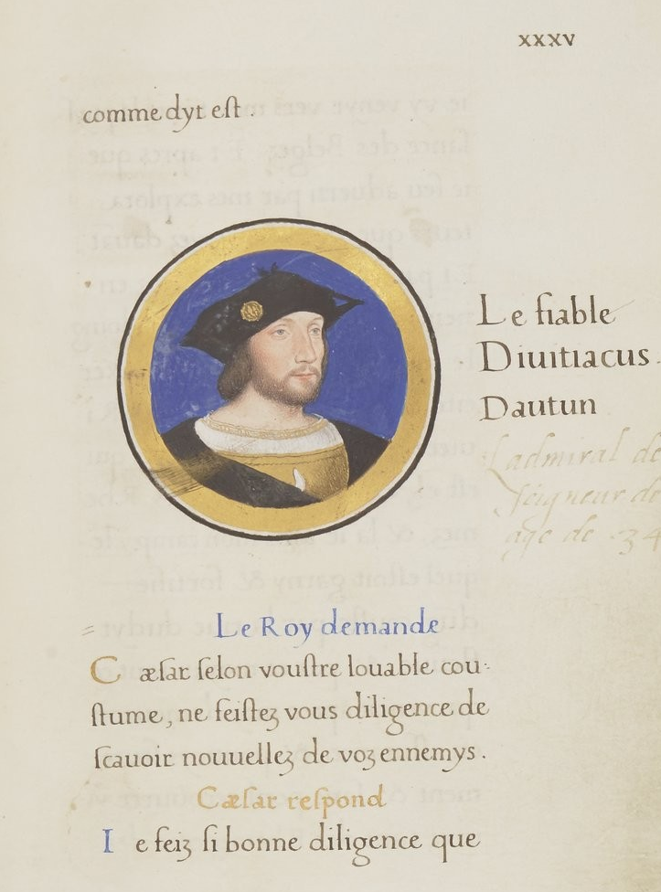
Fig.1: Jean Clouet, Guillaume de Gouffier, Seigneur de Bonnivet, 1519, illuminated manuscript on vellum, from Les Commentaires de la guerre gallique, vol II MS fr.13429 fol.35r, Paris, Biblioteque Nationale (Photo: Stable URL http://gallica.bnf.fr/ark:/12148/btv1b10509396p/f75.item [Last Accessed 16 September 2015].)
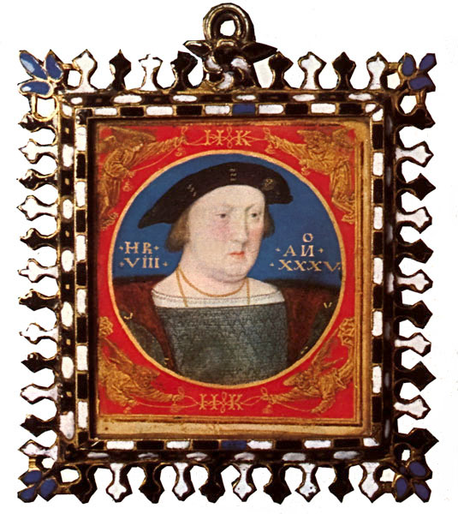
Fig.2: Lucas Horenbout, Henry VIII, c.1526, vellum on card, 5.3 x 4.8 cm, Cambridge, Fitzwilliam Museum (Photo: Stable URL http://tudorhistory.org/henry8/henrymin.jpg [Last Accessed 16 September 2015].)

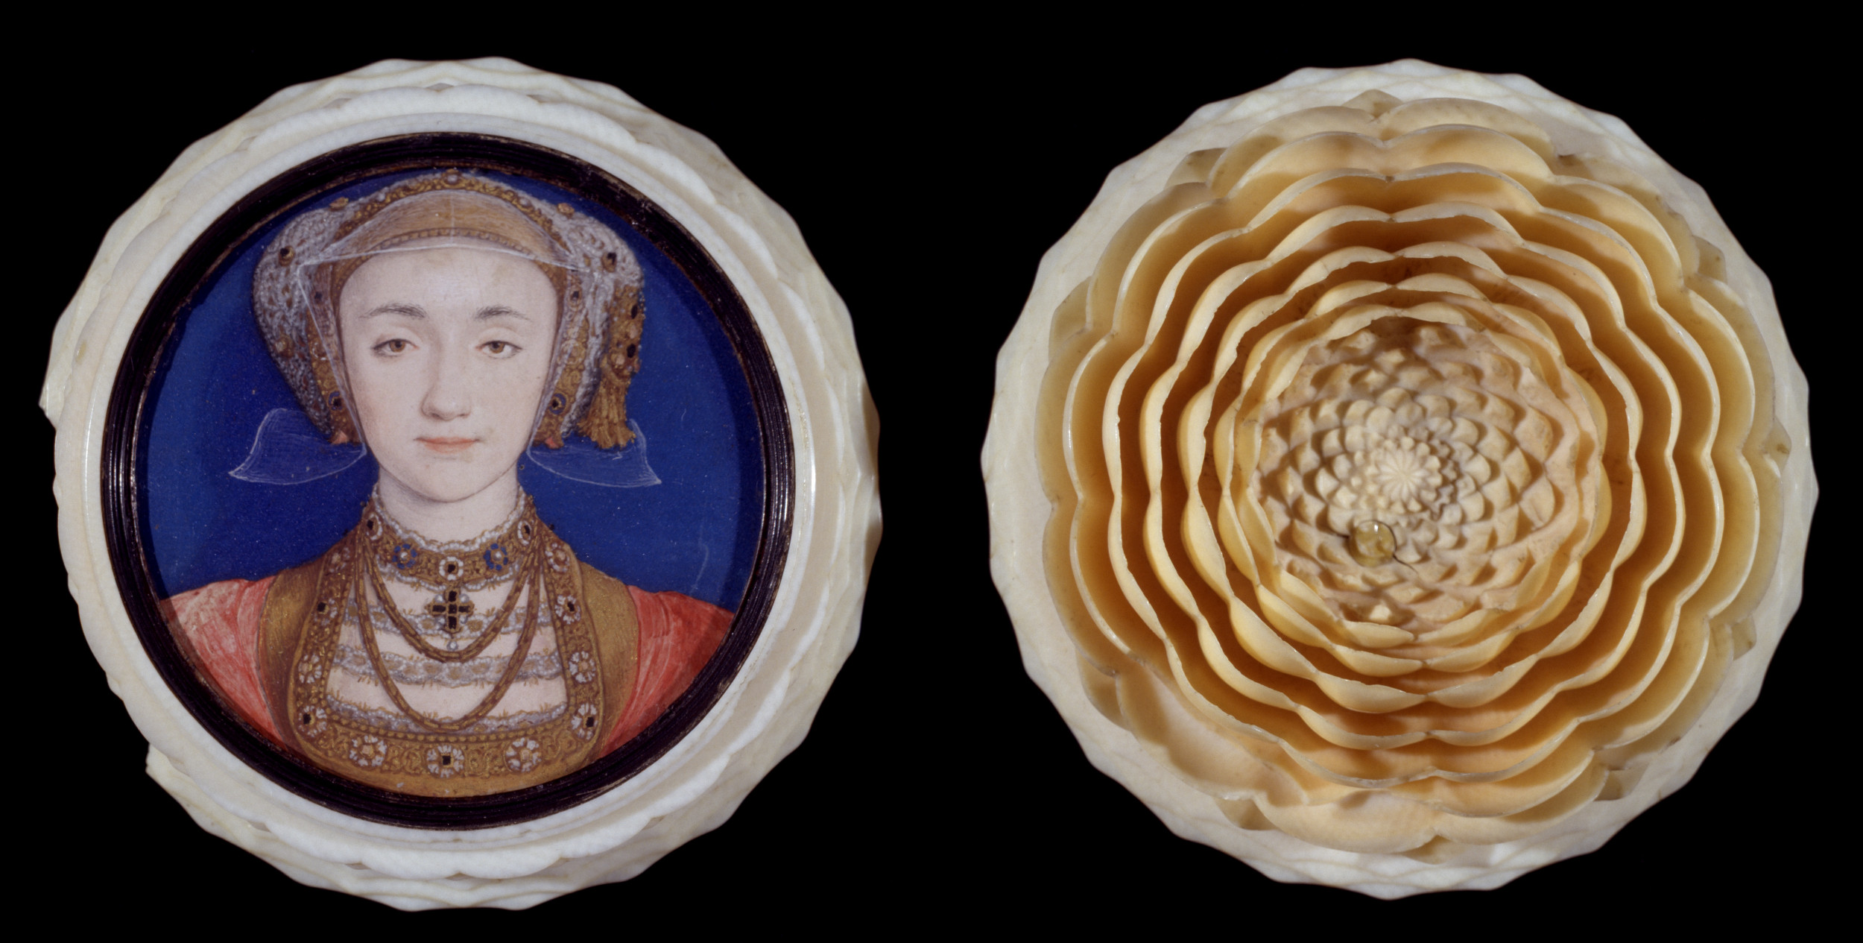
Fig.3: Hans Holbein the Younger, Anne of Cleves, c.1539 (painted), c.1580–1600 (made), watercolour on vellum in turned ivory, diameter of box 6.1 cm, London, Victoria & Albert Museum (Photo: Stable URL http://collections.vam.ac.uk/item/O18966/box-in-the-form-of-portrait-miniature-hans-holbein/ [Last Accessed 16 September 2015].)

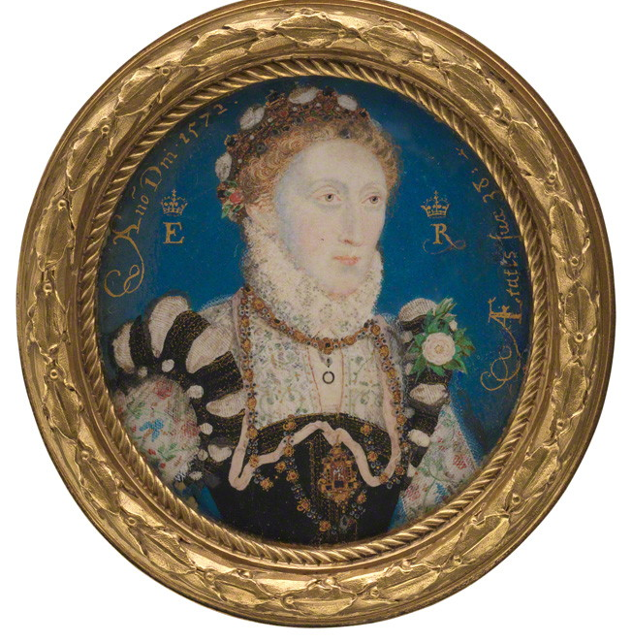
Fig.4: Nicholas Hilliard, Queen Elizabeth I, 1572, watercolour on vellum, 5.1 x 4.8 cm, London, National Portrait Gallery (Photo: Stable URL http://www.npg.org.uk/collections/search/portrait/mw02073/Queen-Elizabeth-I?LinkID=mp07108&role=art&rNo=0 [Last Accessed 16 September 2015].)

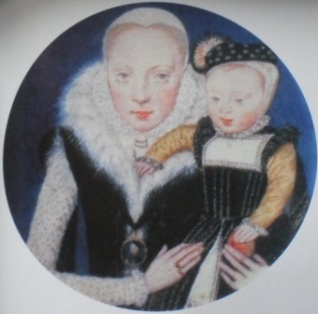
Fig.5: Levina Teerlinc, Catherine Grey, Countess of Hereford, c.1562–3, watercolour on vellum, dia. 5.1 cm, Belvoir Castle, Duke of Rutland Collection (Photo: Stable URL https://upload.wikimedia.org/wikipedia/commons/thumb/a/ad/Catherine_Grey_with_son.jpg/580px-Catherine_Grey_with_son.jpg [Last Accessed 16 September 2015].)
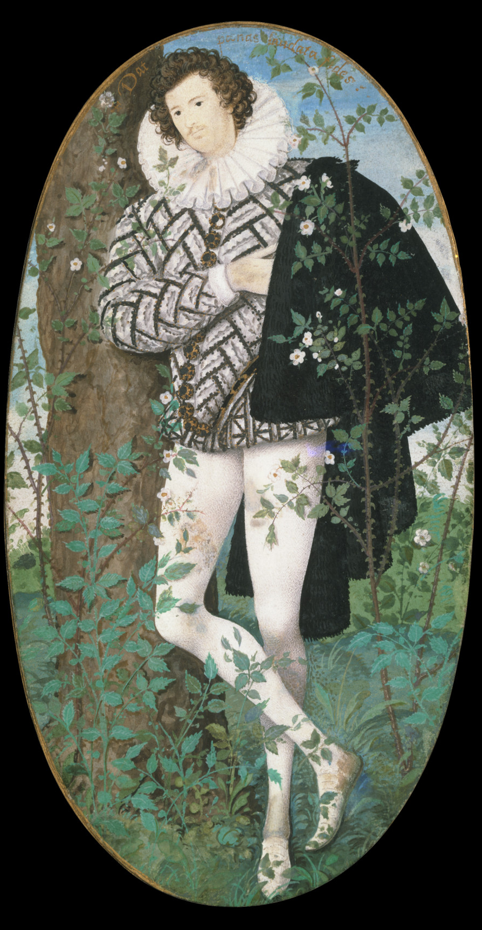
Fig.6: Nicholas Hilliard, Young Man among Roses, c.1587, watercolour on vellum stuck onto card, 13.5 x 7.3 cm, London, Victoria & Albert Museum (Photo: Stable URL http://collections.vam.ac.uk/item/O17315/young-man-among-roses-portrait-miniature-hilliard-nicholas/ [Last Accessed 16 September 2015].)

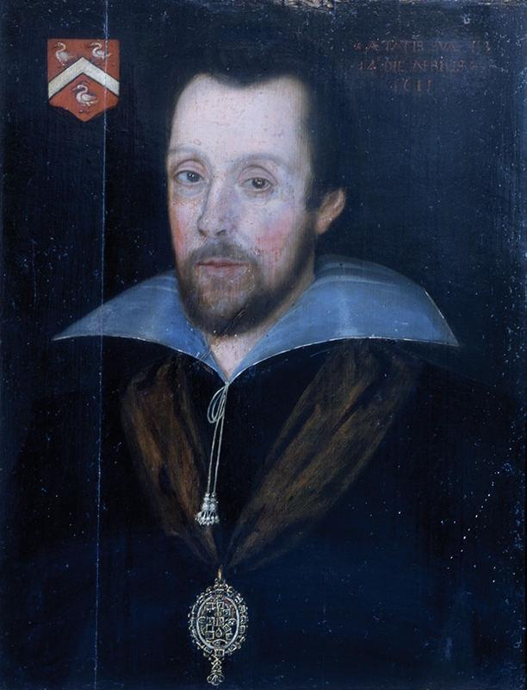
Fig.7: Unknown, Thomas Lyte of Lytes Cary, 1611, oil on wood, 60 x 48 cm, Somerset, Museum of Somerset (Photo: Stable URL http://somersetcollections.org.uk/content/somerset/painting-108-1998.ashx [Last Accessed 16 September 2015].)

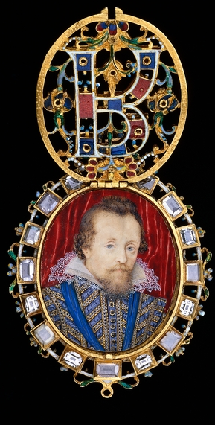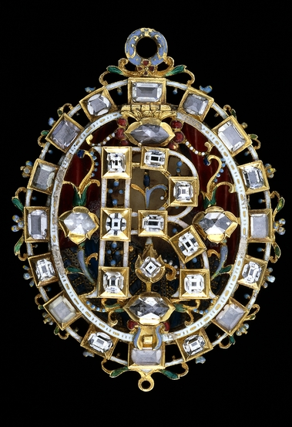
Fig.8: Nicholas Hilliard, The Lyte Jewel, c.1610–11, vellum gold, enamel and diamond, 7.9 x 6.4 cm, London, British Museum (Photo: Stable URL http://www.britishmuseum.org/research/collection_online/collection_object_details.aspx?objectId=7557&partId=1&searchText=MCN4437&page=1 [Last Accessed 16 September 2015].)

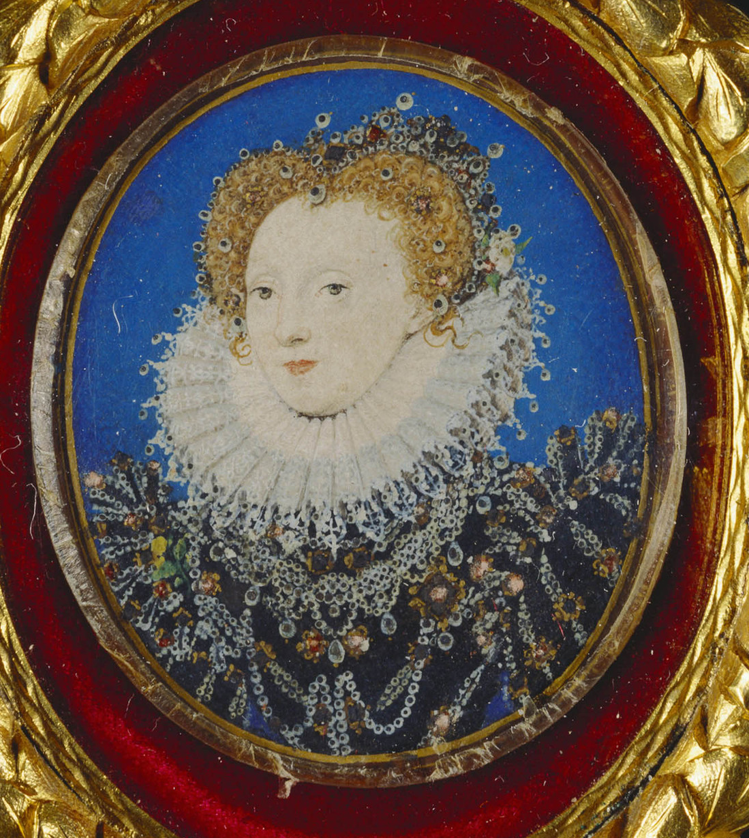
Fig.9: Nicholas Hilliard, Elizabeth I, c.1580–5, watercolour on vellum laid on paper, 3.8 x 3.3 cm, Windsor, Royal Collection Trust (Photo: Stable URL http://www.royalcollection.org.uk/collection/422026/elizabeth-i-1533-1603 [Last Accessed 16 September 2015].)

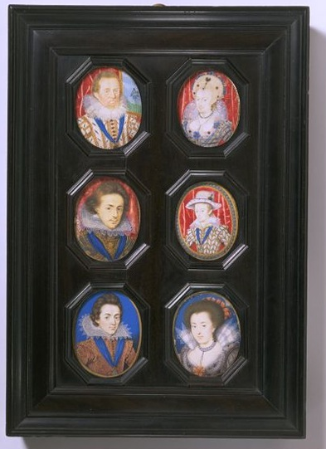
Fig.10: Nicholas Hilliard and Isaac Oliver, Miniatures of the Royal Family, framed together c.1625–1650, watercolour on vellum with frame of ebony on oak, 27.5 x 19.4 cm, London, Victoria & Albert Museum (Photo: Stable URL http://collections.vam.ac.uk/item/O78668/james-i-1566-1625-miniature-hilliard-nicholas/ [Last Accessed 16 September 2015].)
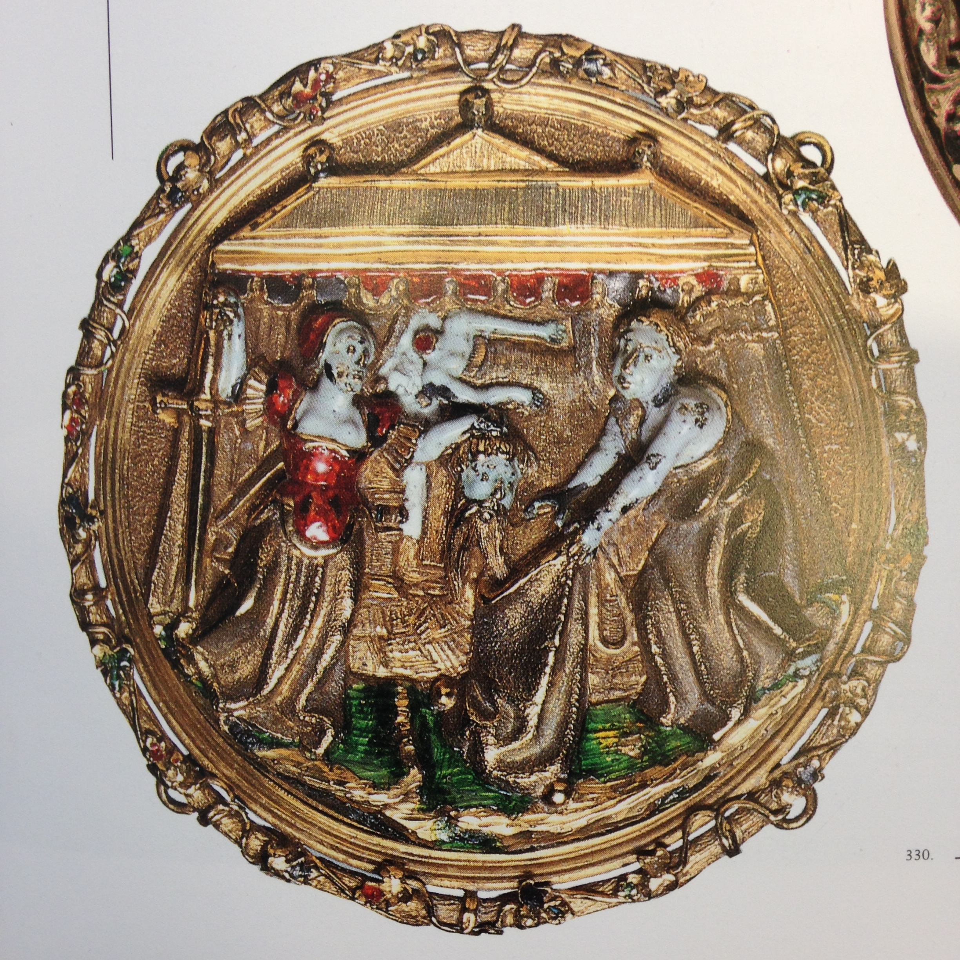
Fig.11: Unknown, Judith with the Head of Holofernes, enseigne (hat badge), c.1535–40, gold and enamel, dia, 5.3cm, London, Wallace Collection (Photo: Found in Hackenbroch, Enseignes: Renaissance Hat Jewels (1996) 357

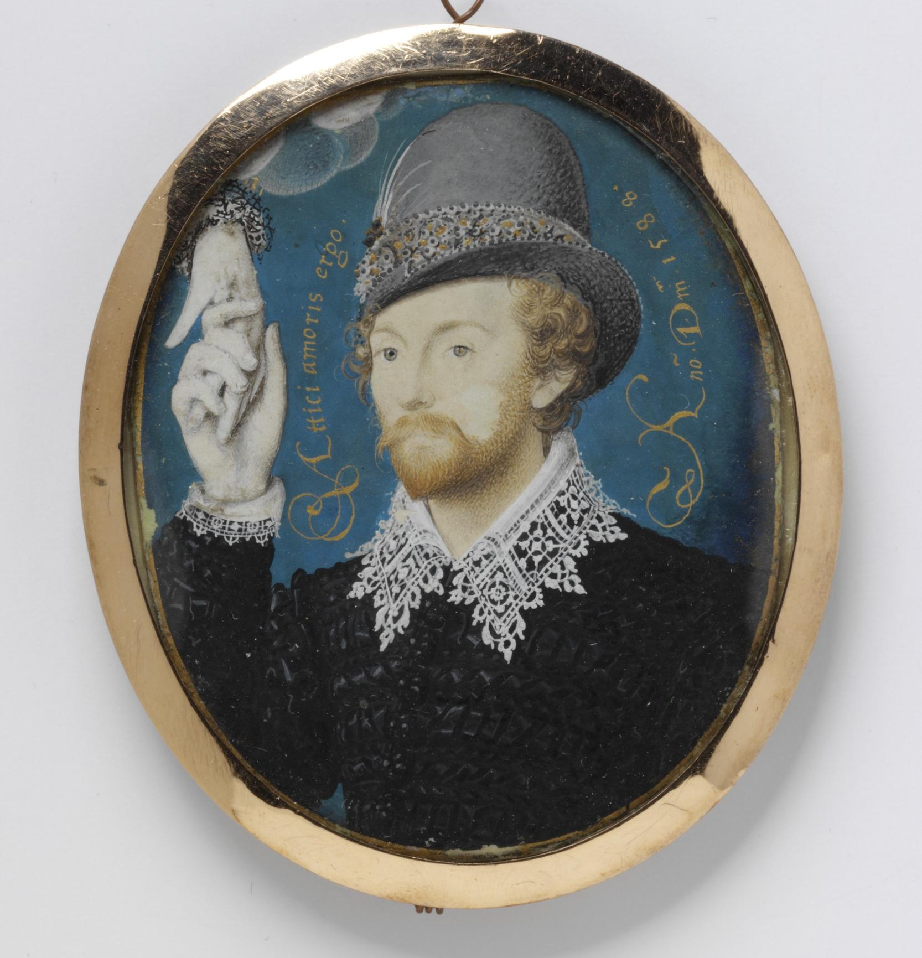
Fig.12: Nicholas Hilliard, Man Clasping a Hand from a Cloud, 1588, watercolour on vellum mounted on to a plain brown card (likely later), 6 x 4.95 cm, London, Victoria & Albert Museum (Photo: Stable URL http://collections.vam.ac.uk/item/O16580/man-clasping-a-hand-from-portrait-miniature-hilliard-nicholas/ [Last Accessed 16 September 2015].)

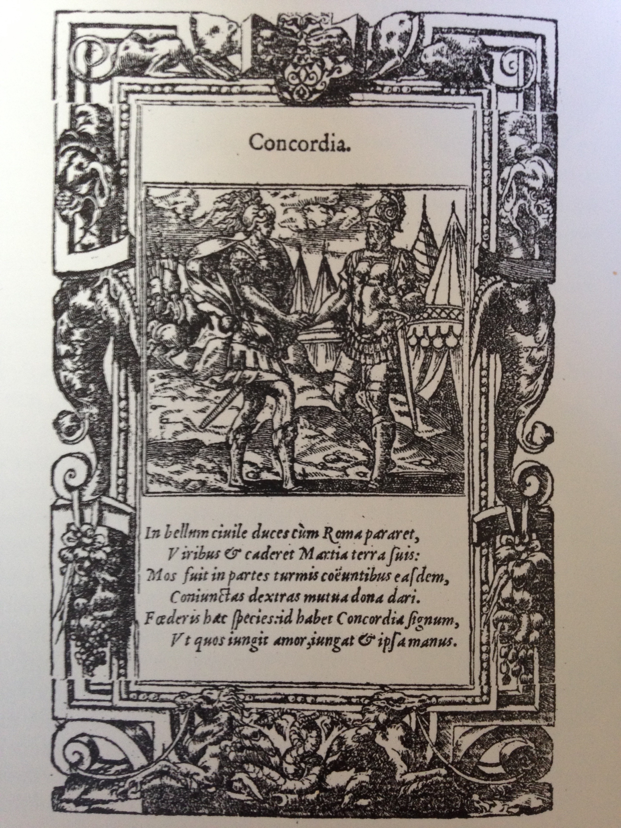
Fig.13: Alciati, Clasped Hands as an Emblem of Concordia, 1534, woodcut (Photo: found in Strong, The English Renaissance Miniature (1983), 94

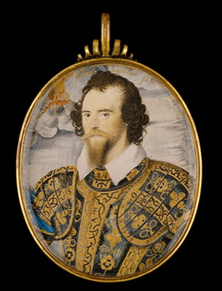
Fig.14: Nicholas Hilliard, George Clifford, 3rd Earl of Cumberland, c.1585–89, watercolour on vellum in brass mount, 6.99 x 5.56 cm, Kansas City, The Nelson-Atkins Museum of Art (Photo: Stable URL http://nelson-atkins.org/collections/iscroll-objectview.cfm?id=20858 [Last Accessed 16 September 2015].)

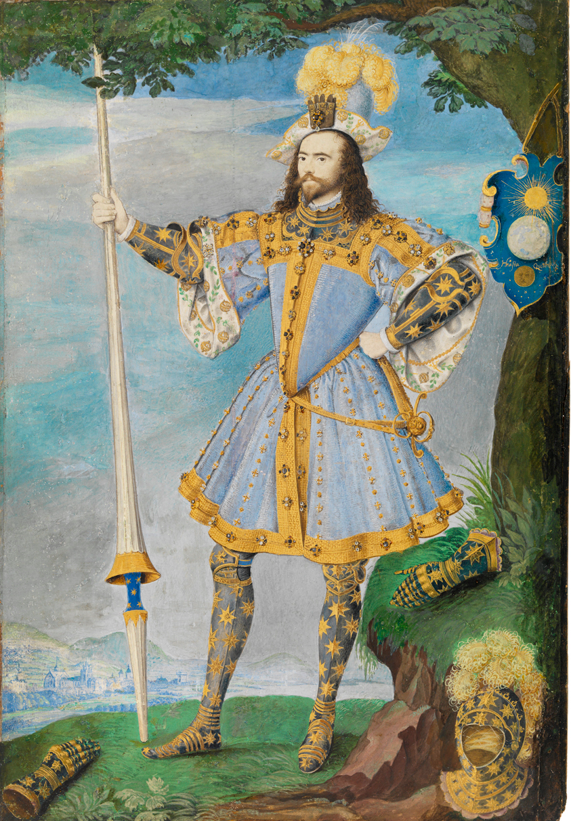
Fig.15: Nicholas Hilliard, George Clifford, 3rd Earl of Cumberland, c.1590, watercolour and body colour on vellum laid on fruitwood panel, 25.8 x 17.6 cm, London, National Maritime Museum (Photo: Stable URL http://collections.rmg.co.uk/collections/objects/42140.html [Last Accessed 16 September 2015].)
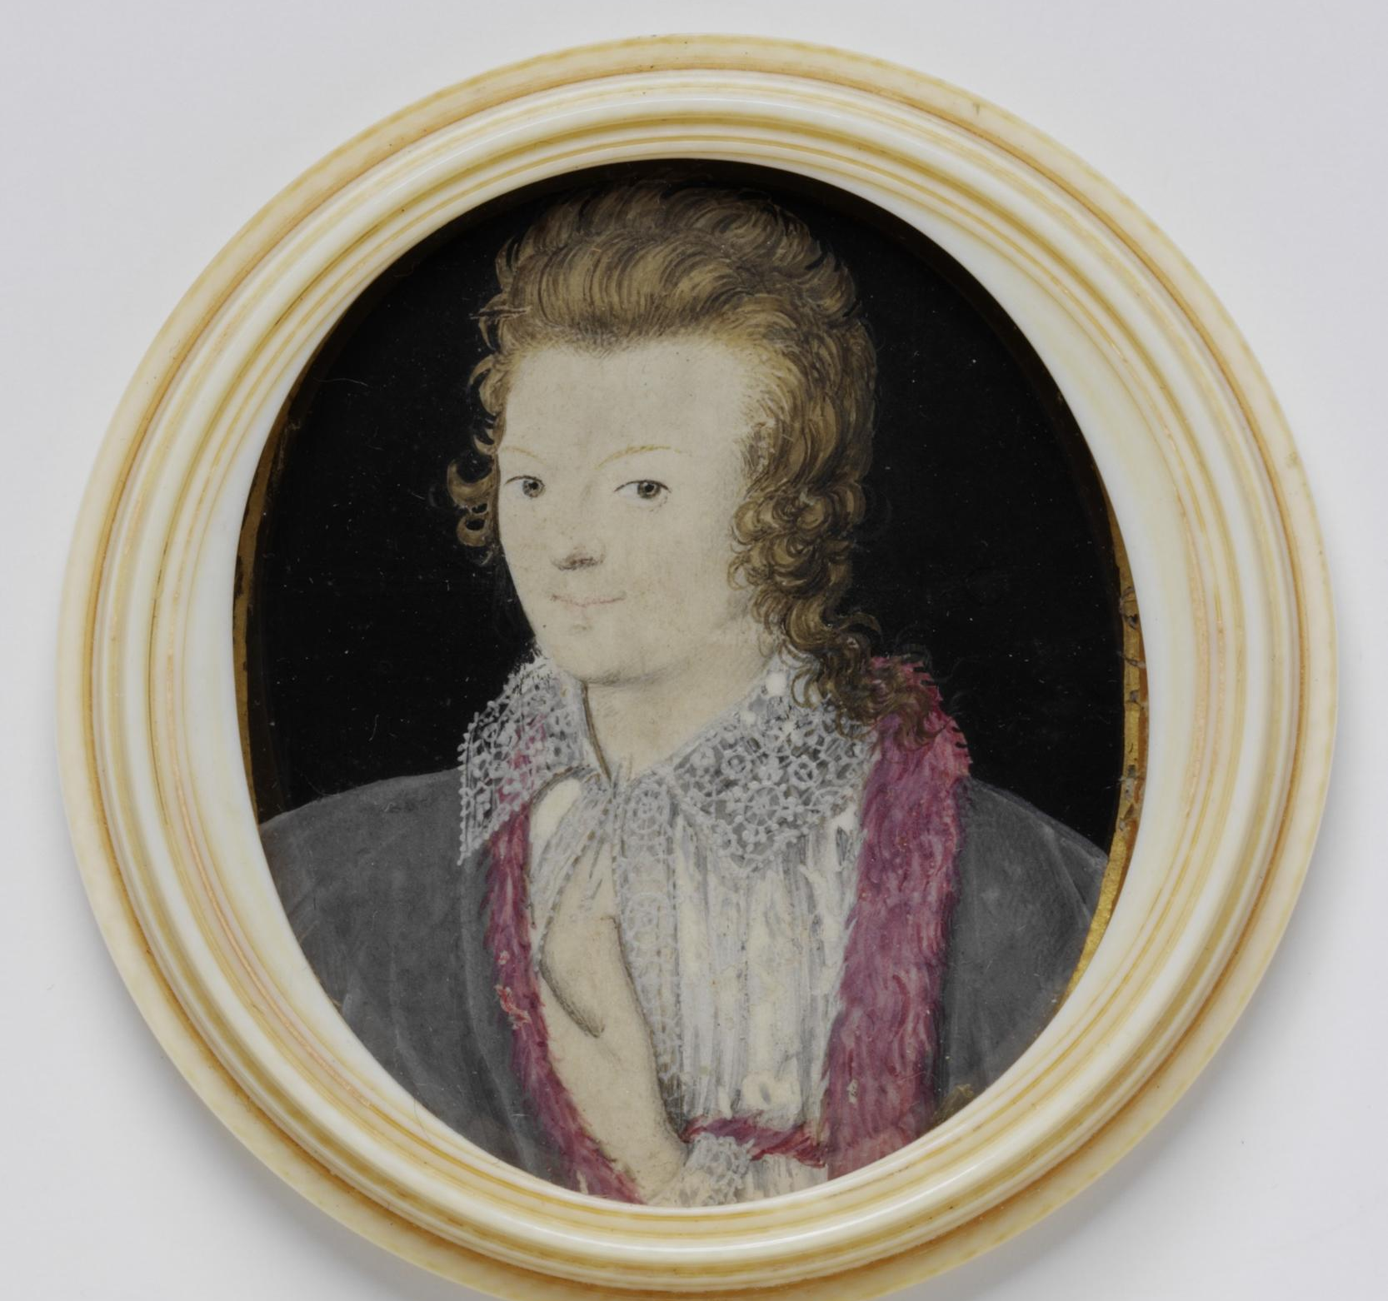
Fig.16: Nicholas Hilliard, An Unknown Young Man, 1590–93, watercolour on vellum mounted on the six of hearts playing card and contained in a box of turned ivory, 5 x 4.2 cm, London, Victoria & Albert Museum (Photo: Stable URL http://collections.vam.ac.uk/item/O81994/an-unknown-young-man-portrait-miniature-hilliard-nicholas/ [Last Accessed 16 September 2015].)

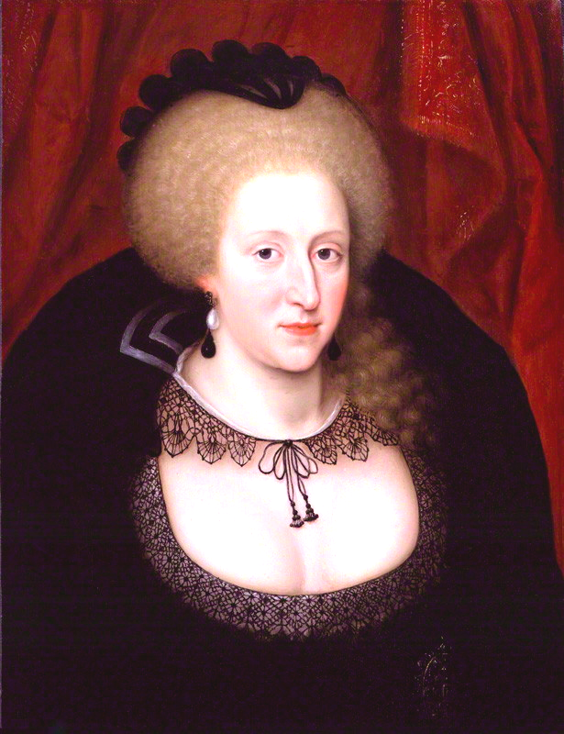
Fig.17: Unknown Artist, Anne of Denmark, wearing a jewelled portrait miniature in bottom right of painting, c.1628–44 (most likely a later copy), oil on panel, 57.2 x 43.8 cm, London, National Portrait Gallery (Photo: Stable URL http://www.npg.org.uk/collections/search/portraitLarge/mw00145/Anne-of-Denmark [Last Accessed 16 September 2015].)
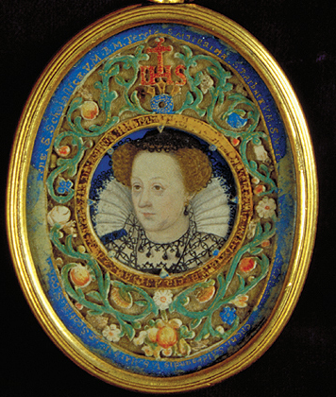
Fig.18: Unknown, Mary Queen of Scots: The Blairs Reliquary, miniature c.1575–80, encased in reliquary c.1610–22, watercolour on vellum in enamelled gold locket, miniature dia.3 cm, whole reliquary 8 x 6 cm, Aberdeen, Blairs Museum (Photo: Stable URL http://www.blairsmuseum.com/Learning/activities/image3.jpg [Last Accessed 16 September 2015].)

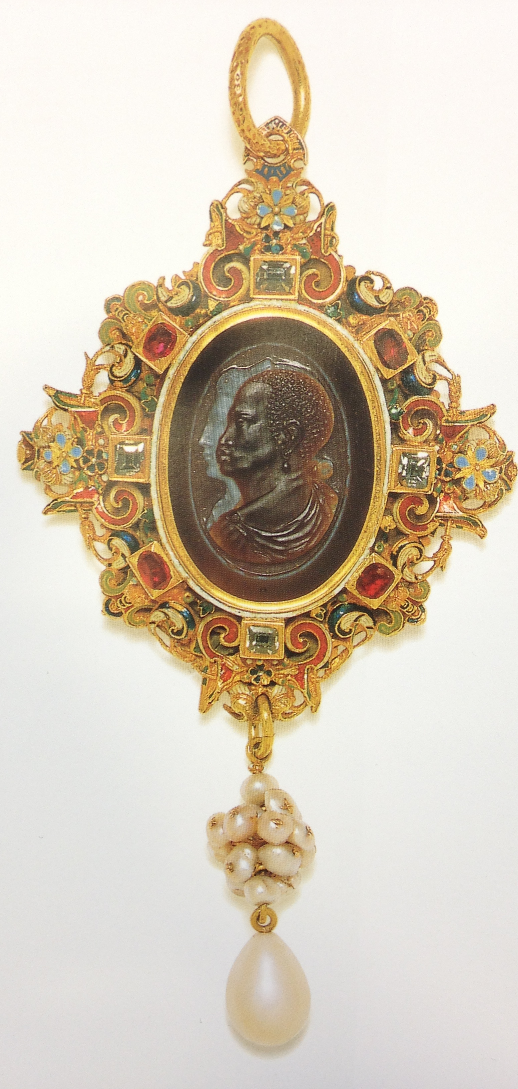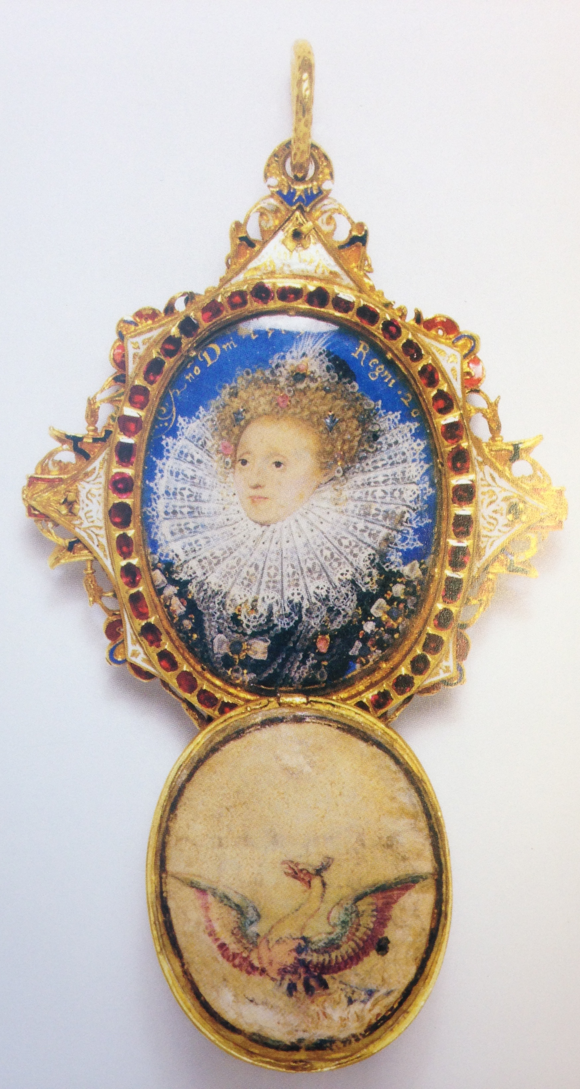
Fig.19: Nicholas Hilliard, The Drake Jewel, c.1586–7, enamelled gold, table-cut diamonds, rubies, pearls, sardonyx cameo, watercolour miniature on vellum, parchment, height 11.7 cm, London, Victoria & Albert Museum (loan) (Photo: Found in Scarisbrick, Portrait Jewels (2011) 60–61

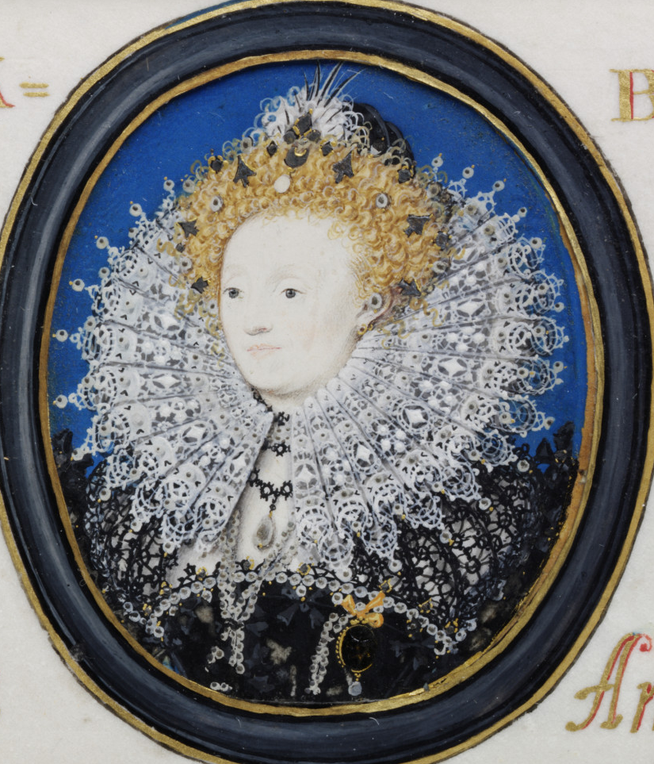
Fig.20: Nicholas Hilliard, Portrait of Queen Elizabeth I, a repetition of the portrait in the Drake Jewel, c.1585–90, watercolour on vellum laid on paper, 4.5 x 3.7 cm, London, Victoria & Albert Museum (Photo: Stable URL http://collections.vam.ac.uk/item/O81995/portrait-of-queen-elizabeth-i-portrait-miniature-hilliard-nicholas/ [Last Accessed 16 September 2015].)
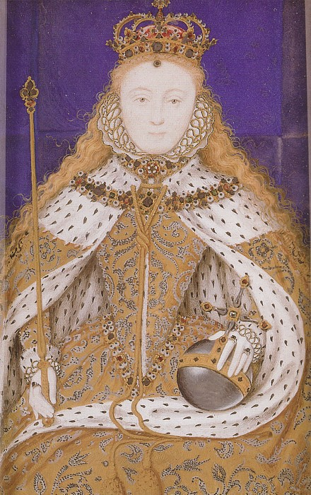
Fig.21: Nicholas Hilliard, Queen Elizabeth in Robes of State (a genuine table-cut diamond is in the centre of the orb surrounded by surrogate jewels); this is a historicising work which Hilliard copied from an earlier painting by another hand, c.1590, watercolour and a diamond on vellum, 9.1 x 5.6 cm, North Nottinghamshire, Welbeck Abbey (Photo: Stable URL https://commons.wikimedia.org/wiki/File:Elizabeth_I_Coronation_Miniature.jpg [Last Accessed 16 September 2015].)
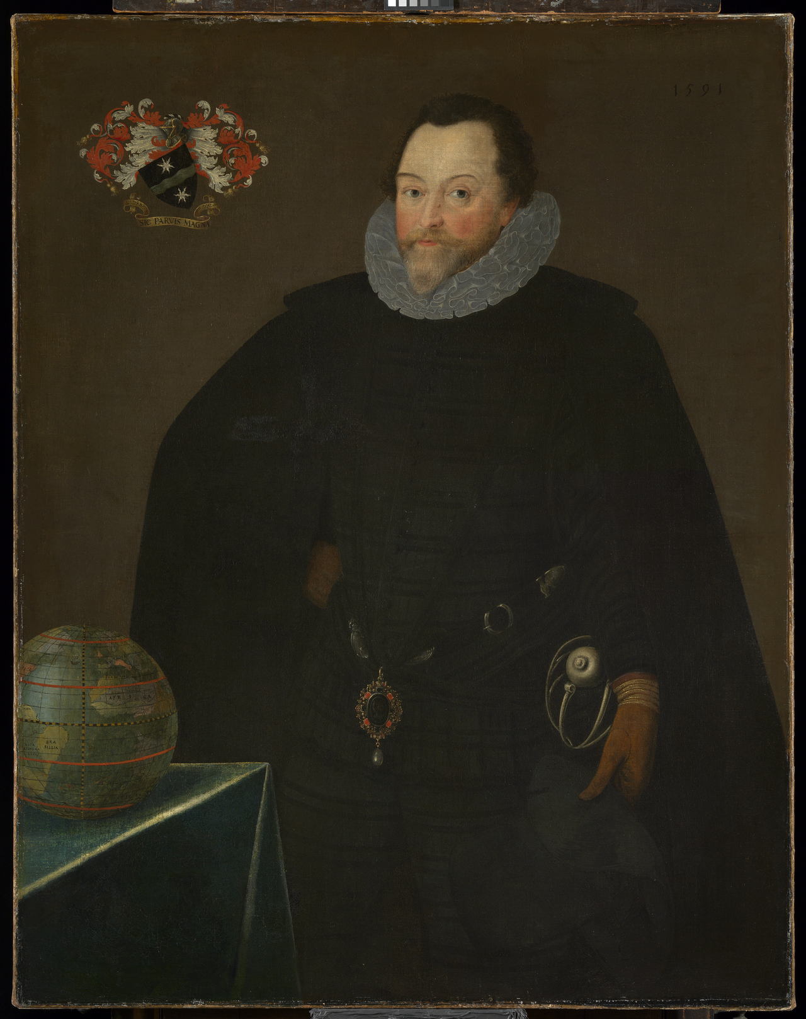
Fig.22: Marcus Gheeraerts, Sir Francis Drake, 1591, oil on canvas, 116.8 x 91.4 cm, London, National Maritie Museum (Photo: Stable URL http://collections.rmg.co.uk/collections/objects/14136.html [Last Accessed 16 September 2015].)
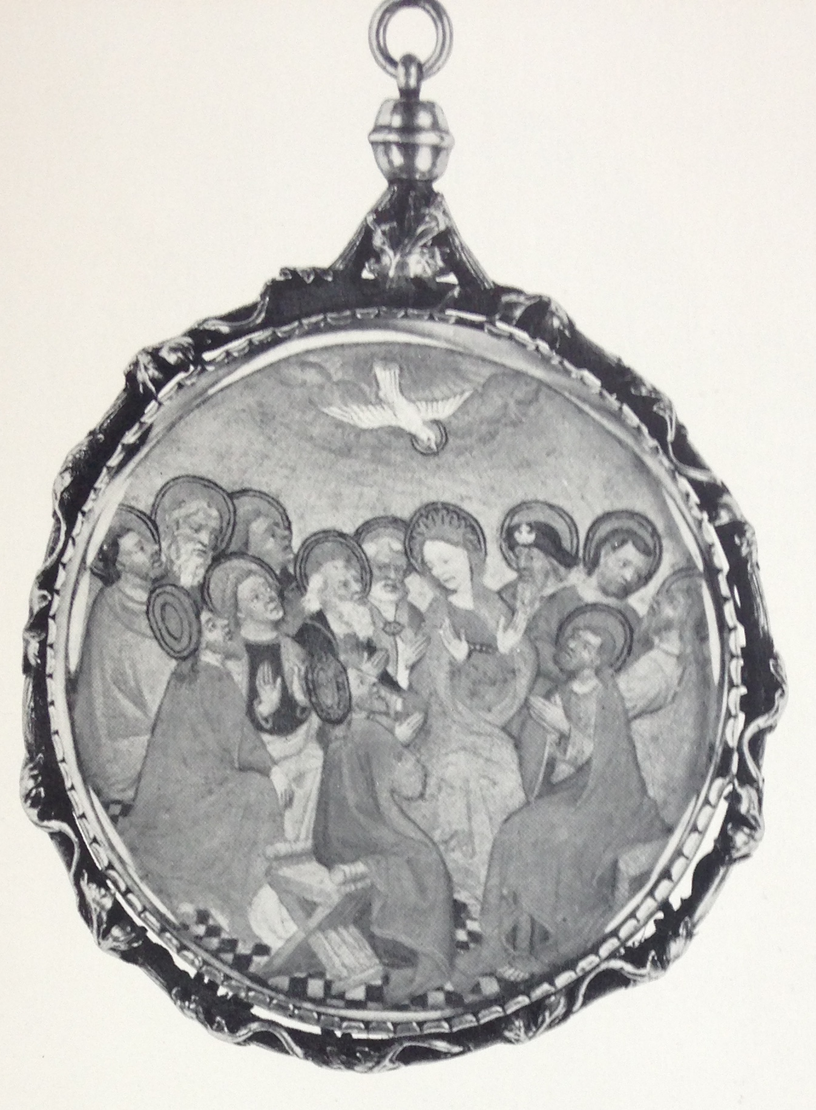
Fig.23: School of Paris, Pendant reliquary, c.1415–20, silver gilt with two rock crystals, a wax relief and a miniature, dia. 7.5 cm, Detroit, Detroit Institute of Arts (now lost) (Photo: found in Colding, Aspects of Miniature Painting (1953) Fig.52–53)

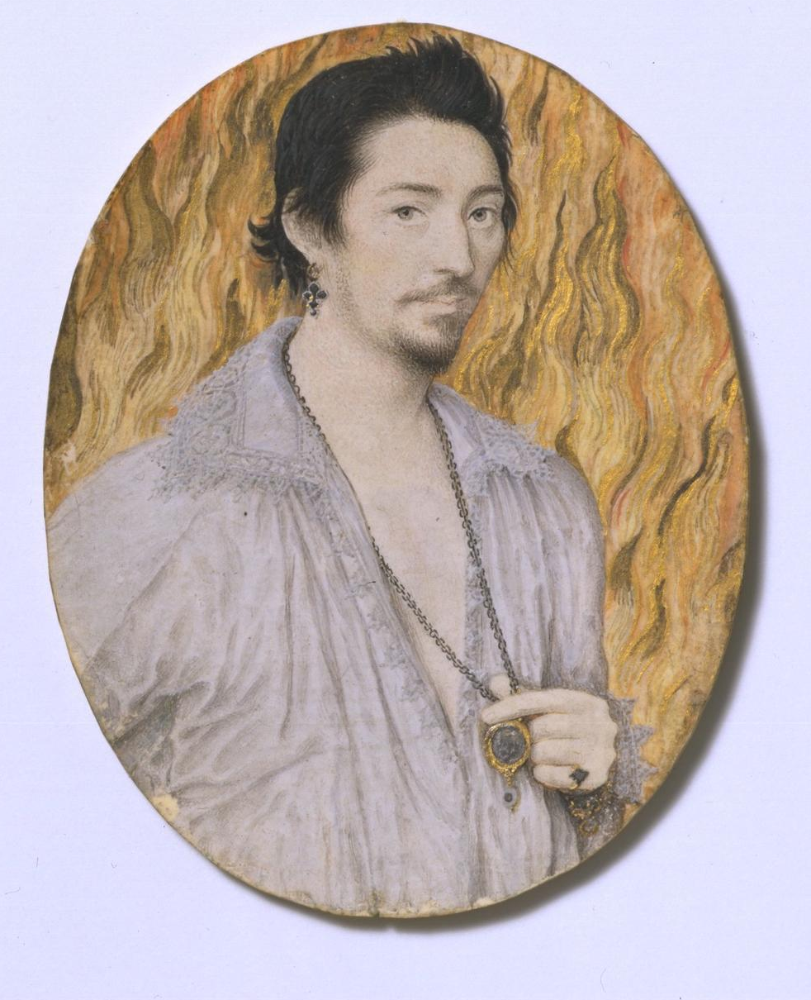
Fig.24: Attributed to Nicholas Hilliard, An Unknown Man, c.1600, watercolour on vellum stuck onto card, 6.9 x 5.4 cm, London, Victoria and Albert Museum (Photo: Stable URL http://collections.vam.ac.uk/item/O16579/an-unknown-man-portrait-miniature-hilliard-nicholas/ [Last Accessed 16 September 2015].)
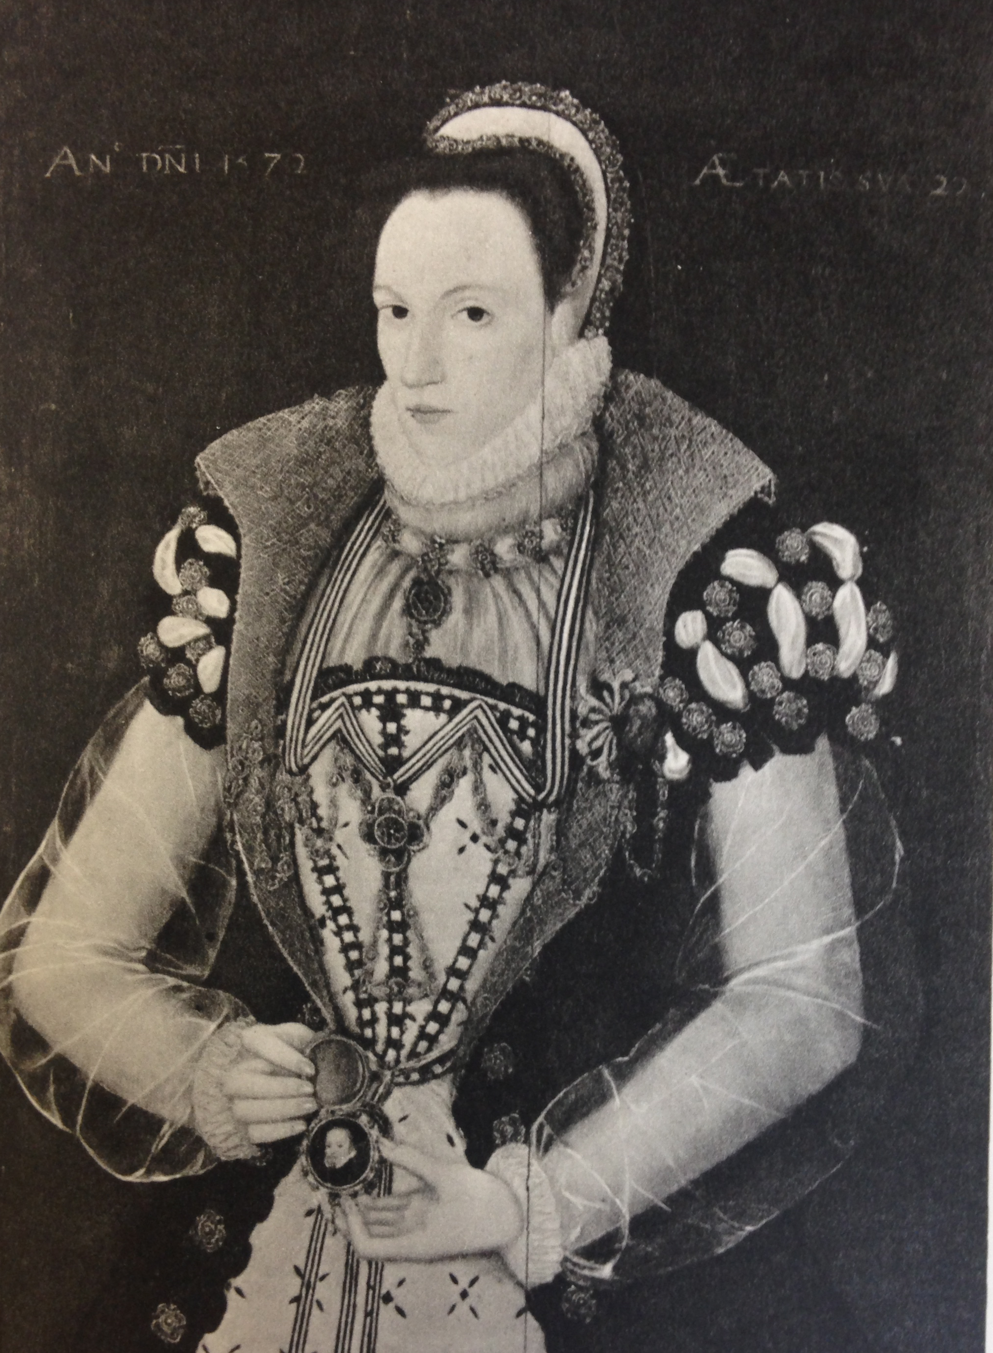
Fig.25: Attributed to George Gower, Lady Walsingham, 1572, oil on panel, 83.9 x 63.5 cm, Private Collection, The Viscount De L’Isle (Photo: found in Strong, The English Icon: Elizabethan & Jacobean Portraiture (1969) 171)

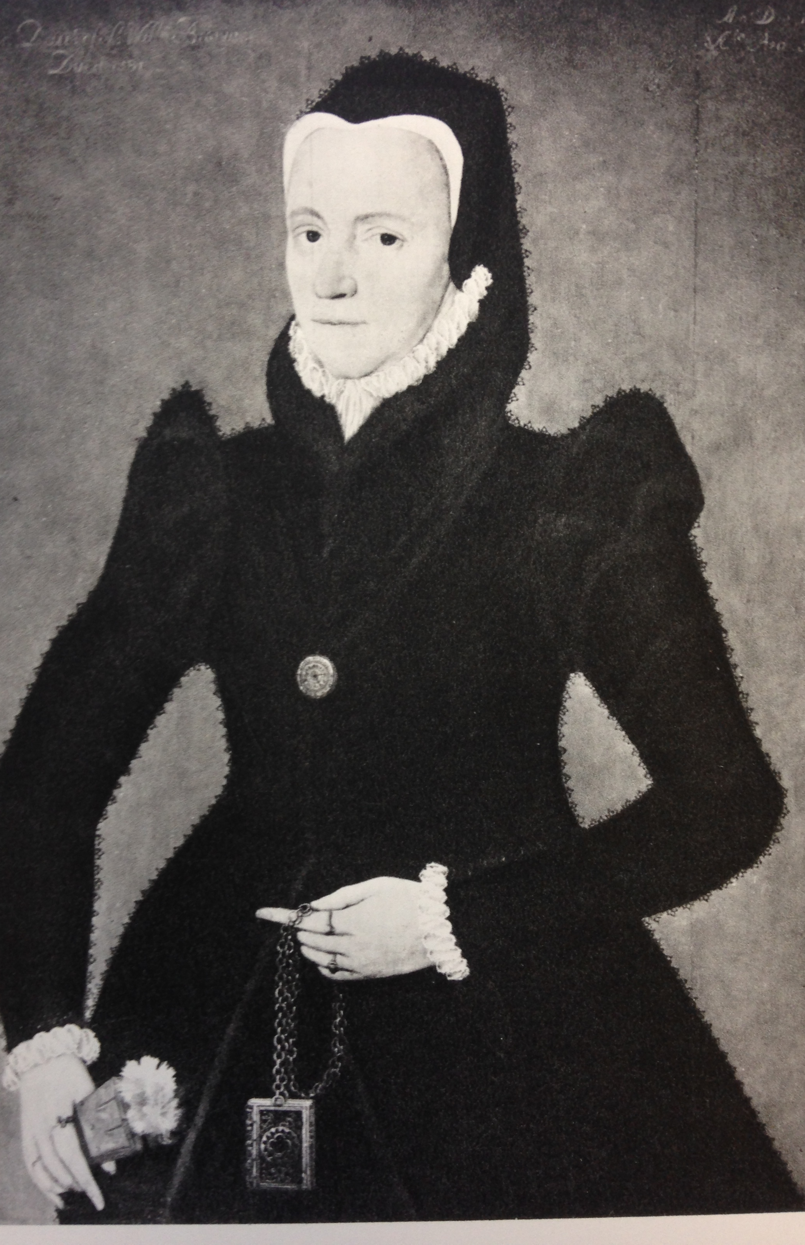
Fig.26: Attribute to Steven van der Meulen, Anne Browne, Lady Petre, holding a girdle prayer book, 1567, oil on panel, 86.4 x 61 cm, Private Collection, Lord Petre (Photo: found in Strong, The English Icon: Elizabethan & Jacobean Portraiture (1969) 128)

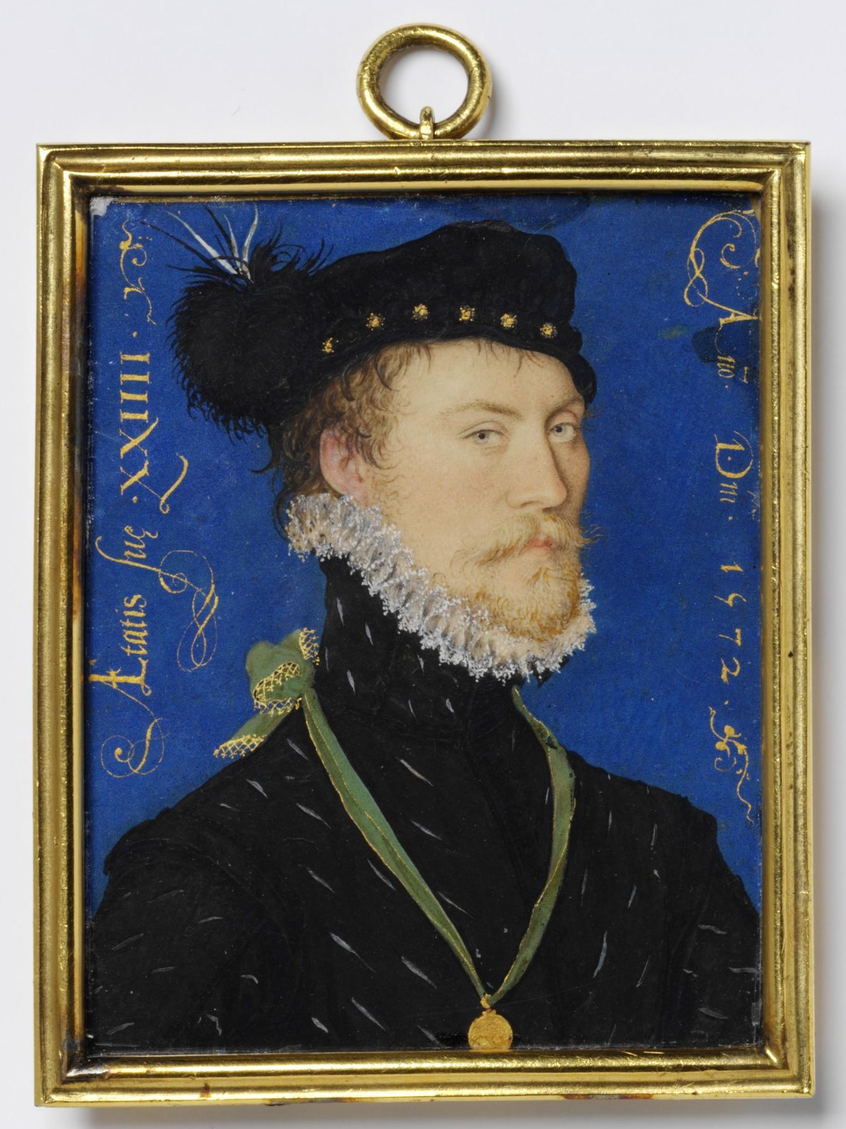
Fig.27: Nicholas Hilliard, An Unknown Man, aged 24, 1572, watercolour on vellum stuck to a playing card, 6 x 4.8 cm, London, Victoria & Albert Museum (Photo: Stable URL http://collections.vam.ac.uk/item/O16581/an-unknown-man-aged-24-portrait-miniature-hilliard-nicholas/ [Last Accessed 16 September 2015].)
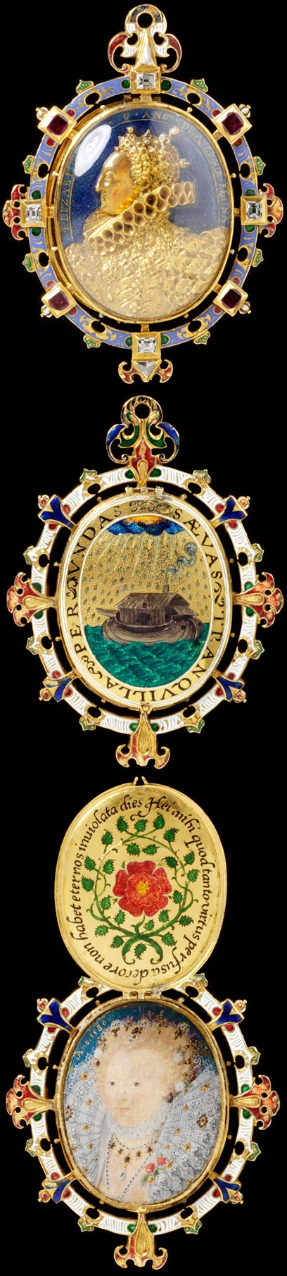
Fig.28: Nicholas Hilliard, The Armada Jewel (The Heneage Jewel), c.1595, enamelled gold, table-cut diamonds, Burmese rubies, rock crystal and a miniature painted on vellum, 7 x 5.1 cm, London, Victoria & Albert Museum (Photo: Stable URL http://www.vam.ac.uk/users/node/19136 [Last Accessed 16 September 2015].)

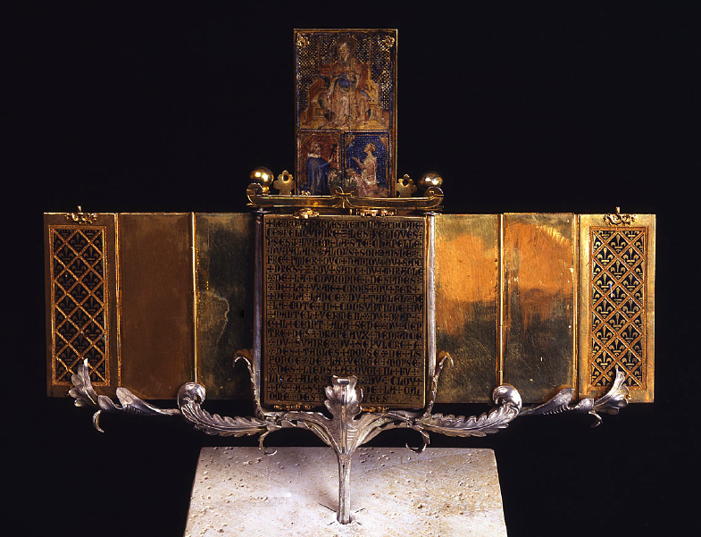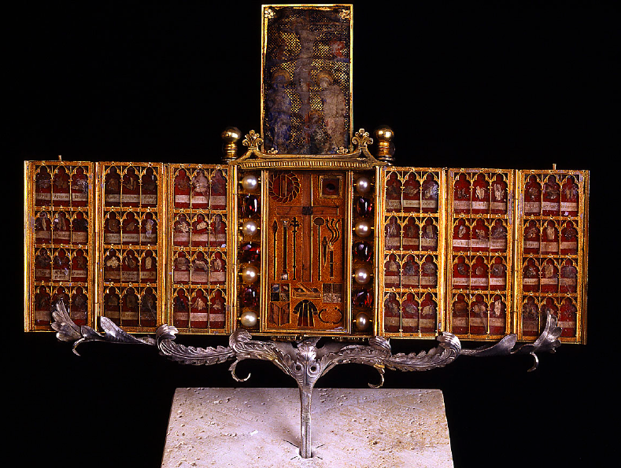
Fig.29: Parisian Goldsmith, Libretto, c.1380, gold, enamel, pearls, rubies, and parchment, 7.5 x 6.3 cm when closed, length 24.4 cm when opened, Florence, Museo dell’Opera del Duomo (Photo: found in Nash, Northern Renaissance Art (2008) 230–231)

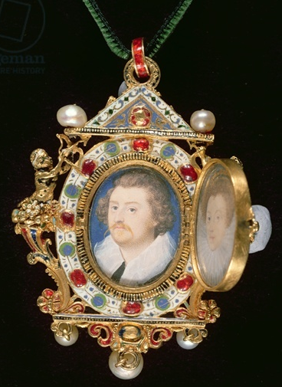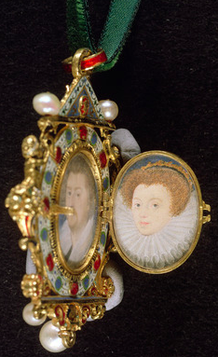
Fig.30: Nicholas Hilliard, The Gresley Jewel, c.1580–90, enamelled gold, table-cut rubies, emeralds, pearls, an onyx cameo and two miniatures painted on vellum, height 6.9 cm, Private Collection (Photo: Stable URL https://www.bridgemanimages.com/en-GB/asset/14568? [Last Accessed 16 September 2015].)

Howard, The Tudor Image (1995) 25
Coombs, The Portrait Miniature in England (1998) 8; 13
Piper, The English Face (1957) 60
Coombs (1998) 13; Strong, The English Renaissance Miniature (1983) 26
Ibid.
Coombs (1998) 13
Piper (1957) 45; 60
Greenblatt, Renaissance Self-Fashioning: From More to Shakespeare (2005) 2
Strong (1983) 29
Auerbach, Tudor Artists (1954) 71
Lloyd, Portrait Miniatures from the National Galleries of Scotland (2004) 10
Murdoch, Murrell, Noon and Strong, The English Miniature (1981) 26–9
Lloyd and Remington, Masterpieces in Little: Portrait Miniatures from the Collection of Her Majesty Queen Elizabeth II (1996) 25
Ibid.
Coombs (1998) 16–17
Ibid, 17; Lloyd and Remington (1996) 31
Howard (1995) 30
Coombs (1998) 27
Chapter Three will consider these types of interaction.
Reynolds, English Portrait Miniatures (1988) 1
Scarisbrick, Portrait Jewels: Opulence and Intimacy from the Medici to the Romanovs (2011) 52
Reynolds (1988) 1
Reynolds (1988) 1
Lloyd and Remington (1996) 11; 25
Colding, Aspects of Miniature Painting: Its Origins and Development (1953) 40
Scarisbrick (2011) 106
Reynolds (1988) 7–8
Besley, Out of Sight, Out of Mind: The Display and Interpretation of Portrait Miniatures (2008) 9
Coombs (1998) 19; Strong and Murrell, Artists of the Tudor Court: The Portrait Miniature Rediscovered 1520–1620 (1983) 9
Scarisbrick (2011) 52
Ibid.
Lebel, ‘British-French Artistic Relations’ (1948) 273–3 in Strong (1983) 28
Lloyd and Remington (1996) 12
Ibid, 32
Piper (1957) 75
Murdoch et al. (1981) 76
Shakespeare, Twelfth Night (2005) Act III Scene IV, line 204
Strong and Murrell (1983) 10
Murdoch et al. (1981) 72
Lloyd and Remington (1996) 12–13
Strong and Murrell (1983) 10
Ibid, 11–12
Murdoch et al. (1981) 68
Edmond, Hilliard and Oliver: The Lives and Works of Two Great Miniaturists (1983) 86–7; Imprese will be discussed in Chapter Two.
Sumner and Walker, Secret Passion to Noble Fashion: The World of the Portrait Miniature (1999) 14
Ibid.
Coombs (1998) 44–45
Besley (2008) 10
Strong and Murrell (1983) 9
Howard (1995) 56; Coombs (1998) 11
Philips, The Reformation of Images: Destruction of Art in England 1535–1660 (1973) 5
Ibid, 202; 203
Exodus 20:45, The Geneva Bible (1599) in Williams, Religious Pictures and Sculpture in Elizabethan England: Censure, Appreciation and Devotion (2001) 11
Philips (1973) 201
Williams (2001) 13
Ibid. These justifications will be looked at in detail in Chapter Two.
Philips (1973) 54
Fuller, The Church-History of Britain; From the Birth of Jesus Christ, Until the Year M.DC.XLVIII (1655) 214; Philips (1973) 54
Fuller (1655) 221
Philips (1973) 55
Ibid, 77
Ibid, 201
Ibid, 103
Ibid, 3
String, Art and Communication in the Reign of Henry VIII (2008) 105; Williams (2001) 16–17
Milner, The Senses and the English Reformation (2011) 1
Gardiner, Gardiner’s Lost Tract Against William Turner in Milner (2011) 1
Milner (2011) 2
Philips (1973) 101
Ibid, 105–7
Ibid, 112
Ibid, 113
McClain, ‘Using What’s at Hand: English Catholic Reinterpretations of the Rosary, 1559–1642’ (2003) 162
Doran, Elizabeth I and Religion 1558–1603 (2002) 14–15
Ibid.
Strong, The English Icon: Elizabethan & Jacobean Portraiture (1969) 9
Hamling and Richardson (eds.), Everyday Objects: Medieval and Early Modern Material Culture and Its Meanings (2010) 243
Philips (1973) 114
Griffiths (ed.), The Two Books of Homilies Appointed to be Read in Churches (1859), 221
Williams (2001) 24
Philips (1973) 123
13 Elizabeth I, c.2 in Scarisbrick, Jewellery in Britain 1066–1837: A Documentary, Social Literary and Artistic Survey (1994) 97
Philips (1973) 117
Scarisbrick (2011) 106
Coombs (1998) 8; Strong and Murrell (1983) 9
Coombs (1998) 8; 27
Besley (2008) 6; Strong (1969) 1
Strong (1969) 3
Philips (1973) 207
Besley (2008) 6
Freedberg, The Power of Images: Studies in the History and Theory of Response (1989) 162; Freedberg’s translation of Commentarium super libros sententiarum: Commentum in librum III, dist. 9, art. 2, qu. 2.
See Chazelle, ‘Pictures, Books, and the Illiterate: Pope Gregory I’s Letters to Serenus of Marseilles’ (1990) 138–53
Ringbom, Icon to Narrative: The Rise of the Dramatic Close-Up in Fifteenth-Century Devotional Painting (1984) 11
Williams (2001) 16
Philips (1973) 41
Ibid, 208
Ibid, 41
Colding (1953) 95; Murdoch et al. (1981) 68
Edmond (1983) 38; Reynolds (1988) 12
Lloyd and Remington (1996) 25
Camden, Remains Concerning Britain (1984) 177
Ibid.
Hackenbroch, Enseignes: Renaissance Hat Jewels (1996) 2; 374
Ibid, ii
Howarth, Images of Rule: Art and Politics in the English Renaissance, 1485–1649 (1997) 107; Hackenbroch (1996) i
Scarisbrick, Tudor and Jacobean Jewellery (1995) 70
Evans, English Jewellery From the Fifth Century A.D to 1800 (1921) 87
Strong (1983) 95; 96
Scarisbrick (1994) 94
Edmond (1983) 87; Reynolds (1988) 13
Strong (1969) 30
Coombs (1998) 34
A detailed (although not universally accepted) attempt to decipher this miniature can be read in Hotson, Shakespeare by Hilliard (1977)
Lloyd and Remington (1996) 42
Strong, The Cult of Elizabeth: Elizabethan Portraiture and Pageantry (1999) 111
Coombs (1998) 34
Edmond (1983) 90
Strong (1999) 69; Edmond believes that they are Rosa arvensis instead of Rosa eglanteria. However, Strong’s interpretation is more widely accepted. See Edmond (1983) 88–91
Edmond (1983) 91
Coombs (1998) 34
Strong (1983) 95
Coombs, ‘English Limning: The Portrait Miniature in Tudor and Early Stuart England’ (2013) 48; Strong (1983) 95–96
Ibid, 96
Ibid.
Ibid; Strong and Murrell (1983) 134
Ibid.
Ibid, 133
Ibid, 134
Ibid, 134–5
For example, imprese in Italy can be seen in Rolo, overo cento imprese de gl'illustri sigri. huomini d'arme sanesi, militanti sotto'l Reale, e felicissimo stendardo del Serenissimo Ferdinando de' Medici, Gran Duca III. di Toscana MDXCI. xxiiii. di Giugno (Bologna, 1591), where Sienese nobles expressed their allegiance to the Grand Duke of Tuscany through their imprese.
Hackenbroch (1996) i
Freedberg (1989) 162
Gent and Llewellyn (eds.), Renaissance Bodies: The Human Figure in English Culture c.1540–1660 (1990) 76
Williams (2001) 27
Gent and Llewellyn (eds.) (1990) 76
Gerson, Opera Omnia, II in Nash, Northern Renaissance Art (2008) 271
Nash (2008) 271
Strong and Murrell (1983) 10
Philips (1973) 10; Pointon, ‘“Surrounded with Brilliants”: Miniature Portraits in Eighteenth-Century England’ (2001) 57
Frank, Love and Loss: American Portrait and Mourning Miniatures (2000) 1
‘Elegy 12. His Picture’, lines 1–2; 5; 13 in Stringer (ed.), The Variorum Edition of the Poetry of John Donne, Vol.2: The Elegies (2000) 264
Strong and Murrell (1983) 80
Scarisbrick (2011) 73
Ringbom (1988) 12
Ibid, 13
Gent and Llewellyn (eds.) (1990) 45; Piper (ed.), The Genius of British Painting (1975) 78
Ringbom (1988) 12
Frank (2000) 16
Sumner and Walker (1999) 15
Freedberg (1989) 205
Proclamation of 19 September 1560, in Aston, England’s Iconoclasts: Laws Against Images (1988) 315
Aston (1988) 257
Philips (1973) 59
Freedberg (1989) 164
Smailes and Thomson, The Queen’s Image: A Celebration of Mary, Queen of Scots (1987) 37; It is not certain that these survive, however the The Blairs Reliquary’s miniature was likely painted from life and is perhaps one of the four made in prison, or copied from one.
Scarisbrick (2011) 54
Smailes and Thomson (1987) 38
Ibid, 37–38
Ibid, 38
Williams (2001) 13
Ibid, 14
Griffiths (ed.) (1859) 233
Williams (2001) 14
Dalton, ‘Art for the Sake of Dynasty: The Black Emperor in the Drake Jewel and Elizabethan Imperial Imagery’ (2000) 178
Spenser, The Fairy Queen (1996) 584; Scarisbrick (2011) 30; 61
Reynolds (1988) 12
Strong (1983) 92
Strong, Gloriana: The Portraits of Elizabeth I (1987) 41
Ibid, 147; Hilliard, A Treatise Concerning the Arte of Limning (1992) 65
Piper (1957) 68–9
Coombs (1998) 34
Edmond (1983) 60
Strong (1987) 109; Strong and Murrell (1983) 11
Lloyd and Remington (1996) 12–13
Strong (1983) 92
Ibid, 65
Lloyd and Remington (1996) 12; Scarisbrick (2011) 36
Davies and Kennedy, Medieval and Renaissance Art: People and Possessions (2009) 294
Strong (1983) 85; Chapter Three will discuss the setting and wearing of this jewel.
Strong and Murrell (1983) 11
Auerbach (1954) 103; Davies and Kennedy (2009) 269
Dalton (2000) 179
Strong (1987) 36
Strong (1983) 81
Strong (1987) 43
Ibid, n.120
Strong (1999) 114; 16
Ibid, 69
Yates, ‘Queen Elizabeth as Astraea’ (1947) 74
Howarth (1997) 90
Piper (ed.) (1975) 104; Yates (1947) 75
Ibid.
Griffiths (ed.) (1859) 167
Williams (2001) 22–23
Mark 12:17
Philips (1973) 119
Ibid, 120; Strong (1999) 16
Piper (ed.) (1975) 79
Bolton-Smith, ‘Miniatures and Museums’ (1980) 306
Sander, Rise and Growth of the Anglican Schism (1877) 172
Strong (1987) 40–41
Coombs (2013), 47; Philips (1973) 119
Somers Cocks (ed.), Princely Magnificence: Court Jewels of the Renaissance, 1500–1630 (1980) 60; Strong (1987) 34
Lloyd and Remington (1996) 12
Ibid.
See n.37
Murrell, The Way Howe to Lymne: Tudor Miniatures Observed (1983) 13; Edmond (1983) 40
Hilliard (1992) 43
Murdoch et al. (1981) 7–8
Murrell (1983) 34
Strong (1983) 119
Ibid.
Somers Cocks (ed.) (1980) 4
Coombs, ‘“A Kind of Gentle Painting”: Limning in 16th-Century England’ (2009) 48
Somers Cocks (ed.) (1980) 61
Scarisbrick (1994) 106
Scot, The Discoverie of Witchcraft (1886) 240
Evans, Magical Jewels of the Middle Ages and the Renaissance, Particularly in England (1922) 152; Scot (1886) 242
Magnus, The Book of Secrets of Albertus Magnus (1973) 31, 44
Barrett-Graves (ed.), The Emblematic Queen: Extra-Literary Representations of Early Modern Queenship (2013) 46
Bartholomaeus, De Proprietatibus Rerum (1582) 262; Barrett-Graves (ed.) (2013) 46
Rodini, ‘Renaissance Jewelry in the Alsdorf Collection: Functional Jewels’ (2000) 76
Evans (1921) 59–60
British Library, Royal MMS: Appx 68, ff. 7, 7b in Scarisbrick (1994) 110; Davies and Kennedy (2009) 244
Hole, ‘Some Instances of Image-Magic in Great Britain’ (1973) 80
Kunz, The Curious Lore of Precious Stones (1971) 102
Murdoch et al. (1981) 2
Hamling and Richardson (eds.) (2010) 248
Norgate, Miniatura or the Art of Limning (1997) 68
Hamling and Richardson (eds.) (2010) 248
Hilliard (1992) 45
Steuart (ed.), Memoirs of Sir James Melville of Halhill 1535–1617 (1929) 94
Labarte, Inventaire du mobilier de Charles V, 282–326 (items 2635–3140) in Nash (2008) 237
Lloyd and Remington (1996) 12
Fumerton, ‘“Secret” Arts: Elizabethan Miniatures and Sonnets’ (1986) 57
‘Sir H. Unton to her Majesty, from Coucy, Feb. 3, 1595–6’ in Burghley, A Collection of State Papers Relating to Affairs in the Reign of Elizabeth, from the year 1571 to 1596, vol.2 (1759), 718
Hilliard (1992) 67
Dircks, (ed.), The Autobiography of Edward, Lord Herbert of Cherbury (1888) 79
Ibid, 87
Colding (1953) 48
Ibid.
Cammell, The Great Duke of Buckingham (1939) 166
Reynolds, In Fine Style: The Art of Tudor and Stuart Fashion (2013) 68; Rodini (2000) 76
Scarisbrick (1995) 47
Scarisbrick (1994) 134
B.L., Royal App. 68, f.7 in Somers Cocks (ed.) (1980) 39
Coombs (1998) 32
Besley (2008) 5
Murdoch et al. (1981) 73
Nash (2008) 229
Ibid, 231–2
Ibid, 231
Edmond (1983) 75
Milner (2011) 25
Butler, The Truths of the Catholic Religion: Proved from Scripture Alone, Vol.1–2 (1841) 313
Burghley (1759) 718
Ringbom (1984) 48
Griffiths (ed.) (1859) 249
Strong (1999) 114
Ibid.

