From data to knowledge: librarians, metadata and the curation of culture

Richard Gartner
Warburg Institue
University of London
London, United Kingdom
Richard.gartner@sas.a.cuk

Abstract—The importance of metadata in the formation of knowledge and culture is discussed in relation to the epistemological model known as ‘Ackoff’s Pyramid’. The importance of libraries and librarians in the curation of culture is examined particularly in the context of their historical and current roles in the development of metadata.
Keywords—metadata; formation of knowledge; curation of culture; epistemology

Introduction (Heading 1)
Librarians are often seen as custodians of a cultural legacy, its keepers whose role is to preserve the intellectual (and not so intellectual) heritage of a culture and to disseminate it with an generation and from one to the next. Cultures develop continuously and so do libraries to accommodate the ever-changing cultural landscape within which they work: not for nothing did S.R. Ranganathan state that 'A library is a living organism' as one of his five laws of library science. The attribution of this role to libraries is undoubtedly valid and demonstrates how fundamental libraries are to a culture's well-being: for this reason their history goes back millennia and this history is full of grandiose libraries that stretch back into antiquity and demonstrate that their importance has been recognized for a long as we have had a written record to preserve the thoughts and achievements of humanity.
There is, however, something slightly passive in this view of libraries, a sense that they react to culture and its shifting sands rather than have a role in shaping it. Norman Cousins spoke of a library as "the delivery room for the birth of ideas, a place where history comes to life” [1, p. 474], but do librarians have a more fundamental role in the birth of ideas that simply acting as the location in which they are formed? The purpose of this paper is to examine one area in which librarians have been at the centre of developments throughout history: this is metadata, the 'data about data' with which we work every day. It seeks to demonstrate how fundamental is metadata to the formation of knowledge and culture and. consequently, how librarians play a central, but often unconscious and certainly unrecognized, role in this formation..

Metadata and knowledge
Without metadata, it can be argued, we would have no knowledge and without knowledge no culture. To justify this argument we have to clarify what we understand by knowledge and its relation to culture. There is a branch of philosophy, known as epistemology, which seeks to define knowledge and examine how it functions. It has a venerable history as a discipline, certainly reaching as far back as Ancient Greece where Plato defined knowledge as "justified true belief" In the modern age, epistemology has tried to define knowledge in the context of information, modifying Plato's concept slightly so that 'true belief' is justified by its derivation from information.
One of the most influential epistemological models of recent times was proposed by Russell Ackoff, an organizational theorist in his article From Data to Wisdom [2]. He suggests that knowledge forms part of a pyramid, below which we find data and information and above which is located wisdom:-
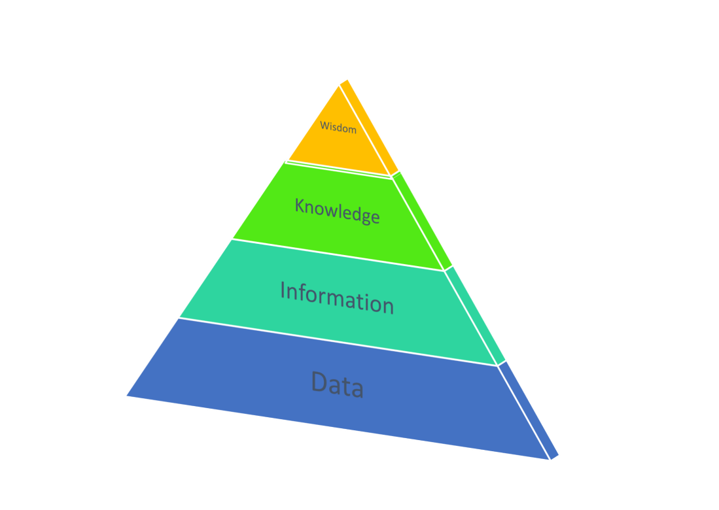
Fig. 1 Representation of Ackoff's Pyramid illustrating the continuum from data to wisdom

At the bottom of this pyramid, we have data, simple components which impart some component of meaning. A unit of data may be, for instance, a number in a spreadsheet or a word in a sentence. They have little meaning on their own, but when aggregated and put into context they begin to convey information: a numerical spreadsheet cell, for instance, can be identified as an amount of money by its place in the spreadsheet and the cells around it (for instance, a currency symbol at the top of the column in which it is located. Information can be considered organized data, the organization giving meaning to its components and allowing them to say something about the world beyond themselves.
To move up to knowledge from here we gather components of information and make meaningful, semantic links between them: we put them into context and examine the patterns that emerge from these linkages. We can begin to use the knowledge we form in this way to answer more interesting questions that information alone can answer: while information can provide answers to such questions as "who?" or "what?", knowledge can allow us to as "how?", specifically "how do things work?" or "how have things come to be the way they are?"
The next, and most controversial step, is to move from knowledge to wisdom. Once again, the process is of aggregation, establishing linkages and discerning patterns amongst them. Here we move to more value-laden questions such as "what is best?" or "what is the right thing to do?". This is the most difficult step to take and one where many find fault with the model – is there more to wisdom than aggregation, linking and pattern recognition? Most of us would agree that there is.
How does culture fit into this model? Ackoff does not touch on it but it is possible to fit culture neatly into his pyramid as a top level. The influential cultural anthropologist Clifford Geertz defined culture as ... “an historically transmitted pattern of meanings embodied in symbols, a system of inherited conceptions expressed in symbolic forms by means of which men communicate, perpetuate, and develop their knowledge about and attitudes toward life"[3, p. 89]. Within the context of Ackoff's model, it can be seen as a further refinement of knowledge and perhaps wisdom, a selective process of defining those parts of these which are collectively significant and once more establishing meaningful links between them to create a discernible pattern which makes the culture something comprehensible if not necessarily tangible. We could therefore see it as an additional layer topping the pyramid, the ultimate step in a chain of aggregation and refinement that starts with data.
How does metadata fit into this model? It can be argued that it is the fundamental mechanism by which we move from one level to another, the 'glue' that forms the aggregations by which we move from data to information to knowledge to wisdom to culture. At each stage we employ metadata to select and bring together, forming linkages between components that have meaning and establish patterns. Metadata, by saying something about each component of data (it is by definition 'data about data'), introduces the semantics into this model without which the move from one layer to another is, literally, meaningless.
Metadata clearly can be argued to be fundamental to how we build knowledge and eventually culture. Librarians have, of course, been the custodians and shapers of metadata for millennia. They are not necessarily able to lay claim to all metadata, particularly at the micro-level that it operates within the model of Ackoff's pyramid. But in their roles within the history of metadata they can claim some tangible contributions to the formation and transmission of cultures and an often recognized part in cultural history.
The template is used to format your paper and style the text. All margins, column widths, line spaces, and text fonts are prescribed; please do not alter them. You may note peculiarities. For example, the head margin in this template measures proportionately more than is customary. This measurement and others are deliberate, using specifications that anticipate your paper as one part of the entire proceedings, and not as an independent document. Please do not revise any of the current designations.

Culture: curation and metadata

A culture is not merely a static abstraction from data, information, knowledge and wisdom but something that has to be curated. Geertz's definition emphasizes that it is 'historically transmitted', which cannot be left to the chance survival of its elements alone. Curation of a culture literally means 'caring for' it: it is often seen as preserving its elements but in reality requires more than this. It involves aiding the selection of those components which are most important in defining what a culture is, putting them into an overall context by describing them and establishing links between them, and preserving and transmitting them both within a generation and between generations.
Perhaps the greatest advance in the curation of culture was the invention of writing which allowed it to be recorded outside the fragile storage mechanisms of the human brain and to be transmitted by more reliable means than the oral exchange of thoughts and ideas. The anthropologist Jack Goody wrote perceptively of its importance in allowing the historical record to be passed for the first time between generations relatively intact and the manner in which it allowed a culture to have some autonomy from societal pressures in the present.
The written record can soon become incoherent and almost impossible to interpret without some organization above the level of the individual record, which is where metadata and the librarians who use it become essential for a culture's curation. We find examples of metadata and curation going back millennia. Ancient Babylonia, for instance, reveals one of the earliest examples of a museum, one curated by Ennigaldi-Nanna, the daughter of the last king of the Neo-Babylonian empire: she assiduously recorded metadata for each object in her collection on a series of clay cylinders which were discovered in the 1920s by the archaeologist Leonard Wooley [4].
Metadata on clay tablets which date back to 2500 BCE has been found in the ruins of the city of Ebla in modern-day Syria. A thousand years later a library at Hattusa in modern day Turkey had at least 30,000 tablets of metadata to aid the curation of its collections, and a thousand years after that, the Royal Library of Alexandria was the location for the construction of the Pinakes, a biographical catalogue of works held in the library compiled by noted poet Kallimachos of Cyrene.
We can follow the history of metadata throughout the history of libraries, up to the 20th and 21st centuries. Ranganathan revolutionized metadata by the development of facetted classification, a revolution has been fully realized in the 21st century when facetted browsing is a feature of everything from library catalogues to shopping on Amazon. One other figure who should be included in the great names of metadata history, but is known to few, is that of Henriette Avram who designed the MARC format which, fifty years later, is used to this day to enable the sharing and transmission of metadata in the form of union catalogues such as WorldCat [5, p. 28]

Metadata is crucial to the process of curation: it is by the application of metadata that we select the defining components of a culture, it is by metadata that we can describe them, establish links between them and put them into context, and it is by the application of metadata that we can preserve and transmit them in an intelligible form between generations. For these reasons, it is difficult to envisage a culture surviving or developing without metadata. Curating a culture is, at least in part, creating metadata – it is by saying something 'about' the components of culture that it becomes understood as culture.

Conclusion: librarians and culture

Metadata is an inherent part of human thought and would exist independently of libraries and librarians, but it is our profession which have turned it into a science and imposed rigour and rationality to its development. It could perhaps be argued that metadata would develop of its own accord as it is so central to humanity, but it cannot be denied that without the input of librarians its advances would have been slower to emerge and more haphazard in shape. If one acknowledges the centrality of metadata to the development of culture, it would be hard to deny the importance of libraries in this development.
Librarians do much more than create metadata in their curatorial roles of course, including creating the physical and intellectual infrastructures within which the cultural record is preserved. But the importance of metadata in curation, its role in selection, putting into context and the transmission of cultural heritage, cannot be understated, nor can the role of librarians in developing and advancing metadata to a stage where information is now so ubiquitous and available to so many.
It is the developments to which librarians have made such significant contributions that allows modern culture, popular and not-so-popular, to develop with the rapidity that we now take for granted. The 'living organism' cited by Ranganathan as the essence of a library is, of course, true of the cultures in which they are embedded. What should be made clear to everyone is how symbiotically the two are conjoined, with metadata as an essential 'glue' by which the linkage is made.

References

[1] N. Cousins, “Introduction: the need for continuity,” Am. Libr. Assoc. Bull., pp. 474–475, 1954.
[2] R. L. Ackoff, “From data to wisdom,” J. Appl. Syst. Anal., vol. 16, pp. 3–9, 2010.
[3] C. Geertz, The interpretation of cultures: selected essays, vol. 5019. New York: Basic books, 1973.
[4] L. Woolley and P. R. S. Moorey, Ur ’of the Chaldees’ : a revised and updated edition of Sir Leonard Woolley’s Excavations at Ur. Ithaca, N.Y: Cornell University Press, 1982.
[5] R. Gartner, “Metadata for digital libraries: state of the art and future directions,” JISC, 2008.

