The London Furniture Trade, 1640–1720

Laurie A. Lindey

Institute of Historical Research School of Advanced Study University of London

Submitted for the Degree of Doctor of Philosophy March 2016

Declaration

I, Laurie A. Lindey, hereby declare that this thesis is purely my own work and is the written record of work carried out for the degree of PhD at the Institute of Historical Research and has not been submitted in any previous application for a higher degree.

Date:

Signed:

Abstract

This thesis examines the London furniture trade in the seventeenth and early eighteenth centuries, a period which witnessed dramatic transformations in the designs, styles and construction of English furniture. While this topic has been addressed in detail in terms of object-based analyses, it has never been examined in depth from a social, economic and cultural perspective.
Although the relationship between many London livery companies and the trades they represented had greatly diminished by the middle years of the seventeenth century, the fact that the majority of Joiners’ Company members were furniture tradesmen (as has been determined by this thesis) means that its archives provide valuable empirical evidence of the people who populated the industry. This documentation in combination with other primary sources, such as parish and tax records, sheds light on the socio- economic profile of London’s furniture tradesmen, their specialised occupations, the way their industry was organised and regulated, and how it was affected by the turbulent political and social upheavals of the seventeenth century, as well as the Fire that ravaged London in 1666.

The thesis begins with a discussion of the evolution of decorative design in England in the early modern period and the effects of burgeoning consumerism. It also defines the parameters and aims of this study. The second chapter introduces the tradesmen who supplied materials to the industry, the specialised artisans and craftsmen who produced new forms and styles of furniture, and the ways in which the chain of production was structured. The following two chapters discuss the relationship between the Joiners’ Company and the furniture trade. The third chapter assesses the extent to which the guild regulated the industry, protected and promoted the livelihoods of its tradesmen, and monitored the quality and standard of manufacture and training through apprenticeship. Chapter Four examines the role of apprenticeship in the furniture industry, analysing in detail patterns of recruitment and the social and geographical origins of apprentices. The fifth chapter identifies the geographical location of the trade in the City of London (focusing on the 1690s and 1721), and its spread into the fashionable West End between 1660 and 1720. The final chapter examines manufacturing networks through the case studies of two cabinetmakers and a cane

chair maker. Finally, the conclusion draws together the themes discussed throughout and queries whether the standard practice of attributing particular pieces of furniture to specific makers or workshops, usually on stylistic grounds, needs to be reconsidered.

Table of Contents

Declaration ........................................................................................................................... 2
Abstract ................................................................................................................................ 3
Table of Contents ................................................................................................................. 5
List of Tables ....................................................................................................................... 7
List of Figures ...................................................................................................................... 9
Abbreviations 12
Acknowledgements 13
Chapter One: Introduction 14
Historiography 21
Sources and methodology 31
Chapter Structure 36
Chapter Two: Furniture Tradesmen and their chain of production 41
How the London furniture trade adapted to the changes 42
Guilbaud’s scriptor 48
The biography of a caned armchair 69
Conclusion 82
Chapter Three: The role of the Joiners’ Company in the London furniture trade 84
Methodology and sources 85
Decline of the guilds 87
Woodworking guilds 93
The growth of the Joiners’ Company 99
Membership in the Joiners’ Company 103
Profile of the Company membership 106
The relationship between the Joiners’ Company and the furniture trade 110
The search 115
Apprenticeship and freedom 118
Conclusion 124
Chapter Four: Apprenticeship in the Joiners’ Company 125
The geographic origins of apprentices 126
Socio-economic standing and origins of apprentices 132
Gentry 138
Agricultural 141
Tradesmen 143
Provincial tradesmen 144
‘Foreign’ tradesmen in London 147
Citizens of London 148
Conclusion 151
Chapter Five: The location of London furniture tradesmen 153
Sources and methodology 153
The 1690s 157
Extramural wards 159
Intramural wards 163
Farringdon without 173
The 1720s 179
Furniture tradesmen in the West End of London 1660–1720 183
Conclusion 210
Chapter Six: Furniture businesses and manufacturing networks 213
The formation of business and networks 213
Theories of manufacturing networks 216
Primary and secondary sources 220
Case studies 222
Edward Traherne (1637–75) 223
Thomas Warden (c.1662–1701) 235
Lazarus Stiles (1656–1724) 246
Conclusion 256
Conclusion 260
Bibliography 266
Glossary of Terms 279
Appendix 1: Study group of 312 West End furniture makers, 1660–1720 283
Appendix 2: List of inventories 286
Appendix 3a: The Court of Orphans inventory of Edward Traherne 287
Appendix 3b: The Court of Orphans inventory of Thomas Warden 296
Appendix 3c: The Court of Orphans inventory of Lazarus Stiles 300
Appendix 4a: PCC will of Thomas Warden 305
Appendix 4b: PCC will of Lazarus Stiles 307

List of Tables

  - Numbers of Apprentices indentured through the Joiners’ Company
at five year intervals, 1650–1720 99
  - Total numbers of Apprentices bound to several London companies,
1650–1720 ............................................................................................................... 100
  - Apprenticeship bindings in the Joiners’ Company and four other
London Companies at ten-year intervals, 1650–1720 101
  - Numbers of Apprentices bound to the Joiners’ and Carpenters’
Companies at five year intervals, 1655–1720 102
  - Estimate of Joiners’ Company membership, 1699 and 1724-5 103
  - Numbers and percentage of joiners and furniture tradesmen in the City
of London and their membership of the Joiners’ Company 104
  - The number and location of furniture tradesmen listed in The Dictionary of English Furniture Makers who were members of the Joiners’
Company, 1660–1720 105
  - Completion rate of Joiners’ Company Apprentices, 1650–1720 119
  - Geographic origins of the Joiners’ Company Apprentices 127
  - Geographic origins of Apprentices 1642–64 129
  - Rebuilding of London after the Fire 1667–73 130
  - Most Frequent value of apprentice premiums 133
  - Joiners’ Company premium payments, 1710–20 135
  - Socio-Economic Backgrounds of Joiners’ Company Apprentices,
1645–1720 .............................................................................................................. 137
  - Socio-economic backgrounds of Joiners’ Company Apprentices
with agricultural occupations,1645–1720 142
  - Inhabitants in the 1692 poll tax assessments of the City of London 158
  - Extramural wards in 1692 160
  - Occupations of furniture tradesmen in three extramural wards in 1692 162
  - Cripplegate Within in 1693–4 165
  - Furniture tradesmen in Cripplegate Within in 1692 166
  - Castle Baynard and Farringdon Within in 1693–4 169
  - Furniture tradesmen in St. Paul’s Churchyard in 1692 170
  - Furniture tradesmen surrounding St. Paul’s Churchyard in the wards
of Castle Baynard and Farringdon Within in 1692 172
  - Farringdon Without in 1693–4 175
  - Furniture tradesmen in Farringdon Without in 1692 176
  - The 1721 list of householders 180
  - Furniture tradesmen recorded in the 1721 list of householders 181

  - Size and density of seven West End parishes in 1693-4 and the location
of a study group of 312 furniture tradesmen situated there, 1660–1720 187
  - Occupations of furniture tradesmen in seven West End parishes,
1660–1720 .............................................................................................................. 188
  - Mean household rent and stock in seven West End parishes in 1693-4 189
  - Furniture makers recorded in the 1693-4 tax assessment 190

List of Figures

  - Room at the Geffrye Museum representing the hall in the home of
a middling Londoner in 1630 (The Geffrye Museum, London) 43
  - Room at the Geffrye Museum representing the typical furniture of
a middling sort of Londoner in 1695 (The Geffrye Museum, London) 44
  - Scriptor on Stand, Burr-elm veneers with ebony on a silvered
stand (Ham House, The National Trust), c.1670–5 49
  - Cabinet on chest of drawers bearing the trade label of John Guilbaud,
walnut (The Geffrye Museum, London, object number 60/2005), c.1695 50
  - A French cabinetmaker’s workshop strewn with tools and materials, depicting cabinetmakers in various stages of manufacture (taken from Denis Diderot’s L’Encyclopédié, ii, plate 1, ‘Ebénisterie et marquetrie’),
1763 ........................................................................................................................ 51
  - Detail from Entrance to the Fleet River, School of Samuel Scott, oil on
canvas (Guildhall Art Gallery, London) , c. 1750 52
  - A mid eighteenth-century French joiner’s timber yard. (taken from Denis
Diderot’s L’Encyclopédié, II, plate 1, ‘Menuiserie), 1763 54
  - Framed panel construction and dovetailed construction 55
  - Diagram of a dovetail joint and detail of one of the drawers from Guildbaud’s scriptor (The Geffrye Museum, London, object number
60/2005), c.1695 55
  - Trade card of John Calfe, colour seller at St. Luke’s Head without Temple Barr (British Museum, Department of Prints and Drawings,
Banks Collection Ref. 89.4), c. 1690 58
  - Floral marquetry and walnut scriptor (Sothebys), c.1690–1710 59
  - Cutting marquetry (taken from Roubo, Le Menuisier Ébéniste), 1774 60
  - A drawer from an arabesque marquetry writing table made from walnut and holly and attributed to Gerrit Jensen, 1690; Windsor Castle. Royal
Collection Trust/© Her Majesty Queen Elizabeth II 2016 61
  - Oyster veneered scriptor (W. R. Harvey and Co), c.1690–1710 61
  - Detail of a drawer from a japanned cabinet-on-stand (Chastleton House,
The National Trust), c.1675–1700 62
  - Brass fittings from Guildbaud’s scriptor (The Geffrye Museum, London,
object number 60/2005), c.1695 65
  - Trade card of John Giles and Shadrach Mulliner, at the ‘Two Candlesticks and Bell’, Addle Street, near Wood Street (British Museum, Department
of Prints and Drawings, Banks Collection, Ref. 85.120), c.1740 66
  - Drawing and estimate of a stool from the Estimate and Memorandum Book 1759-62, of Gillows of Lancaster and London (Westminster Archive Centre, 10 St. Ann’s Street, London, SW1P 2DE): Archive of Gillows of
Lancaster, later Waring and Gillow furniture makers (Ref: GWG/0344) 67
  - Caned elbow chair with a twist-turned walnut frame (Boughton
House, Northamptonshire, property of the Duke of Buccleuch), c.1675 69

  - Armchair made from walnut with a caned back and seat and
carved scroll decoration (Geffrye Museum, London, object no: 50/2000),
c.1715 72
  - The trade card of William Gardner at ‘The Sign of the One Cane-Chair’ in St. Paul’s Churchyard (Lincolnshire Archives, 2-ANC 12/D/6/16),
c. 1692 73
  - Mortice and tenon joint for a chair 75
  - Caning (taken from Roubo. Description des arts et métiers, plate. 288), 1774 77
  - Trade card of Isaac Puller (The Metropolitan Museum of Art, New York, Ref. 47.71.14), 1714 78
  - A walnut elbow chair carved with ‘Boyes and crownes’ resting on acanthus
foliage (property of the Bowes Museum, Barnard Castle), c.1685–90 81
  - Annual number of Apprentices, 1650–1720 101
  - Walnut chest of drawers. The underside of a drawer is dated 1748 and signed
‘Thomas Atkinson’ (property of Apter-Fredricks Ltd., London) 122
  - Trade card of John Coxed at the ‘Swan’ in St. Paul’s Churchyard (British Museum, Department of Prints and Drawings, Heal Collection, Ref. 28.50),
c. 1715–18 144
  - Trade card of William Old and John Ody at ‘The Castle’ in St. Paul’s Churchyard (British Museum, Department of Prints and Drawings, Heal
Collection, Ref. 28.159), c. 1721 145
  - The trade card of Henry Bell at the ‘White Swan’ in St. Paul’s Churchyard
(British Museum, Department of Prints and Drawings, Heal
Collection Ref. 28.14) c. 1740 150
  - Map outlining the twenty-five wards in the City of London and seven
West End parishes 155
  - The trade card of Hugh Granger at the ‘Carved Angell’(British Museum,
Department of Prints and Drawings, Heal Collection Ref. 28.80), c. 1692 167
  - Map of Farringdon Within and Castle Baynard wards, 1720 168
  - The trade card of Phillip Hunt at ‘Ye Looking Glass & Cabenet’ in St. Paul’s Churchyard (British Museum, Department of Prints and Drawings, Heal
Collection Ref. 28.104), c. 1680-1720 171
  - Map of Farringdon Ward Without, 1720 174
  - Label of John Gatehouse near Holborn Bridge at the ‘Golden Ball’, c.1705 177
  - The trade card of G. Coxed and T. Woster at the ‘White Swan’ in St. Paul’s Churchyard, (British Museum, Department of Prints and Drawings, Heal
Collection Ref. 28.49) c. 1720 183
  - Map of St. Clement Danes parish, 1720 192
  - Map of St. Giles in the Fields parish, 1720 195
  - Map of St. Martin in the Fields parish, 1720 197
  - The trade card of John Guilbaud at the ‘Crown and Looking Glasse’ (The
Geffrye Museum, London, object number 60/2005), (Active 1692–1712) 199
  - Map of St. Paul Covent Garden parish, 1720 201

  - Map of St. Anne Soho parish, 1720 203
  - The trade card of John and Robert Hodson at the ‘Looking Glass and
Cabinet Warehouse’ in Frith Street, Soho, c. 1720 204
  - Map of St. James Westminster parish, 1720 206
  - Map of St. Margaret Westminster parish, 1720 209
  - The trade card of John Ball at the ‘Crown & Three Chairs’
© Christie's Images Limited, 1729 211
  - A rosewood and princeswood cabinet (Frank Partridge, London), c. 1680 228
  - Cane chair (Canons Ashby, The National Trust) c. 1715 243
  - Chair leg bearing the initials ‘IP’(Canons Ashby, The National Trust)
c. 1715 243
  - William Hogarth, Plate II from ‘A Harlot’s Progress’, etching, 1732. Parlour from 11 Henrietta Street, London (1727-1732) (V&A Museum,
London, object number F118.37, Room 54) 249
  - Inscription and signature of William Palleday (Private Collection), c. 1720 250
  - The trade card of the ‘Royal Bed’, c. 1722 257
  - The trade card of the ‘Griffin and Chair’, c. 1750 258
Conclusion
1. Print from an engraved catalogue of embossed gilt leather. Made by the Amsterdam manufacturer, Maarten van den Heuvel (property of the Victoria
and Albert Museum, London), c.1670 263

List of abbreviations

GL Guildhall Library

LMA London Metropolitan Archive

TNA The National Archives of the U.K.

Atlas Spence, London in the 1690s: a Social Atlas (London, 2000).

DEFM G. Beard and C. Gilbert, The Dictionary of English Furniture Makers, 1660–1840 (Leeds, 1986).

English Middle Class P. Earle, The Making of the English Middle Class:
Business, Society and Family Life in London, 1660–1730
(Berkeley and Los Angeles, 1989).

English Furniture A. Bowett, English Furniture 1660–1714: from Charles
II to Queen Anne (Woodbridge, 2002).

Furniture Makers A. Heal, The London Furniture Makers: from the
Restoration to the Victorian Era, 1660–1840 (London, 1953).

Gilds G. Unwin , The Gilds and Companies of London
(London, 1908).

JFHS The Journal of the Furniture History Society

JRFS The Journal of the Regional Furniture Society

Tradesman R. Campbell, The London Tradesman (London, 1747).

Acknowledgments

This thesis could not have been written without the enthusiastic and expert guidance of my supervisors, Professors Matthew Davies and Vanessa Harding. Their patience and generosity has been astounding. I am also most grateful to Vivien Aldous, Guy and Harry Apter, David Beasley, Adam Bowett, Jessica Collins, David Dewing, John Fisher, Stephen Freeth, Tim Hitchcock, Nick Humphrey, Eleanor John, Derek Keene, Polly Legg, Sarah Medlam, Mark Merry, David Mitchell, Tessa Murdoch, Olwen Myhill, Elizabeth Scudder, Julie Spraggon, John Styles, Adriana Turpin, Lisa White and Lucy Wood, among others. I also owe a debt of gratitude to the Furniture History Society and the Regional Furniture History Society for inviting me to lecture and publish along the way and to the Joiners’ Company for allowing me to photograph and transcribe their archives. In researching this thesis I have spent years working in the Guildhall Library. Each and every time I sailed through the door the staff have welcomed me with smiles and humour and compassion. Thank you.
I dedicate this to my friends and family, especially Edward and John.

Chapter One: Introduction

Imagine shopping in Covent Garden in late seventeenth-century London. It must have been absolutely thrilling to wander past shop front windows set a glitter in candlelight. Fashionable goods which had been the preserve of the palaces and mansions of the elite were now within reach of the middle classes. Coveted objects, such as exotic japanned cabinets and tables with matching stands and mirrors decorated with floral marquetry, became more affordable because they were no longer exclusive imports from distant Asia, Paris or Amsterdam, but were produced at home. During the second half of the seventeenth century, English furniture design had undergone a dramatic transformation from a style often regarded as heavy, utilitarian and uncomfortable to one considered lively and sophisticated. Innovative London furniture makers were manufacturing outstanding anglicised versions of European and Asian products that set the standard of quality to such an extent that by 1700, ‘Dutch craftspeople at the Hague had to submit an “English cabinet” as their masterpiece’.1 How did London furniture tradesmen achieve such a feat?
This thesis examines the London furniture trade at the period when the capital became a sprawling modern metropolis. Daniel Defoe remarked in the 1720s that ‘New squares and new streets [were] rising up every day to such a prodigy of buildings that nothing in the world does, or ever did equal it, except old Rome in Trajan’s time’.2 London’s population had doubled in size, from 200,000 to 400,000 inhabitants in the fifty-year period from 1600 to 1650, and by 1700 had expanded to 575,000.3 Despite having suffered political, constitutional and social upheaval, plague and fire, by the beginning of the eighteenth century London had become a fashionable European city and a commercial centre of manufacturing and mass consumption. It boasted ‘a thriving trade in musical instruments and watches, art and books, silk and other fine fabrics, exotic food and drink’.4 The furniture industry was a contributor to this economic and cultural boom and in this thesis it is positioned amongst other London manufacturing

1 D. Ormrod, ‘Cultural production and import substitution: the fine and decorative arts in London, 1660
– 1730’ in P. O’Brien (ed.), Urban Achievement in Early Modern Europe (Cambridge, 2001), pp. 210 – 232, at p. 220.
2 R. Porter, London: a Social History (London, 2000), p. 116.
3 V. Harding, ‘The population of London, 1550–1700: a review of the published evidence’, The London Journal, 15 (1990), 111–28, at p. 112.
4 R. O. Bucholz and J. P. Ward, London: a Social and Cultural History, 1550–1750 (Cambridge, 2012), p. 99.

and retailing industries, geographically, economically, socially and culturally. This study explores the dynamics of the trade: the various occupations involved in it; the role of livery companies; the content and quality of apprenticeship and the way it was administered and supervised; the geographical location of the industry; the structure and organisation of manufacture; and relationships between tradesmen. Who were the people who populated the furniture industry? What were their geographical, social and economic origins? How were furniture-making skills and specialised techniques transmitted from generation to generation and between workshops? Who made furniture and how was it sold? This thesis hopes to provide answers to these questions.

The period 1640–1720 has been chosen for study as it was a time of transformation when the English furniture industry dramatically adapted its methods to produce new forms, styles and designs. The topic has been addressed in detail as an object-based analysis by many connoisseurs and furniture historians, but it has never been examined in depth from a social, economic and cultural perspective. One of the primary aims of the thesis is to reconsider this important moment in the history of London furniture manufacture and to broaden the scope of the analysis and scholarship. In order to set the stage, the chapter begins with a brief discussion of the evolution of decorative design, the transmission of skills and knowledge, and burgeoning consumerism in early modern London.

The Restoration is an era considered to have witnessed the birth of modern English furniture. Historians often argue that the single most important cause for this advancement was the jubilant restoration of the monarchy in 1660. An influx of continental craftsmen came to London following Charles II’s return from exile and brought inspiration to the capital’s artisanal communities after the turbulent years of the civil wars and the dour, joyless decade of the Commonwealth. There is clearly some truth to this interpretation as the return of the king and his court certainly benefited the decorative arts financially: the Lord Chamberlain’s accounts document substantial payments to various types of craftsmen to rebuild and refurnish royal palaces.5 This had an effect on the wider community. Middling sorts were keen to emulate the social habits and lifestyles of their betters, thus spurring a consumer

5 Bowett, English Furniture, 1660–1714: from Charles II to Queen Anne (Woodbridge, 2002), pp. 12– 13.

revolution of sorts which some economists have termed ‘the Veblen effect of emulative spending’.6 The seventeenth-century economist and financial speculator Nicholas Barbon wrote in 1690 that ‘it is not Necessity that causeth the Consumption. Nature may be Satisfied with little; but it is the wants of the Mind, Fashion and the desire of Novelties and Things Scarce that causeth the Trade’.7 Lorna Weatherill has shown that ‘emulation of this kind led to penetration down the social scale in the ownership of various goods, with the proviso that this was made possible by price reduction or by increased availability of cheaper (but similar) versions of the same kinds of goods’.8

However, in overemphasising the idea that the return of the monarchy was responsible for the birth of modern English furniture, historians neglect the influence of Asian and continental European designs and styles in England before the Restoration, and underestimate the prowess of London furniture makers. Furthermore, it is a misconception that manufacturing, retailing and installation were at a relative standstill during the civil wars and Commonwealth. Living conditions were unarguably difficult: standards of living in London during the late 1640s represented the worst slump since the 1590s.9 First-hand accounts describe the reality for tradesmen: the London turner, Nehemiah Wallington lamented that ‘workmen are gone and trading is dead’, and the Venetian ambassador recounted that ‘all shops are kept shut by order of Parliament with loss to merchants and inconvenience to the inhabitants’.10 Nevertheless, these circumstances should not obscure the fact that prior to 1660 many English artisans were already highly skilled and well versed in contemporary decorative styles and designs:
Puritan acts such as the demolishing of maypoles, banning of plays and destruction of images in churches were not echoed in architecture or the applied arts, which showed little sign of becoming less elaborate. Indeed one of the earliest datable examples of the naturalistic acanthus-leaf style, which was to become characteristic of the reign of Charles II, appeared in the carved details of the interior of Thorpe Hall in Northamptonshire, the

6 N. McKendrick, J. Brewer and J. H. Plumb, The Birth of a Consumer Society: the Commercialization of Eighteenth-Century England (London, 1982), p. 15.
7 McKendrick, Brewer and Plumb, Birth of a Consumer Society, p. 15, quoting Nicholas Barbon, A Discourse of Trade (1690).
8 L. Weatherill, Consumer Behaviour and Material Culture in Britain, 1660–1760 (2nd edition, London and New York, 1996), p. 194.
9 J. Boulton, ‘Food prices and the standard of living in London in the “century of the revolution”, 1580– 1700’, Economic History Review, 2nd ser., 53 (2000), 455–92, at p. 475.
10 L. Levy Peck, Consuming Splendor: Society and Culture in Seventeenth-Century England
(Cambridge, 2005), p. 235.

house of Oliver Cromwell’s Chief Justice, a couple of years before the Restoration.11

It seems likely that some London craftsmen were familiar with both continental European and Asian styles well before the middle years of the seventeenth century. In addition to the influence of immigrant craftsmen, information could be obtained from finished objects, models, drawings and prints. According to Elizabeth Miller, ‘Prints had originated in continental Europe in about 1400, but it was in the sixteenth century that they came increasingly to be used as sources for design in Britain’.12 Material evidence of the impact of print sources is seen, for example, in a ewer with a London hallmark for 1583–4, adapted from a print by Agustino Veneziano, published in Rome in 1531.13 However, London artisans would have struggled to execute the designs emanating from abroad without the skills and techniques transmitted through apprenticeships with continental craftsmen settled in London. Known as aliens, their presence was not altogether welcome. London freemen were forever watchful of infringement on their livelihoods and highly skilled immigrants posed obvious threats. This was an endemic problem for City companies who were responsible for ensuring the security of their freemen’s trades. They sought – rather unsuccessfully – to protect the rights and interests of London freemen without discouraging the vital contributions that immigrant artisans made to London’s craft-based industries. As Lien Luu notes, ‘With the massive influx of aliens and provincial immigrants in the later sixteenth century many London guilds struggled to deal with the increasing flow of unfree labour’.14 The problem became increasingly difficult and the battle was all but lost by the seventeenth century. Court minutes from the Goldsmiths’ Company ‘contain many references to members complaining about aliens working in London and threatening their livelihoods. These complaints became more numerous after the mid-seventeenth century … Grievances were heightened by the fact that these foreign craftsmen were often more highly skilled than their native counterparts’.15

11 M. Snodin, ‘The civil war and Restoration’, in J. Styles and M. Snodin (eds.), Design and the Decorative Arts: Britain 1500–1900 (London, 2001), p. 54.
12 E. Miller, ‘Prints as sources of design’, in Styles and Snodin, (eds.), Design and the Decorative Arts: Britain 1500–1900 (London, 2001), pp. 78–9, at p. 78.
13 Miller, ‘Prints as sources of design’, p. 79.
14 L. Luu, ‘Natural-born versus stranger-born subjects: Aliens and their status in Elizabethan London’, in
N. Goose and L. Luu (eds.), Immigrants in Tudor and Early Stuart England (Brighton, 2005), pp. 57– 75, at p.70.
15 J. Forbes, ‘Search, immigration and the Goldsmiths’ Company: a study in the decline of powers’, in I.
A. Gadd and P. Wallis (eds.), Guilds, Society and Economy, 1450–1800 (London, 2002), pp. 115–126, at p. 120.

Alien gold- and silversmiths had been working in London since the fourteenth century and ‘with the arrival of Dutch and Walloon refugees in England in the reign of Elizabeth their number rose’.16 Material evidence of their expertise is demonstrated on gold and silver plate.17 The influence of alien craftsmen is also seen in textiles that were imported into England by the English East India Company, which from 1610 ‘brought to England decorative textiles with elaborate botanical patterns’.18 John Styles points out that, contrary to what one might expect, these textiles were made from patterns sent out from London:
The English attachment to applied botanical decoration on textiles was very long standing, dating back to the high Middle Ages. It was reflected in the wide range of textile designs an earlier generation of scholars referred to when they talked of “the English love of flowers”. It was evident in the popularity in the sixteenth and seventeenth centuries of textiles patterned with a wide range of botanical forms.19

The idea that, prior to the Restoration, London craftsmen were manufacturing inferior products in comparison to their continental and Asian counterparts is clearly unfounded. Evidently artisans working with precious metals and textiles were capable of producing sophisticated and well-executed goods, but were furniture tradesmen also capable of such manufacture? Decorative veneered furniture – especially marquetry – is the work of the cabinetmaker and is one of the most distinguishing features of post- Restoration English furniture. There was a rapid proliferation of veneered cabinetwork in 1660s London, but these advances did not magically appear overnight:
The technique of true cabinetmaking – the manufacture of dovetailed carcases combined with the use of decorative veneers – had been known and practised in England since at least the beginning of the seventeenth century and the origins of these practises go back still further. Dovetailed seamen’s chests have been recovered from the wreck of the Mary Rose (1545). 20

Many historians believe that cabinetmaking was a new field of furniture-making introduced to England by continental Europeans after the Restoration. However there were cabinetmakers in London before this date and they were not European

16 R. Esser, ‘Immigrant Cultures in Tudor and Stuart England’, in N. Goose and L. Luu (eds.),
Immigrants in Tudor and Early Stuart England (Brighton, 2005), p. 170.
17 D. Mitchell, ‘Innovation and the transfer of skill in Restoration London’, in D. Mitchell (ed.), Goldsmiths, Silversmiths and Bankers: Innovation and the Transfer of Skill, 1550 to 1750 (London, 1995), pp. 5–22, at p. 13.
18 J. Styles, ‘Indian cottons and European fashion, 1400–1800’, in G. Adamson, G. Riello and S. Teasley (eds.), Global Design History (Abingdon, 2011), pp. 42–3.
19 Styles, ‘Indian cottons’, p. 43.
20 Bowett, English Furniture, p. 36.

immigrants, they were English. Apprenticeship bindings from the London Clothworkers’ Company include seven furniture tradesmen – with English names – who described themselves as cabinetmakers. The earliest recorded date is 1642 and apparently they were actively practising their trade because they were binding apprentices.21 These particular cabinetmakers were located within and near to an established immigrant community in the parish of St. Anne’s, Blackfriars in an area ‘known as a liberty or exempt place, which lay outside guild control’.22 Perhaps they had been situated there since serving an apprenticeship with an alien cabinetmaker or, conceivably, there had been several successive generations of English cabinetmakers before them. Dutch immigrants had established a church in the nearby liberty of Austin Friars in 1550 and ‘Blackfriars saw its alien population grow from 230 to 508 between 1568 and 1593’.23 Hentie Louw noted in his work on English carpenters and joiners, that the techniques of cabinetmaking, ‘namely the use of board construction (rather than framed panelling), dovetailing and veneering were already practised during the first decade of the seventeenth century in London’. 24 It is known that many continental artisans who originated in the Low Countries were living in London, in places such as Clerkenwell and the liberty of St. Katherine’s next to the Tower,25 and furniture makers were situated in Southwark. Edmund Bolton described how ‘At St.
Olaves in Southwark, you shall learn, among the Joyners, what Inlayes and Marquetrie meane. Inlaye (as the word imports) is a laying of colour’d wood in their Wainscot works, Bedsteads, Cupboards, Chayres and the like’.26
Louw explains that:
The size and diversity of London markets for woodwork of various kinds encouraged degrees of competition and specialisation unheard of elsewhere. As a consequence standards of design and manufacture improved rapidly, making the city, within a relatively short period of time,

21 Clothworkers’ Company Apprenticeship bindings, John Browne: CL/C/4/2/8, f. 41r, 20 June 1642; Peter Emery: CL/C/4/2/8, f. 58v, 24 June 1644; Nathaniel Chester: CL/C/4/2/8, f. 65r, 24 June 1645; Francis Cooke: CL/C/4/2/8, f. 85r, 10 Oct. 1646; Edward Cordell: CL/C/4/2/8, f. 94r, 18 July 1646; William Hinshaw: CL/C/4/2/8, f. 121r, 27 Aug. 1647; Ralph Harrison: CL/C/4/2/8, f. 129r, 28 March 1648.
22 Luu, ’Natural-born versus stranger-born’, p. 69.
23 Luu, ‘Natural-born versus stranger-born’, p. 70; N. Goose, ‘Immigrants in Tudor and Early Stuart England’, in Goose and Luu, Immigrants, p. 17.
24 H. J. Louw, ‘Demarcation Disputes between the English Carpenters and Joiners from the Sixteenth to the Eighteenth Century, in Construction History, vol. 5 (1989), pp. 3–20, at p. 12.
25 Luu, ‘Natural-born versus stranger-born’, p. 69.
26 Edmund Maria Bolton, Elements of Armories (1610), quoted in B. M. Forman, ‘Continental Furniture craftsmen in London: 1511–1625’, JFHS, 7 (1971), 94–120, at p.103.

an international centre for certain types of woodwork and a magnet for provincial craftsman and alien refugee alike.27

What these furniture makers were actually manufacturing is unknown, but the surviving examples suggest that they were probably constructing oak dovetailed objects, like the ‘Nonsuch’ chest described in an inventory of 1601 at Hardwick Hall, Derbyshire as a ‘great inlayed chest’.28 It is oak, with dovetail construction overlaid with marquetry veneers of scrolling flowers and architectural scenes.29 These types of objects are ponderous and crudely executed when compared to the styles and designs of furniture available in London from the late 1660s: veneered cabinets on stands en suite with matching mirrors and candle stands, scriptors (escritoires), and dressing boxes.
Many were decorated with intricate floral marquetry and parquetry patterns, made with precious materials such as exotic woods, ivory and mother of pearl, or using the technique of oyster veneering, a geometric arrangement of small diameter timber that creates a decorative Mannerist pattern. They were far more refined and complex than the Nonsuch Chest, and clearly influenced by continental European designs, and the technical expertise and skills transmitted through immigrants.30

Yet when did these craftsmen actually arrive? It is more likely that the majority migrated to London in the wake of the Great Fire in September 1666, rather than at the Restoration six years previously. Guild restrictions preventing non-freemen from working within the City had been suspended for a minimum of seven years to add to the much needed labour force, and the relaxation of these laws in the aftermath of the Fire opened the floodgates to both provincial and continental craftspeople.31 The City of London was all but demolished by the Great Fire: ‘Four hundred streets lay smoking; 100,000 were homeless. It was, reflected Pepys, “the saddest sight of desolation that I ever saw”’.32 Rebuilding schemes began almost immediately.33As well as contributing to the workforce, some of the continental immigrants would naturally
27 Louw, ‘Demarcation Disputes, p. 5.
28 L. Boynton and P. Thornton, ‘The Hardwick Hall inventory of 1601’, JFHS, 7 (1971), pp. 1–14, at p 12.
29 Forman, ‘Continental furniture craftsmen in London’, pp. 102–3.
30 Bowett, English Furniture, pp. 41–61.
31 M. Berlin, ‘Guilds in decline? London livery companies and the rise of a liberal economy, 1600– 1800’, in S. R. Epstein and M. Prak (eds.), Guilds, Innovation and the European Economy, 1400–1800 (Cambridge, 2008), pp. 316–41, at p. 327: ‘Section 16 of the 1667 Act for the Rebuilding of the City of London gave all those engaged the same rights to work in the City as enjoyed by freemen of the companies, for a period of no less than seven years’.
32 Porter, London, p. 109.
33 T. F. Reddaway, The Rebuilding of London after the Great Fire (London, 1940), pp, 68–90.

have introduced new skills and techniques, and these would have been rapidly disseminated through London’s furniture-making communities. Joiners manufactured and installed carved architectural features and wainscoting into parish churches and livery halls, and contributed to the rebuilding of over 13,000 new homes. These new homes of course needed furnishing.

The late 1660s proved a pivotal period in transforming London into a modern European capital and the furniture trade made a substantial contribution to this manufacturing boom with the introduction of fashionable new objects that captivated retailers and consumers alike. Daniel Defoe remarked that in London, ‘the poorest citizens live like the rich, the rich like the gentry, the gentry like the nobility, and the nobility strive to outshine one another’.34 This thesis examines how highly skilled and proficient London furniture tradesmen transmitted novel designs and styles – and adapted their manufacture accordingly – in order to supply the market with fashionable products.

Historiography
The study of furniture as an independent field of scholarship was advanced by the establishment of two history societies in the middle years of the twentieth century: the Furniture History Society (est. 1964) and the Regional Furniture Society (est. 1984). Both combine the disciplines of museology with furniture history studies and are loosely affiliated respectively with the Victoria and Albert Museum and the Geffrye Museum in London. Using the artefact as the primary source, their scholarship considers the context in which objects were produced and how designs and styles reflect periods in history, both socially and economically. Some attention has also been paid to furniture manufacture though the applied methodology remains mostly connoisseurial in nature. Private household inventories, tradesmen’s bills, and royal accounts are used as primary documentation to investigate who commissioned and who made specific objects, in other words, to establish provenance. Both societies publish annual journals, with subject matter ranging from purely object-based studies to the publication of empirical sources, and comprehensive discussions about interior design, consumer consumption, fashion and manufacturing and retailing practices, ranging in period from the early Renaissance to the present day. The Furniture History

34 D. Defoe, The Complete English Tradesman … In two volumes (London, 1732), p. 239.

Society has published several books relevant to this study, in particular The Dictionary of English Furniture Makers 1660–1840.35
The study of English furniture was originally conceived as an adjunct to art history at the beginning of the twentieth century. The subject has conventionally been approached through object-based examinations with the primary aim of establishing provenance. This methodology depends on the survival of labelled artefacts or documentary evidence which links objects to particular makers and consequently limits the examination to rare survivals, most of which are attributed to tradesmen at the top of the furniture-making hierarchy. The father of this object-based analysis was the connoisseur and collector of English furniture, Percy MacQuoid, who produced the four-volume History of English Furniture.36 His intention and that of many authors who followed was to provide useful images and descriptive analysis of various types and forms of furniture for antique dealers and collectors.37 R. W. Symonds was one of these pioneers, prolifically publishing series of books and magazine articles from 1921 until his death in 1958. Like his contemporaries, Symonds aimed to inform the antiques trade, but he broadened the connoisseurial discussion to include furniture tradesmen and their manufacturing organisations, and used contemporary newspapers, tradesmen’s bills, and royal appointments to support his analysis. Symonds recognized that many furniture tradesmen were specialised rather than multi-skilled, but still held fast to the assumption that late seventeenth-century furniture was mostly manufactured within a single workshop, rather than through networks of specialised craftsmen, and that tradesmen usually produced the goods they sold.38

35 G. Beard and C. Gilbert, Dictionary of English Furniture Makers (Leeds, 1986). Other Furniture History Society publications include: P. A. Kirkham, The London Furniture Trade, 1700–1870 (Leeds, 1988); C. Gilbert, Pictorial Dictionary of Marked London Furniture, 1700–1840 (Leeds, 1996).
36 P. Macquoid, A History of English Furniture: the Age of Oak (London, 1904); The Age of Walnut (London and New York, 1905); The Age of Mahogany (London and New York, 1906); The Age of Satinwood (London and New York, 1908).
37 Some examples include R. W. Symonds, The Present State of Old English Furniture (London, 1921);
P. Macquoid and R. Edwards, The Dictionary of English Furniture from the Middle Ages to the Late Georgian Period (3 vols., London, 1924–7); M. Jourdain, English Decoration and Furniture of the Early Renaissance, 1500–1650 (London, 1924); R. W. Symonds, Masterpieces of English Furniture and Clocks (London, 1940);R. Edwards, Georgian Furniture (London, 1947); M. Jourdain, Regency Furniture, 1795–1820 (London, 1948); R. Edwards, English Chairs (London, 1956); C. Hayward, English Period Furniture: an Account of the Evolution of Furniture from 1500 to 1850 (London, 1957);
P. Ward-Jackson, English Furniture Designs of the Eighteenth Century (London, 1958).
38 For example, see chapter IV, ‘The trade of the looking-glass maker’, in Symonds, Masterpieces of English Furniture and Clocks, pp. 61–74.

The canon of British furniture studies also includes books entirely devoted to individual furniture makers.39 They mostly follow a similar structure: the introductory sections are devoted to biographical details and early careers, the styles and designs that served as inspiration, the career trajectory of the craftsman, his patrons and/or clientele, followed by a substantial catalogue raisonné. These publications are documented with empirical sources, i.e. parish registers, livery company archives, newspaper advertisements, tradesmen’s bills and business account ledgers. The modus operandi of these publications remains firmly focused on the catalogue of the craftsman’s output.
The methodologies and subject matter of some recent publications on English and British furniture – although remaining mostly object-based – have developed to position the object within a historical context, politically, socially and economically, and encompass design sources, materials and decorative devices; and authors are increasingly engaging with the relationship between livery companies and the furniture industry. Artefacts are examined as the outcome of manufacturing processes rather than as unique pieces of artwork, with the attribution of the artefacts themselves becoming secondary.40 One of the most influential authors in this advancing field of English furniture studies is Adam Bowett, who has published three books and many journal articles over the past twenty years.41 Bowett’s methodology is not limited to the elite end of the spectrum; rather he incorporates cultural, social, and political history into his analysis to consider the overall context of furniture tradesmen and their production at every stage and level of manufacture. Recently he introduced an entirely new and unique level of scholarship into the field with his 2012 publication, Woods in British Furniture Making, 1400–1900: an Illustrated Historical Dictionary.42 This

39 H. Hayward, Thomas Johnson and English Rococo (London, 1964); C. Gilbert, The Life and Work of Thomas Chippendale (Bristol, 1978); H. Hayward and P. Kirkham, William and John Linnell (London, 1980); G. Beard, The Work of Grinling Gibbons (London, 1989); C. Gilbert and T. Murdoch, John Channon and Brass-Inlaid Furniture (New Haven and London, 1993).
40 V. Chinnery, Oak Furniture: the British Tradition (Woodbridge, 1979); G. Beard, Craftsmen and Interior Decoration in England, 1660–1820 (New York, 1981); C. Gilbert, English Vernacular Furniture, 1750–1900 (New Haven and London, 1991); G. Beard, Upholsterers and Interior Furnishing in England 1530–1840 (New Haven, 1997); C. Gilbert, Marked London Furniture, 1700–1840 (Leeds, 1996); D. Dewing, ‘Cane chairs, their manufacture and use in London, 1670–1730’, JRFS, 12 (2008), 53–86.
41 Bowett, English Furniture; A. Bowett, Early Georgian Furniture, 1715–40 (Woodbridge, 2009); A. Bowett, Woods in British Furniture Making, 1400–1900: an Illustrated Historical Dictionary (Wetherby, 2012); A. Bowett and L. Lindey, ‘Labelled furniture from the White Swan workshop in St. Paul’s’, JFHS, 39 (2003), 71–98.
42 Bowett, Woods in British Furniture Making.

documents historic furniture woods, examining the geographical origins of almost 500 species and their growth, characteristics and appearance. His discussions include domestic and overseas trade and government policies, and most entries include illustrations of furniture made of various types of timber. His scholarship is supported by microscopic analysis of wood samples, thus combining botanical science with empirical historical documentation.
The social and economic history of early modern London is a broad subject encompassing the everyday lives of people, their family structures, households, businesses, and communities. The scholarship of Roy Porter and Peter Earle is particularly pertinent to this study and Earle’s The Making of the English Middle Class serves as a type of framework for many discussions.43 He explores the rise of London’s bourgeoisie in a period ‘which defined and created the society and economy which ushered in the modern world’.44 Like this study, Earle examines the socio- economic status of London apprentices in late seventeenth- and early eighteenth- century London, and their likelihood of success in the business world. Using several of the same sources employed here, such as London Court of Orphans inventories and Robert Campbell’s The London Tradesman,45 Earle examines the social fabric of London (1660–1730), including many topics germane to this discussion: the origins of apprenticeships; the position apprentices held when living with their master and his family in premises which served both domestic and business purposes; who tradesmen married and why; the role of livery companies; the importance of neighbourhoods and parishes; and the various ways London’s middling sort structured their businesses, made financial investments, and lived and died.
The social and economic history of early modern London is a constantly expanding field. Vanessa Harding has published a range of journal articles and books which include studies of London’s demography, City government regulations, and customary and practical rituals of life and death in the early modern period.46 There are many

43 R. Porter, English Society in the Eighteenth Century (London, 1990); Porter, London; Earle, The Making of the English Middle Class: Business, Society and Family Life in London, 1660 –1730 (Berkeley and Los Angeles, 1989); P. Earle, A City Full of People: Men and Women of London, 1650– 1750 (London, 1994).
44 Earle, English Middle Class, p. 3.
45 R. Campbell, The London Tradesman (London, 1747).
46 V. Harding, ‘The population of London’, pp. 111–28; V. Harding, The Dead and the Living in Paris and London, 1500–1700 (Cambridge, 2002).

other works which substantiate and support the primary evidence uncovered through this research. These include: Steve Rappaport’s examination of the population, economy and society in sixteenth century London; Maxine Berg’s work on manufacture and industry in the eighteenth century; Jonathan Barry’s and Christopher Brooks’ edited collection of essays on the middling sort; Leonard Schwarz’s study of London’s entrepreneurs, labour force and living conditions; Craig Muldrew’s work on economic, social and cultural history; Margaret Pelling’s exploration of the structure of seventeenth-century households; and Jeremy Boulton’s studies on the poor in the metropolis.47 Some of the themes in this canon of historical literature have been particularly influential, especially those examining wealth and social structure, living standards, the changing nature of the labour force and the social dynamics of urban communities.

The spatial logic or geographical patterning of the furniture trade in London is a subject which runs through this thesis. Craig Spence published a social atlas of London in the 1690s, examining London within and outside of the City walls, in the metropolitan areas north of the Thames.48 The atlas proves a particularly valuable source by supporting discussions about the clustering of furniture tradesmen in particular areas. Most pertinent are his examinations of the social and economic structures of householders, household density, the sites most popular for manufacturing, warehousing, and shopping and occupational structures and patterns.

Social and economic history is closely related to material and cultural history and often the two disciplines overlap. The publication of The Birth of a Consumer Society (1982)49 broke ground in the field of cultural history with discussions of the development of commercialisation during a period often referred to as the long

47 S. Rappaport, Worlds Within Worlds: Structures of Life in Sixteenth-Century London (Cambridge, 1989); M. Berg, The Age of Manufactures, 1700–1820 (London and New York, 1994); J. Barry and C. Brooks, The Middling Sort of People: Culture, Society and Politics in England, 1550–1800 (New York, 1994); L. D. Schwartz, London in the Age of Industrialisation: Entrepreneurs, Labour Force and Living Conditions, 1700–1850 (Cambridge, 1992); C. Muldrew, The Economy of Obligation: the Culture of Credit and Social Relations in Early Modern England (Basingstoke, 1998); M. Pelling, ‘Skirting the city? Disease, social change and divided households in the seventeenth century’, in P. Griffiths and M.
S. R. Jenner (eds.), Londinopolis: Essays in the Cultural and Social History of Early Modern London (Manchester, 2000), pp. 154–75; J. Boulton, ‘The poor among the rich: paupers and the parish, in the West End, 1600–1724’, in Griffiths and Jenner, Londinopolis, pp. 197–225; J. Boulton, ‘Wage labour in seventeenth-century London’, Economic History Review, 49, Issue 2 (1996), pp. 268–90.
48 Spence, London in the 1690s: A Social Atlas (London, 2000).
49 McKendrick, Brewer and Plumb, Birth of a Consumer Society.

eighteenth century. Neil McKendrick and his colleagues opened the discourse by marrying socio-economic history to consumerism and exploring the burgeoning demand for fashionable products, and the political and social influences that shaped this phenomenon. Maxine Berg’s scholarship embraces the combined study of socio- economics, cultural and material history. In the preface to Luxury and Pleasure in Eighteenth-Century Britain, Berg explains that ‘what really provoked the big changes was not consumption in general, but the desire for and ability to consume luxuries’.50 Material and cultural histories entwine self-identity with materiality by examining ‘the relationship between people and objects’.51 They are concerned with everyday life and the material circumstances of ordinary people, placing them in close proximity to social and economic history, with topics ranging from architectural and art history to consumerism and retail. Elizabeth McKellar, for instance, is an architectural historian who has written about the rebuilding of London after the Great Fire. Most important to this study is her discussion of the organization of the reconstruction project and the contributions of various builders, contractors and craftsmen.52
Theories of social emulation are commonly addressed in material and cultural history. Amanda Vickery and John Styles explain ‘that as new types of objects moved through the social hierarchy, they changed. They were made from different materials, they joined different assemblages of goods, they were used in different ways, and they acquired different meanings’.53 This is made evident in English furniture in our period: London furniture tradesmen were manufacturing objects in various qualities, styles and designs and marketing them to different strata of society. A study in the history of retailing in this period by Nancy Cox questions what actually constituted a consumer revolution; and what the concept of luxury was at a time when new goods were flooding the markets, and retailing was becoming a pastime for middle-class consumers and much more than a mere occupation for shopkeepers.54
Material and cultural history takes two basic approaches: quantitative and qualitative. Most of the scholarship focuses on the quality and desirability of objects, how they

50 M. Berg, Luxury and Pleasure in Eighteenth-Century Britain (Oxford, 2005), pp. ix–x.
51 J. Styles and A. Vickery, ‘Introduction’, in J. Styles and A. Vickery (eds.), Gender, Taste, and Material Culture in Britain and North America, 1700–1830 (New Haven and London, 2006), p. 21. 52 E. McKellar, The Birth of Modern London: the Development and Design of the City, 1660–1720 (Manchester and New York, 1999).
53 Styles and Vickery, Gender, Taste, and Material Culture, p. 20.
54 N. Cox, The Complete Tradesman: a Study of Retailing, 1550–1820 (Aldershot, 2000).

were bought and sold, and the ways in which they were consumed. One such study was made by Linda Levy Peck in her examination of consumerism and collecting in the seventeenth century, and the ways in which cultural and economic changes affected luxury consumption.55 The discipline of museology is also incorporated into this academic field. A publication produced for the opening of the new British galleries in the Victoria and Albert Museum in the late 1990s includes information about design sources, styles and fashions: who led tastes, how people were influenced, what they owned, and how people lived.56 Lorna Weatherill, on the other hand, takes a quantitative approach by using inventories to examine the frequency of ownership of selected goods in several locations across Britain between 1660 and 1760. She also examines how different types of consumers (tradesmen and farmers) utilised their possessions and the ways in which ownership changed.57 Mark Overton and colleagues have also made a statistical analysis of production and consumption for the same period. Their work explores domestic production through the ‘putting out system’ and household consumption in Cornwall and Kent, using inventories and tax records as sources.58 These publications are just a small number of a growing body of scholarship and many have been consulted for this study.59
The relationship between the London furniture trade and the livery companies is a central focus of this thesis. In particular, it examines how much authority the Joiners’ Company actually had over the trade, in terms of regulating and monitoring the quality and content of apprenticeships and overseeing the standards of manufacture and retail.60 Historians have approached this topic in various ways over the last 200 years or so. Some have created gazetteers describing and defining every City company; others have written individual company accounts of a more traditional kind; and there is a growing body of analytical scholarship. Livery companies have been addressed by
55 Levy Peck, Consuming Splendor.
56 J. Styles and M. Snodin, Design and the Decorative Arts: Britain 1500 –1900 (London, 2001).
57 Weatherill, Consumer Behaviour.
58 M. Overton, J. Whittle, D. Dean and A. Hann (eds.), Production and Consumption in English Households, 1600–1750 (London and New York, 2004).
59 M. Berg and H. Clifford, Consumers and Luxury: Consumer Culture in Europe, 1650–1850 (Manchester and New York, 1999); J. Brewer, The Pleasures of the Imagination: English Culture in the Eighteenth Century (London, 1997); J. Brewer and R. Porter (eds.), Consumption and the World of Goods (London and New York, 1994); A. Bermingham and J. Brewer (eds.), The Consumption of Culture, 1600–1800: Image, Object, Text (London and New York, 1997); S. E. Whyman, Sociability and Power in Late-Stuart England: the Cultural Worlds of the Verneys, 1660–1720 (Oxford, 1999); Styles and Snodin, Design and the Decorative Arts.
60 This research project has established that the Joiners’ Company had more furniture tradesmen among their membership than any other City company.

historians of London from Stow (1598) to Strype (1720) and beyond but the earliest most comprehensive general text is William Carew Hazlitt’s survey of all 126 companies: The Livery Companies of the City of London (1892).61
One of the first historians to write a critical analysis of the guilds was George Unwin. During the first decade of the twentieth century he produced two publications: Industrial Organization in the Sixteenth and Seventeenth Centuries (1904) and The Gilds and Companies of London (1908).62 Unwin saw the fifteenth and most of the sixteenth century as the glory days of the London companies, with the late sixteenth and the seventeenth century as the time of change and decline. The theme which runs through his narrative is balance of power. He believed that ‘the ability of livery companies to provide freemen with a sense of community was limited’63 and asked whether City companies were ‘monopolistic cartels exploiting artisans for the benefit of proto-capitalists, or alternatively socially beneficial economic regulators – proto- trades unions’.64 This debate continued and was advanced in the middle of the twentieth century with an article by the economic historian, J. R. Kellett, ‘The breakdown of gild and corporation control over the handicraft and retail trade in London’.65 Kellett takes a more nuanced approach to the decline of London companies than many of his predecessors, arguing that the guilds had always struggled to assert their authority and that there was not a particular point when decline set in.
Accounts of livery companies representing woodworking – including turners, basketmakers, upholders, carpenters and joiners – are numerous.66 Most of this literature simply relates the information contained in company archives. Edward

61 W. C. Hazlitt, The Livery Companies of the City of London: their Origin, Character, Development, and Social and Political Importance (New York, 1892).
62 G. Unwin, Industrial Organization in the Sixteenth and Seventeenth Centuries (Oxford, 1904). G. Unwin, The Gilds and Companies of London (London, 1908).
63 Unwin, Gilds, p. 1.
64 I. A. Gadd and P. Wallis, ‘Introduction’, in I. A. Gadd and P. Wallis, Guilds, Society and Economy in London, 1450–1800, p. 2.
65 J. R. Kellett, ‘The breakdown of gild and corporation control over the handicraft and retail trade in London’, Economic History Review, 2nd ser. 10 (1957–8), 381–94; Unwin, Gilds, pp. 341–51.
66 E. B. Jupp, An Historical Account of the Worshipful Company of Carpenters of the City of London Complied Chiefly from Records in Their Possession (London, 1887); H. L. Phillips, Annals of the Worshipful Company of Joiners of the City of London (London, 1915); A. C. Stanley-Stone, The Worshipful Company of Turners of London (London, 1925); R. W. E. Alford, A History of the Carpenters Company (London, 1968); S. E. Lane, The Worshipful Company of Joiners and Ceilers or Carvers: a Chronological History (London, 1968); P. Ronald, The Basketmakers Company: a History of the Worshipful Company of Basketmakers of the City of London (London, 1978); J. F. Houston, Featherbedds and Flockbedds: the Early History of the Worshipful Company of Upholders of the City of London (Aldwick, 2010).

Jupp’s Historical Account of the Worshipful Company of Carpenters of the City of London (1887) was the first, and remains to this day the most substantial and authoritative of these. He includes topics common to companies across the board: powers of search, the authority exercised by the court, and opposition to foreigners and aliens impinging on members’ livelihoods. In his appendix Jupp reproduces various petitions submitted to the Court of Aldermen by both the Carpenters’ and Joiners’ companies, such as a series of complaints made against the incorporation of sawyers, and, in particular, the decisive 1632 arbitration by the court between the Carpenters and Joiners, which delineated the work belonging to each trade.67
The viability and practicalities of the guild system in early modern London have long attracted debate. The theory accepted by many historians is that by the middle years of the seventeenth century London freemen perceived the medieval institutions as antiquated and dysfunctional because they found the system restrictive and obstructive to entrepreneurship. Patrick Wallis and colleagues have waded into the forefront of this debate, studiously researching the realities of apprenticeships and quality control.68 Their subject matter includes many of the issues addressed here: the content and quality of apprenticeships and the theoretical aspirations of the seven-year training process as opposed to the reality; the decline in popularity of apprenticeships in the later years of the early modern period; the impact of rights of primogeniture on the sons of the gentry; and the percentage of apprentices who completed their period of indenture and became journeymen or independent tradesmen. The overarching question is how beneficial were the apprenticeships administered by London livery companies by the period of this study?
Michael Berlin has written about another aspect of livery companies: the effectiveness of the ‘search’ in early modern London.69 City companies had the power to inspect their members’ workshops and retailing premises to regulate and monitor the

67 Jupp, Carpenters, pp. 295–9.
68 P. Wallis, C. Webb and C. Minns, ‘Leaving home and entering service: the age of apprenticeship in early modern London’, Continuity and Change, 25 (2010), pp. 377–404; P. Wallis, ‘Apprenticeship and training in premodern England’, Journal of Economic History, 68 (2008), pp. 832–61; P. Wallis and I.
A. Gadd, ‘Reaching beyond the City wall: London guilds and national regulation, 1500–1700’, in Epstein and Prak, Guilds, Innovation and the European Economy, 1400 –1800 , pp. 218–316; P. Wallis, ‘Controlling commodities: search and reconciliation in early modern livery companies’, in P. Wallis and
I. A. Gadd (eds.), ‘Guilds, society and economy in London 1450–1800’ (London, 2002), pp. 85–100.
69 M. Berlin, ‘Broken all in pieces: artisans and the regulation of workmanship in early modern London’, in G. Crossick (ed.), The Artisan and the European Town, 1500–1900 (Aldershot, 1997), pp. 75–92.

manufacture and sale of goods. In theory, this was to uphold the reputation and integrity of the guild and to protect consumers from ‘false and deceitful wares’. Berlin examines how effective this form of institutional policing was. Much London-made furniture of the period demonstrates a certain regularity and standard in its construction and decoration. Could this standardisation have been partly the result of the Joiners’ Company’s successful maintenance of quality control through such searches? These privileges were implicit in guild powers over their associated trades but by the seventeenth century, Berlin suggests, searches had become merely perfunctory exercises that had little real effect. This hypothesis is tested here against the evidence of Joiners’ Company inspections of furniture makers’ workshops.
Many others have contributed to the ongoing discussion of the livery companies system. Matthew Davies has explored the history of livery companies in the medieval and early modern period, with special attention to the Merchant Taylors’ Company. He has examined guild regulation and discussed the limitations of the companies’ ability to enforce ordinances and mandates, particularly in the period before 1550.70 Giorgio Riello writes about the guilds at a time when they were in the midst of their alleged decline. His research has focused on the Cordwainers’ Company and he has determined that by the middle of the eighteenth century, ‘the decision to enter one of the livery companies increasingly became a sign of social status rather than a requirement to follow an occupation’.71
Whether there was an active and mutually beneficial relationship between livery companies and the furniture industry is a matter for investigation here. However, the associations between craft-based trades and the guilds was deeply rooted in London’s history. Derek Keene traces their origins to ‘the eleventh century, if not the tenth’, and argues that, ‘the survival and continued utility of the companies [had] much to do with their multi-faceted character and their capacity to provide an environment where

70 M. Davies, ‘Governors and governed: the practice of power in the Merchant Taylors’ Company in the fifteenth century’, in Gadd and Wallis, Guilds, Society and Economy in London, 1450 – 1800, pp. 67– 83.
71 G. Riello, ‘The shaping of a family trade: the Cordwainers’ Company in eighteenth-century London’, in Gadd and Wallis, Guilds, Society and Economy in London, 1450 – 1800, pp. 141–59, at p. 149.

flexible forms of association and exchange conducive to doing business could prosper’.72 The debate continues and this thesis hopefully makes a useful contribution.

Sources and methodology
There are two branches of the furniture-making industry: woodwork and upholstery. This thesis focuses on the woodworking sector. It is an altogether separate branch of the furniture industry from the upholstery trade which was involved in the soft furnishing of seat furniture (chairs, sofas and stools), and also beds and curtains, among other objects. Historically known as upholders or upholsters, they were ‘originally dealers in second-hand clothes and were otherwise known as Fripperers’. In his 1598 Survey of London, Stow recorded them trading in second hand and stolen goods in Cornhill. When the upholders became involved in the upholstery trade is unclear but Hazlitt notes that they had an ‘ancient and intimate relationship’ with the Skinners.73 There is much confusion surrounding the title of upholder because from the late seventeenth and early eighteenth centuries they were not only working in the upholstery industry, but also providing services similar to some cabinetmakers by acting as a type of interior decorator supplying a wide range of household furnishings. The Upholders’ Company records do not survive prior to the turn of the eighteenth century: freedom registers date from 1698 and apprenticeship bindings from 1704.74 Upholders have not been studied in this thesis partially due to the absence of sources, but also because the main focus here is to determine how the furniture industry organised its manufacturing processes to adapt to the dramatic transformations that occurred in the designs, styles and forms of wooden furniture during the period.
Within this framework this thesis aims to take a holistic approach by combining the methodologies of material and cultural history with those of design, social, economic, political and urban history, to produce a broad examination of the woodworking sector of the London furniture trade. Primary information uncovered by this research is tested against the theories and methodologies established in the published scholarship. The intention is to position the London furniture trade among other London manufacturing and retailing industries, through a consideration of how it was organised: who the

72 D. Keene, ‘Livery Companies: what, when and why’, in Gadd and Wallis, Guilds, Society and Economy in London, 1450–1800, p. 172–3.
73 Hazlitt, The Livery Companies of the City of London, pp. 653–4.
74 GL MS 7142/1, Upholders’ Company freedom registers; MS 7142/1, Upholders’ Company apprentice bindings.

tradesmen were and the occupations they held, how they transmitted knowledge and skills, where the trade was situated in the metropolis, and how tradesmen interacted.
The terms ‘furniture makers/making’, ‘furniture trades/men’ and ‘joiners’ are used throughout this thesis. ‘Furniture maker’ is used to denote those who actually produced moveable furniture, or simply refers to those who described themselves as such, while ‘furniture making’ embraces all those who contributed to furniture production. The broader term ‘furniture trades/men’ refers to the actual makers of furniture pieces, but also to a more diverse group or category of tradesmen (such as joiners, turners, carvers, sawyers and gilders), for whom furniture production was perhaps only part of their activity. The term ‘joiner’ is used, as it was at the time, to include those who produced moveable furniture and/or architectural fittings such as chimney pieces, wainscot walls and grooved floors.
There is a substantial and growing body of scholarship concerning the organisation of manufacturing trades in early modern London, but this is the first comprehensive examination of the London furniture trade prior to 1700. There have been two previous studies made of the trade: Edward Joy’s M.A. thesis (1955), which remains unpublished, and Pat Kirkham’s Ph.D. thesis (1982), which was subsequently published as The London Furniture Trade, 1700–1870.75 The primary interest of both of these works lies in examining the trade in the age of industrialisation with little attention given to the period before the eighteenth century. The first part of Joy’s thesis briefly examines ‘the specialisation of craftsmen and the widening of the market’ after the Restoration, before turning to ‘the fashionable craftsmen who dealt with the upper classes and made the best furniture in the classic age of English furniture making’. The second part is a thorough analysis of the role of the furniture industry in eighteenth- century overseas trade.76 Kirkham examines the industry as it developed from ‘the individual master craftsman, to firms which incorporated only one or two crafts, to large and comprehensive establishments’.77 In the introduction to her book, Kirkham defined her dating parameters: ‘The year 1700 is used as a starting point because the main furniture-making crafts of the eighteenth and nineteenth centuries were
75 E. T. Joy, ‘Some aspects of the London furniture industry in the eighteenth century’ (unpublished University of London M.A. thesis, 1955); P. A. Kirkham, ‘Furniture–making in London, c.1700–1870: craft, design, business and labour’ (unpublished University of London Ph.D. thesis, 1982); Kirkham, London Furniture Trade.
76 Joy, ‘Some aspects of the London furniture industry’, abstract.
77 Kirkham, London Furniture Trade, p. 5.

established by then, but the comprehensive manufacturing firm, which brought together those crafts, had not developed’.78
The body of primary evidence used in this thesis is of two categories: systematic and miscellaneous. We begin with systematic evidence and some of the ways it has been employed. This thesis argues that the Joiners’ Company was, even at this late date, composed largely of people working in the furniture trade. The company’s records contain information on a broad sample of individuals who populated the industry providing the data which underpins much of this analysis. Two collections of company records offer evidence for systematic analysis: apprenticeship bindings and freedom admissions.79 Over 13,000 apprentices were bound through the company (1641–1720), and these records in particular provide core data because of the biographical information they contain. Each indenture agreement includes the names of the apprentice and his father, the father’s occupation, their place of origin, the name of the joiner who would be serving as the boy’s master, the proposed length of his term of service, and from 1710 onwards, the amount of the premium paid by the apprentice’s family to the master. The freedom admissions which survive from 1651 onward are inconsistent in the details contained in each entry but, in general, include the prospective freeman’s name and the date when he and his witnesses appeared in court, the method of freedom (servitude, patrimony or redemption), and in cases of freedom through servitude, the name of the master, the date the apprenticeship began and the amount of time served. They can also show whether the apprenticeship was to one master or more and, finally, the names and company affiliations of those who served as witnesses.
Three sets of inhabitants’ assessments form another systematic primary source: the 1692 poll tax, the four shillings in the pound aid of 1693-4 and a 1721 inhabitants’ list. These documents are used to examine the spatial logic, precise geographical whereabouts and the clustering of furniture manufacturing networks throughout the metropolis. The 1692 poll tax only assessed the City of London, but it is the most comprehensive tax assessment of the period.80 Unlike most assessments which rarely include such information, it gives occupations for 50 per cent of the households listed.

78 Kirkham, London Furniture Trade, p. 2.
79 GL, MSS. 8051/1–3, 8052/1–5.
80 LMA COL/CHD/LA/03/032/09 to COL/CHD/LA/03/033/008, 1692 poll tax.

It also provides evidence of family and household structures as all inhabitants residing in a property were recorded (members of the family, servants and apprentices), and an indication of wealth (the tax liability was based on the value of the rent paid, personal goods and trade stock).
The 1693-4 aid details inhabitants’ locations in both the City and Westminster, though it rarely indicates occupations.81 Despite this limitation, the assessment provides a good deal of information about known tradesmen. As with the 1692 poll tax, liability was assessed on the value of the rent, personal goods and trade stock, thus giving a good indication of the householder’s wealth. There are also descriptions of the properties, for example, whether premises had gardens, yards, warehouses or shops.
The purpose of the tax was to fund William III’s European war efforts and one method of increasing the revenue raised was to charge double the normal rate (i.e., eight shillings in the pound) to householders who refused to swear an oath of allegiance, or who were Roman Catholic. This element of the assessment is particularly useful because it acts to identify immigrant furniture tradesmen.
Returns for the 1721 inhabitants’ list survive for only eight of the twenty-eight City wards but fortunately these cover areas surrounding St. Paul’s Churchyard and Ludgate Hill where considerable numbers of furniture tradesmen lived.82 The assessment, however, was drawn up as a jury service list, and this would have excluded many inhabitants. Although the precise criteria for selecting trial juries in the 1720s are unknown, jurors were always property-owning men, aged between twenty- one and sixty and were meant to be geographically representative.83 John Beattie has studied jurors selected in the 1690s and found that they ‘came largely from the ranks of merchants and retail tradesmen of the City and were securely within the prosperous

81 COL/CHD/LA COL/CHD/LA/03/040; COL/CHD/LA/03/042 and COL/CHD/LA/03/0: ‘The four shillings in the pound aid 1693–94 for the city of London, the city of Westminster and Metropolitan Middlesex’, was an assessment on the annual rent of property and for householders and lodgers it also assessed the value of stock which derived income, or on the value of official wages.
82 LMA, COL/CHD/LA/06/025, Returns of the names of several wards in obedience to a precept giving the proper additions and places of abode, 3 Oct. 1721.
83 J. Beattie, ‘London juries in the 1690s’, in J. S. Cockburn and T. Green (eds.), Twelve Good Men and True: the Criminal Trial Jury in England, 1200–1800 (Princeton, 1988): ‘Eligibility for jury service in London had been established by an act of Henry VIII’s reign that set the qualification as the possession of lands, tenements, [and] goods of a hundred marks in value, a requirement that recognised that many men of substance in London might not hold freehold land. The requirements that jurors be inhabitants of the city was included in the jury act of 1730, which also slightly increased the value of property requirement to £100’ (p. 227).

and respectable communities in their wards’.84 The consequence is that the only furniture tradesmen listed are those from the top of the hierarchy. Nevertheless the source is rich in detail, lending itself to a meticulous examination of the trade’s spatial logic: over 90 per cent of occupations are recorded and the geographical information includes wards, parishes and places of abode – streets, lanes and courts – making it possible to identify precisely how and where specific occupations clustered. This systematic data, along with information from Beard’s and Gilbert’s Dictionary of English Furniture Makers,85 has been built into a database to facilitate various types of quantitative and qualitative enquires.
Not all of the Joiners’ Company records are as systematically comprehensive and informative as the apprenticeship bindings and freedom admissions, but they nonetheless provide vital documentary evidence. Company court minutes do not survive before 1661, and there is a gap between 1664 and 1679;86 the financial transactions recorded in the Masters’ and Renters’ accounts are even less thorough.87 Furthermore, like many historical sources, the concern of the Joiners’ Company when recording their court minutes and financial transactions was not necessarily with the affairs of the furniture industry as a whole, but rather the Joiners’ Company itself.
Consequently there is much detail of events unrelated to the trade such as the maintenance and furnishing of the company hall and obligatory functions, like livery processions and dinners. Nevertheless, they relate information about scheduled inspections on members and associated issues such as penalties and fines for various offences. The minutes also record amended and additional statutes to the company ordinance and complaints and petitions between City companies, the Lord Mayor, Court of Aldermen, and parliament. Other more miscellaneous primary sources include Court of Orphans inventories. These documents offer a rare glimpse into the personal and professional lives of London freemen because they describe, room by room, the contents of their domestic and trade related property and their debts, credits and capital investments. In doing so they provide evidence of the ways in which tradesmen organised their labour force and structured their manufacture and retail; whether they diversified their business activities; and how they invested their capital. Probate

84 Beattie, ‘London juries’, p. 242.
85 Beard and Gilbert, DEFM
86 GL, MSS. 8047/1, 8046/1–5.
87 GL, MSS. 8041/1–3, 8042/1–5.

inventories do not usually provide the same level of detail but are also consulted along with copies of wills, Lord Chamberlain’s accounts, import and export ledgers, and trade cards.88
Several published contemporary sources have also been employed. These include English and French didactic literature: Stalker’s and Parker’s japanning treatise (1688), Moxon’s doctrine of woodworking (1703), Langley’s instruction of various types of building construction (1746), Diderot’s illustrated encyclopaedia of furniture tradesmen (1763), and Roubo’s descriptions and illustrations of cabinetmakers workshops and materials (1774).89 These prove instrumental when defining the specific occupations of furniture tradesmen. Three maps of the period inform the geographical configuration of the trade, two from the late seventeenth century and one from the middle of the eighteenth: John Morgan’s and William Ogilby’s 1676 map of the City; Morgan’s 1682 map of the City and Westminster; and John Rocque’s map of the City, Westminster and Southwark (1746).90 John Strype’s illuminating 1720 Survey of London acts as a first-hand account of London in the early eighteenth century.91 Finally, although not a contemporary source, Henry Harben’s early twentieth-century Dictionary of London (1918), is an invaluable guide when navigating through the streets, alleyways, squares, nooks and crannies of early modern London.92

Chapter Structure
Understanding the specialised tradesmen who populated the London furniture industry lays the groundwork for the analysis and discussion in this thesis. Chapter Two describes the various occupations involved, but rather than defining them through a type of gazetteer, a ‘biography’ has been written of two pieces of furniture – a scriptor

88 Court of Orphans inventories are held in the London Metropolitan Archives (LMA) and referenced when discussed. Probate inventories and wills, Lord Chamberlain’s accounts and import and export ledgers are held at The National Archives (TNA); A. Heal, London Furniture Makers, 1660–1840 (London, 1953) .
89 J. Stalker and G. Parker, A Treatise of Japanning and Varnishing (London, 1668); J. Moxon, Mechanick Exercises or the Doctrine of Handy-Works (London, 1703); B. Langley, The Builder’s Director or Bench-Mate (London, 1746); D. Diderot, L’Encyclopédie, ou dictionnaire raisonné des sciences, des arts et des métiers (Paris, 1763); A. J. Roubo, Description des arts et métiers (Paris, 1774). 90 J. Ogilby and W. Morgan, ‘Ogilby and Morgan’s Large Scale Map of the City As Rebuilt By 1676’, in Ogilby’s and Morgan’s Large Scale Map of the City As Rebuilt By 1676 (repr. London, 1976); W. Morgan, Morgan’s Map of the Whole of London in 1682 (repr. in London, 1977): J. Rocque, An Exact Survey of the City’s of London Westminster ye Borough of Southwark and the Country near to 10 miles round London 1746 (repr. London, 1971).
91 J. F. Merritt, ‘The Creation of Strype’s Survey of London’, in Strype, Survey of London (1720) [online].
92 H. A. Harben, A Dictionary of London (London, 1918).

and a cane chair – and the objects’ creation is followed along the production line from conception to the finishing touches. Along this journey every tradesman who participated in the manufacture is introduced, from those who supplied and processed the materials to the craftsmen who constructed the object and the artisans who applied the finishing touches and passed the objects on for sale. The ways that furniture- makers adapted manufacturing methods to adhere to new styles and forms of furniture is examined: how the different tradesmen interacted and whether certain types of furniture were produced entirely within one workshop, or if it was common practice for objects to be passed between various specialised craftsmen. This chapter employs inventories, trade cards, contemporary didactic literature and publications on English furniture, museology, material culture and design, in particular, Robert Campbell’s The London Tradesman.

Chapter Three discusses the relationship between the Joiners’ Company and the furniture trade by exploring the role the guild played in governing the industry. The chapter questions the actual level of authority the guild had over the trade: how effective the Joiners’ Company really was in regulating the quality and content of apprenticeships and the standards and methods of manufacture and retail. Was the company central to regulating the industry and ensuring a certain standard of production or was the guild system becoming obsolete, perceived as antiquated, restrictive and an obstacle to entrepreneurship? This chapter discusses the general decline of the guilds – in particular companies that represented woodworking trades – and questions whether the Joiners’ Company experienced the same trajectory. The growth or decline in its membership is compared to other London companies, especially the Carpenters’ Company. The biographical details of members of the Joiners’ Company are examined, including members’ occupations and status in London’s trade community. If the membership was composed predominantly of furniture tradesmen, could this indicate that the Joiners’ Company was a furniture- making guild that was intimately involved in daily business activities? Evidence is provided by Joiners’ Company minutes, freedom admissions, financial accounts and other associated livery company documentation, and genealogical and biographical information, and supported with published scholarship on London guilds in the early modern period.

Following on from this discussion of the Joiners’ Company, Chapter Four explores the apprenticeships they administered. It considers the apprentices who trained with London joiners, their geographical, social and economic origins and the effect these backgrounds had on their future careers. It also looks at how apprenticeships were arranged. Did the Joiners’ Company act as a kind of broker, or were introductions and arrangements made on a personal basis, with the guilds merely administering the documentation? Did masters choose apprentices from backgrounds similar or different to their own? How did the socio-economic and geographical composition of the joiners compare to that of other London trades and did it change during the period of this study? The seventeenth century witnessed a series of significant events affecting London. This chapter traces the impact of these events on the uptake of apprenticeships, charting the migration of apprentices to London during the civil wars and Interregnum, and considering whether numbers increased at the Restoration, or with the rebuilding project after the Fire of 1666. It also looks at whether the relaxation of guild restrictions acted as a deterrent to formal apprenticeships or, alternatively, whether numbers increased to add to the much-needed labour force. These questions and others are tested against the evidence contained in apprenticeship indentures and other primary and secondary sources, especially the work of Peter Earle.
Chapter Five documents the geographical whereabouts and spatial logic of the London furniture trade in the metropolitan areas north of the Thames: within and outside of the City walls and westward into fashionable Covent Garden, Piccadilly, St. James and Westminster. The aim is to determine where the furniture trade was situated in the capital and to explore its spatial logic at particular dates. The chapter queries whether occupational specialisms influenced where tradesmen chose to live. Like many early modern urban artisanal communities, London furniture makers tended to cluster together in agglomerations or geographical manufacturing networks. Some tradesmen were located in certain positions for obvious reasons, for example timber merchants had their wharfs and storage spaces along the banks of the Thames – but what about other members of the trade? The question of whether some parts of the metropolis were particularly well suited for furniture manufacture and if furniture makers tended to remain in the same areas as the eighteenth century progressed is also considered.
Furniture was sold throughout London, but were certain shopping districts known for

specific types of furniture? Did the growth of the furniture trade keep pace with the overall expansion of London?
The first half of Chapter Five is devoted to examining the trade in the City of London in the years 1692 and 1721. Furniture tradesmen in the western suburbs of London are examined in the second half of the chapter and over a broader period, 1660–1720. The dating is based on the survival of primary sources: two sets of tax assessments (the 1692 poll tax and the four shillings in the pound aid of 1693-4), and a 1721 inhabitants’ list. This information is supported with contemporary maps, trade cards, Strype’s 1720 Survey of London, Harben’s Dictionary of London, Craig Spence’s London in the 1690s and the Dictionary of English Furniture Makers.
The final chapter examines furniture manufacturing networks through the case studies of three tradesmen: a post-Restoration looking-glass and cabinetmaker in Covent Garden, a cane chair maker in St. Paul’s Churchyard at the turn of the eighteenth century, and a cabinetmaker in Aldermanbury in 1724. The aim is to test the hypothesis that it was common for London furniture tradesmen in the early modern period to manufacture and retail cooperatively. A furniture manufacturing and retailing business in the early modern period was an individual and independent enterprise in which one tradesman – or a partnership of two or more – operated to produce particular types of furniture. These case studies explore how furniture tradesmen became associated and how their joint labour forces were structured. The chapter also considers whether geographical proximity was a decisive factor in the composition of manufacturing networks and looks at the associations made with members of Joiners’ Company, as well as relationships with family and friends. Networks comprised independent tradesmen working collaboratively to manufacture wares, thereby utilising each tradesman’s specialisation. How many workers were wholly dependent on their master for employment and, alternatively, how many were independent tradesmen working on a subcontracted basis? The business of retailing could also be collaborative and tradesmen could sell their wares collectively from communal retail premises.
Some furniture tradesmen are known to have diversified into property speculation and investments in the East India trade and to pool their finances to make joint capital investments. These extended business activities are examined here. Court of Orphans and probate inventories, tax assessments, and biographical sources such as wills and

records of birth and marriage are utilised in this chapter along with the scholarship of social, economic and urban historians.
The conclusion outlines the primary contributions this thesis makes to the historiography of English furniture and gives an account of the questions and themes discussed throughout. It also questions whether the standard practice of attributing particular pieces to particular makers or workshops, usually on stylistic grounds, needs to be reconsidered.

Chapter Two: London tradesmen and their chain of production

This chapter aims to reconstruct the furniture industry as a collection of connected trades and to examine the various ways tradesmen interacted. It discusses the techniques and practices that specialised London craftsmen carried out by creating a ‘biography’ of two pieces of furniture – a scriptor and a caned armchair – and tracking the various processes involved in making these objects. The analysis does not take a connoisseurial view discussing who may have commissioned and owned the object, and its aesthetic qualities; rather it concentrates on the line of manufacture from conception to completion identifying which tradesmen were involved and how they interacted.

The transformations in English furniture in the post-Restoration period resulted in the birth of two entirely new trades: caned chair making and japanning. Although we know cabinetmakers were established in London from at least the early seventeenth century, the trade had matured and become far more sophisticated by the 1660s. The developments in cabinetmaking and onset of caned seat production and japanning in London greatly expanded the range and output of the furniture industry as a whole.1 By understanding particular skills and processes – such as dovetail construction, veneering, japanning, and caned chair production – and the impact of these techniques on specialisation of particular craftsmen and workshops, we can reconstruct the workings of an interdependent industry prior to the advent of the industrial revolution, when craftsmen would be replaced by a multi-skilled labour force within a factory setting. 2 This approach helps to address the following specific questions. Which tradesmen were involved in producing ‘standard’ types of London furniture in the
post-Restoration period? How did they acquire the necessary new skills and techniques and how did their methods of construction alter? How did tradesmen interact: were some types of furniture produced entirely within one workshop or was it standard practice to pass objects between specialised craftsmen? What was the average production or turnover time and how efficient and cost effective was this interdependent industry?

1 Bowett, English Furniture, pp. 12–34.
2 Kirkham, London Furniture Trade, pp. 1–9; Joy, ‘Some aspects of the London furniture industry’, pp. 1–9.

How the London furniture trade adapted to the changes in designs, styles and forms of English furniture
As discussed in chapter one, early seventeenth-century English furniture has often been characterised as heavy, utilitarian and uncomfortable in contrast to the lively and sophisticated style of ‘modern’ English furniture. Prior to the 1660s, most English furniture was made from oak – frequently referred to as wainscot – and constructed with mortice and tenon joints, also known as framed-panel construction. It was often turned and carved in a variety of designs such as acanthus leaves or egg and dart motifs, and reeded. Some ornate objects were inlaid, painted and/or stained. Seat furniture included joint stools, back stools (literally a stool with a back), settles and chairs. Most chairs were upholstered in either leather or various types of worsted and twilled cloths, with velvet and satin reserved for more stately versions.3 Trestle and ‘drawing tables’4 were the norm and were, by their nature, ponderous and static.
Furniture designed for storage included trunks, boxes, chests and cupboards.5

Then things changed. English furniture became lighter and more delicate. This is clearly seen when comparing the two display rooms in the Geffrye Museum, illustrated in Figures 2.1 and 2.2. Figure 2.1 represent a mid-seventeenth-century hall and includes an oak table and joint stools which were designed to be stationary. Eleanor John has used household inventories from 1570 to 1665 to analyse the changes in the ways domestic spaces were inhabited. She found that in the late sixteenth and first half of the seventeenth century, the hall was a space used by the entire household for multiple purposes including eating together. However, inventories ‘from the 1650s onward show a significant shift in these domestic arrangements’.6 The hall became a less important place to gather with the creation of the dining room and/or parlour.
Furthermore, John suggests that ‘the rise of the dining room and parlour with their new furnishings may indicate a fundamental shift in domestic life [with] a greater separation between the senior members and the rest of the household’.7 Furniture reflected the changing ways in which rooms were inhabited: the new lighter styles

3 Macquoid, The Age of Walnut, pp. 4–5.
4 LMA, CLA/002/02/01/0013, Court of Orphans inventory, Mathias Prosser, Citizen and Brewer, 29 Jan. 1658/9.
5 Chinnery, Oak Furniture. Chinnery provides detailed definitions and descriptions of sixteenth- and seventeenth-century oak furniture.
6 E. John, ‘At home with the London middling sort – the inventory evidence for furnishings and room use, 1570–1720 ’, JRFS, p. 38.
7 John, ‘At home’, pp. 40–1.

could be easily moved to the edges of the room to open up space for purposes other than dining. The gate-leg table and caned chairs in the parlour (Figure 2.2) demonstrate the point because they were portable. Great chairs and joint stools all but disappeared in the post-Restoration period and were replaced by suites of chairs, often caned, rushed or upholstered.

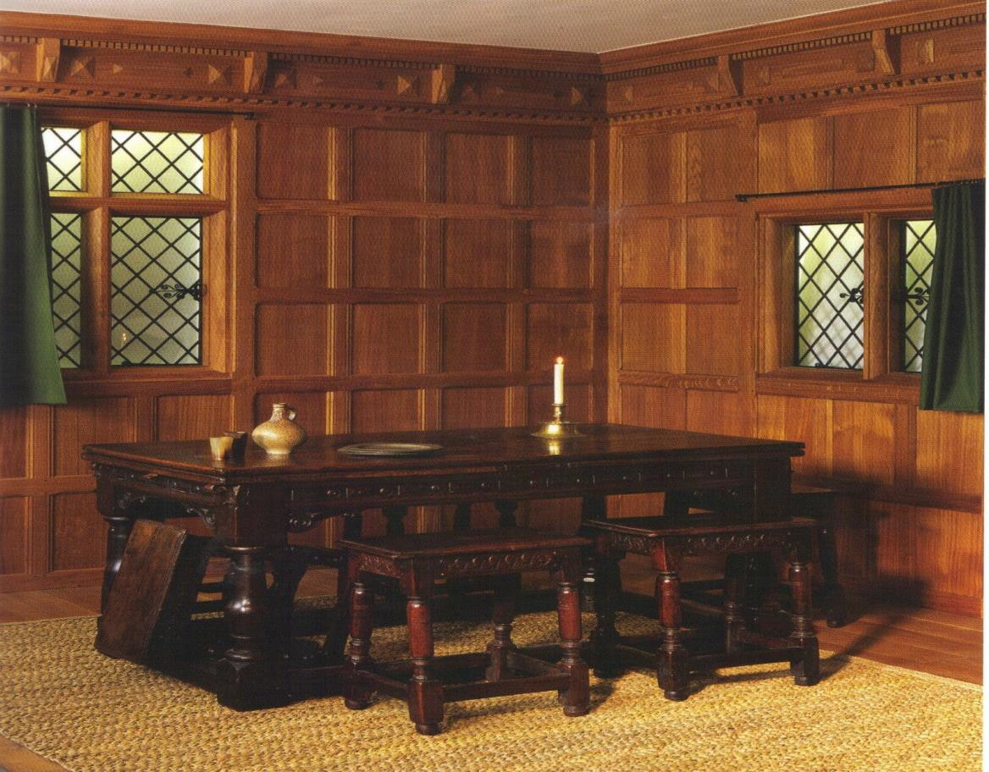

Figure 2.1: Room at the Geffrye Museum representing the hall in the home of a middling Londoner in 1630. The walls are lined with replica oak panelling and the room contains typical furnishings of the period: a turned and carved oak table and joint stools, with the floor covered in a rush mat.
Source: E. John, ‘At home with the London middling sort’, JRFS, 22 (2008), pp. 27–51, at p. 31.

In a similar fashion, while trunks and boxes were still produced, chests of drawers became quite a common feature in middle class London homes where space conservation was a priority. Bowett describes the ‘striking contrast between the heavy, mannered, joiner-made chests of the 1650s and 1660s and the light, cabinet-made versions which superseded them’, arguing that ‘no other article of furniture better illustrates the revolution in design and form brought about by the advent of modern

cabinet-making’.8 The cabinet (and cabinet-on-stand) signifies a milestone in post- Restoration English furniture. It evolved from an essentially personal, portable object to an elaborately decorated and prized showpiece for public display. The same is true of writing cabinets, also known as scriptors, and the scriptor seen in the background of Figure 2.2 is the subject of one of the ‘biographical’ case studies in this chapter.

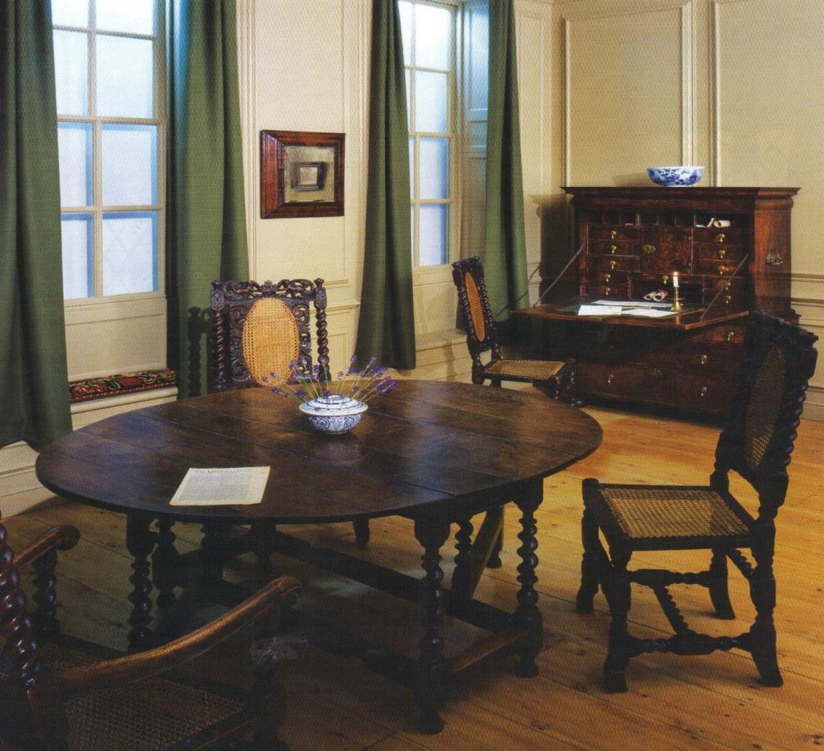

Figure 2.2: Room at the Geffrye Museum representing the typical furniture of a middling sort of Londoner in 1695. Shown is a walnut gate-leg table, caned chairs made of beech, walnut and rattan, and a walnut veneered writing cabinet – or scriptor – bearing the label of John Guilbaud.
Source: E. John, ‘At home with the London middling sort’, JRFS, 22 (2008), pp. 27–51, at p. 32.

By the late seventeenth century London furniture makers were producing goods that in many ways surpassed their continental counterparts as they manufactured fashionable furniture often at a cheaper price. New styles of seat furniture mirrored both

8 Bowett, English Furniture, p. 50.

continental and Asian designs: upholstered furniture became less square and boxy and more delicate and elegant in design; and the popularity of caned chairs was nothing less than phenomenal. Moreover, the construction of London furniture was in some aspects superior in quality to imported products and the ability to replicate fashionable designs coupled with superior durability and functionality placed the London furniture trade in a prominent position.

Chapter One discussed the various factors that influenced London furniture tradesmen (artefacts, printed sources and immigrant craftspeople) introducing them to new styles, designs and forms of furniture and providing them with new skills and the ability to adapt their techniques and manufacturing processes. It also noted how during the post- Restoration period, funds were channelled through the Lord Chamberlain’s Office to refurnish royal households, and that this provided a significant financial boost to the furniture industry as a whole. For example, in January 1662, the king’s upholsterer, Robert Moore, submitted a petition claiming to have supplied His Majesty’s Wardrobe with nearly £10,000 worth of goods in less than two years.9

The return of the monarchy also acted to fuel the market as courtiers, the aristocracy, the gentry and middling sorts were introduced to novel products in the ‘French-style’, and this created an avalanche of conspicuous consumption throughout the social hierarchy as shoppers sought to acquire objects in imitation of those displayed in places such as Whitehall. John Evelyn was one of the fortunate members of London’s elite who gained access to the court and was shocked at the luxury display, commenting ‘what ingag’d my curiosity, was the rich and splendid furniture … Japon Cabinets, Skreenes, Tables, Stands, Chimny furniture, Sconces, branches’.10

We know that continental European artisans passed on their skills and techniques to London craftspeople. As discussed earlier, many had settled in London liberties such as Blackfriars towards the end of the sixteenth century, and there was a major influx of immigrants in the post-Fire period of the late 1660s when livery restrictions on ‘foreigners’ were relaxed. Sara Pennell explains that:
It was primarily immigrants who enabled home-produced luxury goods like glasswares and armour to replace imports. Unlike native craftspeople,

9 Beard, Upholsterers and Interior Furnishing, p. 83.
10 M. Snodin, ‘Who led taste?’, in Styles and Snodin, Design and the Decorative Arts, pp. 65–93, at p. 88, quoting John Evelyn.

the ‘strangers’ were able to use new continental forms of ornament and design and brought with them technical skills that were unmatched by most English artisans. The rate of immigration peaked by the end of the sixteenth century, but immigrants continued to play an important role in high-design manufacturing throughout the seventeenth century.11

In addition to the influence of immigrant craftspeople, artefacts and printed sources, London furniture makers may also have taken advantage of contemporary manuals published in the late seventeenth century. Few survive but these rare works provide a combination of text and illustrations which relate the terminology, equipment, techniques, and materials used in furniture manufacture at the time. Natasha Glaisyer and Sara Pennell have explored English didactic literature and explain that the relationships ‘embodied within the didactic text [were] evocative of the people who might stand in the place of the text: not simply the educator, but those who in early modern England assumed the roles of educator, master/mistress, father/mother, lord/lady – in sum the person of skills, knowledge and experience’.12 Randall Ingram, has suggested that didactic texts were ‘in fact immediately practical works for some seventeenth century readers’.13
One such manual, published in 1678, was Joseph Moxon’s Mechanick Exercises or the Doctrine of Handy-Works.14 Moxon began his career in his father’s printing business but soon switched occupations and became a ‘cartographer, globe maker, and dealer of mathematical instruments’.15 His book of ‘Manuall Arts’ aimed to teach blacksmithing, joinery, carpentry and turning arts through text and image, ‘in workmen’s phrases and their terms explained’.16 Moxon’s description of joiner’s and turner’s tools and the ways in which they were employed was based upon his own personal experience, and he recognised the importance of shared skills across the

11 S. Pennell, ‘Skills from Europe 1500–1600’, in J. Styles and M. Snodin (eds.), Design and the Decorative Arts: Britain 1500–1900 (London, 2001, pp. 126–7, at p. 127.
12 N. Glaisyer and S. Pennell, ‘Introduction’, in N. Glaisyer and S. Pennell (eds.), Didactic Literature in England 1500–1800: Expertise Constructed (Aldershot, 2003), pp. 1–18, at p. 13.
13 R. Ingram, ‘Seventeenth-century didactic readers, their literature, and ours’, in N. Glaisyer and S. Pennell (eds.), Didactic Literature in England 1500–1800: Expertise Constructed (Aldershot, 2003), pp. 63–78, at p. 63.
14 J. Moxon, Mechanick Exercises or the Doctrine of Handy-Works (1st edn., London, 1703; facsimile, New Jersey, 1989).
15 Moxon, Mechanick Exercises, p. iv.
16 Moxon, Mechanick Exercises, Preface.

trades and the virtues of specialisation. ‘Besides’, he wrote, ‘I find that one Trade may borroe many Eminent Helps in Work of another Trade’.17
Ten years later (1688), John Stalker and George Parker published the Treatise of Japanning and Varnishing,18 an instructive illustrated guide on how to execute the decorative device of japanning: an imitation of Japanese style lacquer which was popular at the period. These authors were apparently experienced craftsmen. As they wrote in the introduction to their ‘treatise’, ‘What we have delivered … we took not upon Trust or Hearsay, but by our own personal knowledge and experience and aver, that if you punctually observe them, you must of necessity succeed well’.19 How much direct influence these English ‘how-to-do’ manuals had on tradesmen and amateurs is uncertain.
French successors of the late eighteenth century, such as Diderot’s L’Encyclopédie (1763),20 and Roubo’s Description des arts et métiers (1774),21 had ambitious goals aiming to change the way people considered artisans and the ‘mechanical arts’. Diderot explained his aspirations: ‘We need a man to rise up in the academies and go down to the workshops and gather material about the arts to be set out in a book which will persuade artisans to read, philosophers to think on useful lines, and the great to make at least some worthwhile use of their authority and their wealth’.22 Whatever the outcome of these lofty intentions, Roubo’s and Diderot’s publications provide illustrations and descriptions of tradesmen’s workshops and yards in great detail, something unavailable in English sources from the period.
Drawing from contemporary descriptions, guides and illustrations, along with trade cards, records from the Joiners’, Turners’ and Basketmakers’ Companies, and furniture tradesmen’s inventories, helps to construct – as much as is possible – a portrait of the ways furniture tradesmen interacted. Two other books published towards the end of the period have also been useful: Robert Campbell’s The London Tradesman (1747), and a similar guide by an anonymous author the same year, A general description of all

17 Moxon, Mechanick Exercises, Preface.
18 J. Stalker and G. Parker, Treatise of Japanning and Varnishing (1st edn., London, 1688; facsimile, Reading, 1998).
19 Stalker and Parker, Treatise of Japanning, p. xii.
20 C. C. Gillispie (ed.), A Diderot Pictorial Encyclopedia of Trades and Industry: 485 Plates Selected from ‘L’Encyclopédie’ of Denis Diderot (2 vols., New York, 1993).
21 A. J. Roubo, Description des arts et métiers: le menuisier ébéniste (Paris, 1774).
22 Gillispie, Diderot Pictorial Encyclopedia, i, p. vi.

trades. These were written ‘For the Information of Parents, and Instruction of Youth in their Choice of Business’,23 and consequently describe various London tradesmen.
These sources, along with recent scholarship, are referred to in the following discussion of the manufacture of two pieces of furniture. These objects embody the forms, designs and styles which were popular after the Restoration and which were readily manufactured by London furniture tradesmen.

Guilbaud’s scriptor
The scriptor served as a prototype for other interior-fitted writing cabinets and desks designed for the specific purpose of writing and storing associated materials and was therefore one of the most important new forms of English furniture in the late seventeenth century. It is essentially a fitted cabinet on either a stand or chest of drawers, with a drop-down flap that serves as a writing surface, and an arrangement of small drawers and cubby holes above for storing paper, writing utensils and letters.
Early English writing cabinets were based on French examples and most of the decorative techniques also came from France, but by the 1670s London cabinetmakers were manufacturing English versions. The one illustrated in Figure 2.3 was made for the Duke of Lauderdale’s closet at Ham House sometime between 1672 and 1677, and is one of the first known documented English manufactured scriptors.24 Scriptors soon began to appear in the homes of middle class Londoners. Thomas Issod, a Citizen and Goldsmith of St. Brides parish, had ‘a scrutore’ (an anglicised pronunciation) in his back shop in 1698 and the Citizen and Haberdasher John Watts had a ‘chest of drawers and scrutore’ in his dining room in 1700.25

23 Campbell, London Tradesman; Anon., A general description of all trades, digested in alphabetical order: by which parents, guardians, and trustees, may make choice of trades, agreeable to the capacity, education, inclination, strength, and fortune of the youth (London, 1747). Quotation from Campbell’s title page.
24 P. Thornton and M. Tomlin, ‘The furnishing and decoration of Ham House’, JFHS, 16 (1980), pp. 37–176, at p. 64.
25 LMA, CLA/002/02/01/2296, Court of Orphans inventory, Thomas Issod, Citizen and Goldsmith, 16 May 1698; CLA/002/02/01/2383, John Watts, Citizen and Haberdasher ,14 Oct. 1700.

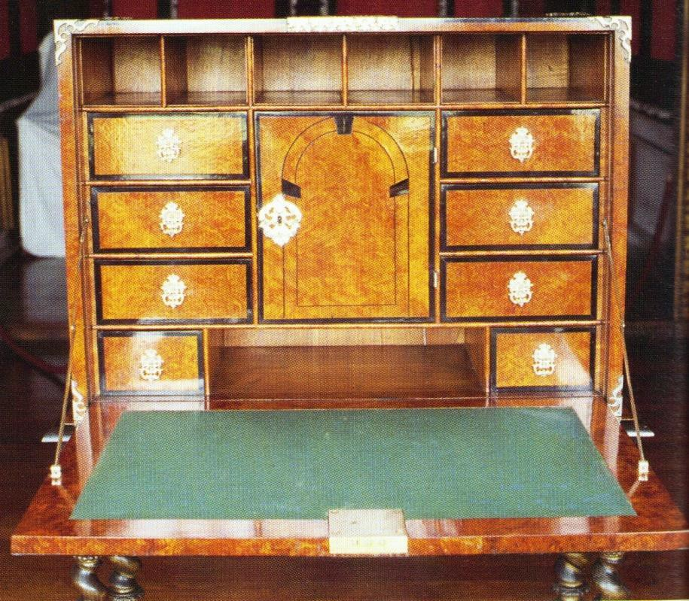

Figure 2.3: Scriptor on Stand c.1670–5. Burr-elm veneers with ebony on a silvered stand (Ham House, The National Trust).
Source: A. Bowett, English Furniture 1660–1714: from Charles II to Queen Anne
(Woodbridge, 2002), p. 48

Figure 2.4 shows a scriptor now at the Geffrye Museum in London which bears the label of John Guilbaud, a cabinetmaker who was situated in Long Acre (1693–1712).26 Guilbaud’s scriptor is the subject of this detailed investigation, looking at how this particular piece of furniture was made and how many tradesmen participated in its construction. The cabinet is in two parts: a top section, containing the writing flap, sitting upon a chest of drawers. Plain veneered case furniture of this type was usually made in its entirety by cabinetmakers while elaborately decorated pieces involved other specialised tradesmen. As this scriptor is simply veneered, it is a fair assumption that it was constructed within one workshop and that most of the tradesmen with whom the cabinetmaker interacted with were those who supplied materials.

26 Bowett, English Furniture, p. 202.

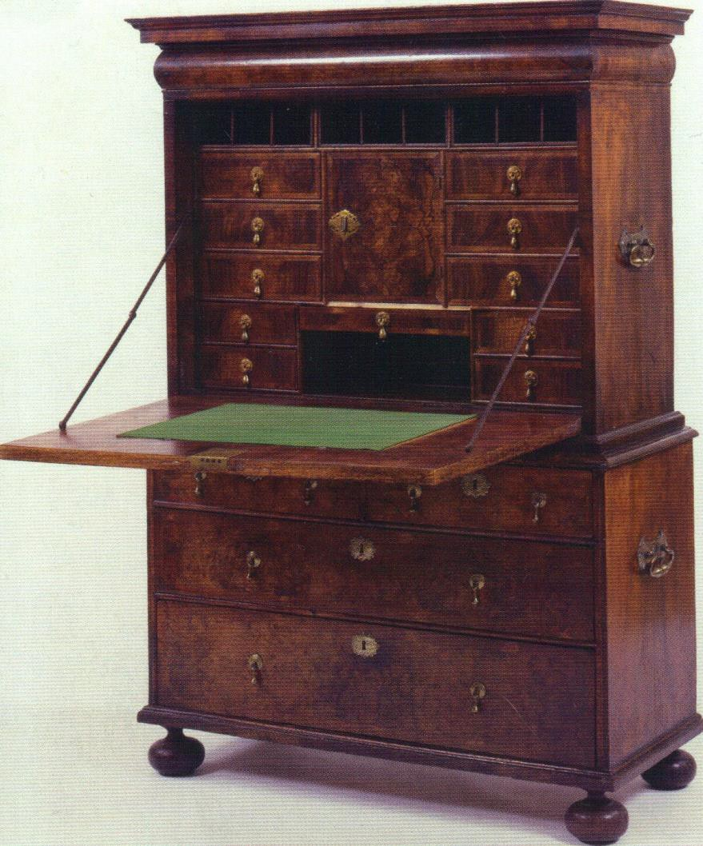

Figure 2.4: Cabinet on chest of drawers bearing the trade label of John Guilbaud, walnut, c.1695 (Geffrye Museum, London, object number 60/2005).

Robert Campbell described the cabinetmakers as ‘by much the most curious Workman in the Wood Way … And [he] requires a nice mechanic Genius … He must have a much lighter Hand and a quicker Eye than the Joiner, as he is employed in Work much more minute and elegant’.27 Figure 2.5 shows a French cabinetmaker’s workshop in the mid-eighteenth century, which is probably a fair guide to the kinds of activities that went on in equivalent premises in London. Whether Guilbaud actually made the cabinet himself or simply sold it is debatable. Nevertheless, for the purposes of this discussion he is considered to be the manufacturer.

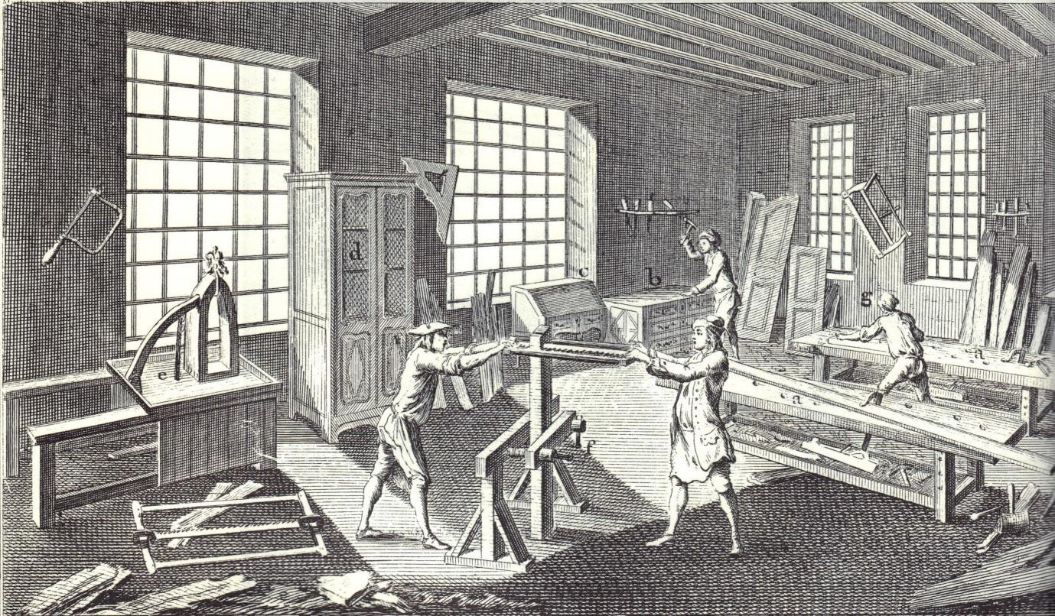

Figure 2.5: A French cabinetmaker’s workshop strewn with tools and materials, depicting cabinetmakers in various stages of manufacture (taken from Denis Diderot’s L’Encyclopédié, plate 1, ‘Ebénisterie et marquetrie’ (1763).
Source: C. C. Gillispie (ed.), A Diderot Pictorial Encyclopedia of Trades and Industry: 485 Plates Selected from ‘L’Encyclopédie’ of Denis Diderot (2 vols., New York, 1993), ii, plate 291, ‘The Cabinetmaker’.

Guilbaud would have purchased his wood from a timber merchant and many were situated along the banks of the Thames. According to Campbell:
The Timber-Merchant properly, is the Importer of Timber from abroad in his own Bottoms: He is furnished with Deal from Norway, either in Logs or Planks; with Oak and Wainscoat from Sweden; and some from the Counties in England [….]; with Wallnut-Tree from Spain. These he sells to the Carpenter, Joiner, and Cabinet-Maker at considerable Profit. It requires no very inconsiderable Stock to set up a Timber-Merchant; he must always have a large Stock by him in his Yards, and give considerable Credit to the Master-Builders.28

Figure 2.6 illustrates a timber merchant wharf on the banks of the Thames where it intersected with the Fleet River, from around the mid-eighteenth century. Lighters were used to transport goods unloaded from seafaring ships because the Thames was not navigable for large ships upstream of London Bridge. In the painting they can be seen moored to the wharf where timber was presumably delivered. Apparently journeys in lighters on the Thames could be dangerous and potentially fraught with disaster, as recorded in the Gentleman’s Magazine in July 1731: ‘Mr. Jakeman, a

28 Campbell, Tradesman, pp. 167–8.

Cabinet-maker … and another Person, going into a boat from on board a Ship, it over set by the weight of Mr. Jakeman, who came too hastily on the side of it, and they, and the Waterman were drown’d’.29

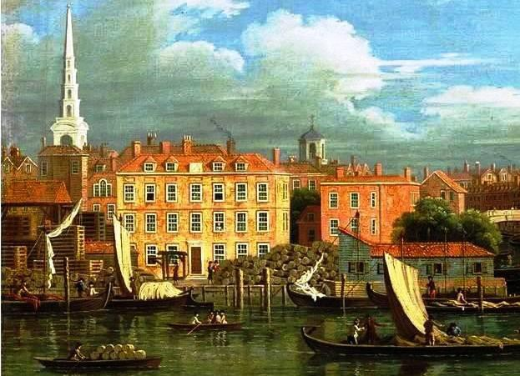
Figure 2.6: Detail from Entrance to the Fleet River, School of Samuel Scott, oil on canvas, c. 1750 (Guildhall Art Gallery, London).

The painting also shows stacks of sawn timber to the left and in the centre logs piled beside what appears to be a roofed sawpit. Some cabinetmakers bought timber directly from importers and sold it. The cabinetmaker Lazarus Stiles in Aldermanbury, for instance, kept an extensive stock of timber,30 and did business with the timber merchant William Astell of Thames Street.31 Samuel Jakeman, who lived in the Minories near to St. Katherine’s Docks, also kept an assorted stock of timber.32

29 Gentleman’s Magazine, i, July 1731, p. 309.
30 LMA, CLA/002/01/3197, Court of Orphans inventory, Lazarus Stiles, 23 Aug. 1724. See Chapter Six for a case study of Lazarus Stiles.
31 LMA COL/CHD/LA/03/032/09 to COL/CHD/LA/03/033/008, 1692 poll tax; LMA,
COL/CHD/LA/06/025, Returns of the names of several wards; GL MS 8052/4, Joiners’ Company apprentice bindings, 7 Sept. 1714. William Astell bound an apprentice for seven years at a consideration of £600.
32 LMA, CLA/002/01/3332, Court of Orphans inventory, Samuel Jakeman, Citizen and Joiner, 3 and 10 Aug. 1731.

Guilbaud used oak (a hardwood often referred to as wainscot) and deal (a softwood) to construct the carcase of his writing cabinet – the standard materials used in most veneered furniture. These timbers were imported from the Baltic region because ‘there was no home grown equivalent’,33 and therefore London furniture tradesmen were wholly dependent on the imported product. Wainscot and deal were sawn into planks suitable for fitting into ships prior to export and required further processing upon arrival in London. This was the work of the sawyer:
The Sawyers Business is quite a separate Trade, and only preparative to the other; nay, they are so strict, that a Timber-merchant or Carpenter, cannot employ indifferent Servants to saw their large Timber &c., but must have regular-bred Sawyers to do that Work, most of which is pretty laborious, therefore requires stout healthy Lads.34

The sawyers jealously guarded their monopoly of the work and their doggedness resulted in frequent disputes, like one in 1693 between the sawyers on one side and the Joiners’ and Carpenters’ Companies on the other. The essence of the dispute was money: the woodworking trades disliked paying the rates which sawyers demanded; though they were also unhappy about workmanship, complaining that ‘they have so ill performed it for want of skill or care as that the Owners of the work have undergone with damage by the spoile thereof and yett never recompensed for the same’.35 Relations between sawyers and woodworking tradesmen were clearly contentious but nonetheless their skills were in demand. Some had their own yards where tradesmen brought their timber for conversion: in 1693 there were a ‘great number of Carpenter Yards which many of the said Freeman Sawyers doe have.36 Figure 2.7 shows sawyers at work in a French timber yard.

33 Bowett, Woods in British Furniture Making, p. xi.
34 Anon, General description of all trades, p. 185.
35 GL, MS. 8046/2, minutes of the Joiners’ Company, 7th Feb. 1693.
36 GL, MS. 8046/2, minutes of the Joiners’ Company, 7th Feb. 1693.

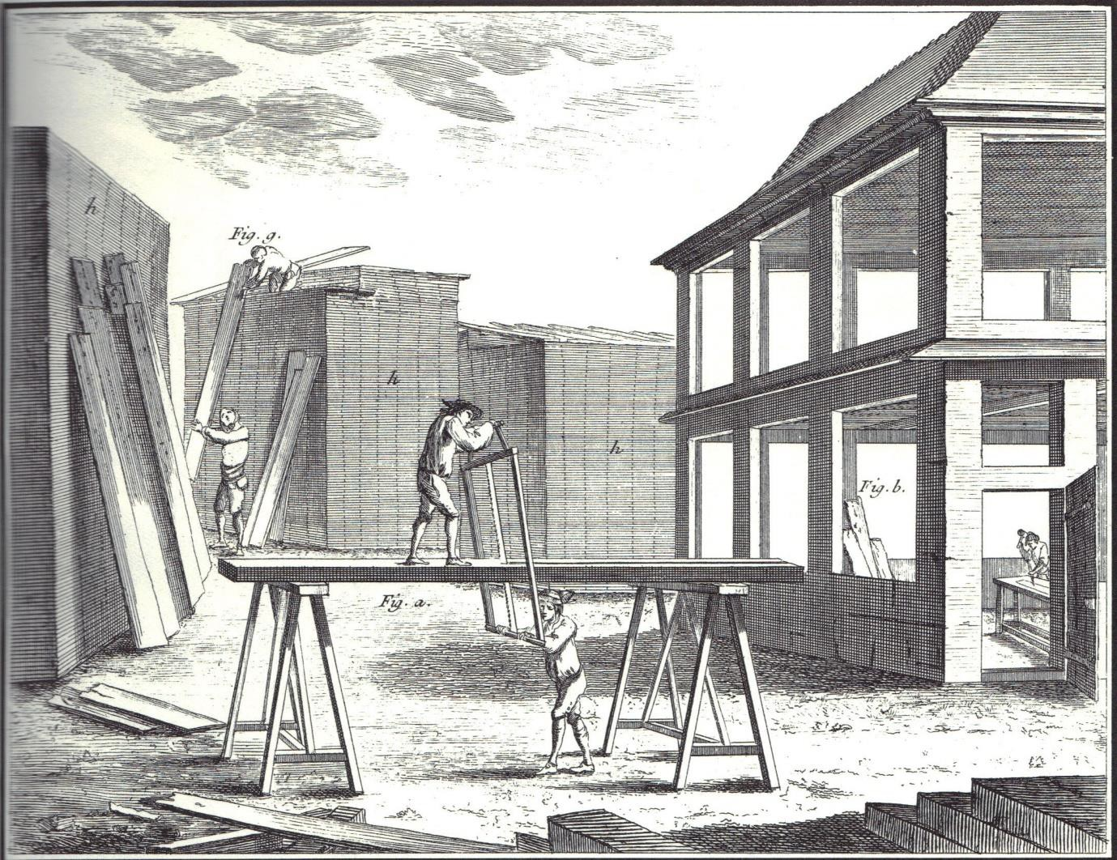

Figure 2.7: A mid eighteenth-century French joiner’s timber yard. Two sawyers can be seen, one atop a trestle and the other at ground level. This was a common way to saw when not using a sawpit. Two other sawyers are seen stacking timber in the background (taken from Denis Diderot’s L’Encyclopédié, ii, plate 1, ‘Menuiserie, 1763).
Source: C. C. Gillispie (ed.), A Diderot Pictorial Encyclopedia of Trades and Industry: 485 Plates Selected from ‘L’Encyclopédie’ of Denis Diderot (2 vols., New York, 1993), ii, plate 292, ‘The Joiner I’.

Once the sawyers had cut Guilbaud’s deal and wainscot into planks and boards fit for purpose, he was ready to build the carcase. It is constructed with dovetail joints and this technique was used when building the carcase for all veneered furniture: ‘The dovetail joint is used to join boards at right angles across the end grain, by means of mutually interlocking series of tongues’.37 Before the onset of veneered cabinetwork, English furniture was commonly built with framed-panel construction where the rails and stiles are united by mortice and tenon joints and then the spaces filled with panels to create an enclosed space, or left as an open framework. However – as demonstrated in Figure 2.8 – framed-panel construction did not provide a suitable base for applying veneers because it requires a flush surface in order to adhere smoothly. Dovetailing was not a new form of construction to London furniture makers – it had been used

since before the Middle Ages, especially for boxes and chests – but as veneered furniture became increasingly popular from the 1660s, so too did this technique because it provided a suitable surface on which to lay veneers.38 Figure 2.9 shows how Guilbauld constructed his drawers with dovetail joints and he employed the same form of construction when building the carcase.

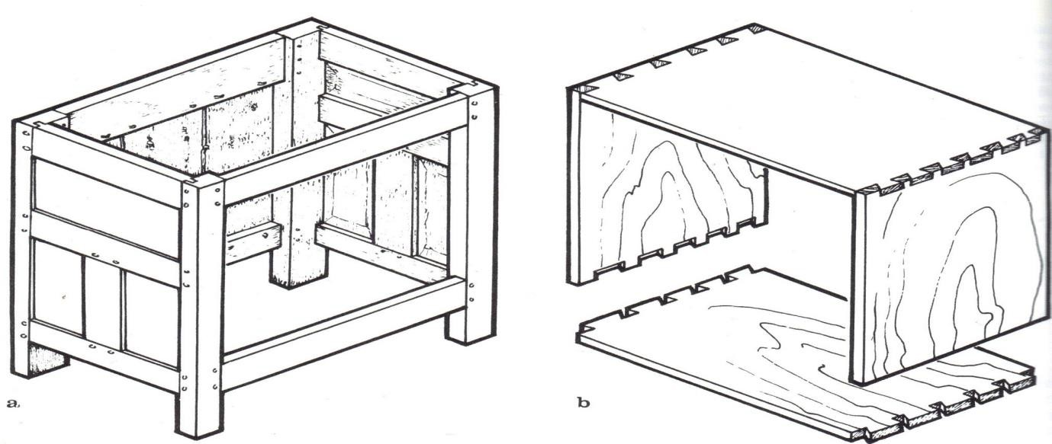

Figure 2.8: a) Framed panel construction b) dovetailed construction.39
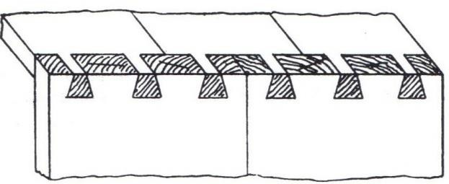
Figure 2.9: Diagram of a dovetail joint and detail of one of the drawers from Guildbaud’s scriptor using the same form of construction. The walnut veneer is seen covering the joints on the left edge (or face) of the drawer.
Source: G. Ellis, Modern Practical Joinery: a Treatise on the Practice of Joiner’s Work by Hand and Machine (3rd edn., London, 1908; Fresno, Calif., 1987), Figure 4, p. 141; A. Bowett, English Furniture 1660–1714: from Charles II to Queen Anne (Woodbridge, 2002), p. 203.

Once the carcase was complete, including its drawers and writing flap, Guilbaud had to plane all of the surfaces to ensure that the groundwork was flat and smooth, ready for the veneers to be applied, but first he attached the ball feet. These are made of oak and

38 Chinnery, Oak Furniture, p. 122.

would have been purchased from a turner. This was not the type of turner who sold general merchandise, but, as Robert Campbell explained, a specialised craftsman: ‘The turner is a very ingenious Business, and brought to great Perfection in this Kingdom.
He makes use of an Engine called a Lathe ... Turners differ among themselves according to the Materials they use’.40 Whether Guilbaud bought his oak ball feet ready-made or had to order them is uncertain. Apparently few turners kept shops: ‘The real Mechanics, who are actually Turners of Box, Lignum Vitae, Ivory, &c whereof they make an abundance of necessary Things, and to sell which only some of them also keep Shops, though there are not many of them’.41

Now it was time to apply the walnut veneers. Walnut is not native to Britain. The tree was introduced by the Romans who harvested the nuts and oil, but it became rare or even extinct after they left. It was slowly reintroduced during the Middle Ages though there are few references to walnut wood being used for furniture or joinery. Some examples of walnut chairs, stools and tables can be found for the sixteenth century – in the 1601 inventory of Hardwick Hall, for instance – but this may not necessarily have been of English manufacture.42 The quality and quantity of English walnut was insufficient to supply the demand and compelled London furniture makers to rely predominantly on imported timber. Documentation of timber importation does not survive in a comprehensive form before 1697, so it is impossible to systematically identify the sources for earlier periods. However, it is likely that France was an important source before this date.43 It was most often shipped in either logs or planks,44 and Guilbaud of course needed his cut into veneers. This was also sawyer’s work.
Evidently, Guilbaud could have bought his walnut veneers ready-sawn, as seen for example in an advertisement dated 30 April 1702, in the London Gazette: ‘A Large Parcel of French Grenoble Walnut-Tree Veneers will be exposed to Sale by Inch of Candle at the Marine Coffee-house on Birchin-Lane, on Thursday the 21st Instant’.45 Further evidence is seen in the descriptions of stocks of veneers listed in the

40 Campbell, Tradesman, p. 243.
41 Anon., General description of all trades, p. 211.
42 Bowett, Woods in British Furniture Making, p. 251.
43 Bowett, Woods in British Furniture Making, p. 254.
44 LMA, CLA/002/01/3332, Court of Orphans inventory, Samuel Jakeman, ‘11 Wallnuttree Loggs’.
45 The London Gazette, 30 Apr. 1702, in ‘The art world in Britain 1660 to 1735’, at
<http://artworld.york.ac.uk> [accessed 20 March 2013].

inventories of London cabinetmakers: ‘a parcel of Holly Peartree & Wallnuttree Finiers’ and ‘some peices of Ewe Feniers’.46

Having finished the carcase, attached the feet and purchased walnut veneers, Guilbaud required glue in order to apply the veneers. This was considered a ‘soft good’ and could be purchased from a cooper.47 These shops apparently sold the types of goods we might consider hardware. Francis Thompson had a shop of this type at the ‘Three Chairs in St. John’s Lane near Hicks’s Hall’, where he was known as a ‘Turner and Chair-Maker’. Amongst other goods he also sold a wide variety of products for furniture-making.48
Now Guilbaud was ready to apply the veneers to his scriptor. First they had to be smoothed because, having been hand sawn the thickness of the veneers was uneven and the surface rough. John Stalker and George Parker explained in their ‘how-to’ manual (1688) that one should
Let your wood which you intend to varnish be … Very smooth, clean, and well rush’t … A good workman or Cabinet-maker, who must scrape it with his Scraper ... And make it as fine and even as possibly he can, then varnish it … This, if well done, will not come behind any for beauty or durability.49

Guilbaud would have used tools such as toothing planes, steel scrapers, ‘Dutch- Rushes’, and ‘dogfish’ or shark skin, which was used as sandpaper. ‘You should furnish your self with Rushes, which are called Dutch-Rushes’, wrote Stalker and Parker, ‘with which you must smooth your work before you varnish it … You may buy them at the Ironmongers’.50 The ironmonger also sold ‘tripolee’, a powder required ‘when you come to polish’.51

Once the surface was perfectly smooth, Guilbaud was ready to make up his varnish and polish, and three further tradesmen supplied the necessary materials: the colour- seller, the distiller and the drugster. John Calfe’s trade card (Figure 2.10) tells us that he supplied goods specifically for varnishing and ‘Japanning’, including several types of brushes and/or pencils, which Stalker and Parker described as being ‘soft, and made

46 LMA, CLA/002/02/01/3197, Court of Orphans inventory, Lazarus Stiles.
47 J. Ayres, Building the Georgian City (New Haven and London, 1998), p. 163.
48 Heal, Furniture Makers, p. 181.
49 Stalker and Parker, Treatise of Japanning, pp. 15, 34–5.
50 Stalker and Parker, Treatise of Japanning, p. 2.
51 Stalker and Parker, Treatise of Japanning, p. 16.

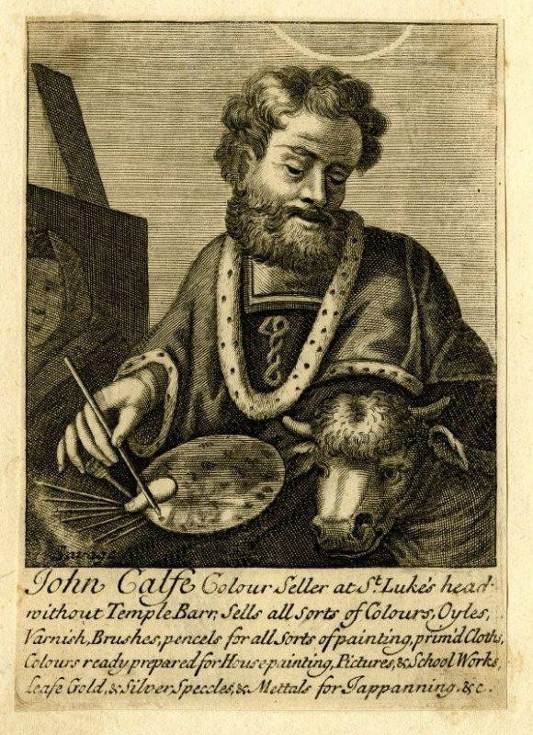
of Camels hair … [available from] Several Colour-Sellers in and about London’.52 The varnish was made from two materials: spirits and seed-lac. ‘To make Varnish you must have Spirit of Wine, which must be strong, or it will spoyl the Varnish, and not dissolve your Gums, and consequently hinder your design’.53 The spirits, of course, was had from the distiller. The seed-lac could be purchased from the druggist: ‘The best Seed-Lac is that which is large-grained, bright and clear, freest from dust, sticks, and dross. The Drugsters afford it at several rates, proportionable to its goodness’.54 Stalker and Parker instructed that once the cabinet received its final polish, with a ‘very fine, soft, dry cloath, rub it all over; spare no place, or pains, but salute it with a nimble, quick stroke, and as hard a hand as possible, and the fruits of your industry will be a dazling lustre, and an incomparable gloss’.55

Figure 2.10: Trade card of John Calfe, colour seller at St. Luke’s Head without Temple Barr, c. 1690 (British Museum, Department of Prints and Drawings, Banks Collection Ref. 89.4).
Source: Anon, Heal, 85.2.92 <http://www.britishmuseum.org/collection>, British Museum, online [accessed 15 July 2015].

52 Stalker and Parker, Treatise of Japanning, p. 1.
53 Stalker and Parker, Treatise of Japanning, pp. 2–3.

Guilbaud’s scriptor was veneered in plain walnut, but if he had wanted something more elaborate – and expensive – he could have decorated it in either floral or arabesque marquetry (Figure 2.11) or ‘oyster’ veneers, or it could have been japanned. Product differentiation was nothing new to furniture tradesmen at the period and some objects decorated in marquetry were clearly targeted towards the wealthiest consumers. Take for example two marquetry cabinets which Gerrit Jensen supplied to Queen Mary at Kensington Palace in October 1690: ‘a folding writeing Table fine Markatree with a Crown & Cypher – £22.10s’ and ‘a large Beuro of fine Markatree wth drawers to Stand upon the Topp carved & gilt pillars – £80’.56 This type of furniture was owned by middling Londoners but would probably not have been of the same quality or price.

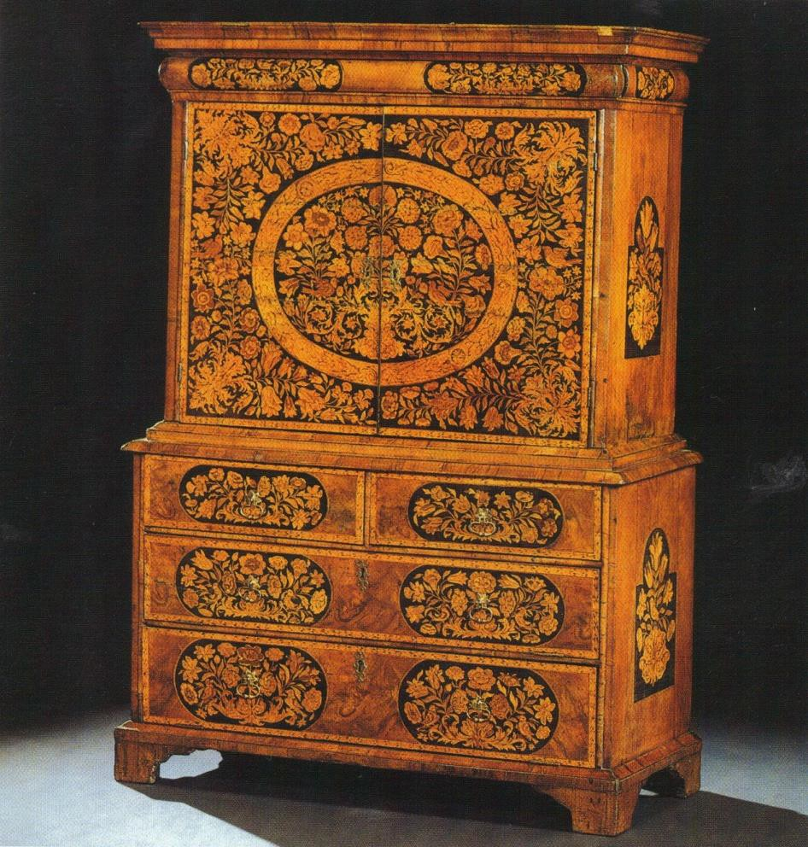

Figure 2.11: Floral marquetry and walnut scriptor (1690–1710) (Sothebys).
Source: A. Bowett, English Furniture 1660–1714: from Charles II to Queen Anne
(Woodbridge, 2002), p. 211.

Marquetry is made by creating a pattern of flowered or arabesque sections to create a design of repeated motifs. Made from wood that is easily dyed – such as holly, pear and sycamore – it is cut on a marqueteur’s donkey (see Figure 2.12). Once individual
56 TNA, LC 9/280, f. 43a, Lord Chamberlain’s accounts, 30 Oct. 1690.

pieces are cut, dyed and stained they can be shaded, if desired, by dipping in hot sand. The ground to which the pieces of marquetry are to be laid is cut out from a copy of the master, glued to a sheet of paper for stability, and then the marquetry pieces can be assembled, piece by piece, to create a panel.57 John Evelyn described floral marquetry in the 1670 edition of Silva:
…when they would imitate the natural turning of Leaves in their curious Compartiments and bordures of Flower-works, they effect it by dipping the pieces (first cut into shapes and ready to In-lay) so far into the hot Sand, as they would have the shadow and the heat of the Sand darkens gradually, without detriment or burning the thin Chip, as one would conceive it to be natural.58

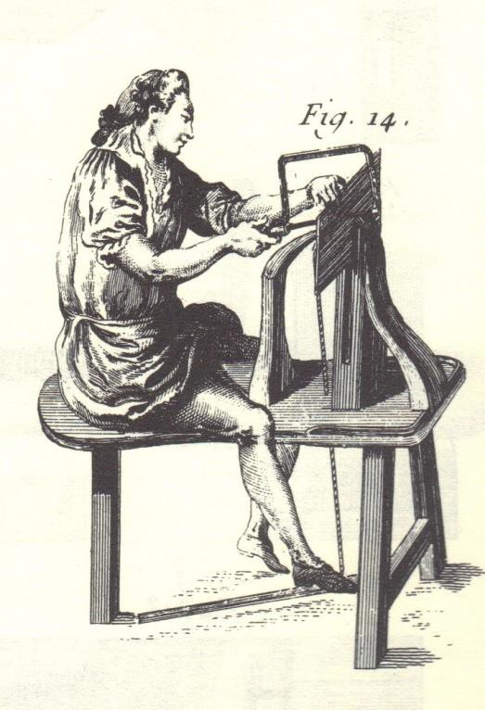
Figure 2.12: Cutting marquetry (taken from Roubo, Le Menuisier Ébéniste, 1774).
Source: A. J. Roubo, Description des arts et métiers: le menuisier ébéniste (Paris, 2006), plate 290, Figure 14.

Arabesque marquetry (Figure 2.13) does not have the naturalistic effects of floral marquetry, but is rather a ‘dense, two-dimensional pattern developed out of highly stylised foliate scrollwork ... Most designs are of two contrasting colours, either light on dark or the reverse.’59 Oyster veneers (Figure 2.14) are made from olive or princes wood which ‘Because of its crooked growth and small size …was rarely used in the

57 P. Raymond, Marquetry (Dourdan, 1989), pp. 135–74.
58 J. Evelyn, Silva, or a Discourse of Forest Trees and the Propogation of Timber in His Majesties Dominions (London, 1670), p. 200.

solid, being most commonly cut into “oyster” veneers or short, straight-grained sections’.60
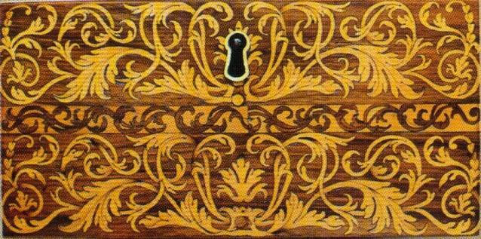

Figure 2.13: A drawer from an arabesque marquetry writing table made from walnut and holly and attributed to Gerrit Jensen, 1690; Windsor Castle. Royal Collection Trust/© Her Majesty Queen Elizabeth II 2016.
Source: Photograph by Adam Bowett, 2001.

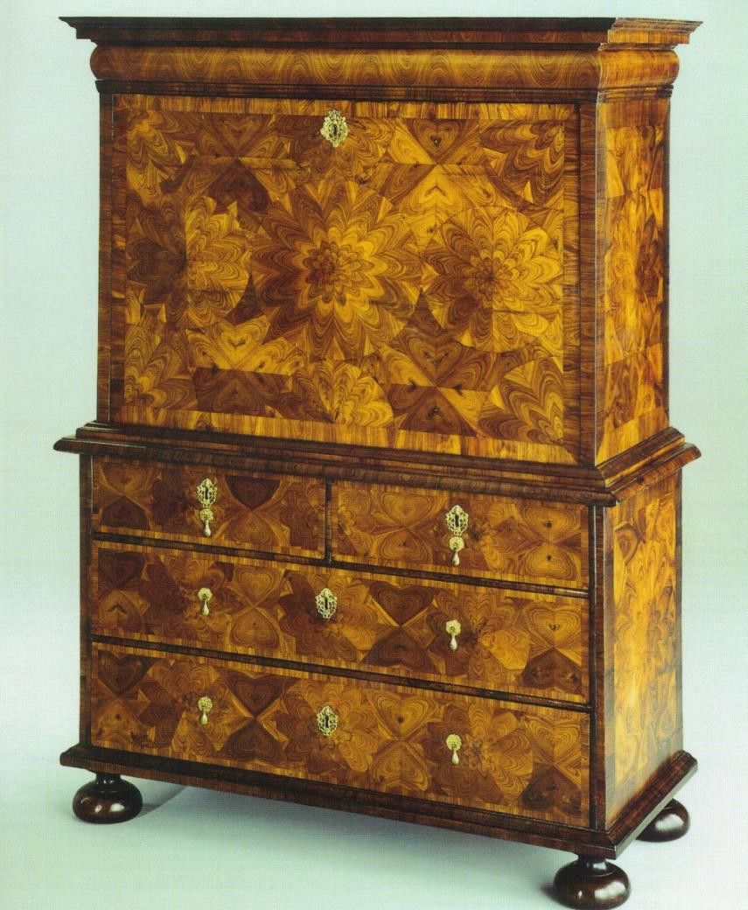

Figure 2.14: Oyster veneered scriptor (1690–1710) (W. R. Harvey and Co).
Source: A. Bowett, English Furniture 1660–1714: from Charles II to Queen Anne
(Woodbridge, 2002), p. 209.

If Guilbaud had chosen to decorate his scriptor in marquetry, he would have needed a marqueteur to carry out this work. Marquetry was an expensive and specialised product and very few furniture makers would have employed marqueteurs on a permanent basis. It is most likely, therefore, that he would have subcontracted these jobs. Whether it was standard practice for this work to be performed in the cabinetmaker’s workshop or put out to a marqueteur is unknown. Nonetheless, subcontracting specialised elements of manufacture was common and is the subject of Chapter Six, which discusses manufacturing networks focusing on three furniture- makers. One was a cabinetmaker in Covent Garden, Edward Traherne (1637–75) who was associated with Jasper Breame, a marqueteur situated at the Savoy in the Strand.61 A plausible alternative to the subcontracting of specific jobs may have been that small panels were produced commercially by marqueteurs and bought ready-made by cabinetmakers, who would then have applied them in the same way as plain veneers. However, evidence remains to be found to prove this supposition.

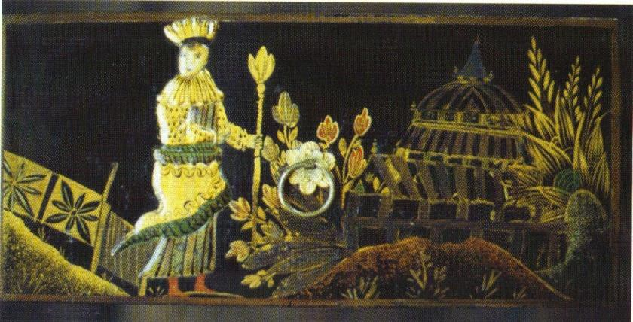

Figure 2.15: Detail of a drawer from a japanned cabinet-on-stand (1675–1700) (Chastleton House, The National Trust).
Source: A. Bowett, English Furniture 1660–1714: from Charles II to Queen Anne
(Woodbridge, 2002), p. 156.

Guilbaud could also have chosen to japan his scriptor, an ornamental device in imitation of Oriental lacquer (see Figure 2.15). The English consumer was fascinated by Oriental lacquerware but the exorbitant price it commanded remained beyond the reach of all but the wealthy. London furniture makers quickly seized the opportunity to fulfil this demand by executing an English adaptation: japanned ware.62 The essential ingredient of true lacquer is a resin (Rhus vernicifera), which was not available in
61 See Chapter Six for further information.
62 Bowett, English Furniture, p. 155: ‘A fine Japanese cabinet might cost between £40 and £50 [and] the japanned English equivalent, including its carved stand, cost less than £20’.

Britain and therefore japanners employed different substances: gum-lac, seed-lac or shell-lac. Essentially, the effect is produced by outlining a chinoiserie decoration in gold size, built up with a composition made of gum Arabic and sawdust and then coloured, polished and gilded with metal dust, and finally burnished.63 Maxine Berg explains how ‘lacquerware became [one of] the defining commodities of a chinoiserie style … and the popularity of Japanese lacquerware prompted imitations’.64 Stalker’s and Parker’s Treatise of Japanning and Varnishing (1688) gave recipes and detailed instructions on japanning and provided engravings of Oriental patterns. They believed that Japanese lacquer was superior to others and wrote that ‘No fiddling pretender could match or imitate it’.65 Amateurs took up japanning as a hobby in much the same way as needlework, and Stalker and Parker balked at this notion, condemning ‘those whiffling, impotent fellows, who pretend to teach young Ladies that Art, in which they themselves have need to be instructed’.66 They must have approved of the fact that japanning became a profession in its own right.

English japanned ware posed a real threat to Oriental lacquerware, which was primarily imported by the English East India Company. One problem was that Oriental cabinets were designed to be placed on or near the floor and this style was inappropriate for English consumers who liked to place prized possessions on elaborately carved and decorated stands to use as impressive centrepieces. In the early 1670s the English East India Company acted to defend their trade, sending English ‘artificers’ to Asia to ensure that the form and style of lacquered goods were made more suitable to English tastes and became more competitively priced.67 This strategy proved successful and accounts from the Joiners’ Company indicate that by the late seventeenth century the market had become flooded with a cheaper and more fashionable version of Oriental lacquerware.68 This of course led to various disputes within the furniture industry as artisans and tradesmen tried to protect their livelihoods. In 1701, a group of cabinetmakers asked the Joiners’ Company to petition parliament

63 J. Fleming and H. Honour, The Penguin Dictionary of Decorative Arts (London, 1989), p. 429.
64 M. Berg, Luxury and Pleasure in Eighteenth-Century Britain (Oxford, 2005), pp. 55, 81.
65 Stalker and Parker, Treatise of Japanning, p. 6.
66 Stalker and Parker, Treatise of Japanning, p. 37–8.
67 J. Pollexfen, A Discourse of trade, coyn and paper credit (London, 1697), p. 99.
68 GL, MS. 8046/3, Joiners’ Company minutes, 4 March 1700/01, parliamentary petition which gives an account of lacquered furniture imported into England 1698–1701: 244 cabinets, 6,582 tea tables, 428 chests, 70 trunks, 52 screens, 189 looking-glass frames, 655 tops for stands, 818 lacquered boards, 197 sconces and 4,120 dressing, comb and powder boxes.

‘on behalfe of the said Company and many Thousand persons depending on the Trade and concerned in making Cabinetts Screwtores’.69 They claimed that the ‘Art of Cabinett Making’ was in danger of ‘ruine and distruccon’ because:
…diverse persons minding only their own private gain and not having any regard to the good of their owne Country but designing rather the ruine and distruccon and especially of the handycraft trades take all opportunities of discloseing the said Art or Mistery by sending Modells or Paternes of the Inventions of your peticoners to India and to severall other ports and places in or neare those parts from whose greate quantities of Cabinetts, Tables, Looking Glasse Frames and other Japaned Wares after such your peticoners Modells or Paterns are in India Manufactured and dayly imported here which if not timely prevented will be to the discouragement and totall ruine of your peticoners.70

Whether thousands of furniture tradesmen were involved in japanning is uncertain but this was conceivably a reasonable estimate considering the popularity of japanned wares. Neither the Joiners nor the japanners they represented stood much of a chance against the influential East India Company, which was of paramount importance to Britain’s economy. The government must have had little allegiance to a City Company representing a domestic industry such as the London furniture trade when considering the amount of income derived for the government’s coffers from Asian imports. In the end, the petitioners only achieved a small concession: import duties on Oriental goods were to be charged according to their ‘true and real value’.71

Guilbaud would have required a japanner to decorate his scriptor, but where this process was carried out is unclear. Japanning was not considered a particularly highly- skilled profession; the parliamentary petition of 1701 describes some as ‘poor Laborius Men who (with their Families) wou’d otherwise have been very Burthensome and Chargeable on their respective Parishes’.72 It could be that few men were exclusively japanners, and that the trade was carried on alongside other more substantial or prestigious occupations. However, if the parliamentary petition accurately described the economic status of japanners, it is unlikely that they could have afforded their own premises and they may have provided their services in cabinetmakers’ workshops. This could explain why very few were recorded in tax, parish or guild records. Only one

69 GL, MS. 8046/3, Joiners’ Company minutes, 7 Apr. 1701.
70 GL, MS. 8046/3, Joiners’ Company minutes, 7 Apr. 1701.
71 J. Rathby (ed.), Statutes of the Realm (1820), vol. 7, 1695–1701, ‘An Act for granting his Majesty several duties upon low wines or spirits … and for improving the duties on japanned and lacquered goods’.
72 GL, MS. 8046/3, Joiners’ Company minutes, 7 Apr. 1701.

japanner is included in the 1692 poll tax: John Hooke, a Citizen and Barber Surgeon of London and a japanner by occupation.73

The next stage in Guilbaud’s manufacture was fitting the metalwork: brass arms, hinges, handles, and lock escutcheons (see Figure 2.16). His scriptor required two brass arms for the drop-down writing flap, nineteen small drawer pulls, four carrying handles and five lock escutcheons. These were supplied by the brass founder who was also known as a brazier. According to Campbell,
The Brazier and Ironmongers Shops are generally united, and in them you find … Locks of all Sorts; Hinges of various Kinds and different Materials; Chases and Handles for Cabinet-Work … and generally all Sorts of Brass and Iron Work that are useful for Furniture, or any Part of Furniture.74

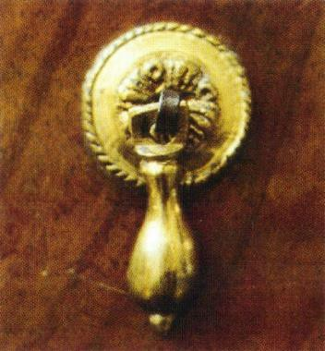
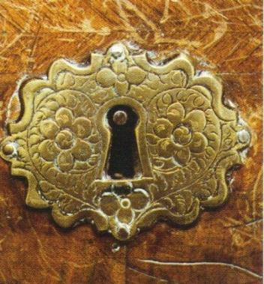
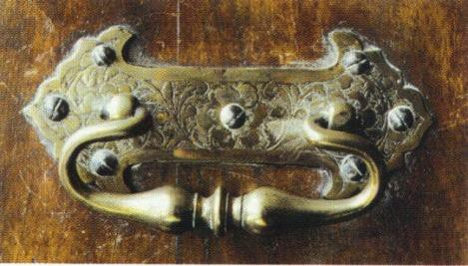

Figure 2.16: Brass fittings from Guildbaud’s scriptor: small shaped drawer pull, cast brass, gilt or lacquered (left); lock escutcheon, cast and chased brass (centre); carrying handle, cast and chased brass (right), (The Geffrye Museum, London, object number 60/2005), c. 1695.
Source: A. Bowett, English Furniture 1660–1714: from Charles II to Queen Anne
(Woodbridge, 2002), pp. 227–9.

Some tradesmen, such as John Giles of Addle Street (see Figure 2.17), specialised in furniture hardware.75 An inventory recorded after Giles’s death indicates that he was supplying furniture makers across London: the cabinetmakers John Belchier of St.
Paul’s Churchyard, William and John Linnell, William Hallett and Peter Hasert of Covent Garden, and William Bradshaw in Soho, are just a few of those listed.76 Giles’s inventory is a fascinating document which merits future research; it includes the names of hundreds of tradesmen and demonstrates the diverse range of supplies that brass

73 GL, MS. 8052/2, Joiners’ Company apprentice bindings. John Hooke, a Citizen and Barber Surgeon, had two apprentices turned over to him through the Joiners’ Company (f. 205, 10 Oct. 1693; f. 238, 11 May 1697; LMA, 1692 poll tax, COL/CHD/LA/0, John Hooke, japanner, St. Andrew Holborn precinct). 74 Campbell, Tradesman, p. 177.
75 TNA, C 11/2488/18, 8 Dec. 1744.
76 Beard and Gilbert, DEFM: Belchier, pp. 59–60; William and John Linnell, pp. 543–8; William Hallett, pp. 387–9; Peter Hasert, pp. 408–9; William Bradshaw, pp. 99–100.

founders stocked. In addition to materials clearly intended for the furniture trade – thousands of nails [silvered, gilt, and plain], cabinet hinges, ‘bow’ latches, brass locks and heading chisels – he also had candlesticks, escutcheon plates, gilt French Gerondoles [sic], ten children’s coffin sets, bell lamps, and ‘a Small nest of Crusibles’.

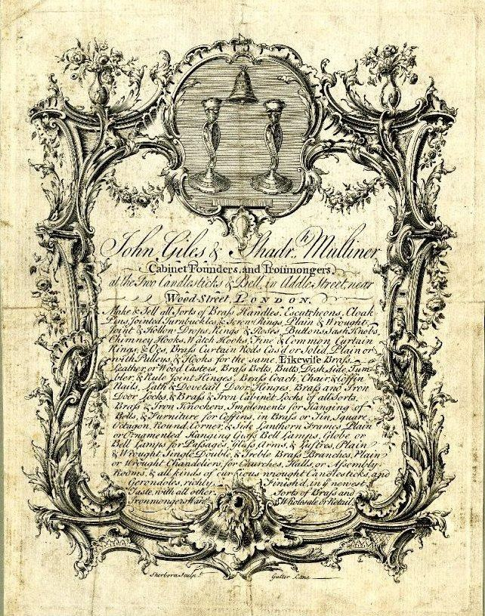

Figure 2.17: Trade card of John Giles and Shadrach Mulliner, at the ‘Two Candlesticks and Bell’, Addle Street, near Wood Street, c.1740 (British Museum, Department of Prints and Drawings, Banks Collection, Ref. 85.120).
Source: Anon, Banks Collection, 85.120, <http://www.britishmuseum.org/collection> British Museum, online [accessed 15 July 2015].

The final finishing touch for Guilbaud’s scriptor was a piece of green baize for the writing flap, and this he would have purchased from a draper. There were two main types of draper: ‘one in Linen Manufactory, and the other in the Woolen, both in large

Branches of Trade, and Shop-keepers, who require great Stocks, especially if in the Wholesale Way’.77

Guilbaud’s scriptor was finished. But how long did the whole process take? Unfortunately, there are no known contemporary documents to shed light on this question. Inventories and bills from the period do itemise particular jobs such as a bill in the Lord Chamberlain’s accounts (1690) ‘for a Scriptoire of Wallnuttree upon a frame with Drawers over the door,78 or a Court of Orphans inventory (1724) ‘to Mr Born for an Escriptore,79 but there is no indication of the time it took to produce the piece. However, although of a later date, an Estimate and Memorandum Book (1759–
62) belonging to the furniture company Gillows gives us a clue (see Figure 2.18), recording an estimate of one and a half days to produce a mahogany stool.
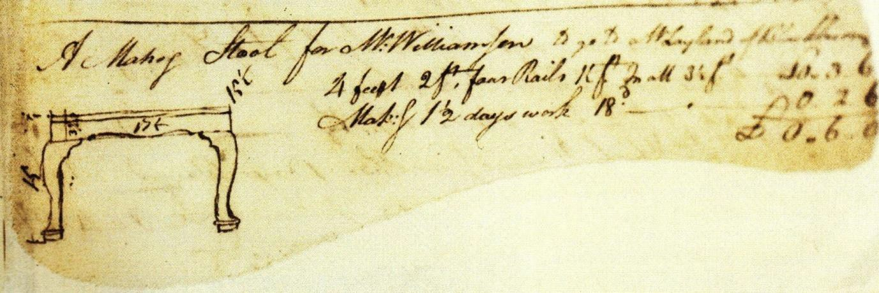

Figure 2.18: Drawing and estimate of a stool from the Estimate and Memorandum Book 1759-62 of Gillows of Lancaster and London, ‘Making 1 ½ days work 18s’.
Source: Westminster Archive Centre, 10 St. Ann’s Street, London, SW1P 2DE: Archive of Gillows of Lancaster, later Waring and Gillow furniture makers (Ref: GWG/0344).

This type of object was cut in the solid, carved and joined. It did not necessitate the construction of a dovetailed carcase with drawers, nor require the time for preparation before the application of the veneers, and for the subsequent finishing work. However, Adam Bowett has commented that ‘the general standard of workmanship [on Guildbaud’s scriptor] is not high’, and points to ‘an abundance of over-cut dovetails, mis-judged scribe lines and glue over runs, all suggesting that the maker was working

77 Anon., General description of all trades, pp. 80–1.
78 TNA, LC 9/280, f. 42b: Lord Chamberlain’s accounts, 30 Oct. 1690.
79 LMA, CLA/002/02/01/3197, Court of Orphans inventory, Lazarus Stiles, Citizen and Joiner, 1724.

in a hurry’.80 Maybe Guilbauld’s workshop was overstretched, or perhaps the scriptor was a bespoke order and the client had grown impatient. Whatever the circumstances, it must have taken a couple of weeks considering that after its manufacture, further time would have been required to allow the varnish to dry before it was either displayed for retail or delivered to the client.

Another interesting consideration is how much Guilbaud would have charged for the scriptor. In the absence of a bill or invoice it is impossible to know for sure. However, in September 1691 he supplied a scriptor to Queen Mary which by its description sounds to be very similar: ‘Sept. 3d 1691, For Her Ma.ts Service at Whitehall, For one plain scriptore £8.10s’.81 The previous year Guilbaud had provided two scriptors decorated with marquetry to the royal household and his bill shows that elaborately decorated furniture cost nearly twice the price: ‘July 31 1690,‘For two Scriptoires Inlaid wth Flowers att £15 each’.82

This biography of Guilbauld’s scriptor has charted the designs, styles, techniques and processes employed in the building of a piece of veneered case furniture. It has introduced the London tradesmen who were involved and considered how they interacted, where they sourced their goods, how they were supplied and who was involved in the various processes. The ways in which the transmission of continental and Asian designs, skills and techniques transformed English case furniture-making (primarily through the deployment of dovetail joints, which enabled new forms of decoration such as veneering, marquetry and japanning) has also been examined, along with the effect these new commodities made on both the consumer and international markets. These novel skills and manufacturing processes were learnt first and foremost within the workshop – from craftsman to craftsman – and passed on generation to generation through apprenticeship, often within manufacturing networks located in geographical pockets of London.

80 Bowett, English Furniture, p. 202.
81 Windsor Archives, bills from royal wardrobe 1689–92, bill no. 30.
82 Windsor Archives, bills from royal wardrobe 1689–92, bill no. 29.

The biography of a caned armchair
Precisely when and why cane chairs came to be made in London is uncertain but a 1690 petition of London cane chair makers states that caning for seat furniture was not fashionable until ‘about the year 1664’.83 An example of the type of caned chair produced at this period can be seen in Figure 2.19. These chairs typically had square seats and backs with wide mesh caning and flat arms, and many had decorative turned elements. According to Benno Forman, ‘The popular demand for these chairs encouraged their production in both joiners’ and turners’ shops and tended to blur the distinctive character of each shop, causing the emergence of a new craftsman, the chair maker’.84 Tax records from the 1690s and an inhabitants’ list from 1721 confirm this to be the case as they include tradesmen who described themselves as chair makers, chair caners and chair frame makers.85
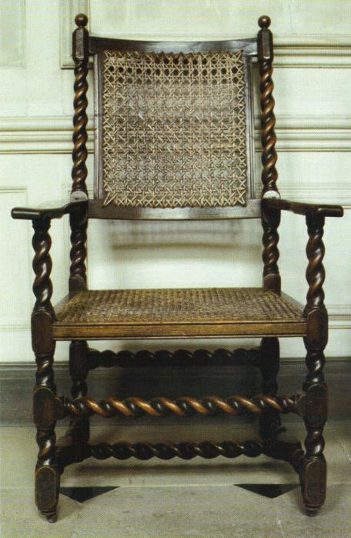

Figure 2.19: Caned elbow chair with a twist-turned walnut frame, c.1675 (Boughton House, Northamptonshire, property of the Duke of Buccleuch).
Source: A. Bowett, English Furniture 1660–1714: from Charles II to Queen Anne
(Woodbridge, 2002), p. 86.
The techniques and materials of caning originate from the Orient, but rattan or split- cane was certainly known in Europe by the beginning of the seventeenth century and
83 R. W. Symonds, ‘English cane chairs – part I’, Connoisseur (March 1951), 8–15, at p. 13.
84 B. M. Forman, American Seating Furniture 1630–1730: an Interpretive Catalogue (New York and London, 1988), p. 229.
85 LMA COL/CHD/LA/03/032/09 to COL/CHD/LA/03/033/008, 1692 poll tax: one chair man, eight chair caners, eight chair frame makers and 17 chair makers; LMA, COL/CHD/LA/06/025, Returns of the names of several wards. 1721: 19 chair makers and six cane chair makers.

was apparently used in making binding or twine long before it was used in furniture.86 Caned seat furniture became popular for several reasons: ‘Durableness, Lightness, and Cleaness [sic] from Dust, Worms, and Moths, which inseperably [sic] attend Turkey- work, Serge and other stuff chairs and couches, to the spoiling of them and all Furniture near them’.87 Not only were cane chairs more hygienic and lighter (thereby more portable) than their upholstered equivalents, they were cheaper to manufacture and sell. Unfortunately there are no known similar carved walnut chairs that are valued from the same date (with one caned and the other upholstered) to serve as a comparison of price. Nevertheless, to give a broad example of the varying prices, a carved walnut caned chair sold for 12s in 1686 while an upholstered and carved walnut chair sold for 30s in 1717.88 The cost of the upholstered chair reflects its retail price whereas the value on the caned chair was determined for a household inventory. Both chairs were made of carved walnut but the upholstered version was more than twice the price.

Peter Earle has shown through his research on London’s middle classes in the late seventeenth century that the decline in the popularity of upholstered chairs coincided with the popularity of cane chairs, and that this demonstrates ‘the influence of fashion on domestic interiors’.89 The first evidence of ownership in London occurs in the inventories of two tradesmen recorded for the Court of Orphans. These show ‘12 Cane Bottom Chayres’ in the dining room of the haberdasher Thomas Seward in 1673, while the cabinetmaker Edward Traherne had ‘five cane chairs’ in his workshop in 1675.90 By the 1680s this type of seat furniture seems to have become commonplace.91
That caned chairs were inexpensive may be the most plausible explanation for their popularity. The dramatic growth of this new trade resulted in disputes within the chair

86 Forman, ‘Continental furniture craftsmen in London’, pp. 229–30.
87 R. W. Symonds, ‘English cane chairs – part I’, Connoisseur (March 1951), pp. 8–15, at p. 13.
88 L. Wood, The Upholstered Furniture in the Lady Lever Art Gallery (2 vols., New Haven and London, 2008), i, pp. 9–10: Richard Roberts supplied a set of eight ‘finely carved’ walnut chairs to Hampton Court in 1717; TNA, LC 9/278, Lord Chamberlain’s accounts, 1686.
89 Earle, English Middle Class, p. 294.
90 LMA, CLA 002/02/01/0957, Court of Orphans inventory, Thomas Seward, Citizen and Haberdasher, 1673; CLA/002/02/01/1177, Court of Orphans inventory, Edward Traherne, Citizen and Joiner, 26 Nov. 1675.
91 LMA, CLA/002/02/01/1794, Court of Orphans inventory, William Plumer, Citizen and Haberdasher, 5 Aug. 1681; CLA 002/02/01/1801, Court of Orphans inventory, Richard Langhorne, Citizen and Grocer, Jan. 1681/2; CLA 002/02/01/2016, Court of Orphans inventory, Ralph Brewer, Citizen and Girdler, 19 Feb. 1686/7. Peter Earle’s extensive examination of Court of Orphans inventories came to the same conclusion: ‘The key decade for the adoption of cane chairs was the 1680s’ (Earle, English Middle Class, p. 294).

making industry: the upholsterers and cloth woollen manufacturers had held a virtual monopoly over the supply of cheap chairs and upholstery materials until the 1680s and this was undermined by the rapid expansion of the caned chair trade.92 This resulted in a series of parliamentary petitions filed between the Upholders’ Company, in association with Woollen Cloth Manufacturers, and the Joiners’ Company who represented the cane chair makers. One such petition filed by the Upholders and the Cloth Woollen Manufacturers, ‘For the Encouragement of the Consumption of the Woollen Manufacture of this Kingdom …’ arose from a resolution of the Upholders’ Company in 1689 ‘towards obteyning an Act of Parliament for prohibiting the making of Cane Chairs etc’.93 In the caned chair makers defence, the Joiners’ Company filed a counter petition explaining that the framing of 192,000 upholstered chairs per year employed as few as 180 joiners and thirty turners, ‘there being but little Work in the making, less Work in the Turning, and generally no Carving at all in those Frames’.
They pointed out that manufacturing caned chairs necessitated a far larger labour force that included joiners, turners and carvers, because it ‘Occasioned the Chair-Frame Makers and Turners to take many Apprentices; and Cane-Chairs &c. coming in time to be Carved, many Carvers took Apprentices and brought them to Carving of Cane- Chairs, Stools, Couches and Squobs only: And there were many Apprentices bound only to learn to Split the Canes, and Cane those Chairs, &c’. The Joiners’ calculated that as a result this manufactory employed ‘many Thousands of People’.94 The cane chair makers eventually won their case.95

It is impossible to verify the vast numbers of chairs claimed to have been made or the numbers of craftsmen and artisans employed in the manufacture, but the petitions demonstrate a chair making industry with an extraordinary productivity and also clearly show the subdivision of labour between the specialised trades. These documents also indicate the numbers of chairs that were exported. Forman wrote that caned chairs were ‘mass-produced and in consequence brought fashionable urban-style chairs within the economic reach of great numbers of people throughout the western world’.96 In 1690 the cane chair makers estimated that they produced 72,000 chairs, stools and couches

92 Bowett, English Furniture, p. 84.
93 Bowett, English Furniture, p. 84.
94 GL, MS. 8046/2, Joiners’ Company minutes, 30 Dec. 1689.
95 Bowett, English Furniture, p. 85.
96 Forman, American Seating Furniture, p. 229.

per annum, of which a third were exported. These went not just to Europe but also to ‘almost all the Hot Parts of the World, where Heat renders Turkey-work, Serge, Kidderminster and other stuffed Chairs and Couches useless’.97 Caned chairs were in the homes of colonial consumers from as early as 1688: a merchant planter in Jamaica was recorded as having thirty-six cane chairs among his household possessions.98
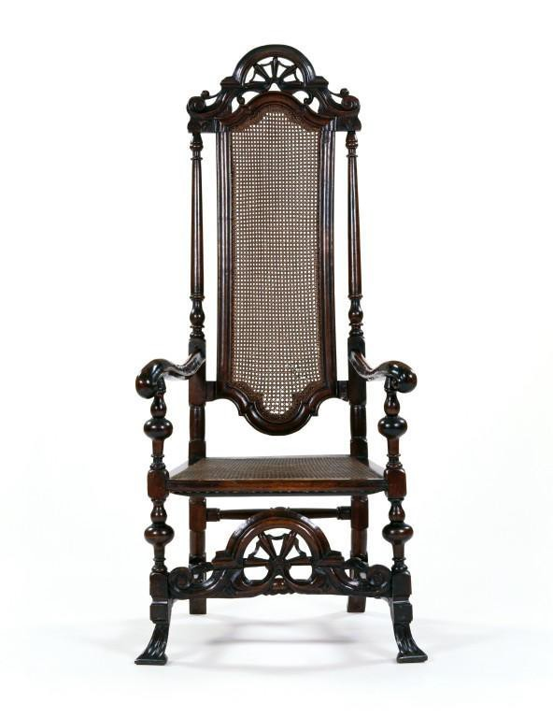

Figure 2.20: Armchair made from walnut with a caned back and seat and carved scroll decoration, c.1715 (Geffrye Museum, London, object no: 50/2000).

The ‘biography’ of a caned armchair follows the tradesmen who participated in its manufacture. The subject is a walnut armchair of around 1715 from the collection of the Geffrye Museum (see Figure 2.20). This type of walnut armchair, with a wide seat and high back, was commonplace in the early eighteenth century. Chair designs are known to have followed dress fashions and our chair would have accommodated the wide skirts of the period and both the large wigs worn by men and the top-knots, adorned with ribbons and bows, favoured by women.99
Made entirely of solid walnut, the chair is turned and carved in decorative motifs of scrolls, bosses, and flowers and has a caned seat and back. We do not know who was responsible for making and/or selling this particular chair nor who bought it, but four
97 Symonds, ‘Cane-Chair makers’, p. 13.
98 N. Zahedieh, ‘London and the colonial consumer in the late 17th century ’, Economic History Review, 47 (1994), 239–61, at p. 253.
99 L. Auslander, Taste and Power: Furnishing Modern France (London, 1996), pp. 67–8.

types of tradesmen would have participated in its manufacture: joiners, turners, carvers and caners. The nature of cane chair production required interdependence between these tradesmen, in particular the joiners and turners who were responsible for constructing the basic chair frame in tandem. The process began with the joiner. By the late seventeenth century, as mentioned earlier, some joiners had focused their trade specifically on caned chair making. The chair maker was responsible for overseeing the entire manufacturing process: determining how many chairs were to be manufactured, acquiring the timber, and employing specialised tradesmen to perform particular aspects of the process. One such tradesman was William Gardner, a member of the Joiners’ Company and a cane chair maker by trade.100 His trade card highlights both the affordability of the cane chair and its hygienic qualities boasting ‘If clean dry Goods is then your End/on me you truly may Depende’ (see Figure 2.21).
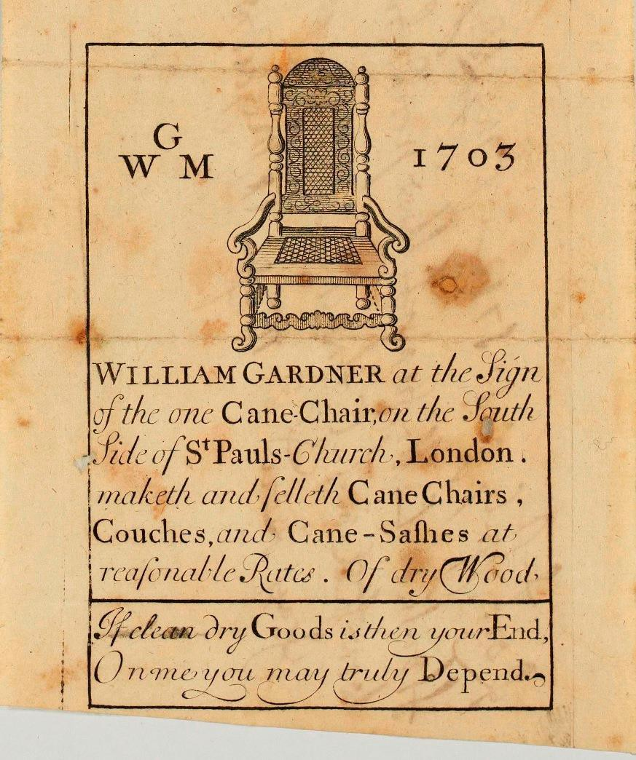

Figure 2.21: The trade card of William Gardner at ‘The Sign of the One Cane- Chair’ in St. Paul’s Churchyard, 1703.
Source: Lincoln Record Office, 2-ANC 12/D/6/16.

The anonymous author of A general description of all trades described the manufacture and sale of the cane chair:

100 William Gardner, chair maker at southwest corner of St. Paul’s Churchyard; LMA, COL/CHD/LA/03/032/09 to COL/CHD/LA/03/033/008, 1692 poll tax; Gardner bound his first apprentice through the Joiners’ Company on 4 Feb. 1695 (see GL MS. 8052/2).

Though this Sort of Household Goods is generally sold at the Shops of the Cabinet-makers for all the better Kinds, and at the Turners for the more common, yet there are particular Makers of each. The Cane chair-makers not only make this Sort, but the better Sort of matted, Leather-bottomed, and Wooden Chairs, of all which there is great Variety and Goodness, Workmanship, and Price, and some of the Makers, who are also Shop- keepers, are very considerable Dealers.101

Most cane chairs were made in sets and this was most likely the case with ours. The lightness and portability of the chairs made them versatile: they could be used as dining chairs but also could be moved to the sides of the room to utilise the space for different purposes.102

The chair maker began by making a cutting list to establish the quantity of wood required. The inventory of the chair maker Thomas Warden of St. Paul’s Churchyard (1692–1701), for example, shows that he had ‘wood & wrought for 5 dozen chairs’.103 Like Jean Guilbaud, the chair maker would have ordered this material from the timber merchant. Chair makers’ inventories describe their stocks of walnut, wainscot and beech, cut into various lengths and described as ‘quarter stuff, planks, and clapboards’. Richard Roberts (1733) had ‘seventy-one feet and a half of English walnut, eight leaves of quarter stuff [and] eighteen beech clapboards’, and Thomas Perkins (1723) owned ‘a large parcel of India Virginia & French Wallnutt tree planks some beech Plank and Quarters & Clapboards’.104 Upon delivery the chair maker would have employed a sawyer to cut the timber into smaller pieces before he cut out his chairs, created the mortice and tenon joints required (see Figure 2.22), and tested them, before disassembling them and passing the component pieces onto the turner.105 The inventories of chair makers’ workshops consistently demonstrate an absence of the equipment and tools used in turning and, therefore, it is believed that turners customarily worked from their own premises.106 This can be seen in the inventories of two chair makers: Warden had four frame maker benches and two carvers’ benches,

101 Anon., General description of all trades, pp. 57–8.
102 Dewing, ‘Cane chairs’, p. 74.
103 LMA, CLA/002/02/01/2439, Court of Orphans inventory, Thomas Warden, Citizen and Joiner, 5 March 1701/2.
104 TNA, PROB 31/32/127, Richard Roberts, Citizen and Joiner, 7 and 24 May 1733; LMA, CLA/002/02/01/3214, Thomas Perkins, Citizen and Joiner, 27 Sept. 1723.
105 Thomas Perkins debts include a payment of £16 9s 1d made to Mr. Shaw the sawyer: CLA/002/02/01/3214, Thomas Perkins, 27 Sept. 1723.
106 LMA, CLA/002/02/01/2735, Court of Orphans inventory, Symon Sheffeild Citizen and Joiner, 2 July
1706; TNA, PROB 3/32/127, Richard Roberts, Citizen and Joiner, 7 and 24 May 1733; PROB 31/119/497, Richard Roberts, Citizen and Joiner, 1733.

but no lathes; and Richard Roberts had seven benches to accommodate frame makers and carvers, but (again) no lathes.107
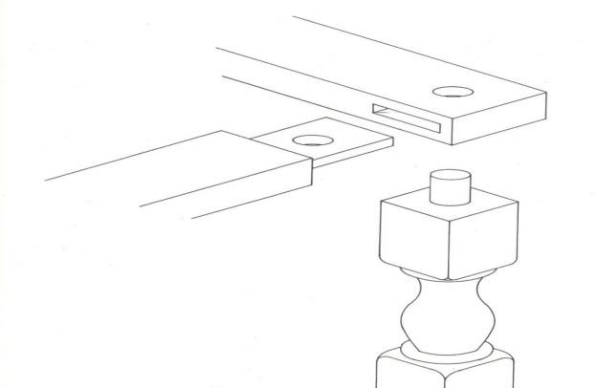

Figure 2.22: Mortice and tenon joint for a chair bisected on the underside by the tenon of the leg.
Source: B. M. Forman, American Seating Furniture 1630–1730: an Interpretive Catalogue
(New York and London, 1988), p. 257.

The expression ‘a turne’ became synonymous with that of ‘a lathe’. In the Dictionary of the English Language (1755), Samuel Johnson defined ‘to turn’ as ‘To form on a lathe by moving round’, and followed this by quoting Moxon: ‘As the placing one foot of a pair of compasses on a plane, and moving about the other foot, pitched steddy on two points as on an axis … This is the whole sum of turning’.108 Turners were responsible for taking the various elements cut by the chair maker and turning them into rounded pieces for a chair, sofa or stool, and if the chair maker requested decorative additions, the turner would also have created patterns – ball, bobbin, double bine, reel-and-bead, ring-and-ball, single and double spiral, and twist.109 Once the turning was complete the constituent pieces were returned to the chair maker.
The next step, if required, was carving. Like the decorative devices turners carried out, carving was optional, as it did not contribute to the basic structure of the chair and many plain caned chairs were manufactured and sold. Carving was a decorative addition that increased the cost of production and this was reflected in the retail price. One plain walnut caned chair, for example, was sold at 13s,110 whereas a carved walnut

107 LMA, CLA/002/02/01/2439, Court of Orphans inventory, Thomas Warden, Citizen and Joiner, 5 March 1701/2; TNA, 31/119/497, probate inventory of Richard Roberts, 1733; Beard and Gilbert, DEFM, p. 752.
108 S. Johnson, A Dictionary of the English Language (London, 1755), vol. ii.
109 Bowett, English Furniture, pp. 69–76.
110 TNA, LC 9/285, Lord Chamberlain accounts, 1713.

caned chair cost nearly twice the price at 25s.111 It is likely that carvers worked to order having been supplied with specific dimensions and patterns. Robert Campbell described them:
The Cabinet-maker and Upholder employ a Species of Carvers peculiar to themselves; who are employed in carving Chairs, Posts and Testers of Beds, or any other Furniture whereon Carving is used. Their work is slight, and requires no great Ingenuity to perform it; I mean, he needs no elegant Taste in the general Art of Carving who performs that used at present upon Furniture. 112

Some chair carvers worked as journeymen in chair makers’ workshops while others carried out this work from their own premises. Thomas Warden operated in this way; he had two carvers’ benches in his workshop and seems also to have employed two other local carvers.113 Our chair is carved in several sections: the crest rail at the top of the chair is arch-shaped and pierced with carved decorations of scrolls, bosses and ball flower motifs; the back rails are reeded; the mid-rail above the seat is decorated in punched crescent motifs; the fore-rail of the legs is arch-shaped with pierced decoration mirroring that of the top crest; and the ends of the arms and feet are scrolled.

When the carving was complete, the chair maker re-assembled the chair and secured the joints either by inserting glue, or by pegging them. Finally he applied polish. The chair was now prepared for its final stage of manufacture: caning (see Figure 2.23). Some chair makers caned their seat furniture in their workshops rather than outsourcing the process, but this appears to have been unusual. Limited documentary evidence makes it difficult to determine what was actually standard practice but out of five inventories analysed, only one tradesman caned seats in his own workshop.114

111 TNA, LC 9/286, 1718.
112 Campbell, Tradesman, p. 172.
113 The carvers were Martha Martin, of St. Paul’s churchyard, and John Baker, of St. Martin Ludgate (LMA, CLA/002/02/01/2439, Court of Orphans inventory, Thomas Warden, Citizen and Joiner, 5 March 1701/2). For further information on Thomas Warden, see his case study in Chapter Six.
114 LMA, CLA/002/02/01/2760, Court of Orphan’s inventory, Robert Loveland, Citizen and Joiner, 31 Aug. 1706; TNA, PROB 4/6830, John Shaw, 21 Sept. 1687; CLA/002/02/01/2735, Court of Orphans inventory, Symon Sheffield, Citizen and Joiner, 2 July 1706; CLA/002/02/01/3214, Court of Orphans inventory, Thomas Perkins, Citizen and Joiner, 27 Sept. 1723; CLA/002/02/01/2439, Court of Orphans inventory, Thomas Warden, 5 March 1701/2.

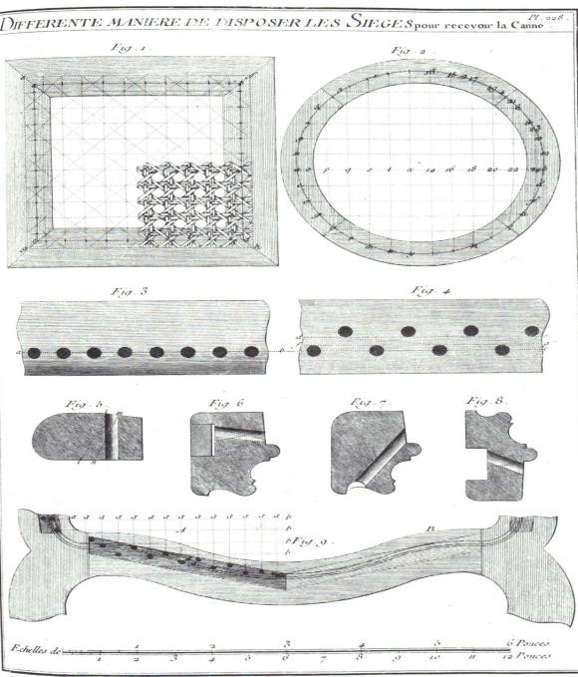

Figure 2.23: Caning (taken from Roubo. Description des arts et métiers, plate. 288), 1774.
Source: B. M. Forman, American Seating Furniture 1630–1730: an Interpretive Catalogue
(New York and London, 1988), p. 374.

The material required for caning is split rattan, which is commonly called cane. David Dewing explained that it was ‘almost unknown in Europe before the seventeenth century’.115 It comes from a type of rattan plant called Calmus rotang which grows in the tropical forests of south-east Asia, particularly Borneo, Malaysia and Indonesia.116 Rattan ‘was a commodity of little monetary value in the East … used as dunnage in ships’ holds to prevent cargoes from shifting during long voyages back from India’.117 It was imported into Britain mainly by the English East India Company. Dewing, in his research on cane chair production in London between 1670 and 1730, determined that there was ‘evidence in the East India Company records that canes and rattan were being shipped to London and sold’, but that ‘either this was happening sporadically or the records are incomplete because there is no consistent pattern’.118 However, the Company does seem to have realised that this dunnage could be turned into a sellable commodity. A letter in 1687 to the governor of Fort St George (the first English fortress in India), instructs him: ‘for the future, not to suffer any ship to come to us wth

115 Dewing, ‘Cane chairs’, p. 56.
116 Dewing, ‘Cane chairs’, p. 56.
117 Dewing, ‘Cane chairs’, p. 62.
118 Dewing, ‘Cane chairs’, pp. 62–3.

empty Tonnage, But in case of any such inevitable necessity… fill up our empty tonnage wth Canes and Rattans rather than let it come wholly empty, for those will pay some freight’.119

Just as some cabinetmakers sold timber there were cane chair makers who sold cane. One was Isaac Puller of St. Paul’s Churchyard (see Figure 2.24), who was a business associate of the chair maker, Thomas Warden.120 Puller purchased cane and rattans directly from the East India Company before selling them onto fellow tradesman, as demonstrated by an entry in the Company’s accounts from 1691 ‘to Cash pr Isaac Puller an overpayment on Rattans’.121
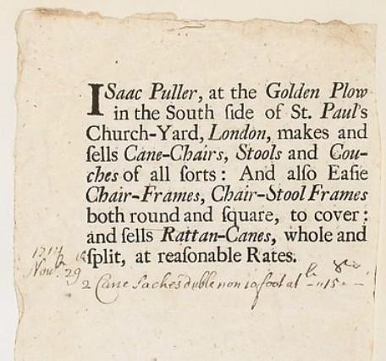

Figure 2.24: Trade card of Isaac Puller, with inscription dated 1714. Puller used this trade card as a receipt for cane sold for 12s (Metropolitan Museum of Art, New York, Ref. 47.71.14).
Source: Gift of Bella C. Landauer, 1925 (47.71.14) © 2016. The Metropolitan Museum of Art/Art Resource/Scala, Florence

The clash between the Upholsterers’ and the Joiners’ Companies has been noted earlier. A similar disagreement arose between the Joiners and the Basketmakers. The Joiners’ minutes from 1698 record concerns that the Basketmakers proposed to incorporate caners into their company, at the expense of the members of the Joiners’ Company. Consequently, the Joiners took measures to ensure their members’ livelihoods were protected:
Severall Caine Chairmakers members of this Company on behalf of themselves and others made their request that this Company would appeare

119 Dewing, ‘Cane chairs’, p. 62.
120 A detailed examination of Warden’s and Puller’s relationship is given in Chapter Six.
121 Dewing, ‘Cane chairs’, p. 63.

before my Lord Mayor and Court of Aldermen who desired in opposicon against the Wardens of the Company of Basketmakers who would have the Cainers of Chairs Incorporated into their Company while this Court doth vote and consent unto provided the Charge hereof be on the account of the said Caine Chairmakers 122

Apparently, company identities and their jurisdictions did not always match the structure of the industry, especially when circumstances evolved – as with the rising popularity of caned chairs. This type of conflict arose time and again between the guilds, as the furniture tradesmen they represented adapted their manufacture to suit the rapidly changing market. Caning of chairs fell between the two companies. The Basketmakers emphasised the skills involved in chair caning, whereas the Joiners considered it simply part and parcel of producing a particular product. In other words, guild structures could not always keep pace with developments in techniques and products and, therefore, companies were sometimes perceived as being hostile or resistant to product innovation.123

It is quite common to find initials stamped on the rear face of the seat rail of caned chairs. Our chair is stamped ‘W’ twice. The purpose of these stamps was obviously to identify the work of individual tradesmen, although which ones is unclear. An interesting dynamic of the chair caners association with the Basketmakers’ Company was a regulation stipulated in one of their 1618 ordinances, which ordered members to mark their wares:
That they and everie of them put to such mark to everie of the same wares and vessels before they shallbe put to sale or use as the Wardens of their occupacons Crafte or misteries shall lymitt and appointe without takeinge aney thinge therefore upon paine of forfeiture the double value of the same wares and vessels.124

It is likely that the initials stamped on the back of our chair belonged to a caner, both because of the Basketmakers’ ordinance requiring its members to mark their wares and the fact that upholstered chairs are not so marked. It may also indicate that the individuals involved were paid piece-rates rather than a daily or weekly wage with marking a means of identifying their work. It is significant that while these stamps are common on caned chairs they do not occur on upholstered chairs, suggesting that the

122 GL, MS. 8046/2, Joiners’ Company minutes, 29 Nov. 1698.
123 See Chapter Three for further discussion of City companies and the regulation of the London furniture trade.
124 GL, MS. 2870, Basketmakers’ Company ordinance, 1618.

latter were probably not manufactured using the same system.125 Perhaps it also suggests that cane chair makers were a separate entity, and the Joiners’ 1689 petition may be a further indication that this was the case.

Once the seat and the back of our chair were caned it was ready for sale. As with Guildbaud’s scriptor, it is difficult to find sources to estimate the amount of time it took to manufacture the object. In this instance there is no evidence. This may partially be indicative of the division of labour: the chair was passed back and forth between the workshops of four tradesmen – the joiner, the turner, the carver, back to the joiner, and then finally the caner.

What type of client would have bought our chair? The relationship between the techniques employed in manufacture, and the resulting quality and standard of the product, reflected the various consumer markets. Our chair is not of the highest standard in terms of workmanship, technique or materials. It is made of walnut, well designed and nicely carved, but it is not of the same quality as the chair shown in Figure 2.25, which is elaborately turned and carved throughout. Such workmanship required a highly skilled chair carver and took longer to execute and this, of course, was reflected in the retail price which could amount to as much as 20s.126 This type of chair was probably supplied to the home of the gentry or aristocracy whereas our chair, being less elaborate – and consequently less expensive – would have been aimed toward a different type of consumer.

125 The Upholders’ Company archives do not survive before the late 1690s, so it is difficult to determine how members organised their trade practices.
126 ‘4 dozen carved walnutree cane chairs finely carved and polished £60’ (TNA, LC 9/286, Lord Chamberlain’s accounts, 1718).

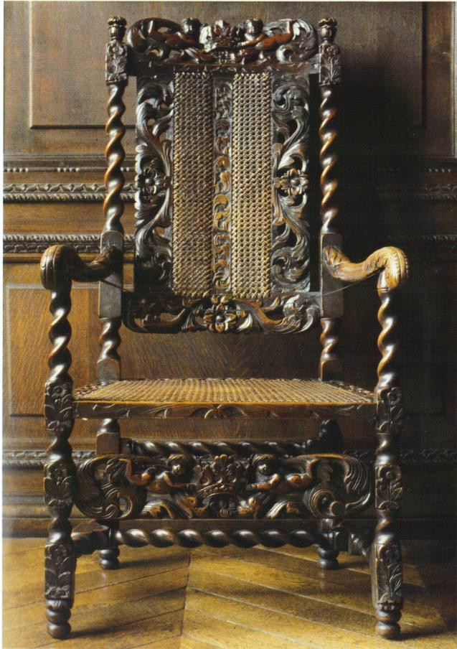

Figure 2.25: A walnut elbow chair carved with ‘Boyes and crownes’ resting on acanthus foliage (1685–90) (property of the Bowes Museum, Barnard Castle).
Source: A. Bowett, English Furniture 1660–1714: from Charles II to Queen Anne
(Woodbridge, 2002), p. 93.

The inventories of forty tradesmen’s dwellings and workshops (1685–1725)127 show that all of them owned cane chairs, kept in their chambers, parlours or dining rooms. These chairs would have ranged in quality but the inventories do not give descriptions, simply listing them as ‘2 cain chairs’ or ‘10 Cane Chaires’.128 The names assigned to these rooms reflect the new domestic arrangements that evolved in the late seventeenth century, though presumably only in the homes of better-off members of society. The consistent appearance of cane chairs in the homes of middle and upper class Londoners suggests that our chair was destined for this type of consumer, and it also speaks of the popularity of the product and the scale of the industry. How much would this ‘middling sort’ have paid for our chair? The inventory of John Shaw, a caned chair

127 These inventories were produced by the London Court of Orphans. For a complete list see Appendix 2.
128 LMA, CLA/002/02/01/2214, Court of Orphans inventory, Lawrence Stevenson, Citizen and Ironmonger, 7 Apr. 1701; CLA/002/02/01/2681, Court of Orphans inventory, Charles Meller, Citizen and Vintner, 15 Jan. 1705/6.

maker of St. Paul’s Churchyard includes, ‘24 elbowe Chairs at 8s p Chaire’,129 and, based on the likeness of our chair to this description, it must have been a similar price.

The late seventeenth century witnessed the birth of a new London trade: cane chair making. This was a mutually dependent relationship between joiners and turners, working alongside carvers and caners to produce caned seat furniture. The biography of a caned armchair takes us from the origins of this type of furniture and explains how and when it came to be produced in London, and the manufacturing processes it entailed. It illustrates the relationships between tradesmen and the conflicts that arose as some of those working in the chair making industry perceived their established livelihoods to be threatened by the soaring popularity of caned furniture. Parliamentary petitions submitted by the Upholsterers’, Joiners’ and Basketmakers’ Companies document such complaints and reveal the resulting fissures between the guilds as their roles and jurisdiction became blurred in the face of the rapidly evolving cane chair industry. Interestingly, there are no known disputes over cane chair making between the Joiners’ and Turners’ Companies These two trades historically manufactured chairs in partnership and perhaps the absence of conflict indicates that the opportunities that arose through the cane chair industry were jointly beneficial.

Conclusion
Although the influence of immigrant craftsmen had been felt from the middle of the sixteenth century onwards, the 1660s ushered in new forms, styles and designs in London furniture inspired by the transmission of artefacts and printed sources. London furniture tradesmen adapted and perfected their products to such a degree that it shifted the flow of imported manufactured luxury goods towards the export of furniture which rivalled – and sometimes surpassed – that of their continental and Asian counterparts. Furthermore, the domestic market was saturated with high design luxury products that were cheaper to purchase than the imported version. John Styles explains that this period in the history of London luxury manufacture was ‘one of progressive import substitution [whereby] the domestic market for imported foreign luxury manufactures was captured by their London-made equivalents.’130 London furniture makers adapted

129 TNA, PROB 4/6830, John Shaw, chair-maker, parish of St. Gregory by St. Paul’s, 1687.
130 J. Styles, ‘Goldsmiths and the London luxury trades, 1550 to 1750’, in D. Mitchell (ed.), Goldsmiths, Silversmiths and Bankers: Innovation and the Transfer of Skill, 1550 to 1750 (London, 1995), pp. 112– 20, at pp. 119–20.

their skill base and manufacturing organisation to keep abreast of the rapidly evolving market. By utilising specialised tradesmen and the division of labour, they could access expertise which was not required frequently enough to justify full-time employment in a single workshop. As Styles points out:
The London metropolitan area became in effect a vast and diverse industrial district, with an exceptionally high density of skilled workers … Linked through criss-crossing networks of subcontracting and piecework. These networks provided masters in luxury trades with a means to secure more minutely defined specialist skills as they required them.131

How far was this organisation cost-effective, and does it fit Adam Smith’s model of economies of scale, where a business obtains larger and more profitable production through the division of labour? Our journey through the manufacture of a scriptor and a caned chair demonstrates that cabinetmaking and cane chair making necessitated different methods of organisation, but both required specialised skills – particularly in decorative ornamentation – and this is where subcontracting played the greatest role.

Did City companies have the capability to monitor and regulate this situation? By the late seventeenth and early eighteenth centuries, were they simply struggling to maintain a role in a fast-changing industry and a city whose population was expanding exponentially? This question will be explored in the following chapter, which discusses the position and authority of the livery companies in the furniture trade – and focussing in particular on the Joiners’ Company.

131 Styles, ‘London luxury trades’, p. 114.

Chapter Three: The role of the Joiners’ Company in the London furniture trade
This chapter examines the relationship between the Joiners’ Company and the furniture trade and questions the extent to which the guild was involved in regulation of the industry and in protecting and promoting the livelihood of its tradesmen. Until recently historians of early modern London believed that by the middle years of the seventeenth century the authority and powers of most London companies were in decline, but this theory is being reconsidered.1 The statutes in the 1614 Company ordinance set out theoretical ideals, but how far were they enforced, or had they come to be effectively no more than guidelines? The Company had to cope with the impact of London’s demographic expansion coupled with the repercussions of the 1666 Rebuilding Act,2 which suspended restrictions on non-freemen working in the building trades in the capital for at least seven years. Consequently the floodgates had opened to a labour force arriving from the provinces and abroad to work alongside, and to compete with, freemen in rebuilding London after the Great Fire.

The chapter begins with a general discussion of the historiography of the ‘decline’ of City companies and ends by focussing specifically on scholarship concerned with the companies representing woodworking trades. It then moves on to a close analysis of the Joiners’ Company. The rate of growth, or decline, is charted and compared to other London companies; an estimate is made of the proportion of the members who were working in the furniture industry; and the socio-economic status and occupation of Company officers and liverymen is considered. Following this is an examination of why freemen maintained their allegiance to the Joiners and how the Company was represented. The next section discusses various economic causes the Company pursued
1 Kellett, ‘Breakdown of gild and corporation control over the handicraft and retail trade in London’, pp. 381–94; G. Unwin, Gilds, pp. 341–51; Gadd and Wallis, Guilds, Society and Economy, 1450–1800; Berlin, ‘Guilds in decline?’, pp. 316–42.
2 ‘Charles II, 1666: An Act for rebuilding the Citty of London.’, in Statutes of the Realm: Volume 5, 1628–80, ed. John Raithby (s.l, 1819), pp. 603-612 http://www.british-history.ac.uk/statutes- realm/vol5/pp603-612 [accessed 7 August 2015]. Artificers working made free of London; and liable to serve in Offices as Freemen. ‘Joyners and other Artificers Workemen and Labourers to be imployed in the said Buildings who are not Freemen of the said Citty shall for the space of seaven yeares next ensueing and for soe long time after as untill the said buildings shall be fully finished have and enjoy such and the same liberty of workeing and being sett to worke in the said building as the Freemen of the Citty of the same Trades and Professions have and ought to enjoy’; Berlin, ‘Guilds in decline?’, p. 327. Section 16 of the 1667 Act for the Rebuilding of the City of London gave all those engaged the same rights to work in the City enjoyed by freemen for a period of no less than seven years.

and the outcome of these endeavours, and also whether these were indicative of active involvement in regulating the furniture industry. The day-to-day activities through which the Company asserted its authority are explored: the searching of furniture- makers’ workshops and retail premises, and the overseeing and monitoring of standards of apprenticeships. This chapter questions whether the theoretical ideals set out in Company statutes was put into practice to the benefit of members; the importance of the institution’s role as a platform for networking; and how far the social standing of its members reflected the overall status of the Company.

As discussed in Chapter One, the primary concerns of all livery companies were to protect members’ livelihoods from encroachment by non-free English tradesmen (foreigns) and immigrants from other countries (aliens), and to limit the numbers of apprentices, thus restricting the number of future masters. In what other ways was the Joiners’ Company involved in their freemen’s business interests? 3 How company regulation of crafts and trades worked in early modern London is frequently the topic of debate amongst historians. This subject is explored through the following issues.
How closely was the Joiners’ Company aligned with the furniture industry, and was it actively regulating the trade? How often did the Company carry out searches? Is there evidence of the outcome of these endeavours such as disciplinary action for defective manufacture? Is there evidence that apprenticeships were actively controlled: were standards of training adhered to and was a particular level of proficiency attained? By the beginning of the eighteenth century London-made furniture was reputed to be of such high standard that by 1700, Dutch craftspeople at The Hague had to submit an ‘English cabinet’ as their masterpiece.4 Does this imply that there was a certain consistency of style, construction, and quality across the industry which characterised London furniture; and how much of a role did the Joiners’ Company’s regulation of the trade play in this?

Methodology and sources
Assessing the relationship between the Joiners’ Company and the furniture trade is problematic due to a lack of distinct documentary evidence. Ordinances embody the

3 GL, MS. 8046/2, Joiners’ Company minutes, 5 Oct. 1686, 24 Nov. 1687; M. Davies, ‘Governors and governed’, pp. 67–83; Gadd and Wallis, Guilds, Society and Economy, 1450–1800, pp. 76–7; Jupp, Carpenters, pp. 142–5, 278–9, 281–2.
4 Ormrod, ‘Cultural production’, p. 220.

collective will of the Company to govern the manufacture, sale and distribution of the products for which they were responsible, and the binding, hiring and treatment of apprentices and journeymen, but how does one determine what the guilds actually did? In his work on the Merchant Taylors’ Company, Matthew Davies explained that ‘Regulations acted as a normative framework with urban crafts. Indeed, they were drafted in the full knowledge that they could never distil work relationships and productive processes into a few statutes’.5 Testing specific statutes against Company minutes, financial accounts, acts of Common Council, and arbitrations between other companies representing woodworking trades gives an approximate idea of what actually took place, but the lack of context in these documents may create a distorted impression of the control which the Company and its officers exercised.6 Therefore, to a certain extent, this examination entails reading between the lines and supporting the analysis with a range of secondary sources.

Two primary sources illustrate the growth of the Company throughout the period: apprentice bindings,7 and a retrospective report, first required in 1724 by the House of Commons, recording the number of liverymen and freemen in the years 1699 and
1724.8 This data can be contextualised by comparing it to the apprenticeship records of other London companies, in particular woodworking and other ‘minor companies’.9 Calculating the proportion of the furniture makers who were members of the Joiners’ Company is difficult. Company records rarely identify members’ occupations and, furthermore, the custom of London allowed a citizen in one company to practise the trade of another. Nevertheless, numerous furniture makers were Company members and they can be identified through various sources such as parish and tax records which often record inhabitants’ occupations.10 Adjudications, an Act of Common

5 Davies, ‘Governors and governed’, pp. 67–8.
6 GL, MS. 8038, 1614 Joiners’ Company ordinance; GL, MS. 8047/1, Joiners’ Company rough minutes (1661–64); GL, MS. 8046/1–7, Joiners’ Company court minutes (1679–1743); GL, MS. 8041/1–2, Joiners’ Company masters’ and wardens’ accounts (1621–87); GL, MS. 2870, 1618 Basketmakers’ Company ordinance; GL, MS. 3295/2, Turners’ Company court minutes (1633–88); Act of Common Council, 9 June 1658 (Guildhall Journal 41, f. 177–8), cited from Phillips, Annals, p. 34.
7 GL, MS. 8052/1–4, Joiners’ Company apprentice bindings.
8 GL, MS, 8046/5, Joiners’ Company court minutes.
9 GL, MS. 8052/1–4, Joiners’ Company apprentice bindings; MS. 8051/1–3, Joiners’ freedom registers; MS, 8046/5, Joiners’ Company court minutes; GL, MS. 4337/1–3, Carpenters’ Company apprenticeship bindings; Records of London’s Livery Companies Online. URL: http://www.londonroll.org/about. Date accessed: 9 Aug. 2015.
10 Beard and Gilbert, DEFM; LMA COL/CHD/LA/03/032/09 to COL/CHD/LA/03/033/008, 1692 poll tax; LMA, COL/CHD/LA/06/025, returns of the names of several wards in obedience to a precept

Council (1658), and several arbitrations and petitions shed light on the ways in which the Joiners aspired to promote and define themselves in relation to the trade and other companies. This empirical evidence alongside the secondary literature on guilds supports the analysis of Company regulation of the industry.11 Company minutes and secondary literature are also used to examine the periodic searching of freemen’s premises and to assess whether corporate policing was effective, or was simply a means of raising revenue and public profile.12 There is a growing body of published work examining London apprenticeships and this scholarship, coupled with primary evidence in company minutes and records of freedom by servitude, enables an examination of how genuine apprenticeships were, and whether the training met the standards required to become a proficient and qualified artisan and/or tradesman.13 In order to explore and ‘map’ Joiners’ Company membership, and to consider whether their social and professional status reflected the standing of the Company itself, we turn to published scholarship on the significance of being a London freeman and biographical details of those individuals who left a documentary trail in their wake.

Decline of the guilds
A conference held in April 2000 at the Institute of Historical Research brought together historians to discuss various aspects of the history of London companies. Papers delivered at the conference were subsequently published as a collection of

giving the proper additions and places of abode, 3 Oct. 1721; GL, MS. 8051/1–3, MS. 8052/1–4, Joiners’ Company freedom records and apprenticeship bindings.
11 Jupp, Carpenters, pp. 295–306: ‘The difference between the Company of Carpenters and the Company of Joyners’, March 25 1632; Act of Common Council, 9 June 1658 (Guildhall Journal 41, f. 177–8), cited from Phillips, Annals, p. 34; Lane, Worshipful Company of Joiners and Ceilers, pp. 80– 1(‘Reasons alleadged against the incorporating of the Sawyers’, 1670); GL, MS. 8046/2, Joiners’ Company minutes, petition to the House of Commons on behalf of cane chair makers 30 Dec. 1689; GL, MS. 8046/2, Joiners’ Company minutes, Joiners’ petition to the Court of Aldermen against the freemen sawyers, 7 Feb. 1693/4; GL, MS. 8046/3, Joiners’ Company minutes, 7 Apr. 1701, Joiners’ petition to the ‘Honourable the Knights, Citizens and Burgesses Assembled in Parliament’ on behalf of the japanners.
12 GL, MS. 8041/1, Joiners’ Company renter accounts; MS. 8046/1–7, Joiners’ Company court minutes; GL, MS. 8047/1, Joiner’s Company rough minutes; GL, MS. 3295/2, Turners’ Company minutes; P. Wallis, ‘Controlling commodities: search and reconciliation in early modern livery companies’, in I. A. Gadd and P. Wallis (eds.), Guilds, Society and Economy, 1450–1800 (London, 2002), pp. 85–100; Davies, ‘Governors and governed’; Berlin, ‘Broken all in pieces’.
13 GL, MSS. 8041/1, 8051/1–3, Joiners’ Company freedom registers; C. Brooks, ‘Apprenticeship, social mobility and the middling sort, 1550–1800’, in Barry and Brooks, The Middling Sort of People, pp. 52– 83; Earle, English Middle Class, pp. 95–105; R. Feldman, ‘Dyeing and the London Dyers’ Company: membership, craft, and knowledge transmission, 1649–1829’, The London Journal, 39 (2014), 37–58; P. Wallis, ‘Undermining apprenticeship: city, law and growth in early modern London’, L.S.E. Department of Economic History Working Papers, no. 154 (2011); Cox, Complete Tradesman, pp. 170–6.

essays: Guilds, Society and Economy in London 1450–1800.14 The articles in this publication examine ‘how company regulations of crafts and trades worked in early modern London’,15 the role they held in London’s economic and social history, and the reasons for their general decline. It did so by broadening the discussion and opening it up to a variety of perspectives.

The received wisdom among some historians regarding the decline of the guilds was that regulatory powers hindered the entrepreneurial spirit of seventeenth- and early eighteenth-century London tradesmen; and that this was one of the primary reasons for the institution’s diminishing authority. Adam Smith was perhaps the first proponent of this theory. Michael Berlin noted that ‘his remarks come at the very period which later historians have pinpointed as a time of declining guild control and concomitant economic growth’.16 Berlin explains how in The Wealth of Nations (1776), Smith considered guilds to be ‘incompatible with advancing economic development in the eighteenth century and antithetical to the new doctrines of economic liberalism; [and that] therefore, as these historical forces advanced, the decline of the guilds could be largely assumed’.17 Smith’s theories of laissez-faire capitalism were echoed by William Carew Hazlitt in 1892 when he wrote in his introduction to The Livery Companies of the City of London how much times had changed. According to Hazlitt, the ‘rigorous protectionist principle’ which governed City companies over the course of centuries ‘was temporarily relaxed only under urgent or special circumstances’.
Hazlitt believed that this ‘rendered such an alliance and brotherhood among the followers of the same calling, as would at present prove a hindrance and an anachronism’.18

George Unwin published two books about the history of the guilds at the beginning of the twentieth century: Industrial Organisation in the 16th and 17th Centuries (1904) and The Gilds and Companies of London (1908).19 Despite repeating the same hypothesis of guild regulation impeding the development of a capitalist economy, he

14 I. A. Gadd and P. Wallis, Guilds, Society and Economy, 1450–1800 (London, 2002).
15 Wallis, ‘Controlling commodities’, p. 86.
16 Berlin, ‘Guilds in decline? London livery companies and the rise of a liberal economy, 1600–1800’, p. 317.
17 Berlin, ‘Guilds in decline’, p. 317.
18 Hazlitt, Livery Companies, pp. 11, 14.
19 Unwin, Industrial Organization; Unwin, Gilds.

concluded that the downfall was the result of mass migration into London and the consequential changes in industrial organisation:
The growth of London as an industrial centre was mainly due to a steady influx of craftsmen from the country. Under such conditions no artificial barriers could long avail to preserve the industrial privileges of the London craftsman resulting in the guilds abandoning restrictions against the number of apprentices and the employment of foreigners.20

Unwin lamented the end of guild regulation over craftsmen, believing that ‘the wealth of society depended on the balance of power between the state, the voluntary body, and the individual’.21 He believed that one of the touchstones of trade unionism, ‘better profits to manufacturers and better wages to work-people, embodied substantially the same ideals as those cherished by the 17th century industrial companies of London’.22

As briefly discussed in Chapter One, J. R. Kellett revisited the theories of earlier historians in his 1958 Economic History Review article, ‘The breakdown of gild and corporation control over the handicraft and retail trade in London’.23 ‘He began by commenting that ‘the waning of gild control over London’s crafts and retail trades in the late 17th and 18th centuries has been referred to so frequently in the course of general economic histories that the process has come to be taken for granted … The impression one receives is that the gilds’ demise was inevitable, and that details may therefore be blanketed [sic]’.24 He argued that companies always struggled with applying theoretical statutes day-to-day and supported this with examples of various challenges to company authority throughout the seventeenth century. He pinpointed the lifting of labour restrictions in 1666 as a critical moment and also discussed plans the Corporation devised to restore their power,25 in particular several eighteenth- century acts of Common Council, such as one which attempted to regulate and licence non-citizens, and another making it mandatory to ‘enrol or translate’ all freemen practising a trade to the corresponding company. Kellett described these policies as ‘fitful and discontinuous’ and suggested that by the early eighteenth century, ‘the duty of enforcing the gilds’ monopoly had devolved very largely upon individuals,

20 Unwin, Gilds, p. 346.
21 T. S. Ashton, ‘Introduction’, in Unwin, Industrial Organization, p. xiii.
22 Unwin, Gilds, p. 343.
23 Kellett, ‘Breakdown of gild and corporation control’, pp. 381–94.
24 Kellett, ‘Breakdown of gild and corporation control’, p. 381.
25 Kellett, ‘Breakdown of gild and corporation control’, p. 383.

neighbouring craftsmen or shopkeepers’.26 While he argued that the Corporation continued to reaffirm guild by-laws encouraging companies to carry out the search, collect quarterage, and police non-citizens, he deemed these efforts to be perfunctory and inconsequential.

Some thirty years later, Steve Rappaport wrote about the authority of the guilds in the sixteenth century in Worlds Within Worlds (1989).27 Rappaport argued that ‘companies continued to play a vital role … and remained a positive, constructive force in urban society in general’.28 He highlighted the level of authority guilds still held: ‘companies devised and monitored regulations which shaped the very nature of work in early modern London and few steps were taken by a craftsman or retailer which did not fall within their jurisdiction … Resisting the search was punishable by a fine and in some companies such as the Brewers, from ten to thirty days in prison’.29 Writing two years after Rappaport, Ian Archer in The Pursuit of Stability (1991), agreed that ‘involvement in the regulation of production and the labour supply was still central to most’ companies in Elizabethan London, and believed that ‘the erosion of the search should not be pre-dated’ to the late sixteenth century.30 However, both Rappaport and Archer conceded that challenges to regulatory powers became increasingly commonplace and at times aggressive as the sixteenth century drew to a close.31

The decline of the guilds in the eighteenth century has been discussed by Leonard Schwarz in London in the Age of Industrialisation (1992).32 Schwarz acknowledged the ‘large and confusing literature on the supposed decline of the London guilds during the seventeenth and eighteenth centuries’.33 He argued against the idea that guilds were ever omnipotent – ‘[the] Golden age is as little likely ever to have existed as the static urban society’ – but goes on to say that:
it is undeniable that the loss of various functions held by the guilds was piecemeal, depending on the functions and the guild, thus making it difficult to discern common patterns [and] in the case of London it was made more

26 Kellett, ‘Breakdown of gild and corporation control’, pp. 383, 385.
27 Rappaport, World Within Worlds.
28 Rappaport, World Within Worlds, p. 184.
29 Rappaport, World Within Worlds, p. 186–7.
30 I. W. Archer, The Pursuit of Stability: Social Relations in Elizabethan London (Cambridge, 1991), p. 124.
31 Archer, Pursuit of Stability, pp. 124–31; Rappaport, pp. 112–15.
32 Schwartz, London in the Age of Industrialisation.
33 Schwartz, London in the Age of Industrialisation, p. 210.

complex by the tradition that one did not need to enrol in the guild of one’s trade in order to become a freeman.34

In reference to the theory that guilds hindered the growth of the capitalist economy, Schwarz maintained that ‘if the guilds were ever supposed to hold back the development of individual enterprise – and this is open to doubt – this was not how they regarded their role in the eighteenth century’. ‘Far from being inflexible institutions that held back the development of market forces’, he pointed out, ‘guilds were remarkably flexible in adapting themselves’.35 Companies continued to exercise economic control by using their powers to regulate apprenticeships and perform searches into the Georgian period.36 Michael Berlin echoed this hypothesis in his essay ‘Broken all in pieces: artisans and the regulation of workmanship in early modern London’ (1997).37 He agreed that the ‘timing of the diminution of powers’ was not as early as some historians have suggested, dating the decline from the middle of the eighteenth century onwards, and explaining that the chronology is unclear because the breakdown of guild control is based on the assumption that there was an ‘inherent incompatibility of guilds with economic growth, technological change and the development of capitalism’. Berlin concluded that ‘the history of waxing and waning of powers of inspection of the London livery companies suggests that the breakdown of guild control came through the conscious decision of those who controlled the companies, rather than because of a failure to adapt to an unseen historic dynamic’.38
The authority companies held to regulate trades and the methods they practised is discussed by Patrick Wallis in ‘Controlling commodities: search and reconciliation in early modern livery companies’ (2002).39 According to Wallis, the ‘interpretations which judge company regulation as either strong or weak are somewhat misleading, and ignore the subtleties of contemporary approaches to policing behaviour’.40 He describes the ‘periodic perambulation to inspect shops and workplaces’, its regularity, extent and effectiveness. The problem, he stressed, with any retrospective historical analysis is that official evidence often only documented ‘particularly recalcitrant

34 Schwartz, London in the Age of Industrialisation, p. 210.
35 Schwartz, London in the Age of Industrialisation, p. 211.
36 Schwartz, London in the Age of Industrialisation, pp. 216–21.
37 Berlin, ‘Broken all in pieces’, pp. 75–91.
38 Berlin, ‘Broken all in pieces’, p. 76.
39 Wallis, ‘Controlling commodities’, pp. 85–100.
40 Wallis, ‘Controlling commodities’, p. 87.

offenders’,41 and consequently those inspections which revealed a high standard of apprenticeship training, quality manufacture, and honest salesmanship remain hidden from the record. Whatever the outcome of an inspection,
The main emphasis of most companies’ courts was upon submission and apology … This was primarily due to weaknesses in the company ordinances themselves. While several legal judgements in the early seventeenth century challenged aspects of companies’ authority, particularly to restrict the use of a trade or to seize goods, the necessity of ordinances and the government of trades was generally accepted.42

Michael Berlin’s article ‘Guilds in decline?’ (2008) summarised the reasons why guild regulations became less effective through the seventeenth century. In addition to explanations given by other scholars, which include the upheaval and mayhem caused by the civil wars and Interregnum, the Great Fire and the subsequent Rebuilding Act, the combined effect of which rendered livery companies impoverished, Berlin noted the pressure on companies due to increasing competition from non-free artisans and tradesmen outside the guilds’ jurisdiction. He also suggested that the growth of subcontracting and subdivision of labour made enforcing City by-laws all the more challenging. Berlin believes the evidence cited for guild decline in this period is ambiguous, explaining that ‘although it is undoubtedly true that the guilds were in a weakened position by the end of the seventeenth century, it is impossible as yet to confirm claims that this loss of regulatory powers was continuous or complete by 1700’.43 Moreover, Berlin argued that, contrary to established historiography, the constant internal disputes over elections and complaints that merchant oligarchs lacked interest in enforcing regulations were not symptoms of the system breaking down, but that ‘these quarrels were endemic to the functioning of the guilds’.44 Nor was the guilds’ decline necessarily due to the introduction of new technologies and skills (a point very relevant to the case of furniture makers given the rapid changes in the industry during the latter half of the seventeenth century). These advances may actually have led to the creation of new specialised guilds – much to the chagrin of established companies who perceived these organisations as ‘wage labourers intent on driving up wages’.45 Berlin concluded that:

41 Wallis, ‘Controlling commodities’, p. 88.
42 Wallis, ‘Controlling commodities’, p. 89.
43 Berlin, ‘Guilds in decline’, pp. 327–8.
44 Berlin, ‘Guilds in decline’, p. 328.
45 Berlin, ‘Guilds in decline’, p. 329.

Rather than being the result of the working out of the unseen hand of some new economic power, the abandonment of powers of control was the effect of deliberate action by mercantile and industrial elites in the companies themselves. It was this social stratum that controlled the mechanisms of guild and civic government, and it was their increasing reluctance to enforce such mechanisms that led to loss of guild control.46

Woodworking guilds
London companies representing woodworking and furniture trades have their origins in the thirteenth century. The Carpenters’ Company was incorporated in 1477,47 the Joiners’ Company was granted its charter in 1571,48 and the ‘Gild of Turners’ received its charter in 1604.49 The Carpenters’ and Joiners’ Companies feature frequently in the historiography of London companies and have both been subjects of recent studies, but the Turners seems to have been neglected, appearing only in historical and/or chronological accounts by company officers and in W.C. Hazlitt’s late nineteenth-century survey of all of London’s livery companies.50 This discussion focuses, therefore, on what has been written about the Carpenters’ and Joiners’ Companies, and their relationships with each other and their respective trades.

Throughout the seventeenth and early eighteenth century companies representing woodworking and furniture trades filed series of complaints resulting in arbitrations against organised groups of artisans and labourers, and on occasion disputes erupted between companies. The orthodox view of the decline of the guilds has presented these demarcation disputes as symptomatic of the companies struggling to maintain their authority. However, as seen, recent scholarship suggests otherwise. According to Michael Berlin:
By the end of the [seventeenth] century attempts at incorporation by groups of artisans and labourers were being refused by the City Corporation, often at the behest of already established guilds … The refusal of the City in1670 to incorporate the sawyers at the request of the Carpenters’, Joiners’, and Shipwrights’ Companies was interpreted by Unwin as indicating the incipient rise of the secret combinations, which were to form such an important part of eighteenth-century industrial relations. But they may also indicate the ebbing away of support for the ideas of incorporation … Alternatively, the denial of livery privileges to aspiring entrants could suggest the continuing interest of the established companies in exerting control over the industry.51

46 Berlin, ‘Guilds in decline’, p. 331.
47 Jupp, Carpenters, p. 5.
48 Lane, Worshipful Company of Joiners and Ceilers, p. 21.
49 Stanley-Stone, Worshipful Company of Turners, pp. 18, 32.
50 Stanley-Stone, Worshipful Company of Turners; Hazlitt, Livery Companies.

Could these disputes indicate that woodworking companies continued to be actively involved in their trades and were not only resistant to the incorporation of new guilds throughout the seventeenth century, but made concerted efforts to define and defend their individual roles and territory within the industry? George Unwin wrote extensively about the methods companies used to strengthen their regulation over trades, arguing that ‘the dominant idea of regulation was the preservation of the status of the master craftsman … Most of the industrial companies limited the number of apprentices’,52 and the Joiners, amongst others, required the making of a masterpiece.53 ‘Many journeymen had refused to make the masterpiece, which they said was an unlawful restraint on their entry into the trade and especially forbidden by an Act of 1536, whilst the Joiners’ Company claimed that the masterpiece was “a thing that had hitherto been put in practice without controversy or refusal by all manner of craftsmen within the city”’.54 The role of masterpieces will be discussed later in this chapter.

Disputes were a feature common to companies representing craft trades and, according to Unwin, ‘were especially common in building trades and eventually led the Carpenters and Joiners to appeal to the city authorities in 1632 for an authorised schedule of woodwork belonging to each’.55 This disagreement was ongoing from 1621 and resulted in a ruling in September 1632 by the Court of Aldermen, ‘settling all differences between the two Companies by describing minutely the several branches of trade to be pursued by each’.56 The Joiners emerged triumphant with the most lucrative end of the deal: they were awarded exclusive rights to produce architectural elements and furniture constructed with mortise and tenon and/or dovetails. The Carpenters on the other hand were limited to joining construction with nails and glue, and this, in effect, excluded them from luxury furniture production and supply.57 In his Historical Account of the Carpenters (1887), Edward Jupp noted that ‘the Carpenters were far from being satisfied with the articles drawn up by the committee … The result of this remonstrance was that the Court of Aldermen, in December 1633, made an Order for
52 Unwin, Gilds, p. 265.
53 Masterpieces were also required by the Weavers, Saddlers, Feltmakers, Broderers and Clockmakers. (Unwin, Gilds, p. 265).
54 Unwin, Gilds, pp. 265–6.
55 Unwin, Gilds, p. 266.
56 Jupp, Carpenters, p. 266; Louw, Demarcation Disputes, p. 8.
57 Jupp, Carpenters, pp. 296–306.

the committee to review their Report’.58 The terms of the delineation were upheld for the following forty years until ‘1672 [when] the feud was renewed by the Joiners, who presented a petition to the Court of Aldermen … praying that they [the Carpenters] might be compelled to observe it’.59 Once again the Joiners came out on top: the Court of Aldermen ordered ‘the particular members of each [company] to confine themselves thereto’.60 The architectural historian, Hentie Louw, pointed out that ‘according to the records [the Carpenters] subsequently sought advice about the legality of the …. decision and planned to take the matter to higher authorities, but nothing came of this’.61 Louw concludes that in all likelihood the urgency to rebuild London after the Fire ‘rendered the dispute largely irrelevant…. [that] age-old craft traditions were swept away in the Acts of 1667 and 1670, and although in theory control over the respective trades was handed back to the companies …. few managed to retain more than a ceremonial and welfare role’.62
Unwin also wrote about the methods craft-based companies used to ensure members were coincident to their particular trades. One such effort began in 1653 when the Joiners, in association with six other ‘minor’ companies,63 ‘presented a joint petition to the Lord Mayor and Aldermen’ requesting an Act of Common Council, which was enacted on 9 June 1658 ‘enjoining all persons using their respective trades to present, bind and make free all their apprentices at their respective companies, and to be subject to the search and government of that company whose trade they use’.64 In theory the Act contradicted the custom of London which allowed a citizen in one company to practise the trade of another. It gave the Joiners and fellow petitioners the right to exercise their power of search over all freemen practising their ‘art and mistery’, and it also ruled that all apprentices were to be bound through and thereafter made free of each individual company. All penalties and suits arising out of a breach of this order were to be heard by the Lord Mayor and the Court of Common Council. The Twelve Great Companies were opposed to implementing the Act into their policies and refused to do so because ‘the existing looseness of the relation between companies and the

58 Jupp, Carpenters, pp. 266–7.
59 Jupp, Carpenters, p. 267.
60 Jupp, Carpenters, p. 267.
61 Louw, Demarcation Disputes, pp. 7–9, at p. 8.
62 Louw, Demarcation Disputes, p. 9.
63 The other companies were the Carpenters, Bricklayers, Weavers, Feltmakers, Plasterers and Hatbandmakers. (Unwin, Gilds, p. 341).
64 Unwin, Gilds, p. 341.

trades they represented was too deeply rooted in the “custom of London”, and too much adapted to the practical needs of the city, to be easily altered’.65 Unwin argued that the Act of Common Council ‘sought to make the membership of each company identical with the membership of a particular trade, and thus strengthen its control over that trade’.66 He likened the alliance between company and trade to that of ‘employers and workers in the hardware trades of Birmingham in the 1890s which aimed to improve both manufacture profit and wages.67 Unwin believed this embodied ‘substantially the same ideals as those cherished by 17th century industrial companies of London’.68 Whether the 1658 Act of Common Council proved beneficial to the Joiners (and in particular those working in luxury manufacture), is discussed below.
However, Mark Jenner commented in his article ‘Guildwork’ (2002):

In high-cost, high-skilled sections of the economy, companies like the Clockmakers and Spectaclemakers seem to have retained a degree of effectiveness in the regulation of their trade in the second half of the seventeenth century. By contrast the regulatory authority of guilds connected with construction work apparently collapsed with particular rapidity in the same period ... Companies like the Carpenters and the Masons continued to campaign in favour of their control over their trade, but the most recent study of the ‘speculative building world’ of late seventeenth-century London concluded that guild regulation was of little consequence.69

The rebuilding of London after the Fire brought both opportunities and problems to building and woodworking trades. Elizabeth McKellar has described the organisational structure of the project in The Birth of Modern London (1991), defining the distinction between the functions of carpenters and joiners, and noting how ‘with the relaxation of guild regulations following the Fire the boundary between the two began to blur and it became common to find both sorts of work being undertaken under the same contract’.70 McKellar refers to Hentie Louw who argued that ‘by the latter part of the seventeenth century the power of the carpenters had waned, while that of the joiners was on the increase’.71 McKellar suggested that while some large-scale carpenter contractors were able to exploit the opportunities, ‘small master craftsmen and their

65 Unwin, Gilds, pp. 341–2.
66 Unwin, Gilds, p. 342.
67 Unwin, Gilds, p. 343.
68 Unwin, Gilds, p. 343.
69 M. Jenner, ‘Guildwork’, in I. A. Gadd and P. Wallis, Guilds, Society and Economy, 1450–1800, pp. 163–70, at pp.163–4.
70 McKellar, Birth of Modern London, p. 75.

apprentices who belonged to the Carpenters’ Company and continued to operate in the traditional manner’72 struggled to keep afloat. On the other hand, ‘the joiners … who were mainly small to medium operators, maintained a flexibility in their range of work and displayed a willingness to adapt to changing economic circumstances and markets which left them overall as a trade in a far better position’.73 McKellar summed up the discussion by quoting Robert Campbell: ‘There are few Joiners but pretend to be Carpenters, so vice versa; but some hands excel more in the one than the other’.74

According to Peter Earle in The Making of the English Middle Class (1989), some 9000 houses were rebuilt after the Great Fire.75 The need for extra labour to achieve this made the relaxation of guild restrictions essential but, once made, ‘Such decisions were not easily reversed and the Fire was very much a turning point in the fortunes of the companies’.76 In their History of the Carpenters’ Company, B. W. E. Alford and
T. C. Barker wrote of the toll taken on the company in the aftermath of the Fire. They explained that the Carpenters were unsettled by the heavy inflow of ‘forrens’ which they believed hindered rising wage rates. ‘The Company realised, however, that in the face of insistent demands by the City authorities for an adequate supply of building labour, this influx could not be checked. As an alternative, therefore, it urged the need for some supervision of this labour, and naturally offered its services for this; but the City rejected the proposal’. Initially free carpenters fears were unfounded: they were not made redundant by the foreign labour force; ‘indeed, the Company itself gained from an increase in the number of redemptioners, who were, in most cases,
provincial-born carpenters who were doing well in London and only too willing to pay £10 to become freemen’. Nevertheless, by the early 1670s ‘unemployment among free carpenters began to appear; and although the Company now had practically no control over the craft, it was still the most effective agency through which ordinary journeymen could express their demands collectively’.77

There is no comparable literature recounting the effects the Rebuilding Act had on the Joiners’ Company or other woodworking and building trades. However, the

72 McKellar, Birth of Modern London, pp. 75–6.
73 McKellar, Birth of Modern London, p. 76.
74 McKellar, Birth of Modern London, p. 76, quoting from Campbell, Tradesman, p. 161. 75 Earle, English Middle Class, p. 22. Reddaway calculated 13,000 houses were rebuilt. 76 Earle, English Middle Class, p. 251.
77 B. W. E Alford and T. C. Barker, History of the Carpenters Company (London, 1968), pp. 114–15.

historiography of companies representing London woodworking trades indicates that the Joiners remained in relatively robust health throughout the seventeenth century. As noted, they had fared well out of the 1632 arbitration between the Carpenters’ and Joiners’ Companies – to such an extent that they were able to reinforce their position in 1672, when the Carpenters appealed to the Court of Aldermen to reconsider the arrangement. Evidence suggests that the Joiners were at least partially successful in applying the 1658 Act of Common Council giving the Company authority to regulate all freemen practising joinery.78 Furthermore, if Elizabeth McKellar and Hentie Louw’s hypothesis is correct, the Joiners generally did better than their contemporaries in the Carpenters’ Company, thanks to their organisational structure and flexibility.

In The London Furniture Trade, 1700–1870 (1988), Pat Kirkham identified several events in the history of the Joiners’ Company which accelerated their loss of authority in the early years of the eighteenth century.79 The first occurred in 1703 when a member of the Company bound an apprentice and turned him over to a member of the Haberdashers’ Company to learn the joiner’s trade. It was perfectly acceptable and commonplace for apprentices to be turned over to joiners outside of the Company.
However, this Haberdasher – John Swithin – decided to flout the 1658 ruling that all freemen practising the joiners’ trade must be free of the Joiners’ Company. This Kirkam argued, was ‘a de facto recognition of the company’s inability to control not only apprentices but also freedoms’.80 Another challenge to the Joiners’ Company was perhaps a decisive moment when their authority began to wane. Kirkham wrote:
Prosecution was made more difficult after 1725 when the Joiners’ Company lost a legal action taken in accordance with a company bye-law of 1695, that no person not free of that company should practice the joiner’s trade under fine of ten pounds. The company attempted to exclude a working joiner, George Wannel, from the freedom of the City because he had been apprenticed in and was free of the Merchant Taylors’ Company. After this defeat, the Joiners’ Company made no further attempts to enforce freedoms for at least a quarter of a century.81

The following examination charts the Company’s fortunes by tracking the number of apprentices bound between 1650 and 1720, and comparing these indentures to apprenticeships in other London guilds, particularly the Carpenters’ Company. It

78 The Joiners’ exploitation of this act is discussed below.
79 Kirkham, London Furniture Trade.
80 Kirkham, London Furniture Trade, p. 141.
81 Kirkham, London Furniture Trade, p. 142.

considers whether allegiance with the Joiners’ Company in this period meant that tradesmen continued to trust the institution to represent their best interests and protect their livelihoods.

The growth of the Joiners’ Company
The numbers of apprentices bound through the Joiners’ Company annually gives an indication of the level of the company’s activity and growth. The Joiners bound 12,495 apprentices over the seventy-year period, 1650–1720.82 Table 3.1 below shows the numbers of apprenticeship agreements administered through the company at five-year intervals over this period.

Table 3.1: Numbers of apprentices indentured through the Joiners’ Company at five-year intervals, 1650–1720

Year | Number of apprentices | Year | Number of apprentices
1650 | 63 | 1690 | 151
1655 | 214 | 1695 | 165
1660 | 95 | 1700 | 222
1665 | 54 | 1705 | 228
1670 | 299 | 1710 | 134
1675 | 145 | 1715 | 176
1680 | 158 | 1720 | 221
1685 | 145

Source: GL, MS. 8052/1–4, Joiners’ Company apprenticeship bindings.

In addition to demonstrating the numbers of apprentices bound through the Joiners’ Company, Table 3.1 also illustrates how historic events affected these arrangements: the period of the Commonwealth in the 1650s, the Restoration, the Great Plague, and the rebuilding of London after the Fire.83 Thereafter, apprenticeship numbers remained at a steady level or increased, with notable peaks, for example, in the early years of the eighteenth century. Tables 3.2 and 3.3 below show the numbers of Joiners’ Company apprenticeship bindings (1650–1720) compared to four other City companies.

82 GL, MS. 8052/1–4, Joiners’ Company apprenticeship bindings.
83 Apprenticeships are discussed in full in Chapter Four.

Table 3.2: Total numbers of apprentices bound to several London companies, 1650–1720

Company | Number of apprentices
Joiners | 12,495
Clothworkers | 12,200
Drapers | 6,462
Mercers | 2,347
Tallow Chandlers | 3,787

Source: Records of London’s Livery Companies Online. URL: http://www.londonroll.org/about. Date accessed: 9 Aug. 2015; GL, MS. 8052/1–4, Joiners’ Company apprenticeship bindings.

Tables 3.2 and 3.3 compare the number of Joiners’ Company apprentice bindings to those in four other City companies over the same period. The Clothworkers, Drapers and Mercers were among London’s affluent twelve ‘great companies’, whereas the Joiners’ and Tallow Chandlers’ companies are classified as less prestigious ‘minor companies’. Yet the numbers enrolled through the Joiners’ Company eclipsed that of all but the Clothworkers. Could it possibly be that that an association with the Joiners’ Company held some type of unique advantage? Table 3.3 breaks down the numbers over ten-year intervals. This detailed analysis demonstrates that while enrolment to the Joiners remained at a steady level or increased, in all other companies it diminished.
The Clothworkers’ and Drapers’ Companies recruited the largest proportion of apprentices in the 1650s and 1660s, but during the following fifty-year period the numbers of apprentices enrolled through all four companies declined, to a greater or lesser degree. This decline can be seen when numbers are plotted on an annual basis (see Figure 3.1).

Table 3.3: Apprenticeship bindings in the Joiners’ Company and four other London Companies at ten-year intervals, 1650-1720

Year | Joiners | Clothworkers | Drapers | Mercers | Tallow Chandlers
 | No | No | No | No | No
1650 | 63 | 218 | 121 | 47 | 69
1660 | 95 | 208 | 126 | 34 | 51
1670 | 299 | 219 | 133 | 38 | 54
1680 | 158 | 140 | 85 | 39 | 71
1690 | 151 | 151 | 85 | 36 | 55
1700 | 222 | 116 | 67 | 29 | 49
1710 | 134 | 105 | 40 | 18 | 44
1720 | 221 | 114 | 60 | 13 | 29
Total | 1343 | 1271 | 717 | 254 | 422

Source: Records of London’s Livery Companies Online. URL: http://www.londonroll.org/about. Date accessed: 9 Aug. 2015; GL, MS. 8052/1–4, Joiners’ Company apprenticeship bindings.

450

400

350

300

250
Joiners'
200
Clothworkers'
150
Drapers'
100
Mercers'
50

0
1650 1655 1660 1665 1670 1675 1680 1685 1690 1695 1700 1705 1710 1715 1720

Figure 3.1: Annual number of apprentices bound in the Joiners’, Clothworkers’, Drapers’, Mercers’ and Tallow Chandlers’ Companies, 1650–1720

Source: Records of London’s Livery Companies Online. URL: http://www.londonroll.org/about. Date accessed: 9 Aug. 2015; GL, MS. 8052/1–4, Joiners’ Company apprenticeship bindings.

Even more important for this discussion is the trajectory of apprenticeship numbers for woodworking companies during the period, in particular the Carpenters’ Company, which almost collapsed during the late seventeenth century. It may be that the Carpenters’ decline began with the 1632 arbitration with the Joiners which resulted in a demarcation between the two trades. Unfortunately apprenticeship records from the 1630s and 1640s no longer exist comprehensively for either company, so how this

initially affected the uptake of apprenticeships in either company is unknown. However, the steady decline in apprenticeship enrolments with the Carpenters for the period after 1655 is demonstrated in Table 3.4. Numbers taken at five-year intervals show that even in the aftermath of the Fire, when there was high demand for carpenters to participate in rebuilding the City, figures remain in decline (compare numbers for the two companies at 1670).

Table 3.4: Numbers of apprentices bound to the Joiners’ and Carpenters’ Companies at five year intervals, 1655-1720

Year | Joiners’ Company | Carpenters’ Company | Year | Joiners’ Company | Carpenters’ Company
1655 | 214 | 105 | 1690 | 151 | 61
1660 | 95 | 71 | 1695 | 165 | 76
1665 | 54 | 27 | 1700 | 222 | 66
1670 | 299 | 72 | 1705 | 228 | 109
1675 | 145 | 42 | 1710 | 134 | 100
1680 | 158 | 38 | 1715 | 176 | 91
1685 | 145 | 48 | 1720 | 221 | 32

Source: GL, MS. 8052/1-4: Joiners’ Company apprenticeship bindings; GL, MS, 4337/1–3, Carpenters’ Company apprenticeship bindings.

In her analysis of the different ways in which the Joiners and Carpenters responded to the Rebuilding Act, Elizabeth McKellar pointed out that it was not uncommon for both trades to work together on the same contracts. However, she noted that, despite the unprecedented circumstances carpenters continued to operate in their customary manner, whereas joiners were more flexible and willing to adapt. This may go some way to explain the decline in Carpenters’ apprenticeships. Yet it may also be that the Joiners were better able to integrate the foreign labour force that arrived with the relaxation of livery restrictions by offering them apprenticeships. The new labour force must have included those interested in working in both carpentry and joinery, but based on the figures in Table 3.4, it seems as if the Carpenters were failing to make new recruits. This loss of influence possibly explains why the Carpenters needed to petition the Court of Aldermen again in 1672, protesting against the earlier ruling defining the parameters of the two trades. The upholding of the original 1632 decision seems to have led to yet further decline.

There must be other explanations for the growth of the Joiners’ Company at a period when membership in the Carpenters was in virtual free-fall, and it cannot be simply

because a career in joinery or the furniture industry was more desirable. On 3 February 1724/5, Parliament ordered the Joiners’ Company to report the ‘exact number of freemen and liverymen’ belonging to the Company in the years 1699 and
1724.84 This account indicates considerable growth in its membership (of journeymen, freemen and liverymen) during the first quarter of the eighteenth century and is demonstrated in Table 3.5.

Table 3.5: Estimate of Joiners’ Company membership, 1699 and 1724/5

Date | Liverymen | Freemen householders | Journeymen | Total membership
1699 | 190 | 1375 | 1724 | 3289
1724 | 286 | 2146 | 2925 | 5357
Growth over 25 years | 50% | 56% | 70% | 63%

Source: GL, MS. 8046/5 – Joiners’ Company Minutes, 5 February 1724/5.

The figures show a 63 per cent increase in the membership of the Joiners’ Company over the years 1699 to1724, a period when the membership in many City companies was in decline (see Table 3.3). The figures were calculated by a clerk in the Joiners’ Company and can therefore not be verified, but nonetheless they are probably relatively accurate and demonstrate a very significant level of growth within the Company, particularly amongst the journeymen. Although the largest rise was in the number of journeymen, the increase in the numbers of tradesmen at the top of the hierarchy is also noteworthy: the livery increased in size by 50 per cent and the freemen who maintained their own workshops by 56 per cent. Who were these people and what proportion of the architectural joinery and furniture trade did they represent?

Membership in the Joiners’ Company
We have established that the level of growth in the Joiners’ Company bucked the trend of several other companies. However, by this period many tradesmen circumvented guild restrictions and it is possible that the majority of joiners did as well. The fact that the custom of London allowed freemen the right to practise any trade means that the relationship between craft and guild cannot be assumed.
Establishing the number of those who were actually working in the industry is difficult, especially as the vast majority of company archives do not record members’

84 This was at the request of the Lord Mayor (GL, MS. 8046/5, Joiners’ Company minutes, 5 Feb. 1724/5).

occupations, nor is it easy to ascertain what proportion of practising joiners were members of the Company. Nonetheless, it is still possible to estimate the proportion working in architectural joinery and furniture-making by linking and cross- referencing company records to other data sources. The first are two City records which provide a snapshot of London in 1692 and 1721.

Table 3.6: Numbers and percentage of joiners and furniture tradesmen in the City of London and their membership of the Joiners’ Company

1692 Poll tax |  |  | 1721 List of Inhabitants
Total tradesmen | members | % | Total tradesmen | members | %
367 | 236 | 64 | 110 | 68 | 78

Source: LMA COL/CHD/LA/03/032/09 to COL/CHD/LA/03/033/008, 1692 poll tax; COL/CHD/LA/06/025, Returns of the names of several wards in obedience to a precept giving the proper additions and places of abode, 3 Oct. 1721; GL, MSS. 8051/1–3, 8052/1–4. Occupations include cabinetmakers, carvers, chair caners, chair frame makers, chair makers, frame makers, gilders, a japanner, joiners, looking-glass makers, sawyers, and trunk makers. This does not include furniture makers working as turners or in the upholstery trades.

Table 3.6 shows the proportion of joiners and furniture makers who were members of the Joiners’ Company in 1692 and 1721. The 1692 quarterly poll tax assessment provides the most comprehensive view of London inhabitants at the period, and comparing this with Joiners’ Company records probably gives the best indication of the proportion of joiners and furniture makers in the City who were members of the Company.85 Furniture tradesmen from across the industry are listed, ranging from prosperous cabinet and chair makers to journeymen joiners. In all, 367 furniture- makers were recorded in the City, of whom 236 (64 per cent) can be identified as members of the Joiners’ Company. Another source is the 1721 inhabitants’ list. This has limits: it is a list of householders eligible for jury service, and so probably excluded many working furniture makers; and returns survive for only eight out of the twenty-eight wards (though fortunately including those in and around St. Paul’s Churchyard where many furniture makers were located). 86 This list records 110 furniture- makers and joiners, of whom eighty-six (78 per cent) can be identifies as members of the Joiners’ Company. This figure demonstrates that membership was higher among householders than furniture craftsmen as a whole, indicating that some

85 This analysis is based on the assumption that the trade identifications in the taxation records correspond with what people did for a living. See introduction for an explanation of the criteria applied when recording the 1692 poll tax and the 1721 inhabitant’s list.
86 See Chapter Five for examples of tradesmen who were excluded.

of the wealthiest members of the trade maintained allegiance to the company at a time when other tradesmen in their socio-economic position seem to have rejected the guild system altogether.

Table 3.7: The number and location of furniture tradesmen listed in The Dictionary of English Furniture Makers (1660–1720) who were members of the Joiners’ Company

City | Westminster | Total Number | Members of Joiners’ Company
100 | 104 | 204 | 90 (44 %)

Source: G. Beard and C. Gilbert, The Dictionary of English Furniture Makers, 1660–1840 (Leeds, 1986). Occupations include: cabinetmakers, carvers, chair caners, chair frame makers, chair makers, frame makers, gilders, a japanner, joiners, looking-glass makers, sawyers, and trunk makers. This does not include furniture tradesmen working as turners.

The information in Table 3.7 is compiled from the Dictionary of English Furniture Makers and covers a wider period of sixty years. It includes 204 London furniture- makers residing in the City and Westminster (1660–1720), more than half of whom
(104) were located outside of the City walls, an area where it would be expected that company membership was lower. Of the entire group, 44 per cent (ninety) were members of the Joiners’ Company and the majority of these tradesmen were involved in luxury manufacture and retail: cabinetmakers, carvers, gilders and japanners.87 This particular analysis is of limited value because the date parameters are broad but, nonetheless, it is notable that a significant number of tradesmen of this status (including those situated outside of the City), continued to maintain allegiance with the Joiners’ Company. The 1614 Company ordinance defines the Company’s jurisdiction as ‘within the said Cittye of London libertyes thereof or within two myles circuite of the said Cittye’.88 Does this imply that to some extent furniture tradesmen outside of the City maintained their membership because the Company was capable of successfully enforcing its authority, even in the early eighteenth century? The London historians Valerie Pearl and A. L. Beier were sceptical: Pearl argued that ‘companies had little power in the suburbs and liberties, for although most seventeenth-century company charters enabled their officers to inspect economic activity up to several miles from the City’ it was unlikely that their authority ‘ever operated very efficiently

87 Tradesmen in the DEFM were identified through trade cards, private household archives and tradesmen’s bills.
88 GL, MS. 8038, 1614 Company ordinance.

so far afield’.89 Beier raised similar doubts: ‘manufacturers who established themselves [outside of the walls] did so for political as well as economic reasons because they knew that they were defying the authority of the livery companies’.90 If Pearl’s and Beier’s position is correct, does this mean that furniture tradesmen who lived outside the City maintained their membership out of choice?

Profile of the Company membership
Who were the members of the Joiners’ Company and what were their socio-economic positions and occupations? The details of most members of the Company remain unknown, particularly journeymen, but several hundred members are documented including members of the court. Many held prominent positions in places such as the Office of Works, and supplied the royal household and the aristocracy. Jonathan Barry suggested that most members of livery company governing bodies were from ‘a middle rung of the bourgeoisie, including lesser merchants, professionals, shopkeepers, and skilled craftsmen’, and that these were people who ‘had the time and resources to devote to the association, but needed to act collectively to make their mark in urban life’.91 Many members of the Joiners’ governing body were from the upper echelons of London’s business communities and, with the exception of one master, all worked in either architectural joinery or the furniture industry.92 Could this indicate that they were actually representing and administrating a company of similar tradesmen? Is it possible that the impact of the custom of London on craft based trades was that it induced occupational homogeneity? 93 Peter Earle deemed it most unlikely by this period. 94 In his analysis of the membership of livery companies, he concluded that ‘from quite an early date, the uniformity of occupation began to be undermined as people changed their trades or as sons acquired the freedom through patrimony but did not practise their father’s trade … The result was that a livery

89 J. Ward, Metropolitan Communities: Trade, Guilds, Identity, and Change in Early Modern London
(Stanford, Calif., 1997), p. 27, quoting Valerie Pearl.
90 Ward, Metropolitan Communities, p. 28, quoting A. L. Beier.
91 Barry, ‘Bourgeois collectivism? Urban associations and the middling sort’, in Barry and Brooks, The Middling Sort of People, pp. 84– 112, at p. 103.
92 John Green was a glass seller, located at the ‘King’s Arms, Poultry, who imported glass from Venice. He was master of the Joiners’ Company in 1663 (Phillips, Annals, p. 114; Beard and Gilbert, DEFM, p. 368).
93 Feldman, ‘Dyeing’, p. 38.
94 Earle, English Middle Class, p. 258.

company label was by no means a good indication of a man’s occupation’.95 Was the Joiners’ Company an exception to Earle’s view?

Biographical details of members of Company officers and liverymen (1654–1730) may provide a clue as to why the number of apprenticeship arrangements through the Joiners’ Company far exceeded that of the Carpenters’ Company – especially in the aftermath of the Great Fire – and may shed light on how the Company was seemingly able to incorporate some of the young men arriving into the capital to join the labour force. With the exception of the three-year period, 1682-85, the position of Master Joiner to the Office of Works was held exclusively by five officers or liverymen of the Joiners’ Company between 1660 and 1761.96 The architectural historian John Summerson described the position:
The Office of Works recruited the best abilities in all the trades and applied them to the architectural opportunities afforded by Crown expenditure.
Those opportunities were often the greatest; but even when they were not, the royal Works continued as a nucleus of superior talent, its officers being employed by whichever patrons had the means to promote the most important buildings.97

This connection alone must have presented great opportunities to members of the Company and encouraged many prospective apprentices to enrol. Thomas Kinward, for example, was a member of the livery from 1654 and Master Joiner to the Office of Works from 1660 to 1682 during the period when London was being rebuilt.98 Another Master Joiner was Sir Charles Hopson. He was master of the Joiners’ Company in 1708, and held his position in the Office of Works from1706 to 1710.99 During his tenure he supervised the execution of joinery work for Christopher Wren at St. Paul’s Cathedral, and at Eton College, Hampton Court, St James’s Palace, Somerset House and Whitehall Palace, amongst other commissions. Apparently Kinward and Hopson could also have been awarded other contracts. Howard Colvin pointed out that ‘most people thought it unnecessary to consult anyone but master workmen when undertaking building operations’. One of the perks of the position was

95 Earle, English Middle Class, p. 251.
96 These were Thomas Kinward (1660–82), Alexander Fort (1685–1706), Sir Charles Hopson (1706– 10), John Hopson (1710–18) and John Smallwell Jnr. (1718–61) (who was apprenticed to his father in 5 July 1698 for 7 years (GL, MS. 8052/3, f. 4)). See Phillips, Annals; Beard, Craftsmen.
97 J. Summerson, Architecture in Britain, 1530–1830 (9th edition, New Haven and London, 1993), p. 28. 98 Kinward is recorded working at Whitehall, Hampton Court, St. James’s Palace, and other Crown estates (Phillips, Annals; Summerson, Architecture, p. 117; Beard, Craftsmen, p. 267).
99 Phillips, Annals, p.116; Beard, Craftsmen, p. 265.

that ‘the Office of His Majesties [sic] Works gave them a basic income in return for official duties which left them ample time for private practice’.100

Other liverymen and Company officers with prestigious appointments included carvers who worked on both architectural commissions and on furniture. Four were employed by the Royal Household. William Emmett was appointed by Charles II as ‘Master Sculptor and Carver in Wood to the Crown’ in 1661, and he maintained this position until Grinling Gibbons was awarded the job in 1682.101 Jonathan Maine actually worked alongside Gibbons at St. Paul’s Cathedral, carving designs by Christopher Wren.102 The brothers Richard and William Cleare were also carvers who executed designs by Wren on several projects, such as the Sheldonian Theatre in Oxford, Chelsea Hospital and many City churches, and they carved the models Christopher Wren designed for St. Paul’s.103 Cabinet and chair makers also served as officers and liverymen and several provided their services to the royal household: for example, Gerrit Jensen, ‘Cabinetmaker in Ordinary’ to the Crown from the reign of Charles II through to Queen Anne; and the chair and frame makers Thomas and Richard Roberts, who held the position of chief suppliers of bed frames, seat furniture and fire screens to royal households between 1686 and 1729.104

All but two of these tradesmen gained their freedom through servitude; they did not arrive at their position through inheritance or by purchasing their citizenship through redemption.105 They all originated from middle-class backgrounds: two were sons of citizens of London and the rest were the children of yeomen and tradesmen who

100 H. Colvin, Biographical Dictionary of British Architects, 1600–1840 (New Haven and London, 1995), p. 32.
101 Phillips, Annals, p. 112; Beard, Craftsmen, p. 258; Beard, The Work of Grinling Gibbons, p. 207.
102 Phillips, Annals, p. 119; Beard, Craftsmen, p. 269.
103 Phillips, Annals, p. 109; Beard, Craftsmen, p. 251.
104 Gerrit Jensen: Phillips, Annals, p. 116; Beard and Gilbert, DEFM, pp. 485–7; Thomas and Richard Roberts: Phillips, Annals, p. 123; Beard and Gilbert, DEFM, pp. 752–4.
105Thomas Kinward: GL, MS. 8051/1, f. 1a, 17 Oct. 1651 – apprentice indentures do not survive comprehensively before 1645 but freedom registers indicate that he was made free through servitude. Alexander Fort: GL, MS. 8052/1, f. 78, 26 May 1659 – son of a Freemason from Salisbury, Wiltshire. Sir Charles Hopson: GL, MS. 8052/2, f. 30 – apprenticed 6 July 1675, son of a Citizen and Weaver. John Hopson: MS. 8051/3, f. 1–5, Sept. 1710 – free by patrimony. William Cleare: GL, MS. 8052/1, f. 24, 24 Apr. 1647 – son of a husbandman from Hampshire. Richard Cleare’s apprenticeship and freedom records do not survive but he bound 10 apprentices through the company, 1647–76. Thomas Roberts: GL, MS. 8052/1, f. 89 – son of a clothworker from Shrewsbury, Shropshire. Richard Roberts: GL, MS. 8052/3, f. 132, 10 Feb. 1707/8 – apprenticed to his father. Jonathan Maine: GL, MS. 8052/1, f. 93 – son of a Citizen and Haberdasher; Gerrit Jensen: GL, MS. 8051/1, f. 76b, 22 Oct. 1667 – free by redemption; his birthplace and socio-economic origins remain undocumented but it is believed that he was from the Low Countries and was trained in either France or Holland.

migrated into London in the mid-seventeenth century from cities such as Salisbury and Birmingham, or small provincial towns and villages. Their families must have recognised the benefits associated with membership in the Joiners’ Company and the potential for a successful career as a London joiner or furniture tradesman.106 Whether they knew that placing their children with particular joiners paved the way to such distinguished futures is unknown, but it does suggest that the Company was a well- reputed guild. Obviously not all apprenticeships offered such high standards of training and future opportunities as will be discussed below. Nonetheless, these examples may indicate that, even at this period, some apprenticeships in the Joiners’ Company consisted of more than just introductions into the upper echelons of the urban trade community; that Joiners’ apprentices were in fact being trained to become highly skilled artisans and craftsmen. It seems unlikely that the carver Jonathan Maine would have worked alongside Grinling Gibbons, or that Richard and William Cleare would have been awarded contracts to execute Christopher Wren’s architectural designs if they had not been talented artisans.

Evidently membership in the Joiners’ Company was valued and maintained at a period when many companies were fading in significance. This would seem to indicate that, in addition to at least some apprenticeships of a high standard, the Company provided both business and social opportunities. Guilds historically acted as a type of community and a social and networking institution. Joseph Ward believed that in the early modern period ‘many Londoners defended companies because they lent stability to their lives during a period of considerable economic, social and cultural change. The extent to which Londoners considered companies to be meaningful associations – and therefore sources of community – depended largely on how closely they chose to identify themselves and their interests with their guild’s’.107 A key component of the association between the guild and its freemen would have been the relationships that were formed between members. Was there a certain level of assumed trust between freemen, an unspoken guarantee, so to speak? The case studies of two cabinetmakers and one chair maker featured in Chapter Six indicate that the Joiners’ Company played a considerable role in the formation of manufacturing networks. In 1675, 43 per cent of the network of cabinetmaker Edward

106 The socio-economic backgrounds of Joiners’ apprentices are examined in the following chapter.
107 Ward, Metropolitan Communities, p. 6.

Traherne were members of the Joiners’ Company; in 1701, 50 per cent of cane chair maker Thomas Warden’s network were Company freemen; and in 1724, 91 per cent of the tradesmen in cabinetmaker Lazarus Stiles’s network belonged to the Company.108 Ian Archer has explored social networks in Restoration London, and argues that ‘community entails some sense of emotional attachment … In a city as institutionally complex as London, guilds could be a focus of social and business interaction for Londoners’. Looking at social networking, he argued, ‘has encouraged us to think of individual Londoners as belonging to a variety of interlocking communities (parishes, wards and guilds), each of which generated loyalties’.109

In addition to the benefits associated with a community of affiliated tradesmen, what other ingredients may have induced loyalty and patronage amongst the membership of the Company? The underlying basic principle of the guild was to protect its members’ livelihoods and personal interests, but how far did the Joiners’ Company fulfil that function or was it simply an ideal?

The relationship between the Joiners’ Company and the furniture trade London tradesmen historically looked to livery companies to represent and defend their livelihoods and regulate their craft and trade interests. ‘To be a freeman of
London’, it has been argued, was ‘to be an economically and politically active citizen
– one needed to be a member of one of the companies which represented and regulated various trades and crafts in the city’.110 Documentary evidence demonstrates some of the efforts the Joiners’ Company made to represent their membership and regulate the trade. The Company pursued two lines of approach: they petitioned and lobbied the Lord Mayor of London, Court of Aldermen and Parliament on various causes; and they exercised their rights to search and to administer apprenticeships. Although company ordinances often served simply as a ‘normative framework with urban crafts’,111 is there any evidence that the statutes in the Joiners’ Company ordinance were upheld? For example, did the Company carry out regular searches and did they have the mandate to search anyone practising the

108 See Chapter Six.
109 I. W. Archer, ‘Social networks in Restoration London: the evidence in Samuel Pepys’s diary’, in A. Shepard and P. Withington (eds.), Communities in Early Modern England : Networks, place, rhetoric (Manchester and New York, 2000), p. 76.
110 Gadd and Wallis, ‘Introduction’, in Guilds, Society and Economy, 1450–1800, p. 4.
111 Davies, ‘Governors and governed’, pp. 67–8.

trade? The 1614 ordinance gave the Company ‘the survey government and search of all Joyners aswell free as forreine and of all other person and persons usinge and makinge any thinge belonginge or in any wyse apperteyninge to the said ffacultye of Joyininge Ceelinge and Carvinge within the said Cittye and of London libertyes thereof’.112 Were such searches actually carried out? Another area is the administration of apprenticeships. How far was the quality and content of apprenticeships actually monitored and is there any evidence that apprentices were required to demonstrate their abilities at the end of an indenture?

This examination begins by discussing the ways in which the Joiners attempted to regulate the trade by seeking legislation through City government and Parliament, and explores the outcomes. As mentioned earlier, the 1632 arbitration between the Joiners’ and Carpenters’ Companies resulted in a demarcation of the two trades with the Joiners awarded exclusive rights to dovetailed construction. There is no surviving documentary evidence to demonstrate the result of this adjudication, though the subsequent growth of the Company and the level of prestige among its membership are probably indicative of how much the Joiners benefited. In contrast, there is a good deal of evidence for the outcome of the 1658 Act of Common Council, which made all freemen practising joinery subject to regulations of the Company.113 These privileges had, of course, been established in theory forty-four years earlier in the Joiners’ Company ordinance. The Act passed on 9 June 1658 decreed that:
Joyners free of other Comps to be subject to the search and ordinances of the Joiners and to be bound and made free by the Joyners Compy and presented to the Chamberlain. Penalty in default of such binding &c £20. Penalty to be prosecuted in the Court of His Highness, the Lord Protector.114

Apparently the Joiners sought this arrangement which indicates that the Company took a proactive stance expanding its authority to regulate the entire industry. The motivating factor for attaining the Act may have been as a means of sourcing additional revenue. The renter warden’s account from 1657-8 record a payment of £8

112 GL, MS. 8038, 1614 Company ordinance.
113 Unwin, Gilds, p. 341 Seven craft-based companies petitioned for the 1658 Act: the Joiners, Carpenters, Bricklayers, Weavers, Feltmakers, Plasterers and Hatbandmakers. With the exception of the Carpenters’ Company, the extent to which the others may have benefited is not discussed in this thesis. 114 This is a summary from the Guildhall Journal 41, f. 177–78. It is not a direct quotation from the Act (Phillips, Annals, p. 34). Therefore this statement does not mention the other companies that petitioned for the Act.

9s 10d for obtaining the agreement,115 and in the following year the accounts confirm that the Company had gained the right to force anyone working in the trade to enrol themselves and their apprentices as member and to ensure that their apprentices became free of the Joiners in due course.116 The Joiners began immediately to take control of apprenticeship agreements made with tradesmen outside of the Company: the first occurrence was recorded on 30 June 1658, twenty-one days after the Act was passed. Each entry in the Joiners’ apprentice bindings thereafter marked this type of indenture with the following clause: ‘Apprentice bound to the master and wardens and turned over to other men free of other companies using the joiners trade according to the late act of common counsel bearing date 9th June 1658’.117

A total of 11,626 apprentices were bound through the Company between 30 June 1658 and 14 June 1720. Of these, 1,730 (15 per cent), were turned over to joiners with membership in fifty-one other companies.118 It is impossible to know how many similar apprenticeships slipped through the net, though it seems to have become increasingly problematic to regulate: from 9 April 1689, Company minutes record a series of petitions to the Lord Mayor and Aldermen registering complaints for failure to comply with the Act, and such petitions continued periodically into the eighteenth century (the last one recorded for this study being dated 6 November 1739).119 One petition, dated 5 June 1694, is particularly revealing and worth including in its entirety.120 It begins by setting out the penalty for non-compliance:

115 GL, MS. 8041/1, renter accounts, 14 Sept. 1657 to 7 Aug. 1658: ‘Dispursed about prosecucon of the peticon and obteyning the new Act of Comon Councel for all using the Joyners Trade to bind and make free at our hall’.
116 GL, MS. 8041/1, renter accounts, 6 Aug. 1658 to 6 Sept. 1659: ‘ffor entering severall Caveats here against inrolling and making free persons of other Companyes using the Joyners trade’.
117 GL, MS. 8052/1–4, apprentice bindings.
118 These were the Armourers, Bakers, Barber Surgeons, Blacksmiths, Box Makers, Bricklayers, Butchers, Carmen, Carpenters, Chandlers, Clockmakers, Clothworkers, Cordwainers, Cutlers, Drapers, Dyers, Embroiderers, Feltmakers, Farriers, Founders, Freemasons, Fruiterers, Girdlers, Glovers, Goldsmiths, Grocers, Haberdashers, Innholders, Innkeepers, Ironmongers, Leathersellers, Lorimers, Masons, Mercers, Merchant Tailors, Painter Stainers, Patternmakers, Plaisterers, Poulterers, Sadlers, Salters, Sawyers, Shipwrights, Stationers, Tallow Chandlers, Turners, Vintners, Wax Chandlers, Weavers, Wheelwrights and Woodmongers.
119 GL, MS. 8046/6, Joiners’ Company court minutes, 6 Nov. 1739: ‘The Court being informed that diverse persons who use and exercise the Joyner Art and trade and are free members of other Company’s do bind and make Free Apprentices in such other Company’s in breach of an Act of common Council prohibiting such Freedoms It was therefore ordered that a proper Application be made to the Chamberlain of London to prevent such practices and to oblige all such Apprentices to take up their Freedom’s in this Company before they are respectively admitted Free of this City as the said Act of common Council directs’.
120 GL, MS. 8046/2, Joiners’ Company court minutes, 5 June 1694. The 1694 petition is published in B. Forman, “‘The Joyners’ Company” in 1694’, JFHS, 10 (1974), pp. 12–14, at pp. 13–14.

That then all and every such person and persons so doing and offending shall forfeit and pay for every such offence the summ of Ten pounds of lawfull money of England to be recovered by accon of debt bill or complaint to be collected and presented in the name of the Chamberlain of the said City of London for the time being in their Masters Court of Lord Mayor and Ald[e]r[m]en to hold in the Chamber of the Guildhall of the said City of London.121

The petition then continues by defining the Company’s reasoning for administering apprenticeships and searching joiners free of other companies:
The reasons and grounds of the humble desires of the Company of Joyners in the Peticon are these:
- That the fundamental cause of incorporating handicraft trades & manuall occupacons into distinct bodies was to the end that there might be a succession of expert and skillfull Governors, who should take the charge and care of regulating, ordering and correcting the severall Artificers in their materials and workmanshipps, whereby the Kingdom might be furnished with good and substantial wares and commodities & the credit of ye manufactures preserved.
- That those contrary Companies of which sundry Joyners by profession are free, as they have no clause or branch in the least, to regulate & order any part of the said trade by neither have the Governors of the Companies any skill or knowledge to judge of or reforme any of their manufacturers when they are illwrought or defective Which your Pet[itioner]s are dayly sensible of upon their views or searches and upon complaints of others.
- By which meanes many unskillfull & ignorant persons set up & thereby 1: Deceive Gentlemen and others for whom they work, or to whom they sell their commodities.
2: They deceive their Apprentices not being able to teach them true and solid workmanship.
- As the case is at present the privledges and immunities purchased by their Predecessors of late yeares are to become their greatest snares, Because: Each Joyner free of the Joyners Company is bound up by oath to the due observance of the constitucon and ordinances of the said Company.
  - In the number and qualificacon of their Apprentices and Journeymen.
  - In the nature and manner of workmanship.
  - In their respective services and charges which they cann not avoid And yet those Joyners which are free of other Companies, and who seldom or never beare any offices of charge in those Companies do with Two or Three yeares after they are Freemen take more Apprentices than those who have beene Master and Wardens of the Joyners Company And have laid out themselves for the publick good, Insomuch.

Was this petition a plea from the Company to maintain its authority to ensure good practice and collective integrity throughout the furniture trade, or was it merely a ploy to ensure they continued to receive income from all freemen working in the industry? It addresses issues specific to maintaining a high standard of manufacture across the board: sound materials, skilled workmanship, and a governing body with expert

121 GL, MS. 8046/2, Joiners’ Company court minutes, 5 June 1694.

knowledge and skills. It also highlights the importance of maintaining honesty and integrity in retail and ensuring that apprentices were trained to a high standard.
However, it then discusses the ‘oath’ taken by members of the Joiners’ Company to limit the numbers of apprentices indentured and ensure that only properly certified journeymen were employed. Such a measure might protect existing members against competition and notwithstanding these anxieties, membership of the Company continued to rise.
With regard to the powers of search, there is much evidence for searches generally but nothing which specifically identifies its exercise on joiners free of other companies.
However, there is mention of the Company asking such joiners to accompany them on the search. The court minutes from 8 December 1687 record an order
… That Mr Shrewsbridge Mr Gibson Mr Simpson & Mr Pick or any two of them do agree among themselves upon A day before next Monthly Court to search for insufficient goods & do make their Report to ye Court & that they do desire two or three Joyners who are Free of other Companys to go along wth them.122

The Joiners were able to make full use of the Act in a variety of ways. One was to apply it retrospectively. Apprentices who had completed their training with joiners free of other companies prior to 1658 were still forced to enrol with the Company, as seen, for example in this entry from the Freedom registers of April 1659: ‘William Brandon App to Robert Merry Cit. & Butcher using the Joiners trade 14 Jan 1646 for 8 years’,123 and another from November 1659: Anthony Baker App to Richard Furmyne Cit and Leatherseller using the trade of a Joiner 5 November 1652 for 8 years & 11 July 1657 commited to John Lyon Haberdasher using the trade’.124 The mandate was also applied to the those who became free by patrimony: ‘John Chevall free of the Merchantaylors who hath been made free his sonne & servant of that Company promiseth at the next Cort to p[rod]uce them to be translated to this’.125 Company minutes also record action taken against joiners free of other companies who refused to enrol with the Joiners or translate (switch) their membership: ‘5th October 1686 That Francis Stoashey bee exsecuted [prosecuted] for using the Trade of Joyner, hee having

122 GL, MS. 8046/2, Joiners’ Company court minutes, 8 Dec. 1687.
123 GL, MS. 8051/1, f. 38a, Joiners’ Company freedom register, 12 Apr. 1659. 124 GL, MS. 8051/1, f. 40a, Joiners’ Company freedom registers, 7 Nov. 1659. 125 GL, MS. 8047/1, Joiners’ Company rough minutes, 1 Sept. 1664.

been Apprentice to a Weaver’.126 This continued well into the eighteenth century apparently with some success:
6th December 1726
Charles Francis by Trade a Cabbinett maker formerly apprentice to Stephen Dear Citizen and Haberdasher of London afterwards turned over to John Hassell Citizen and Joyner of London was made free of the Company of Haberdashers but refused att Guildhall before he had been first made free of this Company pursuant to an Act of Common Councill made for that purpose was admitted into the freedom of this Company on the report of John Boyce and John Boyce his son.
Company 10s Fees 12:6 127

The Company also filed series of petitions throughout the later part of the seventeenth century and into the eighteenth century against freemen sawyers who were members of other companies, and on behalf of members working in the specialised fields of cane chair making and japanning (discussed in detail in Chapter Two above). Evidently the Joiners’ Company had considerable success in applying the 1658 Act of Common Council, though whether their motivation was primarily a concern with quality and standards in the trade or merely financial and protectionist is open to debate. It is likely to have been a bit of both.

The search
Central to the guilds’ authority was the right to inspect the working premises of their members and – for some companies – of any person following their associated trade. According to Wallis, ‘The ability of companies to regulate and discipline their members and restrict who practised their trade is central to interpretations of their economic and social impact’.128 The Joiners’ Company carried out monthly searches in Southwark, the City and Westminster. A forthcoming inspection was announced in court one or two weeks in advance,129 and those who were to be searched were notified by the beadle.130 The ‘viewers’ or ‘searchers’ seem to have varied, depending on the location and specialisation of the tradesmen they were searching, but the group usually consisted of two Company officers, several members of the Company, and liverymen.

126 GL, MS. 8046/2, Joiners’ Company court minutes, 5 Oct. 1686. 127 GL, MS. 8046/5, Joiners’ Company court minutes, 6 Dec. 1726. 128 Wallis, ‘Controlling commodities’, p. 86.
129 GL, MS. 8051/1–6, Joiners’ Company court minutes; MS. 8041/1, renter wardens accounts; GL, MS. 8047/1, Joiners’ Company rough minutes, 4 July 1664: ‘Search day to be on Wednesday the 13th of July 1664 towards Westmr’; GL, MS. 8046/2, Joiners’ Company court minutes, 6 March 1693: ‘Ordered the Southwark search be Friday next’.
130 GL, MS. 8046/3, Joiners’ Company court minutes, 1 Aug. 1704: ‘Ordered that Friday next be search for Westminster and that the Beadle carry out Summons’.

For example, the minutes of 1 June 1725 record a ‘Search for the City of London be made on Wednesday … The Court of Assistants to attend at Eight o’clock in the morning of the same day at the Hall and that ye Beadle do consult the Master and Wardens what persons of the Livery they think most proper to attend the same’.131 Sometimes this was quite a large group of people: in November 1687, the beadle was instructed to ‘sumon 12 of ye Assistant Liverymen to go to ye Search’.132
As has been seen, in various petitions the Company stressed its desire to have an ‘expert and skilful governing body’ to police the trade, and appear to have appointed acknowledged experts ‘as arbiters of their colleagues products’.133 The search was meant to deal with a variety of possible offences, and involved, for instance, the policing of aliens and foreigners, and ensuring adherence to the regulated number of apprentices.134 It must have been extremely daunting for a tradesman to have a large governing body march into his workshop and inspect his stock in trade. Both raw materials and finished products were inspected, 135 and at the end of the search, tradesmen were charged a groat for the pleasure of having been scrutinised.136 The search teams were not always met with a warm welcome: in December 1690, ‘Thomas Blinckee a member of this Company appeared on a summons for not paying for searching his goods according to their book of ordinances and for badd language’.137
Ostensibly the Joiners’ Company was actively regulating the standard and quality of London furniture production through the search. However, there is a distinct lack of evidence for any disciplinary actions being taken when joiners misbehaved, refused to pay for the search, or were deemed to be using substandard materials, or producing shoddy goods. For example, when Thomas Blinckee was summoned to court for his misbehaviour he ‘begged the pardon of [the] Court and promised to amend for the future [and] was ordered to be discharged paying the Beadle for the Summons which

131 GL, MS. 8046/5, Joiners’ Company court minutes, 1 June 1725.
132 GL, MS. 8046/2, Joiners’ Company court minutes, 8 Nov. 1687.
133 GL, MS. 8046/2, Joiners’ Company court minutes, 5 June 1694; Berlin, ‘Broken all in pieces’, p. 79.
134 Freemen applied to the company for ‘supernumerary’ apprentices and, if given permission, they paid
£1 10s (GL, MS. 8046/1–3, Joiners’ Company court minutes); the fine for ‘an over apprentice’ found during the search was £5 (MS. 8047/1, Joiners’ Company rough minutes, 1 Sept. 1656).
135 See, for instance, GL, MS. 8046/2, Joiners’ Company court minutes, 8 Nov. 1687: ‘Reported that they found the Work and Materialls to be generally Good’.
136 GL, MS. 8041/1, renter wardens accounts, Aug. 1694–Aug. 1695: ‘ffor Groats on Search £7 9s 11d’.
137 GL, MS. 8045/2, Joiners’ Company court minutes, 2 Dec. 1690.

he accordingly did’.138 John Leadbetter was found to be producing substandard wares and was fined, but there is no mention of his inferior products being removed and destroyed in order to prevent them from being sold. In fact, the court was sympathetic: having been originally fined 20s for ‘Breach of ye 12th Ordinance for insufficient Ware
… opon his Submission & promise of Amendm:t It was Ordered that 10s should bee returned to him wch was done accordingly so ye Warden hath 10s’.139 Perhaps the Company’s compassionate response was motivated by the need to preserve corporate harmony through careful implementation of Company regulations. Derek Keene argues that:
Too strong an intervention could risk fracturing the collective trust that [companies] sought to promote, while low fines, the encouragement of apology, and the tolerance of frequent offenders against regulations might serve to keep members sufficiently in line, but at the same allow them to pursue private advantage.140

In 1704 William Wallis was found to be in possession of ‘defective wares’ and once again the Company was lenient, although they did require he show proof of having served a seven year apprenticeship:
Now appeared William Wallis according to order the last Court day concerning defective wares, refers himself to this Court and it being his first offense ordered he be discharged at this time on his promise for amendment for the future and that he produce an authoritative certificate against next Court day that he hath served seven yeares to the trade and that he pay the Warden Ten Shillings quarteridge.141

Ian Archer has pointed out that ‘the system of treating those who willingly submitted to the judgement of the search with leniency, while dealing more harshly with the recalcitrant, helped to secure acceptance of the practice by the individuals involved’.142 If that was the case, the vast majority of joiners must have been remarkably compliant because there is only one recorded instance where manufactured goods were removed. Even then, the way the case was handled is perplexing because the wares which were deemed ‘insufficient and unlawful’ were actually sold and the proceeds taken by the Company:
At this Court three small slitt deal boxes taken out of the Shop of Thomas Perrey living in Drury Lane in the County of Middx on the 21st day of July 1732 by the Master Wardens & part of the Court of Assistants being

138 GL, MS. 8045/2, Joiners’ Company court minutes, 2 Dec. 1690. 139 GL, MS. 8045/2, Joiners’ Company court minutes, 25 July 1688. 140 Keene, ‘Livery Companies: what, when and why’, p. 173.
141 GL, MS. 8045/3, Joiners’ Company court minutes, 1 Aug. 1704.
142 Berlin, ‘Broken all in pieces’, p. 82, quoting Ian Archer.

the day the Company made the Westminster search as Goods & wares made of insufficient and unlawfull Stuff & carried as such to the Comon Hall of this Company were produced & the same being now viewed by the Master Wardens & more part of the Court of Assistants in open Court were found insufficient & unlawfull & as such condemned & were appraised at the Sume of 1s 6d & ordered to be sold for the use of the Company.143

Michael Berlin has argued that the ‘vested powers in guild and city officials to inspect standards [was] a means of upholding the Crown as guarantor of the urban consumer against fraud and deceitful practices’.144 If maintaining the integrity of the trade was truly at the centre of the Joiners’ modus operandi, and they were responsible for protecting ‘urban consumers from fraud’,145 why did they allow the ‘condemned’ boxes onto the market? Didn’t this compromise the integrity of the Company itself?
Perhaps the public-spirited motives the Company claimed for searching joiners’ premises was merely a guise for gaining revenue. Berlin goes on to point out that a central purpose of policing the industry through the search was to ‘control production and distribution in [the companies’] own interests’.146 Although the Joiners actively carried out searches on a regular basis, it is impossible to determine the extent to which effective quality control was applied. If there was a certain consistency of style, construction and quality which characterised London furniture, maybe it was only partially down to the trade regulation; perhaps the most powerful arbiter of high standard manufacture was the consumer.

Apprenticeship and freedom
The next chapter will discuss the social, economic and geographic origins of the people who served their apprenticeship with members of the Joiners’ Company. The remainder of this chapter, however, focuses on the training aspect of apprenticeship. The essence of an apprenticeship was the transmission of knowledge and skills from master to apprentice. Ideally this included not only specialised technical and artisanal skills, but training in business management and introductions to the master’s network of business associates and clients. Stephan Epstein has suggested that the success of apprenticeship in supplying technical training depended on the craft guilds’ ability to enforce the contracts between masters and their apprentices. Innovative skills were

143 GL, MS. 8045/6, Joiners’ Company court minutes, 5 Sept. 1732.
144 Berlin, ‘Broken all in pieces’, pp. 75–6.
145 Berlin, ‘Broken all in pieces’, p. 75.
146 Berlin, ‘Broken all in pieces’, p. 75.

transmitted in a variety of ways with knowledge passed not only from master and apprentice but also disseminated from workshop to workshop in urban locations where trades clustered together and ‘through travelling journeymen’.147 Epstein saw technological transfer from transient journeymen as ‘proportionally stronger’ than other means of transmission, but it posed obvious threats to the guilds’ ability to control aliens and foreigners from impinging on their members’ livelihoods.148
After completing an apprenticeship newly trained artisans would seek work as journeymen and those with financial means would have wanted to obtain a licence to set up their own businesses. This entailed becoming a freeman of London. In the Joiners’ Company the standard practice was for the apprentice to appear in court with his master, and usually two witnesses to attest that the young man had used his time of training diligently and was proficiently skilled. The standard Company fee for freedom from indenture was 10s for enrolment and 12s 6d for fees, gifts and duty.149 Unlike some companies, the Joiners stipulated that the new freeman must serve a mandatory two years as a journeyman before setting up as an independent tradesman, thus maintaining skill levels among master joiners.150 The process of becoming a freeman was expensive. As well as ‘fees, gifts or other payments to guild urban authorities’,151 there were the quarterly dues required for membership in a livery company.152 Nevertheless, as Wallis noted, ‘becoming a freeman brought significant benefits – settlement and its associated right to poor relief, and the right to work at a trade’.153 Many freemen spent their working lives as journeymen, but those with the financial means to become householders and set up their own businesses gained particular social status and the right to vote in civic and parliamentary elections.

Table 3.8: Completion rate of Joiners’ Company apprentices, 1650–1720

Apprenticeships | Freedom by servitude | Percentage of apprentices made free
12,495 | 5,139 | 41%
Source: GL, MS. 8052/1-4, apprentice bindings; MS. 8051/1-3, freedom Registers.

147 S. Epstein, ‘Craft guilds, Apprenticeship and Technological change in Pre-industrial Europe’, in Epstein and Prak, Guilds, Innovation and the European Economy, pp. 52–80, at p. 75.
148 Epstein, ‘Craft guilds’, p. 75.
149 GL, MSS. 8051/1–3, 8046/1–6.
150 GL, MS. 8046/1, Joiners’ Company minutes, 3 July 1688: ‘An apprentice to serve two years as journeyman’.
151 Wallis, ‘Apprenticeship and training’, p. 10.
152 Quarteridge payments varied. Journeymen often paid 6s per quarter and master joiners 10s per quarter (GL, MS. 8046/1–6, Joiners’ Company minutes).

Fewer than half of all apprentices became freemen. Between 1650 and 1720, only 41 per cent of Joiners’ Company apprentices gained the freedom of the City through servitude (see Table 3.8), and this is precisely in line with findings from other London livery companies: Wallis and Feldman determined the same completion rate in six London companies.154 It is impossible to determine why the remaining 59 per cent failed to complete their apprenticeships, but it could have been the result of several factors. If apprenticeship actually constituted a genuine period of training – rather than being a ritualised event – it would be natural that some apprentices would fail to make the grade: some may have left after gaining a sufficient amount of skill to find work, even if this breached the Company’s regulations; others may have given up or died, or their completion may simply have gone unrecorded. Steve Rappaport examined the attrition rates of London apprentices in the Tudor period and found that between the 1540s and the 1580s only 40 per cent finished their terms. He determined that ‘15 per cent died while in service, 1 per cent married and for that reason were probably forced to abandon their training, and the remaining 44 per cent were described as ‘gone’ or ‘run away’”.155 Rappaport suggested that ‘most young men who never finished their apprenticeship must have gone home or elsewhere after spending several years of valuable training in the capital’.156 Sickness was of course a contributing factor: in 1683, cabinetmaker and marqueteur Jasper Bream was allowed a new apprentice because his was too ill to work: ‘Upon the desire of Mr Braem that he may have another apprentice by reason that one he hath is sick ordered that he have another paying ye Warden 10s’.157 Patrick Wallis questions Rappaport’s analysis; his research for the 1690s determined that ‘10 per cent of apprentices died [and] even more must have experienced serious sickness or disability’.158 Wallis argues that they left at all stages of the apprenticeship, not just at the end: ‘apprentices quit throughout their term. It is not the case that apprentices were simply not taking the freedom’.159

154 41 per cent of London apprentices became freemen, 1633–60. The companies looked at included Masons, Carpenters, Stationers, Cordwainers and Drapers (Wallis, ‘Apprenticeship and training’, p. 9). 40 per cent of Dyers became freemen, 1649–1819 (Feldman, ‘Dyeing’, p. 4).
155 Rappaport, Worlds Within Worlds, pp. 313–14.
156 Rappaport, Worlds Within Worlds, p. 314.
157 GL, MS. 8047/1, Joiners’ Company rough minutes, 5 June 1683.
158 Wallis, ‘Apprenticeship and training’, p. 9

There is an aspect of the Joiners’ directive that implies the Company was genuinely monitoring apprenticeship attainments at the end of the apprenticeship. The 1614 Company ordinance mandated that all apprentices were to produce proof of their abilities by presenting a ‘proof piece’ to the Company for inspection:
The apprentice shall make with their owne handes some handsome peece of worke for his proofe peece whereby it may be knowne whether he be a good and sufficient workman or no … And whosoever reteyneth any servant before the makinge of his said proofe piece in forme aforesaid … shall forfeyth to the master wardens and commonality … For every moneth so offendinge twenty six shillings and eight pence and shall have his shop windows shutt upp until such tyme as he hath made his proof peece [and] the said money to be payd. 160

If the proof piece was found satisfactory by the master and wardens of the Company, the apprentice was then free to work as a journeyman. Though there is no documentary evidence for the production or inspection of such objects, one artefact may be taken as a possible example. Although of a later date than this study, a chest of drawers produced in 1748 may be a proof piece. It is signed and dated by Thomas Atkinson, and records show a man of that name apprenticed to John Belchier in June 1741, and made free of the Company in July 1748.161 The timing makes it very tempting to suggest that this was Atkinson’s proof piece, a conjecture which is sadly impossible to substantiate.

160 GL, MS. 8038, 1614 Company ordinance.
161 GL, MS. 8052/5, f. 230, Joiners’ Company apprenticeship bindings, June 1741; MS. 8051/4, f. 141, freedom registers, July 1748.

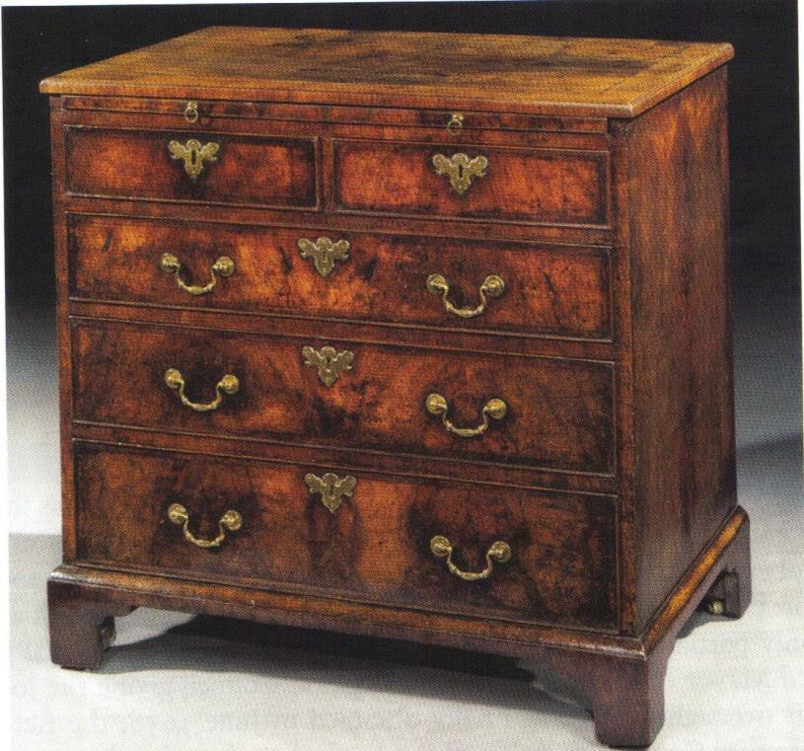

Figure 3.2: Walnut chest of drawers. The underside of a drawer is dated 1748 and signed ‘Thomas Atkinson’ (property of Apter-Fredricks Ltd., London).

In the absence of documentary evidence that apprentices produced a proof piece, is there any other indication of the Company having monitored the standards and the level of expertise apprentices attained? Did an apprentice or the Company ever make a complaint, or did a master ever try to prevent an apprentice from taking the freedom because he was insufficiently skilled? Company records simply give the date that the freedom was registered and list witnesses, noting only that the apprentice was ‘made free by consent of the master’ or ‘faithfully served out his apprenticeship’.162 There is no known case of an apprentice or his representative attending court to file a complaint, but there is one example of a master trying to prevent an apprentice from being made free. In 1682, Matthew Hall was apprenticed to the carver Jonathan Maine who is remembered for working alongside Grinling Gibbons on projects instructed by Christopher Wren.163 Hall presented himself in court to become free and Jonathan Maine objected on the grounds that the apprentice had wasted his time in service: ‘7 June 1692 – At this Court a difference was heard betweene Jonathan Maine a Member of this Company and Matthew Hall his Apprentice alleadgeing that he had misspent his time in his service which this Court examining both parties doe consent that the

162 GL, MS. 8051/1–3, Joiners’ Company freedom registers.
163 GL, MS. 8052/2, f. 144, Joiners’ Company apprentice bindings, 6 March 1682.

said Matthew should be made free’.164 Whether or not this apprentice proved his competency by submitting an example of his carving prowess as a proof piece is unknown – and perhaps Maine was an exceptionally severe critic – but apparently he gained the freedom despite his master’s protestations.
One aspect of overseeing freedoms that the Company systematically policed was locating apprentices who had completed their training and failed to take the freedom. Such apprentices, in effect, worked as foreigners because they were not enrolled in the Company. The penalty to the apprentice for non-enrolment was relatively nominal, ranging from 3s 4d to 10s.165 The Company used several methods of enforcement including giving financial rewards to freemen for reporting offenders,166 and punishing master joiners for non-compliance. They also instructed the beadle to search for foreign joiners,167 and called him to account when he appeared not to be doing the job thoroughly enough:
Whereas a complaint has been made at this board of the small number of Apprentices that has been summoned by the Beadle to take up their freedoms to the great damage of this Company It is therefore Ordered that the Beadle doo give an exact account for the three months past of the Christian and surnames of the persons he then summoned and where and with whome they worke that due course may be taken against them and that the said Beadle doo observe the same method for the future and that he brings Two Lists every monthly Court.168

Although there is little to suggest that the Joiners’ Company was directly involved in monitoring the standard and content of the apprenticeships they administered, evidently they did invest time and effort into ensuring that those who completed their training were duly enrolled as freemen. Enforcing membership would have made them more subject to the Company’s discipline and easier to control, however evidence points towards raising revenue being the Company’s priority. Nevertheless, there is a remarkable consistency in the construction and quality of most London furniture from the period, which testifies to uniformity of manufacture across the trade and to the fact that it was populated with high skilled intergenerational craftsmen. Apprentices were

164 GL, MS. 8046/2, Joiners’ Company court minutes, 7 June 1692.
165 GL, MS. 8051/1–3, Joiners’ Company freedom registers.
166 GL, MS. 8046/2, Joiners’ Company court minutes, 1 March 1697: ‘Paid some Joyners who tooke up severall persons for working in the Citty not being free 6s’.
167 GL, MS. 8046/5, 4 June 1728: ‘Ordered That the Beadle do make a Search over the City of London and Westminster and the Liberties thereof and enquire the Names of all such persons who follow the Business of a Joiner and are not free of this Company and report the same with their Respective names in Writing to this Court on the next Court Day’.
168 GL, MS. 8046/3, 5 Sept. 1704.

taught at the bench by their masters, journeymen, and networks of specialised artisans who collectively produced outstanding products. The Joiners’ Company provided an institutional structure in which tradesmen could operate.

Conclusion
Some of London’s most prominent architectural joiners and furniture tradesmen were members of the Joiners’ Company during the period of this study. They maintained their allegiance to the guild because it was a cohesive community populated with significant numbers of freemen who practised the same crafts and trades and with whom they could, therefore, closely identify. The socio-economic status of the membership was reflected in the kudos of the Company itself: the Joiners had influence enough to gain exclusive rights from the Lord Mayor and Court of Aldermen and to monopolise the most profitable branch of the woodworking industry – dovetailed construction. The Company was also granted the power to force their authority on all London freemen working in the industry through the 1658 Act of Common Council, which required that all joiners affiliated with other London companies must also enrol with the Joiners. In these ways the Company did represent the best interests of its membership and, in doing so, protected their livelihoods. It was not, however, particularly involved in overseeing the quality of training and manufacture. This was left in the hands of the individual master-craftsmen.

Chapter Four: Apprenticeship in the Joiners’ Company

Between 1642 and 1720, more than 13,000 young men were bound to members of the Joiners’ Company. This chapter examines their social, economic and geographical origins. The last chapter discussed the Joiners’ governing body and livery and the extent to which the Company was involved in administering and regulating apprenticeships. The purpose here is to examine those individuals who were apprenticed to London Joiners in order to create a profile of the types of people who became furniture tradesmen throughout the period. To achieve this several factors are considered. The chapter examines apprentices’ geographical origins and whether the proportion of those from various regions changed over the period – especially during the tumultuous civil, political and constitutional events of the mid-seventeenth century and during the rebuilding of London in the late 1660s.
Then the apprentices’ social and economic status is examined and the question of whether their social backgrounds and connections influenced their future success is discussed. Did masters take apprentices from social backgrounds similar to their own? Did apprentices from high-status families enter the service of prominent masters? How did the socio- economic and geographical composition of the Joiners compare to that of other London trades and how did that change over time? The growth of the Joiners’ Company in comparison to other City companies has been determined. This chapter begins by estimating the Company’s relative size and expansion in relation to London as a whole and compares the growth of the Company to the broad picture of the City’s development, assessing whether its growth reflected the overall expansion of the furniture trade.

The Joiners’ apprenticeship bindings survive for the entire period and form the core data for this chapter. Indenture agreements made within the City were originally recorded in two forms. The first was a formal indenture certificate issued by the Corporation of London and signed by the apprentice’s parent or guardian and his master. It was a two- part document: one half was presumably to be kept by the apprentice, or his parent, and the other by the master.1 The second was an entry recorded in the Joiners’ Company apprentice binding books. These bindings detail every individual indenture agreement

1 Some indenture certificates survive in the London Metropolitan Archives as part of the Corporation of London record collection.

made between one of its members and an apprentice from 1643 onwards. As described in Chapter One, each entry records the name of the apprentice and his father; the father’s occupation and whether he was still alive; the town, city or parish, and county of his origin; the joiner who would be serving as the boy’s master; the length of his term of service; and, from 1710 onwards, the amount of the premium paid by the apprentice’s family to the master. The particulars recorded in the bindings are similar to those required by other City companies.2

The evidence in the apprentice bindings informs the examination of the type of people who were apprenticed to the Joiners’ Company and subsequently those who completed their training and worked in the furniture trade. This information is supported by reference to other sources which enrich the analysis and aid interpretation. These include recent studies of the demography and social structure of London and of England as whole in the early modern period, and Robert Campbell’s The London Tradesman.3 The result is an approximation of the type of people who populated the furniture trade, and a consideration of the shifts in the migration patterns of Joiners’ apprentices to London over the period of study and of the changing social composition of the Company.

The geographic origins of apprentices
The population in London increased by approximately 44 per cent in the second half of the seventeenth century with roughly 400,000 inhabitants residing within and without the City walls in 1650, increasing to around 575,000 by 1700.4 By comparison, the numbers of apprentices enrolled to the Joiners’ Company more than doubled over the period, rising from 1,996 in the period 1645–63 (an average of 105 a year) to 4,040 in a similar period, 1702–20, in the early years of the eighteenth century, an average of 213 a year (see Table 4.1).
2 M. Davies and A. Saunders, The History of the Merchant Taylors’ Company (Leeds, 2004), pp. 53–4; Records of London’s Livery Companies Online <http://www.londonroll.org/about> [accessed 31 July 2015]. 3 D. V. Glass, ‘Notes on the demography of London at the end of the seventeenth century’, in D. V. Glass and R. Revelle (eds.), Population and Social Change (London, 1972); Harding, ‘The population of London’, pp. 111–28; Harding, The Dead and the Living; G. King, ‘Natural and political observation upon the state and condition of England’, in J. Thirsk and J. P. Cooper (eds.), Seventeenth Century Economic Documents (Oxford, 1972), pp. 751–815, at pp. 780–1; Berg, Age of Manufactures; G. Holmes, The Making of a Great Power,1660–1722 (Harlow, 1993); Earle, English Middle Class; Earle, A City Full of People; Barry and Brooks, The Middling Sort of People; Rappaport, Worlds Within Worlds; Campbell, Tradesman.
4 Harding, ‘Population of London’, p. 112.

Table 4.1: Geographic origins of the Joiners’ Company Apprentices

Geographic origins | Period One 1645–63 |  | Period Two 1664–82 |  | Period Three 1683–1701 |  | Period Four 1702–20
 | No. | % | No | % | No. | % | No. | %
London: Citya & metropolitan areab | 517 | 26 | 773 | 23 | 1417 | 42 | 2046 | 51
Southeast | 539 | 27 | 913 | 27 | 809 | 24 | 843 | 21
The Midlands | 428 | 21 | 684 | 20 | 450 | 13 | 367 | 9
Southwest | 162 | 8 | 412 | 12 | 293 | 8 | 219 | 5
East Anglia | 158 | 8 | 290 | 9 | 223 | 6 | 335 | 8
Northeast | 41 | 2 | 69 | 2 | 59 | 2 | 59 | 1
Northwest | 96 | 5 | 112 | 3 | 88 | 2 | 96 | 2
Wales | 53 | 3 | 101 | 3 | 60 | 2 | 66 | 2
Scotland | 2 | 0.1 | 4 | 0.1 | 8 | 0.2 | 6 | 0.1
Outside British Islesc | 0 | 0 | 3 | 0.08 | 3 | 0.08 | 3 | 0.07
Subtotal outside of London | 1479 | 74 | 2588 | 77 | 1993 | 58 | 1994 | 49
Total | 1996 | 100 | 3361 | 100 | 3410 | 100 | 4040 | 100
Mean number of apprentices per year | 105 |  | 177 |  | 179 |  | 213
Source: Analysis of Joiners’ Company apprentice bindings, 1642–1720 (GL, MS. 8052/1–4).

- For the jurisdiction of the City of London, see D. V. Glass (ed.), London Inhabitants Within the Walls 1695 (London Record Society, 2, 1966), pp. xli–xlii.
- The built-up area surrounding the City. North of the Thames: Middlesex, Westminster; Holborn; Clerkenwell and Wapping. South of the Thames: Southwark, Lambeth, Surrey, Greenwich and Deptford.
- Virginia, Barbados, France and Flanders.

Most of the Joiners’ apprentices originated from the British Isles. Londoners were increasingly in the majority and an average of 25 per cent originated from surrounding counties in the southeast.5 The proportion of those from further afield decreased throughout the period, although this decline was relatively small for more distant regions, whereas the Midlands saw the proportion of apprentices fall more significantly (see Table 4.1). Peter Earle’s study of London apprentices (1660–1730) had similar results: ‘There was a tendency over time for an increasing proportion [of apprentices] to be drawn from south-eastern England as opportunities opened up elsewhere for young people to learn a trade’. 6 Nearly two-thirds of apprentices in Earle’s sample came from either London or from the eastern and south-eastern counties.

5 This is not surprising considering the density of the population: ‘By 1689 the four south-eastern counties of Middlesex, Surrey, Kent and Sussex contained roughly a million men, women and children, the capital itself accounting, with Southwark, for half of them’ (Holmes, Making of a Great Power, p. 48).
6 Earle, English Middle Class, p. 86.

There are several possible reasons for the consistent reduction in the numbers of migrants from the Midlands and beyond filling Joiner apprenticeships in London in the second half of the seventeenth century. One explanation may be that there was a greater internal supply of apprentices in London and its hinterland caused by urbanization and population growth, which created an ever-expanding pool of potential recruits. Another may be the greater employment opportunities becoming available in some English towns and villages as a consequence of the growth of the textile, metal and coalmining industries. Young men of the kind to take up apprenticeships were no longer as focused on London as before because other attractive opportunities were opening up for them in the provinces.7 The decreasing numbers of apprentices from the Midlands illustrates this point. In the period 1645–63 over a fifth of apprentices came from this region, but by the beginning of the eighteenth century the proportion had dropped below 10 per cent. The West Midlands was an established centre of the metal trades long before the industrial revolution and descriptions of iron manufacture in Stourbridge, Dudley and Wolverhampton are recorded as early as 1677.8 Those who desired a career in furniture making in the Midlands could have taken advantage of local opportunities as the region developed into a centre for manufacture where artisan-organised production was the ‘dynamic industrial structure of urban villages, suburbs and unincorporated towns in areas such as Birmingham by the eighteenth century’.9 Apprenticeship in Birmingham was seemingly more flexible than London, possibly because no guild regulations existed. Some terms lasted for as little as a year and premium payments were not always required, making such apprenticeships attractive for unskilled rural boys.10 By 1720, Birmingham had become a centre for manufacture and was the fourth largest provincial town in England.11

With the exception of the Midlands, the proportion of apprentices migrating from the various counties of England remained relatively consistent throughout the period. New incentives developed for farmers in eastern counties during the 1670s when grain exports

7 Berg, Age of Manufactures, p. 45, Table 2.4, ‘Estimated output of coal, 1700, by mining region’; Homes, Making of a Great Power, p. 450, Table L.3, ‘Industrial production and expansion by region 1651–60, 1681–90; 1700’.
8 Berg, Age of Manufactures, p. 48.
9 Berg, Age of Manufactures, p. 58.
10 Berg, Age of Manufactures, p. 276.
11 Holmes, Making of a Great Power, p. 305.

to the Continent began.12 In addition, woollen cloth was Britain’s chief home, as well as export, industry and provided 70 per cent of exports in 1700.13 However, London still attracted increasing numbers from distant parts of the realm and only the Midlands showed a significant decrease.

How did the turbulent thirty-year period between 1640 and 1670 affect apprentice arrangements in the Joiners’ Company and more broadly the London furniture trade? This was, of course, the period which witnessed civil war, the beheading of a monarch and the escape of his heir along with the royal household to France, the commonwealth of the 1650s and the return of Charles II in 1660. In 1665 London suffered further turmoil when the plague killed approximately 76,500 people,14 and in the following year the Great Fire ravaged much of London, demolishing up to 430 acres of the metropolis, much within the City walls. Among other losses, over 13,200 houses, eighty-seven parish churches and forty- four livery company halls were destroyed, leaving approximately 100,000 homeless.15

Table 4.2: Geographic origins of apprentices 1642–64

Geographic origins | 1642–51  (10 Years) Civil wars |  | 1652–9  (8 Years) Interregnum |  | 1660–4  (5 Years) Restoration
 | No. | % | No. | % | No. | %
London: City and the metropolitan area | 156 | 24 | 223 | 24 | 227 | 32
Southeast | 179 | 27 | 246 | 27 | 182 | 26
The Midlands | 138 | 21 | 202 | 22 | 131 | 18
Southwest | 55 | 8 | 81 | 9 | 50 | 7
East Anglia | 60 | 9 | 76 | 8 | 56 | 8
Northeast | 12 | 2 | 22 | 2 | 11 | 2
Northwest | 37 | 6 | 37 | 4 | 35 | 5
Wales | 16 | 2 | 26 | 3 | 16 | 2
Scotland | 1 | 0.01 | 1 | 0.1 | 0 | 0
Subtotal outside of London | 498 | 76 | 691 | 76 | 481 | 68
Total | 654 | 100 | 914 | 100 | 708 | 100
Mean number of apprentices per year | 65 |  | 114 |  | 142
Source: Analysis of Joiners’ Company apprentice bindings, 1642–1720 (GL, MSS. 8052/1–4)

Despite the upheavals and hardships of the 1640s and 1650s, the uptake of apprenticeships in the Joiners’ Company seems to have remained relatively consistent (see Table 4.2), but

12 Holmes, Making of a Great Power, p. 49.
13 Berg, Age of Manufactures, p. 112.
14 Harding, The Dead and the Living, p. 16.
15 Porter, London, p. 109.

at the Restoration there was a substantial increase in the numbers of indenture agreements made both with Londoners and those from the surrounding counties in the southeast.
Perhaps this was due to the increased demand on the furniture industry and its need to recruit a larger labour force. As discussed earlier, the return of the monarchy led to a rise in demand for some furniture tradesmen as, for example, with the king’s upholsterer Robert Morris, who claimed to have supplied Charles II with nearly £10,000 worth of goods between 1660 and 1662.16 The tradesmen’s bills in the Lord Chamberlain’s accounts record the manufacture and delivery to the royal palaces of dozens of state beds, hundreds of looking-glasses, ensembles of tables and stands, chests, dining tables, and thousands of chairs, stools and couches.17 A further and substantially greater boost to the Joiners’ Company and the furniture industry was the rebuilding of London after the Great Fire. In 1666, 120 apprentices were bound to the Company but these numbers rose dramatically over the next three years, peaking at 363 apprentices being enrolled in 1669. Table
4.3 demonstrates the total number and percentage of apprentices bound between 1667 and 1673.

Table 4.3: Rebuilding of London after the fire 1667–73

Geographic origins | Rebuilding London after The Fire  1667–71a
 | No. | %
London: City and metropolitan area | 250 | 18
Southeast | 386 | 28
The Midlands | 324 | 23
Southwest | 174 | 12
East Anglia | 125 | 9
Northeast | 33 | 2
Northwest | 53 | 4
Wales | 47 | 3
Scotland | 1 | 0.07
Subtotal outside of London | 1143 | 82
Total | 1393 | 100
Mean number of apprentices per year | 279

Source: Analysis of Joiners’ Company apprentice bindings, 1642–1720 (GL, MS. 8052/1–4).

- This date range covers five years when the apprentice intake fluctuated beyond the normal range, rising and then gradually falling back: 1667 – 197; 1668 – 317; 1669 – 363; 1670 – 283; 1671 – 245.

16 Beard, Upholsterers and Interior Furnishings, p. 83.
17 TNA, LC 5, LC 9, Lord Chamberlain’s warrants.

These statistics clearly demonstrate that London’s internal supply of apprentices could not sustain this level of demand: 82 per cent between 1667 and 1671 migrated from outside of the metropolis (see Table 4.3). This is not surprising considering that in 1665 one in five Londoners perished as a result of the plague.18 A number of questions arise. Was this a matter of increased demand, increased supply, or both? Why did members of the Joiners’ Company require so many apprentices at this time? What made an apprenticeship with the Joiners’ Company so attractive, and how was such a sudden influx of apprentices accommodated? The Joiners’ Company 1614 ordinance regulated the number of apprentices allowed to members at any one time: ‘Whereas the freemen of the said Company are tyed and restrayned to the number of two Apprentices only’.19 However, during this period individual members took an average of five apprentices. Examination of several joiners known to be involved in furniture manufacture shows that they apprenticed large numbers. For example, three cabinetmakers were recorded as taking more than their official allowance: Gerrit Jensen bound seven apprentices (1667–73); Edward Traherne, whose case study is included in Chapter Six, bound four (1667–75) and Thomas Pistor bound six apprentices (1668–75).20

There appears to have been a surplus of apprentices indentured to the Company; between 1667 and 1671, 160 were indentured to only four members, and none of these were recorded as having been ‘turned over’ (meaning passed on) to freemen of other City companies.21 It is hard to imagine that these four joiners employed such a large number of apprentices for themselves, especially considering that the usual Company regulations were two at any one time. There may be an explanation for one of the joiners in this group: Thomas Kinward, as Master Joiner to the Office of Works (1660–82)22 was certainly well placed to find apprenticeship positions, through no records survive to confirm this.

18 Porter, London, p. 99.
19 GL, MS. 8038, Joiners’ Company 1614 ordinance.
20 GL, MS. 8052/1, f. 127; MS. 8052/2, ff. 1, 8, 15 (Gerrit Jensen); MS. 8052/1, ff. 129, 169; MS. 8052/2, ff.
21, 28 (Traherne); MS. 8052/1, ff. 139, 159; MS. 8052/2, ff. 3, 5, 23, 34 (Pistor).
21 Oliver Atkinson (master in 1672) bound 37 apprentices in 1670; William Harley (warden in 1667) bound 35 apprentices between 1667–70; John Holmes (liveryman) bound 35 apprentices between 1661–71; Thomas Kinward (liveryman) bound 53 apprentices between 1668–69.
22 Beard, Craftsmen, p. 267; see Chapter Three above for further information about Thomas Kinward.

Clearly, the exceptional circumstances following the Great Fire evoked an exceptional response from the Company as the necessary reconstruction demanded large numbers of joiners. Members of the Company were involved in rebuilding domestic properties – wainscoting walls, laying floors and framing doors and windows.23 While Thomas Kinward’s apprentices may well have been employed principally for architectural joinery, others were almost certainly making furniture.

Overall, the trend in apprentice recruitment from 1640 to 1720 saw increasing numbers drawn from the southeast and the metropolitan areas, at the expense of the Midlands in particular. An exception to this general trend was the period after the Great Fire, when large numbers of apprentices were recruited by the Company from throughout the kingdom to provide the skills and labour to rebuild the City.

Socio-Economic standing and origins of apprentices
Robert Campbell’s ‘General Table of the several Trades’ provides estimates of the premium fees and setting up costs associated with London trades in 1747, and his calculations provide a useful comparative guide when analysing the premiums paid to London Joiners. 24 According to Christopher Brooks:
The amount of the apprenticeship premium was determined primarily by the prestige and potential profitability of any given occupation, and early modern trades and crafts fell into a distinct status hierarchy which corresponded roughly to John Stow’s division of the citizens of his native London into wholesalers, retailers, and artisans, a division which also translated into a range of wealth and political influence. 25

Evidently the amount of the premium may have indicated the status of a particular trade and the level of demand for an apprenticeship with a master within that industry.
Comparison of a selection of wholesalers, retailers and artisans (including those unrelated to the furniture industry), helps to indicate the position in the hierarchy of trades held by the Joiners as well as other London furniture tradesmen.

23 McKellar, Birth of Modern London, pp. 75–6, 78–9, 80, 87, 98–9.
24 Campbell, Tradesman, pp. 331–40.
25 Barry and Brooks, The Middling Sort of People, p. 60.

Table 4.4: Most Frequent value of apprentice premiums

Tradea | Premiums (£) | Setting up costs
Mercers | 50–200 | 1000– 10,000
Coachmakers | 50–100 | 500–3,000
Ironmongers | 30–100 | 500–2,000
Grocers | 20–100 | 500–2,000
Goldsmiths | 20–50 | 500–3,000
Upholders | 20–50 | 100–1,000
Shipwrights | 10–50 | 500–2,000
Haberdashers | 10–50 | 100–2,000
Cabinetmakers | 10–20 | 200–2,000
Joiners | 10–20 | 100–500
Carpenters | 10–20 | 50–500
Turners | 5–20 | 50–500

Source: Campbell, ‘A General Table of the several Trades mentioned in this Treatise’, The London Tradesman, pp. 331–40.
  - Table includes a selection of trades and not livery companies. It does not represent the entire list.

Table 4.4 lists the premium payments and setting up costs associated with several London trades. Apparently those apprenticed to high-level trades such as mercers, coachmakers and goldsmiths originated from families who had the means to pay considerable premiums and the subsequent expenses associated with establishing a business. Campbell’s explanatory text offers some observations on why certain trades or businesses were more highly regarded than others. He described coachmakers and goldsmiths as ‘most genteel and profitable’, and stressed that both trades required substantial sums of money: ‘Coachmakers require a great stock of ready money to set up and continue trade; they deal with none but nobility and quality; and according to their mode must trust a long time and sometimes may happen never paid’.26 Mercers were involved in the wholesale and retail of expensive textiles and ornaments to ‘the Fair Sex’. Their trade necessitated ‘a very considerable stock; ten thousand pounds [and] a very polite Man, skilled in all the Punctilio’s of City-good-breeding’.27 A mercantile trade such as the Grocers also attracted those from affluent backgrounds. Christopher Brooks’s sample of the social status of

26 Campbell, Tradesman; Goldsmiths, pp. 141–3; Coach makers, pp. 229–30.
27 Campbell, Tradesman, pp. 197–8.

apprentices (1690–3) found that of the Grocers’ apprentices, 28 per cent originated from the gentry.28

A career in a retail or mercantile trade was apparently a more attractive choice to members of the gentry than a career as an artisan. Brooks’s study revealed that 10 per cent of apprentices in the Joiners and Carpenters (trades with similar social origins) came from the gentry while over 50 per cent came from trade-related backgrounds.29 Although their social status was similar and the premium payment for apprenticeship into the Joiners’ and Carpenters’ Companies was within the average value (see Table 4.4), the standing of the two companies may not have been equal. Both trades were involved in the construction of domestic and business premises – and in that respect their work overlapped. Although it is impossible to be certain, the majority of Carpenters were probably not working in the furniture industry, while many Joiners did. We have seen how the close proximity of some of their work resulted in conflict between these trades as they attempted to define and protect their livelihoods.30 Campbell warned that many joiners and carpenters claimed to be expert in both elements of house construction, but that it was important to carefully monitor the way their roles were delegated: ‘There are few joiners but pretend to be carpenters, so vice versa; but a gentleman who wants to build with security as well as beauty would do well not to trust entirely to their skill’.31

In Chapter Three it was established that while apprenticeship enrolments consistently increased in the Joiners’ Company between 1655 and 1720, those with the Carpenters’ Company were in steady decline.32 This may be because a career as a joiner was perceived to be more lucrative. Some elements of the joiners’ trade were naturally more successful than others, especially for those who became cabinetmakers. However, like other high-

28 Barry and Brooks, The Middling Sort of People, Table 2.1 demonstrates the social composition of the fathers of entrants to the London guilds. For the Grocers’ Company this breaks down as: gentry 28%; professionals 9%; yeomen 9%; husbandmen n/a; tradesmen 32%; citizens of London 22% (p. 59).
29 Carpenters’ Company: gentry 5%; professionals 4%; yeomen 11%; husbandmen 8%; tradesmen 57%;
citizens of London 17%. Joiners’ Company: gentry 7%; professionals 1%; yeomen 8%; husbandmen 13%; tradesmen 51%; citizens of London 18% (Barry and Brooks, The Middling Sort of People, Table 2.1, pp. 58–9).
30 Jupp, Carpenters, pp. 295–306; GL, MS. 8332, dispute between Joiners and Carpenters. Details of this ongoing dispute are discussed in Chapter Three above.
31 Campbell, Tradesman, p. 161.
32 See above, Chapter Three, Table 3.4.

level trades, the setting up and running costs associated with cabinetmaking were substantially higher than those of an ordinary joiner (see Table 4.4). As following the manufacturing process of Guilbauld’s scriptor in Chapter Two demonstrated, cabinetmakers often had an expensive stock of goods and raw materials, and many subcontracted elements of their work to furniture tradesmen with specialised skills.
Payments of rent and taxes, stocking materials, employing journeymen and specialised artisans, and in some cases buying in finished objects for retail, required a substantial amount of capital, and because persons of ‘quality’ were notoriously dilatory in paying tradesmen, an ample pocket or credit was a prerequisite. Nevertheless, for those who could afford it, Campbell tells us that cabinetmaking was a ‘very profitable trade; especially if he works for and serves the quality himself’.33

Table 4.5: Joiners’ Company premium payments, 1710–20

Premium (£) | Number of apprentices | Percentage
1–5 | 271 | 30
6–9 | 155 | 17
10–20 | 442 | 48
21–40 | 36 | 4
41–100 | 9 | 1
101–600 | 2 | 0.2
Total | 915 | 100

Source: Analysis of Joiners’ Company apprentice bindings, 1710–1720 (GL, MS. 8052/3).

Table 4.5 indicates that Campbell’s estimates of premium payments were reasonably accurate: nearly half of the Joiners’ premiums confirm his calculations and practically the same amount falls below that level, with only 5 per cent of the payments exceeding his range of £10 to £20 (see Table 4.4). It is possible that by the time that Campbell wrote The London Tradesman in 1747, the Joiners’ Company and the furniture industry were becoming more high profile and therefore the cost of the joiners’ premium fees was inflated in line with the trade’s heightened status.

It is of course impossible to judge whether premium amounts are a true representation of an individual’s socio-economic position. Premiums in the Joiners’ Company were not recorded in the apprenticeship bindings until 1709 when a stamp duty was levied, holding

33 Campbell, Tradesman, p. 171.

the master responsible for paying duty. It is a moot question how accurate the records are and how far tax avoidance may have distorted the declared amount, but the penalty imposed on the master for failure to comply with payment of stamp duty was severe and included forfeiture of double the value of the premium, half of which was to go to the crown and half to the informer who reported it.34 There was also a strong incentive for the apprentice to ensure that his master paid the tax: unstamped indentures were void from 1709 and therefore deprived the apprentice of legal rights associated with formal apprenticeship.35 It is probable that in the majority of cases the amount of the premium is a relatively accurate indicator of both the master’s position in the trade hierarchy and the apprentice’s socio-economic status. As Table 4.5 shows, the largest single group of premiums averaged between £10 and £20 (48 per cent). The chair maker Thomas Perkins of St. Giles Cripplegate only charged a £6 premium,36 whereas two cabinetmakers, John Coxed of St. Paul’s Churchyard and William Palleday of Aldermanbury, charged £12.37 Several pieces of furniture bearing Coxed’s and Palleday’s trade labels survive and these objects are typical of the good but unspectacular furniture that was sold by many shops in the area geared towards the middle class consumer. George Nix was also a cabinetmaker but he charged the substantially higher premium of £30.38 Nix was, however, of a different calibre. He was positioned in Covent Garden rather than St. Paul’s Churchyard and provided more elaborate furniture to members of the aristocracy, such as the Duke of Montrose and the Earl of Dysart.39 It is possible that a successfully completed apprenticeship with furniture tradesmen charging these levels of premium would have potentially positioned emerging apprentices into similar circumstances.

Table 4.6 shows the numbers and percentages of apprentices to the Joiners’ Company analysed by their father’s occupation and the range of premium payments each group made. Earle found that ‘increasing numbers [of London apprentices] were the sons of

34‘A statute passed in 1709 (8 Anne, c.9) levied a tax on apprenticeship premiums. The rate was 6d. in the pound for premiums under £50 and 12d. in the pound for values over £50. The master was responsible for paying the duty to Stamp Officers’ (Barry and Brooks, The Middling Sort of People, p. 66).
35 Barry and Brooks, The Middling Sort of People, p. 66.
36 GL, MS. 8052/4, f. 157; LMA, CLA/002/02/01/3214, Court of Orphans inventory, 27 Sept. 1723.
37 GL, MS. 8052/4, John Coxed, f. 4; William Palleday, f. 22.
38 GL, MS. 8052/4, f. 82.
39 Beard and Gilbert, DEFM, p. 649.

urban professional or commercial people or of such “middling” members of rural society as innkeepers, clothiers, millers and the like’. This finding is corroborated by the social composition of Joiners’ apprentices.40 While the proportion of apprentices from agricultural backgrounds rapidly decreased after the middle of the seventeenth century, increasingly more apprentices were the children of tradesmen. Members of the gentry represented an average of 6 per cent of the apprentice group throughout the period and on the opposite end of the spectrum, the small proportion of apprentices whose fathers were labourers or servants slightly increased. It seems significant that the proportion of citizen’s sons who apprenticed their sons to Joiners more than doubled from the earliest quarter of the period, 10 per cent between 1645 and 1663, to 22 percent between 1702 and 1720.
Perhaps this is an indication of the way citizens perceived a career as a furniture tradesman in association with the Joiners’ Company.

Table 4.6: Socio-Economic Backgrounds of Joiners’ Company Apprentices, 1645–1720

Father’s occupation | No. | % | No. | % | No. | % | No. | % | £ | £
 | Period 1  1645–63 |  | Period 2  1664–82 |  | Period 3  1683–1701 |  | Period 4  1702–20 |  | Range of premiums 1710–20 | Mean premium 1710–20
Gentry: esquire & gentlemen | 134 | 7 | 212 | 6 | 197 | 6 | 201 | 5 | 1–600 | 24a
Professionalsb | 8 | 0.4 | 26 | 0.7 | 27 | 0.7 | 24 | 0.5 | 3–30 | 14
Yeomanry: yeomen, farmers & graziers | 425 | 21 | 698 | 21 | 485 | 14 | 432 | 11 | 10–38 | 10
Husbandmen | 319 | 16 | 449 | 13 | 272 | 8 | 222 | 5 | 1–20 | 8
Tradesmen in the provinces | 617 | 31 | 1231 | 37 | 1097 | 32 | 1134 | 28 | 1–175 | 11
‘Foreign’ tradesmen in London | 263 | 13 | 354 | 10 | 684 | 20 | 898 | 22 | 2–60 | 9
Citizens of London | 194 | 10 | 314 | 9 | 572 | 17 | 882 | 22 | 1–100 | 10
Labourers & servants | 22 | 1 | 70 | 2 | 91 | 3 | 235 | 6 | 3–30 | 8
Total | 1982 | 100 | 3354 | 100 | 3425 | 100 | 4028 | 100 | 1–600 | 10
Gentry, professionals & yeomanry | 567 | 29 | 936 | 27 | 709 | 20 | 657 | 16 | 1–600 | 17
Husbandmen, labourers & servants | 341 | 17 | 519 | 15 | 363 | 11 | 457 | 11 | 1–30 | 8
All tradesmen plus Citizens of London | 1074 | 54 | 1899 | 57 | 2353 | 69 | 2914 | 73 | 1–175 | 10
Source: Analysis of Joiners’ Company apprentice bindings, 1642–1720 (GL, MSS. 8052/1–4).
- The mean premium for the gentry would be £15 if the £600 premium were omitted.
- Professionals include aldermen, attorneys, a doctor of divinity, doctors of medicine, a doctor of physics, scriveners and surgeons.

40 Earle, English Middle Class, p. 86.

The categories in Table 4.6 are roughly based on Gregory King’s analysis of status and income published in 1688.41 Although King’s work is now considered ‘idiosyncratic, obscure, and at times faulty’ by many economic historians,42 it remains the only contemporary source which links income to social class. King suggested that members of the gentry had an average annual income of £280 to £450. By comparison professionals had an estimated £40 to £160; those working in agriculture £50 to £84; tradesmen, shopkeepers, and artisans £40 to £45; and labourers £15. Thus it is obvious that a craftsman or labourer would have had to sacrifice a far larger proportion of his annual wage than a member of the gentry in order to make the premium payment for his son’s apprenticeship. These financial constraints would have restricted many families from placing their sons with high-status masters who commanded large premiums and, furthermore, would have prohibited a large proportion from becoming established as independent tradesmen. As would be expected, positions at the top of the trade hierarchy were usually reserved for the elite. Christopher Brooks has commented, ‘It is clear that the apprenticeship premiums meant that the financial position of a father had a direct influence on the point at which his son would be able to enter the urban hierarchy’.43

The following is a description of each social group found among the Joiners’ Company apprentices with identifying distinctive social characteristics.

Gentry
At the top of the socio-economic hierarchy of Joiners’ apprentices were the sons of gentry. The gentry were positioned between the peerage and the yeomanry and included baronets, knights, esquires and gentlemen. An average of 6 per cent of apprentices originated from this category, all of them among the minor gentry. The majority of fathers were gentleman
(498) and there were only five ‘esquires’ (see Table 4.6).44 The definition of a ‘gentleman’ was nebulous by the end of the seventeenth century and ‘anyone who looked and behaved

41 G. King, ‘A Scheme of the Income and Expense of the several Families of England Calculated for the Year 1688’, in Thirsk and Cooper, Seventeenth Century Economic Documents, pp. 751–815, at pp. 780–1. 42 J. A. Taylor, British Empiricism and Early Political Economy: Gregory King’s 1696 Estimates of National Wealth and Population (London, 2005), p. 4.
43 Barry and Brooks, The Middling Sort of People, p. 70.
44 For an explanation of the hierarchal status within the gentry, see G. Mingay, English Landed Society in the Eighteenth Century (London, 1963), pp. 115–20.

like a gentlemen might be accepted as one’.45 It is questionable, therefore, how many of these fathers were actually members of the gentry and how many were simply wealthy. The comments of Nathaniel Bailey in 1730 suggest the latter may have been the more likely case: ‘In our days all are accounted Gentlemen that have money’.46 Some of the apprentices from this category trained with London’s foremost furniture tradesmen and afterward established themselves in businesses at the top of the trade hierarchy. Table 4.6 demonstrates a direct correlation between the amount of premium paid and the level of the prestige of apprenticeship arrangements: the value ranged from £1 to £600 with a mean value of £24.

The records of the Heralds’ Visitations during the reign of Charles I show that 91 per cent of London gentry were either the younger sons of country gentry or merchants and tradesmen who ‘relied mainly on urban investments’.47 The custom of primogeniture, whereby the eldest sons inherited the family estate, meant that the younger siblings had to find another means of support, and the common way was to provide them with an education and an inheritance sufficient enough to make their own way either in a trade or profession. The Trahernes are an example of a gentry family that contributed apprentices to two London companies. The family was of Cornish descent but lived in Hereford from the 1530s.48 Successive generations were born at their ancestral home, Middle Court, and when Thomas Traherne died in 1644, the land and title was passed down to his eldest son, also Thomas.49 Two of Thomas’s younger brothers were subsequently apprenticed to London tradesmen: Philip to the Goldsmiths’ Company in 1651 and Edward to the Joiners’ Company in 1654.50 The two brothers were apprenticed to high-level tradesmen where they presumably received quality training and introductions to influential members of their respective trades. Both went on to have successful careers: Philip became a ‘shop
45 Earle, English Middle Class, p. 6. 46 Earle, English Middle Class, p. 6. 47 Earle, English Middle Class, p. 6.
48 L. Lindey, ‘A Restoration London cabinet and looking-glass maker: Edward Traherne’, JFHS, 50 (2014), pp. 17–36, at p. 17; L. Lindey, ‘Edward Traherne: a study of the furniture trade in Restoration London’ (unpublished Royal College of Art M.A. thesis, 2003), p. 38. Cornish branches of the Traherne family were entitled to display a coat of arms, viz: – ARMS – Argent a chevron gules, between three herons sable, a canton barry of six azure, charged with a lion rampant of the third. CREST – A demi griffin erased or, gorged with two bars azure, holding between the claws a fleur-de-lis also azure.
49 Lindey, ‘Edward Traherne’, p. 38.
50 L. Lindey, ‘A Restoration London cabinet and looking-glass maker: Edward Traherne’, p. 18.

keeping goldsmith’ (retailer), in the Strand,51 and Edward became a cabinetmaker in Covent Garden. Thomas (who had inherited the family estate), subsequently apprenticed his son Benjamin to Philip, and he also became a London goldsmith. The record of this indenture relates that Thomas no longer used the title, gentleman, but referred to himself as a yeoman, illustrating the tenuous nature of these social titles.52
Edward Traherne is studied in more detail in Chapter Six, but he is mentioned here as an example of how social connections could secure an illustrious apprenticeship in the Joiners’ Company and a successful career thereafter. Traherne was apprenticed to John Burrowes, a cabinet and looking-glass maker in Cornhill. Burrowes had established his cabinetmaking business by 1645 when he bound two apprentices, one the son of a silversmith and the other the son of a yeoman.53 He only had five apprentices through the Joiners’ Company during his career and all but one came from outside the metropolis, the exception being the son of a London Citizen and Stationer. Burrowes must have operated a high-level business because his clients included members of the royal households of Charles II and William and Mary.

After his apprenticeship, Traherne established a business which in some respects seems to have been similar to that of Burrowes, especially with regards to the clients with whom he was associated, perhaps acquired through both family connections and his former master. They included the queen, Catherine of Braganza, two of the king’s mistresses (Nell Gwynn and the Duchess of Cleveland), two future queens (the Princesses Mary and Anne), and numerous aristocrats.54 Traherne’s background and apprenticeship enabled him to attain a position in the upper echelons of his trade. His career demonstrates how successful members of the gentry could become as London tradesmen and serves to illustrate Robert Campbell’s model of a cabinetmaker at the forefront of fashion.
Campbell wrote that, ‘He who first hits upon any new whim is sure to make by the invention before it becomes common in the trade; but he that must always wait for a new
51 Lindey, ‘A Restoration London cabinet and looking glass maker’, p. 18.
52 Records of London’s Livery Companies Online <http://www.londonroll.org/about> [accessed 29 Aug. 2015]: 15 Sept. 1665, ‘Benjamin Traherne, son of Thomas Traherne of Lugwardine in the County of Hereford Yeoman, do put my self Apprentice unto Philip Traherne for the Terme of seaven years from this day 15 Sept 1665’.
53 GL, MS. 8052/1, f. 11, 24 June 1645, Thomas Moore and George Wither.
54 Lindey, ‘A Restoration London cabinet and looking glass maker’, p. 23.

fashion, or is hit upon by his neighbour, is never likely to grow rich or eminent in his way’.55

The geographical origins of apprentices from the gentry are similar to the rest of the apprentice group; throughout the four periods of study the majority of the gentry originated from London and nearby counties in the southeast (see Table 4.1).

Agricultural
The second largest group of Joiners’ Company apprentices during the first period of this analysis, 1645–63, originated from families involved in agriculture (37 per cent). In comparison, the average percentage of apprentices in this category from the Grocers’ and Apothecaries’ Companies was slightly less: 30 per cent between the years 1629–32, and declining by the end of the century to an average of 14 per cent.56 There was a similar decline in the Joiners’ Company: in the early eighteenth century (1702–20), the proportion of apprentices from agricultural backgrounds had dropped to 16 per cent (see Table 4.6).

The agricultural sector was a broad category and consisted of individuals from varying socio-economic positions. Yeomen, farmers and graziers were often wealthy landowners while many husbandmen were tenant farmers. It is hard to distinguish minor gentry from rich yeomen and poorer yeomen from husbandmen, especially as these occupational titles were often used interchangeably. The terms farmer and yeoman frequently meant the same thing. Samuel Johnson defined a yeoman as, ‘A man of a small estate in land; a farmer; a gentleman farmer’.57 The vague and inconsistent use of this terminology is problematic and may be one explanation for the substantial decrease in the numbers of yeomen who apprenticed their sons by the early eighteenth century and the enormous increase in the numbers of farmer’s sons.

55 Campbell, Tradesman, p. 171.
56 Barry and Brooks, The Middling Sort of People, pp. 56–9.
57 Johnson, Dictionary of the English Language, vol. ii.

Table 4.7: Socio-economic backgrounds of Joiners’ Company apprentices, 1645– 1720: agricultural occupations

Father’s occupations | Period 1  1645–63 |  | Period 2  1664–82 |  | Period 3  1683–  1701 |  | Period 4  1702–20 |  | Range of premiums | Mean value of premiums
 | No. | % | No. | % | No. | % | No. | % | £ | £
Yeomen | 415 | 56 | 652 | 57 | 401 | 53 | 179 | 27 | 3–30 | 10
Farmers | 2 | 0.2 | 20 | 2 | 71 | 9 | 240 | 37 | 4–37 | 10
Graziers | 8 | 1 | 26 | 2 | 13 | 2 | 13 | 2 | 5–15 | 12
Husbandmen | 319 | 42 | 449 | 39 | 272 | 36 | 222 | 34 | 1–20 | 8
Total | 744 | 100 | 1147 | 100 | 757 | 100 | 654 | 100 | 1–37 | 10
All agricultural occupations | 744 | 37 | 1147 | 34 | 757 | 22 | 654 | 16 | 1–37 | 10

Source: Analysis of Joiners’ Company apprentice bindings, 1642–1720 (GL, MSS. 8052/1–4)

Those who called themselves yeomen, farmers and graziers made up approximately 60 per cent of this category over the four periods of study (see Table 4.7). Many would have come from prosperous families and obtained apprenticeships relatively similar to members of the gentry, as seen with John Burrowes who indentured apprentices from both gentry and yeomanry origins. Some were apprenticed to London’s leading cabinetmakers. Gerrit Jensen, for example, cabinetmaker to three successive monarchs,58 apprenticed the son of a yeoman and one of a farmer, and another whose father held the title of esquire.59

The sons of graziers were also well placed in the trade. Robert Gammage, a cane chair maker in St. Paul’s Churchyard, took two graziers’ sons as apprentices.60 There are, however, few known instances of husbandmen placing their sons with top cabinetmakers, confirming that social backgrounds and connections did influence the apprentice’s potential for success and that only those from high-status families were indentured to prominent masters. Several yeomen’s sons became independent tradesmen in London after completing their term of indenture. One was the cane chair maker Thomas Warden, whose Court of Orphans inventory was used in Chapter Two as documentary evidence of a manufacturing network in the late seventeenth-century caned chair industry. Warden was the son of a yeoman from Oxfordshire and was made free of the Joiners’ Company in

58 Beard and Gilbert, DEFM, pp. 486–7.
59 GL, MS. 8052/2, f. 1, 10 Oct. 1671, Roger Philpot, son of an esquire; MS. 8052/2, f. 181, 7 July 1691, Edward Slone, son of a yeoman; MS. 8052/3, f. 136, 6 July 1708, James Ellye, son of a farmer.
60 Beard and Gilbert, DEFM, pp. 328–9.

1684.61 He established a chair-making business in 1687 when he bound his first apprentice, also the son of a yeoman.62 By 1692 Warden was located on the southwest corner of St. Paul’s Churchyard, a popular place to shop for a broad range of furniture and the location of many cane chair makers.63 A case study of Thomas Warden’s manufacturing network is given in Chapter Six.
The geographical background of apprentices in this category is similar to the broad group (see Table 4.1), with the exception of East Anglia: the number of apprentices from this region increased by 8 per cent in the first two decades of the eighteenth century.

Tradesmen
The largest single group of apprentices throughout the period was that of tradesmen’s sons (see Table 4.6). Over half of the total apprentice group (51 per cent) were in this category and this again tallies with research into other City companies. As Earle suggests, this was a diverse group representing a wide range of incomes. In general, tradesmen were considered to be well positioned socially and financially secure and by the mid- seventeenth century were part of an emerging middle class. Earle defines ‘middling’ as ‘a description of a certain sort of life-style which was different from that both of the aristocracy and gentry and of the common people’.64 Such families were ‘politely mannered, well spoken, [and] fairly cultured’, with aspirations to look and behave like genteel people, and to have fashionable homes.65

For the purposes of this study, apprentices whose fathers described themselves as being tradesmen or merchants have been classified together into a single group, which includes all fathers involved in the field of handicraft and artisanal work, those involved in food supply, such as bakers, butchers, and brewers, and families who catered to hoteliers, coachmen, seafarers, and other members of the travelling public. Apprentices from this group made up 44 per cent of the total between 1645 and 1663, rising to 50 per cent

61 L. Lindey, ‘The Orphans Court record of Thomas Warden, a cane chair maker’, The Furniture History Society Newsletter, 155 (2004), pp. 2–4.
62 GL, MS. 8052.2, f. 147, 5 Apr. 1687, Thomas Smith, son of a yeoman.
63 LMA, COL/CHD/LA/03/032/09 to COL/CHD/LA/03/033/008, 1692 poll tax.
64 P. Earle, ‘The middling sort in London’, in Barry and Brooks, The Middling Sort of People, pp. 141–58, at p. 156.
65 Earle, ‘The middling sort in London’, p. 157.

between 1702 and 1720 (see Table 4.6). This group has then been further divided into two sub-groups: tradesmen from the provinces and ‘foreign’ tradesmen from London. Citizens of London will be discussed in a separate category.

Provincial tradesmen
There are many reasons why tradesmen from the provinces would put their sons out as apprentices to London joiners if they could afford it. One might be lack of opportunity for employment within the family business or in the local community. Furthermore, London was the place to acquire up-to-date training and gainful employment in any trade, and in view of the rapid expansion of the Joiners’ Company (particularly from 1660), furniture making may have been a particularly good prospect. Certainly the opportunities for employment and advancement in London exceeded those in most provincial towns.
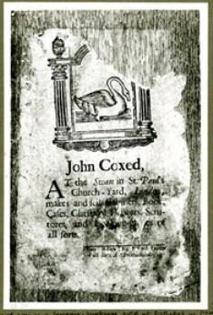

Figure 4.1: Trade card of John Coxed at the ‘Swan’ in St. Paul’s Churchyard
c. 1715–18 (British Museum, Department of Prints and Drawings, Heal Collection, Ref. 28.50).
Source: Anon, Heal, 28.50<http://www.britishmuseum.org/collection>, British Museum, online [accessed 19 March 2016]

Many of the apprentices from this category became successful London furniture tradesmen. Examples of these tradesmen demonstrate their privileged position and

probably also their prowess, because they quickly established themselves in business after completing their apprenticeships and the mandatory two years as a journeyman. One example is John Coxed, whose labelled furniture was mentioned earlier.66 A brewer and innkeeper’s son from Berkshire, Coxed was apprenticed to the cabinetmaker John Mayo in 1694, and became free in 1703.67 By 1708 he had established a cabinetmaking business at the ‘Swan’, on the southwest corner of St. Paul’s Churchyard, with his wife Grace, the widow of his late master (see Figure 4.1). By the time of his death in the autumn of 1718, he had amassed a respectable amount of money – he left several thousand pounds to family members – and, one assumes, considerable social recognition because he was buried in the chancel of St. Mary Magdalene, Old Fish Street.68

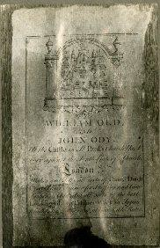
Figure 4.2: Trade card of William Old and John Ody at ‘The Castle’ in St. Paul’s Churchyard c. 1721 (British Museum, Department of Prints and Drawings, Heal Collection, Ref. 28.159).
Source: Anon, Heal, 28.159<http://www.britishmuseum.org/collection>, British Museum, online [accessed 19 March 2016]

66 Bowett and Lindey, ‘Labelled furniture from the White Swan Workshop’, pp. 71–98.
67 GL, MS. 8052/2, f. 214, 13 Nov. 1694, John Coxed, son of a brewer; MS. 8051/2, f. 101, 7 Sept. 1703.
68 TNA, PROB 11/566/409, 23 Dec. 1718.

John Ody was another provincial tradesman’s son, his father being a butcher in Oxfordshire. Ody began his apprenticeship in January 1704-5 with William Palmer and gained his freedom in 1713.69 Perhaps he worked as a journeyman in William Old’s workshop because by the spring of 1717 he had established an alliance with William Old at ‘The Castle’ in St. Paul’s Churchyard (see Figure 4.2) and had married Old’s daughter, Mary.70 Their business was on the southwest corner of the churchyard, a few doors away from Coxed.71
Only 5 per cent of fathers working as tradesmen in the provinces were themselves involved in the furniture industry. This may have been because the trade was centred in London at this period and was only in its developmental stages in the provinces. It is possible that some of those who completed their apprenticeships, but failed to become members of the Joiners’ Company, actually returned to their home communities to set up in business. It is very difficult to find solid evidence of this, but Edward Everett may be one case. His father was a basketmaker from Farnham in Surrey and, as we have seen, some basketmakers were involved in caned chair manufacture. Perhaps Everett was sent to London to acquire up-to-date skills in order to enhance the family business. He was apprenticed in 1698 to the cane chair maker Thomas Warden,72 and after Warden’s death in 1701 was ‘turned over’ to Warden’s business associate, Isaac Puller, a Basketmaker in St. Paul’s Churchyard. Although Everett completed his apprenticeship, he failed to become a Citizen of London. His eventual whereabouts remain unknown but perhaps he returned to Farnham and joined the family firm.

Many of the apprentices in this category were probably relatively wealthy and would have been able to afford a quality apprenticeship. Their geographical background/origins was slightly different to that of the entire apprentice group; their migration into London dropped slightly (4 per cent) in the first two decades of the eighteenth century, in contrast

69 GL, MS. 8052/3, f. 97, 9 Jan. 1704/5, John Ody, son of a butcher; MS. 8051/3, f. 22, 1 Sept. 1713.
70 GL, MS. 10.091, marriage allegation, 19 Apr. 1717. For further information on the firm Old and Ody, see
- Lindey, ‘William Old and John Ody at The Castle in St. Paul’s Churchyard’, The Furniture History Society Newsletter, 161 (Feb. 2006), pp. 1–4.
71 The spatial logic of the furniture trade is discussed in Chapter Five.
72GL, MS. 8052/2, f. 246, 12 Apr. 1698, son of a basketmaker; Warden’s case study is featured in Chapter Six below.

to that of the broader group which was on the increase. This may have been a result of developing opportunities for joiners outside of London.

‘Foreign’ tradesmen in London
A ‘foreign’ tradesman was an individual working within the jurisdiction of the City who had not become a freeman of London. All of the fathers of apprentices in this category lived within the City and their occupational titles were described simply by the trade they practiced, such as baker, tailor or grocer, whereas citizens are described in the apprenticeship bindings as, for example, ‘Citizen and Stationer of London’. The previous chapter discussed the waning authority of London guilds throughout the seventeenth century and questioned their ability to police tradesmen who chose to flout City authority by practising a trade without becoming a Citizen of London. Theoretically, although ‘foreign’ tradesmen did not have the privileges associated with citizenship, they were still subject to livery company regulations, which may at times have restricted their ability to operate a business successfully. Whether or not this was the case in practice is debatable, especially considering that the children of ‘foreign’ London tradesmen who were apprenticed to Joiners actually increased in number throughout the period (see Table 4.6). The fact that unfree tradesmen seem to have wanted their sons to have a City apprenticeship suggests that they perceived the status to have real benefits. In the years 1643–59, only 12 per cent of apprentices were the sons of ‘foreign’ tradesmen, but by the early eighteenth century this had increased to 22 per cent. Thus the number of sons of ‘foreigners’ entering the Company increased not just absolutely but relatively over time and these statistics support theories of the slow demise of the authority of London’s livery companies. Why should ‘foreigners’ wish for their children to serve an apprenticeship with a member of the Joiners’ Company, quite apart from the quality of training potentially offered? Could it be that there were unique opportunities available to their members?

The average premiums paid by ‘foreign’ tradesmen were £2 lower than those paid to their equals in the provinces (See Table 4.6), but the significance of this is unclear. Possibly they were not as well-off as those from outside of the metropolis or perhaps restricting ordinances did hamper their earning potential. Additionally, working as a ‘foreign’

tradesman may have made it difficult for them to secure high-status apprenticeships for their children. Nevertheless, it made sense for the Joiners to bring the sons of foreign tradesmen into the Company, thereby increasing its authority and income at the same time. Several high-status masters gave apprenticeships to boys from ‘foreign’ fathers: in 1720, for example, a dyer from Southwark paid £40 for his son to be apprenticed to Henry Williams of Long Acre, a chair maker to the royal family.73 Not only did the dyer have the ability to pay for such an apprenticeship, but he must also have had the appropriate social and business connections.

Only 8 per cent of the fathers who were ‘foreign’ tradesmen worked in the furniture trade and these included basketmakers, chair makers, joiners, sawyers and turners. Of these individuals, 60 per cent were practicing as ‘foreign’ joiners and a further 21 per cent were sawyers. The notion that an apprenticeship in the Joiners’ Company was an attractive proposition for the sons of ‘foreign’ tradesmen is reinforced by the fact that until the early eighteenth century they outnumbered the sons of freemen of London (see Table 4.6). As with the high level of apprentices from the provinces, this suggests that before 1700 the Company was unable to meet its labour requirements from within the City companies.

Citizens of London
Citizenship was a prerequisite for full participation in the economic and political life of London. We have discussed the associated privileges and status that allowed for a parliamentary vote and the right to operate a business and trade within the jurisdiction of the City. An overall average of 16 per cent of apprentices were the sons of London freemen; these proportions more than doubled from the early period when only 9 per cent of the entire group were citizens’ sons compared to 22 per cent by the early eighteenth century (See Table 4.6).

Many of the fathers of apprentices in this category were themselves furniture tradesmen and nearly a fifth (18 per cent) of those who were members of the Joiners’ Company apprenticed their own sons. This is particularly interesting because the children of freemen had the right to citizenship through patrimony. In other words, the sons of freemen did not

73 GL, MS. 8052/4, f. 119, 1 Nov. 1720; Beard & Gilbert, DEFM, p. 980.

have to serve a period of training in order to earn the rights and privileges of citizenship; they could have simply claimed them by inheritance. There must, therefore, have been a perceived benefit to this formal arrangement. The proportion of apprenticeships within familial relationships increases when cousins, nephews and relations by marriage are taken into account, but these are more difficult to establish. Several of these apprentices far exceeded their father’s level of success and William Astell serves as an excellent example. John Astell was a timber merchant in the late seventeenth century and in 1688 bound his son, William, as apprentice.74 William Astell subsequently joined his father in the family business in Thames Street, and in 1714 he himself bound an apprentice for which he was paid the highest premium recorded for this study: £600.75 This payment may have included something totally unrelated to the apprenticeship, such as an investment in Astell’s business; however, if the value of the premium fees reflected the status of a master and his relative level of success, William Astell must have been one of London’s leading timber merchants (see Table 4.5).76 He also attained social prestige, acquiring the title of esquire by 1721.77

Some apprenticeships were organised between the same families of furniture tradesmen over successive generations. For example, in 1691 Thomas Halfehide apprenticed George Nix, who was the son of a member of the Joiners’ Company.78 Nix later became a cabinetmaker in Covent Garden and in 1716 apprenticed his former master’s son, Edward Halfehide.79 A sense of loyalty, kinship and reciprocal support appears to have been quite common. It is not possible to accurately estimate the total proportion of apprentices who were the sons of furniture tradesmen because they could have been members of any London company. It is likely, however, that they would have apprenticed their children to people they knew in their communities, or to business associates, or other members of

74 GL, MS. 8052/2, f. 155, 3 Apr. 1688.
75 GL, MS. 8052/4, f. 37, 7 Sept. 1714; LMA, COL/CHD/LA/06/025, returns of the names of inhabitants of several wards in obedience to a precept giving the ‘proper additions and places of abode’.
76 Campbell estimated the premium fee for timber merchants from £50 upward. It is the only trade where he did not give a ceiling price (Tradesman, p. 336).
77 LMA, COL/CHD/LA/06/025.
78 GL, MS. 8052/2, f. 185, 1 Dec. 1691.
79 GL, MS. 8052/4, f. 61, 21 Aug. 1716; Beard and Gilbert, DEFM, pp. 648–9.

their family. These interpersonal arrangements may be one explanation for the relatively low premiums (See Table 4.6).

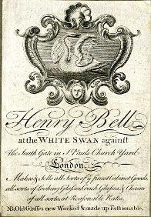

Figure 4.3: Trade card of Henry Bell, cabinet maker at the ‘White Swan’ against the south gate in St. Paul’s Churchyard, c. 1740 (British Museum, Department of Prints and Drawings, Heal Collection Ref. 28.14).
Source: Anon, Heal, 28.14 <http://www.britishmuseum.org/collection>, British Museum, online [accessed 29 January 2016].

The remaining four-fifths of apprentices who were the sons of London tradesmen had fathers representing virtually every City company. Some of these citizens may have been furniture tradesmen because, as we know, they were free to follow the trade of their choice, no matter what their company affiliation. In some families there was evidently a sense of loyalty to their parent’s particular livery company and this may have been the situation with the cabinetmaker Henry Bell, whose father was a member of the Vintners’ Company. Henry served his apprenticeship with John Coxed at the White Swan in St.
Paul’s Churchyard and after being made free of the Joiners’ Company in 1720 he also became a member of the Vintners’ Company. In 1736 Bell took over his late master’s business at the White Swan (see Figure 4.3), illustrating a closely knit urban trade

community which provided opportunities to the children of friends and family members across the generations.80

Conclusion
The numbers of apprentices enrolled in the Joiners’ Company increased at two and a half times the rate of London’s population in the second half of the seventeenth century. In the first two decades of the eighteenth century its overall membership grew by 63 per cent at a time when the power and control of many City companies was rapidly diminishing (see Table 3.6). A major factor in the Company’s unique position must have been the rapid growth and economic prominence of the London furniture trade and the opportunities available to its members.
The majority of apprentices originated from the British Isles. Their migration patterns were similar to those apprenticed to other London companies, with an increasing proportion over time coming from London and south-eastern England (see Table 4.1). This may have been the consequence of proto-industrialisation, especially in regions such as the Midlands, and also the increasing numbers of apprentices originating from the rapidly expanding metropolis.

The socio-economic origins of the apprentices remained relatively consistent throughout the period of this study with around 87 per cent coming from relatively prosperous backgrounds: approximately 22 per cent of the group were the offspring of gentry, professionals and wealthy landowners; about 65 per cent were the sons of tradesmen and Citizens of London; and the remaining 13 per cent were the offspring of husbandmen, labourers and servants. There was a substantial increase in the proportion of apprentices whose fathers were tradesmen, especially tradesmen or citizens in London, and a small decrease in tradesmen from the provinces which doubtless reflected in part the changes in geographical origins. For an increasingly elaborated and skilled trade such as that of furniture making, this development may have had a significant impact, with more apprentices coming from backgrounds with experience of trade and manufacture. This

80 GL, MS. 8052/4, f. 17, 11 Nov. 1712; Beard and Gilbert, DEFM, p. 61.

would have been useful in London, adding to the already high level of inter-generational accumulation of skill.

In many cases the socio-economic status of apprentices seems to have influenced their future success: children of the gentry and yeomanry were apprenticed to prominent masters and enjoyed prosperous careers in the furniture trade, presumably as a result of the advantages of their backgrounds. The core of the apprentices – those from trade-related origins – also fared extremely well. They were a burgeoning group, many taking apprentices from backgrounds similar to their own over successive generations and becoming prosperous members of London’s trade community.

Chapter Five: The location of London furniture tradesmen

This chapter looks at where and why furniture tradesmen were located in particular areas of London. It discusses the spatial logic and geographical layout of the trade with the aim of establishing where groups of furniture makers were concentrated; whether occupational specialisms influenced the choice of location; and if these were places where particular types of furniture were manufactured. The positioning of retail districts is also examined. Covent Garden and St. Paul’s Churchyard were shopping vicinities but was furniture sold throughout London? Were some areas known for selling particular types of furniture? The size of the Joiners’ Company membership expanded by 63 per cent between 1699 and 1724 (see Table 3.5) and as previously discussed, this may have reflected the overall growth of the furniture trade. Here we investigate whether the trade remained in the same places as it and London grew.

Different methodologies have been employed to adapt to discrepancies in primary sources and the analysis is structured accordingly. There is a lack of evidence to document many locations outside of the City walls, places increasingly populated by manufacturing industries throughout the early modern period. Consequently, this is not a complete description of the spatial logic of the entire furniture trade. However, the nucleus of the industry was probably the City, Holborn and the West End, and there is a comprehensive collection of primary and published sources for these areas. The trade in the City is focused on the years 1692 and 1721, while furniture tradesmen in the western suburbs of London are examined over a broader period, 1660–1720. A. L. Beier encountered the same difficulties when documenting the spatial logic of early modern London industries. He found that ‘patchy source material provides no more than partial views of the numbers and types of trades practiced and rarely allows one to glimpse how the different crafts and professions were organised or how they evolved over the period’.1

Sources and methodology
One method for broadening and substantiating the information contained in primary sources is through data linkage and cross-referencing and this has been achieved with

1 A. L. Beier, ‘Engine of manufacture: the trades of London’, in A. L. Beier and Roger Finlay (eds.), London 1500–1700: the Making of the Metropolis (London and New York, 1986), pp. 141–67, at p. 142–3.

the use of a database. Three primary sources have been entered into the database: the 1692 poll tax; the four shillings in the pound aid of 1693-4; and the 1721 inhabitants’ list, all of which create a ‘snapshot’ of a particular moment.2 In addition to these sources, parish records, wills and Court of Orphans and probate inventories were also consulted alongside miscellaneous sources such as trade cards. Three maps of the period inform the geographical configuration of the trade: John Morgan’s and William Ogilby’s 1676 map of the City; Morgan’s 1682 map of the City and Westminster; and John Rocque’s map of the City, Westminster and Southwark (1746).3 The returns to the 1695 Duty on Marriages have also been employed, but this source is of limited value because the surviving records are confined to the City and only a handful of parish returns give occupations. Nevertheless it provides the names, occupations and parish of forty-one furniture tradesmen who were previously unknown.4

A particularly valuable source for examining the City in the 1690s and 1720s, and for helping to place the furniture trade in its appropriate geographical and socio-economic context is Strype’s updated version of Stow’s 1598 Survey of London.5 Through Strype we get a sense of what London was actually like in the early eighteenth century. His edition is an extraordinary account of the various people and areas of the City and some surrounding suburbs in the early eighteenth century and discusses topics that would have significantly affected the trade, such as the Great Fire and the state of public health in different parts of the City. It also contains ward and parish maps which cover both the City and some of the surrounding suburbs where furniture tradesmen were located. Although published in 1720, Strype wrote his account over the first twenty years of the eighteenth century and, therefore, the dates of this source fit perfectly with this study.

2 LMA, COL/CHD/LA/03/032/09 to COL/CHD/LA/03/033/008, 1692 poll tax; COL/CHD/LA
COL/CHD/LA/03/040; COL/CHD/LA/03/042 and COL/CHD/LA/03/0, ‘The four shillings in the pound aid 1693–4 for the city of London, the city of Westminster and Metropolitan Middlesex’; COL/CHD/LA/06/025, returns of the names of several wards in obedience to a precept giving the proper additions and places of abode, 3 Oct. 1721.
3 Ogilby and Morgan, ‘Ogilby and Morgan’s Large Scale Map of the City As Rebuilt’; Morgan, Morgan’s Map of the Whole of London in 1682; Rocque, An Exact Survey.A detailed description of the attributes and limitations of these sources is given in the introductory chapter to this thesis.
4 D. V. Glass (ed.), London Inhabitants within the Walls, 1695 (London Record Society, vol. 2, 1966).
5 Strype, Survey of London (1720), [online] (hriOnline, Sheffield).

155

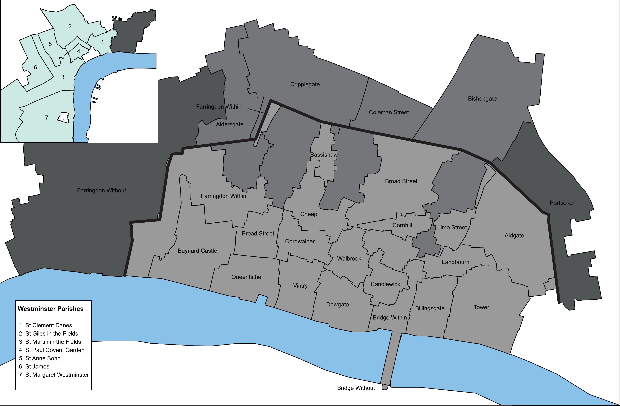

Figure 5.1: Map outlining the twenty-five wards in the City of London and seven West End parishes.

A wide range of published material supports this examination. Most valuable is Craig Spence’s London in the 1690s: a Social Atlas which guides the entire analysis.6 His research is based primarily on the two 1690s tax assessments which he used to document the social geography of London; the building density in various areas of the metropolis; the spatial distribution of rent and stock in trade values; and the social and economic status of householders. Other published sources include scholarship on the spatial logic of urban communities, manufacturing and retailing methods, socio- economic history and cultural and material history. Beard’s and Gilbert’s Dictionary of English Furniture Makers is used throughout, especially in the second half of the chapter which examines London’s West End.

The analysis of the furniture trade is in two parts: the first is devoted to the City of London and the second to the West End. The examination of the City begins in the 1690s, looking at three areas: the extramural wards (outside the City walls) to the north and northeast of the City, the intramural wards (inside the City walls); and Farringdon Ward Without to the west of Newgate and Ludgate. Next the trade is considered in the 1720s, focussing on the eight wards in and around St. Paul’s Churchyard and westward through Farringdon Without, for which documentary evidence survives. The methodology employed to examine the West End of the metropolis is described at the beginning of that section. See Figure 5.1 for a map outlining the twenty-five wards in the City of London and seven West End parishes discussed in this chapter.

Throughout the following discussion there is reference to some inhabitants being ‘poor’ but this is used as a relative term.7 Craig Spence, in his analysis of the poor in the 1690s, advised that, ‘rent values may not always be a true reflection of the underlying pattern of wealth or poverty but possession of stock tends to denote increased wealth’.8 This examination is mostly based on the returns of the 1692 poll tax and the aid assessments from 1693-4.9 The principles applied in identifying the inhabitants and items to be taxed in the assessments included all adults and children (under16 years of age). There were, however, exemptions for certain groups deemed to
6 Spence, Atlas.
7 Strype, Survey of London (1720), [online] (hriOnline, Sheffield). Available from: bk. 3, ch. 7, p. 122 [accessed 23 July 2015].
8 Spence, Atlas, p. 109.
9 LMA, COL/CHD/LA/03/032/09 to COL/CHD/LA/03/033/008, 1692 poll tax; COL/CHD/LA
COL/CHD/LA/03/040; COL/CHD/LA/03/042 and COL/CHD/LA/03/0, ‘The four shillings in the pound aid 1693-4.

be poor: those in receipt of alms or poor-relief, or the children of day-labourers.10 As discussed in the introduction, the 1692 poll tax gives occupations for only 50 per cent of households. Therefore it should not be assumed that people without a declared occupation were unemployed; it may simply be that their occupations were left unrecorded. The aid assessments from 1693-4 required everyone to pay four shillings in the pound on the yearly profits accrued to any personal estate, assessed on the value of their stock which included ready moneys, debts owing, goods, wares, merchandises and ‘other chattels or personality belonging to or held in trust’ for them. Individuals whose property was worth less than twenty shillings a year were exempt from payment.11 Inhabitants who are listed as owning no stock might therefore have owned up to 20 shillings worth of stock.

The 1690s
By the time that Ogilby and Morgan produced their map of the City of London in 1676, most of the areas devastated by the Fire had been restored. However despite the rebuilding, London remained slightly disordered as ‘social conditions and their physical setting presented a complex and bewildering variety across the capital … London was a muddle but nevertheless this apparent confusion embodied networks of movement, social credit, ideas and information which made an essential contribution to London’s success’.12 In many parts of the City rich merchants lived in the same wards as households packed with poor inhabitants in multiple-occupant dwellings. Likewise, apparently successful tradesmen lived and worked in neighbourhoods where many heads of households gave no declared occupation, and were recorded as paying no rent and owning no stock. The impression given is that of a city with uncertain boundaries and with a mixture of rich and poor inhabitants.

Furniture tradesmen were only recorded in twenty of the twenty-six City wards with the majority situated within the City walls, particularly in and around St. Paul’s Churchyard and westward down Ludgate Hill and into Holborn (see Table 5.1).13 Many were also in the northeast of the City in the wards of Portsoken and Bishopsgate Without and in the north of the City in Cripplegate Without. Table 5.1 also reveals that

10 Spence, Atlas, pp. 14–15.
11 Spence, Atlas, p. 10.
12 Spence, Atlas, p. 4.
13 There are only 20 wards listed in Table 5.1. Aldersgate, Cripplegate and Bishopsgate are single wards but are listed separately in the table because they are ‘within’ and ‘without’ the City walls.

only half of all householders recorded in the 1692 poll tax declared an occupation and that of those 3 per cent (597) were working in the furniture industry.

Table 5.1: Inhabitants in the 1692 poll tax assessments of the City of London

Ward | Furniture tradesmena | Householders: other declared occupations | Householders: employed in the furniture trade (%) | Householders: no declared occupation | All householders
Aldersgate Within | 16 | 2,370 | 0.7 | 1546 | 3,932
Aldersgate Without | 22 | 2,327 | 1 | 1659 | 4,007
Aldgate | 13 | 1,369 | 1 | 1896 | 3,278
Billingsgate | 4 | 1,131 | 0.4 | 1127 | 2,256
Bishopsgate Within | 12 | 554 | 2 | 873 | 1,414
Bishopsgate Without | 47 | 522 | 8 | 964 | 1,506
Bread Street | 16 | 542 | 3 | 1232 | 1,805
Bridge Within | 14 | 487 | 3 | 377 | 878
Candlewick | 14 | 542 | 2.5 | 1179 | 1,821
Castle Baynard | 52 | 917 | 5 | 789 | 1,753
Cheap | 14 | 874 | 2 | 227 | 1,115
Coleman Street | 8 | 293 | 3 | 1154 | 1,455
Cordwainer | 18 | 494 | 3.5 | 156 | 668
Cornhillb | 28 | 504 | 5 | 569 | 1,100
Cripplegate Within | 54 | 513 | 9.5 | 542 | 1,108
Cripplegate Without | 49 | 839 | 5.5 | 246 | 1,131
Dowgate | 8 | 279 | 3 | 127 | 414
Farringdon Within | 59 | 1,196 | 5 | 1007 | 2,257
Farringdon Without | 90 | 1,213 | 7 | 3678 | 5,423
Langbourne | 7 | 634 | 1 | 193 | 834
Portsoken | 37 | 423 | 8 | 362 | 823
Queenhithe | 10 | 379 | 2.5 | 116 | 505
Walbrook | 5 | 279 | 2 | 181 | 454
Totalc | 597 | 18,681 | 3 | 20,200 | 39,478

Source: LMA, COL/CHD/LA/03/032/09 to COL/CHD/LA/03/033/008, 1692 poll tax.
  - Furniture tradesmen include box makers, cabinetmakers, carvers, chair frame makers, chair makers, frame makers, gilders, japanners, joiners, looking-glass makers, sawyers, timber merchants, trunk makers, turners and upholsterers.
  - 75% of furniture tradesmen in Cornhill were upholsterers. This trade is not examined in detail in this study.
  - Table is to be read from left to right.

Spence has concluded that of twenty-four different trades, the joiners’ trade was the seventh largest industry in the City.14 Michael Power’s study of the social topography of Restoration London noted a concentration of ‘wood working craftsmen’ in some of these same wards in 1666, a location they apparently continued to inhabit in the following decades.15 The largest clusters of tradesmen were located in six wards: Bishopsgate, Castle Baynard, Cripplegate, Portsoken, Farringdon Within and Farringdon Without.

Extramural wards
Although little is known about the actual activities and personal biographical details of most of the furniture tradesmen in three of the extramural wards – Cripplegate Without, Bishopsgate Without and Portsoken – an assessment of their social and economic status can be made by considering their occupations as described in the 1692 tax assessment (see Table 5.3) in combination with their geographical positioning.
Spence has concluded that these areas commanded the lowest rents, that 10 per cent of households had multiple-occupancy, and that 95 per cent of poor relief was distributed to parishes outside of the walls, indicating that areas on the periphery were poor.16

Furniture tradesmen may have been in the extramural regions of the City for a multitude of reasons but one must have been that rent on most properties was less expensive than within the City walls. Many London tradesmen did not have the capital to set up an independent business and may have worked for others on a subcontractual basis. Others may have chosen to be outside of the City walls for the convenience of being near to a particular auxiliary trade, or perhaps they found properties that were more suitable to their manufacture.

14 Spence, Atlas, p. 129, Table 5.5.
15 M. J. Power, ‘The social topography of Restoration London’, in Beier and Finlay, London 1500–1700, pp. 199–224, at pp. 216–8. Power included trades such as coopers in his woodworking category; although they worked with wood they are not generally considered to be part of the furniture trade. This may explain why he cited areas such as Vintry ward as being densely populated with woodworkers. The 1692 poll tax shows no furniture makers there.
16 Spence, Atlas, pp. 45, 101, 109, 119.

Table 5.2: Extramural wards in 1692

 | Cripplegate Without | Bishopsgate Without | Portsoken
All households
Number of householdsa | 743 | 1,612 | 1,395
Household density (hh/ha)b | 96.5 | 89.6 | 86.7
Inhabitants declaring an occupation (%) | 56 | 45 | 52
Rent range (£)c | 2–200 | 1–185 | 1–300
Mean rent (£) | 21 | 11 | 11
Inhabitants declaring stock (%) | 12.5 | 17 | 24
Stock range (£) | 25–2,000 | 25–1,667 | 25–1,100
Mean stock (£) | 146 | 119 | 75
Furniture tradesmen
Number of furniture tradesmen | 49 | 47 | 37
Rent range (£) | 4–36 | 4–90 | 5–31
Mean rent (£) | 12 | 21 | 21
Declaring stock (%) | 27 | 43 | 54
Stock value range (£) | 25–50 | 25–250 | 25–150
Mean stock value (£) | 33 | 60 | 55

Source: C. Spence, London in the 1690s: a Social Atlas (London, 2000), Appendix III, p. 176.

- Data regarding all households was taken from Spence, London in the 1690s.
- Household density: number of households per residential hectare (hh/ha).
- Figures in pounds taken from Spence have been rounded to the nearest pound value therefore introducing some variable from the totals recorded in the 1693-4 assessment.

The extramural wards Cripplegate, Bishopsgate and Portsoken are outside the northern boundaries of the City walls. These were densely built-up wards – in particular Bishopsgate – where over 1,600 houses were built on 89.6 hectares (see Table 5.2).
High numbers of inhabitants lived in crowded single dwellings, rent values were low, and approximately 50 per cent of the population declared an occupation.17 One indication that an area was populated with poor inhabitants was the lack of declared stock and as previously mentioned, this indicates they had property valued at less than 20 shillings.18 Table 5.2 demonstrates this to be the case with less than one quarter of residents having declared stock value in Portsoken, only 17 per cent in Bishopsgate Without and just over 10 per cent in Cripplegate Without. Despite the high level of poor householders there was a broad range of occupations and, as in all areas of the City, there was a mix of socio-economic backgrounds. As would be expected in one of the poorest parts of the City, large numbers listed unskilled occupations – for example, coachman, porter, boiling cook and hemp burner – or were in low paid employment –

17 Spence, Atlas, p. 101.
18 Spence, Atlas, p. 176.

such as fringe making and bricklaying. There were also professionals – accountants, attorneys and chemists – and skilled craftsmen – such as gold and silversmiths and herald painters. There were also forty-one merchants, some declaring a relatively substantial stock in trade ranging from £100 to £300. Margaret Pelling described the increasing numbers of merchants in ‘urbanized fringes like Houndsditch and Goodman’s Fields’ as ‘middling elites, who ‘did not behave so differently from the commercial classes’.19

Considering the housing density and high levels of unemployment, what was the environment like for those living in these wards? In his Survey of London, John Stow gave a perhaps surprising portrayal of Portsoken at the end of the sixteenth century as an open and pleasant environment for ‘citizens therein to walk, shoot, and otherwise to recreate and refresh their dull spirits in the sweet and wholesome air’.20 He went on to describe,
The ditch without the walls of the city, which of old time was used to be open, always from time to time cleansed from filth and mud, as need required ... but now of later time the ditch is inclosed and the banks thereof let out for garden-plots, carpenters’ yards, bowling allies, and diuerse houses thereon built, whereby the city wall is hidden, the ditch filled up, a small channel left, and that very shallow.21

The ward apparently deteriorated during the next century. Much of Portsoken was owned by the Corporation of London who leased out small parcels of land at high rents, so that ‘by the late seventeenth century the area was thickly covered with houses’.22 Vanessa Harding described the characteristic housing of the ‘inner suburbs’ as ‘a narrow cul-de-sac leading off from the main street, giving access to several dwellings that may have been formed from the outbuildings of the original street-front house … These small dwellings generally lacked any private open space … And contained some of the worst housing’.23

19 Pelling, ‘Skirting the city?’, p. 162.
20 J. Stow, ‘Survey of London’, in W. J. Thoms (ed.), Survey of London, Written in the Year 1598 by John Stow: a New Edition (London, 1842), p. 48.
21 Stow, ‘Survey of London’, p. 48.
22 V. Harding, ‘The changing shape of seventeenth-century London’, in J. F. Merritt (ed.), Imagining Early Modern London: Perceptions and Portrayals of the City from Stow to Strype 1598–1720 (Cambridge, 2001), pp.117–43, at p. 125.

Descriptions of Cripplegate Without also show a crowded urban space filled with all sorts of life. In 1595 this included ‘An exceeding number of lewd and wicked women called fishwives, which swarm about in all parts of this city liberties and suburbs [and] Be of such vile behaviour and condition as is not fit any longer to be suffered’. 24
These ‘street sellers’ had a reputation for dealing in stolen goods, using false measures, blocking the roads, trading without a license and prostitution. So desperate was their reputation that from 1590, orders were made by the Mayor and Aldermen’s Court attempting to restrict their numbers, movement and work. These crowded and impoverished conditions acted as a breeding ground for disease. Harding calculates that in the plague of 1665, 30,000 people died in sixteen City parishes and that one- sixth of these (5,000) perished in St. Giles Cripplegate.25

Table 5.3: Occupations of furniture tradesmen in three extramural wards in 1692

Occupation | Cripplegate Without | Bishopsgate Without | Portsoken | Total
Box makers | 0 | 0 | 2 | 2
Cabinetmakers | 5 | 2 | 0 | 7
Carvers | 1 | 3 | 1 | 5
Chair caners | 5 | 0 | 0 | 5
Chair frame makers | 5 | 1 | 0 | 6
Chair maker | 0 | 0 | 1 | 1
Gilder | 0 | 1 | 0 | 1
Joiners | 12 | 18 | 12 | 42
Looking-glass makers | 1 | 0 | 0 | 1
Sawyers | 3 | 0 | 2 | 5
Trunk makers | 1 | 1 | 2 | 4
Turners | 14 | 17 | 2 | 33
Upholsterers | 2 | 4 | 15 | 21
All furniture tradesmen | 49 | 47 | 37 | 133

Source: LMA, COL/CHD/LA/03/032/09 to COL/CHD/LA/03/033/008, 1692 poll tax.

The economic status of furniture tradesmen was slightly higher than the general population when based on the amounts of rent paid and the value of stock declared (see Table 5.2). With the exception of Cripplegate Without, rent was higher than average and this may indicate that furniture tradesmen in these wards had larger properties than some other inhabitants. A substantial proportion of them declared a stock in trade.
Table 5.1 demonstrates that the furniture trade was a significant industry in these

24 L. Gowing, ‘The freedom of the streets: women and social space, 1560–1640’, in Griffiths and Jenner,
Londinopolis, pp. 130–51, at pp. 141–2.
25 Harding, ‘The changing shape of seventeenth-century London’, p. 134.

extramural wards and particularly in Portsoken where the trade employed nearly 8 per cent of all inhabitants with a declared occupation.

Given the social and economic character of this area of London it is likely that many furniture tradesmen focused primarily on manufacture, although the possibility that some may have also sold their goods cannot be entirely excluded. A number were involved in the production of caned, rushed and upholstered seat furniture and others in the manufacture of architectural features for the interiors of buildings. That these tradesmen had little retail activity is based on the assumption that extramural vicinities close to the walls were often not the type of environment attractive to would be shoppers. Cripplegate Without, for instance, seems to have been a place where seat furniture was manufactured, with numerous inhabitants listing associated occupations: chair makers, caners, chair framers, carvers, joiners and turners. There was also a small cluster of cabinetmakers and a looking-glass maker (see Table 5.3). One of the inhabitants, the joiner John Belchier, was known for his architectural supply. Between 1687 and 1710, he supplied Boughton House in Northamptonshire with £3,880 worth of architectural fittings, including glass, solder, piping and lead.26 There were metal workers in areas outside of the City walls (representing nearly 11 percent of all occupations),27 and this may have been one reason Belchier chose this location.

Portsoken shows a similar pattern to the other wards, with joiners, sawyers, turners and a chair maker living there (see Table 5.3). One, John Markham, was a member of the Joiners’ Company and apparently had a successful career. He became a liveryman in the Company in 1704, and lived in a quite substantial property in Houndsditch.
Although his rent was listed in 1692 as only £9, he seems to have got a lot for his money: the property included a yard behind the house along with sheds, stables and a loft.28 It was evidently more affordable to run a manufacturing business outside of the City walls.

Intramural wards
Three of the twenty-three intramural wards were populated by large numbers of furniture tradesmen: Cripplegate Within, Castle Baynard and Farringdon Within (see

26 Beard and Gilbert, DEFM, p. 59.
27 Spence, Atlas, p. 136.

Table 5.1). In contrast to the wards outside of the City walls where furniture tradesmen may have worked primarily as manufacturers, inventories and trade cards indicate that many furniture tradesmen within the walls were involved in both manufacture and retail. The areas in and around Cheapside, St. Paul’s Churchyard, and Ludgate were well-known for shopping in the early modern period, and were places to buy fashionable furniture.29 Roy Porter said that ‘London seemed designed to cater for the “born-to-shop” mentality’, and according to John Stow, this market was well- established by the late sixteenth century.30 Stow sang the praises of Cheapside, describing ‘the most beautiful frame and front of houses and shops within the walls of London’.31 These areas were largely destroyed by the Fire but by the end of the seventeenth century most had been restored, and some shop fronts and homes were fitted with modern new features like bow fronted windows made from two foot glazed panes that were joined with thin bars of brass. Signs and fascia boards were hung outside premises, ‘signalling to potential customers that this was a retail shop in a busy street’.32

It was more expensive to be situated within the City walls; properties were at a premium – which would have inflated rents – and tradesmen would have vied for the most competitive retail positions. The biographical information about several members of the furniture trade in these wards confirms that they came from wealthy backgrounds with their fathers being among the gentry or yeomanry, the middle classes, or citizens of London.

Analysis of furniture tradesmen inside the City walls is divided into two sections, beginning with Cripplegate Within. Castle Baynard and Farringdon Within are treated as one locale because they encompassed the areas in and around St. Paul’s Churchyard.

29 For further information about fashionable shopping and trading areas of the City of London in the early modern period, see D. Defoe, The Complete English Tradesman (London, 1726), pp. 59–61; Cox, Complete Tradesman, pp. 66, 96, 99, 126, 133.
30 R. Porter, London: a Social History (London, 2000), p. 174.
31 P. Griffiths, ‘Politics made visible: order, residence and uniformity in Cheapside, 1660–45’, in Griffiths and Jenner, Londinopolis, pp. 176–96, at pp. 176–7.
32 Cox, Complete Tradesman, p. 96.

Cripplegate Within
In 1598 John Stow described Cripplegate Within as having ‘fair houses for wealthy merchants and others’.33 Much of the ward was destroyed by the Fire; it burnt for days and was one of the last places to be extinguished. By the early 1670s the majority of the ward had been densely rebuilt in brick or stone and ‘many [houses were] three or four stories high to be able to accommodate business premises and living accommodation’ with residents who included several prosperous merchants and retailers.34

Table 5.4: Cripplegate Within in 1693-4

All households
Number of households a | 743
Household density (hh/ha)b | 96.5
Inhabitants declaring an occupation (%) | 51
Rent range (£)c | 2–200
Rent average (£) | 22
Inhabitants declaring stock (%) | 47
Stock range (£) | 25–2000
Stock average (£) | 146
Furniture Tradesmen
Number of furniture tradesmen | 54
Rent range (£) | 6–60
Mean rent (£) | 20
Declaring stock (%) | 37
Stock value range (£) | 25–150
Mean stock value (£) | 89

Source: C. Spence, London in the 1690s: a Social Atlas (London, 2000), p. 176.

- Data regarding all households was taken from Spence, London in the 1690s.
- Housing density: number of households per residential hectare (hh/ha).
- Figures in pounds taken from Spence have been rounded to the nearest pound value therefore introducing some variable from the totals recorded in the 1693-4 aid assessment.

An indication of the wealth of these householders is that nearly half of them owned stock at an average value of £146 and paid an average rent of £22. In addition to merchants and retailers the ward was also populated with professionals – attorneys, surgeons and scriveners – and some seemingly successful tradesmen. As elsewhere in London, not all inhabitants in the ward were prosperous, however some of those with no recorded livelihood paid considerable amounts of rent and owned several hundred pounds worth of stock, giving the impression that they had inherited wealth.

33 Stow, Survey of London, p. 111.
34 M. Galinou, ‘Merchants’ houses’, in M. Galinou (ed.), City Merchants and the Arts 1670–1720
(London, 2004), pp. 25–40, at p. 28; Spence, Atlas, p. 47.

Table 5.5: Furniture tradesmen in Cripplegate Within in 1692

Occupations of furniture tradesmen in Cripplegate Within
Box maker | 2
Cabinetmaker | 4
Chair maker | 1
Frame maker | 1
Joiner | 31
Looking-glass maker | 2
Sawyer | 4
Turner | 7
Upholsterer | 2
All furniture tradesmen with a declared occupation | 54
Percentage of furniture tradesmen with a declared occupation | 9.5
Source: LMA, COL/CHD/LA/03/032/09 to COL/CHD/LA/03/033/008, 1692 poll tax.

Cripplegate Within had the largest proportion of furniture tradesmen in the City and they represented nearly 10 per cent of all householders with an occupation (see Table 5.1). Many worked in retail, especially those in the parish of St. Mary Aldermanbury. Several cabinetmakers lived in close proximity in Aldermanbury: Daniel Bayly was at the ‘White Bear’ with Hugh Granger nearby at the sign of the ‘Carved Angell’ where he had ‘All sorts of fashionable household goods at reasonable rates’ (see Figure 5.2).35 Lazarus Stiles was their neighbour and worked as both a cabinetmaker and timber merchant. He was part of a manufacturing network with Bayly and other neighbouring cabinetmakers: William Palleday at ‘The Crown’ and John Prankard at the ‘Golden Ball’.36 Lazarus Stiles and his network of furniture tradesmen are studied in Chapter Six.

35 Beard and Gilbert, DEFM, p. 52; Heal, Furniture Makers, pp. 10, 66, 68, 228.
36 Gilbert, Pictorial Dictionary, p. 361; Beard and Gilbert, DEFM, pp. 67, 712; Heal, Furniture Makers,
- 142; LMA, OCR Roll 3197, 23 Aug. 1724, Lazarus Stiles.

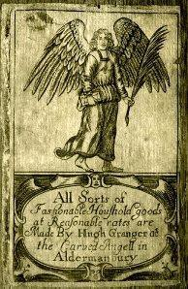

Figure 5.2: Trade card of Hugh Granger, cabinet maker at the ‘Carved Angell’ in Aldermanbury, c. 1692 (British Museum, Department of Prints and Drawings, Heal Collection Ref. 28.80).

Source: Anon, Heal, 28.80 <http://www.britishmuseum.org/collection>, British Museum, online [accessed 29 January 2016].

The ward of Cripplegate Within was evidently populated with relatively wealthy merchants and tradesmen. Many of those working as furniture tradesmen appear to have been fairly prosperous with some involved in both manufacture and retail. Others may only have been involved in manufacture given that 39 per cent owned no stock. It is possible that these men worked from either their own workshops on a subcontractual basis or as journeymen.

Castle Baynard and Farringdon Within
The wards of Castle Baynard and Farringdon Within surround St. Paul’s Churchyard and the nearby districts of Ludgate, Blackfriars, Paternoster Row and parts of Cheapside, and are situated in the southwest corner of the City inside of the walls. Like Cripplegate Within to the north, Castle Baynard was mostly destroyed by the Fire, but rebuilding and repopulating was soon underway. By 1672 most of the houses in the City were near completion though, according to Thomas Reddaway, of the ‘eighty

thousand inhabitants who fled the flames a quarter had still to come back’.37 John Strype claimed that many affluent City inhabitants like ‘eminent Mercers, Silk-men, and Lace-men, whose Shops [in Paternoster Row] were so resorted unto by Nobility and Gentry in their Coaches, settled themselves in several other Parts; especially Covent Garden in Bedford Street … To return no more’.38

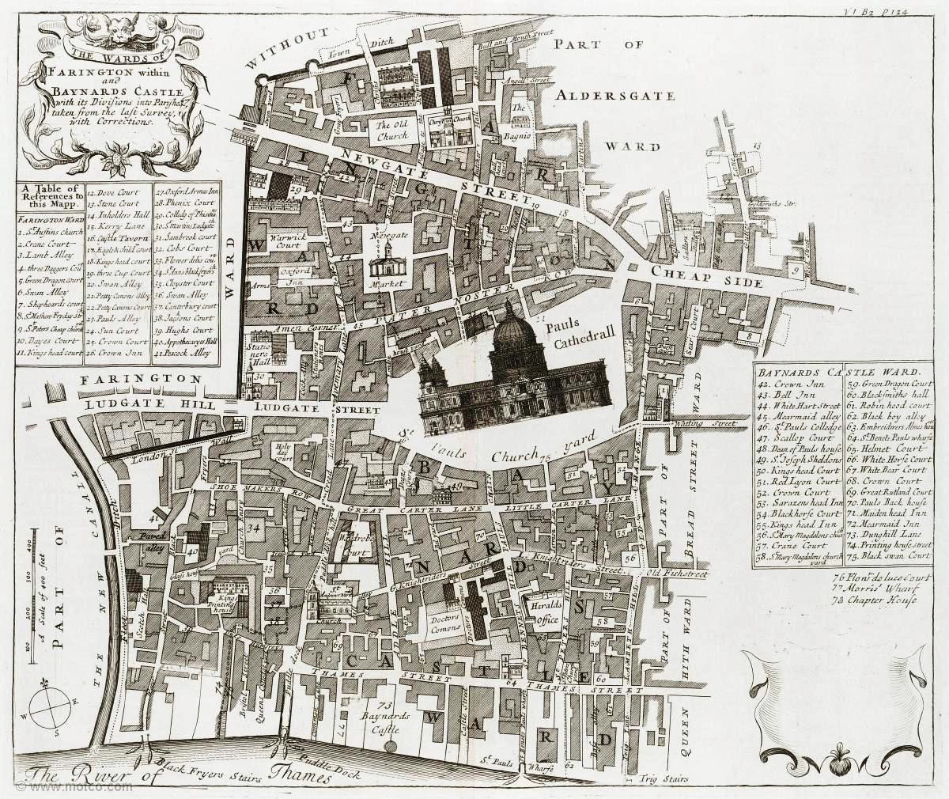

Figure 5.3: Map of Farringdon Within and Castle Baynard wards, 1720.

Source: Strype, Survey of London (1720), bk. 3, ch. 8, p. 125: Motco Enterprises Limited
<www.motco.com/strype/images/figures> [accessed 21 August 2015].

Strype’s conclusion that ‘eminent’ tradesmen permanently abandoned the area does not, however, tally with the evidence. This shows that by the 1690s the areas in and around St. Paul’s Churchyard were once again populated with a wide range of tradesmen, including silk-men and mercers along with other ‘eminent’ tradesmen like cabinetmakers, haberdashers, goldsmiths and jewellers. Table 5.6 demonstrates that, as with other wards in the City, there appears to have been a diverse socio-economic composition of inhabitants with some very wealthy tradesmen, government, church

37 Reddaway, Rebuilding of London, p. 300.
38 Reddaway, Rebuilding of London, p. 302, quoting Strype’s edition of Stow, bk. III, p. 195b.

officials and gentry living near to others who did not declare an occupation, paid little or no rent and owned no stock.

Table 5.6: Castle Baynard and Farringdon Within in 1693-4

 | Castle Baynard | Farringdon Within
All households
Number of householdsa | 755 | 1360
House density (hh/ha)b | 69.3 | 93.8
Inhabitants declaring an occupation (%) | 56 | 56
Rent range (£)c | 5–200 | 3–420
Rent average (£) | 20 | 22
Inhabitants declaring stock (%) | 45 | 54
Stock range (£) | 25–1500 | 25–3500
Stock average (£) | 90 | 112
Furniture Tradesmen
Number of furniture tradesmen | 52 | 59
Rent range (£) | 6–80 | 5–67
Rent average (£) | 23 | 22
Declaring stock (%) | 50 | 56
Stock Range (£) | 25–200 | 25–250
Stock average (£) | 45 | 69

Source: C. Spence, London in the 1690s: a Social Atlas (London, 2000), Appendix III, p. 176.
  - Data regarding all households was taken from Spence, London in the 1690s.
  - Household density: number of households per residential hectare (hh/ha).
  - Figures in pounds taken from Spence have been rounded to the nearest pound value therefore introducing some variable from the totals recorded in the 1693-4 aid assessment.

St. Paul’s Churchyard
John Strype described St. Paul’s Churchyard as an elegant environment, ‘graced with good Houses, loftily built and uniform’ populated by some of London’s finest booksellers, furniture tradesmen and textile merchants.
The part or side of Pauls Churchyard in the ward [of Castle Baynard and Farringdon Within] all lieth open to St. Pauls and is a spacious street graced with good houses loftily built and uniform, well inhabited by woollen drapers with a mixture of them that make and sell cane chairs and couches and some cabinet and looking glass sellers.39

Castle Baynard only had a household density of 69.3 hh/ha because part of the ward was open space whereas Farringdon Within was far more crowded (93.9 hh/ha). The average rent and stock values demonstrate the affluence of the area: the average rent was £20–£22 and average stock value was £90–£122 (see Table 5.6).

39 Strype, Survey of London (1720), [online] (hriOnline, Sheffield). Available from bk. 3, ch. 11, p. 230 [accessed 28 July 2015].

Table 5.7: Furniture tradesmen in St. Paul’s Churchyard in 1692

Trade | No. of furniture tradesmen in St. Paul’s Churchyard
Box maker | 1
Cabinetmaker | 5
Carver | 3
Chair Caner | 1
Chair maker | 10
Joiner | 6
Sawyer | 2
Trunk maker | 5
Turner | 3
Upholsterer | 8
Total number | 44

Source: LMA, COL/CHD/LA/03/032/09 to COL/CHD/LA/03/033/008, 1692 poll tax.

Of the 111 furniture tradesmen recorded in Castle Baynard and Farringdon Within, 40 per cent (44) were located in St. Paul’s Churchyard (see Table 5.7). The majority were chair makers and among others there were also upholsterers, joiners, cabinetmakers and trunk makers. The average rent paid in Castle Baynard and Farringdon Within where St. Paul’s Churchyard was situated was £22–£23 and the average value of stock was between £45 and £60 (see Table 5.6). Biographical details for several of these tradesmen survive and indicate that – as discussed in Chapter Four – they were from middling backgrounds and had served their apprenticeships with prominent furniture tradesmen. They presumably learned state-of-the-art skills and techniques during their training, but were probably also introduced to their masters’ networks of trade associates, which no doubt helped to pave the way to their ending up in one of the most popular shopping districts of the City.

One of these tradesmen was Thomas Warden, the cane chair maker who has been mentioned in previous chapters.40 His situation was probably quite common for families living in relatively cramped quarters in the churchyard where both manufacturing and retailing activities took place. The value of his stock in trade was
£50 and this apparently comprised a very large amount of seat furniture. His Court of Orphans inventory shows every space, both domestic and business-related, packed with trade materials, giving the impression that those living in his house must have constantly navigated their way around mountains of stacked up chairs and couches

40 For more about Warden, see Chapter Six.

when going about their day-to-day lives.41 A case study of Warden’s personal life and business career is given in Chapter Six.
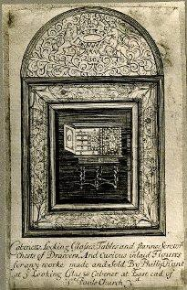

Figure 5.4: Trade card of Philip Hunt, cabinet maker at ‘ye Looking Glas & Cabinet’ at the east end of St Pauls Church yd, c. 1690 (British Museum, Department of Prints and Drawings, Heal Collection Ref. 28.104).

Source: Anon, Heal, 28.104 <http://www.britishmuseum.org/collection>, British Museum, online [accessed 30 January 2016].

One of the cabinetmakers across the churchyard from Thomas Warden was Phillip Hunt at ‘ye looking Glas & Cabenet’. His trade card (Figure 5.4) tells us that he ‘made and sold’ a broad range of case furniture which included cabinets, mirrors, scriptors, chests of drawers and ‘curious inlaid figures for any work’. His trade card portrays a cabinet-on-stand reflected in a framed and crested mirror. The crest is decorated in an arabesque scrolling pattern, while the frame surrounding the looking-glass and the cabinet-on stand is decorated in a floral design. This was probably advertising to potential customers that he specialised in marquetry and offered a choice of patterns and designs. We know that these types of furniture and decorative designs were at the

41 LMA, OCR Roll 2439, box 36, 5 March 1701/2, Thomas Warden.

height of popularity in the late seventeenth century and, along with caned chairs, were what consumers expected to find when shopping in fashionable St. Paul’s Churchyard. The trade card may also imply that Hunt supplied ready-made marquetry panels directly to the trade, however this interpretation remains speculative.

Table 5.8 shows sixty-seven furniture tradesmen in the areas surrounding St. Paul’s Churchyard. Most of the cabinetmakers and joiners were located in the popular shopping districts of Blackfriars, Ludgate Street and Newgate Street. As discussed in Chapter One, the parish of St. Anne’s in Blackfriars was the location where Dutch immigrants had settled from the 1550s because it was a ‘liberty’ that was exempt from guild restrictions.42

Table 5.8: Furniture tradesmen surrounding St. Paul’s Churchyard in the wards of Castle Baynard and Farringdon Within in 1692

Streets/ precincts | Black- friars | Cheap- side | Gutter Lane | Lud- gate | Newgate St. | Old Fish St. | Silver St. | St. Andrew Hill | Upper Thames St. | Warwick Lane | Wood St. | Total
Occupations
Box maker | 0 | 1 | 0 | 0 | 2 | 0 | 0 | 0 | 0 | 0 | 0 | 3
Cabinetmaker | 5 | 0 | 0 | 2 | 0 | 1 | 0 | 0 | 2 | 0 | 0 | 10
Carver | 0 | 0 | 0 | 0 | 0 | 0 | 0 | 1 | 0 | 0 | 0 | 1
Chair caner | 0 | 0 | 0 | 0 | 0 | 0 | 0 | 0 | 1 | 0 | 0 | 1
Chair maker | 0 | 0 | 0 | 0 | 0 | 0 | 0 | 1 | 0 | 0 | 0 | 1
Joiner | 5 | 0 | 1 | 1 | 5 | 3 | 5 | 2 | 0 | 0 | 2 | 24
Sawyer | 8 | 0 | 0 | 0 | 0 | 0 | 1 | 2 | 0 | 0 | 0 | 11
Trunk maker | 0 | 0 | 0 | 0 | 0 | 0 | 0 | 1 | 0 | 0 | 0 | 1
Turner | 2 | 0 | 1 | 0 | 3 | 0 | 0 | 1 | 0 | 0 | 0 | 7
Upholsterer | 0 | 0 | 0 | 0 | 0 | 0 | 1 | 0 | 0 | 1 | 0 | 2
Timber merchant | 0 | 0 | 0 | 0 | 1 | 0 | 0 | 1 | 4 | 0 | 0 | 6
Total no. of  furniture tradesmen | 20 | 1 | 2 | 3 | 11 | 4 | 7 | 9 | 7 | 1 | 2 | 67

Source: LMA, COL/CHD/LA/03/032/09 to COL/CHD/LA/03/033/008, 1692 poll tax.

As would be expected, timber merchants were located near to the river in Upper Thames Street, which was bordered by wharves that lined the banks of the river. John Strype complained about the annoyance of carts barrelling up and down to the wharves along the Thames to collect and deliver goods offloaded from lighters. He described Paul’s Wharf as ‘a noted stairs for watermen [where] on each side of the stairs is a very

42 Luu, ‘Natural-born versus stranger-born’, p. 70; Goose, ‘Immigrants in Tudor and Early Stuart England’, p. 17.

handsome House, one made use of by a brewer and the other for a timber yard’.43 Woodmongers and timber merchants were known to keep ‘wharves by the Thames’ and to ‘cart timber’. Before the practice of coal burning became widespread in London in the mid-seventeenth century, most woodmongers were involved in selling firewood, but thereafter they increasingly turned their attention to selling timber to carpenters and furniture tradesmen.44

The wards of Castle Baynard and Farringdon Within were a part of the City that had the largest numbers of furniture tradesmen. The nucleus was St. Paul’s Churchyard. Many of these tradesmen may have been both manufacturing and retailing furniture, but because they were situated in an exclusive area of the City renowned for shopping, and rent values were at a premium, it is most likely that they were there because retail was their primary focus.

Farringdon Without
Farringdon Without is one of the largest City wards and the westernmost. In contrast to the other extramural wards where furniture tradesmen lived in crowded environments with high levels of poverty, Farringdon Without had several affluent neighbourhoods and was relatively spacious with many parts newly developed after the Fire. By the 1690s new buildings were emerging along widened roads, especially in areas around Holborn and Fleet Bridge, broadening the approach from the West End into the City.
John Strype described the ward:

Ludgate hill cometh down from Ludgate, and runneth Westwards to Fleetstreet; from which it is severed by a handsome large Stone Bridge, the breadth of the Street; which gives a passage over the new Canal, where Fleet Ditch was. Which since the Fire of London, was made so deep and wide, This Street, as also Fleetstreet (into which it falls) and so to Temple Bar, is a great Thorowfare for Coaches, Carts, Horse and Foot Passengers; being the great Way from London to Westminster, and the adjacent Parts. Both these Streets are therefore very spacious, graced with good Buildings of the first Rate, and well inhabited by Shopkeepers of the best Trades; as Woolen Drapers, Linnen Drapers, Grocers, Sadlers, Upholsters, Booksellers, and drive a very considerable Trade.45

43 Strype, Survey of London (1720), [online] (hriOnline, Sheffield). Available from bk. 3, ch. 11, f. 229 [accessed 28 July 2015].
44 Alford and Barker, History of the Carpenters’ Company, pp. 36.

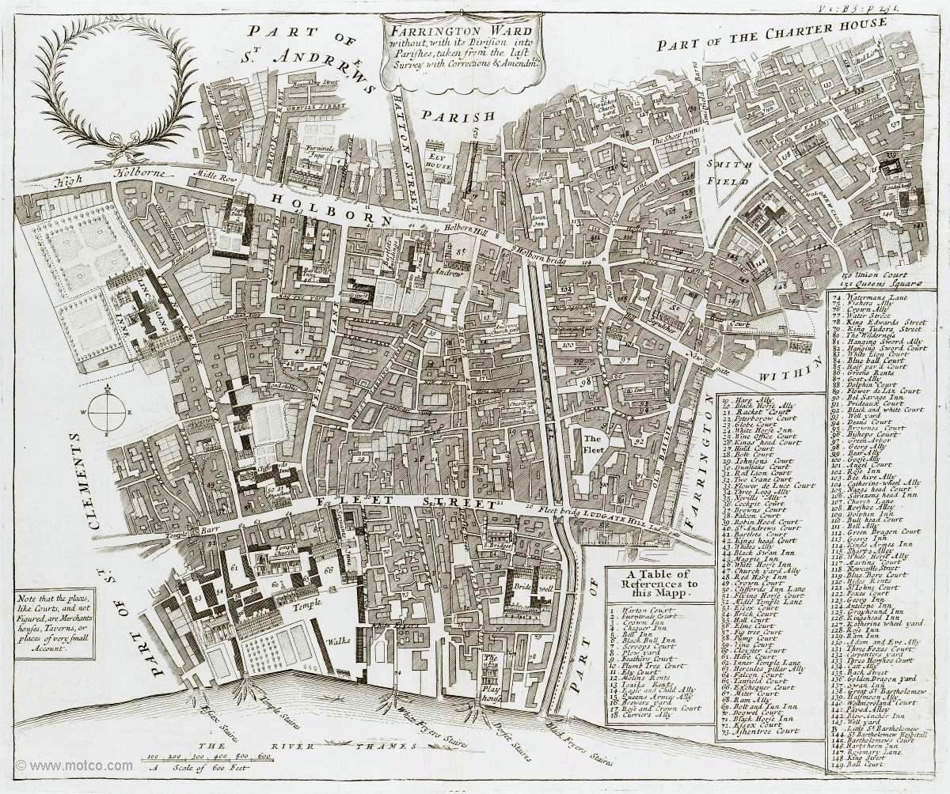

Figure 5.5: Map of Farringdon Ward Without, 1720.

Source: Strype, Survey of London (1720), bk. 3, ch. 12, p. 247: Motco Enterprises Limited
<www.motco.com/strype/images/figures> [accessed 21 August 2015].

Not all was newly refined, especially in the northern regions near the walls in places like St. Bartholomew, which Strype said, ‘held a fair … That lasted a fortnight at a time; and became of little other Use, than for idle Youth, and loose People, to resort to, and to spend their Money in Vanity; and … In Debaucheries, Drunkeness, Whoredom, and in seeing and hearing Things not fit for Christian Eyes and Ears’.46

Table 5.9: Farringdon Without in 1693-4

All households
Number of householdsa | 4,145
House density (hh/ha)b | 82.7
Inhabitants declaring an occupation (%) | 32
Rent range (£)c | 1–400
Rent average (£) | 19
Inhabitants declaring stock (%) | 36
Stock range (£) | 25–10,000
Stock average (£) | 100
Furniture Tradesmen
Number of furniture tradesmen | 90
Rent range (£) | 5–60
Rent average (£) | 14
Declaring stock (%) | 30
Stock Range (£) | 25–250
Stock average (£) | 85

Source: C. Spence, London in the 1690s: a Social Atlas (London, 2000), Appendix III, p. 176.
- Data regarding all households was taken from Spence, London in the 1690s.
- Household density: number of households per residential hectare (hh/ha).
- Figures in £ taken from Spence’s summary statistics have been rounded to the nearest pound value therefore introducing some variable from totals recorded in the 1693-4 aid assessment

Table 5.9 shows relatively low household density in Farringdon Without, indicating it was more spacious than other parts of the City. The average rent value was relatively low (£19) and the average stock value was high (£100). Craig Spence suggests that low levels of rent may reflect the number of inhabitants in each dwelling. However he warned that this is speculative because it is ‘difficult to form an absolute definition for the term “house” and “household” from the returns’.47 The socio-economic status of the inhabitants is rather curious as less than one-third of householders declared an occupation. This could indicate various scenarios, ranging from high levels of unemployment, to inhabitants with inherited income, or it could simply be that the assessors left many occupations unrecorded. These statistics could be accounted for by the fact that over a quarter of the inhabitants in the city who described themselves as gentry lived in Farringdon Without. Half of them were in the western end of the ward in the parish of St. Dunstan in the West, ‘a location immediately adjacent to the Temple, Chancery Lane and Lincoln’s Inn, which points to some members of this group being employed in the law’.48 There were few other professionals, with the

47 Spence, Atlas, p. 90.
48 Spence, Atlas, p. 141.

exception of a handful of apothecaries, surgeons and clergy, but there were many tradesmen and in particular those supplying food and clothing. The average rents paid and stocks declared by furniture tradesmen was just below the average of the general population.

Table 5.10: Furniture tradesmen in Farringdon Without in 1692

Parishes | St.  Dunstan In the West | St.  Andrew Holborn | Bridewell | St. Martin Ludgate | St.  Sepulchre | Whitefriars | St.  Bartholomew the less | Total
Occupations
Box Maker | 0 | 0 | 0 | 0 | 1 | 0 | 1 | 2
Cabinetmaker | 0 | 0 | 0 | 3 | 0 | 0 | 0 | 3
Carver | 0 | 0 | 1 | 4 | 2 | 0 | 0 | 7
Chair caner | 0 | 0 | 0 | 0 | 1 | 0 | 0 | 1
Chair framer | 0 | 0 | 0 | 0 | 1 | 0 | 0 | 1
Frame maker | 0 | 1 | 1 | 0 | 1 | 0 | 0 | 3
Gilder | 0 | 0 | 1 | 3 | 1 | 0 | 0 | 5
Japanner | 0 | 1 | 0 | 0 | 0 | 0 | 0 | 1
Joiner | 2 | 17 | 0 | 8 | 4 | 1 | 1 | 33
Looking glass maker | 0 | 0 | 1 | 0 | 0 | 0 | 0 | 1
Sawyer | 0 | 1 | 0 | 0 | 5 | 0 | 0 | 6
Trunk maker | 0 | 1 | 0 | 0 | 1 | 0 | 0 | 2
Turner | 0 | 5 | 0 | 0 | 6 | 0 | 2 | 13
Upholsterer | 0 | 4 | 0 | 1 | 5 | 0 | 2 | 12
Total | 2 | 30 | 4 | 19 | 28 | 1 | 6 | 90

Source: LMA, COL/CHD/LA/03/032/09 to COL/CHD/LA/03/033/008, 1692 poll tax.

Table 5.10 demonstrates the parishes where furniture tradesmen were situated in Farringdon Without. The largest concentrations were in St. Andrew Holborn, St. Martin Ludgate and St. Sepulchre. The remainder were spread across the ward with a few on the west side near the law courts, a handful near the river in Bridewell, and the rest in St. Bartholomew. Many of these people may have been working primarily in manufacture, especially those situated in the parish of St. Bartholomew near the fairground where there were a few turners and upholsterers; and there were several carvers and gilders in St. Sepulchre around Smithfield. Their geographical position placed them conveniently near to retailers in St. Paul’s Churchyard and also places like Covent Garden in the West End, so perhaps they were involved in decorative work for luxury objects, such as mirror frames, cabinets and pier tables.

Furniture tradesmen living in Holborn were in a similar situation, as they were almost equidistant between the City and the West End, but because Holborn was being newly developed in the 1690s and was becoming an attractive part of London for tradesmen to sell their wares, some also worked as retailers. One of these was the cabinetmaker John Gatehouse who was located by the ditch side near Holborn Bridge at the ‘Golden

Ball’ (see Figure 5.6). According to Gatehouse’s label, he made and sold a varied selection of case furniture: chests of drawers, book cases, cabinets, scrutores and ‘all sorts of glasses … at reasonable rates’.49 Apparently by the 1690s the ditch side near Holborn Bridge was a newly emerging shopping district. Others in Holborn may also have been acting as retailers, while some were clearly specialised craftsmen executing specific decorative techniques, as seen for example with the japanner John Hooke.50 He was certainly well positioned to provide his expertise to tradesmen in both the City and the West End.
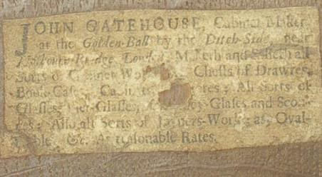

Figure 5.6: Label of John Gatehouse in a desk drawer of a walnut bureau bookcase c.1705.

Source: C. Gilbert, Marked London Furniture, 1700–1840 (Leeds, 1996), p. 216.

The ward was a seeming hotchpotch of people and places with areas like Smithfields ‘the usual Rendezvous of Ruffians and Quarrellers’,51 juxtaposed with refined Fleet Street, where ‘Students of the Common Laws of England’ were graced by such architecture as ‘the entrance into the Temple [which had] a very graceful Front of Brick Work, with four large Pilasters of Stone, of the Ionic Order; and an handsome Pediment, with a Round in the middle of it’.52 Likewise, a range of furniture tradesmen populated the industry in the ward, ranging from frame makers (a repetitive and

49 Gilbert, Marked London Furniture, p. 216.
50 LMA, COL/CHD/LA/03/032/09 to COL/CHD/LA/03/033/008, 1692 poll tax.
51 Strype, Survey of London (1720), [online] (hriOnline, Sheffield). Available from bk. 3, ch. 12, p. 240 [accessed 28 July 2015].
52 Strype, Survey of London (1720), [online] (hriOnline, Sheffield). Available from bk. 3, ch. 12, p. 271 [accessed 28 July 2015].

monotonous job) to prestigious cabinetmakers on Ludgate Hill, sitting at the foot of St. Paul’s Churchyard.

There were two areas in Farringdon Without where furniture was probably made and sold: Bridewell and Ludgate. Bridewell is situated in the southern end of the ward where the Thames met the Fleet River. Four furniture tradesmen were there: a carver, a gilder, a frame maker and a looking-glass maker. Given their allied occupations they may have been involved in mirror production. Perhaps they supplied John Gatehouse with mirrors to sell nearby at the ditch side near Holborn Bridge.

The parish of St. Martin Ludgate extended into both Farringdon Within and Without. The furniture tradesmen in the extramural ward were located on Ludgate Hill and its surrounds, which despite housing the Fleet Prison (burnt in the Fire but later restored), was quite a fashionable area. Carvers and gilders were clearly involved in specialised manufacture and one local cabinetmaker who may have used their services was Thomas Pistor, a member of the Joiners’ Company who served twice as an officer.53 Pistor was part of a family business which his father Thomas senior had established in the 1650s.54 An advertisement in The Spectator announced the business closure on 22 March 1711 and it describes Pistor’s stock of luxury furniture: cabinets, mirrors, desks and tables, decorated in precious materials such as tortoiseshell or inlaid with marquetry or japanned.55 If the Pistors were representative of other joiners and cabinetmakers in the neighbourhood, Ludgate Hill must have been a place where luxury furniture was both made and sold.

By the 1690s the London furniture trade was a well-established and thriving manufacturing industry with tradesmen spread across the City. The majority were clustered in seven wards, four outside of the City walls and three within. To a certain extent geographical positioning seems to have been a determinate of occupation: most high end tradesmen like retailing cabinetmakers were positioned within the City walls while some tradesmen on the periphery of the City appear to have worked primarily as manufacturers, operating perhaps on a subcontractual basis. Moreover, there was a broad socio-economic diversity amongst tradesmen and it appears that family
53 GL, MS. 8046/1, renter warden accounts, 1682–3; MS. 8046/2, renter warden accounts, 1689–90. 54 A. Turpin, ‘Thomas Pistor, father and son, and Levens Hall’, in JFHS, 36 (2000), pp. 43–60, at pp. 46, 55.
55 Turpin, ‘Pistor’, p. 43.

background affected occupational mobility and geographical positioning.56 Many of the tradesmen working within the City walls in places such as the St. Paul’s Churchyard area and Ludgate were the children of yeomanry and tradesmen, while those in extramural locations such as the Minories and St. Giles Cripplegate had more humble origins, their fathers in occupations such as husbandmen and labourers.

The 1720s
In 1700 the population of London was estimated at approximately 575,000, and by 1750 it had increased in size by about 15 per cent to roughly 675,000.57 The furniture trade also grew apace and, although it is impossible to estimate the precise number of people working in the industry, it has been seen in Chapter Three how the Joiners’ Company membership expanded by an average of 63 per cent between 1692 and 1721. This gives an indication of the overall growth of the furniture trade based on the assumption that the majority of the Company’s membership were furniture tradesmen (see Table 3.6).

Identifying the whereabouts of furniture tradesmen in the 1720s is problematic because there is no single source that provides systematic documentation comparable to the 1692 poll tax. The 1721 inhabitants’ list, however, provides a considerable amount of detail about the occupations and residents of the population of eight of the City wards surrounding St. Paul’s Churchyard.58 Nearly 90 per cent of the records give the name of the street, alleyway, court or yard of each inhabitant. It was recorded to be used as a jury service list and, therefore, only represents a select group, but despite these limitations it is comprehensive and, furthermore, the only available source for such information.

56 Rappaport has argued in Worlds Within Worlds (pp. 287–91) that while a father’s social status may have determined the quality of apprenticeship it was that of the master which ultimately determined the future success of the apprentice. This is perhaps a circular argument as social status would have dictated the quality of the apprenticeship and, therefore, the subsequent career.
57 Holmes, Making of a Great Power, p. 403.
58 LMA, COL/CHD/LA/06/025, returns of the names of several wards, 3 Oct. 1721.

Table 5.11: The 1721 list of householders

Occupations | Wards
 | Bassishaw | Bread Street | Castle Baynard | Cord- wainer | Farringdon Within | Farringdon Without | Vintry | Walbrook | Total
 | (no.) | (no.) | (no.) | (no.) | (no.) | (no.) | (no.) | (no.) | (no.)
Furniture trade | 4 | 23 | 40 | 9 | 31 | 77 | 7 | 12 | 203
Other trades | 83 | 252 | 214 | 236 | 525 | 520 | 158 | 160 | 2,148
Gentry | 5 | 6 | 17 | 13 | 10 | 35 | 14 | 1 | 101
Professionals | 4 | 18 | 25 | 22 | 15 | 15 | 9 | 7 | 115
Civic | 1 | 6 | 0 | 6 | 6 | 8 | 0 | 3 | 30
Foreigners | 0 | 0 | 0 | 0 | 0 | 0 | 0 | 50 | 50
Lodgers | 0 | 0 | 0 | 0 | 0 | 6 | 0 | 0 | 6
Poor | 0 | 0 | 234 | 0 | 9 | 0 | 0 | 0 | 243
No occupation | 8 | 0 | 2 | 2 | 0 | 209 | 3 | 47 | 271
Total of included householders in each ward | 105 | 305 | 532 | 288 | 597 | 870 | 191 | 280 | 3,167

Source: COL/CHD/LA/06/025, ‘Returns of the names of several wards in obedience to a precept giving the proper additions and places of abode, 3 Oct. 1721’.

Table 5.11 records 3,167 potential jurymen inhabiting eight London wards in 1721. Nearly 75 per cent were tradesmen and 9 per cent of that group worked in the furniture industry. Of the other inhabitants, 8 per cent declared no trade, 8 per cent were recorded as being poor, and the remaining 8 per cent were members of the gentry, professionals, foreigners or civic workers, such as clergymen, excise officers and parish clerks.59 Furniture tradesmen were situated in all eight wards and as in 1692, the majority were in the areas in and surrounding St. Paul’s Churchyard and Farringdon Without.

Table 5.12 shows the specialisms and locations of 203 furniture tradesmen. Although the nature of the list is exclusive and by no means a comprehensive account of the actual number of furniture tradesmen situated in the wards, it does indicate where some of the wealthiest ones were situated. A comparison with their whereabouts in 1692 indicates that they remained in the same places.

59 Castle Baynard and Farringdon Within were the only wards to record poor inhabitants.
180

Table 5.12: Furniture tradesmen recorded in the 1721 list of householders

Trades | Wards
 | Bassishaw | Bread Street | Castle Baynard | Cordwainer | Farringdon Within | Farringdon Without | Vintry | Walbrook
 | (no.) | (no.) | (no.) | (no.) | (no.) | (no.) | (no.) | (no.)
Box maker | 0 | 3 | 0 | 1 | 1 | 0 | 0 | 1
Cabinetmaker | 0 | 2 | 3 | 1 | 2 | 11 | 1 | 0
Cane chair maker | 0 | 0 | 0 | 0 | 6 | 0 | 0 | 0
Carver | 0 | 0 | 4 | 0 | 0 | 0 | 0 | 0
Chair maker | 0 | 4 | 12 | 0 | 0 | 3 | 0 | 0
Clock case maker | 0 | 0 | 0 | 1 | 0 | 1 | 0 | 0
Frame maker | 0 | 0 | 0 | 0 | 1 | 0 | 0 | 0
Japanner | 0 | 0 | 0 | 0 | 0 | 1 | 0 | 0
Joiner | 3 | 6 | 4 | 2 | 9 | 28 | 0 | 3
Looking- glass maker | 0 | 0 | 0 | 0 | 0 | 0 | 0 | 1
Sawyer | 0 | 0 | 0 | 0 | 0 | 3 | 1 | 0
Timber merchant | 0 | 0 | 9 | 0 | 0 | 0 | 0 | 0
Trunk maker | 0 | 0 | 0 | 0 | 1 | 0 | 0 | 0
Turner | 0 | 3 | 1 | 1 | 5 | 9 | 0 | 4
Upholder | 0 | 0 | 0 | 0 | 0 | 16 | 0 | 0
Upholsterer | 1 | 5 | 5 | 3 | 6 | 4 | 1 | 3
Woodmonger | 0 | 0 | 2 | 0 | 0 | 1 | 4 | 0
Total furniture tradesmen | 4  (2%) | 23  (11%) | 40  (20%) | 9  (4%) | 31  (16%) | 77  (38%) | 7  (3%) | 12  (6%)

Source: COL/CHD/LA/06/025, ‘returns of the names of several wards in obedience to a precept giving the proper additions and places of abode, 3 Oct. 1721’.

It is impossible to ascertain how many furniture tradesmen were omitted from the jury service list, but considering the level of growth in the trade it was in all likelihood a very large proportion. St. Paul’s Churchyard is the one place where it is possible to get an idea of the types of tradesmen that were excluded because some of them are known. One such person was Grace Coxed. Grace was involved in the furniture trade for at least thirty-five years and was twice married and twice widowed by cabinetmakers.60 Widows were allowed to carry on their late husband’s trades, ‘the period of marriage being seen as the equivalent of an apprenticeship’.61 Her second marriage was to the cabinetmaker John Coxed, of St. Paul’s Churchyard, who died in November 1718 leaving instructions in his will for Grace, to ‘go partners’ with his brother-in-law, Thomas Woster, also a cabinetmaker. The partnership was established and Grace lived in the ‘White Swan’ with the lease on the property held jointly. Thomas Woster lived just north in Chiswell Street, Cripplegate Without. They managed the business together until Grace died in August 1735.

60 All information about this firm is taken from Bowett and Lindey, ‘Labelled Furniture from the White Swan Workshop’.

Coxed and Woster was apparently quite a substantial company; the premises was large enough to accommodate several workshops and retail spaces because it occupied two adjacent houses on the southwest corner of the churchyard at a combined rent of £52 per annum. Their output seems to have been prolific because their furniture constitutes the largest single group of labelled English case furniture surviving from the first half of the eighteenth century.62 Despite all this, because women were not allowed to serve as jurors, Grace Coxed is not on the inhabitants’ list.

Another example is John Ody (see Figure 4.2) who was introduced in Chapter Four. Ody was a cabinetmaker and member of the Joiners’ Company livery, but he did not qualify for jury service, even though his business partner did. Perhaps this was because Ody did not own a freehold property (though this is unknown), nor did he hold the lease on ‘The Castle’ in St. Paul’s Churchyard, which was in the name of William Old. That successful furniture makers like Grace Coxed and John Ody were both excluded strongly suggests that the 203 furniture makers were the tip of the iceberg and that St. Paul’s Churchyard was populated by far more furniture tradesmen than were record in the inhabitants’ list.

62 A. Bowett and L. Lindey, ‘Labelled furniture from the White Swan workshop in St. Paul’s’, JFHS, 39 (2003), pp. 71–98, at p. 71.

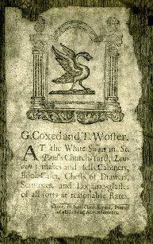

Figure 5.7: Trade card of G. Coxed and T. Woster, cabinet makers at the ‘White Swan’ in St. Paul’s Churchyard, c. 1720 (British Museum, Department of Prints and Drawings, Heal Collection Ref. 28.49).

Source: Anon, Heal, 28.49 <http://www.britishmuseum.org/collection>, British Museum, online [accessed 30 January 2016].

The population of London is estimated to have grown by approximately 15 per cent in the first half of the eighteenth century and the growth of the furniture trade was perhaps parallel, if not greater, especially when considering the 71 per cent expansion in Joiners’ Company membership between 1692 and 1721. Although the exact number of tradesmen working in the furniture industry is unattainable, it is evident that its size expanded exponentially. It also appears that furniture tradesmen continued to inhabit those parts of the City with which the business was customarily associated.

Furniture tradesmen in the West End of London 1660-1720
Porter commented on the westward migration of Londoners from the City in the years after the Restoration, believing it to be ‘epochal’, resulting in the birth of the West End as a residential quarter. ‘Hitherto’, he wrote, ‘people had settled in the metropolis because that is where they earned their livelihood … After the Restoration, however, thousands took up residence in the West End because that was the finest place to live –

a place to spend money, to entertain or just to bask in being’.63 London furniture tradesmen seized the opportunity to place themselves among those with money to spend. This section describes the type of furniture tradesmen who were there, which areas they populated, and why.

The West End was transformed in the seventeenth century from a gabled Tudor suburb of the City to a place more continental in nature, where open squares became public meeting places in which to sit and stare and be seen, and where people could stroll along wide, paved and well lit streets to browse the shop fronts of newly built terraced houses.64 This must have been a new concept for most Londoners who would have been accustomed to the maze of medieval streets. ‘The creation of shops, gardens, waterworks, churches, and hospitals’, was actively promoted by the early Stuarts, who also allowed the building of ‘townhouses for the well-to-do’.65 The passion for the arts was revived after the restoration of the monarchy resulting in the opening of the Theatre Royal in Drury Lane in 1663. Other theatres soon followed, as for example, John Vanbrugh’s Queen’s Theatre in the Haymarket (1705).66 The population of the West End rapidly expanded during the second half of the century as the gentry and professional classes converged on London: in St. Martin in the Fields and surrounding parishes it grew from 19,000 in 1660 to 86,000 in 1700. By 1720 there were over
100,000 inhabitants.67

When the London elite moved west in the seventeenth century shops and shop keepers moved west too.68 Places like the New Exchange in the Strand and the Piazza in Covent Garden became showplaces for luxury goods, and furniture tradesmen were

63 Porter, London, pp. 115–16.
64 L. Stone, ‘The residential development of the West End of London in the 17th Century’, in B. C. Malament (ed.), After the Reformation: Essays in Honor of J. H. Hexter (Manchester, 1980), pp. 167–
212. One of the first Englishmen to study architecture in Italy, Inigo Jones was the Surveyor of Works to Charles I and Henrietta Maria. Commissions in the West End included Whitehall Palace (1619–20), the Banqueting House (1619–22), Somerset House (1617–18), Arundel House (1618), St. Paul’s Church Covent Garden (1631–3) and St. Giles in the Fields Church (1634). Jones was also known for his stage designs and for introducing movable scenery and the proscenium arch. His deputy was the architect, Edward Carter, pp. 226–7 (Colvin, Biographical Dictionary of British Architects, pp. 554–61).
65 Levy Peck, Consuming Splendor, pp. 190, 201.
66 For Thomas Killigrew, royalist, dramatist and manager of the Theatre Royal, Drury Lane, see J. Richardson, Covent Garden Past (London, 1995), p. 13. Colvin, Biographical Dictionary of British Architects, p. 1003.
67 Boulton, ‘The poor among the rich’, p. 201.
68 Levy Peck, Consuming Splendor, pp. 46–7.

soon established there, especially after the Fire.69 In Lawrence Stone’s opinion, the expansion of the western suburbs in the 1660s was a consequence of the increasing demand for upper-class housing following the great expansion in the numbers of the gentry and professional classes who wanted to live in London.70 However, to suggest that the entire West End was wealthier than the City would be wrong because in some ways the social topography was characteristically similar, with pockets of affluence and poverty existing within close proximity. Stone believed that ‘the desire to preserve an exclusive residential neighbourhood was thwarted by the inexorable westward thrust of the lower classes of London, who year by year moved further and further into areas which had originally been designed for, and inhabited by, their betters’.71

The profile of the trade is quite different from that in the City; whereas the majority there described themselves as joiners and chair makers, almost two-thirds of tradesmen in the West End described themselves as upholders (27 per cent), upholsterers (18 per cent) and cabinetmakers (20 per cent). This could be the result of several factors, one being that as the eighteenth century progressed the terminology used to describe various specialisms altered. Another may have been a response to the different demands of wealthy consumers, both City merchants and nobility.72 Upholders and/or upholsterers, like cabinetmakers, are known to have supplied a broad range of goods and services.73 They coordinated a range of specialised trades that provided their clients with fashionable and often high-status furniture. Some also acted as interior decorators, advising their clientele on architectural features and colour schemes to complement the broad range of interior furnishings they provided. They were also known to clean and maintain furniture and textiles for their wealthiest clientele.

The West End became a place to shop for luxury goods and as Levy Peck explains, ‘the establishment of the New Exchange created a new public sphere’ attracting both the middle and upper classes.74 Like going to the theatre or perambulating through the

69 Lindey, ‘A Restoration London cabinet and looking glass maker’, p. 18. See Heal, Furniture Makers,
p. 72, on John Gumley cabinetmaker and glass manufacturer at Salisbury Exchange in the Strand from 1674.
70 McKellar, Birth of Modern London, pp.17–18.
71 Stone, ‘Residential development of the West End’, p. 191.
72 In assessing the importance of furnishings in rich merchants’ houses, it is clear that similar furniture appears at the same time in both mercantile and aristocratic houses (A. Turpin, ‘Furnishing the London merchant’s town house’, in Galinou, City Merchants, pp. 55–67, at p. 65).
73 See Chapter Two for a detailed description of a cabinetmaker’s activities.
74 Levy Peck, Consuming Splendor, p. 52.

Mulberry and Spring Gardens in Vauxhall, shopping was an opportunity to be seen and to socialise, as well as to purchase goods. This pastime was mainly popular with the aristocracy who lived part of the year in the West End, whereas ‘there was very little infiltration of city merchants into the western suburbs, which remained an exclusive preserve of professional men, courtiers, and the landed classes’.75

Much of the following discussion draws on the empirical and systematic evidence that Craig Spence presented in his London in the 1690s: a Social Atlas, in particular his summary statistics compiled from the 1693-4 aid assessments. His conclusions help to broaden the analysis of the geographical whereabouts and socio-economic status of the West End furniture trade. A study group of 312 furniture tradesmen in the period 1660–1720 has been constructed using a combination of sources.76 244 were located from The Dictionary of English Furniture Makers;77 sixty-eight tradesmen were identified from wills proved in the Prerogative Court of Canterbury (PCC).78 Only thirteen furniture tradesmen were found in the 1693-4 aid assessment and they are also included in The Dictionary.79 The methodology used to date these tradesmen varies.
Those recorded from the Dictionary are dated using the time span of their residence at a particular location while those identified in PCC wills are dated more systematically based on the date when their will was probated. This data enriched with other information, creates a profile of the type of people who worked in the West End furniture trade (1660–1720) and identifies where they were situated.

Although lack of evidence makes it impossible to reconstruct actual clusters of furniture tradesmen as has been done for the City, we may assume that they operated in a similar fashion. John Strype observed groups of tradesmen involved in similar and complementary occupations in West End neighbourhoods. For example, when walking in and out of streets off the Strand he commented that: ‘White Hart Yard comes out of Drury-lane, and falls into Bridges-street against Exeter-street, a Place of some Trade,

75 Stone, ‘Residential development of the West End’, p. 186.
76 See Appendix 1.
77 Beard and Gilbert, DEFM.
78 TNA, PCC (1384–1858); The majority of the study group of 312 West End furniture tradesmen were identified through the DEFM and the remainder through PCC wills and the 1693-4 aid assessment. It is likely that the demography of the furniture trade in the West End was similar to that of the City and, consequently, it is clear that most of the trade is unaccounted for.
79 The assessment gives the names and addresses of inhabitants and records the rents paid and the value of stock in trade but rarely gives occupation.

especially for Upholsters’.80 Peter Earle surmised that ‘furniture and cabinet-making
…was concentrated in the area north of the Strand’.81 Many tradesmen were involved in coach making which employed specialists such as upholsterers, carvers and gilders.82

Table 5.13: Size and density of seven West End parishes in 1693-4 and the location of a study group of 312 furniture tradesmen situated there, 1660–1720.

Parish | Area in hectares | Number of households | Household density (hh/ha) | Furniture Tradesmen no. | Furniture Tradesmen  %
St. Clement Danes | 13 | 1,246 | 95.9 | 46 | 15
St. Giles in the Fields | 100 | 2,825 | 28.9 | 27 | 9
St. Martin in the Fields | 568 | 3,363 | 5.9 | 106 | 34
St. Paul Covent Garden | 10.5 | 521 | 49.6 | 54 | 17
St. Anne Soho | 21.5 | 1,099 | 51.1 | 26 | 8
St. James | 64 | 2,304 | 36.0 | 43 | 14
St. Margaret Westminster | 174 | 3,143 | 18.2 | 10 | 3
 |  |  |  | 312 | 100

Source: C. Spence, London in the 1690s: a Social Atlas (London, 2000), Appendix III, pp. 177–8.

Table 5.13 shows the size, area, population and density of West End parishes in the 1690s, and the numbers and percentages of the identified furniture tradesmen situated there from 1660 to 1720. St. Martin in the Fields was by far the largest parish, and by a smaller degree the most populous, and was the place where the majority of tradesmen were located. There was a notable concentration of furniture tradesmen in the smallest parish, Covent Garden, and a sizable cluster in the easternmost parish closest to the City, St. Clement Danes. The remaining tradesmen were north of St. Paul Covent Garden in St. Giles in the Fields, and westward in Soho, St. James, and the parish of St. Margaret. Spence determined that conditions were marginally less crowded in Covent Garden, where rent could purchase a larger house than in the City, while the most spacious houses of all were to be found in St. James Westminster.’83

80 Strype, Survey of London (1720), [online] (hriOnline, Sheffield). Available from bk. 6, ch. 5, p. 75 [accessed 28 July 2015].
81 Earle, English Middle Class, p. 23.
82 Earle, English Middle Class, n. 27, pp. 343–4.
83 Spence, Atlas, p. 72.

Table 5.14: Occupations of furniture tradesmen in seven West End parishes, 1660-1720

Occupation | St. Clement Danes and St. Mary Savoy | St. Giles in the Fields | St. Martin in the Fields | St. Paul Covent Garden | St. Anne Soho | St. James | St.  Margaret Westminster | Total
Cabinetmaker | 8 | 5 | 27 | 15 | 6 | 1 | 1 | 63  (20%)
Cane chair maker |  |  | 1 | 1 |  |  |  | 2  (1%)
Carver |  | 2 | 5 | 2 |  | 1 | 1 | 11  (4%)
Carvers and gilder |  |  | 1 | 1 | 1 |  |  | 3  (1%)
Chair maker | 1 |  | 4 | 1 |  |  |  | 6  (2%)
Dutch table maker |  |  |  |  | 1 |  |  | 1  (0.3%)
Engraver |  |  | 1 |  |  |  |  | 1  (0.3%)
Frame maker |  |  | 3 |  |  |  | 1 | 4  (1%)
Gilder |  |  |  | 1 |  |  |  | 1  (0.3%)
Inlayer | 1 |  |  |  |  |  |  | 1  (0.3%)
Japanner |  | 1 |  |  |  |  |  | 1  (0.3%)
Joiners | 11 | 12 | 17 | 4 | 5 | 6 | 4 | 59  (19%)
Looking-glass maker |  |  | 3 | 1 |  |  |  | 4  (1%)
Looking-glass seller |  |  | 1 |  |  | 1 |  | 2  (1%)
Sawyer |  |  | 1 |  |  | 1 |  | 2  (1%)
Table maker | 1 |  |  |  |  |  |  | 1  (0.3%)
Timber merchant |  |  |  | 1 |  | 1 | 1 | 3  (1%)
Trunk maker | 1 |  |  |  |  |  |  | 1  (0.3)
Turner |  |  | 2 | 1 | 1 |  |  | 4  (1%)
Upholder | 14 | 5 | 23 | 16 | 9 | 17 |  | 84  (27%)
Upholsterer | 9 | 2 | 17 | 10 | 3 | 15 | 1 | 57  (18%)
Woodmonger |  |  |  |  |  |  | 1 | 1  (0.3%)
Total | 46 | 27 | 106 | 54 | 26 | 43 | 10 | 312  (100%)
Source: G. Beard and C. Gilbert, The Dictionary of English Furniture Makers, 1660–1840 (Leeds, 1986); TNA, PROB 11 (See Appendix 1); COL/CHD/LA/03/040; COL/CHD/LA/03/042 and COL/CHD/LA/03/0.

Table 5.14 identifies each furniture tradesman’s specialism and the parish in which they were located. The predominant trades were upholders, upholsterers and cabinetmakers. Although there appear to be few artisans who supplied the furniture

trade with their specialised products, such as turners, carvers and gilders, this may simply be a reflection of the limitations associated with the documentary sources which tend to be biased in favour of high-end and wealthy tradesmen.

The 1693-4 aid assessments record no aristocratic households in the City of London’s boundaries, but there were 101 in the West End and twelve in the parish of St.
Margaret Westminster.84 One such household was Montagu House in Great Russell Street, Bloomsbury, in the parish of St. Giles in the Fields. In 1708, Edward Hatton described Montagu House as ‘a noble and beautiful Palace … The inside … richly furnished and beautifully finished’.85 The average rent and stock values from the 1693- 4 tax assessments give a general picture of the neighbourhoods where tradesmen were situated in the 1690s, and values for thirteen furniture makers provide more precise detail.

Table 5.15: Mean household rent and stock in seven West End parishes in 1693-4.

Parish | Mean rents |  | Rent range (£) | Mean stock |  | Stock range (£)
St. Clement Danes | £21 | 14s | 1–400 | £132 | 4s | 25–1,000
St. Giles in the Fields | £18 | 10s | 1–462 | £198 | 12s | 25–5,000
St. Martin in the Fields | £24 | 10s | 1–500 | £164 | 11s | 13–5,000
St. Paul Covent Garden | £34 | 8s | 4–250 | £303 | 2s | 50–4,500
St. Anne Soho | £22 | 16s | 1–300 | £220 | 16s | 13–5,000
St. James | £21 | 14s | 1–320 | £163 | 2s | 13–5,000
St. Margaret Westminster | £11 | 19s | 1–300 | £150 | 2s | 25–3,000

Source: Spence, London in the 1690s, Appendix III, pp. 177–8.

Table 5.15 shows the mean rent and stock values in seven parishes where furniture tradesmen were situated. The mean rent in St. Margaret was the lowest and that in St. Paul Covent Garden the highest, but the rent range indicates that some of the wealthiest households were in St. Martin in the Fields and St. Giles in the Fields. This is probably because the northern border of St. Giles in the Fields was open pasture land and the location of properties such as Montagu House, and the western border of St. Martin in the Fields was semi-rural and a place where many of the gentry had their London homes.86

84 Spence, Atlas, Table 4.4, ‘The distribution of aristocratic and gentry householders by social group’, p. 83.
85 E. Hatton, A New View of London; or, an ample account of that city, in two volumes, or eight sections
(2 vols., London, 1708), vol. 2, p. 628.
86 Spence, Atlas, pp. 83, 87.

Two areas characterised by particularly high rents were in the parishes of St. Paul Covent Garden and St. James Westminster. Properties central to the Piazza in Covent Garden were most expensive, with the mean rent for a house in the Piazza itself being
£74 5s. Rents in adjacent streets were also high: £45 19s in Henrietta Street and £40 6s in King Street. In the parish of St. James, the mean rent for a house in Pall Mall was
£95 14s and on St. James’s Square, the mean rent was exceptionally high at £205 11s.87

Table 5.16: Furniture makers recorded in the 1693-4 tax assessment

Name and sign | Parish | Street | Occupation | Rent | Stock
John Gumley | St. Clement Danes | Salisbury Exchange in the Strand | Cabinetmaker and glass manufacturer | £55 | £100
Peter Gumley  at the sign of ‘The Cabinet’ | St. Clement Danes | The Strand | Cabinetmaker | £40 | £200
Richard Robinson at ‘The Flower Pot’ | St. Clement Danes | Beaufort Street, The Strand | Looking-glass maker | £50 | £100
Jasper Braem | St. Mary Savoy | The Savoy | Cabinetmaker and inlayer | £70 | £150
Edward Sparkes | St. Clement Danes | Witch Street | Upholsterer | £30 | £100
Thomas Nash | St. Clement Danes | Windsor Court | Cabinetmaker | £15 | -----
John Youle at the sign of The Cabinet | St. Giles in the Fields | Drury Lane | Cabinetmaker | £27 | £100
Gerrit Jensen | St. Martin in the Fields | St. Martin’s Lane | Cabinetmaker | £40 | £400
Gerrit Jensen | St. Martin in the Fields | Hills Alley | Cabinetmaker | £8 | -----
Gerrit Jensen | St. Martin in the Fields | Castle Street | Cabinetmaker | ----- | £400
Jean Guilbaud  at the sign of ‘The Crown and Looking Glass’ | St. Martin in the Fields | Long Acre | Cabinetmaker | £20 | £50
John Norris | St. Martin in the Fields | Long Acre | Picture frame maker | £30 | £300
Thomas Arne at the sign of ‘The George and White Lion’ | St. Paul Covent Garden | Bedford Street | Upholder | £60 | £50
Francis Lapiere | St. James | Pall Mall | Upholder | £60 | £200
Jean Guillotin | St. James | Pall Mall | Upholder | £16 | £50

Source: COL/CHD/LA/03/040; COL/CHD/LA/03/042 and COL/CHD/LA/03/0, ‘The four shillings in the pound aid 1693-4 for the city of London, the city of Westminster and Metropolitan Middlesex’.

Table 5.16 shows the thirteen furniture makers in five West End parishes who were listed in the 1693-4 tax assessment. In keeping with the spatial logic of the City of London, high-profile tradesmen were situated in prominent positions like the Strand,
87 Spence, Atlas, p. 70.

Covent Garden Piazza, and Long Acre, while those operating seemingly more modest businesses were in the smaller streets, lanes and courtyards. Unfortunately there are no known inventories to shed light on the way these people ran their businesses, but the information in several published sources like the Dictionary of English Furniture Makers helps to fill in some of the blanks. The following discussion introduces several of the furniture tradesmen identified in the study group of 312 West End furniture tradesmen (compiled from PCC wills and the Dictionary) and describes the parishes where they worked and lived.

St. Clement Danes and St. Mary Savoy
After the Restoration the areas around the Strand and Bloomsbury were the first to see large-scale redevelopment. Much of this was the work of Nicholas Barbon and, as Elizabeth McKellar has noted, it ‘provides interesting examples of the mixing of residential and commercial functions’.88 Strype described the area as being ‘large, well built and inhabited, by many Persons both of the Nobility and Gentry, as well as rich Tradesmen’.89 The demographic profile of tradesmen in the parish was diversified with wealthy shopkeepers in and around the Strand while in the streets and alleyways towards the north it appears that tradesmen were more involved in manufacturing.

88 McKellar, Birth of Modern London, p. 23.
89 Strype, Survey of London (1720), [online] (hriOnline, Sheffield). Available from bk. 4, ch. 7, p. 116 [accessed 28 July 2015].

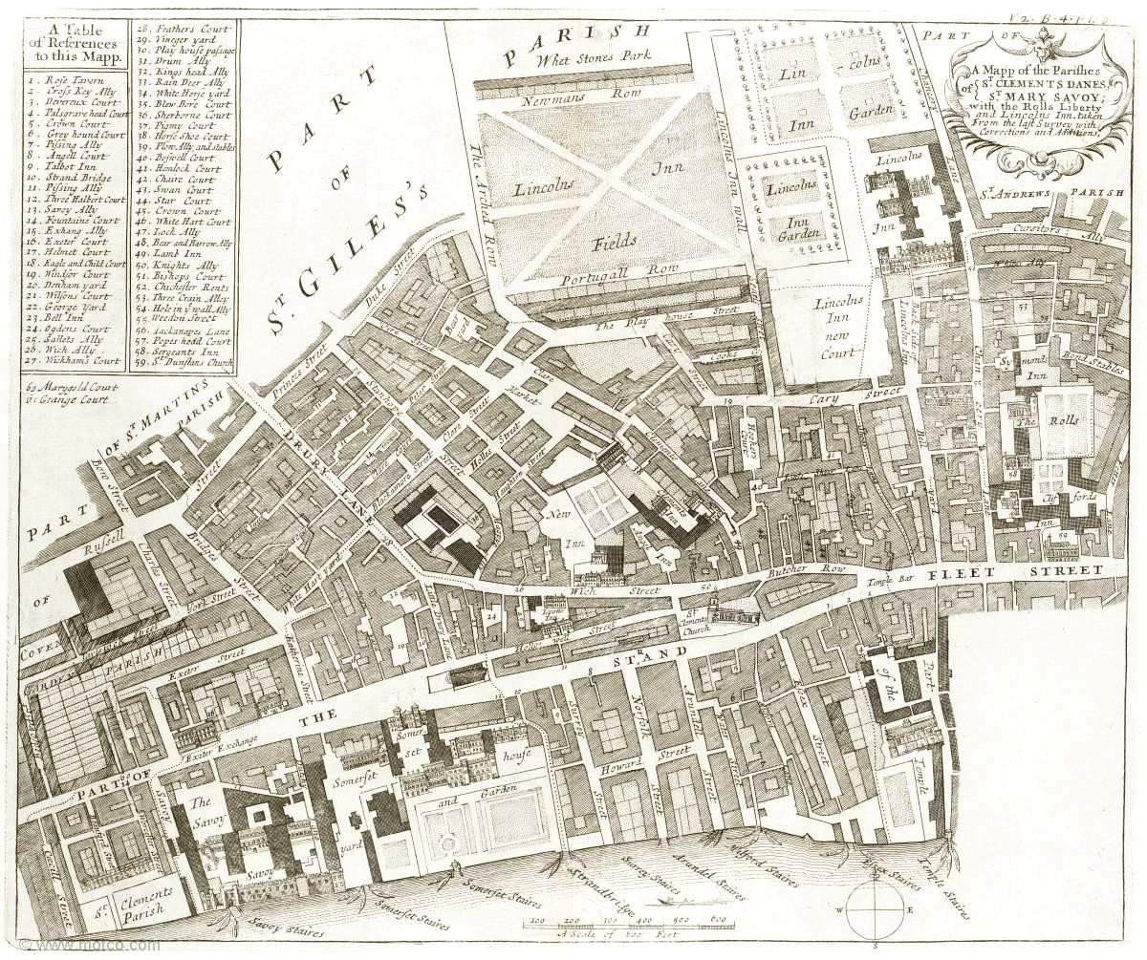
Figure 5.8: Map of St. Clement Danes parish, 1720.

Source: Strype, Survey of London (1720), bk. 4, ch. 7, p. 109: Motco Enterprises Limited
<www.motco.com/strype/images/figures> [accessed 21 August 2015].

By the late seventeenth century the Strand was lined with shops that were ‘light, lofty and theatrically designed’.90 Shopping became an entertainment on a par with going to the theatre.91 In The Complete English Tradesman, Defoe described the fitting up of a ‘fine shop’, like those in the New Exchange. Mirrored sash windows were installed and the walls were lined with tiles and seven foot mirrors. There were large branches of candlesticks, glass lanterns and ‘twenty-five sconces’, and the ceiling was painted and gilded. Customers were served sweetmeats, tarts and jellies on ‘fine large silver salvers’.92 To walk past these shop fronts would have been seductive and to enter this environment must have been dazzling; it was ‘an enviable position for any shopkeeper’.93

Fifty-two furniture tradesmen are identified as living and/or working in St. Clement Danes. Several of those in the Strand in the 1690s demonstrate the high calibre of those fortunate enough to have been situated there. Their biographical details reveal

90 Porter, London, p. 173.
91 Levy Peck, Consuming Splendor, p. 51.
92 Defoe, Complete English Tradesman, pp. 203–4.
93 Cox, Complete Tradesman, p. 140–2.

that they provided their services not only to passing trade but also through private commissions; that some diversified their trade practices beyond retail; and that most of them had a particular specialisation which would no doubt have helped them achieve prominence. One was John Gumley, a cabinetmaker and looking-glass manufacturer at the Salisbury Exchange.94 He had the fashionable stock in trade that would have been expected in the Strand, and amongst his commissions he supplied the royal household of William III. In addition to his interests in retail, he was also involved in the establishment of a glass manufactory at Lambeth in 1705. Several years later he opened a warehouse in the New Exchange where he sold cabinetwork, looking glasses and chandeliers.95 Another looking-glass maker in the Strand was Richard Robinson at the ‘Flower Pot’. He was recorded as serving the nobility and seems to have been something of an inventor, holding a patent for an ‘Engine for Grinding, Pollishing and Cutting Looking-Glass Plates’.96

The cabinetmaker and marqueteur Jasper Braem was situated in the Savoy.97 He was apparently viewed as a fine marqueteur because he was employed to lay a parquetry floor in the Duchess of York’s bedchamber at Windsor Castle in the 1680s.98 Prior to his residence in the Savoy, in the 1670s, he was a co-tenant with the clockmaker Thomas Tompion in Fleet Street and, according to the horological expert Jeremy Evans, Braem manufactured marquetry clock cases for Tompion.99

Northeast of the Strand was Witch Street which appears to have been a less prominent retail vicinity. Rents were cheaper than in the Strand or Savoy and tradesmen appear to have managed more modest businesses. Strype described it as ‘much taken up by Upholsters for the Sale of Bedding and second hand Houshold Goods’.100 The Strand was a major route leading out of the City into the West End. Like Cheapside in the City, it was one of London’s most fashionable places to shop. The New Exchange in particular offered a ‘superior shopping experience’ and ‘marked a significant departure in consuming because of its location: it was suburban and private, a shopping mall
94 John Gumley paid £555 in rent and declared £100 of stock in 1694.
95 Beard and Gilbert, DEFM, pp. 379–80.
96 Robinson paid £50 in rent and declared £100 of stock (Beard and Gilbert, DEFM, p. 759).
97 Braem paid £70 in rent and declared £150 of stock.
98 Beard and Gilbert, DEFM, p. 104. Braem also worked on a subcontractual basis, his name appearing in the cabinetmaker Edward Traherne’s inventory of 1675 (LMA, CLA/002/02/01/1177).
99 J. L. Evans, Thomas Tompion at the Dial and Three Crowns (Wadhurst, 2006), pp. 28–31.
100 Strype, Survey of London (1720), [online] (hriOnline, Sheffield). Available from bk. 4, ch. 7, p. 118 [accessed 28 July 2015].

located close to the court and to new aristocratic housing’.101 Top notch cabinetmakers and upholders were positioned in this part of the parish while less prominent upholsterers and joiners were located to the north of the Strand in Witch Street and in adjacent lanes and courtyards.102

St. Giles in the Fields
In 1694 much of St. Giles in the Fields remained undeveloped and the north end of the parish consisted of open fields and pasture land. The plague started here and, as Porter pointed out, ‘the 1665 outbreak predictably started in what was soon to be the slum of slums’.103 By the late seventeenth century the parish had suffered some of the greatest casualties and there remained several toxic areas, especially around Lincoln’s Inn which bordered the parish’s most affluent neighbourhoods.

Situated to the west of Holborn, St. Giles in the Fields was developed from about 1609 when the ‘inhabitantes of the dwellings at the newe gate neere Drury Lane [asked for] a name unto that place’.104 Here, as elsewhere in London, abject poverty lived next to extraordinary wealth. John Strype said of it: ‘It is of a very large extent, and as populous, with a mixture of rich Inhabitants, to wit, of the Nobility, Gentry, and Commonalty; but withal, filled with abundance of Poor’.105 Montagu House in Great Russell Street lay on the northern border of the parish with views of ‘pleasant Fields up to Hamsted and Highgate’. Strype praised it ‘for Stateliness of Building and curious Gardens, Montague House hath the Pre-eminence, as indeed of all Houses within the Cities of London and Westminster, and the adjacent Parishes’.106 Not all of Great Russell Street was pleasant though: some ‘inhabitants could not use their front rooms due to the stench’, and Lincoln’s Inn Fields was a site where butchers were apparently told to dump ‘their stinking veal and other meats too rank for Sale’.107

101 E. Cockayne, Hubbub: Filth, Noise and Stench in England (New Haven and London, 2007), p. 177; Levy Peck, Consuming Splendor, p. 46.
102 There were six cabinetmakers and 14 upholders in the Strand, nine upholsterers in Witch Street, and two joiners in Drury Lane, 1660–1730.
103 Porter, London, p. 100.
104 N. G. Brett-James, The Growth of Stuart London (Woking, 1935), p. 166.
105 Strype, Survey of London (1720), [online] (hriOnline, Sheffield). Available from bk. 4, ch. 4, p. 75 [accessed 28 July 2015].
106 Strype, Survey of London (1720), [online] (hriOnline, Sheffield). Available from bk. 4, ch. 4, p. 85 [accessed 28 July 2015].
107 Cockayne, Hubbub, pp. 148, 189.

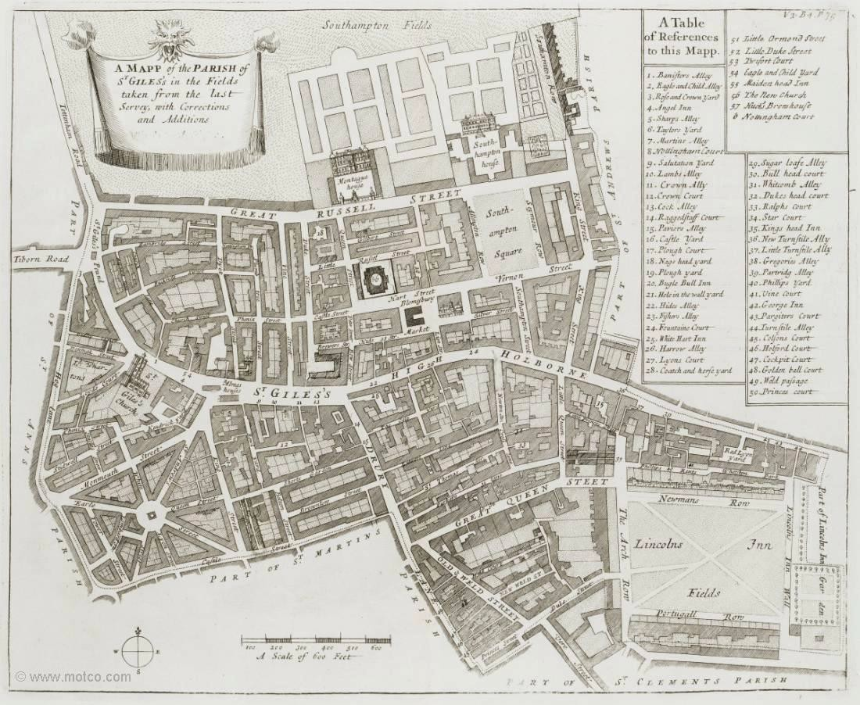

Figure 5.9: Map of St. Giles in the Fields parish, 1720.

Source: Strype, Survey of London (1720), bk. 4, ch. 4, p. 75: Motco Enterprises Limited
<www.motco.com/strype/images/figures> [accessed 21 August 2015].

Despite some unseemly neighbourhoods several areas were suitable for furniture tradesmen to set up shops, especially Drury Lane and Great Queen Street which became a ‘fashionable suburb of London under the first two Stuarts’.108 In Howe’s 1631 edition of Stow’s Annals, he described ‘new fair buildings called Queene’s Street leading into Drury Lane … that … soon became an aristocratic neighbourhood’.109 Strype noted that ‘For the generality it is well built, and inhabited by Shopkeepers and others’.110 The cabinetmaker John Youle was situated in Drury Lane and the cabinetmaker and japanner Abraham Massey was at the ‘Two White Posts’ in Great Queen Street. Massey’s obituary, published in the General Advertiser in 1736, described him as ‘the most eminent Japanner in England’.111 There were also joiners and carvers situated in the parish, some in less prominent areas. Two of the joiners

108 Brett-James, Growth of Stuart London, p. 297.
109 Brett-James, Growth of Stuart London, p. 166.
110 Strype, Survey of London (1720), [online] (hriOnline, Sheffield). Available from bk. 4, ch. 4, p. 76 [accessed 28 July 2015].
111 Youle paid £27 in rent and declared £100 of stock (Beard and Gilbert, DEFM, p. 585).

were located in Vine Street: ‘a place of no great Account’, and another was in Gilbert Street, which was ‘but ordinary’, according to Strype.112

Overall, the parish contained a broad mix of furniture tradesmen: those offering specialised skills or services were in fashionable locations, and more generalised tradesmen like joiners were in less prominent positions.

St. Martin in the Fields
St. Martin in the Fields (568 ha.) was the largest parish in metropolitan London.113 Parts of the parish were semi-rural and inhabited by nobility and landed gentry: there were twenty-five gentry households south of Oxford Street and seventeen aristocratic residences further west, ‘positioned at the very edge of the open space and clean air afforded by the surrounding fields’.114 It was not all countryside, however, with areas of development to the east. This, according to Strype, had been elegantly done, as in the case of Leicester Fields, ‘a very handsome large Square, enclosed with Rails, and graced on all Sides with good built Houses, well inhabited, and resorted unto by Gentry’.115 Other neighbourhoods near Covent Garden were ‘bohemian’, according to McKellar, though she commented that ‘if the area was an experiment in creating a new kind of socially exclusive environment then it most certainly failed’. The main impact of the development there in the 1670s was in ‘shifting the retail axis of the metropolis westwards away from the City’.116 These were the streets enveloping Covent Garden, a vibrant commercial district populated with many furniture tradesmen. Despite its bohemian character, the parish ‘came increasingly to contain a large number of poor as well as wealthy inhabitants, causing the social character to decline markedly’.117 Strype described one alleyway off of Long Acre as a ‘pretty open Alley, but ill inhabited, and nastily kept’.118

112 Strype, Survey of London (1720), [online] (hriOnline, Sheffield). Available from bk. 4, ch. 4, pp. 84– 5 [accessed 28 July 2015].
113 Spence, Atlas, pp. 176–8: St. Martin in the Fields 568.0 (ha), St. John at Hackney (1,335.6), St. Mary Islington (1,258.7), St. Paul Shadwell (1,081.8).
114 Spence, Atlas, pp. 83, 87.
115 Strype, Survey of London (1720), [online] (hriOnline, Sheffield). Available from bk. 4, ch. 4, p. 68 [accessed 28 July 2015].
116 McKellar, Birth of Modern London, pp. 194–5.
117 Boulton, ‘The poor among the rich’, p. 198.
118 Strype, Survey of London (1720), [online] (hriOnline, Sheffield). Available from bk. 4, ch. 4, p. 74 [accessed 28 July 2015].

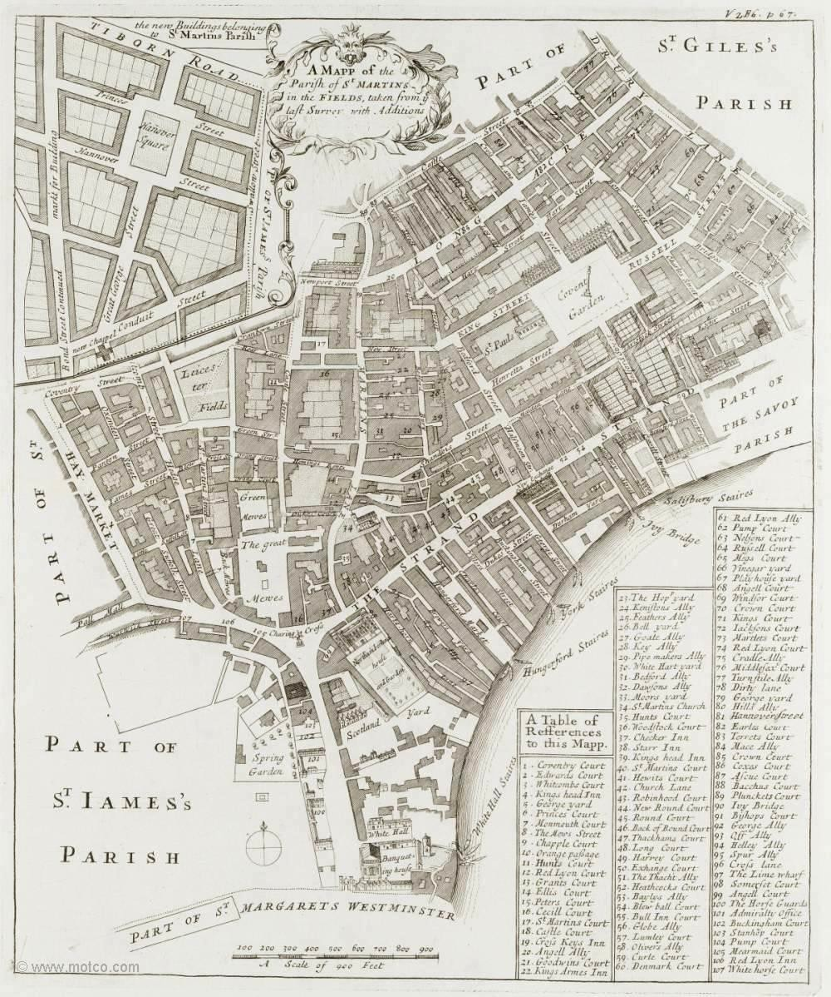

Figure 5.10: Map of St. Martin in the Fields parish, 1720.

Source: Strype, Survey of London (1720), bk. 6, ch. 5, p. 67: Motco Enterprises Limited
<www.motco.com/strype/images/figures> [accessed 21 August 2015].

The furniture trade had been established in the eastern parts of the parish from the middle of the seventeenth century. One of its most famous later members was the cabinetmaker Thomas Chippendale who had workshops in St. Martin’s Lane from
1753.119 Like furniture tradesmen in the Strand, those in the eastern part of St. Martin in the Fields abutting Covent Garden were situated in a most advantageous position. There were two furniture tradesmen in Long Acre in the 1690s. Samuel Pepys recorded a visit to one of them, the joiner and frame maker John Norris, who showed him ‘several forms of frames to choose by; which was pretty’.120 Norris apparently benefitted from his enviable location being noted for high-profile commissions: he supplied picture frames to Hatfield House in 1687, and in 1689 was appointed ‘Joiner

119 Gilbert, Life and Work of Thomas Chippendale, p. 9.
120 1666 Hearth taxes, book 60, f. 40: John Norris, Long Acre North Syde, 6 hearths; quotation from Beard and Gilbert, DEFM, p. 654.

to the Privy Council and thereafter worked on a number of commissions for the Crown’.121

There was a substantial French community in and around Long Acre and St. Martin’s Lane. Strype commented that the area was ‘inhabited by Tradesmen, several of which are French’.122 Some had immigrated to London in 1685 after the Revocation of the Edict of Nantes.123 French furniture tradesmen in London – like many immigrant communities – remained a tightly knit community; cabinetmakers who were brothers lived around the corner from each other and many families were related through marriage. Presumably these were political and religious refugees who brought with them different traditions and ideas, and continental designs and techniques. This would have served them well in London because of the all-consuming desire for continental (especially French) goods. There was a cultural message associated with owning French wares which ‘marked their purchasers as fashionable, cosmopolitan and in some cases, modern. The endless desires met by these luxury objects helped to support status, shape identities, promote creature comforts, enlarge sociability, as well as advance the economy’.124

As we have seen, the cabinetmaker Jean Guilbaud (who sold the scriptor that featured in Chapter Two) was a French Huguenot living in Long Acre at the ‘Crown and Looking Glasse’ (see Figure 5.11).125 Guilbaud married the daughter of another Huguenot, Thomas Pelletier, a carver and gilder who had immigrated to London in 1681, and lived nearby on the south side of the Piazza in Covent Garden. The Pelletier family firm supplied goods to William and Mary at Kensington Palace and Hampton Court and to Lord Montagu at Boughton.126 Guilbaud’s marriage ensured that he, too,

121 Norris paid £30 in rent and owned £300 of stock (Beard and Gilbert, DEFM, p. 654).
122 Strype, Survey of London (1720), [online] (hriOnline, Sheffield). Available from bk. 6, ch. 5, p. 68 [accessed 28 July 2015].
123 Beier and Finlay, London 1500–1700, p. 21. Huguenots, the Irish and Jews lived in their own communities in the seventeenth century. There were eight furniture makers with French surnames in the neighbourhood: Jacob Arbuthnot, cabinetmaker (1709); Philip Arbuthnot, cabinetmaker (1709); Thomas Casser, frame maker (1692); Nicholas Felliot, cabinetmaker (1709); John Guilbaud, cabinetmaker (1693); Peter Hasert, cabinetmaker (1692); Philip Le Caron, upholsterer (1716); and Rénee Pelletier, engraver (1692).
124 Levy Peck, Consuming Splendor, p. 113.
125 COL/CHD/LA/03/040; COL/CHD/LA/03/042 and COL/CHD/LA/03/0, ‘The four shillings in the pound aid’ record Guilbaud as a papist. Guilbaud paid £20 in rent and declared £50 of stock.
126 Beard and Gilbert, DEFM, p. 687; T. Murdoch, ‘Jean, Rene and Thomas Pelletier, a Huguenot family of carvers and gilders in London 1682–1726’, The Burlington Magazine (November 1997), pp. 732–42, at pp. 732–36.

was the fortunate recipient of high-profile commissions: records of the Great Wardrobe show him working for the same group of people.127

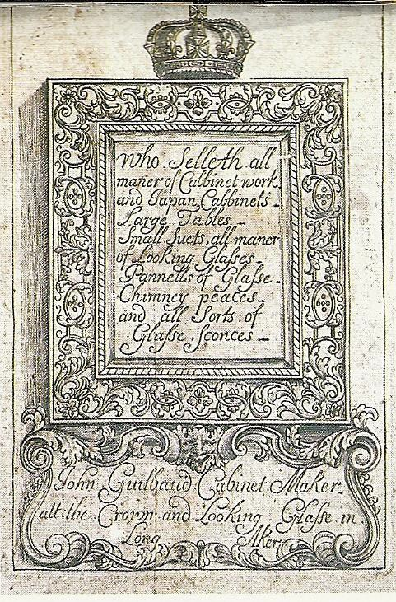

Figure 5.11: The trade card of John Guilbaud, cabinet maker at the ‘Crown and Looking Glasse’ in Long Aker (The Geffrye Museum, London, object number 60/2005) (Active 1693–1712).
Source: A. Bowett, English Furniture 1660–1714: from Charles II to Queen Anne
(Woodbridge, 2002), p. 203.

Just around the corner from Guilbaud’s establishment was the cabinetmaker Gerrit Jensen who has previously been mentioned. He provided his services to three successive monarchs and many members of the aristocracy and gentry.128 He had three addresses in the neighbourhood which he occupied at the same time: two the north side of St. Martin’s Church in Red Lyon Street which ran between St. Martin’s Lane and Castle Street; and a third nearby in Hills Alley beside a large timber yard.129 Nothing is

127 ‘Item to John Guilliband Cabonet maker for two Scruitores inlaid with flowers for our dearest Consort the Queens Service £30’ (TNA, LC 5/42, f. 344, Michaelmas 1690); ‘Item to John Guillibaude for one plaine Scriptoire for the King’s service at Whitehall £8;10s’ (LC 5/43, f. 32, Michaelmas 1691). 128 Beard and Gilbert, DEFM, pp. 485–7.
129 COL/CHD/LA/03/040; COL/CHD/LA/03/042 and COL/CHD/LA/03/0, ‘The four shillings in the pound aid’ record Jensen having rented three properties in St. Martin in the Fields. In Red Lyon Street he paid £40 in rent and declared £400 of stock on one property and in the adjacent house he paid no rent and also declared £400 of stock. In Hills Alley he paid £8 in rent with no stock. The tax assessment says this property included a ‘yard, etc.’; (TNA, PROB 11/550, Gerrit Jensen, 17 Feb. 1716).

known about his origins except that he was Catholic.130 He was made free of the Joiners’ Company by redemption in 1667, which implies that he received letters of denization, and had perhaps come to London to participate in its reconstruction after the Fire.131 He was situated in a neighbourhood populated with many French immigrants, but the only known link is his business dealings with the Parisian ébéniste, Pierre Gole.132 The furniture Jensen supplied was French in form and style and he is best known for pieces inlaid with metal and tortoiseshell in an arabesque design, often referred to as ‘Boulle work’. This large group of continental immigrants formed part of a larger furniture-making community in St. Martin in the Fields, nestled around Covent Garden in the eastern part of the parish, many of whom were high-profile retailers.

St. Paul Covent Garden
St. Paul Covent Garden was the place to shop and be seen, and visitors could get a taste of the continent from its architecture, and from the luxurious shops selling many European goods. Inigo Jones’s Covent Garden was the epitome of European classicism: ‘The design of the scheme combined elements from the piazza at Livorno and the Place des Vosges in Paris’.133 Whether or not Jones actually patterned Covent Garden after Livorno’s piazza, the contemporary love of Italian architecture meant that the association would not have been missed.134 Wealthy merchants in the early eighteenth century displayed their gentlemanly behaviour in walking through the streets and visiting coffee houses like Will’s on Russell Street in Covent Garden. And there were other sorts of pleasures available that were perhaps not so gentlemanly: prostitutes ‘plied their trade on the streets’ and there were ‘bawdy houses and brothels’.135

130 COL/CHD/LA/03/040; COL/CHD/LA/03/042 and COL/CHD/LA/03/0, ‘The four shillings in the pound aid’ record Jensen as a papist.
131 GL, MS. 8051/1, f. 56, 22 Oct. 1667, ‘Garret Johnson ye ordin Dni Major it Alderman admiss fuit et drdit & fin XXX:s et & cochleare Xs et’.
132 Beard and Gilbert, DEFM, p. 486.
133 McKellar, Birth of Modern London, p. 193.
134 Levy Peck, Consuming Splendor, p. 134.
135 Berg, Luxury and Pleasure, p. 207; T. Hitchcock, ‘”You bitches … die and be damned”: Gender. Authority and the Mob in St Martin’s Round-House Disaster of 1742’, in T. Hitchcock and H. Stone (eds.), The Streets of London: from the Great Fire to the Great Stink (London, 2003), pp. 69–81, at p. 70; J. Black, ‘Illegitimacy, sexual relations and location in Metropolitan London, 1735–85’, in T. Hitchcock and H. Stone (eds.), The Streets of London: from the Great Fire to the Great Stink (London, 2003), pp. 101–18, at p. 108.

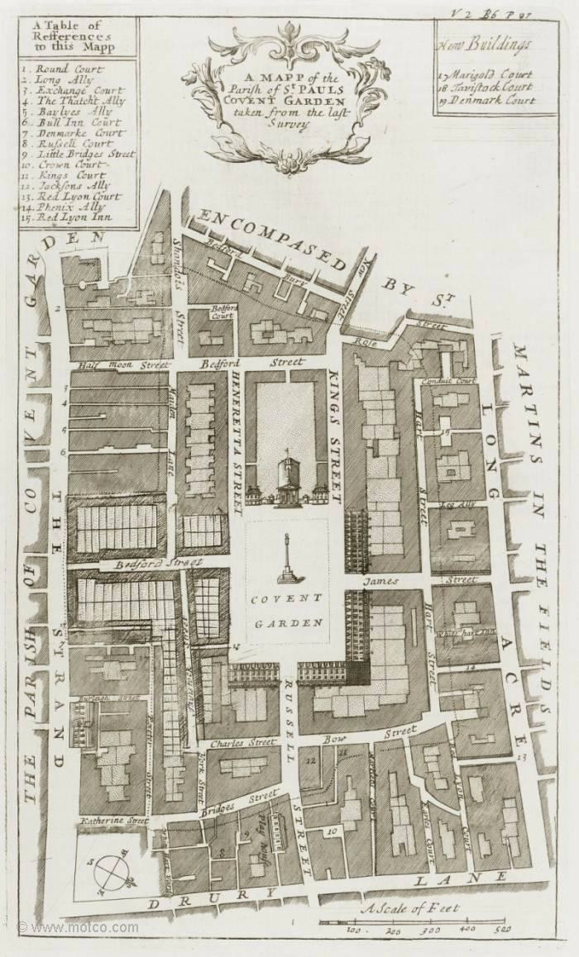

Figure 5.12: Map of St. Paul Covent Garden parish, 1720.
Source: Strype, Survey of London (1720), bk. 6, ch. 6, p. 87: Motco Enterprises Limited
<www.motco.com/strype/images/figures> [accessed 21 August 2015].

Shops in Covent Garden would have been similar to those in the New Exchange: seductive and luxurious. It is a safe assumption that tradesmen in the piazza were at the top of their game. One was the upholder Thomas Arne, who was at the ‘George and White Lion’ in 1694.136 He served fashionable clients like Benjamin Mildmay, 1st Earl FitzWalter.137 Another was the cabinetmaker Edward Traherne who has already been mentioned and who features in a case study in Chapter Six.138 In 1675, Traherne was situated in Bedford Street, which, according to Strype, was frequented by ‘Nobility and

136 Arne paid £60 in rent and declared £50 in stock.
137 Beard and Gilbert, DEFM, pp. 18–19.
138 LMA, CLA/002/01/1177, Court of Orphans inventory, 26 Nov. 1675.

Gentry in their Coaches’.139 Like other prominent shopping districts, many of the furniture tradesmen in Covent Garden were specialists and provided unique services and products: the French gilder and carver, Thomas Pelletier was on the south side of the Piazza, and Anne Wraugthon in King Street at the ‘Blue and White Balls’, where she specialised in the sale of Indian and Japanned cabinets.140

St. Anne Soho
Soho was a relatively newly-developed area when compared to the eastern parishes of the West End. The building speculators Nicholas Barbon and Richard Frith obtained a lease from the Earl of St. Albans in 1677, and the parish of St. Anne Soho was formed from part of St. Martin in the Fields in 1678.141 A series of regulations enacted at the time ‘made it clear … That the aim of the Court [was] that only houses of quality were to be built … And only people of substance were allowed to live there’.142 This was probably a reaction to a petition submitted to the king by Christopher Wren ‘expressing anxiety about new housing in Soho designed for workmen and small tradesmen fleeing regulations in the City’.143

139 Reddaway, Rebuilding of London, p. 302, quoting Strype’s Stow, bk. III, p. 195b.
140 Beard and Gilbert, DEFM, p. 687. Heal, Furniture Makers, p. 209.
141 McKellar, Birth of Modern London, p. 40; Brett-James, Growth of Stuart London, p. 394.
142 Brett-James, Growth of Stuart London, p. 304.
143 P. Thorold, The London Rich: the Creation of a Great City from 1666 to Present (London, 2001), p. 43.

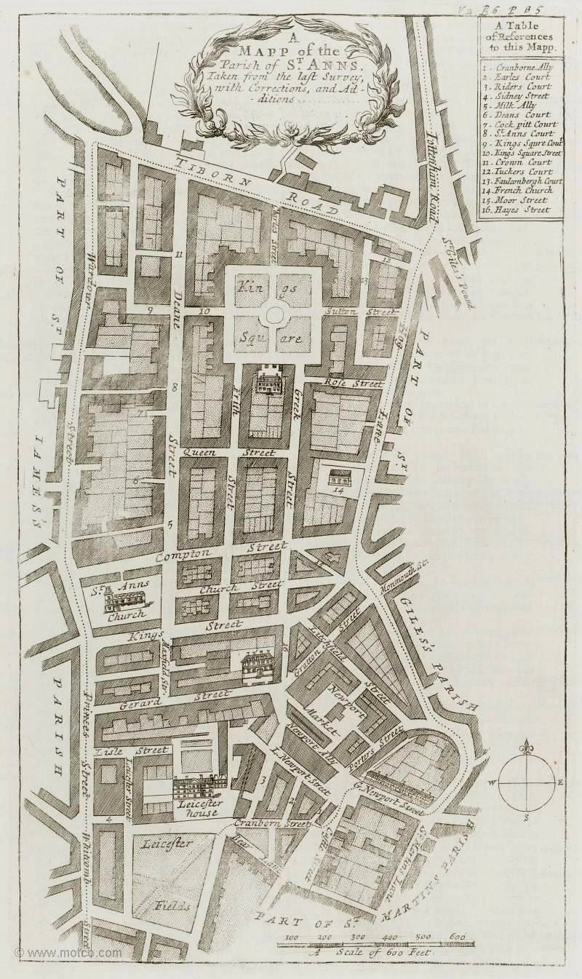

Figure 5.13: Map St. Anne Soho parish, 1720.
Source: Strype, Survey of London (1720), bk. 6, ch. 6, p. 85: Motco Enterprises Limited
<www.motco.com/strype/images/figures> [accessed 21 August 2015].

Much of the parish was open and spacious with terraced houses built around squares. London squares, which were a feature of 1660–1720 development, combined ‘existing and new ways of organising space’ in much the same way as the houses of the period.144 Thanks to its spacious environment, the parish would have been an ideal setting for building tradesmen like furniture makers to store materials and manufacture their wares.

144 McKellar, Birth of Modern London, pp. 40, 204.

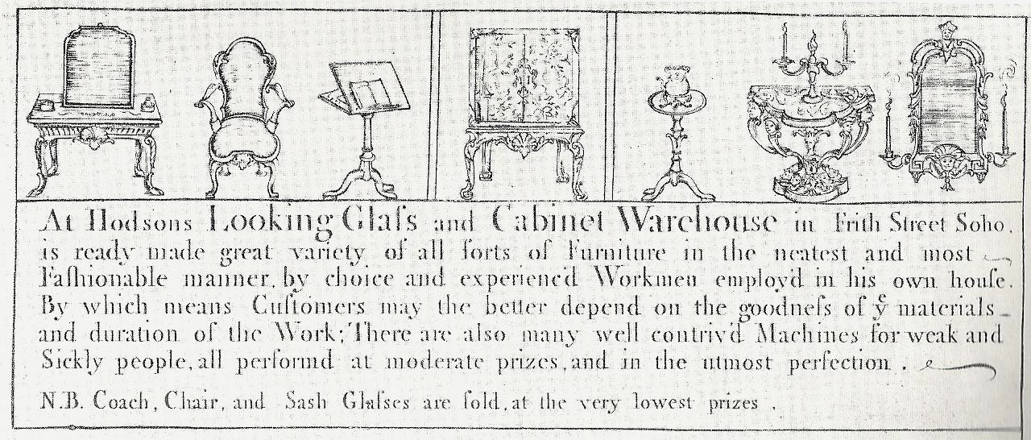

Figure 5.14: The trade card of John and Robert Hodson at the ‘Looking Glass and Cabinet Warehouse’ in Frith Street, Soho, c. 1720.
Source: A. Heal, The London Furniture Makers: from the Restoration to the Victorian Era, 1660–1840 (London, 1953), p. 80.

Over 70 per cent of identified furniture tradesmen in the parish were cabinetmakers, upholders and upholsterers and there were also several joiners, a turner, and a carver and gilder. Some parts of Soho would have been good places to sell furniture, especially considering that it was a newly developed area of the West End where nobility and gentry lived.145 In the late seventeenth century Soho Square was one of the most fashionable addresses in London.146 The furniture makers John and Robert Hodson were in Frith Street, which Strype described as being ‘graced with good Buildings well inhabited’.147 They sold a ‘great variety of all sorts of furniture in the neatest and most fashionable manner … [made] by choice and experiene’d Workmen employ’d in [the Hodsons’] own house’ (see Figure 5.14).148 Soho certainly must have been spacious if Hodson had room for a warehouse on his property. However, not all of Soho was so salubrious: the demographic profile was mixed, with some wealthy inhabitants, a wide range of tradesmen and the poor. Many of the aristocratic rich and professional people who moved into the West End avoided sections of Soho, like Broadwick Street where a pest house had been established during the plague.149
As with St. Martin in the Fields, many continental families settled in the parish towards the end of the seventeenth century, and of the twenty-six identified furniture tradesmen,

145 McKellar, Birth of Modern London, p. 201.
146 Thorold, London Rich, p. 46.
147 Strype, Survey of London (1720), [online] (hriOnline, Sheffield). Available from bk. 6, ch. 6, p. 87 [accessed 28 July 2015].
148 Heal, Furniture Makers, p. 80.
149 Thorold, London Rich, p. 53.

six were French and one was Dutch. Apparently they were part of an established community: a church of non-conforming French refugees was established in1687 and several French Huguenot churches were opened over the following ten years.150

St. James Westminster
In his petition to the Crown to grant freeholds in 1663, the Earl of St. Albans wrote that ‘ye beauty of this great Towne and ye convenience of your Court are defective in point of houses fit for ye dwellings of Noble men and other Persons of quality … Ye Place in St James Field should be built in great and good houses’.151 And so it was.
Jeremy Boulton says that ‘St. James’s Square … Set the blueprint for architectural planning during England’s urban renaissance’ and Lord St. Albans’s mansion was one of the most spectacular, ‘the largest on the square with some fifty rooms … And stables accommodating twenty horses and five coaches’.152 Of course a part of the West End renowned for having vastly wealthy inhabitants attracted varied types of establishments and business opportunities: coffee houses, churches, theatres and ‘beautiful women, with or without impunity’.153 In such a neighbourhood, surrounded with gardens, enormous parks and squares, prostitution and thievery were an issue, especially at night.154 Charles II may have endeavoured to ‘fashion St. James’s Park as a reinstatement of natural sovereign order’ but he created it in a city filled with all sorts. 155

150 Brett-James, Growth of Stuart London, p. 489.
151 McKellar, Birth of Modern London, p. 18.
152 Boulton, ‘The poor among the rich’, p. 197; Thorold, London Rich, p. 65.
153 Brett-James, Growth of Stuart London, p. 323.
154 D. Palk, ‘Private crime in public and private places: pickpockets and shoplifters in London’, in Hitchcock and Shore, Streets of London, pp.135–50, at p. 142.
155 L. Williams, ‘To recreate and refresh their dulled spirites in the sweet and wholesome ayre’: green space and the growth of the city’, in Merritt, Imagining Early Modern London, pp. 185–213, at p. 190.

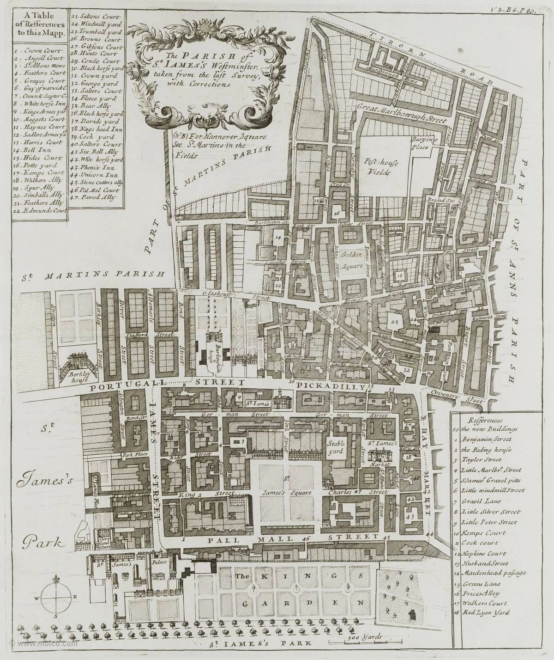

Figure 5.15: Map of St. James Westminster parish, 1720.
Source: Strype, Survey of London (1720), bk. 6, ch. 6, p. 81: Motco Enterprises Limited
<www.motco.com/strype/images/figures> [accessed 21 August 2015].

According to Nancy Cox, ‘finding the right area to match the social aspirations of the envisaged clientele was important’ for tradesmen.156 It comes as no surprise, then, that furniture tradesmen were situated in the parish’s best neighbourhoods: Piccadilly, St. James Street, Jermyn Street, Haymarket and Pall Mall. Seventy-four per cent of them were upholders and upholsterers and there was also a cabinetmaker, a carver and six joiners. As seen in other communities in the West End, there were continental immigrants and six in this group were French. One was the upholsterer Francis Lapiere, who in 1694 was situated in Pall Mall, an area described as being ‘quite

156 Cox, Complete Tradesman, p. 70.

aristocratic and exclusive’.157 By all accounts Lapiere would have felt quite at home in this setting as he was known as ‘one of the grandest and most accomplished upholsterers of the late seventeenth century’.158 Like his contemporary, the cabinetmaker Gerrit Jensen of St. Martin’s Lane, Lapiere was Catholic, but despite the religious bias of the day both were employed on an extensive scale to furnish households for the crown and nobility. One of Lapiere’s most notable London commissions was furnishing Montagu House in St. Giles in the Fields from 1690 until 1714.159

Lapiere rented two houses on the north side of Pall Mall on a lease from Lord Montagu, valued at £1,050 in 1715. His household inventory in that year illustrates how a high-calibre furniture maker lived in the early eighteenth century and how he structured his domestic and business space. Annabel Westman has described his domestic dwelling. It comprised thirty-one rooms as ‘a Messuage & Backhouse with the Ground & appurtenances situate on the North side of the Street called Pall Mall’. His main home was the smaller of the two houses; he lived in part of it and used some of the space as a storeroom. The adjoining house was split into apartments and was partly lived in by Lapiere, but mainly used by lodgers. The rooms which were probably used by Lapiere personally were richly furnished.160 One of these must have been his parlour. The walls were lined with two tapestries and he had crimson serge window curtains with matching valances and window seats. Among other furniture he had two velvet chairs (one crimson and the other blue), two cabinets (one lacquered and one of walnut), and a harpsichord. Lapiere was perhaps the most high-profile furniture maker in the parish and had access to the best furnishings. Perhaps he wanted to show them off to potential clients.

157 Brett-James, Growth of Stuart London, p. 369; Lapiere paid £60 in rent and declared £200 in stock. His neighbour, Jean Guillotin, was also an upholder who paid £16 in rent and declared £50 in stock (Table 5.16).
158 G. Beard and A. Westman, ‘A French upholsterer in England: Francis Lapiere’, The Burlington Magazine, 135 (Aug. 1993), 515–24, at p. 515.
159A. Westman, ‘Lapiere’, JFHS, 30 (1994), pp. 1–12. The inventory was valued at just over £650.
160 The rooms ‘stand out in the inventory because of their personal contents’ (Westman, ‘Lapiere’, p. 2).

St. Margaret Westminster
The Palace of Westminster has been in existence in the parish of St. Margaret since the eleventh century although much of it was destroyed by fire in 1512. The parish began to be developed from the 1630s but Norman Brett-James suggested that much still remained open land and parks in the late 1670s.161 Strype gives the impression of it being quite antiquated by the standards of the day: the streets were narrow making it difficult for the constant traffic to negotiate, and the buildings had yet to conform to the new regulations established after the Fire and were ‘generally built after the old Way’.162 This was a place where the highway met the City and because the streets remained a medieval labyrinth they were ‘somewhat narrow, which causeth Stoppage sometimes, by Reason of Multitude of Coaches passing backwards and forwards; for it is a very great Thorough-fare, being the common Passage to Westminster Hall, and the Parliament House’.163 There were many coaching inns along the highway as the parish was on the western periphery of the metropolis and some were ‘good Inns for their Reception, and not a few Taverns for Entertainment, as is not unusual in Places of great Confluence’.164

This was a very different area of Westminster from nearby St. James. According to Jeremy Boulton, ‘there were significant numbers of poor living in and around Westminster Abbey and the Houses of Parliament … Who were seen as socially and morally offensive by their loftier neighbours’.165 Conditions for some were harsh, with parts prone to flooding from the Thames resulting in poor ventilation, condensation and rising damp.166

161 Brett-James, Growth of Stuart London, p. 308.
162 Strype, Survey of London (1720), [online] (hriOnline, Sheffield). Available from bk. 6, ch. 5, p. 63 [accessed 28 July 2015].
163 Strype, Survey of London (1720), [online] (hriOnline, Sheffield). Available from bk. 6, ch. 5, p. 63 [accessed 28 July 2015].
164 Strype, Survey of London (1720), [online] (hriOnline, Sheffield). Available from bk. 6, ch. 5, p. 63 [accessed 28 July 2015].
165 Boulton, ‘The poor among the rich’, pp. 197–8, 209, Table 10.s, ‘Exempt poor in Westminster and the West End, 1664’. Out of the six parishes, St. Margaret had the highest numbers (1,486) and percentage (47.4) of exempt poor.
166 Cockayne, Hubbub, p. 151.

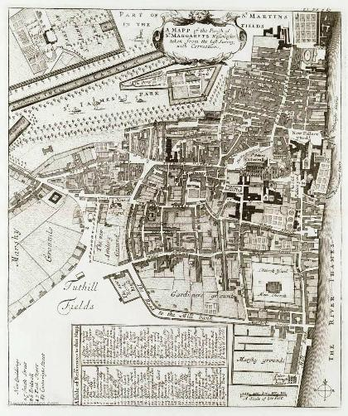

Figure 5.16: Map of St. Margaret Westminster parish, 1720.
Source: Strype, Survey of London (1720), bk. 6, ch. 3, p. 63: Motco Enterprises Limited
<www.motco.com/strype/images/figures> [accessed 15 January 2016].

The profile of the furniture trade also appears to be very different to that of the rest of the West End. This was probably not a popular commercial district for shopping, although there was one cabinetmaker, several joiners, a carver, and a frame maker.
There was also a timber merchant and a woodmonger, whose position on the outskirts of London near the Thames would have been convenient for receiving stock and distributing it to the trade.

The West End of London experienced dramatic changes throughout the seventeenth century, transforming from an essentially medieval western suburb of the City into a fashionable modern metropolis. By the early eighteenth century London had become one of the most important and rapidly expanding capitals in Europe, and many of the furniture tradesmen in the West End must have been at the top of their trade. This is

made apparent by the fact that nearly two-thirds (65 per cent) of identified Westminster furniture makers were either cabinetmakers or upholders, tradesmen who were mostly involved with providing luxury goods to the elite. The majority were situated in prime locations in the West End, along the Strand, in and around Covent Garden and St. Martin in the Field, and westward throughout newly fashionable Soho and St. James. They were presumably ambitious and competitive, with great business expertise.

Conclusion
Furniture tradesmen could be found throughout London in this period. Most were concentrated in a broad swathe from Aldgate and Houndsditch in the east, through Cornhill to St. Paul’s Churchyard and Ludgate Hill, extending north into Aldermanbury and Holborn, then west to Fleet Ditch, along Fleet Street and the Strand to Covent Garden, Long Acre and Soho, with outlying pockets in St. James’s and Westminster.

In the 1690s the majority of identified tradesmen in the northwestern extramural wards of the City appear to have been involved in manufacture, working as turners, joiners, upholsterers, chair frame makers and chair caners. They may have been situated there for several reasons: spacious properties to accommodate their manufacture, lower rents, and close proximity to tradesmen with allied occupations. The nucleus of the retail district was in St. Paul’s Churchyard, Aldermanbury, Ludgate Hill and their surrounds, and this is where the majority of cabinetmakers, chair makers and upholders could be found. Although there is limited evidence to document the trade’s whereabouts in the 1720s, the sources that survive indicate that the furniture trade remained in the same parts of the City. Based on the growth of Joiners’ Company membership, it is likely that the trade more than doubled in size during the first quarter of the eighteenth century (see Table 3.5).

We may assume that the geographical arrangement of the trade remained relatively the same throughout the period under examination, with tradesmen who worked outside of the City walls concentrating primarily on furniture manufacture while most of those within the walls made and sold their wares. It may be, however, that by the middle years of the eighteenth century increasing numbers of furniture tradesmen in outlying

areas were also selling their goods. John Ball was a chair maker in the Minories. His trade card from 1729 (Figure 5.17) demonstrates that he was making and selling ‘all Sorts of Cane Chairs Silk Chairs Leather Chairs Matted Chairs and Couches for Sea & Land at Reasonable Rates’. It looks as if he was a shrewd operator; evidently he took advantage of his near proximity to the river by selling furniture specifically designed for seamen. In 1731, one of John Ball’s neighbours in Aldgate was also making and selling his own products: the cabinetmaker and timber merchant Samuel Jakeman (mentioned in Chapter Two), manufactured mirrored glass and built frames and also had a ‘shop’ and an ‘auction room’.167

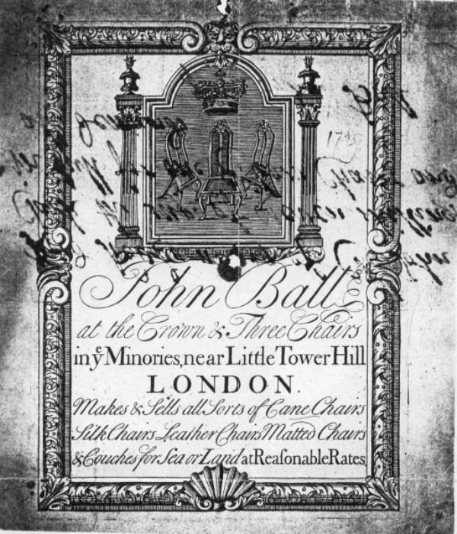

Figure 5.17: The trade card of John Ball at the ‘Crown & Three Chairs’, 1729 © Christie's Images Limited (2008).

West End furniture tradesmen were situated in clusters in and around the Strand, Covent Garden and westward through Soho and St. James, with a few on the western edge of the metropolis near to the Palace of Westminster. The majority were either cabinetmakers or upholders who provided a wide ranging service akin to modern day

167 LMA, CLA/002/02/01/3332, Court of Orphans inventory, Samuel Jakeman, dated 3 and 10 Aug. 1731.

interior designers. Shopping was a leisure activity and ‘being situated in an area to match the social aspirations of the envisaged clientele’ was no doubt paramount in the minds of furniture tradesmen when setting up in business in the newly developed and fashionable West End. 168

The clustering of tradesmen was a characteristic feature of the medieval and early modern urban landscape, but its continuance in a period of rapid change suggests that there were still significant benefits from the arrangements. The near proximity of colleagues made for a close-knit community, in which prominent furniture tradesmen were known to each other and could work together with a skilled and often mobile workforce. This would have resulted in the rapid transmission of ideas and techniques from one workshop to another and made for high-quality and fashionable products. A discussion of how these geographical patterns intersected with businesses, manufacturing and retailing networks is the subject of the next chapter together with case studies of three furniture makers.

168 Cox, Complete Tradesman, p. 70.

Chapter Six: Furniture businesses and manufacturing networks

This chapter examines how London furniture tradesmen organised their industry into manufacturing networks of specialised artisans and tradesmen. The aim is to explore the theory that groups of independent tradesmen with complementary skills worked collaboratively to produce and sell particular types of furniture. Through the case studies of three furniture makers this chapter examines how and why tradesmen became associated; how their labour forces were structured; and how they organised their manufacture and retail. The spatial logic of the trade was examined in the Chapter Five. This chapter questions whether geographical proximity was a decisive factor in the makeup of manufacturing networks and if these networks were comprised of
larger-than-expected numbers of Joiners’ Company members.

The chapter also looks at what actually went on in individual workshops; the role of family members and friends in business activities; and whether workers were usually employed directly by their master or were hired on a subcontractual basis. It considers how far furniture tradesmen diversified their business interests and if there is any evidence of the ways credit was maintained and capital invested. After a discussion of business and network formation and associated theories, the case studies of three furniture tradesmen are presented: looking-glass and cabinetmaker Edward Traherne; cane chair maker Thomas Warden; and cabinetmaker Lazarus Stiles.

The formation of businesses and networks
Early modern Britain could hardly be described as a ‘fluid’ and upwardly mobile society but an apprenticeship in London was a route taken by many in the hope of building a life and career in the metropolis. Chapter Three established that only 41 per cent of Joiners’ Company apprentices completed their apprenticeship (see Table 3.8). Documentary evidence of the careers of this select group exists for only a handful of individuals and this chapter discusses a few of them. Evidence compiled from Joiners’ apprenticeship bindings indicates that the quality and standard of arrangements was often based on the apprentice’s background as well as his social connections and ability to pay premiums, and that he probably received more than just the skills of the trade during the period of indenture. During his apprenticeship he would have been introduced to his master’s family, friends and business associates, specialised tradesmen and journeymen and, in some instances, clients. Over the seven years he

would undoubtedly have gained familiarity with the neighbourhood where he had trained and become associated with groups of furniture tradesmen living and working there. This was certainly the case with one apprentice associated with a group of cabinetmakers in Aldermanbury (introduced in Chapter Five). John Prankard was apprenticed to Daniel Bayly in 1686.1 Once a freeman he not only remained in the same street as his master; he set up his business next door. Lazarus Stiles was a business partner of both Bayly and Prankard; effectively, they were co-members of a manufacturing network working in the same neighbourhood.2

In addition to establishing a business in a familiar community, some tradesmen also aligned themselves through marriage. The cabinetmaker John Ody (mentioned in previous chapters), served his apprenticeship in Milk Yard off Fleet Street and set up in St. Paul’s Churchyard, becoming partner to William Old at ‘The Castle’ (see Figure 4.2). Ody went on to marry Old’s daughter Mary.3 Perhaps they met while he was an apprentice or journeyman in the neighbourhood. Another cabinetmaker in the churchyard who gained a business through marriage was John Coxed, but he did more than simply establish himself in the neighbourhood where he had trained and marry his way into a firm: he married his late master’s widow and they set up their business together at the ‘Swan’ in St. Paul’s Churchyard.4

Schwarz has argued that the principal ingredient in creating and running a successful business is the ability to establish ‘extensive capital in order to set up with much security’.5 Robert Campbell estimated these costs to range between £200 and £2,000 for a cabinetmaker (see Table 4.4).6 Once established, a line of credit was fundamental to sustaining business. As Earle has written, ‘nearly every branch of London industry required a greater capital to run it as time went on. This requirement reflected the widening, deepening and greater sophistication of the market’.7 Such credit was

1 GL, MS. 8052/2, f. 141, 16 July 1686, John Prankard apprenticed for seven years to Daniel Bayly; MS. 8051/2, f. 32, 3 Oct. 1693, free by servitude; Heal, Furniture Makers, p. 10, Daniel Bayly, cabinetmaker, Aldermanbury.
2 LMA, COL/CHD/LA/03/032/09 to COL/CHD/LA/03/033/008, 1692 poll tax.
3GL, MS. 8052/3, f. 97, 9 Jan. 1704/5, apprenticed to William Palmer for seven years; GL, MS. 8051/3,
f. 22, 1 Sept. 1713, free by servitude; LMA, COL/CHD/LA/06/025, returns of the names of several wards; Lindey, ‘William Old and John Ody at The Castle’, p. 3.
4 Bowett and Lindey, ‘Labelled furniture from the White Swan workshop’.
5 Schwartz, London in the Age of Industrialisation, p. 43.
6 Campbell, Tradesman, p. 332.
7 Earle, English Middle Class, p. 27.

realised through ‘legacies, dowry and loans being offset by portions and dowries for children and outgoings for the service and repayment of loans … Money from apprenticeship premiums … [and] Payment from customers’.8 Earle also found that ‘terms of credit varied enormously depending on the status, wealth and credit- worthiness of the debtor, [and] the custom and conventions of different types of businesses’.9 The case studies later in this chapter give examples of some of the ways that furniture tradesmen established and managed their lines of credit.

Networks comprised independent tradesmen working collaboratively to manufacture wares by utilising each individual’s specialisation in his own workshop. This may also have included joint retailing, the shared bulk purchase of materials (thus lowering costs), and joint capital investments. Phil Withington and Alexandra Shepard found that ‘network analysis … confirmed on a systematic basis that people were connected with many different groups both at any one time and over the course of their lives’.10
The characteristics of networks varied depending on the size of the organisation, the type of goods produced and the sort of clients served, but generally included a combination of elements ranging from the acquisition of materials to the sale of wares. The need to minimise expenses would have been universal to all businesses. Rents and labour costs were higher in London than elsewhere in England, though this was partially offset by London’s close proximity to the river, reducing the amount paid to acquire raw materials and the cost of transport. Although labour was more expensive in London, there was more available and a wider choice of specialists.11 William Hazlitt observed in the late eighteenth century that in London, ‘you are within two or three miles reach of persons that outside the capital would be some hundreds apart’.12 The greatest benefit was that manufacturing networks allowed for shared production between masters, journeymen and specialists without the need for a large workshop to accommodate them all. As Schwarz put it, ‘the assembly line ran through the street,

8 Earle, English Middle Class, pp. 112–13.
9 Earle, English Middle Class, p. 115.
10 A. Shepard and P. Withington, ‘Introduction: communities in early modern England’, in Shepard and Withington, Communities in Early Modern England (Manchester, 2000), pp. 1–17, at p. 5.
11 H. Clifford, Silver in London: the Parker and Wakelin Partnership 1760–76 (New Haven and London, 2004), p. 63.
12 Hazlitt (1773–1830), quoted in Clifford, Silver in London, pp. 63–5.

where the material, in its different stages of completion, was carried from one manufacturer to another’.13

Theories of manufacturing networks
There is a substantial collection of published and unpublished research that examines manufacturing practices in the proto-industrial period. These sources explore the various ways building manufacturers organised their labour force, production and capital investments. It includes discussion of the benefits and risks associated with the division of labour and subcontracting; the repercussions of technological change throughout the early modern period; and the advantages of networks of tradesmen working collectively and pooling their capital and investments to increase financial flexibility and security. The specific scholarship consulted in this chapter focuses on several London luxury trades which utilised a wide variety of materials and specialised skills: coach-making, silversmithing and goldsmithing. Many of the scholars who have contributed to the history of urban manufacturing organisations – and also to the history of material culture and socio-economic history – are discussed throughout this thesis, but of particular interest for this chapter are Helen Clifford and John Styles on London goldsmiths and silversmiths; Styles and David Mitchell on coach-making; and Craig Muldrew on the culture of credit and social relations in early modern England.14 Their theories are tested against the evidence for the business organisation and capital investments of two London cabinetmakers and a chair maker.

Work on London’s gold and silversmith industries has established theoretical and practical models which help to define the way small businesses operated as well as how they established credit and cash flow; sourced and purchased raw materials; forged relationships between specialisations; and enabled networks of tradesmen to build a cost-effective and efficient manufacture that satisfied consumers and fulfilled their expectations. David Mitchell’s edited collection of essays has been employed

13 Schwarz, London in the Age of Industrialisation, p. 33.
14 Berg, Age of Manufactures; M. Berg, P. Hudson and M. Sonenscher (eds.), Manufacture in Town and Country Before the Factory (Cambridge, 1983); H. Clifford, ‘The Kings Arms and Feathers: a case study exploring the networks of manufacture operating in the London goldsmiths’ trade in the eighteenth century’, in Mitchell, Goldsmiths, Silversmiths and Bankers, pp. 84–95; Clifford, Silver in London; J. Styles, ‘The goldsmiths and the London luxury trades, 1550 to 1750’, in Mitchell, Goldsmiths, Silversmiths and Bankers, pp. 112–20; D. Mitchell, ‘Coachbuilding case study’, unpublished paper, 2004; Muldrew, Economy of Obligation.

throughout this thesis.15 Mitchell demonstrates that subcontracting was an important way of organising production and shows that commissioning specific stages of manufacture was a way for tradesmen to respond to the rapid transformations in technique and design that occurred throughout the early modern period. Not only did it enable the execution of high quality contemporary styles and technical innovations, but it resulted in the production of up-to-date designed products, which kept apace of the consumer’s expectations for quantity, range, quality and cost.16 Giorgio Riello, who has studied London cordwainers, found that
Subcontracting could be seen as a way to respond to profound changes in the way commodities were produced, exchanged and consumed in an eighteenth-century metropolis like London. The expansion in size and complexity of the metropolitan market, the appearance of new commodities classified as semi-luxuries and fashion items, and the consequent re- assessment of traditional social structures and norms of production, made subcontracting a tool of organisational flexibility.17

Helen Clifford has written extensively on the London silver trade in the later eighteenth century, examining both the object and its manufacture. Her research has often focused on the partnership of Parker and Wakelin, whose archive is a prized source for any historian researching manufacturing networks because a surviving ledger details their makers and suppliers.18 Clifford, therefore, has intimate knowledge of the pair’s workforce and has concluded that ‘to maximise the extent of services offered by the business on a flexible basis, Parker and Wakelin operated not a workshop but a network of specialised subcontractors’.19 She found that close geographical proximity played a significant part in this: 44 per cent of their specialised workforce was situated within a quarter mile radius of their premises in Panton Street. We know there was a similar situation with furniture tradesmen being closely situated within the City of London.

Clifford determined that Parker’s and Wakelin’s subcontractors fell into two main categories: ‘dependents who seem to have relied on one firm for most, if not all, of their trade and independent suppliers who either had their own retail outlets and/or

15 Mitchell, Goldsmiths, Silversmiths and Bankers.
16 Mitchell, ‘Innovation and the transfer of skill’, in Goldsmiths, Silversmiths and Bankers, pp. 5–22, at. pp. 15–19.
17 G. Riello, ‘Strategies and boundaries: subcontracting and the London trades in the long eighteenth century’, Enterprise and Society, 9 (2008), 243–80, at p. 243.
18 Clifford, Silver in London, pp. 208–9.
19 Clifford, ‘The King’s Arms and Feathers’, p. 86.

supplied other businesses’.20 She suggested that this practice was long established, citing Daniel Defoe in The Complete English Tradesman: ‘Those who make goods they sell, though they do keep shops to sell them, are not called tradesmen, but handicrafts, such as smiths, shoemakers, founders, joiners, carpenters, carvers, turners, and the like; others, who only make, or cause to be made, goods for other people to sell, are called manufacturers and artists, &c.’21
In addition to a subcontracted workforce, Parker and Wakelin also had a combination of apprentices, journeymen and unskilled workers, comprising a ‘flexible workforce of between eight to thirteen men at any one time’.22 Some journeymen were paid ‘a regular wage over relatively short periods of time’, while others with no apparent training carried out unskilled work and received a small annual salary.23 Presumably this method of management was cost-effective and protected the firm from having to pay waged employees like journeymen during a period of low demand. Was this a universal method of management and did furniture tradesmen operate in a similar fashion?

The assembly of a coach demonstrates the array of specialists that were employed for this particular product. John Styles has explained that the process ‘involved the assembly of a finished vehicle from a great diversity of component parts’, and that while ‘Final assembly may have taken place within the master coach maker’s workshop … the parts themselves were often made and assembled to order by independent businesses in other parts of the metropolitan area’.24 Campbell described the intricacy of the coach maker’s job:
To make the Body of the Coach, and all the Carriage except the Wheels; his Trade is compounded of the Carpenter, Taylor and Shoe-Maker; he finishes his work by the assistance of the Founder, Tiresmith, Wheeler, Carver and Painter: He is a Carpenter as he frames the Body and Carriage of Wood; a Taylor as he lines the Inside with Cloth; Silk, Velvet and other Materials, to which he is obliged to use his Needle, and he is a Shoe-Maker, as he covers the Top and sides with Leather, in which he is sometimes obliged to use his Awl. This is a Coach-Maker’s proper Business; as to the rest of the Work, it is finished by Tradesmen who know nothing of his Art, and apply themselves only to particular articles.25

20 Clifford, ‘The King’s Arms and Feathers’, p. 91.
21 Defoe, Complete English Tradesman, author’s preface.
22 Clifford, ‘The King’s Arms and Feathers’, p. 93.
23 Clifford, ‘The King’s Arms and Feathers’, p. 93.
24 Styles, ‘Goldsmiths and the London luxury trades’, pp. 113–14.
25 Campbell, Tradesman, pp. 229–30.

David Mitchell has examined the number of craftsmen involved in coach-making through evidence in the Chancery master exhibits. He noted that ‘a coach consisted of hundreds of components, many of which were made or supplied by specialists’, and discovered the ‘complexity of the network of suppliers, subcontractors and directly employed men which was controlled by the coach maker’.26 One firm used more than seventy suppliers and subcontractors. Christopher Hall’s shop had three or four coach maker’s benches and he employed ten or twelve men throughout 1760 for the coach bodies and carriages (generally made by directly employed labour), while also subcontracting repairs to another coach maker.27

Mitchell described the organisation of a coach makers’ workshop:
Typically, coach bodies were made in a … loft on the first or second floor, and the harness made in a harness maker’s loft, also above stairs. Carriages were assembled in a ground floor shop where wheels, supplied by the subcontract wheeler, were mounted. Cranes and cradles were used to assemble the complete vehicle. If the coachmaker had a paint shop it was a separate part of the yard or at the top of the building as it had to be dust proof … However [three firms] seem to have subcontracted the finishing trades of painting, japanning and engraving.28

Considering the historiography of urban manufacturing practices, how similar was furniture manufacturing in London to the craft-based trades of coach-making and silversmithing? All shared a linear process from the acquisition of raw materials to the sale of products and many of their wares required a specialised workforce for certain stages of production. However, there were two fundamental differences between woodworking and silversmithing trades: the cost of materials and the level of monitoring and control. Coaches and pieces of furniture were sometimes made with precious or rare specimens of wood and other costly materials, like moving mechanisms, gilt mounts and locks and expensive textiles, but in silversmithing the entire object was constructed with precious metal and its weight and quality was scrupulously monitored by the assay office, which was associated with the Goldsmiths’ Company. As Glanville wrote, ‘Silver has one special and ancient attribute. Like gold, its unique and intimate relationship with currency necessitated the oldest form of consumer protection, guaranteeing the consistency of the alloy, the

26 Mitchell, ‘Coachbuilding’, p. 10.
27 Mitchell, ‘Coachbuilding’, p. 10.
28 Mitchell, ‘Coachbuilding’, pp. 11–12.

mixture of pure silver and base metals in various proportions’.29 The guarantee to the consumer of ‘sterling standard’ was assured by the hallmark indicating that silver objects had been ‘found pure, reliable and true … assayed and tested by cupellation’.30 This aside, all competitive manufacturers were faced with the task of satisfying consumer demand and offering an efficient and reliable service, while producing objects that were both fashionable and of a high standard.

Primary and secondary sources
The documentary evidence in this chapter is mostly based on inventories recorded for the City of London’s Court of Orphans following the death of a city freeman with under-age children. Like the two 1690s tax assessments and the 1721 inhabitants’ list, these provide a ‘snapshot’ of the personal and business lives of London furniture makers. Cross-referencing these documents with parish records, wills, tax assessments, livery company accounts and published sources, makes it possible to examine comprehensively the way furniture makers operated their businesses. However, there are inherent limitations associated with using inventories as historical evidence. In theory they provide a fleeting glimpse into a tradesman’s life but this view was easily distorted: valuations on property were subjective and the state of affairs easily compromised in the time that elapsed between the subject’s death and the recording of the inventory.31 There was of course the risk of assets, such as stock-in trade and domestic property, being removed from the deceased freeman’s residence and capital investments dispersed before the estate was assessed. The Court of Orphans stipulated that an inventory of the deceased’s personal estate should be produced within three months, ‘but in practice executors rarely met these deadlines’.32 Fortunately, the inventories of two of the tradesmen examined here were produced relatively promptly: one was recorded four days after the will was proved and the other in three and a half months, only slightly longer than the stipulated time limit.33 Notwithstanding events that may have occurred after the tradesman’s death to alter the picture, these

29 P. Glanville (ed.), Silver (London, 1996), pp. 7–11, at pp. 7–8.
30 Glanville, Silver, p. 8.
31 M. Overton, ‘Prices from probate inventories’, in T. Arkell, N. Evans and N. Goose (eds.), When Death Do Us Part: Understanding and Interpreting the Probate Records of Early Modern England (Oxford, 2000), pp. 124–5.
32 C. Carlton, The Court of Orphans (Leicester, 1974), p. 43.
33 Thomas Warden, will proved 15 Nov. 1701 (TNA, PROB 11/462) and Court of Orphans inventory dated March 1701/2 (LMA, CLA/002/02/01/2439); Lazarus Stiles, will proved 18 Aug. 1724 (TNA, PROB 11/599) and Court of Orphans inventory dated 23 Aug. 1724 (LMA, CLA/002/02/01/3197).

inventories provide a significant amount of information enabling the reconstruction of networks of tradesmen. They often include the names and occupations of people with whom the deceased did business, as well as details about the organisation of the labour force, in both manufacture and retail, how tradesmen diversified their business activities and how they maintained credit and invested capital.

The Court of Orphans handled cases relating to the care of minor children of the deceased freemen of the City of London.34 It was presided over by the ‘Common Serjeant’ who, in effect, had custody of the under-age orphans of freemen, and supervised the administration of their estate. At a freeman’s death one-third of his movable property went to his widow, another third was equally divided between his children, and the final portion could be disposed of in his will.35 The Court of Orphans commissioned an inventory and valuation of all the personal property of a deceased freeman who left minor children. These inventories include a detailed description of the contents of the freeman’s house, room by room, as well as recording plate, jewellery, leases on property, ready money, stock in trade, debts owing to and owed by the freeman, and his funeral expenses.36 Those who served as assessors of the trade- related sections of the inventory are of particular interest because, as the following case studies demonstrate, they were often leading authorities in their particular field.
The evidence suggests that they may have been associated with the late tradesman’s network and that this was one of the reasons they were employed to assess the stock. The same is observed in wills, where the executors and witnesses were fellow tradesmen and may also have had both personal and business relationships with the deceased.
Peter Earle’s work, in particular his use of Court of Orphans inventories in The Making of the English Middle Class, serves as a backbone to this discussion and his analysis is interwoven throughout. The sources Earle selected for his study and the topics of his research queries are in many ways similar to those employed here. In addition to livery company apprentice bindings and freedom registers, which he used to gather information on the socio-economic and geographical origins of freemen, Earle

34 Under the custom of London, the minor children of deceased freemen were considered orphans whether or not their mother was alive.
35 J. Cox and N. Cox, ‘Probate 1500–1800: a system in transition’, in Arkell, Evans and Goose, When Death Do Us Part, p. 20.
36 Carlton, Court of Orphans, pp. 42–4.

established a study group of Court of Orphans inventories by selecting 375 inventories for which Boyd’s Index of London Citizens had a date of birth or baptism. The cross- referencing of these documents provided him with information on the genealogical and material conditions of deceased citizens, thereby enabling him to analyse ‘such things as fortune at death, investment and household structure of freemen who died between 1665 and 1720’.37 He grouped the freemen into eight categories: merchants, textile wholesalers, rentiers/moneylenders, manufacturers, tavern-keepers, apothecaries, textile retailers and artisans. The highest average gross asset in his study group were the merchants (£17,667) of which forty-two were sampled; twenty-nine manufacturers were sampled and their average gross asset was £3,773; and those with the lowest gross asset were artisans (£620) of which thirty-eight were sampled.38

The average gross assets of the manufacturers and artisans in Earle’s study sample, when compared with the furniture tradesmen in the following three case studies, show the cabinetmaker Edward Traherne’s wealth to have been slightly higher than the average, whereas the chair maker Thomas Warden’s and the cabinetmaker Lazarus Stiles’s gross assets fall well below the others in their occupational group. Perhaps the criteria Earle applied when creating his study group (only using inventories which could be cross-referenced to Boyd’s Index of birth and death records) acted to eliminate the inventories of some tradesmen in his categories with modest levels of wealth, thereby inflating the average levels for each occupational category. Edward Traherne is included in Earle’s sample,39 and may be representative of the types of tradesmen he surveyed, while Thomas Warden and Lazarus Stiles are omitted (Stiles 1724 inventory is outside of Earle’s date parameters).

Case Studies
This section presents three case studies. These empirical inquiries provide intimate details of the lives and business operations of three tradesmen at specific points between 1675 and 1724. The intention is to determine how London furniture makers became established in business; how they organised their personal and business lives; and how they diversified their business activities and invested their capital wealth. The theoretical knowledge that emerges from this examination can be used to show how

37 Earle, English Middle Class, p. 394.
38 Earle, English Middle Class, p. 121, Table 4.6, ‘Analysis of Assets’.
39 Earle, English Middle Class, p. 397, Appendix A, The Sample, no. 86.

furniture-making businesses and associated manufacturing networks operated in practice. The first two case studies examine tradesmen who died in their thirties in the middle of their careers. Their inventories, therefore, portray businesses at peak activity. The third focuses on a tradesman at the end of a long working life whose inventory depicts a career spanning over four decades which was being slowly wound down.

A network of furniture makers was comprised of a group of artisans and tradesmen working co-operatively in a particular branch of the furniture industry. Many of the furniture tradesmen and artisans identified for the following three case studies were found in Court of Orphans inventories, which list the names (and sometimes) the relationships and/or occupations of the people who were associated with the deceased citizen. The names of the individuals in these lists of debts and credits are the people who the deceased freeman was associated with at the time of his death: journeymen, specialised furniture makers, family members, clients and miscellaneous tradesmen, who provided auxiliary services and products to the freeman’s family and business.40 Additional names of tradesmen and their occupations, addresses and their relationships with the subject of each case study, along with information regarding assets held in the estate, were obtained from PCC wills. By cross-referencing this information with livery company accounts, parish and tax records, and published sources, it becomes possible to identify these people and their relationships.

Edward Traherne (1637–75), looking-glass manufacturer and cabinetmaker Edward Traherne was a cabinetmaker in Bedford Street at the south end of Covent Garden from 1667 until his death in 1675.41 In the early eighteenth century the fifth Earl of Bedford boasted that Covent Garden was ‘fit for the habitations of gentlemen and men of ability’, and indeed courtiers, nobility and the emerging middle classes all lived, shopped and socialised in the gracious houses and streets that surrounded the Piazza.42 At the time of his death, Traherne, his wife and five children lived with one apprentice,43 and probably several journeymen,44 in a large house consisting of

40 See Appendix 3a, 3b and 3c for full transcriptions of Traherne’s, Warden’s, and Stiles Court of Orphans inventories.
41 Westminster Archives, Poor rate ledger, F1112, f. 32, Apr. 1667.
42 Porter, London, p. 88.
43 GL, MS. 8052/1, f. 28, 4 May 1675, ‘Charles Mason the son of George Mason, gentleman, from Kilpeck in the county of Hereford apprenticed to Edward Traherne Citizen and Joyner of London for 7 years’; MS. 8051/2, f. 28, 4 May 1675, ‘Charles Mason turned over to Daniel Howell, Citizen and Haberdasher of London to learne the art of a Joyner’.

fourteen rooms. Four of these were used for business purposes: two workshops and two cellars. His inventory shows his gross assets to have been £3,873, slightly higher than Earle’s sample of manufacturers (£3,773). His net worth, after the deductions of debts and obligations was £1,779 9s 8d.45

Family and personal connections appear to have been a major factor in Traherne’s success. Born into a life of privilege in 1637, he was the sixth child of the gentleman Thomas Traherne of Lugwardine in Herefordshire.46 Earle has noted that ‘family relationships (like uncles and god-parents), and the mediation of friends such as business or social associates of one’s father … were an obvious link between master and apprentice’.47 It would not have been by chance that, in June 1654, seventeen-year old Edward was apprenticed to one of London’s foremost looking-glass and cabinetmakers, John Burrowes, at ‘Ye Looking Glass’ Cornhill.48 Burrowes became cabinetmaker to Charles II and, as well as having royal patronage, he served members of the nobility and City officials. He seems to have been very selective when choosing apprentices, binding only five young men (including Traherne) through the Joiners’ Company over eighteen years (1645–63).49 Another of his apprentices was the son of a yeoman from Surrey, Philip Hunt (introduced in Chapter Five). Hunt also became a looking-glass and cabinetmaker with a business situated in St. Paul’s Churchyard (see Figure 5.4).50

Considering his background, Traherne may have been au fait with the social circles which provided his master’s exclusive clientele, and this could have been one of the reasons that Burrowes approved the indenture. Apprenticeship bindings from the Joiners’ Company indicate that on average 6 per cent of their intake were sons of the gentry and 17 per cent of the yeomanry (see Table 4.6). These findings align with those of other historians: Christopher Brooks has concluded that ‘the financial position of a father had a direct influence on the point at which his son would be able to enter

44 His inventory indicates that he employed nine journeymen in 1675.
45 LMA, CLA/002/02/01/1177, Court of Orphans inventory, Edward Traherne, 26 Nov. 1675. Unless otherwise stated details of Traherne’s business come from the inventory.
46 Lindey, ‘A Restoration London cabinet and looking glass maker’, p. 17; see also, Lindey, ‘Edward Traherne’.
47 Earle, English Middle Class, pp. 90–3.
48 A. Heal, Sign Boards of Old London Shops (London, 1957), p. 42.
49 GL, MS. 8052/1, f. 11, f. 11, f. 44, f. 96, f. 103.
50 GL, MS. 8052/1, f. 96, 2 Aug. 1662; Beard and Gilbert DEFM, p. 464.

the urban hierarchy’,51 and Earle’s analysis of Court of Orphans inventories found that ‘those likely to end up in independent business were the sons of yeomen or gentlemen’.52 A quarter of Earle’s study group were the sons of gentlemen and they trained for a variety of prestigious occupations which, alongside looking-glass and cabinetmaking, included silkmen, merchants, bankers and jewellers and ‘tended to be concentrated in such potentially profitable occupations as overseas trade, linen-draping and finance’.53 As Chapter Four showed, two of Traherne’s brothers illustrate Earle’s point as they also trained in elite trades: Philip was a London Goldsmith and managed a retail business in the Strand, and John became a master in the Haberdashers’ Company and ran a business in Drury Lane in the 1690s.54

Edward Traherne’s training seems to have equipped him with the necessary skills and connections to navigate his way to the top of the trade. By 1667 (six years after completing his apprenticeship), he had established a business similar to his master’s and may have been serving many of the same clients. He had become a freeman in June 1661,55 and in theory would have been restricted from setting up in business for a further two years (the mandated period for working as a journeyman).56 He indentured his first apprentice in 1664 and by the spring of 1667, when he settled in his home in Covent Garden, he had acquired two more, suggesting that he already had established a client base.57

Traherne ran his cabinetmaking business from his house in Bedford Street where he sold a substantial collection of luxury furniture from his ‘Greate Warehouse’: cabinets on stands, chests of drawers, tables with matching stands and mirrors, secretaires and a variety of boxes. This was an elaborate display in contemporary styles and designs, made of wood veneers such as ebony, walnut and princes wood, and decorated with

51 Barry and Brooks, The Middling Sort of People, p. 70.
52 Earle, English Middle Class, p. 86.
53 Earle, English Middle Class, pp. 86–7.
54Goldsmiths’ Hall, Goldsmiths’ apprentice binding book 2, f. 44; LMA, CLA/002/01/002/1526, Court of Orphans inventory, dated 1679, Philip Traherne. His estate was valued at £992 2s 4d; John Traherne, Haberdasher 1668 – a master; COL/CHD/LA/03/042 and COL/CHD/LA/03/0, ‘The four shillings in the pound aid 1693/4.
55 GL, MS. 8051/1, f. 31, June 1661.
56 GL, MS. 8046/1, 3 July 1688, ‘An apprentice to serve two years as journeyman’.
57 Westminster Archives, Poor rate ledger, F1112, f. 32, Apr. 1667, Edward ‘Trahearne’, Bedford Street, 12s; GL, MS. 8052/1, f. 113, John Tomas apprenticed for eight years, 29 Sept. 1664; GL, MS. 8052/1, f. 116, Nicholas Rogers apprenticed for seven years, 23 May 1665; GL, MS. 8052/1, f. 129, Richard Greenwood apprenticed for seven years, 13 March 1667.

floral marquetry and/or japanned, with many embellished in silver and gilt bronze mounts.58 The question is how much of this stock was manufactured by him and how much had been subcontracted out to specialised tradesmen.

Traherne’s inventory indicates that he mirrored glass and constructed frames in two workshops and a ‘Fileing Room’ at his home. A foiling room was the place where glass was mirrored and his contained an enormous volume of plate glass cut into assorted sizes and shapes,59 plus ‘quicksilver’ (mercury), foil and lead, materials used in the mirroring process,60 along with dozens of empty frames which were decorated in silver, or ‘olivewood’ marquetry.61 He stored hundreds of finished framed mirrors in his ‘Chamber next the ‘Fileing Roome’,62 and more frames were stored in one of his two garrets.63 The frames were probably built in one of his workshops because it contained ‘tooles benches and wood’.

In addition to the work spaces, raw materials and completed stock in trade, Traherne also had the labour force for this manufacture: in 1675 he employed nine journeymen, a glass grinder, a frame maker, two carvers and gilders, and he had one apprentice. The inventory indicates that after his death his journeymen were paid different amounts, though the terms for these enumerations are vague: ‘Mr Gumwright’ was paid £2 while someone else simply called ‘a journeyman’ received £3 15s 6d. The amount of time calculated into the remuneration is unknown, but according to Campbell’s assessment of the cabinetmaking trade, ‘a journeyman who knows his Business may have a Guinea a Week’.64 Those with outstanding skills earned more: the carver Thomas Johnson wrote in his diary in Easter 1745 that ‘a journeyman in the best shop in London … Had twenty six shillings per week’.65 Campbell described the process of manufacturing looking-glasses:
Plate glass [is bought] from the Glass-House rough, and it is the Glass- Grinder’s Business to grind them even then polish them, which is done by Sand and Water … After the Glass has been ground to a true Plain, it is

58 His stock of case furniture was valued at £458 7s 2d.
59 Plates of glass valued at £165 10s 6d.
60 ‘The actual silvering [mirroring] of sheet glass was known as foiling, foiliating, and occasionally, as filing’ (G. Wills, English Looking-glasses: a Study of the Glass, Frames and Makers 1670–1820 (London, 1965), p. 63).
61 Frames in the ‘Fileing Room’ were valued at £178 14s.
62 Frames stored in the ‘Chamber next the Fileing Room’ were valued at £91 10s.
63 Frames in the garret were valued at £29 1s.
64 Campbell, Tradesman, p. 171.
65 J. Simon, ‘Thomas Johnson’s “The Life of the Author”’, JFHS, 39 (2003), 1–64, at p. 42.

then polished ... The next Operation to form the Looking-Glass is, to silver it; which is done with Plates of Lead and Quicksilver … We have prepared the Looking-Glass, we must send for the Frame-Maker, Carver and Gilder, before it is fit for use.66

Although mirrors and frames were manufactured in Traherne’s house, he had few materials that could have been used to produce luxury cabinet ware, and for this reason it is highly likely that he subcontracted its manufacture to other tradesmen.67 However, there was an item in his workshops that may have been destined for a cabinet: ‘2 marble flowers’. Perhaps these marble flowers were a pair of pietre dure plaques. The Victoria and Albert Museum owns a cabinet on stand known as ‘The John Evelyn Cabinet’ veneered with ebony and inlaid with pietre dure panels.68 Evelyn travelled extensively through France and Italy and in 1644 bought pietre dure plaques in Florence.69 He recorded this in his diary:
27 October … Here were divers tables of Pietra Commesso, which is a marble ground inlaid with several sorts of marbles and stones of various colors representing flowers, trees, beasts, birds, and landscapes. In one is represented the town of Leghorn, by the same hand who inlaid the altar of St. Laurence, Domenico Benotti, of whom I purchased nineteen pieces of the same work for a cabinet.70

Evelyn’s cabinet was probably made in Florence or Paris but some wealthy patrons apparently commissioned English cabinetmakers to do the same. Perhaps one of Traherne’s clients had returned from the Grand Tour with the marble flowers and instructed him to design a piece of furniture to incorporate them. Traherne may then have commissioned a London cabinetmaker to execute the job. Although it cannot be assumed that it was commonplace for clients to provide their cabinetmakers with precious materials of this calibre, some clearly did. An English-made cabinet survives that incorporates such plaques. It is veneered in rose and prince’s wood and inlaid with pietre dure plaques (Figure 6.1).

66 Campbell, Tradesman, p. 173.
67 This would include cabinetmakers, marqueteurs, japanners, turners, carvers, gilders, timber merchants, woodmongers, sawyers, brass founders and ironmongers.
68 Victoria and Albert Museum, Museum number W–24: 1 to 23 – 1977; Gallery location, British Galleries, Room 56e, case 5.
69 J. Styles, ‘Introduction: Tudor and Stuart Britain, 1500–1714’, in Snodin and Styles, Design and the Decorative Arts, pp. 3–33, at p. 15.
70 Bédoyère, G. (ed.), Diary of John Evelyn (London, 1997), p. 49.

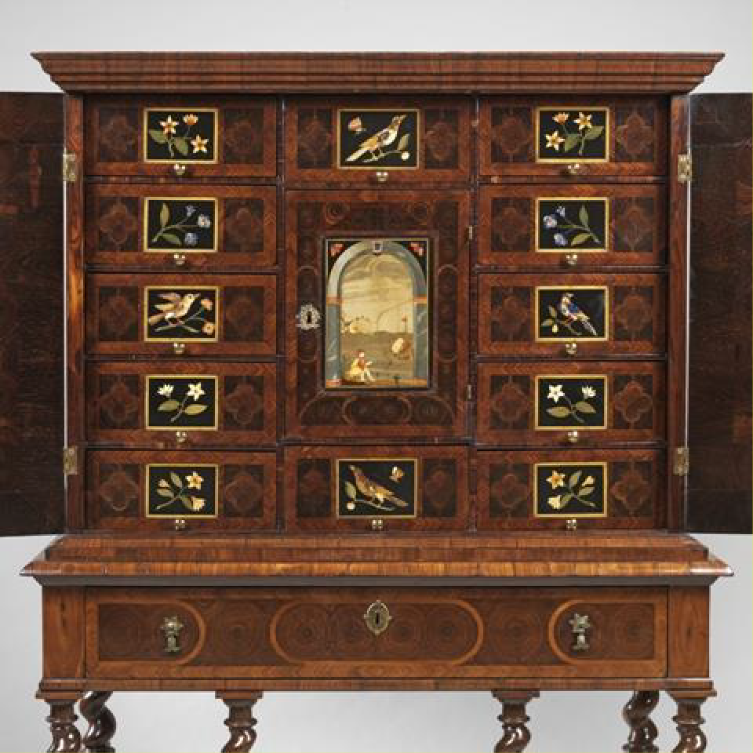

Figure 6.1: A rosewood and princeswood cabinet with pietre dure plaques, c.1680 (Frank Partridge, London).

Traherne had employees for mirror and frame making but subcontracted other work with independent manufacturers. Case furniture was most often manufactured by cabinetmakers and Traherne’s inventory indicates that he was associated with five. Two of these men were identified in the inventory by name and occupation, while the others were simply named in the inventory and their occupations have been determined by cross-referencing them to Joiners’ Company accounts, a PCC will and the Dictionary of English Furniture Makers.71 Of the debts settled by the estate ‘Mr.
Wiseham Cabbinett maker’ was paid £58; the cabinetmaker and marqueteur Jasper Bream was paid £13; and cabinetmakers Valentine Cozens and Samuell Axell were paid £20 and £6 respectively. ‘Mr Naylor Cabbinett maker’ was owed £2 as listed in the debts owing to the estate.’ It is possible that Bream may have been responsible for

71 Jasper Bream: GL, MS. 8052/2, f. 97, 5 Sept. 1682; TNA, PROB 11/430, 27 Feb. 1696/7, Beard and Gilbert, DEFM, p. 104; Samuel Axell: GL, MS. 8052/2, f. 138, 6 Nov. 1668; Valentine Cozens: GL, MS. 8052/2, f. 106, 22 May 1683.

the marquetry described in the inventory, but what any of these payments actually
represented remains guesswork.72

Traherne’s membership of the Joiners’ Company contributed to the makeup of this network: of the twenty-three tradesmen he worked with ten (43 per cent) were also members of the Company. The importance of geographical proximity is more difficult to address because there are no sources available to document the whereabouts of the majority of tradesmen included in the 1675 inventory. Two at least were close by in the Savoy: the marqueteur Jasper Bream and the glass merchant, George Ravenscroft, who had built a Glass House there in 1673.73 Furthermore, as seen in Chapter Five, the West End and Covent Garden and its surrounds, including St. Martin’s Lane, Long Acre and the Strand, were populated with furniture tradesmen. In the period 1660 to 1720 there were fifty cabinetmakers, fifty-three upholders, ten carvers and gilders, along with several turners, frame makers and sawyers, many of whom could have been useful for Traherne’s business (see Table 5.13).

Traherne sold his furniture to some of the most influential and well-known inhabitants of Restoration London: the queen, Catherine of Braganza, and the princesses Ladies Mary and Anne of York; royal mistresses Nell Gwynne and Barbara Palmer, 1st Duchess of Cleveland; Charles Lennox, third Duke of Richmond, one of Charles II’s illegitimate sons; and two members of the king’s cabal, George Villiers, second Duke of Buckingham and Henry Bennet, first Earl of Arlington.74 Covent Garden was an expensive address and Traherne was situated beside the Piazza where rents were highest.75 It was, however, probably worth the expense because the area was a showplace for luxury goods.76 Promenading and window shopping were pastimes for the middle and upper classes, and as they browsed the window of Traherne’s ‘Greate Warehouse’ they were no doubt seduced by its splendour into coming inside. It was also conveniently located for his clients who ordered bespoke furniture, being

72 For Jasper Bream see Chapter Five. He was situated in the parish of St. Mary Savoy.
73 R. J. Charleston, English Glass and the Glass Used in England, circa 400–1940 (London, 1984), pp. 109–10. Ravenscroft was a Catholic, born 1618 in Hawarden, Flintshire and died 1681. He acted as a London merchant importing Venetian glass (both glass vessels and plates).
74 Other clients listed in the inventory include courtiers and members of the aristocracy: Isabella Bennet, 1st Countess of Arlington; Thomas Lennard, 1st Earl of Sussex; Robert Bertie, 3rd Earl of Lindsey; Charles Paulet, 2nd Duke of Bolton; Anthony Grey, 11th Earl of Kent and the Countess of Kent; and Sir Charles Stanley.
75 Spence, Atlas, p. 70.
76 Levy Peck, Consuming Splendor, pp. 46–7.

equidistant between Somerset House, where the queen sometimes lived, and Whitehall Palace where Nell Gwynne, Barbara Palmer and several courtiers had rooms.77

It might be said that Traherne’s business reflected his very specialised field, looking- glass manufacture, and it is difficult to find documented cases of London cabinetmakers and upholders of a similar standing in order to make comparisons. One notable exception is the extraordinary Gerrit Jensen, a cabinetmaker who was situated in St. Martin’s Lane between 1667 and 1716.78 Jensen acted as an appraiser on Traherne’s inventory and this was probably because he was involved in a similar type of business. We do not know how he organised his business, what proportion of his stock was his own manufacture or who his subcontracted suppliers might have been, but the clients he served and the types of furniture he dealt in were similar to those of Traherne. As mentioned, the appraisers of Court of Orphans inventories often shared the deceased’s specialisation.79 Furthermore, both men were members of the Joiners’ Company and lived in the same neighbourhood. Gerrit Jensen’s origins have yet to be identified but it is most likely that he was from the Low Countries. He became free by redemption on the orders of the Lord Mayor and Court of Aldermen in 1667,80 a method of entry which has been described as ‘a vital way of incorporating new blood into the City ... [and which added] Entrepreneurial skills to the economy’, particularly in the aftermath of the Fire the previous year.81

Jensen was appointed ‘Cabinetmaker in ordinary’ to William and Mary in 1689.82 The description of his business, as given in the patent of appointment, highlights the similarity to Traherne’s, especially in its emphasis on glass: ‘Cabbinet maker and Glasse seller … for making providing and Selling of all Sorts of Cabbinets Boxes Looking Glasses Tables and Stands Ebony Frames and for the furnishing providing

77 Catherine of Braganza withdrew to Somerset House after Charles II installed his mistress, Barbara Palmer, at Whitehall Palace (Porter, London, p. 51). See S. Thurley, The Whitehall Palace Plan of 1670 (London, 1998), for Princesses Mary and Anne (pp. 41–2), Nell Gwynne (p. 18), Barbara Palmer, Duchess of Cleveland (p. 31), Elizabeth Monck, Duchess of Albemarle (pp. 33–4), Henry Bennet, 1st Earl of Arlington and Isabella Bennet, 1st Countess of Arlington (p. 32), and Charles Lennox, 3rd Duke of Richmond (pp. 51–2).
78 Beard and Gilbert, DEFM, pp. 485–7; TNA, PROB 11/550/313, 17 Feb. 1716/17.
79 See the following inventories: LMA, CLA/002/02/01/2439, Court of Orphans inventory, Thomas Warden, 5 March 1701/2; CLA/002/02/01/3197, Court of Orphans inventory, Lazarus Stiles, 23 Aug. 1724; CLA/002/02/01/3332, Court of Orphans inventory, Samuel Jakeman, 3 and 10 Aug. 1731.
80 GL, MS. 8051/1, f. 56, 22 Oct. 1667.
81 V. Aldous, My Ancestors were Freemen of the City of London (London, 1999), p. 65.
82 Beard and Gilbert, DEFM, p. 485–7. All of the following information about Jensen is taken from this source.

and Selling of all Sorts of Glasse plates as well plained and polished as not plained and pollished’.83 The Lord Chamberlain’s accounts describe his activities at Hampton Court, Richmond, Whitehall, Windsor and Kensington Palace and indicate that he provided an extensive range of services over and above the supply of bespoke pieces of furniture.84 He was responsible for the delivery, installation and maintenance of furniture and also for moving objects from one household to the other. For example, he arranged ‘for Porteridge Boat hire and a Servant going with ye Kings Cabinet to Hampton Court’,85 and for ‘porteridge & cart hire w.th the goods & those from Whitehall’ being moved to Kensington.86 His maintenance service was extensive, often in situ, and included cleaning, scraping and polishing, repairing and re-gilding objects. The accounts show payments ‘for mending and Varnishing Severall Tables Stands Frames and other things’, ‘for sending a Servant to pollish and whiten a Bewro inlaid with metall’, and ‘for taking down ye Silver Looking glass taking it out of ye frame putting it in againe and hanging it up’.87 Sometimes he accompanied his servants (‘for my selfe waiting’), or did the maintenance work himself (‘for mending the Jewell case my self’ and ‘for my Self and 4 Serv.ts at Severall times to fix up the Glasses’).88 It may be that these were standard services provided to the royal household. While we do not know whether Traherne was also involved with installation and maintenance activities it was apparently a service which could be provided to certain clients.

In addition to royalty, Jensen provided services to the aristocracy at Ham House, Chatsworth, Drayton House, Arundel Castle, Petworth House, Knole and Hatfield House, among others. His supply was varied, as seen for example at Chatsworth where he was paid for ‘glass for the door of the great chamber and for japanning the closet’ in
1692.89 He also supplied luxury furniture which included amongst other types, metal marquetry in an arabesque design, floral marquetry and silvered furniture. Much of this

83 R. W. Symonds, ‘Gerrit Jensen, cabinet-maker to the royal household’, Connoisseur, 95 (1935), 268– 74, at pp. 268–9.
84 TNA, LC 9/279, 1689–90; LC 9/281, 1690–6; LC 9/281, 1699–1703.
85 TNA, LC 9/281, f. 23b
86 TNA, LC 9/2801, f. 214b.
87 TNA, LC 9/ 281, f. 23a–b.
88 TNA, LC 9/280, ff. 214a, 335b; LC 9/281, f. 79b.
89 Beard and Gilbert, DEFM, p. 486.

survives in British country houses, along with his bills.90 Jensen died in the parish of St. Martin in the Fields in 1716.91

Edward Traherne diversified his business interests and this activity was linked with his capital investment; he was a building contractor involved in rebuilding domestic premises after the Fire and was also a landlord. He was not alone in this endeavour: Peter Earle examined the distribution of investment assets recorded in the Court of Orphans inventories of London tradesmen and concluded that 22 per cent invested their capital into leases on property.92 Earle described the ‘property boom’ after the Fire citing several tradesmen who were ‘big developers’, including a ‘cabinetmaker who built ten houses in the area of the Strand and Fleet Street’.93 He was no doubt referring to Edward Traherne, whose inventory lists the following leases:
Item: The lease of a peece of ground lying on Shooe Lane and parte in Fleete Street on which is built 5 houses for about 54 yeares to come where upon is reserved the yearly rent of £42: Valued at £620
Item The lease of a peece of Ground lying in Shooe Lane on which is built one house for about 93 yeares to Come att Lady day 1st past whose upon is reserved the yearly rent of £40: Valued at £216
Item: the lease of a peece of Ground lying in Fleet Street on which is built one house for about 44 yeares to come where upon is reserved the yearly rent of £12: Valued at £484
Item: a peece of ground in Ludgate Hill held by severall Leases one which is built 2 houses for about forty yeares to come att Lady day last past where upon is reserved the yearly rent of £30: Valued at £484
Item: a House and a peece of ground lying in the Strand in the County of Middlesex Parish of St. Martin in the fields held by severall leases for about 44 yeares to come from Michelmas last past of part of which ground is built a new house Where upon is reserved the yearly rent of £75 10s: Valued at
£450
Total value: £2254

The surveyors Peter Mills and John Oliver recorded Traherne’s payment to the Lord Chamberlain’s office for ‘staking out the foundations of their houses within the ruins of ye Citty of London’ at 6s 8d for each foundation they surveyed between 1668–9 and 1671–2.94 Traherne did not own the freeholds on these properties; as Earle explained

90 Beard and Gilbert, DEFM, p. 485–7
91 TNA, PROB 11/550, Gerrit Jensen, will proved 17 Feb. 1716.
92 Earle, English Middle Class, Table 5.3, ‘Distribution of investment assets’, p. 146.
93 Earle, English Middle Class, p. 148.
94 P. E. Jones and T. F. Reddaway (eds.), The Survey of Building Sites in the City of London After the Great Fire of 1666 by Peter Mills and John Oliver (4 vols., London, 1967), vol. I, p. 36, Fleet Street, 4 Feb. 1668/9; p. 47, Ludgate Hill, 31 Jan. 1671/2; p. 69, Shoe Lane, 25 Mar. 1669; vol. III, p. 13, Fleet Street, 13 Feb. 1668/9; p. 83, Shoe Lane, 7 Apr. 1669.

‘not very many middling people owned the freehold of their houses … Most belonged to public bodies such as the Corporation, parishes, hospitals and Livery Companies’.95

Traherne’s inventory indicates that in addition to his cabinetmaking business he was also actively involved in house construction at the time of his death, because there were building materials in his Covent Garden house such as ‘20 yards of wainscot for a floor’, and he had debts for other materials such as ‘tyles for two chimneyes’. He also owed money to builders: for example, to ‘two joiners for ‘making three chimney peeces’ and for ‘a payre of doors’, and to a turner for ‘turning the Bannisters for the stayre’. There were other unspecified debts to bricklayers, plasterers, sawyers, ironmongers and a carpenter.96 Nor was he the only member of his family involved in rebuilding City property after the Fire: his brother John, the haberdasher, began construction on a house on the south side of Cheapside by Bull’s Head Yard in February 1668–9.97

Edward Traherne died intestate in 1675 when he was thirty-eight years old. His death was presumably unexpected, leaving his accounts in disarray and probably in the hands of his widow Anna and officers of the Court of Orphans to reconcile. Together they would have called in outstanding payments from the sale of his furniture and rents on properties, and paid his unsettled debts. The method for doing so was probably, according to Craig Muldrew, ‘to “reckon” or compare accounts, cross out equivalent debts, and then to settle only the difference in cash or with a bond’.98 This could be complicated, as ‘goods were sold on credit; wages, commissions, taxes and rent payments were normally in arrears … [and] Terms of credit varied enormously’.99 Earle noted the increasing need for tradesmen to have ample credit because it ‘reflected the widening, deepening and greater sophistication of the market’. However, ‘the growing ubiquity of retail credit … meant that manufacturers might need to wait a very long time before they received payment for their goods, while they were liable for

95 Earle, English Middle Class, p. 207.
96 It is not clear if these stocks and payments related to the houses he rebuilt after the Fire or to other unspecified house-building. The ‘new house’ in St. Martin in the Fields might be an example of the latter.
97 P. E. Jones (ed.), The Fire Court: Calendar to the Judgments and Decrees of the Court of Judicature Appointed to Determine Differences Between Landlords and Tenants as to Rebuilding after the Great Fire (London, 1970), vol. II, p. 29; Jones and Reddaway, Survey, vol. 1, p. 28, Cheapside South near Bull’s Head Yard North, 19 Feb. 1668; vol. IV, p. 124.
98 Muldrew, Economy of Obligation, p. 107.
99 Earle, English Middle Class, p. 115.

payment to their journeymen … and for their raw materials’.100 Like many, Traherne was in this predicament: for example, a payment of £10 was made ‘for getting in Madam Gwyn and the Duke of Bucks debts’. This dilemma evidently persisted because nearly a century later, in 1771, Thomas Chippendale was rebuked for asking Sir Edward Knatchbull to settle his account: ‘As I receive my rents once a year, so I pay my Tradesmens Bills once a year wch is not reckoned very bad pay as ye world goes; so that when the time comes round that shall be pd also’.101

Besides property investments, Traherne seems to have employed several other strategies to establish lines of credit. Muldrew believes that ‘the peerage and gentry were heavily involved in credit networks as increasing expenditure required estate holders to maximize profits from rent and other resources’.102 Traherne owned a few small value bonds,103 of the type which Muldrew suggests ‘were used by people to provide liquidity needed to obtain more small amounts of sale credit, or … Until they could cancel their debt in some other way’.104 Another common investment was loans. Earle remarked that ‘lending to relatives, fellow citizens and the West End gentry is very much what one would expect the middling people to do with their savings’.105 Traherne also appears to have made a small overseas investment, putting £20 into an unspecified ‘Adventure beyond the seas’.

The study of Edward Traherne’s business exemplifies the way that a high-profile London cabinetmaker might have become established and operated in the Restoration period. The use of overlapping personal and company relationships as a means of social mobility was common and, in all likelihood, was fundamental to Traherne’s modus operandi.106 His personal relationships no doubt opened the door to his affiliations within the Joiners’ Company which acted as a springboard to his subsequent career. Although there are few documented furniture trdesmen who compare with Traherne, his methods of business organisation and financial management were probably commonplace within his lofty circle.
100 Earle, English Middle Class, p. 26.
101 Gilbert, Life and Work of Thomas Chippendale, p. 32.
102 Muldrew, Economy of Obligation, p. 96.
103 Traherne appears to have co-invested in bonds: ‘In debts owed to him: Item: by Mr Sherman by bond to be paid att the day of daughter’s marriage £30; Item: by Madam Noodham to be paid att the day of death or marriage £7’.
104 Muldrew, Economy of Obligation, p. 109.
105 Earle, English Middle Class, pp. 145–6.
106 After all deductions his estate was valued at £1,177 9s 8d.

Thomas Warden (c.1662–1701), chair maker
Thomas Warden was a cane chair maker in the southwest corner of St. Paul’s Churchyard. A widower at the time of his death in 1701, he was the father of five minor children who lived together with three apprentices, and perhaps a few journeymen, in an eight-roomed house which included a garret, two bedrooms, three further rooms where stock in trade was stored, a shop, a kitchen and a cellar.107 His gross assets amounted to £497, considerably less than Peter Earle’s sample of artisans (£620), and over seven-and-a-half times less than Earle’s sample of manufacturers (£3,773). His net worth, after the deductions of debts and obligations, was only £91 1s 4d. 108 The vast discrepancy between Warden’s level of wealth and that of those in Earle’s sample study could indicate various scenarios. Warden’s will was proved on 15 November 1701 and his inventory was recorded nearly four months later, 5 March 1701/2. Perhaps he anticipated his death for some time before dying and distributed his assets himself, or alternatively, property may have been removed from his estate in the time that elapsed between his death and the inventory being recorded. Perhaps chair making was not a particularly profitable branch of the furniture industry, especially given the overhead costs associated with operating a business in St. Paul’s Churchyard. Whatever the reality, Warden had the capital means and social connections to establish and operate a business in one of London’s most popular shopping vicinities. Daniel Defoe advised tradesmen to situate themselves in a place well resorted to by both the consumer and allied tradesmen. He commented that ‘a tradesman’s business is to follow wherever the trade leads … The place, therefore, is to be prudently chosen … That he may put himself in the way of business; and then, with God’s blessing, and his own care, he may expect his share of trade with his neighbours’.109 Not only was Warden in a neighbourhood filled with kindred tradesmen but, as Chapter Five has demonstrated, St. Paul’s Churchyard was at the heart of the City’s shopping district.

Warden was born in Long Combe, Oxfordshire in about 1662 and his father was a yeoman.110 Although this social rank was below that of the gentry, yeomen were often

107 GL, MS. 11316/7, Land tax assessment for St. Gregory’s, 1692/3, Thomas Warden; GL, MS. 8052/2,
f. 208, 30 Jan. 1693/4, John St. Clare for eight years; f. 222, 1 Oct. 1695, William Mann for seven years;
- 246, 12 Apr. 1698, Edward Everett for eight years.
108 LMA, CLA/002/02/01/2439, Court of Orphans inventory, Thomas Warden, 5 March 1701/2. Unless otherwise stated details of Thomas Warden’s business come from the inventory.
109 Defoe, Complete English Tradesman, p. 60.
110 Lindey, ‘The Orphans’ Court record of Thomas Warden’, pp. 2–5.

prosperous landholders who could afford to pay an expensive London apprenticeship premium and to provide capital for their children to establish themselves as London freemen. The division between a gentleman and a yeoman is somewhat blurred but both could be considered part of the ‘middling sort’.111 Warden began his apprenticeship in 1676 and it appears to have provided a solid foundation for his subsequent career.112 Although little is known about his master William Tanner, he must have been a tradesman of good standing, indenturing nine apprentices over a twenty-seven year period (1660–87).113 Some came from similar social backgrounds as Warden: two also had yeomen fathers, and two others were the sons of a grazier and a grocer. Five of them were from Oxfordshire, so it is possible that their place of origin was significant.114 An indication of Warden’s advantaged socio-economic position is demonstrated by the speed at which he set up as an independent tradesman: he became a freeman in 1684,115 married Hester Greene seven months later,116 and was apparently established soon after serving the mandatory two years as a journeyman because he indentured his first apprentice in 1687.117

By 1692, Warden was in a prime position on the southwest corner of St. Paul’s Churchyard near Blackfriars and Ludgate Hill.118 The City, like Covent Garden, was renowned as one of London’s popular shopping vicinities; Cheapside, which leads into the northeast corner of the churchyard, was known as ‘a great shopping street’.119 St.
Paul’s Churchyard was filled with a myriad of tradesmen and shops. There were booksellers, stationers, mercers, drapers, china shops, victuallers, haberdashers, upholsterers, and cabinet and chair makers.120 Warden was one of forty-four furniture tradesmen in the churchyard in 1692 of whom ten were chair makers (see Table 5.7). As established in Chapter Five, tradesmen with aligned specialisms often lived and

111 Earle, ‘The middling sort in London’, pp. 147–8.
112 GL, MS. 8052/2, f. 43, 31 Oct. 1676, ‘Thomas Warden fil Robto Warden nuper de Long Combe Oxon Yeom defunct pose William Tanner rivi et Junctor London pro 7 ano Dat of supra.’
113 GL MS 8052/1, f. 83, f. 110, f. 126; MS 8052/2, f. 31, f. 43, f. 58, f. 76, f. 111, f. 153.
114 See Table 4.1. See also, P. Wallis, C. Webb and C. Minns, ‘Leaving home and entering service: the age of apprenticeship in early modern London’, L.S.E. Economic History Working papers, no. 125/09 (2009) <http://eprints.lse.ac.uk/27873/> [accessed 14 Aug. 2015].
115 GL, MS. 8051/1, f. 41, 5 Aug. 1684, ‘Thomas Warden appr Wm Tanner Citizen of London for 7 years Ind Dat 7 November 1676 was made free by consent of ye said Tanner’.
116 Lindey, ‘The Orphans’ Court record of Thomas Warden’, pp. 2–5.
117 GL, MS. 8052/2, f. 147, 5 April 1687, Thomas Smith son of Thomas Smith, yeoman, from Withbrook in the county of Warwickshire for seven years.
118 GL, MS. 11316/7, Land tax assessment for St. Gregory, 1692/3
119 Levy Peck, Consuming Splendor, p. 45.
120 LMA, COL/CHD/LA/06/025, returns of the names of several wards.

worked in close proximity. James Raven found the same in his analysis of the book trade in St. Paul’s Churchyard in the eighteenth century: ‘The churchyard clearly attracted booksellers wishing to join in an area of noted trade specialism. Commercial advantages included sharing of warehousing and the proximity of allied trades … Crucial also were the sources of capital needed to set up and sustain business and shared operations became the most obvious form of risk limitation’.121

Caning for seat furniture was inspired by the Orient and became fashionable in London from the 1660s,122 as is made evident in the household inventories of both the aristocracy and the middle classes. Its soaring popularity was twofold: it was inexpensive to buy and easily maintained because it did not attract worms and moths like its upholstered equivalent.123 According to members of the Joiners’ Company the demand for caned furniture necessitated an enormous labour force, which amounted to thousands. It is of course impossible to know whether this was an accurate estimation but nonetheless it is likely that Thomas Warden was one of hundreds of masters.124

As has been seen, three extramural wards to the north of the City – Cripplegate Without, Bishopsgate Without and Portsoken – showed concentrated numbers of furniture tradesmen who potentially worked in the chair making industry. There were 117 altogether, including five carvers, five chair caners, six chair frame makers, forty- two joiners, five sawyers, thirty-three turners and twenty-one upholsterers (see Table 5.3). Many of these were probably working as manufacturers and selling on their wares to retailers in and around St. Paul’s Churchyard, but caned chair production was also taking place there, as demonstrated by Warden and his business associates.125

121 J. Raven, ‘St. Paul’s Precinct and the book trade to c.1800’, in D. Keene, A. Burns and A. Saint (eds.), St. Paul’s: the Cathedral Church of London 604–2004 (New Haven and London, 2004), pp. 430– 8, at p. 436.
122 See Chapter Two for information about caning.
123 GL, MS. 8046/2, Joiners’ Company minutes, 30 Dec. 1689.
124 GL, MS. 8046/, 30 Dec. 1689, dispute between the Upholders’ and Joiners’ Companies.
125 Considering the size of the trade, however, there must have been chair makers situated throughout London. The following tradesmen have been identified: William Gardner, chair maker, southwest corner of St. Paul’s Churchyard (Heal, Furniture Makers, p. 61); Samuel Walsch, chair maker, St. Gregory by St. Paul’s; John Taylor, turner, Bishopsgate Without; John Baker, carver, St. Martin Ludgate, Farringdon Within; John Wild, joiner, St. Bartholomew, Farringdon Without; Isaac Puller, cane chair maker, Old Fish Street, Bread Street; Henry Iden, cabinetmaker, St. Gregory by St. Paul’s; Martha Martin, carver, St. Gregory by St. Paul’s; Joseph Chitty, timber merchant, Queenhithe; John Hunt, timber merchant, St. Bennet Paul’s Wharf (all LMA, COL/CHD/LA/03/032/09 to COL/CHD/LA/03/033/008, 1692 poll tax); William Claxton, upholsterer, St. Andrew Undershaft, Aldgate; Samuel Attlee, caner, St. Mildred Bread Street; Robert Atkinson, caner, Watling Street, Farringdon Within; William Warren, turner, St. Anns Blackfriars, Farringdon Within; Joseph Fellowes,

Whether Warden chose his manufacturing associates because of their location is impossible to determine but, whatever his reasons, geographical proximity appears to have been an important ingredient in his business network. Four of the tradesmen noted in his inventory were neighbours in St. Paul’s Churchyard. One of these was William Gardner (see Figure 2.21). Four others were just to the west in Blackfriars and Ludgate Hill, and two more were southeast of the churchyard in Old Fish Street. Warden’s timber merchants were, of course, located beside the river, one on St. Benet Paul’s Wharf and the other in Queenhithe Ward. Four others in his inventory were in Aldgate and Bishopsgate Without. There is one puzzling factor which makes Warden’s business arrangements unclear: despite there being hundreds of pieces of finished seat furniture in his house, the inventory lists no unpaid bills or debts owing by possible clients or customers to show how he traded (whether he sold his products on to retailers or direct to the public). The fact, however, that he occupied a prime position for retailing makes it seem very likely that he did deal directly with customers.

It is possible to identify and trace seventeen of the tradesmen mentioned in the inventory whose company affiliations have been identified: eight were members of the Joiners’ Company. Of the others, five were Basketmakers; one was a Turner; one was a member of the Carpenters’ Company: and one was a Merchant Taylor.126 Some were evidently well established Londoners: six had subscribed to the ‘Oath Roll’ in 1696, demonstrating a certain level of wealth, and two had personal estates exceeding
£600.127 Considering their company affiliations and economic status it is likely that they were all independent tradesmen who managed their own workshops and/or showrooms and had some business or commercial relationship with Warden. There

caner, St. Katherine Coleman, Aldgate (Glass, London Inhabitants, pp. 65, 10 (x 2), 307, 105); Robert Fisher, St. Botolph Without, Aldgate (TNA, PROB 11/557, 16 June 1710).
126 The 17 tradesmen were as follows. Joiners: John Baker (LMA, COL/CHD/LA/03/032/09 to COL/CHD/LA/03/033/008, 1692 poll tax); John Hunt (GL, MS. 8052/1, f. 139); Samuel Walsch; John Taylor,(GL, MS. 8052/2, ff. 68, 161); Thomas Davis; Robert Fisher; William Gardner; Martha Martin; John Wild (GL, MS. 8052/3, ff. 1, 4, 10, 38, 107). Basketmakers: Isaac Puller (GL, MS. 2877); Samuel Attlee; Robert Atkinson; Joseph Fellowes; Richard Errington (C. Webb, London Apprentices, vol. 10: Basketmakers’ Company, 1639–1824 (London, 1997), pp. 1, 10, 28, 39). Carpenters: Joseph Chitty; Turner: William Warren (C. Webb, An Index to the Association Oath Rolls for the City of London, 1696 (West Surrey Family History Society, 2006), vol. 40, p. 23. P. 121). Merchant Tailors: Henry Iden (TNA, PROB 11/529, 15 Oct. 1712).
127 ‘In 1696 all substantial people and office-holders were “invited” to subscribe to an Association Oath of loyalty to William III’. The six subscribers were: Samuel Attlee, Thomas Davis, Richard Errington, John Rymill, John Taylor and William Warren. Those with personal estates exceeding £600 were Joseph Chitty and Joseph Fellowes (Glass, London Inhabitants, pp. iii (quotation); 4, 23, 33, 39, 101, 114 and
121; 60 and 105).

were three men in his inventory with no known address or company affiliations and these may have been his journeymen: Benjamin House and Robert and Thomas Webster. Peter Earle has suggested that some London journeymen may have learned their skills in the provinces and come to London as trained artisans in their twenties:
Such people had been encouraged to come to London after 1666 when the rebuilding after the Great Fire led to huge increase in demand for building workers and a relaxation in rules requiring that those who worked in London had served their apprenticeship there. Once the gates had been opened, provincial workmen in almost any trade took the opportunity to seek employment in the metropolis.128

By organising his labour force with allied specialists, Warden would have limited the number of employees who were wholly dependent on him financially and would have only been directly responsible for paying three journeymen and training three apprentices. Once again there is a clear demarcation in the relationship between paid employees and independent tradesmen working in collaboration.

Chair making incorporates a combination of skilled occupations – joinery, turning, carving, upholstering, caning and rushing.129 All were represented in Warden’s network of tradesmen and this makes Warden’s case study particularly interesting. The contents of his workspaces indicate that his manufacturing was limited to constructing chair frames and carving them. He had the necessary raw materials, tools and equipment for this production: beech and walnut, wood commonly used in chair making, and benches to accommodate framers and carvers. The work probably took place at the top of his house in ‘The Garret’, where ‘workeing Tooles with a glew pott’ and ‘4 fframe makers Benches & 2 carvers Benches’ were kept; and also ‘In the Roome 3 pr. Of Stairs forward’, where there were additional ‘Benches for a fframe maker & a Carver’.130 The skills required to construct a chair frame would be fundamental to a joiner and it is likely that this was one of the major activities carried out by the journeymen in Warden’s house. Journeymen must have been carving there because he had three
carvers’ benches to accommodate them, but his inventory indicates that he probably also outsourced this to local tradespersons. One of these carvers may have been John Baker, a joiner and carver on Ludgate Hill who was owed £8 3s 4d out of the estate, and the other the widow Martha Martin, who was due to be paid £4 4s. Martha
128 Earle, A City Full of People, p. 62.
129 See Chapter Two for details of the manufacturing process for caned seat furniture.
130 There are five people named in his inventory whose occupations and whereabouts are unknown so they may have been his journeymen.

operated her late husband Bartholomew’s carving workshops next door to Warden on the southwest corner of the churchyard.131 Turning may have been executed by three turners in the City. The inventory shows that the turner William Warren in Blackfriars was paid £9 14s by Warden’s estate, while John Taylor from Bishopsgate Without paid
£12 to the estate. Thomas Chad was also a turner and resident in the churchyard and he acted as a witness when Warden signed his will.132 However, his relationship with Warden is unknown. Presumably the various carved and turned elements that had been put out to these specialists were returned to Warden’s workshop where they were joined together to produce a chair awaiting its caned, rushed or upholstered seat.

The other stages of Warden’s production (caning, rushing and upholstering) were apparently outsourced, because although he had over 100 carved chairs, couches and ‘stobs’ awaiting seats, none of the materials, tools and equipment used in this stage of manufacture were in his workshops. There were no lathes for turning various elements, or the paraphernalia and raw materials used to make seats: cane, rush or upholstery textiles. In Warden’s case, caning was most likely subcontracted and the finished product brought back to his dwelling, where there were 351 chairs ready for sale. His inventory includes the names of several specialised caners and one upholsterer. The upholsterer was William Claxton of Fleet Ditch.133 The caning and rushing of Warden’s seats was probably undertaken by Richard Errington, whose whereabouts are unknown, and three neighbourhood caners: Robert Atkinson of Watling Street; Samuel Attlee of Bread Street,134 and Isaac Puller at the ‘Golden Plow’, also in Old Fish Street (see Figure 2.24).135 As will be demonstrated, Puller was in all probability Warden’s business partner and a close friend.

131 LMA, COL/CHD/LA/03/032/09 to COL/CHD/LA/03/033/008, 1692 poll tax, John Baker, St. Martin Ludgate, Farringdon Within; Martha Martin, St. Gregory by St. Paul’s. Both were members of the Joiners’ Company.
132 LMA, COL/CHD/LA/03/032/09 to COL/CHD/LA/03/033/008, 1692 poll tax, John Taylor, Bishopsgate Without; Glass, London Inhabitants, pp. 56 (Thomas Chad, St. Gregories by St. Paul’s), 307 (William Warren, St. Ann’s Blackfriars). For Warren see also, TNA, PROB 11/517, 20 Oct. 1710. TNA, PROB 11/462, 15 Nov. 1701, Thomas Warden.
133 For Claxton at the ‘Golden Lyon’, see Heal, Furniture Makers, p. 37.
134 See Webb, Index to the Association Oath Rolls, p. 39, for Richard Errington and Glass, London Inhabitants, p.10, for Samuel Attlee, St. Mildred Bread Street, and Robert Atkinson, Watling Street, Farringdon Within; TNA, PROB 11/462, 15 Nov. 1701, Thomas Warden, Isaac Puller, ‘Caine Chaire maker’ Citizen and Basketmaker of London, Executor in Old Fish Street.
135 GL, MS. 2877, 4 Sept. 1673, Isaac Puller son of Thomas Puller from Wharton Davenham in Cheshire, husbandman, apprenticed to Anthony Watts, Citizen and Basketmaker of London and turned over to Thomas Puller, Citizen and Merchant Taylor.

Some chair makers evidently did cane seat furniture themselves. One was Robert Loveland in Red Cross Street in St. Giles Cripplegate (next door to two other chair makers, Timothy and John Berry, see Table 5.3). Loveland’s 1706 Court of Orphans inventory reveals that along with walnut and beech planks, tools and four benches, he also had 468 bundles of various cuts of cane: short, long, whole, split and some described as ‘damaged’.136 However, analysis of five inventories (including Warden’s and Robert Loveland’s), indicates that Loveland was the only person who caned his own seats. John Shaw, a chair maker in St. Paul’s Churchyard (1687), held a large stock of finished caned chairs, couches and stools that were presumably awaiting sale, and his workshop contained walnut and beech planks cut and ready to use along with the necessary tools; but there was no cane recorded or any other materials that could be used to construct seats.137 Simon Sheffield was a chair maker located in Blackfriars in 1706. He also had wood planks ready for use in his workshop but no cane. Unlike the others, he did not own any finished stock and it is likely that he was a manufacturer not involved in retailing his product.138 Finally, there was Thomas Perkins, a chair maker in St. Giles Cripplegate (1723). He, too, had walnut and beech cut into planks, quarters and clapboards but no materials for seat construction. Moreover, he had outstanding debts to three caners and one upholsterer, suggesting that he outsourced this element of his manufacture.139
It may be safe to assume, therefore, that seat construction was typically a separate stage of manufacture that was executed by specialists. A further indication that these aspects of manufacture were carried out by different workshops is seen in the terminology of a stock investment mentioned in Warden’s will: ‘My stock in the joint stock of Cane Chaire Makers and the Caners of Chairs’.140 The name of this stock clearly differentiates between the chair makers and the seat caners, supporting the hypothesis that they were customarily separate but associated specialisms. Warden’s inventory suggests that he organised his manufacture in this way because it includes the names of several specialised caners and one upholsterer.

136 LMA, CLA/002/02/01/2760, Court of Orphans inventory, Robert Loveland, 31 Aug. 1706.
137 TNA, PROB 4/6830, John Shaw, 21 Sept. 1687.
138 LMA, CLA/002/02/01/2735, Symon Sheffield, 2 July 1706.
139 LMA, CLA/002/02/01/3214, Thomas Perkins, 27 Sept. 1723.
140 Thomas Warden, will proved 15 Nov. 1701 (TNA, PROB 11/462).

Caned chairs are the only type of furniture which, in theory, were systematically stamped. All silver vessels bear a maker’s mark or hallmark by order of the assay office because of silver’s unique relationship with currency, this mark guaranteeing the consistency of the alloy and serving as a form of consumer protection. For obvious reasons furniture is not subject to such stringent regulation. Nonetheless some caned chairs do bear stamped initials. As mentioned earlier, caned seat furniture may have been stamped because many caners were members of the Basketmakers’ Company and their 1618 Company ordinance ruled that:
to lymitt and appoint to everie Stranger of the misterie and handicrafte that they be of inhabiting within the said Cittie suburbs places or premise above remembered a proper marke without fakinge aney thinge therefore by the marking their wares vesselles and workmanshippe that they make may be knowne … And that noe stranger borne out of the Kings obedaince using aney of the misteries or occupacons of Smiths Joyners or Cowpers shall make any manner of wares or vessells concerninge the same misteries or occupacons excepte that they and everie of them put to such mark to everie of the same wares and vessels before they shallbe put to sale or use.141

This regulation, designed to prevent aliens from encroaching on the Basketmakers’ trade, provides tantalising clues for furniture historians with some chairs bearing the initials of those involved in its production. Obviously, it is impossible firmly to identify a tradesman through initials alone but, interestingly, a caned chair in the National Trust collection at Canons Ashby in Northamptonshire bears the initials ‘IP’, which may possibly have been Warden’s business associate, Isaac Puller (see Figure 6.2 and 6.3).

141 GL, MS. 2870, Basketmakers’ ordinance 1618.

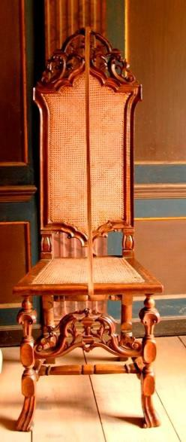

Figure 6.2: Cane chair at Canons Ashby, Northamptonshire (property of the National Trust), c. 1715.

Source: photograph by Laurie Lindey, 12 July 2012.

Figure 6.3: Chair leg bearing the initials ‘IP’.

Source: photograph by Laurie Lindey, 12 July 2012.

This is the point in the story when relationships become entangled and the concept of a manufacturing network merges with family and friends to encompass an entire

community. Warden’s business network and group of friends and associates seems to have been part of a tightly knit unit, bound by both professional and personal loyalties. They apparently functioned on a cooperative basis in nearly every aspect of their lives and this far exceeded business transactions: they apprenticed each other’s children and served as executors, assessors and witnesses to each other’s estates. Naomi Tadmor described friendship in the early modern period as ‘a general and heterogeneous category of guardians, protectors and supporters’.142 This seems an apt description of the relationship between Warden and Puller. Puller appears to have acted as a guardian to at least one of Warden’s children after his death in 1701, and in 1705 took one of his sons, William Warden, as an apprentice.143 William went on to marry Puller’s daughter, Sara in 1713.144 Puller also acted as one of the executors of Warden’s estate and in this role gave consent for his friend’s former apprentice to gain the freedom of the City (1702).145

The friendship was also entwined financially and involved mutual credit agreements. Muldrew explains that ‘credit was a public means of social communication and circulating judgement about the value of other members of communities’.146 Offering credit in this way was quite commonplace. Tradesmen ‘needed to be good neighbours’, as Earle points out, ‘both for friendship and for the sake of business’.147 This was ‘a culture which increasingly possessed a fairly high degree of unity in economic and legal practices which created conditions of understanding favourable to the creation of reliability’.148 Warden’s will includes one of his lines of credit and/or capital investment: his forty shares in the ‘joint stock of Caine Chaire Makers and the Caners

142 Quotation taken from Natasha Glaisyer who discusses Tadmor’s work on Samuel Richard’s Pamela (1740) in her article on the meaning of communities and friendship (see N. Glaisyer in Shepard and Withington, Communities in Early Modern England, pp. 235–51, at pp. 245–6).
143 GL, MS. 8052/3 f. 99, 3 Apr. 1705, ‘William Warden, son of Thomas Warden, Citizen and Joiner of London, decd, putts to Samuel Walsch Citizen and Joyner of London for 7 yeares. To be turned over to Isaac Puller Citizen and Baskettmaker of London to learne the art of a Joyner’; MS. 8051/3, f. 10, 5 Aug. 1712, ‘William Warden app Samuel Walsch Citizen and Joyner of London for 7 yres per Ind dat 3 Aprill 1705 turned over to Isaac Puller Citizen and Basketmaker of London to learne the art of a Joyner was admitted into the freedome by consent of the said Isaac’.
144 Westminster marriage transcriptions <www.findmypast.co.uk> [assessed 4 Aug. 2015], Sara Puller married William Warden at St. Margaret’s Westminster, 26 May1713.
145 GL, MS. 8051/2, f. 96, 2 Feb. 1702, ‘William Mann app Thomas Warden Citizen and Joyner of London for 7 yeares per Ind dat 8th Oct 1695 was admitted into the freedome by consent of Isaac Puller Citizen and Baskettmaker of London Exec of the said Thomas here in Court’.
146 Muldrew, Economy of Obligation, p. 2.
147 Earle, English Middle Class, p. 268.
148 Muldrew, Economy of Obligation, p. 188.

of Chairs’ previously mentioned.149 Although it is not known for certain, it would seem logical to surmise that Warden would have made these investments as part of a small consortium of chair makers. This investment in ‘joint stocks’ is evidence of chair makers collaborating in credit or financial arrangements (even if the exact aims and terms of that collaboration are unknown). The Court of Orphans inventory of the Blackfriars chair maker, Simon Sheffield (1706) describes such a partnership: it includes a debt owed to him ‘on bond’ for the amount of £150 from four City tradesmen including Isaac Puller, William Gardner (an appraiser of Warden’s inventory) and John Berry (a cane chair maker in Red Cross Street, Cripplegate).150 This bond was probably unconnected to the joint stocks that Thomas Warden owned, but it nonetheless indicates that this group (two of whom had served as Warden’s executors) pooled their capital investments to maintain credit and they may also have done the same with joint stocks in the caned chair trade.

Apparently joint stocks were a popular form of investment. In a sample study of the distribution of investment assets, Earle found that investments in company stocks and bonds increased in popularity from 24 per cent between 1665 and 1689 to 35.6 per cent between 1690 and 1720.151 The value of Warden’s forty shares is unknown, but there is an item in his inventory that describes ‘shares in canes estimated at £200’. Whether this is a reference to his joint stocks or to cane that he had purchased in partnership with his business associates is unclear. His will also mentions an investment in walnut: ‘And for what moneys may arise of the Wallnutt Tree trade … what moneys is due to me to be payd to the Executors of this Will to be distributed for the use of my children’. No value is given.

Thomas Warden died when he was about thirty-nine years old. He obviously anticipated his death because his will was written on 23 June 1701, when he was ‘in perfect sense and memory as I was in the time of my health’ and it was proved nearly five months later on 15 November 1701.152 His Court of Orphans inventory was recorded four and a half months after that on 5 March 1701/2. Warden’s son William and Isaac Puller’s son Jonathan both followed in their fathers’ footsteps by establishing

149 Thomas Warden, will proved 15 Nov. 1701 (TNA, PROB 11/462).
150 LMA, CLA/002/02/01/2735, Symon Sheffield, 2 July 1706.
151 Earle, English Middle Class, Table 5.3 ‘Distribution of assets’, p. 146.
152 TNA, PROB 11/462, probated 15 Nov. 1701. After all deductions his estate was valued at £471 3s 11d.

their own cane chair businesses. In 1721 they were located in St. Paul’s Churchyard: Jonathan Puller was on the southwest corner of the churchyard (where Thomas Warden had been located twenty years previously) and William Warden around the corner in Black Swan Court.153

Warden’s case study is a classic example of a network of allied furniture makers in the early modern period. Positioned in St. Paul’s Churchyard in the heart of the City’s retail district, Warden was in an ideal location to manufacture and sell caned chairs which were at the height of popularity at the close of the seventeenth century.
Surrounded by furniture tradesmen who worked in associated aspects of the furniture trade, Warden organised his labour force to maximise cost effectiveness. He operated a single manufacture: constructing and carving chair frames, much of this carried out in his workshops, although some of the specialised processes were outsourced to local carvers. Seat construction seems to have been a separate industry executed by caners and/or upholsterers. Warden was evidently also a retailer of finished goods. This division of labour ensured that the number of employees who were wholly dependent on Warden for their livelihoods was limited. He is likely to have shared other financial risks with his business associates and this included the pooling of capital to invest in bonds and stock related to their trade. It was a closely-knit community bound together through family, friends and business.

Lazarus Stiles (1656–1724), cabinetmaker
Lazarus Styles was a cabinetmaker in Aldermanbury, a long established location for furniture tradesmen, where he lived for at least forty-one years. In 1692 Cripplegate Within had the largest population of furniture tradesmen in the City (see Table 5.5) and quite a few remained there into the 1720s, especially the cabinetmakers.154 In the early eighteenth century, John Strype described Aldermanbury as a fashionable neighbourhood: ‘In this Aldermanbury street be divers fair Houses on both the sides,

153 LMA, COL/CHD/LA/06/025, returns of the names of several wards 1721, the names and professions of the inhabitants of the ward of Castle Baynard in the east precinct of St. Gregory.
154 LMA, COL/CHD/LA/03/032/09 to COL/CHD/LA/03/033/008, 1692 poll tax, Lazarus Stiles, St. Mary Aldermanbury, Cripplegate Within; LMA, CLA/002/02/01/3197, Court of Orphans inventory, Lazarus Stiles. Unless otherwise stated, details of Lazarus Stiles’s business come from the Court of Orphans inventory dated 23 Aug. 1724. There were seven cabinetmakers in Aldermanbury in 1724: Daniel Bayley, James Field, William Palleday, John Prankard, Christopher Sibthorpe (Heal, Furniture Makers, pp. 10, 57, 128, 142, 169); John Meader, John Woodward (Beard and Gilbert, DEFM, pp. 599,
1000).

meet for Merchants or Men of Worship’.155 Only a ten-minute walk northeast from St. Paul’s Churchyard and Cheapside – and considering the numbers of cabinetmakers in the neighbourhood – it may also have been a popular place to buy furniture. There must have been other residents in the neighbourhood involved in woodworking trades because, according to Strype, ‘Ruins of the old Court Hall, in Aldermanbury Street … of late hath been imployed as a Carpenters Yard’.156

This case study of Stiles provides an example of a cabinetmaker with a long established career. Compared with the last two tradesmen, who died in their thirties, Stiles lived to be a relatively old man, dying aged sixty-eight. He was born in Buckinghamshire in September 1656 and his father, like Thomas Warden’s, was a yeoman.157 In 1671, aged only fifteen, he began an eight-year apprenticeship. This was slightly younger than average: Jeremy Boulton found that most apprentices were over sixteen years of age.158 Evidently, like Traherne and Warden, Stiles originated from a family that had the financial means to establish their children in business. Immediately after completing his eight years’ training and two years as a journeyman (in 1681) he bound his first apprentice. This time frame is precisely the same as in the other case studies.159 He also married that year and his first child was born and christened in Aldermanbury two years later.160 Stiles remarried in 1688 and this marriage produced nine children.161 He was twice a widower at the time of his death in 1724 and two of his daughters were still under the age of twenty-one. His gross assets amount to
£1,210, which is less than a third of the manufacturers’ group (£3,773) surveyed in

155 Strype, Survey of London (1720), [online] (hriOnline, Sheffield). Available from bk. 3, ch. 6, p. 71 [accessed 4 Aug. 2015].
156 Strype, Survey of London (1720), [online] (hriOnline, Sheffield). Available from bk. 3, ch. 6, p. 71 [accessed 4 Aug. 2015].
157 International Genealogical Register <https://familysearch.org/search/collection/igi> [accessed 9 July 2012] (hereafter IGI), Lazarus Stiles born 12 Sept. 1656, Langley Marish, Buckinghamshire.
158 J. Boulton, Neighbourhood and Society: a London Suburb in the Seventeenth Century (Cambridge, 2005), p. 134; GL, MS. 8052/2, ff. 2–3, Oct. 1671, Lazarus Stiles son of Jacob Stiles yeoman deceased from Langley Marish, Buckinghamshire, apprenticed to Thomas Needler and turned over to Michael Archangel for eight years. Archangel was not a member of the Joiners’ Company and no other information is known about him.
159 GL, MS. 8052/2, f. 81, 3 May 1681, Edmund Thomas, son of William Thomas, gentleman, from Swansea in Glamorgan, apprenticed to Lazarus Stiles for seven years.
160 IGI, Lazarus Stiles married Elizabeth Legg, 1 Dec. 1681, Allhallows London Wall; John Stiles, born 27 Aug. 1683 and baptised 29 Aug. 1683, St. Mary the Virgin Aldermanbury.
161 IGI, married 16 Jan. 1688, St. Martin Outwich; Samuel Stiles born 9 Dec. 1689; Joseph Stiles born 4 Oct. 1690; Benjamin Stiles born 24 Oct. 1692; Benjamin Stiles born 18 June 1694; Lazarus Stiles born 26 Feb. 1696; Mary Stiles born 6 Jan. 1699; Nathaniel Stiles born 1 Dec. 1700; Susanna Stiles born 8 May 1704. All the children were christened within two weeks of their birth at St. Mary the Virgin Aldermanbury.

Earle’s sample. Perhaps the large discrepancy between Stiles’s level of wealth and those in Earle’s sample is simply due to the criteria Earle applied when constructing his study group. However, as will be demonstrated, Lazarus Stiles anticipated his death and it is possible that he distributed some of his wealth before he died. He signed his will on 28 May 1724 and attached a codicil five weeks later (7 July); it was proved on 18 August so his death must have occurred sometime within that six week period. His net worth, after the deductions of debts and obligations was £867 3s 4d.

As Stiles’s inventory was recorded within just weeks of his death, it gives a relatively accurate description of the way he left his household.162 It describes the house as three stories high with workshops in the garret and six additional rooms distributed over three floors: a retail shop, two kitchens, a wash house, a cellar and a yard where there was a second workshop. It seemed to be used primarily for business purposes with little evidence to suggest that it was a family home or that many people lived there.
Amanda Vickery, discussing London households in the eighteenth century, suggested that ‘prosperous landlords lived apart from their lodgers in separate establishments’.163 It is unclear whether or not Stiles actually lived at this address. His two under-age daughters were teenagers and may have been in service or residing in some other household. Only one room appears to have been used exclusively for domestic purposes: ‘the back chamber behind the kitchens’, which by its contents appears to have been a bedroom. That room excepted, every other room in the house was absolutely crammed with tools, work benches, timber and stores of stock-in-trade, with one of the rooms in the garret beside a workshop containing ‘a bedstead a flock bed bolster and pillow and blankets’ amid stacks of timber, work benches, stools and a ‘rub stone’. He even stored stock-in-trade in his kitchen. Needless to say, things could have been moved around during his illness and after he died, but considering that his inventory was recorded so soon after his death, it probably gives a reasonably accurate picture of the way he left his household.

Unlike the luxury cabinetmaker Edward Traherne, Stiles’s stock-in-trade mostly consisted of furniture that would have been considered standard for the homes of

162 Will proved 18 Aug. 1724 (TNA, PROB 11/599) and inventory recorded 23 Aug. 1724. Unless otherwise stated all further information regarding Stiles’s estate comes from the will.
163 A. Vickery, Behind Closed Doors: At Home in Georgian England (New Haven and London, 2009), p. 34.

middle-class Londoners.164 It was largely case furniture – bookcases, chests of drawers, tea tables, close stools and dressing boxes – but he also had lanterns, sconces and looking glasses. Most of this was made of walnut and was, by its description, quite plain compared to pieces designed for display with their japanned or marquetry finishes, or in the newly fashionable Palladian style which featured carved and gesso work.
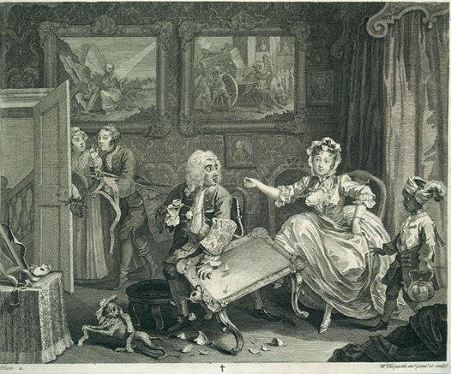

Figure 6.4: William Hogarth, Plate II from ‘A Harlot’s Progress’, etching. Parlour from 11 Henrietta Street, London (1727-1732) (V&A Museum, London, object number F118.37, Room 54), 1732.
Source: © Victoria and Albert Museum online [accessed 30 January 2016].

Tea tables like those listed in Stiles’s inventory were at the height of fashion in the 1720s and featured in countless family portraits and contemporary illustrations, like Hogarth’s ‘The Harlot’s Progress’ (see Figure 6.4). Their popularity was no doubt beneficial to members of the Joiners’ Company, who reacted when they felt this trade

164 See the Court of Orphans inventories of the following London tradesmen: LMA, CLA/002/02/01/2977, Daniel Dale, Citizen and Tallow Chandler of London, 1713; CLA/002/02/01/3129, William Hasler, Citizen and Gunmaker of London, Allhallows Barking, 1722; CLA/002/02/01/3271, John Alsop, Citizen and Vintner of London, St. Lawrence Jewry, 1726.

encroached upon by the East India Company’s importing of lacquered tea tables. They petitioned Parliament in 1701 complaining that some 6,582 tea tables had been imported in the previous four years.165 London tradesmen went about producing their own version in order to meet consumers demand and to protect their livelihoods. It may be that Aldermanbury was, in general, a place where less flamboyant furniture was made and sold. There were other cabinetmakers in the neighbourhood who supplied ‘middling’ types of furniture, such as William Palleday at ‘The Crown’ (1713–40), an associate of Stiles (see Figure 6.5).166

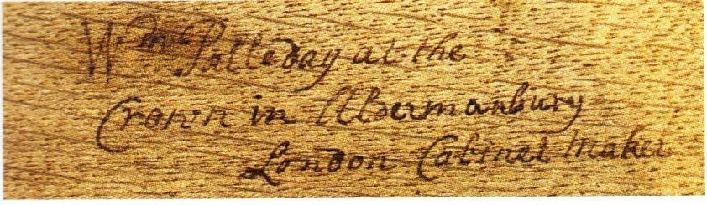

Figure 6.5: Inscription and signature of William Palleday, inscribed in the drawer of a walnut chest of drawers, c. 1720 (Private Collection).
Source: A. Bowett, Early Georgian Furniture, 1715–1740 (Woodbridge, 2009), pp. 14.

Stiles probably manufactured a good deal of the furniture in his inventory, although he did acquire some from other cabinetmakers, as seen, for example, in the debt of £3 owed to Robert Borne ‘for an escriptoire’.167 He certainly had the timber to build the furniture because it was stacked up all over his house and yard. His two workshops – one in the house and one in the yard – contained nine benches between them along with all of the prerequisite tools and equipment necessary for production: saws, hammers, screwdrivers and presses. He also had a stock of metal work: handles, escutcheon plates, hinges, locks and keys. These metal fittings may have been purchased from the brass founder, John Giles, another neighbour in Aldermanbury, to whom he owed £8 14s.168 He also bought glass which could have been used for fitting into cabinet doors or lanterns, or passed on to a looking glass maker for mirroring.169

165 Bowett, Early Georgian Furniture, p. 241.
166 Beard and Gilbert, DEFM, p. 671.
167 Robert Borne was a member of the Joiners’ Company.
168 Item: to Mr Giles founder – £8 14s. An inventory recorded as a result of a dispute between members of Giles’s family following his death indicates that he supplied dozens of furniture makers in London, including some famous cabinetmakers like William Linnell and John Belchier (TNA, C 11/2488/18, an account of the personal estate of John Giles, brass founder in Aldermanbury, Cripplegate Within).
169 Item: to Mr Basrig for Glass – £33 10s.

The sizable collection of mirrors and sconces recorded in the inventory had probably been bought in, as there is no indication that he was manufacturing looking glasses; he also had owed £17 10s to Isaac Odell, a sconce and looking glass maker in St. Clement Danes.170

In all likelihood Stiles sold furniture from his premises because he had a ‘shop’ filled with various types of case furniture along with mirrors, sconces and lanterns. Some of the mirrors were fashionable, like a pair of carved and gilt pier glasses, which had become popular during the 1720s with the growing interest in classical architecture and the Neo-Palladian style.171 Unfortunately, it is difficult to identify Stiles’s customers because although many individuals owed money to him the reason for the debts are not specified, however, it is likely that people like Lord Pomfrit who owed the estate £4 10s and Lady Colet who owed £1 5s, were clients.

In addition to cabinetmaking, Lazarus Stiles diversified his business activities by acting as a type of timber merchant. This was not altogether unusual: the 1731 inventory of the cabinetmaker Samuel Jakeman, who was situated in the eastern borders of the City in the Minories, indicates that he also may have been selling timber.172 John Cross has defined tradesmen like Stiles as ‘Landlocked Merchants’, with yards around the metropolis, whose stock was purchased from the ‘Riverside Merchants’ who imported the timber.173 Stiles had £247 13s 6d of timber stored in his yard and one of his workshops consisting of mahogany, walnut, Virginia walnut, maple ‘sugar-chest’, fir, wainscot and yew. As his own stock of furniture was predominantly made of walnut, it is unlikely that he kept this wood solely for his cabinetmaking business. Furthermore, his debts and credits indicate that he was buying wood from William Astell, a timber merchant of Thames Street, and one of the executors of his will, William Terrett of Carter Lane, was also a timber merchant.174

170 Isaac Odell, Looking glass maker, will proved 1 Apr. 1727 (TNA, PROB 11/615).
171 For further information on Neo-Palladianism, see M. Snodin, ‘Style: Georgian Britain, 1714–1837’, in Snodin and Styles, Design and the Decorative Arts, pp. 187–216, at pp. 189–92.
172 LMA, CLA/002/02/01/3332, Court of Orphans inventory, 3 and 10 Aug. 1731, Samuel Jakeman. Jakeman of St. Katherine Coleman had ‘working garrets and a yard’ where he stored several types of timber (some cut) and walnut logs, valued at £159 7s.
173 J. Cross, ‘Against the grain: the trading and supplying of timber in London 1670 to 1730’ (unpublished Royal College of Arts M.A. dissertation, 1993), p. 14.
174 Two timber merchants have been identified but there may have been more. LMA, COL/CHD/LA/06/025, returns of the names of several wards, William Astell, Esquire, timber merchant in Thames Street. William Astell is recorded as receiving an impressive £600 premium when he bound an apprentice in 1714. GL, MS. 8052/4, f. 37, 7 Sept. 1714, James Small, son of a gentleman from

That Stiles was selling wood on is indicated by two items in the inventory: ‘Ready money for wood sold at the woodyard £26’ and ‘of Mr Dan Bailey for wood £6 5s 3d’. Cross believes that timber merchants had little to do with the conversion of timber because he found only one with a sawpit in his inventory, while these were quite common in the inventories of carpenters. This suggests that sawyers’ work was mostly performed in carpenter’s yards.175 We have already seen that a carpenter’s yard was conveniently located in Lazarus Stiles’s street.

Stiles had an impressive and broad range of timber. His inventory appears to contain the earliest reference to mahogany held in the stock of a London furniture tradesmen and Adam Bowett believes he may have been one of the first to supply it:
The first specific mention of mahogany in the English Customs returns occurs in 1700 … thereafter small shipments were recorded
… [and] in the 1720s the quantity of mahogany imported increased dramatically. The reason for this was the passing of the Naval Stores Act of 1721 … The Act was intended to assist shipping in the North American and West Indian trades by allowing timber from British possessions to be imported duty-free. The first known record of mahogany timber in a London workshop is the inventory of Lazarus Stiles.176

Stiles also owned other woods that were scarce, like ‘sugar-chest’ (a type of chestnut), which was rarely used for furniture but more often for joinery work like dado rails and fireplace beams, and yew veneers which were used when creating the finest quality marquetry for furniture and parquetry for floors. Bowett notes that ‘Lazarus Stiles had some “Ewe Feniers” in his workshop in Aldermanbury [and] this is one of the very few references to yew in a London workshop’.177 In addition to dealing in timber he also rented out space in his yard for others to store their wood: ‘of Mr. Harad for half a Years rent of the Woodyard – 19s’. Perhaps this was a side line to his timber selling to generate a small income from empty space in his wood yard.

Stiles’s network was comprised of people who meet all of the criteria established in the outset of this chapter: close geographical proximity, family ties, friendship and company allegiance. Such relationships seem to have been commonplace in early

Gloucestershire; Lazarus Stiles, will proved 18 Aug. 1724 (TNA, PROB 11/599). William Terrett was named as an executor.
175 Cross, ‘Against the grain’, pp. 54–5.
176 Bowett, Woods in British Furniture Making, pp. 121–2.
177 Bowett, Woods in British Furniture Making, pp. 62 (sugar chestnut), 315(yew).

modern London and would have developed through Stiles’s long career. As Earle points out, ‘long periods of continuous residence suggest that the middle class must have been tied into local networks’.178 Ian Archer examined social networks in Restoration London using Pepys’s diary and found that for ‘communities in a city as institutionally complex as London, guilds could be a focus of social and business interaction’.179 These neighbourly relationships, according to Earle, ensured ‘the maintenance of a reputation for honesty, business probity, sound credit and reliability
… The sanctions available to neighbours were very considerable. Gossip itself was a powerful weapon of control which could destroy a small businessman’.180

Over the years Stiles may have worked with successive generations of the same families as, for example, with the Palledays. They had been involved in the London furniture trade from at least the 1640s when Richard Palleday joined the livery of the Joiners’ Company.181 First situated in St. Benet Paul’s Wharf, they had relocated to Aldermanbury by 1678.182 William Palleday (son of Richard) was born in Cripplegate in 1689 and evidently remained in the neighbourhood.183 The cabinetmaker Daniel Bayly of Aldermanbury was also a contemporary of Lazarus Stiles, and served as an appraiser of his inventory and executor to his estate. The other appraiser and executor was the cabinetmaker John Prankard, who had moved to Aldermanbury when apprenticed to Daniel Bayly.184 These two men became long-term neighbours and business associates of Stiles. Together they must have seen many neighbourhood furniture makers come and go, for example Hugh Granger, who had a business there from at least 1692 until 1706 (see Figure 5.2).185

Geographical proximity was clearly a dominant feature of Stiles’s network. We know he was in Aldermanbury from the early 1680s, which predates the residence of other documented furniture tradesmen, but it could be that it was already an established area

178 R. Shoemaker, ‘Gendered spaces: patterns of mobility and perceptions of London’s geography, 1660–1750’, in Merritt, Imagining Early Modern London, pp. 144–65, at p. 154.
179 Archer, ‘Social networks in Restoration London’, p. 76.
180 Earle, A City Full of People, pp. 170–1.
181 Phillips, Annals, p. 121.
182 IGI, 26 Sept. 1641, Thomas Palleday had a child christened at St. Mary the Virgin Aldermanbury; 19 Jan. 1686, child born in St. Mary the Virgin Aldermanbury.
183 IGI, 5 Nov. 1678, Richard Palleday had a child christened at in St. Benet Paul’s Wharf; 11 Oct. 1689, William Palleday christened at St. Giles Cripplegate.
184 GL, MS. 8052/2, f. 141, 6 July 1686, apprenticed for seven years; GL, MS. 8051/2, f. 32, 3 Oct. 1693, free by servitude.
185Heal, Furniture Makers, pp. 66, 68.

for furniture tradesmen and that this was the reason he settled there. His allegiance to the Joiners’ Company seems to have been key to the makeup of his relationships.186 All seven cabinetmakers in his neighbourhood were members of the Company and Stiles’s inventory indicates that he was associated with five of them.187 Ten additional tradesmen listed in debts and credits were also members of the Company though their whereabouts are uncertain.188 In all, of the twenty-four tradesmen listed in his inventory whose occupations are known, only two were not members of the Joiners’ Company.189 We can assume that these men worked cooperatively to some extent in manufacturing and retailing their wares and although there is no evidence to show that they pooled capital to purchase materials (particularly timber), the example of Thomas Warden shows that this practice did occur.

Stiles’s inventory records a cabinetmaker at the end of a long career and so reflects a tradesman winding down his responsibilities. It is difficult to ascertain precisely how he had structured his business, or whether the ‘snapshot’ we have is representative of the way that business operated over the course of his career. The inventory does not name journeymen, so how many people might have been dependent on him for wages is unknown, nor does it indicate which independent furniture tradesmen were actively involved in his manufacture and retail network. Moreover, by the 1720s Stiles’s sons seem to have been running the operation. Joseph, Benjamin and Lazarus junior had all served apprenticeships with their father.190 Benjamin is not mentioned in his father’s will and it seems likely he had died by that date. The will states that two other sons had already received their share of their father’s goods to set them up, while the three other children were provided for differently:
I have already fully preferred my Sons Joseph Style and Lazarus Style I do therefore leave unto and amongst my three other Children yet unpreferred namely Nathaniel Style Susanna Style and Elizabeth Style all such part and share of my personall Estate as upon my

186 Stiles served as a liveryman for 24 years (Phillips, Annals, p. 126).
187 Daniel Bayly at the ‘White Bear’, James Field at the ‘Desk and Bookcase’, William Palleday at ‘The Crown’, John Prankard at the ‘Golden Ball’ and Christopher Sibthorpe at the ‘Japan Cabinet’ (Beard and Gilbert, DEFM, pp. 52, 299, 671, 712, 814).
188 Henry Howard, frame maker (GL, MS. 8052/2, f. 195), John Leadbetter, Michael Bailey, Edmund Joyner (MS. 8052/3, ff. 99, 148, 154); William Astell, timber merchant, William Woodhouse, Robert Borne, cabinetmaker, William Moyle, Joseph Maisters, Stephen Hill (MS. 8052/4, ff. 37, 53, 94, 95, 103, 113).
189 Mr Stallwood and Mr Ben, gilders.
190 GL, MS. 8052/3, f. 94, 3 Sept. 1704, Joseph Stiles for seven years; MS. 8052/3, f. 146, 3 May 1709, Benjamin Stiles for seven years; MS. 8052/4, f. 1, 22 Aug. 1710, Lazarus Stiles for seven years.

Decease they shall be entitled unto by virtue of the Custom of the said Citty.

It is likely that his sons were gradually taking over responsibility for daily activities in their father’s workshops as Lazarus grew older, with most of this handover apparently having taken place by 1720. Lazarus junior indentured an apprentice in the winter of 1719–20 for seven years,191 and Joseph bound four apprentices through the Joiners’ Company between 1717 and 1720, three of those between April and July of 1720.192 Joseph charged a £20 premium for a seven year apprenticeship, an average price (48 per cent of all premiums cost between £10–20, see Table 4.5). Following in his father’s footsteps, Joseph seems to have been a loyal member of the Joiners’ Company joining the livery in 1725. The situation with the youngest son, twenty-four-year-old Nathaniel, is unclear. He did not serve an apprenticeship in the Joiners’ Company, but nonetheless took an active role in settling his father’s estate, working alongside the executors to sell ‘sundry goods after ye Testators decease & before the appraisement’.

If the behaviour of Lazarus Stiles during his final months reflected the way he operated throughout his life, he must have controlled his business meticulously. His will gives the impression of a person who micromanaged every detail. One can imagine him planning the distribution of his estate on his death bed because six weeks after writing his will he attached a codicil adding additional executors: ‘I do also name and appoint my other good friends (to Wit) Daniel Bayly of Aldermanbury and Robert Henley of Phillip lane’, and he carefully distributed some of his effects between his five children:
Item I give unto my said son Nathaniel and Daughters Susanna and Elizabeth Eighteen such Books of mine as they shall choose that is six to each of them and to each of them also a pair of the best Sheets Item all the rest of my Books I give equally between my said sons Joseph and Lazarus and all the rest of my Sheets and all my Napkins and Towells.

By all accounts Stiles was a leading player in the furniture trade. He ran what appears to have been a prosperous cabinetmaking business for over forty years and also operated as a minor timber merchant, selling various types and qualities of wood. He lived and worked in an area of London popular with the furniture trade and appears to have collaborated with neighbourhood cabinetmakers throughout his career. He

191 GL, MS. 8052/4, f. 94, 2 Feb 1719, William Gray, son of William Gray, farmer from Bridser in Wiltshire, apprenticed to Lazarus Stiles for seven years.
192 GL, MS. 8052/4, f. 81, 4 Feb. 1717, George Bond; f. 113, 26 Apr. 1720, John Butler; f. 115, 21 June
1720, John Dick; f. 116, 19 July 1720, Edward Hodskin.

certainly passed on his passion for cabinetmaking to his sons and, as was also the case in Thomas Warden’s family, the following generation mirrored their father’s enterprise.

Conclusion
It was common for London furniture tradesmen in the early modern period to manufacture and retail as part of productive networks. Although the characteristics of each business varied, depending upon the type and quality of furniture produced and the clientele served, a universal feature was the aim of maintaining a cost-effective and profitable enterprise. This was achieved by organising a labour force of independent tradesmen with complementary skills, working cooperatively to execute specific stages of manufacture in their own workshops. This structure ensured efficient production while reducing the financial burden on individual businesses, avoiding, for example, the need to pay weekly wages to journeymen with specialised skills. It also enabled furniture tradesmen to pool their assets to purchase materials in bulk, further lowering individual expense. A similar way of working was adopted by other London manufacturing industries, like coach-building and silversmithing.

The masters of independent businesses usually came from the gentry, yeomanry or middle classes and so were able to afford a quality apprenticeship and the capital needed to set up in business, an observation borne out by the case studies of Edward Traherne, Thomas Warden and Lazarus Stiles. Many of the independent tradesmen associated with our subjects can also be seen to have come from similar backgrounds. This concurs with Peter Earle’s conclusion that the majority of London businessmen had relatively privileged socio-economic origins.

The London furniture trade seems to have been a close-knit community despite the burgeoning population of London. This was demonstrated through loyalty to livery companies, neighbours, friends and families. Working relationships were inextricably entwined with personal lives: tradesmen apprenticed each other’s children, families intermarried, and successive generations carried on their parents’ professions. The clustering of tradesmen was a characteristic feature of the medieval and early modern urban landscape but its continuance in a period of rapid change suggests that there were still significant benefits to be had from such arrangements. The proximity of colleagues made for a cohesive community, in which prominent furniture tradesmen

were known to each other, and for a skilled and often mobile workforce. The result was a rapid transmission of ideas and skills from one workshop to another, enabling the production of high quality and fashionable goods.
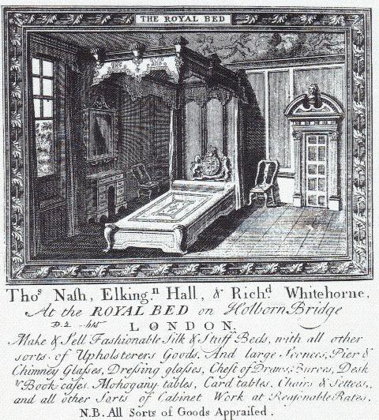

Figure 6.6: The trade card of the ‘Royal Bed’ on Holborn Bridge, 1722.

Source: A. Heal, The London Furniture Makers: from the Restoration to the Victorian Era, 1660–1840 (London, 1953), p. 120.

Not only did furniture tradesmen co-operate to produce their wares, they also seem to have sold one another’s products. In the 1670s Edward Traherne sold the mirrors he manufactured himself but also seems to have bought a broad range of luxury cabinet ware made by other cabinetmakers to sell on. His organisation, however, does not appear have been a joint retailing enterprise. The trade card of the ‘Royal Bed’ on Holborn Bridge (see Figure 6.6), on the other hand, appears to illustrate just such an outlet in which several furniture tradesmen with different specialisations sold their products in partnership. The proprietors were Thomas Nash, Elking[to]n Hall and Richard Whitehorne. Nash was an upholsterer and Whitehorne a cabinetmaker. Hall’s

occupation is unknown.193 Their trade card offers a comprehensive service both making and selling all types of furniture of their own manufacture: upholstered goods, cabinet ware, mirrors and seat furniture. They also offered an appraisal service.

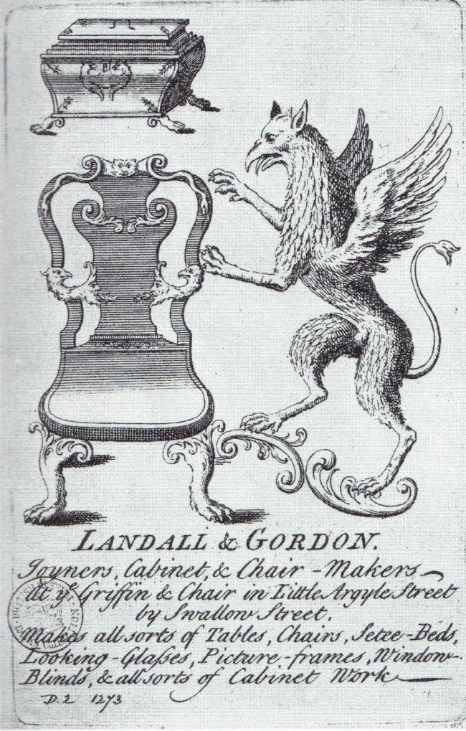

Figure 6.7: The trade card of the ‘Griffin and Chair’, c.1750.

Source: A. Heal, The London Furniture Makers: from the Restoration to the Victorian Era, 1660–1840 (London, 1953), p. 93.

In the eighteenth century this sort of shop was often advertised on trade cards, like that for the ‘Griffin and Chair’. One of the proprietors was Thomas Landall who, along with son Owen, was a cabinetmaker and member of the Joiners’ Company.194 They were first established in Chandos Street, near Covent Garden, in 1724–49 before relocating further west to Little Argyle Street, near Oxford Street, in 1750. The area around Oxford Street was becoming increasingly popular with furniture tradesmen:

193 C. Webb, London Apprentices, vol. 19: Upholders’ Company 1704–22 (London, 1998), p. 31, Thomas Nash, master. GL, MS. 8052/3, f. 19, 28 Nov. 1699, Richard Whitehorne, son of Richard Whitehorne, vintner from Northampton, apprenticed to Thomas Bavin for seven years.
194 GL, MS. 8052/2, f. 175, 4 Nov. 1690, Thomas Landall, son of Ross Landall, husbandman from London, apprenticed to John Mitchell for seven years; MS. 8051/3, f. 63, 5 Apr. 1720, Thomas Landall became free. Owen served his apprenticeship with his father (MS. 8052/4, f. 112, 12 Apr. 1720, Owen Landall, son of Thomas Landall, Citizen and Joiner of London apprenticed to his father for seven years).

cabinetmakers William and John Linnell, for instance, had moved from Covent Garden to Berkeley Square in Mayfair in 1754.195 At their new address the Landalls forged a partnership with a tradesman called Gordon.196 Like the ‘Royal Bed’ in Holborn, the ‘Griffin and Chair’ made and sold ‘all sorts of Tables, Chairs, setee-Beds, Looking- Glasses, Picture-frames, Window-Blinds & all sorts of Cabinet Work’ (see Figure 6.7).

Furniture tradesmen often diversified their activities with related business endeavours and investments: cabinet and looking glass maker Edward Traherne had a dual role working as a property developer and speculator; cane chair maker Thomas Warden invested with his partners in joint purchase of cane and walnut; and cabinetmaker Lazarus Stiles acted as a minor timber merchant. It is difficult to determine whether this was common across the trade, but as all three of these furniture tradesmen diversified in this way it may well signify a paradigm for the entire trade. The case studies in this chapter also show that, in keeping with other London tradesmen, furniture tradesmen established lines of credit and maintained liquidity by purchasing Bank of England bonds and joint stocks. This is underscored by other financial activities.

195 Hayward Kirkham, William and John Linnell, vol. 1, p. 29.
196 Heal, London Furniture Makers, p. 101. Gordon’s occupation and company affiliation is unknown.

Conclusion

This thesis has examined the woodworking sectors of the London furniture trade between 1640 and 1720. The date range was chosen because it was a transformative period when the designs, styles and construction of English furniture were adapted in order to manufacture a totally new and diverse range of sophisticated goods. The study takes a unique approach by combining the methodologies of social, cultural, economic and design histories, in order to examine broadly the organisational structure of the furniture trade and to position it among the other manufacturing industries of early modern London. This is a subject which has been largely neglected in the canon of English furniture scholarship.
Prior to this thesis there was a chronological gap in the historiography of the London furniture trade: the two previous studies made by Edward Joy and Pat Kirkham began their examination from 1700.1 The primary interest of both of these works lies in examining the trade in the age of industrialisation, with little attention given to the seventeenth century, when the industry was adapting its manufacturing techniques to keep pace with rapid changes in designs and styles. Some historians wrongly assume London furniture makers possessed only a rudimentary level of skill and expertise prior to the Restoration in 1660, and in doing so underestimate the prowess of these craftsmen in the first half of the century. This study has established that London furniture makers were, in fact, highly skilled and therefore readily able to adapt their manufacture in order to produce the new products that became increasingly popular as the seventeenth century progressed. One obvious example is the onset of the manufacture of decoratively veneered cabinetwork in London, which is considered to be the defining moment in the birth of ‘modern’ English furniture. The production of veneered dovetailed objects was in the exclusive domain of cabinetmakers, and the received wisdom has been that cabinetmaking was unknown in London before the 1660s. However, this was clearly not the case because cabinetmakers were well- established in the metropolis by the 1640s.2

1 E. T. Joy, ‘Some aspects of the London furniture industry in the eighteenth century’ (unpublished University of London M.A. thesis, 1955); P. A. Kirkham, ‘Furniture–making in London, c.1700–1870: craft, design, business and labour’ (unpublished University of London Ph.D. thesis, 1982); Kirkham, London Furniture Trade.
2 See Chapter One, notes 21 and 24.

Another missing component in the historiography is an examination of the complexities and interconnections of the industry. Some London furniture tradesmen are known to have practised dual occupations by working in both architectural joinery and furniture making, as demonstrated through case studies of Edward Traherne, who managed a cabinetmaking business in Covent Garden and was also involved in property development and reconstruction in the aftermath of the Great Fire, and Lazarus Styles, who in addition to working as a cabinetmaker was also operating a small timber merchant business. Cabinetmakers were not the only members of the trade with interests in both sectors of the industry: joiners and turners participated in both house construction and the manufacture of moveable and immovable furniture, and some carvers and gilders applied their decorative skills to both architectural features and artefacts.
One of the furniture industry’s greatest attributes was import substitution and this is seen particularly in decoratively veneered and japanned cabinetwork, and caned seat furniture. The quality of production in many ways rivalled, and even surpassed, that of continental European and Asian tradesmen, and, moreover, at a competitive price. This achievement has been lauded by English furniture historians, but they have failed to recognise that the trade’s ability to produce anglicised versions of imported prototypes at an affordable price was made possible by its organisational structure. Through the division of labour, and by subcontracting various elements and stages of manufacture to artisans and craftsmen with specialised skills, both the overall cost of production, and hence the cost to the consumer, were lowered. The manufacture of such high- quality fashionable goods at prices accessible to the middle classes clearly increased consumer demand, resulting in the growth of the industry, and this was reflected in the expansion of membership in the Joiners’ Company.
The Company more than doubled in size in the early years of the eighteenth century, expanding by 63 per cent between 1699 and 1724 (see Table 3.5). This phenomenon was without doubt the result of its relationship with the furniture trade, which by the 1690s represented the seventh largest industry in the City of London.3 Unlike some other companies, the Joiners’ Company remained connected to its trade into the eighteenth century and was able to build on earlier achievements in defence of its

3 Spence, London in the 1690s, p. 129, Table 5.5.

members’ interests and keep pace with developments in the industry, with membership increasing considerably (though not as fast as the growth of the trade itself).
The position the Joiners’ Company held in monitoring and regulating the furniture trade and its ability to protect its members’ livelihoods is central to this analysis, a topic mostly overlooked in English furniture historiography. This thesis has determined that there is little to suggest that the Company was directly involved in monitoring the day-to-day activities of the furniture trade. Yet, although the Company left the daily activities of the furniture industry in the hands of its artisans, craftsmen and tradesmen, it successfully exerted its authority to represent and protect its members’ livelihoods through various means, and in particular by persuading the City government to enact two important pieces of legislation in its favour. First was the 1632 arbitration between the Joiners’ and Carpenters’ Companies, which resulted in the Joiners being awarded the sole right to practice dovetailed construction. This, in effect, gave them an exclusive licence to manufacture luxury furniture. Second, the Company took the proactive stance of expanding its authority to regulate the entire industry through an Act of Common Council in 1658, which forced all joiners (no matter what their guild affiliation), to enrol with the Joiners. The Act was applied to great advantage because it was not only a means of sourcing revenue but also served to encourage furniture tradesmen to congregate within a single institution, thus increasing its membership and influence over the trade.
It appears that the vast majority of furniture tradesmen who managed independent businesses originated from the middle classes and made their way into the London furniture trade by serving an apprenticeship with Joiners of similar backgrounds. One explanation for the vitality and sustainability of the Joiners’ Company was that its membership included freemen from the upper echelons of London’s business communities, most of whom worked in either architectural joinery or the furniture industry. Successive masters of the Company were Master Joiners to the Office of Works, while several liverymen held monopolies to supply the royal households from Charles II to Queen Anne. An association with tradesmen of such stature would clearly have provided great opportunities to members, and this network was the essential ingredient of the Company’s growth and endurance into the eighteenth century.

Most, if not all, London furniture was manufactured through networks of tradesmen. The labels on surviving artefacts indicate that cabinet and chair makers were involved in both manufacture and retail, and this thesis has established that it was standard practice for craftsmen to be responsible only for particular stages of the production, and that furniture was often sold cooperatively. The fact that furniture was made and sold in this way, and that specialised artisans provided their services across the trade, raises doubt about the methods employed to attribute furniture to one workshop, particularly when these attributions are based solely on physical characteristics. In addition to furniture tradesmen co-operating in making and selling their goods, they must also have been inspired by the same design sources.
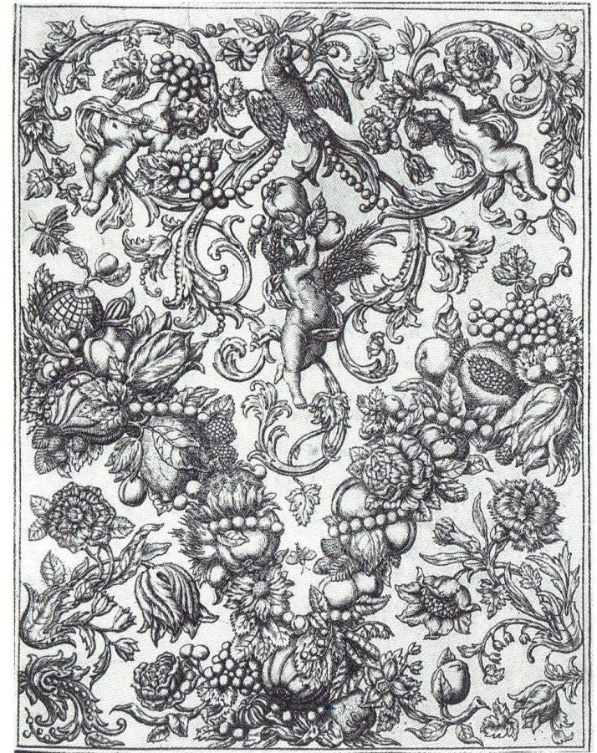

Figure 1: Print from an engraved catalogue of embossed gilt leather (c.1670). It is inscribed on the back with prices and a pattern name (Bacchus and Ceres). Made by the Amsterdam manufacturer, Maarten van den Heuvel (property of the Victoria and Albert Museum, London).
Source: M. Snodin and M. Howard, Ornament, a Social History since 1450 (New Haven and London, 1996), p. 54.

Michael Snodin and Maurice Howard have examined prints and drawings used in the workshops of craftsmen from various manufacturing trades, including furniture. 4 One person who owned portfolios or volumes of prints was the French ébéniste (cabinetmaker), André Charles Boulle, known for his supply of floral and arabesque
4 M. Snodin and M. Howard, Ornament, a Social History since 1450 (New Haven and London, 1996).

marquetry. He had sets of prints and drawings ‘by all the main seventeenth century French printmakers as well as Ducerceau and the Italian baroque etcher Agostino Mitelli’.5 Presumably his workshop used these printed sources when designing marquetry and japanned patterns. Figure 1 illustrates the type of prints that were available in the late seventeenth century. These catalogues would also have been available in London and cabinetmakers must have used them as design sources and also shown them to would-be clients. If several cabinetmakers used the same catalogues when designing marquetry patterns, it cannot be assumed that even though two objects look identical they were executed by the same marqueteur or supplied by the same furniture maker.
The London furniture trade was populated with highly-skilled craftsmen and artisans who produced outstanding products. They regulated the quality and standards of their industry themselves, and although the Joiners’ Company was not actively involved in monitoring and controlling the trade, it effectively represented its membership ensuring their allegiance and trust.

5 Snodin and Howard, Ornament, p. 45.

Bibliography

Unpublished Primary Sources

London, Clothworkers’ Company archives

CL/C/4/2/8, Apprenticeship bindings, 1642–8.

London, Guildhall Library

Joiners’ Company (CLC/L/JA):
MS. 8058–9, 1614, Company ordinance.
MS. 8051/1–3, Freedom registers, 1651–1724.
MS. 8052/1–5, Apprenticeship bindings, 1641–1724.
MSS. 8047/1; 8046/1–6, Court minutes, 1661–40; 1679–1729.
MS. 8041/1–3, Master and wardens’ accounts, 1621–87. MS. 8042/1–5, Renter wardens’ accounts, 1687–1739.

Carpenters’ Company (CLC/L/CC):
MS. 4337/1–3, Apprenticeship bindings.

London Metropolitan Archives

COL/CHD/LA/03/032/09 – COL/CHD/LA/03/033/008, 1692 poll tax assessments. COL/CHD/LA COL/CHD/LA/03/040, COL/CHD/LA/03/042
COL/CHD/LA/03/0, Returns of the names of several wards in obedience to a precept giving the proper additions and places of abode, 3 Oct. 1721.

COL/CHD/LA/06/025, Returns of the names of several wards in obedience to a precept giving the proper additions and places of abode, 3 Oct. 1721.

CLA/002/02/01, Court of Orphans inventories.

The National Archives of the U.K.

PROB 11, Prerogative Court of Canterbury (PCC) wills
LC 9, LC 11, Lord Chamberlain’s Department: Accounts and Miscellanea. Great Wardrobe Yearly Accounts, 1689–1713.

Lincoln Record Office

2 ANC 12/D/6, Trade card of William Gardner at the sign of the ‘One Cane- Chair’ in St. Paul’s Churchyard.

The Royal Archives at Windsor Castle Windsor and Maidenhead

Lord Chamberlain’s Department: Accounts and Miscellanea. Great Wardrobe Yearly Accounts, 1689–92.

Printed Primary Sources

Anon., A general description of all trades, digested in alphabetical order: by which parents, guardians, and trustees, may make choice of trades, agreeable to the capacity, education, inclination, strength, and fortune of the youth (London, 1747).

Campbell, R., The London Tradesman (London, 1747).

Chippendale, T., The Gentleman and Cabinet-Maker’s Director. Being a large collection of the most elegant and useful designs of household furniture in the gothic, Chinese and modern taste (London, 1754; facsimile, Leeds, 2005).

Croker, T. H., Williams, T. and Clark, S., The Complete Dictionary of Arts and Sciences in which the Whole Circle of Human Learning is explained … (London, 1766).

Defoe, D., The Complete English Tradesman (London, 1726).

Diderot, D., L’Encyclopédie, ou dictionnaire raisonné des sciences, des arts et des métiers (Paris, 1763).

Evelyn, J., Silva, or a Discourse of Forest Trees and the Propagation of Timber in His Majesties Dominions (London, 1670).

Hatton, E., A new view of London; or, an ample account of that city, in two volumes, or eight sections (2 vols., London, 1708).
Johnson, S., A Dictionary of the English Language (2 vols., London, 1755). Jones, P. E. (ed.), The Fire Court: Calendar to the Judgments and Decrees of the
Court of Judicature Appointed to Determine Differences Between Landlords and Tenants as to Rebuilding after the Great Fire (London, 1970).

Jones, P. E. and Reddaway, T. F. (eds.), The Survey of Building Sites in the City of London After the Great Fire of 1666 by Peter Mills and John Oliver (London, 1967).

Langley, B., The Builder’s Director or Bench-Mate (London, 1746).

The Lists of the Liveries of the fifty six Companies in the City of London ... With an account who poll’d, and who did not at the late election of Members of Parliament for the said City of London. Begun ... Jan. 20. Ended ... Jan. 23 ... 1700, etc (London, 1701).

Morgan, W., Morgan’s Map of the Whole of London in 1682 (repr. in London, 1977).

Moxon, J., Mechanick Exercises or the Doctrine of Handy-Works (1st edition, London, 1703; facsimile, New Jersey, 1989).

Ogilby, J. and Morgan, W., ‘Ogilby and Morgan’s Large Scale Map of the City As Rebuilt By 1676’, in Ogilby and Morgan’s Large Scale Map of the City As Rebuilt By 1676 (repr. by Harry Margary, Lympne Castle, Kent, 1976).

Polloxfen, J., A Discourse of trade, coyn and paper credit (London, 1697). Raithby, J. (ed.), Statutes of the Realm (1820), vol. 7, 1695–1701.
Rocque, J., An Exact Survey of the City’s of London Westminster ye Borough of Southwark and the Country near to 10 miles round London 1746 (repr. by Harry Margary, Lympne Castle, Kent,, 1971).

Roubo, A. J., Description des arts et métiers: le menuisier ébéniste. 1774 (repr. in Paris, 2006).

Stalker, J. and Parker, G., Treatise of Japanning and Varnishing (1st edition, London, 1688; facsimile, Reading, 1998).

Stow, J., ‘Survey of London’, in W. J. Thoms (ed.), Survey of London, Written in the Year 1598 by John Stow: a New Edition (London, 1842).

Thirsk, J. and Cooper, J. P. (eds.), Seventeenth Century Economic Documents (Oxford, 1972).

Webb, C., London Apprentices, vol. 10: Basketmakers’ Company, 1639–1824
(London, 1997).
- London Apprentices, vol. 19: Upholders’ Company 1704–22 (London, 1998).

Secondary Sources

Aldous, V., My Ancestors were Freemen of the City of London (London, 1999). Alford, R. W. E., A History of the Carpenters Company (London, 1968).
Archer, I. W., The Pursuit of Stability: Social Relations in Elizabethan London
(Cambridge, 1991).
- ‘Social networks in Restoration London: the evidence in Samuel Pepys’s diary’, in
    - Shepard and P. Withington (eds.), Communities in Early Modern England: Networks, place, rhetoric (Manchester and New York, 2000), pp. 76–94.

Auslander, L., Taste and Power: Furnishing Modern France (London, 1996). Ayres, J., Building the Georgian City (New Haven and London, 1998).

Barry, J., ‘Bourgeois collectivism? Urban associations and the middling sort’, in J. Barry and C. Brooks (eds), The Middling Sort of People: Culture, Society and Politics in England, 1550–1800 (New York, 1994), pp. 84–112.

Barry, J. and Brooks, C. (eds.), The Middling Sort of People: Culture, Society and Politics in England, 1550–1800 (New York, 1994).

Beard, G., Craftsmen and Interior Decoration in England, 1660–1820 (New York, 1981).
- The Work of Grinling Gibbons (London, 1989).
- Upholsterers and Interior Furnishing in England 1530–1840 (New Haven, 1997).

Beard, G. and Gilbert, C., The Dictionary of English Furniture Makers, 1660–1840
(Leeds, 1986).

Beard, G. and Westman, A., ‘A French upholsterer in England: Francis Lapiere’, The Burlington Magazine, 135 (Aug. 1993), pp. 515–24.

Beattie, J., ‘London juries in the 1690s’, in J. S. Cockburn and T. Green (eds.), Twelve Good Men and True: the Criminal Trial Jury in England, 1200–1800 (Princeton, 1988), pp. 214–53.

Bédoyère, G. (ed.), Diary of John Evelyn (London, 1997).

Beier, A. L., ‘Engine of manufacture: the trades of London’, in A. L. Beier and R. Finlay (eds.), London 1500–1700: the Making of the Metropolis (London and New York, 1986), pp. 141–67.

Berg, M., The Age of Manufactures, 1700–1820 (London and New York, 1994).
- Luxury and Pleasure in Eighteenth-Century Britain (Oxford, 2005).

Berg, M. and Clifford, H., Consumers and Luxury: Consumer Culture in Europe, 1650–1850 (Manchester and New York, 1999).

Berg, M., Hudson, P. and Sonenscher, M. (eds.), Manufacture in Town and Country Before the Factory (Cambridge, 1983).

Berlin, M., ‘Broken all in pieces: artisans and the regulation of workmanship in early modern London’, in G. Crossick (ed.), The Artisan and the European Town, 1500–1900 (Aldershot, 1997), pp. 75–92.
- ‘Guilds in decline? London livery companies and the rise of a liberal economy, 1600–1800’, in S. R. Epstein and M. Prak (eds.), Guilds, Innovation and the European Economy, 1400–1800 (Cambridge, 2008), pp. 316–41.

Bermingham, A. and Brewer, J. (eds.), The Consumption of Culture, 1600–1800: Image, Object, Text (London and New York, 1997).

Black, J., ‘Illegitimacy, sexual relations and location in Metropolitan London’, in T. Hitchcock and H. Stone (eds.), The Streets of London: from the Great Fire to the Great Stink (London, 2003), pp. 101–18.

Boulton, J., ‘Wage labour in seventeenth-century London’, Economic History Review, 49 (1996), pp. 268–90.
- ‘Food prices and the standard of living in London in the “century of the revolution”, 1580–1700’, Economic History Review, 2nd ser., 53 (2000), pp. 455– 92.
- ‘The poor among the rich: paupers and the parish, in the West End, 1600–1724’, in
P. Griffiths and M. S. R. Jenner (eds.), Londinopolis: Essays in the Cultural and Social History of Early Modern London (Manchester, 2000), pp. 197–225.
- Neighbourhood and Society: a London Suburb in the Seventeenth Century
(Cambridge, 2005).

Bowett, A., English Furniture 1660–1714: from Charles II to Queen Anne
(Woodbridge, 2002).
- Early Georgian Furniture, 1715–40 (Woodbridge, 2009).
- Woods in British Furniture Making, 1400–1900: an Illustrated Historical Dictionary (Wetherby, 2012).

Bowett, A. and Lindey, L., ‘Labelled furniture from the White Swan workshop in St.
Paul’s’, JFHS, 39 (2003), pp. 71–98.

Boynton, L. and Thornton, P., ‘The Hardwick Hall inventory of 1601’, JFHS, 7 (1971).

Brett-James, N. G., The Growth of Stuart London (Woking, 1935).

Brewer, J., The Pleasures of the Imagination: English Culture in the Eighteenth Century (London, 1997).

Brewer, J. and Porter, R. (eds.), Consumption and the World of Goods (London and New York, 1994).

Brooks, C., ‘Apprenticeship, social mobility and the middling sort, 1550–1800’, in J. Barry and C. Brooks, The Middling Sort of People: Culture, Society and Politics in England, 1550–1800 (New York, 1994), pp. 52–83.

Bucholz, R. O. and Ward, J. P., London: a Social and Cultural History, 1550–1750
(Cambridge, 2012).

Carlton, C., The Court of Orphans (Leicester, 1974).

Charleston, R. J., English Glass and the Glass Used in England, circa 400–1940
(London, 1984).

Chinnery, V., Oak Furniture: the British Tradition (Woodbridge, 1979).

Clifford, H., ‘The Kings Arms and Feathers: a case study exploring the networks of manufacture operating in the London goldsmiths’ trade in the eighteenth century’, in D. Mitchell (ed.), Goldsmiths, Silversmiths and Bankers: Innovation and the Transfer of Skill, 1550 to 1750 (London, 1995), pp. 84–95

- Silver in London: the Parker and Wakelin Partnership 1760–76 (New Haven and London, 2004).

Cockayne, E., Hubbub: Filth, Noise and Stench in England (New Haven and London, 2007).

Colvin, H., Biographical Dictionary of British Architects, 1600–1840 (New Haven and London, 1995).

Cox, J. and Cox, N., ‘Probate 1500–1800: a system in transition’, in T. Arkell, N. Evans and N. Goose (eds.), When Death Do Us Part: Understanding and Interpreting the Probate Records of Early Modern England (Oxford, 2000), pp. 14–37.

Cox, N., The Complete Tradesman: a Study of Retailing, 1550–1820 (Aldershot, 2000).

Davies, M., ‘Governors and governed: the practice of power in the Merchant Taylors’ Company in the fifteenth century’, in I. A. Gadd and P. Wallis (eds.), Guilds, Society and Economy, 1450–1800 (London, 2002), pp. 67–83.

Davies, M. and Saunders, A., The History of the Merchant Taylors’ Company (Leeds, 2004).

Dewing, D., ‘Cane chairs, their manufacture and use in London, 1670–1730’, JRFS, 12 (2008), pp. 53–86.

Earle, P., The Making of the English Middle Class: Business, Society and Family Life in London, 1660–1730 (Berkeley and Los Angeles, 1989).
- A City Full of People: Men and Women of London, 1650–1750 (London, 1994).
- ‘The Middling Sort in London’, The Middling Sort of People: Culture, Society and Politics in England, 1550–1800 (New York, 1994), pp. 141–158.
- ‘The economy of London, 1660–1730’, in P. O’Brien (ed.), Urban Achievement in Early Modern Europe (Cambridge, 2001), pp. 81–96.

Edwards, R., Georgian Furniture (London, 1947).
- English Chairs (London, 1956).

Ellis, G., Modern Practical Joinery: a Treatise on the Practice of Joiner’s Work by Hand and Machine (3rd edition, London, 1908; Fresno, Calif., 1987).

Epstein, S. R., ‘Craft Guilds, Apprenticeship and Technological Change in Pre- industrial Europe’ in S. R. Epstein and M. Prak (eds.), Guilds, Innovation and the European Economy, 1400–1800 (Cambridge, 2008), pp. 52–80.

Esser, R., ‘Immigrant Cultures in Tudor and Stuart England’, in N. Goose and L. Luu (eds.), Immigrants in Tudor and Early Stuart England (Brighton, 2005).

Evans, J. L., Thomas Tompion at the Dial and Three Crowns (Wadhurst, 2006).

Feldman, R., ‘Dyeing and the London Dyers’ Company: membership, craft, and knowledge transmission, 1649–1829’, The London Journal, 39 (2014), 37–58.

Fleming, J. and Honour, H., The Penguin Dictionary of Decorative Arts (London, 1989).

Forbes, J., ‘Search, immigration and the Goldsmiths’ Company: a study in the decline of powers’, in I. A. Gadd and P. Wallis (eds.), Guilds, Society and Economy, 1450–1800 (London, 2002), pp. 115–26.

Forman, B. M., ‘Continental Furniture craftsmen in London: 1511–1625’, JFHS, 7 (1971), pp. 94–120.
- ‘”The Joyners’ Company” in 1692’, JFHS, 10 (1974), pp.12–14.
- American Seating Furniture 1630–1730: an Interpretive Catalogue (New York and London, 1988).

Galinou, M., ‘Merchants’ houses’, in M. Galinou (ed.), City Merchants and the Arts 1670–1720 (London, 2004), pp. 25–40.

Gilbert, C., The Life and Work of Thomas Chippendale (Bristol, 1978).
- English Vernacular Furniture, 1750–1900 (New Haven and London, 1991).
- Marked London Furniture, 1700–1840 (Leeds, 1996).
- Pictorial Dictionary of Marked London Furniture, 1700–1840 (Leeds, 1996).

Gilbert, C. and Murdoch, T., John Channon and Brass-Inlaid Furniture (New Haven and London, 1993).

Gillispie, C. C. (ed.), A Diderot Pictorial Encyclopedia of Trades and Industry: 485 Plates Selected from ‘L’Encyclopédie’ of Denis Diderot (2 vols., New York, 1993).

Glaisyer, N., ‘Readers, correspondents and communities: John Houghton’s A Collection for Improvement of Husbandry and Trade (1692–1703), in A. Shepard and P. Withington (eds.), Communities in Early Modern England (Manchester and New York, 2000), pp. 235–51.

Glaisyer, N. and Pennell, S. (eds.), Didactic Literature in England 1500–1800: Expertise Constructed (Aldershot, 2003).

Glanville, P. (ed.), Silver (London, 1996).

Glass, D. V. (ed.), London Inhabitants within the Walls, 1695 (London Record Society, vol. 2, 1966).
- ‘Notes on the demography of London at the end of the seventeenth century’, in D.
V. Glass and R. Revelle (eds.), Population and Social Change (London, 1972).

Gowing, L., ‘The freedom of the streets; women and social space, 1560–1640’, in P. Griffiths and M. S. R. Jenner (eds.), Londinopolis: Essays in the Cultural and Social History of Early Modern London (Manchester, 2000), pp. 130–51.

Griffiths, P., ‘Politics made visible: order, residence and uniformity in Cheapside, 1660–45’, in P. Griffiths and M. S. R. Jenner (eds.), Londinopolis: Essays in the Cultural and Social History of Early Modern London (Manchester, 2000), pp.
176–96.

Harben, H. A., A Dictionary of London (London, 1918).

Harding, V., ‘The population of London, 1550–1700: a review of the published evidence’, The London Journal, 15 (1990), pp. 111–28.
- ‘The changing shape of seventeenth-century London’, in J. F. Merritt (ed.), Imagining Early Modern London: Perceptions and Portrayals of the City from Stow to Strype 1598–1720 (Cambridge, 2001), pp. 117–43.
- The Dead and the Living in Paris and London, 1500–1700 (Cambridge, 2002).

Hayward, C., English Period Furniture: an Account of the Evolution of Furniture from 1500 to 1850 (London, 1957).

Hayward, H., Thomas Johnson and English Rococo (London, 1964). Hayward, H. and Kirkham, P., William and John Linnell (London, 1980).
Hazlitt, W. C., The Livery Companies of the City of London: their Origin, Character, Development, and Social and Political Importance (New York, 1892).

Heal, A., The London Furniture Makers: from the Restoration to the Victorian Era, 1660–1840 (London, 1953).
- Sign Boards of Old London Shops (London, 1957).

Herman, B. L, ‘Tabletop conversations: material culture and everyday life in the eighteenth-century Atlantic world’, in J. Styles and A. Vickery (eds.), Gender, Taste, and Material Culture in Britain and North America, 1700–1830 (New Haven and London, 2006).

Hitchcock, T., ‘“You bitches … die and be damned”, Gender, Authority and the Mob in St Martin’s Round-House Disaster of 1742’, in T. Hitchcock and H. Stone (eds.), The Streets of London: from the Great Fire to the Great Stink (London, 2003), pp. 69–81.

Holmes, G., The Making of a Great Power 1660–1722 (Harlow, 1993).

Houston, J. F., Featherbedds and Flockbedds: the Early History of the Worshipful Company of Upholders of the City of London (Aldwick, 2010).

Ingram, R., ‘Seventeenth-century didactic readers, their literature, and ours’, in N. Glaisyer and S. Pennell (eds.), Didactic Literature in England 1500–1800: Expertise Constructed (Aldershot, 2003), pp. 63–78.

John, E., ‘At home with the London middling sort – the inventory evidence for furnishings and room use, 1570 – 1720 ’, JRFS, 22 (2008), pp. 27–51.

Jourdain, M., English Decoration and Furniture of the Early Renaissance, 1500–1650
(London, 1924).
- Regency Furniture, 1795–1820 (London, 1948).

Jupp, E. B., An Historical Account of the Worshipful Company of Carpenters of the City of London Complied Chiefly from Records in Their Possession (London, 1887).

Keene, D., ‘Livery Companies: what, when and why’, in I. A. Gadd and P. Wallis (eds.), Guilds, Society and Economy, 1450–1800 (London, 2002), pp. 171–4.

Kellett, J. R., ‘The breakdown of gild and corporation control over the handicraft and retail trade in London’, Economic History Review, 2nd ser., 10 (1957–8), 381–94.
Kirkham, P. A., The London Furniture Trade, 1700–1870 (Leeds, 1988). Lane, S. E., The Worshipful Company of Joiners and Ceilers or Carvers: a
Chronological History (London, 1968).

Leunig, T., Minns, C. and Wallis, P., ‘Networks in the premodern economy: the market for London apprenticeships, 1600–1749’, Journal of Economic History, 71 (2011), pp. 413–43.

Levy Peck, L., Consuming Splendor (Cambridge, 2005).

Lindey, L., ‘William Old and John Ody at The Castle in St. Paul’s Churchyard’, The Furniture History Society Newsletter, 161 (Feb. 2006), pp. 1–4.
- ‘A Restoration London cabinet and looking glass maker: Edward Traherne’, JFHS, 50 (2014), pp. 17–36.

Louw, H. J., ‘Demarcation Disputes between the English Carpenters and Joiners from the Sixteenth to the Eighteenth Century, in Construction History, vol. 5 (1989), pp. 3–20.

Luu, L., ‘Natural-born versus stranger-born subjects: aliens and their status in Elizabethan London’, in N. Goose and L. Luu (eds.), Immigrants in Tudor and Early Stuart England (Brighton, 2005), pp. 57–75.

Macquoid, P., The Age of Mahogany (London and New York, 1906)
- A History of English Furniture: the Age of Oak (London, 1904).
- The Age of Walnut (London and New York, 1905).
- The Age of Satinwood (London and New York, 1908).

Macquoid, P. and Edwards, R., The Dictionary of English Furniture from the Middle Ages to the Late Georgian Period (3 vols., London, 1924–7).

McKellar, E., The Birth of Modern London: the Development and Design of the City, 1660–1720 (Manchester and New York, 1999).

McKendrick, N., Brewer, J. and Plumb, J. H., The Birth of a Consumer Society: the Commercialization of Eighteenth-Century England (London, 1982).

Miller, E., ‘Prints as sources of design’, in J. Styles and M. Snodin (eds.), Design and the Decorative Arts: Britain 1500–1900 (London, 2001).

Mingay, G., English Landed Society in the Eighteenth Century (London, 1963).

Minns, C. and Wallis, P., ‘Rules and reality: quantifying the practice of apprenticeship in premodern England’, Economic History Review, 65 (2012), pp. 556–79.

Mitchell, D., ‘Innovation and the transfer of skill’, in D. Mitchell (ed.), Goldsmiths, Silversmiths and Bankers: Innovation and the Transfer of Skill, 1550 to 1750 (London, 1995), pp. 5–22.

Muldrew, C., The Economy of Obligation: the Culture of Credit and Social Relations in Early Modern England (Basingstoke, 1998).

Murdoch, T., ‘Jean, Rene and Thomas Pelletier, a Huguenot family of carvers and gilders in London 1682–1726’, The Burlington Magazine (November 1997), pp. 732–36.
- ‘Doors open on capital’s cabinets’, Country Life, 6 Dec. 2001, pp. 100–101. ‘

Ormrod, D., ‘Cultural production and import substitution: the fine and decorative arts in London, 1660–1730’, in P. O’Brien (ed.), Urban Achievement in Early Modern Europe (Cambridge, 2001).

Overton, M., ‘Prices from probate inventories’, in T. Arkell, N. Evans and N. Goose (eds.), When Death Do Us Part: Understanding and Interpreting the Probate Records of Early Modern England (Oxford, 2000), pp. 124–5.

Overton, M., Whittle, J., Dean, D. and Hann, A. (eds.), Production and Consumption in English Households, 1600–1750 (London and New York, 2004).

Palk, D., ‘Private crime in public and private places: pickpockets and shoplifters in London’, in T. Hitchcock and H. Stone (eds.), The Streets of London: from the Great Fire to the Great Stink (London, 2003), pp. 135–50.

Pelling, M., ‘Skirting the city? Disease, social change and divided households in the seventeenth century’, in P. Griffiths and M. S. R. Jenner (eds.), Londinopolis: Essays in the Cultural and Social History of Early Modern London (Manchester, 2000), pp. 154–75.

Pennell, S., ‘Skills from Europe 1500–1600’, in J. Styles and M. Snodin (eds.), Design and the Decorative Arts: Britain 1500–1900 (London, 2001), pp. 126–7.

Phillips, H. L., Annals of the Worshipful Company of Joiners of the City of London
(London, 1915).

Porter, R., English Society in the Eighteenth Century (London, 1990).
- London: a Social History (London, 2000).

Power, M. J., ‘The social topography of Restoration London’, in A. L. Beier and R. Finlay (eds.), London 1500–1700: the Making of the Metropolis (London and New York, 1986), pp. 199–224.

Rappaport, S., Worlds Within Worlds: Structures of Life in Sixteenth-Century London
(Cambridge, 1989).

Raymond, P., Marquetry (Dourdan, 1989).

Reddaway, T. F., The Rebuilding of London after the Great Fire (London, 1940). Richardson, J., Covent Garden Past (London, 1995).
Riello, G., ‘The shaping of a family trade: the Cordwainers’ Company in eighteenth- century London’, in I. A. Gadd and P. Wallis (eds.), Guilds, Society and Economy, 1450–1800 (London, 2002), pp. 141–59.
- ‘Strategies and boundaries: subcontracting and the London trades in the long eighteenth century’, Enterprise and Society, 9 (2008), pp. 243–80.

Ronald, P., The Basketmakers Company: a History of the Worshipful Company of Basketmakers of the City of London (London, 1978).

Schwartz, L. D., London in the Age of Industrialisation: Entrepreneurs, Labour Force and Living Conditions, 1700–1850 (Cambridge, 1992).

Shepard, A. and Withington, P. (eds.), Communities in Early Modern England : Networks, place, rhetoric (Manchester and New York, 2000), pp. 1–17.

Shoemaker, R., ‘Gendered spaces: patterns of mobility and perceptions of London’s geography, 1660–1750’, in J. F. Merritt (ed.), Imagining Early Modern London: Perceptions and Portrayals of the City from Stow to Strype 1598–1720 (Cambridge, 2001), pp. 144–65.
Simon, J., ‘Thomas Johnson’s “The Life of the Author”, JFHS, 39 (2003), pp. 1–64. Snodin, M., ‘Style: Georgian Britain, 1714–1837’, in J. Styles and M. Snodin (eds.),
Design and the Decorative Arts: Britain 1500–1900 (London, 2001), pp. 187–216.
- ‘Who led taste?’, in J. Styles and M. Snodin (eds.), Design and the Decorative Arts: Britain 1500–1900 (London, 2001), pp. 65–93.
- ‘The civil war and restoration’’, in J. Styles and M. Snodin (eds.), Design and the Decorative Arts: Britain 1500–1900 (London, 2001), p. 54.

Spence, C., London in the 1690s: a Social Atlas (London, 2000).

Stanley-Stone, A. C., The Worshipful Company of Turners of London (London, 1925).

Stone, L., ‘The residential development of the West End of London in the 17th Century’, in B. C. Malament (ed.), After the Reformation: Essays in Honor of J. H. Hexter (Manchester, 1980), pp. 167–212.

Stuart, S. E., Gillows of Lancaster and London 1730–1840: Cabinetmakers and International Merchants (2 vols., Woodbridge, 2008).

Styles, J., ‘Goldsmiths and the London luxury trades, 1550 to 1750’, in D. Mitchell (ed.), Goldsmiths, Silversmiths and Bankers: Innovation and the Transfer of Skill, 1550 to 1750 (London, 1995), pp. 112–20.
- ‘Introduction’, in J. Styles and M. Snodin (eds.), Design and the Decorative Arts: Britain 1500–1900 (London, 2001), pp. 3–33.
- ‘Indian cottons and European fashion, 1400–1800’, in G. Adamson, G. Riello and
S. Teasley (eds.), Global Design History (Abingdon, 2011), pp. 42–3.

Styles, J. and Vickery, A. (eds.), Gender, Taste, and Material Culture in Britain and North America, 1700–1830 (New Haven and London, 2006).

Summerson, J., Architecture in Britain, 1530–1830 (9th edition, New Haven and London, 1993).

Symonds, R. W., The Present state of old English Furniture (London, 1921).
- ‘Gerrit Jensen, cabinet-maker to the royal household’, Connoisseur, 95 (1935), 268–74.
- Masterpieces of English Furniture and Clocks (London, 1940).
- ‘English cane chairs – part I’, Connoisseur (March 1951), pp. 8–15.

Taylor, J. A., British Empiricism and Early Political Economy: Gregory King’s 1696 Estimates of National Wealth and Population (London, 2005).

Thornton, P. and Tomlin, M., ‘The furnishing and decoration of Ham House’, JFHS, 16 (1980).

Thorold, P., The London Rich: the Creation of a Great City from 1666 to Present
(London, 2001).

Thurley, S., The Whitehall Palace Plan of 1670 (London, 1998).

Turpin, A., ‘Thomas Pistor, father and son, and Levens Hall’, JFHS, 36 (2000), pp.
43–60.
- ‘Furnishing the London merchant’s town house’, in M. Galinou (ed.), City Merchants and the Arts 1670–1720 (London, 2004), pp. 55–67.

Unwin, G., Industrial Organization in the Sixteenth and Seventeenth Centuries
(Oxford, 1904).
- The Gilds and Companies of London (London, 1908).

Vickery, A., Behind Closed Doors: at Home in Georgian England (New Haven and London, 2009).

Wallis, P., ‘Controlling commodities: search and reconciliation in early modern livery companies’, in I. A. Gadd and P. Wallis (eds.), Guilds, Society and Economy, 1450–1800 (London, 2002), pp. 85–100.
- ‘Apprenticeship and training in premodern England’, Journal of Economic History, 68 (2008), pp. 832–61.
- ‘Undermining apprenticeship: city, law and growth in early modern London’,
L.S.E. Department of Economic History Working Papers, no. 154 (2011)
<http://www.press.uchicago.edu/ucp/journals/journal> [assessed 29 July 2014].
- ‘Labor, law and training in early modern London: apprenticeship and the City’s institutions’, Journal of British Studies, 51 (2013), pp. 791–819.
<http://www.press.uchicago.edu/ucp/journals/journal> [assessed 29 July 2014].

Wallis, P. and Gadd, I. A., ‘Reaching beyond the city wall: London guilds and national regulation, 1500–1700’, in S. R. Epstein and M. Prak (eds.), Guilds, Innovation and the European Economy, 1400–1800 (Cambridge, 2008), pp. 288–316.

Wallis, P. and Webb, C., ‘The education and training of gentry sons in early modern England’, Social History, 36 (2011), pp. 36–53.

Wallis, P., Webb, C. and Minns, C., ‘Leaving home and entering service: the age of apprenticeship in early modern London’, Continuity and Change, 25 (2010), pp. 377–404.

Wallis, P. and Wright, C., ‘Evidence, artisan experience and authority in early modern England’, in P. H. Smith, A. R. W. Mayers and H. J. Cook (eds.), Ways of Making and Knowing: the Material Culture of Empirical Knowledge (Ann Arbor, 2013),

Ward, J., Metropolitan Communities: Trade, Guilds, Identity, and Change in Early Modern London (Stanford, Calif., 1997).

Ward-Jackson, P., English Furniture Designs of the Eighteenth Century (London, 1958).

Weatherill, L., Consumer Behaviour and Material Culture in Britain, 1660–1760 (2nd edition, London and New York, 1996).

Westman, A., ‘Lapiere’, JFHS, 30 (1994), pp. 1–12.

Whyman, S. E., Sociability and Power in Late-Stuart England: the Cultural Worlds of the Verneys, 1660–1720 (Oxford, 1999).

Williams, L., ‘To recreate and refresh their dulled spirites in the sweet and wholesome ayre’: green space and the growth of the city’, in J. F. Merritt (ed.), Imagining Early Modern London: Perceptions and Portrayals of the City from Stow to Strype 1598–1720 (Cambridge, 2001), pp. 185–213.

Wills, G., English Looking-glasses: a Study of the Glass, Frames and Makers 1670– 1820 (London, 1965).

Wood, L., The Upholstered Furniture in the Lady Lever Art Gallery (2 vols., New Haven and London, 2008).

Zahedieh, N., ‘London and the colonial consumer in the late 17th century’, Economic History Review, 47 (1994).

Unpublished secondary sources

Joy, E. T., ‘Some aspects of the London furniture industry in the eighteenth century’ (unpublished University of London M.A. thesis, 1955).

Kirkham, P. A., ‘Furniture–making in London, c.1700–1870: craft, design, business and labour’ (unpublished University of London Ph.D. thesis, 1982).

Lindey, L., ‘Edward Traherne: a study of the furniture trade in Restoration London’ (unpublished Royal College of Art M.A. thesis, 2003).

Mitchell, D, ‘Coachbuilding case study’, unpublished paper, 2004.

Online Resources

The London Gazette, in ‘The art world in Britain 1660 to 1735’, at
<http://artworld.york.ac.uk> [accessed 20 March 2013].

Records of London's Livery Companies Online (ROLLCO)
<http://www.londonroll.org/> [Last accessed: 9 Aug. 2015]

Strype, Survey of London (1720), [online] (hriOnline, Sheffield)
<http://www.hrionline.ac.uk/strype/ > [Last accessed 28 July 2015]

Motco Enterprises Limited < http://motco.com/> [Last accessed 21 August 2015]

International Genealogical Index (IGI) <https://familysearch.org/search/collection/igi> [Last accessed 9 July 2012]

Westminster marriage transcriptions <http://www.findmypast.co.uk> [Last accessed 4 Aug. 2015]

Glossary of key trades and technical terms

This glossary describes some of the main woodworking specialisms and techniques practised in furniture making and architectural joinery in the seventeenth and early eighteenth centuries. The practical divisions between the occupations are not always clear: tradesmen could be referred to in different ways at different times in the documentary sources, and some practised more than one specialism, demonstrating the complexities and interconnections of the industry.

Trades

Brass founder – The brass founder made and sold many products similar to those produced by ironmongers. Some also specialised as ‘Cabinet Founders’, supplying metal work used in cabinetmaking: brass and gilt handles, escutcheon plates, hinges, brass and iron cabinet locks, and dovetail door hinges.

Cabinetmaker – Cabinetmakers acted as both manufacturers and retailers. The core of their manufacture was focused on veneered, dovetailed objects: cabinets, scriptors, bookcases, tables, frames, sconces and boxes. Some seventeenth-century cabinetmakers mirrored glass and several produced marquetry panels. Cabinetmakers were also known to deliver, maintain and repair furniture, and some high-end cabinetmakers offered services akin to modern day interior decorators.

Carver – There were several types of carver: some specialised exclusively in carving furniture, others in architectural carving, while some worked in both divisions of the trade. The furniture carver’s trade was subdivided into chair carving (often requiring only basic skills), and more elaborate work, such as carving decorative elements in wood and gesso for objects such as pier tables, frames and cabinets. Architectural carvers applied their craft to carving decorative features in wood, stone and plaster to the exterior and interior of buildings (for example, coving, overmantles and ceiling roses).

Chair caner – Chair caners constructed (caned) the seats and backs of chairs, sofas and stools, with either cane (created with rattan or split-cane calmus rotang), or rush (created with bulrush reedmace typha alekseevii). Chair caners also produced caned sashes for windows.

Chair frame maker – The chair frame maker was responsible for constructing the basic frames of chairs, which included the back, seat rails, legs and stretchers.

Chair maker – Chair makers acted as both manufacturers and retailers, organising the overall manufacture of seat furniture. They worked in tandem with the other specialised tradesmen involved in chair production: turners, carvers, gilders, japanners, upholsterers and caners. They were often responsible for manufacturing a single element of chair production, such as the frame, before passing the products on to specialists participating in their manufacturing network.

Frame maker – The frame maker constructed basic frames for mirrors and various types of pictures, which were then passed on to specialised artisans (carvers, gilders, japanners and marqueteurs) for decoration.

Gilder – Gilding entailed ornamenting wood, metal, glass and ceramics with gold leaf. Carving and gilding were often carried out by the same artisan, the occupation described as ‘Carver and Gilder’.

Glass grinder – The glass grinder was responsible for grinding, polishing and bevelling glass plates.

Ironmonger – Both manufacturers and retailers, ironmongers manufactured a range of kitchen utensils, fittings for the fire (such as pokers and fire shovels), exterior fixtures (gates, railings etc.), and other types of household goods. They also supplied ironwork for furniture makers, including brass and iron handles, nails and screws, and products used in japanning and veneering furniture such as sandpaper, brushes and polishes.

Japanner – The japanner was responsible for japanning, a European imitation of Oriental lacquerware (see japanning below).

Joiner – The joiner’s trade was both highly specialised and diversified, incorporating architectural joinery as well as furniture making. Joiners were responsible for producing both stationary and moveable furniture. They manufactured dovetailed carcases: cabinets, boxes, cupboards, chests, bookcases, writing furniture and various types of tables, which could then be passed on to cabinetmakers to decorate with veneers, marquetry or japanning. They also produced picture frames, frames for chairs and coffins. Their architectural work included constructing framed, panelled or glued doors, laying grooved floors, lining and wainscoting walls, installing wainscot panels on the wall side of staircases, preparing ceilings and walls for plastering, installing all sorts of shop windows, ornamental shop fittings and shop hatches, and building pews, pulpits and seat and table furniture for churches and livery halls. The title ‘Joiner’ could refer to an individual who was a member of the London Joiners’ Company and/or a joiner by trade. It covered a range of trades and specialisms, including, but not limited to, joinery as a particular craft.

Looking glass maker – The looking glass maker was responsible for mirroring glass. The contemporary terminology for mirroring was as either ‘foiling’ or ‘silvering’.
Some cabinetmakers also manufactured mirrored glass and described themselves as ‘Cabinet and looking-glass makers’.

Marqueteur – A high skilled artisan, the marqueteur produced decorative wooden inlaid veneer panels of flowers (floral) and/or scrolling foliate (arabesque) designs and patterns (see marquetry below).

Sawyer – The sawyer converted (sawed) large timber logs into planks and boards of a size suitable for house construction and furniture manufacture.

Timber merchant – An importer of timber from various parts of the country and abroad, Timber merchants kept yards to store the timber which could then be sold on to woodworking tradesmen.

Turner – By employing a lathe (a machine which turns cylindrical material), the turner fashioned wood, ivory, tortoiseshell and various types of metal (iron, brass, gold

or silver). Turners were involved in several aspects of furniture making. They worked in tandem with chair makers to shape and form various structural and decorative elements for chairs, sofas, stools and benches, and also turned elements for other types of furniture, such as beds and tables, as well as for applied decorative devices. In house building, turners supplied parts of staircases: threads, balusters balustrades and hand rails. Someone described as a ‘Citizen and Turner’ would have been a member of the Turners’ Company but may not necessarily have practised the craft.

Upholder – Historically upholders were dealers in second-hand clothes and were otherwise known as ‘fripperers’, but from the late seventeenth century they were working in the upholstery industry. By the eighteenth century some provided services similar to high-end cabinetmakers, acting as a type of interior decorator and supplying a wide range of household furnishings. Someone described as a ‘Citizen and Upholder’ would have been a member of the Upholders’ Company but may not necessarily have practised the craft.

Upholsterer – Upholsterers were responsible for soft furnishing (upholstering), which included webbing and stuffing the seats and backs of chairs, sofas and beds, and covering them with various types of fabrics. The upholsterer also supplied bed hangings, carpets, curtains and wallpaper.

Woodmonger – Historically woodmongers specialised in selling firewood but by the middle of the seventeenth century they were also known to supply various types of timber to London woodworking trades.

Technical terms

Arabesque marquetry – A decorative repetitive pattern using a combination of flowing lines, tendrils etc., interspersed in a light and fanciful way. In the antique trade, arabesque marquetry is often referred to as ‘seaweed’ marquetry. It is created in the same way as floral marquetry (see below).

Case furniture – A group of furniture which includes boxes, cabinets and writing furniture (desks and scriptors).

Cresting – An ornamental decoration usually set in the centre of the top of a piece of furniture. Commonly seen on chairs, mirrors, cabinets and bookcases.

Dovetail joint – A method of joining boards together at right angles by a series of interlocking triangular projections.

Floral marquetry – A decorative repetitive flowered pattern, applied in sections to create a design of repeated motifs. Floral marquetry panels are created by inlaying small sections of wood veneers into a veneer panel. Tortoiseshell, mother-of-pearl, ivory and bone were also commonly inlaid.

Framed-panel construction – This technique involves constructing a panel with several pieces of solid wood running in a vertical or horizontal direction, subsequently

enclosed in a wooden frame. This method of construction is used to produce doors, wainscoting, and elements of some types of furniture, such as the doors on cabinets.

Foiling or silvering glass – The process of mirroring glass with tin (called foil), and mercury.

Gilding – Gilding is the application of paper thin sheets of gold on to a surface. There are two types: oil gilding and water gilding. Used as an ornamental device for picture frames and raised and carved elements of furniture, gilding is also used architecturally, both internally and externally.

Inlay – Marquetry and parquetry are forms of inlay.

Japanning – An imitation of Oriental lacquer incorporating a chinoiserie design. The essential ingredient of true lacquer is a resin (rhus vernicifera), which was not available in Europe and therefore japanners employed different substances: gum-lac, seed-lac or shell-lac. Stalker’s and Parker’s Treatise of Japanning and Varnishing (1688) gave recipes and detailed instructions on japanning and provided engravings of Oriental patterns.

Marquetry – An inlaid veneer panel. The materials used for inlay are primarily hardwoods which are easily dyed (holly, pear and sycamore), but may include bone, ivory, tortoiseshell, mother-of-pearl, pewter, brass or fine metals, to create a flowered or arabesque design or motif.

Mortice and tenon joint– A method of joining wood together by creating a rectangular tongue or groove on one piece that fits into a corresponding slot in the other.

Parquetry – Inlaid work composed with a combination of wood veneers to form a decorative geometric pattern. Commonly used in flooring.

Pegged – A type of mortice and tenon joint.

Pitsaw – A long, two-man saw used to cut logs length-wise into boards.

Plate glass – Polished glass cut into sheets or plates.

Seat back – The entire back of a chair from the seat to the top.

Seat furniture – A group of furniture which includes chairs, sofas, stools and benches.

Seat rail – Strips of wood that run between the legs of chairs and sofas, connecting to the seat.

Stretcher – A horizontal and often decorative wooden element, joining and strengthening the legs of chairs, stools, sofas or tables.

Veneering – The application of a thin sheet of wood or metal (otherwise called a veneer) to an object, to create a decorative effect.

Appendix 1: Study group of 312 West End furniture makers, 1660–1720
Sources: Beard, G. and Gilbert, C., The Dictionary of English Furniture Makers, 1660–1840 (Leeds, 1986) = DEFM
Prerogative Court of Canterbury Wills (PCC), TNA PROB = Reference number
* Furniture makers in DEFM may also have left wills.

No. Name Source No. Name Source

1. | Randolph Aaron | DEFM | 50. | Robert Campfield | DEFM
2. | John Abraham | DEFM | 51. | Peter Carey | DEFM
3. | Edmund Alden | 11/383/104 | 52. | Andrew Carpenter | DEFM
4. | William Alldridge | 11/467/179 | 53. | George Carter | DEFM
5. | Randolph Allen | DEFM | 54. | John Carter | DEFM
6. | Jacob Arbuthnot | DEFM | 55. | Thomas Casser | DEFM
7. | Philip Arbuthnot | DEFM | 56. | John Chaplyn | 11/525/276
8. | Thomas Arne | DEFM | 57. | Henry Cheere | DEFM
9. | Thomas Aycliffe | DEFM | 58. | Bryan Clark | 11/589/304
10. | Benjamin Bacon | 11/54/238 | 59. | -------- Clark | DEFM
11. | Nicholas Baker | 11/637/194 | 60. | William Clements | DEFM
12. | William Bakestrom | DEFM | 61. | John Cobb | DEFM
13. | Joseph Barber | 11/434/251 | 62. | William Cook | DEFM
14. | Edward Bartlett | DEFM | 63. | John Combe | DEFM
15. | Joseph Bayliss | DEFM | 64. | Phillipp Corbett | 11/469/335
16. | Joseph Beach | 11/625/370 | 65. | Michael Cornish | 11/348/452
17. | Thomas Beale | 11/635/132 | 66. | John Cox | DEFM
18. | Thomas Bedford | DEFM | 67. | John Crackerode | DEFM
19. | Daniel Bell | DEFM | 68. | Charles Craford | 11/495/323
20. | John Bersselaer | DEFM | 69. | Thomas Cross | 11/501/193
21. | William Best | DEFM | 70. | George Cure | DEFM
22. | Philibert Beydaels | DEFM | 71. | William Dale | DEFM
23. | John Bladwell | DEFM | 72. | Thomas Daniel | DEFM
24. | Solomon Blakeman | DEFM | 73. | William Darlaston | 11/351/215
25. | Nicholas Black | DEFM | 74. | George Davis | 11/313/302
26. | Jeremiah Bolton | DEFM | 75. | Humphrey Davis | DEFM
27. | William Bowler | 11/446/386 | 76. | Robert Dawson | 11/317/569
28. | Abraham Bomer | DEFM | 77. | J. Davis | DEFM
29. | Adrian Bonnet | DEFM | 78. | John Dean | 11/590/128
30. | John Boson | DEFM | 79. | Lazaire Debois | DEFM
31. | James Bostock | DEFM | 80. | Henry Deckard | DEFM
32. | Thomas Braman | 11/474/129 | 81. | Henry Dennis | 11/398/463
33. | Ebenezer Braitwaite | DEFM | 82. | Nathaniel Derrett | DEFM
34. | Jasper Breame | DEFM | 83. | Joseph Devenish | DEFM
35. | Benjamin Brecknock | DEFM | 84. | John Dorrell | 11/359/503
36. | William Breman | DEFM | 85. | Richard Drake | 11/353/477
37. | Richard Briscoe | DEFM | 86. | Abraham Dugdello | DEFM
38. | William Brocke | 11/318/362 | 87. | John Dunton | DEFM
39. | John Brooks | DEFM | 88. | Thomas Earl | DEFM
40. | William Brushfield | DEFM | 89. | Francis Ember | DEFM
41. | Edmund Burchell | 11/580/431 | 90. | Thomas England | DEFM
42. | Samuel Burnet | DEFM | 91. | Richard Everard | 11/610/407
43. | Thomas Burrows | 11/559/341 | 92. | Nicholas Fallet | DEFM
44. | Thomas Burton | 11/570/382 | 93. | Benjamin Faulkner | DEFM
45. | John Butler | 11/599/390 | 94. | Nathaniel Fauset | DEFM
46. | George Buy | DEFM | 95. | Abraham Field | DEFM
47. | Arthur Calcott | DEFM | 96. | Nicholas Felliot | DEFM
48. | Henry Calloway | DEFM | 97. | William Fifield | DEFM
49. | Richard Campfield | DEFM | 98. | Jeremiah Fletcher | DEFM

No. Name Source No. Name Source

99. | Timothy Fortune | DEFM | 157. | James Knight | 11/527/76
100. | Anthony Freeman | 11/381/229 | 158. | John Knowles | DEFM
101. | Thomas Gablin | DEFM | 159. | William Langley | 11/600/489
102. | Thomas Gamlyn | DEFM | 160. | Henry Langthorn | DEFM
103. | Jeremiah Geery | 11/533/297 | 161. | Francis Lapierre | DEFM
104. | Grinling Gibbons | DEFM | 162. | Thomas Lappington | DEFM
105. | ---------- Goddiar | DEFM | 163. | William Larson | DEFM
106. | Richard Godwin | 11/481/232 | 164. | Hugh Lansdall | 11/570/88
107. | Benjamin Goodison | DEFM | 165. | John Lawrence | 11/564/110
108. | Michael Graveley | DEFM | 166. | John Lawson | DEFM
109. | Thomas Gregory | 11/454/231 | 167. | John Lea | 11/332/666
110. | Giles Grendey | DEFM | 168. | Philip Le Caron | DEFM
111. | James Grenons | DEFM | 169. | Andrew Lenn | DEFM
112. | William Griffith | DEFM | 170. | Henry Lobb | 11/491/32
113. | Thomas Groome | 11/474/282 | 171. | John Le Sage | DEFM
114. | John Grosvenor | DEFM | 172. | Richard Lewis | DEFM
115. | John Grousset | 11/508/383 | 173. | Joel Lobb | DEFM
116. | Philip Guibert | DEFM | 174. | Andrew Lynn | DEFM
117. | ---------Guillotin | DEFM | 175. | Philip Maram | DEFM
118. | John Gumley | DEFM | 176. | Jeremy Marshall | 11/286/33
119. | Peter Gumley | DEFM | 177. | Benjamin Martin | DEFM
120. | William Gunter | 11/434/227 | 178. | James Martin | DEFM
121. | Peter Gwyn | DEFM | 179. | John Martin | 11/329/328
122. | Robert Hall | 11/517/82 | 180. | Abraham Massey | DEFM
123. | William Hallett | DEFM | 181. | Luke Matthews | DEFM
124. | Adam Hampton | 11/558/319 | 182. | Robert Maxwell | DEFM
125. | Isaac Harris | DEFM | 183. | William Maxwell | DEFM
126. | William Harris | DEFM | 184. | Pierre Menardeau | DEFM
127. | Peter Hasert | DEFM | 185. | Richard Middleton | DEFM
128. | Charles Harvey | DEFM | 186. | John Miles | DEFM
129. | Thomas Hatley | DEFM | 187. | Peter Miller | DEFM
130. | Henry Heasman | DEFM | 188. | Thomas Moor | DEFM
131. | John Heath | DEFM | 189. | James Moore | DEFM
132. | Detloffe Heitman | DEFM | 190. | John Moore | DEFM
133. | Thomas Hetley | DEFM | 191. | Richard Moore | DEFM
134. | John Higgins | DEFM | 192. | John Morris | 11/497/4
135. | Benjamin Higgs | DEFM | 193. | Joshua Morris | DEFM
136. | Robert Hiller | DEFM | 194. | Thomas Nash | DEFM
137. | Robert Hinder | DEFM | 195. | William Neachills | 11/507/190
138. | Richard Hodges | 11/363/432 | 196. | William Newman | DEFM
139. | John Hodson | DEFM | 197. | John Nicholson | 11/614/88
140. | Robert Hodson | DEFM | 198. | George Nix | DEFM
141. | Charles Holland | DEFM | 199. | John Norris | DEFM
142. | John Horne | DEFM | 200. | John Northcote | 11/564/372
143. | George Horner | DEFM | 201. | Edmund Norton | DEFM
144. | Joseph Horton | DEFM | 202. | Richard Nott | 11/484/207
145. | John Hose | DEFM | 203. | Isaac Odell | 11/615/5
146. | Thomas How | DEFM | 204. | Robert Ogden | 11/412/161
147. | William Howell | DEFM | 205. | George Oldner | DEFM
148. | John Hudson | 11/555/229 | 206. | William Outrem | DEFM
149. | Nicholas Hurst | DEFM | 207. | Overton | DEFM
150. | Gerrit Jensen | DEFM | 208. | Jacques Paillet | DEFM
151. | Francis Johnson | DEFM | 209. | Henry Painter | DEFM
152. | Thomas Johnson | DEFM | 210. | Peter Painter | DEFM
153. | Sandys Jones | DEFM | 211. | Matt Palmer | DEFM
154. | David Imrie | 11/564/408 | 212. | John Pardoe | DEFM
155. | Henry Jones | 11/305/208 | 213. | Reuben Parke | DEFM
156. | Thomas Kingsman | DEFM | 214. | John Parker | DEFM

No. Name Source No. Name Source

215. | Nicholas Patrick | DEFM | 273. | Thomas Taylor | 11/303/607
216. | James Pattison | DEFM | 274. | Compton Teage | 11/382/138
217. | Edward Pearce | DEFM | 275. | ------Tharp | DEFM
218. | Francis Pearce | DEFM | 276. | Xtopher Thornton | DEFM
219. | Renee Pelletier | DEFM | 277. | Edward Thursfield | DEFM
220. | Thomas Pellitier | DEFM | 278. | Henry Tombes | DEFM
221. | Xtopher Pembrook | DEFM | 279. | Edward Traherne | DEFM
222. | Stephen Penson | DEFM | 280. | John Tufnell | DEFM
223. | Walter Peete | 11/433/357 | 281. | Samuel Tull | DEFM
224. | John Pettit | 11/369/177 | 282. | William Turing | DEFM
225. | Bladwell Peyton | DEFM | 283. | --- Van Dem Helm | DEFM
226. | Thomas Phill | DEFM | 284. | Edward Vaughan | DEFM
227. | Benjamin Powell | DEFM | 285. | Edward Vernon | DEFM
228. | Robert Preville | 11/555/181 | 286. | William Walker | DEFM
229. | Richard Price | DEFM | 287. | Robert Walrond | DEFM
230. | William Pyke | DEFM | 288. | Robert Wallrod | DEFM
231. | Augustus Quineau | DEFM | 289. | Henry Warner | DEFM
232. | Benj. Rackstrow | DEFM | 290. | William Waters | DEFM
233. | Robert Ragdell | 11/589/229 | 291. | Robert Wawen | DEFM
234. | James Raye | 11/587/350 | 292. | Robert Webb | DEFM
235. | Thomas Reason | DEFM | 293. | William Webb | DEFM
236. | Ezechiel Reckards | DEFM | 294. | Stephen West | DEFM
237. | Xtopher Rednapp | DEFM | 295. | John Wells | DEFM
238. | Hambden Reeve | DEFM | 296. | Joseph Whitall | DEFM
239. | Robert Richards | DEFM | 297. | Robert Whitmore | DEFM
240. | John Rickards | 11/487/523 | 298. | William Whittaker | DEFM
241. | Peter Rieusset | DEFM | 299. | Laurence Wilkinson | DEFM
242. | James Rioto | DEFM | 300. | Charles Williams | DEFM
243. | Thomas Roberts | DEFM | 301. | Henry Williams | DEFM
244. | Richard Roberts | DEFM | 302. | William Wingfeild | DEFM
245. | Richard Robinson | DEFM | 303. | William Wright | DEFM
246. | Charles Rowe | DEFM | 304. | -------- Wollaston | DEFM
247. | Edward Roybould | DEFM | 305. | Alexander Wood | DEFM
248. | Stephen Russell | DEFM | 306. | John Wood | DEFM
249. | Thomas Rymell | 11/497/323 | 307. | Richard Wood | DEFM
250. | Thomas Sacx | DEFM | 308. | Ann Wraughton | DEFM
251. | Joseph Sale | DEFM | 309. | William Yewd | DEFM
252. | William Sambach | DEFM | 310. | George Youle | DEFM
253. | John Sanderson | DEFM | 311. | John Youle | DEFM
254. | Michael Savage | DEFM | 312. | Thomas Young | DEFM
255. | William Sedwell | DEFM
256. | Robert Shaw | 11/581/306
257. | Benjamin Sidney | DEFM
258. | Elias Simes | DEFM
259. | Humphrey Skelton | DEFM
260. | Anthony Smith | 11/343/80
261. | Edward Smith | 11/524/221
262. | Matthew Smith | DEFM
263. | Edward Sparkes | DEFM
264. | Thomas Spence | DEFM
265. | John Spicer | DEFM
266. | Edward Stanton | DEFM
267. | Joshua Stead | 11/528/301
268. | -------- Stephens | DEFM
269. | Renard Stone | DEFM
270. | Nicholas Stroubridge | DEFM
271. | Thomas Sutton | DEFM
272. | Charles Taylor | 11/571/363

Appendix 2: List of Inventories

London Metropolitan Archives Court of Orphans inventories

CLA/002/02/01/3271, John Alsop, Citizen and Vintner of London, 1726
CLA 002/02/01/2016, Ralph Brewer, Citizen and Girdler, 19 February 1686/7 CLA/002/02/01/2977, Daniel Dale, Citizen and Tallow Chandler of London, 1713 CLA/002/02/01/3129, William Hasler, Citizen and Gunmaker of London, 1722
CLA/002/02/01/2296, Thomas Issod, Citizen and Goldsmith of London, 16 May 1698 CLA/002/01/3332, Samuel Jakeman, Citizen and Joiner, 3 and 10 August 1731
CLA 002/02/01/1801, Richard Langhorne, Citizen and Grocer, January 1681/2 CLA/002/02/01/2760, Robert Loveland, Citizen and Joiner, 31 August 1706 CLA/002/02/01/2681, Charles Meller, Citizen and Vintner, 15 January 1705/6 CLA/002/02/01/3214, Thomas Perkins, Citizen and Joiner, 27 September 1723 CLA/002/02/01/1794, William Plumer, Citizen and Haberdasher, 5 August 1681 CLA/002/02/01/0013, Mathias Prosser, Citizen and Brewer, 29 January 1658/9 CLA 002/02/01/0957, Thomas Seward, Citizen and Haberdasher, 1673 CLA/002/02/01/2735, Symon Sheffield, Citizen and Joiner, 2 July 1706 CLA/002/02/01/2214, Lawrence Stevenson, Citizen and Ironmonger, 7 April 1701 CLA/002/02/01/2383, John Watts, Citizen and Haberdasher 14 October 1700

The National Archives of the U.K. Probate inventories

PROB 31/32/127, Richard Roberts, Citizen and Joiner, 7 and 24 May 1733 PROB 4/6830, John Shaw, chair-maker, Parish of St. Gregory by St. Paul’s, 1687

Appendix 3a: The Court of Orphans inventory of Edward Traherne

Edward Traherne
LMA, CLA/002/02/01/1177
20 November 1675

The Inventory Indented bearing date the six and twentyeth day of November Anno 1675 of all and singular the Goods and Chattells rights and Creditts which late belonged unto Edward Traherne late Cittizen and Joyner of London deceased and whilst he lived of the Parish of St. Martin’s in the fields the County of Middlesex, some valued and appraised by same Gerritt Jensen, John Latham and William Jackson, Cittizens of London – Sworne for the true valuation and appointment there of before the Right Worshipfull Sir. Robert Hanson, Knight and one of the Alderman of the Citty of London. The Particulars whereof doe hereafter Ensew (Viz)

Glasse in the fileing Roome
Imprimis Two nyne and thirtyes one forty and two eight and thirtyes filed four thirty fours naked two twenty nynes two twenty seaven three slipps of twenty eight five slipps of three and twenty four eight and twentyes four five and twentyes one two and twenty two eighteens three sixteenes eight fourteens four eleavens four tenns one two and twenty four and twentyes slipps three fifteenes three fifteenes more three seaventeenes three one and twentyes slipps eight and twenty tennes nyne two and twenty slipps one four and twenty slipps one eightteene thirteene eleavens five hoelves diamond cutt seaven eleavens diamond cut seaven tenns diamond cutt eight thirteenes diamond cutt one and twenty nynes five tennes five one twentyes and three twentyes two playne tenes eighteene sixes seaven and twenty fives nyne four fourteenes ruffe two five and twentyes slipps two twentyes diamond cutt eight nynes diamond cutt two tennes diamond cutt and three sixes
All valued att 165.10.6

Imp 12 pare tree frames four tymes about 2 Dressing frames of ollisse wood Two thirteene olivewood twice about Eleaven black dressing frames forty three deale frames two silver frames fourteen inches 2 Marble flowers one slate 5: ¾ of lead att 14s and six pounds of Quicksilver
All att 178.14.0

In the Garrett
Item: one frame 36 inches and seaven and thirty inches and 35 one 31 and one thirty inches two seaventennes two fifteenes of olive wood three tymes with topps one thirteen of olive wood fifty seaven. Dressing frames of olive wood 13 black frames four tymes about 24 deale frames 42 deale frames more one dressing flowered frame a large peartree box with a blackframe under itt £2: 3 of brasse stamps and severall old frames and others in that Roome
All valued att 29.01.0

In Mrs. Trahernes Chamber
Item: one table and payre of stands and a large looking glasses frame Garnished with brasse. Valued att 8.00.0

In the Chamber next the Fileing Roome
Item: one Giled frame 21 Inches one looking glasse 34 Inches with a Jappan frame five looking glasses 24 Inches in olive wood frames one looking glasse 30 Inches in an old

blacke frame one glasse 21 Inches in an olive frame a broken glasse in a black frame of 27 Inches one broken glasse-28 Inches in a blacke frame broken 2 glasses 27 Inches in blacke frames one looking glasse in a walnutt tree frame 31 Inches four times one looking glasse in olive wood frame 31 Inches four tymes 2 looking glasses in olive wood frames 27 inches 3 looking glasses with blacke frames 16 Inches 23 looking glasses in black frames 10 inches 15 looking glasses in black frames 12 inches diamond cut 12 looking glasses in black frames 13 Inches 4 tymes 4 looking glasses in olive frames 12 Inches twice about 2 looking glasses in olive frames 12 Inches twice about one looking glasse in an olive frame 11 Inches 3 dressing glasses in black frames Diamond Cutt 12 Inches one dressing glasse in a black frame Diamond Cut 15 Inches 6 Dressing glasses in olive wood 13 Inches Diamond Cutt 16 dressing glasses in olive wood 12 Inches Diamond Cutt and 5 dressing glasses in olive wood 11 Inches Diamond Cutt all
Valued att 91.10.0

9 dressing glasses in olive wood frames 10 Inches Diamond Cutt 3 looking glasses in olive wood 17 Inches Diamond Cutt with topps 10 playne black dressing glasses 10 Inches 9 playne deale looking glasses 5 Inches two olive wood frames 20 Inches thrice about one olive wood frame 24 Inches 4 times about 12 deale frames 10 Inches one looking glasse in old broad frame 18 Inches one looking glasse 20 Inches in a black frame one frame 35 Inches with glasses with quill worke one 17 Inch – glasse naked 3 backe stooles and one Elbow Chayre one Chest of drawers with foure small locks and other brasse ware there in contayned other odd things about the said roome
Valued att 111.19.0

In the Greate Warehouse
Item: one Chest with four Drawers of olive wood upon a frame yard wide a strong box of tortoise shell with quill worke one looking glasse frame 28 Inches gilt with Gold with boyes one looking glasse frame 21 Inches gilt with gold and boyes to it one Secretaire 3 foot four Inches of walnutt tree one walnutt tree Cabinett 3 foot and ½ varnished one olive Cabinett 3 foot and ½ one looking glasse olive frame 38 Inches inlaid one Ebony Cabbinett 3 Foot 9 Inches garnished with silver one looking glasse in a gilt hollow frame with boyes 27 Inches one Cabinnett 3 Foot and ½ of walnutt tree flowers upon the doores and prospect a princewood Cabbinnett 4 foote a Cabbinett of Yew 3 Foot and ½ a Chest of Drawers of walnutt tree yard long four drawers in itt one Cabbinett 3 foot of walnutt tree one strong Ebony box 2 foot 4 inches the gilt worke some not Burnished and one olive Cabbinett 2 foot ½ All Valued att 127.00.0

Item: of Chest of Drawers of Walnut tree 3 foot with 5 drawers one strong box 2 foot and
½ of walnut tree one olive Chest of drawers 2 footed and a half with six drawers one Secretaries 3 footed and 4 Inches of walnut tree one olive wood quelled Cabinet 2 footed and a half one Cheste of drawers 3 foote of olive wood with 4 drawers one old glasse Cabbinett 4 foote and ½ long one olive wood Cabbinet 3 foote and 8 Inches with flowers one Cabinett of Ebony 4 foote and ½ inlaid with flowers and Garnished with silver one old Coine Cabbinett 2 foote one Cabbinett 3 foote of walnutt tree one walnutt tree Cabbinett 3 foote and ½ without doores one looking glasse 25 Inches in a gilt frame one gilt frame for a looking glasse 25 Inches one olive wood stand table two olive wood tables with stands one flowered olive wood table with stands inlayd two walnutt tree

tables with stands one three foote walnutt tree table with flowers in the Middle one Jappan table one Cocus table with stands one black table with glasse round the Edges and stands Eight dressing boxes quilted of olive wood, 5 seal skin standishes Eight black leather boxes with gilt locks quilted and frames to stand upon four black tables nyne Comb boxes of olive wood two payre of powder boxes and one payre of patch boxes 3 suites of brasse gilt worke for strong boxes one suite more of gilt work for a strong box 2 large suites more of gilt worke for strong boxes two locks for strong boxes and severall odd things Remaining All Valued att 331.07.2

In the Parlour
Item: one range and fender one fire shovell and tongs a little table two window curtaines 11 turkey worke Chayres and 12 dozen of glasse bottles 14 flour bottles a Jacke and Chayne, with an iron weight: Valued att Suma 5.03.0

In the Dyneing Roome
Item: one ovall table one payre of Andirons with brasses a payre of brasse doggs and an old dripping pan Valued att 0.10.0

In the Kitchen
Item: one pull up Jacke and Chayne and Iron grate one racke and Andiron 2 payre of Tongnes one fire shovell two pott hangers one frying pan and hanger: Valued att 0.16.0

Item: 2 old warming pans two brasse bottles three brasse potts 2 brasse skilletts two scumors and a fish scumor 2 old brasse pott lidds one dough tubb one meal tubb an old box and others Valued att 2.08.0

Item: 255 of fine pewter and of course Chamber pot pewter Valued att 2.08.0 255 of fine pewter and 9 of course chamber pot pewter Valued att 9.07.0
Item: 24 pounds of old brasse at 6d per pound Valued att 0:.2.0

Suma 13.03.0

In the little Chamber within the Parlour
Item: 3 peeres of old tapestry hangings window Curtains and a odd one Jack Cloth bedstead and rods with Cloth Curtains and valence one feather bedd and bolster 2 pillows one flock bolster 2 ruggs 2 blanketts 4 stools and three chayres Valued att 14.10.0

In the With-drawing Roome
Item: one round table and Carpet one small fire grate with brasses one fender blow 6 Cushions and the top of a little bed table Valued att 1.06.0

In the Child’s Chamber
Item: one bedstead matt cord with Curtains valens quilt of painted Calicoe and lynen with white Calico 12 cases for Chayres of the same one fether bed and bolster one rugge and a

blankett one window curtaine and rodd one large peece of old tapestry hanging 3 Chayres, a [---] of Irone with brasses and tongs with an iron backe Valued att 6.00.0

In the Chamber next the fileing Roome
Item: one bedstead with a jack Cloth bottome one fether bed and bolster one green rugge one suite of tapestry hangings a mohayre furniture for the bedd with 8 cushions and one old deale box.
Valued att 71.00.0 Item: 20 hooks for looking glasses one large locke and one sett of locks 1.10.8
Item: 3 small Gilt frames 0.10.0
Item: an ounce of shoe silver 1.00.0
Item: 8 ounces of shell brasse 4.00.0
Item: one old turkey Carpett 3 old blanketts one old Green serge furniture for a bed and two Remenants of green Cloth 3.15.0
Suma 81.15.9

In the Greater Parlour
Item: 3 old bedsteads mats and cords 2 old feather bedds and two bolsters two old flockbedds one flock bolster 5 old ruggs 3 blanketts one pintado quilt 2 old small pillows some odd Remenants of old stript hangings one old Chest of drawers one old box of drawers one spice box 5 old Chayres a pewter still and an old frame for a trunke to stand on Valued att 9.00.0

In the Middle Garrett
Item: 2 old flockbedds five bolsters 3 old ruggs 2 blanketts and an old Mapp of London
Valued att 1.02.0

In the two Cellers
Item: one old broken Marble Stone 0.15.0
Item: one old leaden Cisterne computed att 700 weight att 14s per pound 4.18.0
Suma 6.15.0

In the Work shopp
Item: 20 yards of wainscott for a floore 5 Cane Chayres and two old Cabbinetts and Lumber Valued att 18.00.0

In the Lower Work shopp
Item: Ebony strong box gilt worke with a gilt frame and tooles utensills benches, and wood. Valued att 14.00.0

In the Celler
Item: the Wood in the Celler 6.00.0
Item: the Cocus in the next celler Valued att 36.00.0

Apparrell
The Intestates wearing Apparrell Valued att 10.00.0

Lynnen
Item: 2 dozen of Damask napkins and a long Damask table cloth 3 dozen of diaper napkins and three dozen diaper table cloths 2 dozen of flaxen napkins and four flaxen table cloths 3 payre of fine holland shootes 6 payre of pillow bears and a dozen of towels

Valued att 14.10.0

Plate
Item: 77 ounces and a halfe of plate att 5s per [--] Suma 19.07.6

Leases Belonging to the Intestate
Att his decease valued and appraised by John King and Bernard Lipscombe the six and twentyeth Day of May Anno 1676 as followeth/viz:
Item: the lease of a peece of ground lying on Shooe Lane and parte in Fleete Street on which is built 5 houses for about 54 years to come where upon is reserved the yearly Rent of 42 Valued att 620.00.0

Item: the lease of a peece of Ground lying in Shooe Lane on which is built one house for about 93 yeares to Come att Lady day lst past whose upon is reserved the yearly rent of 40s.
Valued att 216.00.0 Item: the lease of a peece of Ground lying in Fleet Street on which is built one house for about 44 yeares to come where upon is reserved the yearly rent of 12 Valued att 484.00.0

Item: A peece of ground lying in Ludgate Hill held by severall Leases on which is built 2 houses for about forty yeares to come att Lady day last past where upon is reserved the yearly rent of 30. Valued att 484.00.0

Item: a House and a peece of ground lying in the Strand in the County of Middlesex, Parish of St. Martin in the field in the County of Middx held by severall leases for about 44 yeares to come from Michelmas last past on part of which ground is built a new house Where upon is reserved the yearly rent of 75.10.0 Valued att 450.00.0 Suma 2254:00:0

The Whole Suma of all and singular, the Goods, Chattell and other possessions late belonging and appertaining unto Edward Traherne, the Intestate- valued and appraised by the above said persons to the which they have sett their hands Andinsoforth to
Ready Money | Suma 3164.09.4
Item: in Ready money in the house att the Intestates} Deceased | 20.00.0
Item: Received from wares sold since the Intestate decease | 37.13.0  Suma 7.13.0
Debts Owning to the Testator att his decease and fined – Received  Items: Recvd of the Dutchess of Cleaveland | 33.00. 0
Items: of the Countess of Middlesex | 22.12. 0
Items: of the Grocer in Fleetstreet for a Quarter Rcvd | 15.00.0
Item: of Madam Gwyn | 100.00.0
Item: of Mrs. Knight | 7.05.0
Item: of Mrs. Willis | 29.00.0
Item: of the Duchess of Albermarle | 3.00.0
Item: of the old Lady Corrs Servant | 1.05.0
Item: of the Shoemaker in Shooe lane for a quarter Rent | 4.10.0

Item: of the Grocer in Fleetstreet for a quarter rent | 30.00.0
Item: of the Earle of Sussex | 50.00.0
Item: of the Lady Marshall | 20.00.0
Item: of Madam Gwyn More | 160.11.0
Item: of Lady Arlington | 23.10.0
Item: of Mr. Maynard | 1.10. 0
Item: of the Earle of Kent | 3.10.0
Item: of the Lady Scroppe | 4.00.0
Item: of the Countess of Kent | 1.03.0
Item: of the Highnesses the Lady Anne and the Lady Mary | 1.10.0
Item: of the Smith in Shooe lane for Rent | 3.10.0
Item: more of the Shoemaker in Shoe lane for rent | 3.00.0
Item: for Mr. Kirkwood | 20.00.0
Item: for Mr. Savill | 4.00.0
Item: of the Queen’s Majesty | 3.10.0
Item: of Mr. Lloyd for a quarter rent for the House in fleet street | 5.00.0
Item: of the Lord Dunbarr | 9.00.0
Item: of the Queen’s most Excellent Majesty Cleare | 46.18.0
Item: of the Duke of Buckingham | 24.15.0
Item: of Mr. Thyn Cleare | 4.10.0
Item: of Mr. Mannoll the Spanish Embassadors Interpretor Cleare | 5.00.0
 | Suma 650.19.0

The Totall Suma of the Inventory for so much as Is Worthy Amounteth to 3873.01.4 Debts Owing to the Intestate att his Decease, nott yett Received
Item: Owing by Mr. Howard | 7.00.0
Item: by Madam Devour | 20.00.0
Item: by Mr Sherman by bond to be paid att the day of daughter’s marriage | 30.00.0
Item: by the Duke of Richmond | 15.08.0
Item: by the Earle of Sussex | 200.00.0
Item: by the Earle of Lindsey | 8.00.0
Item: by Sir John Chitsley | 20.00.0
Item: by Madam Brewerton | 29.00.0
Item: by Sir Charles Stanley | 5.10.0
Item: by Sir Phillipp Cartwright | 3.00.0
Item: by Lord Pawlett | 2.00.0
Item: by the Lady Cranbourne | 10.00.0
Item: by the Lord Grey’s Daughter | 3.05.0
Item: by Madam Noodham to be paid att the day of death or Marriage | 7.00.0
Item: by Mr. Naylor, Cabbinett maker | 2.00.0
Item: by the Countess of Southashe | 11.05.0
Item: by Mr. Price Aminister | 1.15.0
Item: by an Adventure sent beyond the seas | 20.00.0
Item: by Mr. John Traherne | 5.05.0
Item: by Mr. Axtell | 90.00.0

Suma 490.08.0

Debts Owing By the Intestate and Charges and Expenses since his decease and paid by the Adminstratix as followeth, (viz)
Item: Paid to for Rent of the dwelling house due att his decease | 11.05.0
Item: to a Smith | 0.10.0
Item: to Mr. Axtoll | 6.00.0
Item: to severall persons for Interest money | 5.05.0
Item: to the Two Journeymen | 2.01.0
Item: to the Joyner | 1.12.0
Item: for the house hold Expences owing att the death | 0.16. 6
Item: a Joyner for a payre of doores | 2.00.0
Item: to Mr. Grico the Ironmonger | 9.07.6
Item: to Mr. Gumwright a Journeyman | 2.00.0
Item: to the Locksmith | 1.00.0
Item: to a Joyner for making three Chimney peeces | 3.00.0
Item: to Mr. Ravenscraft the Merchant | 36.10.0
Item: for ffile | 2.06.0
Item: to a Workman | 2.05.0
Item: to a Journeyman | 1.00.0
Item: to three Sawyers | 10.19.6
Item: to Mr. Lamb | 1.06.10
Item: for ground rent for the House on Ludgate hill | 18.00.0
Item: to a Journeyman | 3.15.6
Item: for Wood | 2.10.0
Item: to Mr. Brunster | 4.00.0
Item: to Monsier – a worke man | 1.05.0
Item: to the Cheesemonger | 1.09.0
Item: to the Glasse Grinder | 0.11.0
Item: to four Journeymen | 3.07.0
Item: for Ground rent for the houses in fleet street | 10.10.0
Item: to the Playsterer | 1.00.0
Item: to a Scrivner for makeing the Lease of the House this Accomptant
now lives in | 1.15.0
Item: to Mr. Bream | 13.00.0
Item: to a Scourerer | 0.05.0
Item: for tyles for two Chimneyes | 1.00.0
Item: to Mr. Watts | 20.00.0
Item: to Mr. Wandall for boyling of silver and brasse worke | 8.00.0
Item: to Mr. Howard Mercer | 1.19.0
Item: for Meale | 2.00.0
Item: for mending a figure for the Children’s Schooling | 3.10.0
Item: to the Taylor for worke done for the Children | 2.04.6
Item: to the Turner for turning the Bannisters for the stayre | 0.09.0
Item: for oyled cloth | 1.11.0
Item: to Mr. Furnier | 0.08.0
Item: to Mrs. Willis for her glasse that was broken | 6.00.0

Item: to the bricklayer | 7.10.0
Item: to Mr. Boman | 1.00.0
Item: to Mr. Lamott | 20.00.0
Item: to Mr. James Gilder | 10.00.0
Item: to Mr. Brumsill Gilder | 20.00.0
Item: for quit Rent on the House on Ludgate hill | 3.00.0
Item: to the Sawyer | 9.00.0
Item: to the Playsterer | 13.00.0
Item: to Mrs. Davis | 2.10.0
Item: for Lynnen Cloth | 2.07.0
Item: to a Gilder | 1.18.0
Item: to Mr. John Traherne | 10.03.4
Item: for turning over the Intestates 1 Apprentice to another | 5.00.0
Item: to Mr. Wiseham Cabbinett maker | 58.00.0
Item: to Mr. Cozens | 20.00.0
Item: for quitt Rent for the Houses on fleet streete | 10.100
Item: to Haberdasher principall and Interest | 102.10.0
Item: for Chymney money  Item: to the Earle of Kent for a glasse broke for filing a glasse for the Earle of Middlesex | 0.10.0  4.10.0
Item: to a Playsterer | 3.10.0
Item: to A Warfinger | 1.10.0
Item: to a frame maker | 4.00.0
Item: for getting in Madam Gwyn and the Duke of Bucks debt Item: paid for the share of the Lymbuens house in fleet street to Mortar and Playster | 10.00.0  6.00.0
Item: paid ground Rent for the house on Ludgate hill | 9.00.0
Item: paid halfe a yeare Schooling for the Children | 3.00.0
Item: paid Mr.Goddard, the Carpenter att four all tymes | 25.04.0
Item: paid for Nursing att severall tymes | 7.07.0
Item: paid to Mr. Brunetta - Merchant | 1.15.0
Common Serjeant
EDWARD TRAHERNE
Debts Owing him 490:09:0 Annae Relicta and Admistratix

Edward Traherne late Citizen and Joyner of London deceased his present good of state as appreareth by an Inventory exhibited the 21st day of November 1676
amounteth to |  |  |  |  |  | 3873.01.4
Whereof to be deducted for debts owing | by | the | Intestate | att | his | decease as
appeareth in the said Inventory |  |  |  |  |  | 2675.11.8
More for funerall according to the Custome |  |  |  |  |  | 50.00.0
 |  |  |  |  |  | 2695.11.8

And for there Remayneth | 1177. 09.8
The 1/3 part whereof is belonging to Annae Traherne | 392.09.10
Which 1/3 part by the Inventory is to be divided among 5 Orphans viz:
Anne, Francis, Philip, Susanna and John and maketh every of them | 78. 09.11
For money or Securities are to be putt in for the 5 Orphans for
Secured by lease. | 392.09.10

Appendix 3b: The Court of Orphans inventory of Thomas Warden

Thomas Warden
LMA, CLA/002/02/01/2439
5 March 1701/2

The Inventory Indented bearing Date the 5th day of March Anno 1701 of all the Singular the Goods Chattles Rights & Creditts late belonging & appertaining unto Thomas Warden late Citizenand Joyner of London deceased Seene Valued & appraised by Samuel Walsch William Gardner Citizens & Joyners of London Sworn for the true Valuation & appraisement thereof before

The particulars whereof doe hereafter Ensue Viz

In the Garrett
Imprimis a parcel of pieces unwrought Val at 0.05.0
It. Elbow Chaire fframes white Val at 0.17.6
It. Some workeing Tooles with a glew pott Val at 0.04.6
It. 4 fframe makers Benches & 2 carvers Benches Val at 0.08.0
Suma 0.19.0

In the Roome 3 pr. of Staires forward
It. 12 white fframes 2 Elbow Chair fframes an old halfe headed bedstead Bedd rug & Blankett Benches for a fframe maker & a Carver
Val at Suma 3.01.0

In the Roome 3 pr. of St:rs Backwards  It. an old bedstead & bed & Curtains & all belonging to itt Val at | 1.15.0
It. an old table Bedstead & 2 beds | 0.04.0
It. 5 Chaires & a table Val at | 0.14.0
It. old Chest & an old Chaire Val at | 0.00.9
It. 4 old coates an old wastcoat old paire of Breeches Val at | 1.00.0
It. 4 old Hatts Val at | 0.01.6
It. 4 petty coates & 2 Mantua Gownes | 0.15.0
It. 1 Skreene with 4 Leaves | 0.02.6
It. a Lambs Cane with an Ivory head | 0.01.0
It. a Cradle Quilt & an old Blankett | 0.01.0
It. 5 Window Curtaines | 0.03.0
It. a Sett of White Curtaines & Vallance for the Bed att | 0.04.0
It. 2 Damaske Table Clothes at | 0.06.0
It. 2 Mantuas 2 Coats pr. of Childs Sleeves att | 0.02.0
It. 2 Dimity Wastcoates a pr. of pillow Bears & a pr. of Sheets | 0.02.6
It. 3 Gold Rings 6 dwt: 12 Grames att | 1. 07.0
It. 1 Watch with a Tortoisshell Case | 1.05.0
It. a Silver Cup & Caster Val at | 1.05.0
It. a Spoone a Needle Case & an old Shilling att | 0.05.0
It. an old Childbed Baskett Val at | 0.00.4
It. old Hangings in the Roome at | 0.02.6

Suma

In the Roome 2 pr of Staires Backwards It. old Hangings in a Little Closett Val at |  | 0.01.0
It. one old bed & bedstead Curt: Val at |  | 0.15.0
It. 7 old Chaires Val at |  | 0.08.0
 | Suma
Forward  It.12 White Chaires Val at |  | 1.13.0
It. 24 peare of Chaires Val at |  | 9.14.0
It. 8 Elbow Chaires Ditto |  | 4.08.0
It. 10 Elbow Chaires peares at |  | 4.00.0
It. 2 odd Elbow Chaires |  | 0.12.0
It. 1 Elbow Chaire fframe Val at |  | 0.04.0
It. 8 Elbow Chaires 1 of them a fframe |  | 1.16.9
It. 3 Couches Val at |  | 3.00.0
It. 3 Stobs of several sorts Val at |  | 5.11.0
It. 6 old Chaires Val at |  | 0.16.0
It. 21 old & odd Chaires Val at |  | 1.03.0
It. 15 old fframes att |  | 0.10.0
 | Suma
Up 1 pr. of Staires Backward  It. 1 Leaden Cesterne & sinke Val at |  | 2.10.0
It. 2 porridge potts 1 Kettle 1 Skillet 1 ffrying pan & warming pan
Val at |  | 0.11.0
It. 15 pewter Dishes a Collander 11 plates 2 spoones a Saucer
Val at 1.12.0
It. 2 Racks a Cross Barr in the Chimney a Spitt rack & Dripping pan 0.02.0
Val at
It. 4 old Chaires a Table a Salt box Val at 0.02.0

Suma

Up pr. of Staires Forward  It. 8 Black Elbow Chaires Val at | 3.00.0
It. 11 Elbow Chaires Val at | 3.16.0
It. 24 Walnut polished Chaires | 9.12.0
It. 24 Chaires of severall sorts at | 3.12.0
It. 12 Ordinary Beach Chaires at | 2.02.0
It. a parcell of pieces wrought in the Chimney at | 0.02.6
It.12 ffeanex Chaires Val at | 2.11.0
It. 24 Peacock Stobs Val at | 6.00.0
It. 12 Best peacock Stobs Val at | 4.16.0
It. 7 Black Chaires Val at | 2.16.0
It. 6 Walnutt Chaires Val at | 1.08.0
It. 6 Peacock Stobs Val at | 1.16.0
It. 6 Peacock Chaires Val at | 1.10.0
It. 5 Black Stobs Val at | 1.10.0
It. 18 Chaires Val at | 3.18.0
It. 6 Black Stobs Val at | 1.16.0
It. 6 Black Val at | 1.13.0
It. 6 Black Stobs Val at | 1.13.0

It. 15 Black Stobs Val at |  | 3.07.6
It. 15 Black Stooles |  | 3.15.0
It. 1 Couch |  | 0.18.0
 | Suma
In the Shopp  It. 24 fframes & carved Val at |  | 3.06.0
It. 36 Peacock Stooles Val at |  | 8.10.0
It. 12 walnut Stobs Val at |  | 4.04.0
It. 6 old Stobs Val at |  | 0.12.0
It. 12 plaine Stobs 1 ribb Val at |  | 2.02.0
It. 12 ffeanex Stooles Val at |  | 2.04.0
It. 51 old Chaires Val at |  | 3.16.6
It. 9 Plaine Chairs Val at |  | 1.11.6
It. 33 Black Chaires Val at |  | 8.05.0
It. 4 Elbow Chaires Val at |  | 1.10.0
It. 7 Chaires Val at |  | 1.15.0
It. 5 Chaires Val at |  | 1.00.0
It. an old Chest of Drawers a table & a glass Val at |  | 0.12.0
It. 12 fframes Val at |  | 1.10.0
It. 45 fframes at 2s 8d frames Val at |  | 5.17.4
 | Suma
In the Celler  It. a parcell of pieces & wrought Val at |  | 0.06.0
It. wood & wrought for 5 Doz of chaires Val at |  | 3.00.0
 | Suma

The whole Sume of all and singular the Goods & Chatts & other the premises late belonging & appertaining unto Thomas Warden the Testator seene Val & appraised
unto which they see their Hands Unto | 170.15.5
It. his shares in canes Estimated at | 200.0.0
It. a parcell of Walnuttree Cast | 16.13.4
Ready Money  It. Ready money in the House at the time of his Decease Amt to | 6.19.0
Debts to the Test. Att the time of his Decease & Since Recvd Item Recvd of John Taylor | 12.00.0
The whole sume of this Invy for soe much is presently good | 406.07.9
Debts oweing to the Test att the time of his Decease & not yet Recvd: Imprimis by Rob.t Webster | 13.00.0
It. by Tho. Webster | 14.12.6
It. by Benj. House | 19.18.0
It. by Wm. Claxton | 8.10.0
It. by Wild | 4.05.0
It. by George Sanger | 14.19.1
It. by Sam Attlee | 4.02.0

It. by Rob.t Anthison 3.10.0

Suma

Debts oweing by the Test att the time of his Decease
It.to Rich Errington 113.10.0
It. to Isaac Puller 135.04.6
It. to Henry Iden 15.00.0
It. to Martha Martin 4.04.0
It. to Joseph Chitty 20.10.0
It. to Wm. Warren 9.14.0
It. to Isaac Hall 13.00.0
It. to John Hunt 15.10.0
It. to ffellows 13.00.0
It. to Rob.t ffisher 51.00.0
It. by Jn. Baker 8.03.4
Suma 390.12.6
ffunerale
It. bestowed in & about the Test at ffuneralls as blacks for mourning apparels

It. pd. Charges of exhibiting this Invy. Into the Court of Orphans London 3.16.4

Exhb. In Court of Orphans 14 die April 1702

Thomas Warden Citz & Joyner of London & Deducted Suma to the Inventy

All debts oweing by the Testator being deducted 5.15.3

Debts oweing to him 91.01.4

Isaac Puller Caine Chaire maker Citizen & Joiner of London Executor Old Fish Streete

Appendix 3c: The Court of Orphans inventory of Lazarus Stiles

Lazurus Stiles
LMA, CLA/002/02.01/3197
23 August 1724

The Inventory Indented bearing date the 23rd Day of Aug Anno Dmo 1724 of all & Singular the Goods Chattels Rights and Credditts late belonging & appertaining unto Lazurus Stiles of the parish of St. Mary Aldermanbury late Citizen & Joiner of London deced seen Valued & Appraised by John Prankard & Christopher Sibthorpe Citizens of London Sworn for the true Valuation & Appraisement thereof before

The Particulars whereof do hereafter ensue Viz

In the Workshop
Imprimis 5 Benches a Stoole 16 pounds of Wainscott 7 half Inch Boards 2 Deales some Ends of Deal and Wainscott 20 foot of Mahoganie 12 peices of Wallnuttree quarter Stuff 16 Table Feet a parcel of Moulds and Bench Boards
Valued at 2.12.6

Three pair of Stairs
Item the Inside of 3 Book Cases 5 Hoops for Close Stooles 5 Sett of Balls 7 Sett of Chest Pillows a Square Stoole 2 Stoves 2 Tea Tables 2 Chamber Ditto a Bedstead a Flock Bed Bolster and Pillow 3 Blanketts a Rugg two Chairs a Cushoon 2 Curtains a Rod 2 Deales 3 Inch Boards 5 half Inch 10 Quarter leaves some odd Ends of Wainscott & Deal a Bench 2 Stooles a rub Stone a Deal Chest a Box a Deal press a Partition 2 Doors 2 Locks a Bell and Lumber
Valued at 6.18.6

Two pair Stairs forwards
Item 3 Desks & Book Cases 3 Desks a Chest of Drawers a round Cupboard 10 Tables 2 Deal leaves 4 Joint Stooles 2 Cain Chaires 5 Shelves a Sash Door a front of a Table Bed Valued at

Two pair Stairs backwards
Item 16 Tables 2 Shelves Val at 3.06.8

One pair Stairs backwards and Closett
Item a Wallnuttree Cabinett a Desk Ditto 2 Dressing Tables a Whisk Table 3 Chamber Tables 4 Card Tables 13 Tea Tables 15 hand boards 2 round Tables 9 Close Stooles two Dressing Boxes 20 Prints a Curtain 7 peir Glasses 3 Glasses with Drawers 4 Swinging Ditto 2 Tea Tables Frames 164 Dozen of Wallnuttree Furniture & quarter Stuff Val at 8.16.0

In the Shop
Item a Screwtoroir Beaufait 4 Chest of Drawers 4 Corner Cupboards 4 Chimney Glasses 9 Sconces in Gold frames 7 pair Small Sconces 12 old Ditto 2 Carved a peir Glasses 6 Swinging Glasses 12 Small Glasses 13 peices of Glass 2 Lanthorns 3 frames 9 old Glasses unsilvered 2 Tea Tables a Sett of Boxes 3 old Glasses 2 Remenants
of Shagg some peices of Cloth 70 Cords 7 dozen pair Ditto 13 Escutchions 18 handles 72 Corner peices 4 Dozen of Buttons 2 pair Branches & old Brass 19 pair Butts with Rivetts 3 peir of side Hinges 10 peir Dolphin Hinges 3 Saws 2 Hammers Screw Key a

parcel of Locks & Keys 2 Gilt Cups 3 peir Glass Armes a Bell a Sash Door & Lumber
Valued at 43.10.0

In the Two Kitchins and Wash house
Item a Rainge Fender Shovell Tongs & Poker a Trevitt & Gridiron a Jack a Spitt and Racks 3 Box Irons 4 Heaters 2 Stands 4 potts & covers 4 Sauce pans a Stew Ditto Copper potts a pestle & Mortar 5 Candlesticks Snuffers & Stand a Tinder Box a Tea Kettle a Warming pan a Dripping pan 9 Dishes a pye plate 36 plates 2 Basons 3 Chamber potts a 3 peice pott a Copper & Iron Work as Fixt a Leaden pipe 2 Cocks 3 Chest of Drawers a Desk 4 Tables 2 Stooles a Clock a Cupboard 9 Chairs Spriggs for China 2 Window Curtains seven Pictures 2 prints a Nest of Drawers an Ironing board a peir Bellows a Mashing Tin 2 Coolers 5 Barrells 6 Vessells Tin Wood & Earthen Ware
Valued at 14.09.6

In the back Chamber
Item a Bedstead & Curtaines a Couterpain 2 Rods a Window Curtain a Bed and Bolster 2 pillows 3 Blanketts a Rug a Table a Glass a Box a Chair & Cushoon a Stove 4 Stooles Valued at 3.12.0

In the Cellar
Item 6 Nine foot Inch boards 30 six foot Ditto Deales 3 Cases & odd peices about 2 ½ Chaldron of Coales two Stillings Valued at 7.05.6

In the Yard and Work Shop
Item 338 foot of 4 inch Mahoganie 1240 foot of one Inch Mahoganie 390 foot of Slabs of Ditto 416 foot of 2 Inch Sugar Chest 209 foot of one Inch Ditto 122 foot of half Inch Ditto 117 foot of 2 Inch half Virginia 317 foot of One Inch Ditto 58 foot of 2 Inch Cedar 7 peices of odd Wood 72 of Mapell 6 Wainscott boards 2 Inches one half 567 Ditto one Inch & half 51 Ditto one Inch & ¼ 1369 Ditto one Inch 501 Ditto 3 quarters 624 Ditto half Inch 28 Dozen & ¾ leaves 21 Dozen of Slabs 35 Clapboards 46 peices of Virginia for feet 21 fir quarters & an 11 for 100 wast peices 42 Bed sides 7 pillows 20 Slabs 509 Deales 48 peices of Virginia quarters 60 three quarter boards Beach 212 Ditto half Inch 130 peices of Wallnuttree ¼ Stuff 4 Table feet 4 Benches some peices of Deal Wainscott Ewe Feniers and Lumber
Valued at 247.13.6

The Whole Sume of all and Singular the Goods Chattles & other the premises late belongong & appertaining unto Lazurus Stiles the Testator seen Valued & appraised by the abovesaid appraisers unto which they have sett their hands
Amounts to 504.12.6

Ready Money
Item Ready money unto the house at the time of the Test decease 74.11.0
Item Reced of Nath Stiles for Sundry Goods Sold after ye Testators decease & before the appraisement 56.04.4
Item Reced of Ditto for Wood sold at the Woodyard Ditto 26.00.0
Item Reced of Mr Daniel Bayley for Sundry Goods sold after the Testators decease & before the appraisement 44.05.0
Item Reced for the Household and Shop Goods sold more than the same were appraised at

Debts owing to the Testator at the time of his decease & since reced
Imprimis Reced of Mr Coulson 8.08.6
Item of Mr Michael Bailey 5.14.0
It of Mr Boris 3.13.6
It of Mr Thomas 1.16.8
It of Mr Hall 3.07.0
It of Mr Bassiller 46.00.0
It of Mrs Fisher 7.00.0
It of Mr Westfield 6.14.0
It of Mr Vanbrook 15.17.0
It of Sr Gerrard Conyers 33.17.0
It of Mr Evans 8.10.0
It of Mr Mackleton 17.13.0
It of Mr Daniel Bailey 24.9.0
It of Mr Howard 3.06.0
It of Mr Dan Bailey for Wood 6.05.3
It of Mr Masters 7.06.0
It of Mr Burton upon Note 3.00.0
It of Mr Sam Hall 18.16.6
It of Mr Field for ¾ of years Rent 8.05.0
It of Ditto for a Corner Cupboard 0.15.0
It of Mr Harad for half a Years rent of the Woodyard 0.19.0
It of Mr Westfield 2.02.0
It of Mr Elliott 1.15.0
It of Mr Wildman 4.00.0
It of Mr Towerdine 23.02.0
It of Mr Basey 3.15.0
It of Mr Kirkman 22.02.0
It of Mr Myster 29.04.0
It of Mr Moyd 2.05.0
It of Mr Rice for Wood 0.09.0
It of Mr Woodhouse a Quarters Rent for a House & Yard due at Michelmas
1724 Year of Taxes 3.14.0
It of Mr Woodhouse & Bole a quarter of a Years Rent due at Michelmas
1724 for a House and Yard in Noble Street 4.05.6 Suma 330.10.11
The Totall Sume of this Inventory for so much as is presently good
Amounts to 1072.10.11

Debts Owing to the Testator at the time of his decease and not received
Imprimis owing by Mr Hatfield 36.09.0
Item by Mr Scaterbuck 3.01.6
Item by Mr Parocele 0.16.0
It by the Lady Colet 1.05.0
It by Mr Barker 2.08.9
It by Mr Clark 0.03.9
It by Mr Nicholson 2.02.6
It by Mr Wright 1.07.0
It by Mr Woodhouse 3.00.0
It by Draper against Bow Church 0.09.0

It by Mr Bell | 11.15.4
It by Mr Edwards | 8.00.8
It by Mr Watson | 0.18.1
It by Mr Monford | 1.07.0
It by Mr Booth | 5.17.0
It by Mr Bailey at Finsbury | 1.08.3
It by Mr Gloucester | 1.05.6
It by Mr Palladay | 1.05.0
It by the Lord Pomfrite | 4.10.0
It by Mr Leithuber | 2.06.0
It by Spencer Cowper Esq. At old House in Tooley Street | 17.10.0
It by Mrs Hall | 5.15.6
It by Mr Combs | 2.19.0
It by Mr Post | 11.01.0
It by Mr Joyner | 3.00.0
Suma | 138.15.5
Debts owing by the Testator at the time of his Decease Imprimis paid to Mr Tomson a quarter of a Years Rent due at
Michelmas 1724 | 3.18.0
Item to Mr Lazurus Stiles the balance of his account | 2.11.6
It to Stephen Hill Do | 8.11.0
It to Mr Wm Astell in full | 17.09.0
It to Mr Tillow Ironmonger | 5.17.0
It to Mr Basrig for Glass | 33.13.0
It to for Rent of the Yard & Little house | 13.10.0
It to Mr Giles founder | 8.14.0
It to Mr Hedson Ironmonger | 9.09.0
It to Mr Odell Sconcemaker | 17.10.0
It to Mr Vanderlin Woodmonger | 15.0.0
It to Mr Stallwood Gilder | 2.02.0
It to Mr Henry Howard Framemaker | 6.18.0
It to Mr Ben Gilder | 3.10.0
It to Mr Peles for half a Years Rent of a House in Aldermanbury due at
Michaelmas 1724 | 11.05.0
It to Mr Born for an Escriptore | 3.00.0
It to Mrs Manwaring for Malt | 3.07.7
It to Mr Tonson for half a Years Rent due at Michaelmas 1724 | 7.16.0
It to Sundry persons severall small Sumes under 40s oath
amounting to | 8.04.4
Suma | 182.01.5
Funeralls
Item Bestowed in & about the Testators Funeralls
as Blacks for Mourning Apparell &c. | 12.11.4
Item paid Sundry petty Charges and Disbursements
concerning the Estate | 7.05.2
Item paid & Disbursed by Nath Stiles to severall persons
for work done in & about diverse Goods sold both before
and after the appraisement was made & for porteridge &

other Expenses relating to the Estate | 32.07.1
Item paid & allowed Nath Stiles & Susan Stiles Moneys
disbursed & laid out by them for & on account of Housekeeping | 19.15.9
Item paid Charges of proving the Will at Doctors Comons | 3.15.0
Item paid Mr Jn Prankard & Mr Sibthorpe appraisers for
appraising the Household Goods & Stock in Trade | 8.08.0
Item paid Mr Brace for Attendances and Examining & drawing
out all the Amounts & settling & Methodizing the Inventory | 2.02.0
Item paid Charges of Exhibiting this Inventory into the Court of
Orphans London Mr Comon Cryers Fee | 9.07.6
Item paid to Mr Edward Moor Clerk of the Orphans | 0.08.8
Suma | 83.09.2

Lazurus Stiles Citizen and Joyner of London deceased
Suma to this Inventory | 890.09.6
All debts owing by the said Testator being deducted
Debts owing to him | 138.15.3
Dan Bailey & Robtus Hewley Executors Aldermanbury

Appendix 4a: PCC will of Thomas Warden

Thomas Warden 15 November 1701
TNA, PROB 11/462/218

In the 13 year of the Raigne of our Soveraigne Lord King William the third King of England Scotland ffrance and Ireland I Thomas Warden being in perfect sense and memory as I was in the time of my health now I made this my last Will Item I will and give to my Daughter Easter Warden after my Decease eight shares of my stock in the joint stock of Caine Chaire Makers and the Caners of Chaires with all the profitt and Interest it will Amount to and to be surrendered unto her at the yeares of one and twenty year of her age or at the day of Marryage Item I will and give unto my sonn Thomas Warden after my Decease eight shares of my stock in the joint stock of Cane Chaire Makers and the Caners of Chaires with all the profit and Interest it will amount unto and to be surrendered to him at the one and twenty years of age Item I will and give unto my sonn William Warden after my Decease eight shares of my stock in the joint stock of Cane Chaire Makers and the Caners of Chaires with all the profit and Interest it will amount unto and to be surrendered to him a t the one and twenty years of age Item I will and give unto my daughter Mary Warden after my Decease eight shares of my stock in the joint stock of Caine Chaire Makers and the Caners of Chaires with all the profitt and Interest it will Amount to and to be surrendered unto her at the yeares of one and twenty year of her age or at the day of Marryage Item I will and give unto my sonn John Warden after my Decease eight shares of my stock in the joint stock of Cane Chaire Makers and the Caners of Chaires with all the profit and Interest it will amount unto and to be surrendered to him a t the one and twenty years of age Item I will and give unto my Daughter Easter Warden after my Decease the sume of fforty pounds in good and Lawfull money of England to be payd at the yeares of one and twenty or at the day of Marryage Item I will and give unto my sonn William Warden after my Decease the sume of fforty pounds in good and Lawfull money of England to be payd at the yeares of one and twenty year of his age Item I will and give unto my Daughter Mary Warden after my Decease the sume of fforty pounds in good and Lawfull money of England to be payd at the yeares of one and twenty or at the day of Marrayage Item I will and give unto my sonn John Warden after my

Decease the sume of fforty pounds in good and Lawfull money of England to be payd at the yeares of one and twenty year of his age Item I will and give unto my Daughter Easter Warden after my Decease all her Mother wearing Cloathes and her Mother Wedding Ring and her ffather Watch and to be given her a ffortnight after his Decease Item I will and give unto my sonn Thomas Warden after my Decease the Silver Cup to be given him at the age of one and twenty Item my household goods and brass and pewter and Lynnen and Bedding to be valued with the rest of my stock to be made money to be putt to the remainder of the money for the use of my children Item if any of the children should dye under age their stock and money shall be given and divided equally among those that are living Item I will and give ffour gold rings to my ffour youngest children to be given them each one apeese when they are at the age of one and twenty Mr Isaac Puller
After my Decease I doe impower you both to devise all my money as moneys due in my booke and debts whatsoever and to sell my goods and dispose of my Lease of my house to the best advantage you can and after that to pay such debts as is due from me and the remainder of the moneys that is left to be distributed as above mentioned And for what moneys may arise of the Wallnutt Tree trade after Mr ffisher and Mr Davis is payd what moneys is due to me to be payd to the Executors of this Will to be distributed for the use of my children above mentioned Witness John Riman Thomas Chad Witness Thomas Wetherfield James Taylor
15 Novemviers 1701
Which day appeared personally Thomas Wetherfield of the parish of St. Gregory by St. Paul London Caner and being sworne at the holy Evangaliste Depose the Truth and say and depose as followeth viz that on or about the three and twentieth day of June past this was so devised by Thomas Warden late of the parish of St. Gregory aforesaid to write this will which this Depondent did according to the said deeds directions And the paid deceased did name me and Intended Mr Isaac Puller therein named & for one of his Executors designeing to add one Thomas Davis of the parish of St. Boltholph Aldgate as another Executor but deferred it from time to time so long till he grew incapable of doing it and that the paper hereunto amended is the very Will above mentioned and that Mr Issac Puller therein mentioned in this affadavit be one and the same person and not divers Thomas Whetherfield

Appendix 4b: PCC will of Lazarus Stiles

Lazarus Stiles 18 August 1724
TNA PROB 11/599/105

In the Name of God Amen this Eight and Twentieth day of May in the Tenth yeare of the Reigne of his Majesty King George over Great Brittain Anno Dom 1724. I
Lazarus Style of the Parish of St. Mary in Aldermanbury Citizen and Joyner of London being in competent health of Body and sound and disposing mind and memory praised be God for the same yet considering the certainty of Death and the uncertainty of the hour and time thereof and being desireous to Settle my affairs so make and ordain
this my last Will and Testament in manner following ffirst and principally I Resigne my Soul into the hands of Almighty God my Creator hopeing for Eternal Life and Salvation in and thro the alone Meritts of Jesus Christ my Lord and Saviour my Body I committ to the Earth to be decently Interred at the discretion of my Executors hereinafter named so they lay out not more therein then the Sume of Tenn Pounds and as for that portion of Worldly Goods and Estate which God hath been pleased to bestow upon me I give and dispose there of as ffollows to Witt I Will that all such Debts which I shall truly owe at the time of my decease as also any ffunerall Charges be in the first place paid and satisfyed and whereas I have already fully preferred my Sons Joseph Style and Lazarus Style I do therefore leave unto and amongst my three other Children yet unpreferred namely Nathaniel Style Susanna Style and Elizabeth Style all such part and share of my personall Estate as upon my Decease they shall be entituled unto by virtue of the Custom of the said Citty my said Son Nathaniel Allowing thereout the sume of Thirty five pounds which I have already given and advanced him Towards his preferment in the World and as to all the rest and residue
of my said Personal Estate being my Testamentary part and where of I have power to dispose I give and bequeth the same as follows Vizt. I give unto my said Sons Joseph Style and Lazarus Style ten pounds a piece to my Daughter in Law Mary Style ffifteen pounds and to my Executors hereinafter named ffive Guineas in Gold a piece
and as to the Surplus and Residual of my said Personall Estate I give and bequeath one half part thereof unto my said Son Nathaniel and as such of my said two Daughters Susanna and Elizabeth who shall be living at the time of my Decease and shall live to Attain the Age of Twenty one Yeares or Day of Marriage equally to be divided

between them part and share alike and the benefitt of Suvivorship to take place between the same daughters the same to be improved for them at Interest or otherwise and to be applied for or towards their maintenance and support in the meantime by my Executors or the Survivor of them and the other half part thereof I give and bequeath unto my Executors herein after named In Trust for all and every such Grandchildren of mine as shall be living at the time of my decease and the survivors of them and to the intent that they my said Executors and the Survivor of them his Executors and Administrators shall and may improve pay and apply the same and every part thereof and the interest and profitts thereof unto or for and for the benefit of my said Grandchildren or the Survivors of them in equall parts so farr as conveinently may be for or towards their respective maintenances placeing out Apprentice or other proferment in the World and in such proportions at such time and in such manner as my said Executors and the survivior of them and the Executors and Administrators of the Survivors of them shall see fit and as they shall adjusge their severall Ages necessitys or occasions to require And I do name and ordaine and appoint my good friends William terrett of Carter Lane London Timber Merchant and Daniel Hudson of Phillip Lane London ffounder Executors of this my last Will and Testament And I do hereby expressly provide and declare my Will and mind to be that my said Executors their Executors and Admors and each and every of them shall and may in the first place satisfye and reimburse themselves by and out of my Estate all such costs charges and Expences as they either or any of them shall reasonably spend or sustain in the Execution of this my Will and that they either or any of them shall not be chargeable with or answeable for any part of my said Estate save what shall actually be come unto their own respective hands or Custody or be actually received by the respectively or by their respective Express orders nor shall either or any of them answerable for the defaults neglects or misdoings of the other or others of them nor shall either or any of them be chargeable with any moneys they shall according to the best of their Judgements place out at Interest or for Improvement if the same shall thereby happen to be lost in part or in all so the same do not miscarry by or thro their default or mismanagment and Lastly I do hereby revoke and make void and Null all former and other Wills by me made and do publish and declare this present writeing contained
in three sheets of paper including this sheet all of them written on one side only to be and stand as and for my only last Will and Testament In Witness whereof I the said

Testator to every of the said sheets have Sett my hand and Seale and to the Tab or Ribbon fastning the whole have affixed my Seale the day and Yeare first above Written Lazarus Styles /. Signed Sealed Published and Declared by the said
Lazarus Style the Testator as and for his his last Will and Testatment in the presence of us after the Interline action of the Words / and the Survivors of them / and / or the Survivors of them in the Second Sheet John Prankard Thomas Trott

In the above named Lazarus Style (als Stiles) do by this present Codocill or Addition to my last Will and Testatment above written give and bequeath all the apparrell usually worne by me both Linnen and Wollen unto my Sons Joseph Stiles and Lazarus Stiles equally to be divided between them part and share alike Item I give unto my son Nathaniel Stiles the Bed and Bedstead I usually lye on with all the ffurniture thereto belonging Item I give all the Apparrell and Cloths both Linnen and Woollen which were usually worne by or did belong to my loving Wife and Daughter Mary unto my Daughters Susanna Stiles and Elizabeth Stiles equally to be divided between them part and share alike I also give unto my said daughter Susanna the Cabinet and to my said daughter Elizabeth the Wainscott Chest of Drawers they usually put their Cloths in Item I give unto my said son Nathaniel and Daughters Susanna and Elizabeth Eighteen such Books of mine as they shall choose that is six to each of them and to each of them also a pair of the best Sheets Item all the rest of my Books I give equally between my said sons Joseph and Lazarus and all the rest of my Sheets and all my Napkins and Towells I give equally between my said two last named Sons Wives and to prevent
and disappointment ot prejudice which may arise in case the Executors in my said Will named or either of them should either dye before me od --- refuse to Act I do also name and appoint my other good friends (to Wit) Daniel Bayly of Aldermanbury and Robert henley of Phillip lane to be two of the Executors of my last Will and Testament and in Token of respect I give unto each of my Acting Executors ffive Guineasin Gold a piece And I Will that the Legacys hereby made and given be paid and made Good out of the Surpluss and Residuim of my Estate above mentioned And I do hereby made and ordaine this present Codicil or writeing to be part of my last Will and Testatment and do hereby Publish and declare the same accordingly In Witness whereof I the said testator have here unto Sett my hand and Seale the seventh day of July in the yeare of our lord One Thousand Seven hundred Twenty and ffour above written Lazarus Stiles

Signed Sealed Published and declared by the said Lazarus Stiles the Elder as and for part of his Last Will and Testament in the presence of us Will Withers Jno. Wildman John Prankard Tho. Trott

Probatum fuit hujus mode Testament apud London (cum Codicillo Annex) Coram Venerabili viro Johanne Andrew Legum Doctore Surrogato venerablis et Egregii viri Johannis Betterworth Legum Doctoris Curix Prerogative Centuarieusis Magistri Custodis sive Commissary legitrine constituti Decimo octavo die mensis Augusti Anno Domin Millimo Septm gentesino Vicesino Quarto Juramentis Danielis Bayly et Roberti henley Executorum in dicto Codicillo Substitut Quibus commista fuit Administratio onnium et Singulorium bonorum Jurium et Ceditorium dicti defuncti debene et fideliter Administrando eadem ad Sancta Deilvangelia Jurat Gulielino Territt et Daniele hudson Executoribus in dicto Testamento Naninat prius renunciantibus. / Exer

